A
PROJECT REPORT
ON
AI-POWERED MULTI-TENANT SMART PLACEMENT PORTAL

Submitted by
Pratham Raval (23IT449)
Prit Patel (23IT408)
Yashvi Chauhan (23IT447)
For Partial Fulfillment of the Requirements for Bachelor of Technology in Information Technology

Guided by
Dr. Dharmesh G. Patel

December, 2026

Information Technology Department
Birla Vishvakarma Mahavidyalaya Engineering College
(An Autonomous Institution)
Vallabh Vidyanagar – 388120
Gujarat, INDIA

Birla Vishvakarma Mahavidyalaya Engineering College
(An Autonomous Institution)
Information Technology Department
AY: 2026-27, Semester I

CERTIFICATE

This is to certify that the project work entitled AI-POWERED MULTI-TENANT SMART PLACEMENT PORTAL has been successfully carried out by Pratham Raval (23IT449), Prit Patel (23IT408) and Yashvi Chauhan (23IT447) for the subject Project I (4IT31) during the academic year 2026-27, Semester-I for partial fulfilment of Bachelor of Technology in Information Technology. The work carried out during the semester is satisfactory.

Dr. Dharmesh G. Patel  IT Department  BVM | Dr. Keyur Brahmbhatt  Head, IT Department  BVM

Acknowledgement
We take this opportunity to express our sincere gratitude to everyone who supported us in the successful completion of our Project I, titled "AI-Powered Multi-Tenant Smart Placement Portal".
First and foremost, we are deeply thankful to our faculty guide, Dr. Dharmesh G. Patel, Associate Professor, Department of Information Technology, for his constant guidance, valuable suggestions and encouragement at every stage of the project. His insights into system architecture and his regular reviews helped us shape the work into a complete and well-engineered system.
We express our sincere thanks to Dr. Keyur Brahmbhatt, Head of the Department of Information Technology, for providing the facilities and the academic environment needed to carry out this work. We are also grateful to all the faculty members and the supporting staff of the department for their help and cooperation.
We thank Birla Vishvakarma Mahavidyalaya Engineering College for giving us the opportunity to work on a real-world problem that connects directly with the placement process of our own institution. Finally, we thank our families and friends for their patience and moral support throughout the semester.

Pratham Raval (23IT449)
Prit Patel (23IT408)
Yashvi Chauhan (23IT447)
Abstract
Campus placement is the most visible outcome of an engineering college, yet its management is still dominated by spreadsheets, messaging groups and disconnected third-party tools, while students prepare for interviews without institution-specific guidance. This project presents the AI-Powered Multi-Tenant Smart Placement Portal, a multi-tenant Software-as-a-Service platform that digitises the complete placement lifecycle and improves student employability.
The platform allows colleges to register themselves with official-domain OTP verification, configure branches, curriculum and fee templates, and subscribe to licensed features through Razorpay after SuperAdmin approval. Four roles (Student, TPO, College Admin and SuperAdmin) are protected by role-based access control, and every tenant query is scoped by a college identifier. Students receive eligibility-aware placement drives, ATS resume scoring and enhancement, ten-question AI mock interviews, weak-area diagnostics, a placement readiness score and curriculum-aligned resources curated by AI under TPO approval. TPOs can run AI-generated instant tests under browser-based proctoring with a five-strike rule, verify fee receipts using Tesseract OCR and a large language model with a 0.85 confidence gate, and export accreditation reports.
The system is built with FastAPI, SQLAlchemy and PostgreSQL on the back end and React on the front end, uses the Llama 3.3 70B model through Groq for seven AI workflows, and comprises 15 modules, 33 database tables and 186 REST endpoints. It was verified with eleven automated test suites containing 52 tests and with use-case based test cases. The result is an integrated and secure alternative to fragmented placement tools.
Keywords: Campus Placement, Multi-Tenant SaaS, Large Language Model, Applicant Tracking System, Online Proctoring, OCR, Role-Based Access Control, FastAPI, React.
List of Figures
Figure 1.1: Stakeholders, institutional tiers and external engines of the platform 2
Figure 1.2: Module map of the Smart Placement Portal 4
Figure 3.1: Project timeline (Gantt chart), July to December 2026 13
Figure 3.2: Request pipeline enforcing authentication, role and tenant isolation 14
Figure 3.3: Weights used in the Placement Readiness Score 17
Figure 3.4: Server-side strike evaluation for proctoring violations 18
Figure 3.5: Layered system architecture of the portal 21
Figure 3.6: Use case diagram of the Student actor 22
Figure 3.7: Use case diagram of the TPO actor 22
Figure 3.8: Use case diagram of the College Admin actor 23
Figure 3.9: Use case diagram of the SuperAdmin actor 23
Figure 3.10: Level 0 DFD (context diagram) 24
Figure 3.11: Level 1 DFD of the Smart Placement Portal 25
Figure 3.12: Level 2 DFD of Process 4.0: Fee Receipt Verification 26
Figure 3.13: Level 2 DFD of Process 6.0: Proctored Instant Tests 27
Figure 3.14: Class diagram: tenancy, identity and billing 28
Figure 3.15: Class diagram: student profile and placement pipeline 29
Figure 3.16: Class diagram: assessment and AI preparation 30
Figure 3.17: Class diagram: curriculum and communication 31
Figure 3.18: Entity relationship diagram of the complete database 32
Figure 3.19: ER diagram: tenancy, identity and billing 33
Figure 3.20: ER diagram: student profile and placement pipeline 33
Figure 3.21: Sequence diagram: student signup with OTP verification 34
Figure 3.22: Sequence diagram: college registration and approval 35
Figure 3.23: Sequence diagram: feature request, payment and activation 36
Figure 3.24: Sequence diagram: fee receipt verification 37
Figure 3.25: Sequence diagram: drive application with eligibility check 38
Figure 3.26: Sequence diagram: proctored instant test 39
Figure 3.27: Sequence diagram: AI mock interview 40
Figure 3.28: State diagrams of the college status and the feature licence 41
Figure 3.29: State diagrams of the application pipeline and the proctored attempt 42
Figure 3.30: State diagrams of the fee receipt and the user account 43
Figure 3.31: Activity diagrams of the student journey 44
Figure 3.32: Activity diagrams of the TPO workflow and college onboarding 45
Figure 3.33: Activity diagrams of feature licensing and curriculum curation 46
Figure 4.1: Student signup with OTP verification 57
Figure 4.2: Student dashboard 57
Figure 4.3: Fee receipt upload and verification 58
Figure 4.4: Placement drives with eligibility 58
Figure 4.5: AI mock interview session 59
Figure 4.6: TPO drive management 59
Figure 4.7: TPO proctoring audit 60
Figure 4.8: College Admin dashboard and setup checklist 60
Figure 4.9: SuperAdmin Command Deck 61
Figure 4.10: Automated tests per suite 62
List of Tables
Table 1.1: Summary of project modules 4
Table 1.2: Hardware requirements 5
Table 1.3: Software requirements and technology stack 5
Table 2.1: Summary of the reviewed literature 9
Table 3.1: Merits and demerits of existing approaches versus the proposed portal 10
Table 3.2: Feature coverage of existing applications and the proposed portal 11
Table 3.3: Cost and revenue heads 12
Table 3.4: Functional requirements 19
Table 3.5: Non-functional requirements 20
Table 3.6: Role-based access control matrix 20
Table 4.1: Automated test suites 61
Table 4.2: Test cases: authentication, tenant isolation, onboarding and licensing 62
Table 4.3: Test cases: fee verification, drives, proctoring, AI and curriculum 62
List of Abbreviations
AI Artificial Intelligence
API Application Programming Interface
ATS Applicant Tracking System
BVM Birla Vishvakarma Mahavidyalaya
CAT Common Admission Test
CGPA Cumulative Grade Point Average
CORS Cross-Origin Resource Sharing
CRUD Create, Read, Update, Delete
CSV Comma-Separated Values
CTC Cost to Company
DFD Data Flow Diagram
ER Entity Relationship
FK Foreign Key
GATE Graduate Aptitude Test in Engineering
HMAC Hash-based Message Authentication Code
HTTP Hypertext Transfer Protocol
JSON JavaScript Object Notation
JWT JSON Web Token
LLM Large Language Model
LPA Lakhs Per Annum
NAAC National Assessment and Accreditation Council
NBA National Board of Accreditation
OCR Optical Character Recognition
ORM Object Relational Mapper
OTP One-Time Password
PK Primary Key
RBAC Role-Based Access Control
REST Representational State Transfer
SaaS Software as a Service
SMTP Simple Mail Transfer Protocol
SPA Single Page Application
SQL Structured Query Language
SRS Software Requirements Specification
STAR Situation, Task, Action, Result
TPO Training and Placement Officer
UI User Interface
UML Unified Modeling Language
UPI Unified Payments Interface
URL Uniform Resource Locator
UTC Coordinated Universal Time
Table of Contents
Chapter 1: Introduction 1
1.1 Brief overview of the work 1
1.2 Objective 2
1.3 Scope 3
1.4 Project Modules 4
1.5 Project Hardware/Software Requirements 5
Chapter 2: Literature Review 6
2.1 Multi-tenant SaaS architecture 6
2.2 Secure authentication and web security 6
2.3 Placement analytics and employability research 7
2.4 AI-assisted resume analysis and interview preparation 7
2.5 Online assessment and proctoring 8
2.6 Document verification using OCR 8
2.7 Summary of the literature and research gap 9
Chapter 3: System Analysis & Design 10
3.1 Comparison of Existing Applications with your Project with merits and demerits 10
3.2 Project Feasibility Study 11
3.2.1 Technical feasibility 11
3.2.2 Economic feasibility 11
3.2.3 Operational feasibility 12
3.2.4 Schedule feasibility 12
3.2.5 Legal and ethical feasibility 12
3.3 Project Timeline chart 13
3.4 Detailed Modules Description 13
3.4.1 M1: Authentication, OTP, JWT and RBAC 13
3.4.2 M2: College SaaS Onboarding 14
3.4.3 M3: College Admin Governance Hub 14
3.4.4 M4: Feature Catalogue and Razorpay Licensing 15
3.4.5 M5: Curriculum Ingestion and AI Curation 15
3.4.6 M6: Fee Receipt OCR Verification 15
3.4.7 M7: Placement Drives and Eligibility Engine 15
3.4.8 M8: Application Tracker and TPO Pipeline 16
3.4.9 M9: Accreditation Reports 16
3.4.10 M10: AI Mock Interview 16
3.4.11 M11: Resume ATS Analyzer and Enhancer 16
3.4.12 M12: Weak Areas, Readiness Score and Insights 16
3.4.13 M13: Proctored AI Instant Tests 17
3.4.14 M14: SuperAdmin Command Deck 18
3.4.15 M15: Notifications, Announcements and Audit 18
3.5 Project SRS 18
3.5.1 Use Case Diagrams 22
3.5.2 Data Flow Diagrams 24
3.5.3 Class diagram 28
3.5.4 Entity Relationship Diagrams 32
3.5.5 Sequence Diagrams 34
3.5.6 State/Activity Diagram (Whichever is applicable) 41
3.6 Data Dictionary 46
Chapter 4: Implementation and Testing 57
4.1 User Interface and Snapshot 57
4.2 Testing using Use Cases 61
Chapter 5: Conclusion & Future work 64
5.1 Conclusion 64
5.2 Limitations 64
5.3 Future work 65
Chapter 6: References 66

Chapter 1: Introduction

1.1 Brief overview of the work
Campus placement is the single most important outcome metric for most engineering institutions in India, yet the processes that surround it are still largely manual. Training and Placement Officers (TPOs) collect student data in spreadsheets, verify eligibility by hand, circulate drive details through messaging groups and run assessments on third-party platforms that are disconnected from the college record. Students, on the other hand, prepare for interviews and resumes without any institution-specific guidance, and have no single place that tells them which drives they qualify for or where their preparation is weak.
This project, the AI-Powered Multi-Tenant Smart Placement Portal, addresses these gaps with a single multi-tenant Software-as-a-Service (SaaS) platform. Any college can register itself, verify its official email domain, configure its branches and curriculum, subscribe to the features it needs, and onboard its Training and Placement Officers and students. Each college operates inside its own logically isolated data boundary, identified by a college_id tenant key, so that one platform can safely serve many institutions [1, 2].
For students, the portal combines placement logistics with AI-driven career preparation: an eligibility-aware drive board, resume scoring and enhancement against Applicant Tracking System (ATS) criteria, conversational mock interviews evaluated by a Large Language Model (LLM), weak-area diagnostics, a composite Placement Readiness Score and curriculum-aligned study resources. For TPOs and administrators it provides drive and applicant pipelines, proctored AI-generated instant tests, fee-receipt verification using Optical Character Recognition (OCR) with AI, and accreditation-ready reports. A SuperAdmin Command Deck governs the platform itself: it approves colleges, manages the feature catalogue and monitors subscriptions.
The back end is a Python FastAPI service [3] backed by PostgreSQL [4] through the SQLAlchemy ORM [5]; the front end is a React single-page application [6]. The platform exposes 186 REST endpoints across 25 router namespaces [7], authenticates users with short-lived JSON Web Tokens [8], and integrates the Groq inference cloud [9] (serving the open-weight Llama 3.3 70B model [10]), the Razorpay payment gateway [11], Tesseract OCR [12] and web-search APIs for resource curation [13].
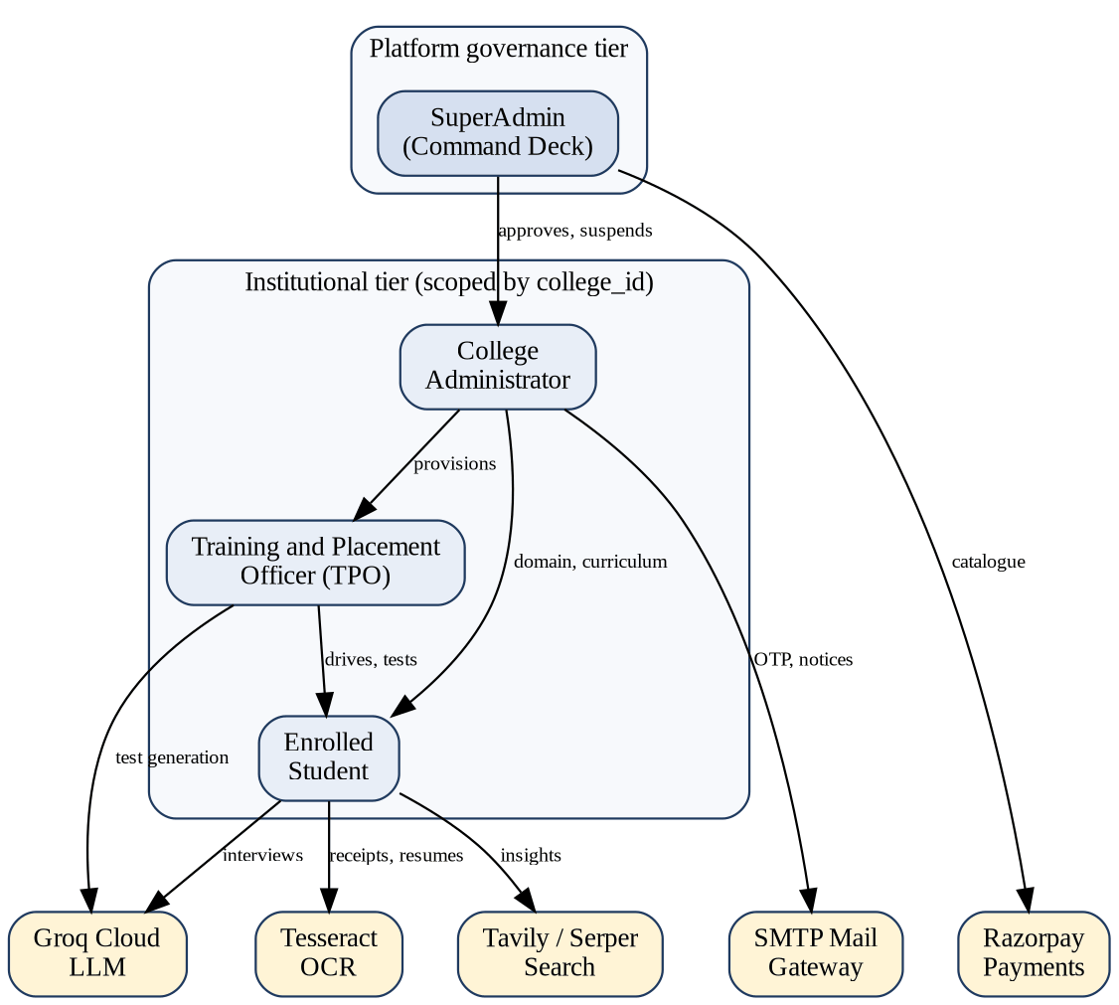
Figure 1.1: Stakeholders, institutional tiers and external engines of the platform

1.2 Objective
The overall objective is to design, implement and verify a secure, scalable and intelligent platform that digitises the complete placement lifecycle of a college and simultaneously improves the employability of its students. The specific objectives are:
- To build a multi-tenant architecture in which many colleges share one deployment while every query is automatically scoped to the caller's college_id, with a SuperAdmin tier that sees only aggregate platform data.
- To implement self-service college onboarding with official-domain email verification through One-Time Passwords (OTP), a five-item setup checklist and an explicit SuperAdmin approval gate.
- To provide role-based access control for four roles (Student, TPO, College Admin, SuperAdmin) enforced on every protected route, with brute-force lockout, refresh-token rotation and an immutable audit trail.
- To monetise the platform through a modular feature catalogue with a request, approval and payment workflow integrated with Razorpay and verified through HMAC-SHA256 signatures [14].
- To automate eligibility screening of students against drive criteria (CGPA, backlogs, branch, 10th and 12th percentages) and to maintain a transparent application pipeline.
- To deliver AI-powered preparation tools: ATS resume analysis and enhancement, a ten-question conversational mock interview, weak-area synthesis and a data-driven readiness score.
- To conduct AI-generated instant tests under browser-based proctoring that detects tab switching, fullscreen exit, clipboard use, developer tools, absent or multiple faces and ambient noise, with an automatic strike system.
- To verify placement-fee receipts using OCR and an LLM with a confidence threshold, escalating uncertain cases to a TPO for manual review.
- To ingest college syllabi and curate trustworthy learning resources aligned to the institution's own curriculum, under TPO approval.

1.3 Scope
The scope of the work covers the complete software system for one academic cycle of a placement office. The following capabilities are within scope:
- Web-based portals for Students, TPOs, College Admins and the SuperAdmin, accessible from any modern desktop browser.
- Tenant onboarding, subscription billing and feature licensing for institutions.
- Placement drive management, eligibility evaluation, application tracking and NBA/NAAC style report export.
- AI features: mock interviews, resume analysis and enhancement, instant-test generation and grading, curriculum parsing and resource curation.
- Integrity features: proctored tests, OTP verification, lockout, audit logging and token revocation.
The following are outside the scope of the current release: a native mobile application, a dedicated recruiter or company login portal, live video interviews between students and recruiters, integration with institutional ERP or Learning Management Systems, and automatic payroll or offer-letter generation. Several of these are discussed as future enhancements in Chapter 5.

1.4 Project Modules
The system is organised into fifteen functional modules grouped under six capability areas, as shown in Figure 1.2. Table 1.1 summarises each module, its primary users and its core capability; the detailed description of every module is given in Section 3.4.
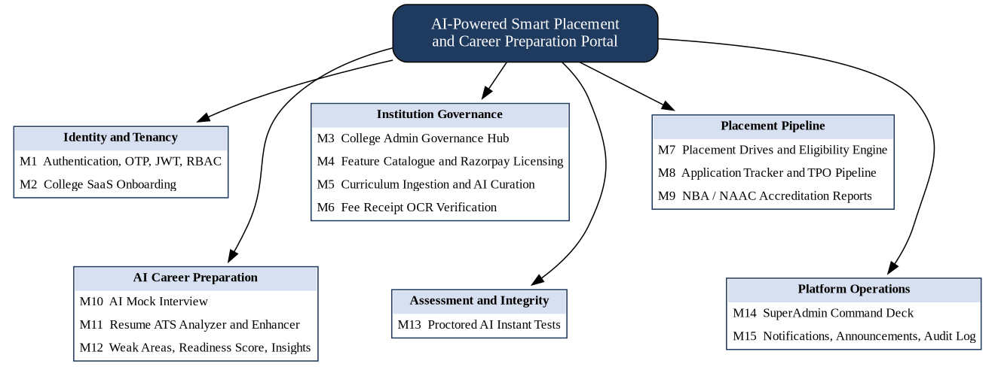
Figure 1.2: Module map of the Smart Placement Portal
Table 1.1: Summary of project modules
ID | Module | Primary users | Core capability
M1 | Authentication, OTP, JWT, RBAC | All roles | Domain-checked signup, login, lockout, refresh rotation, role guards
M2 | College SaaS Onboarding | College Admin, SuperAdmin | Self-registration, setup checklist, approval workflow
M3 | College Admin Governance Hub | College Admin | Domains, branches, TPO provisioning, audit feed
M4 | Feature Catalogue and Razorpay Licensing | College Admin, SuperAdmin | Feature requests, approvals, paid licences, expiry sweep
M5 | Curriculum Ingestion and AI Curation | College Admin, TPO, Student | Syllabus PDF to subject tree, AI-curated study resources
M6 | Fee Receipt OCR Verification | Student, TPO | Tesseract plus Groq verification with 0.85 confidence gate
M7 | Placement Drives and Eligibility Engine | TPO, Student | Drive creation, criteria matching, placement lock
M8 | Application Tracker and TPO Pipeline | TPO, Student | Stage updates, shortlisting, selection, CTC recording
M9 | Accreditation Reports | TPO, Admin | NBA/NAAC style CSV and printable HTML reports
M10 | AI Mock Interview | Student | Company-aware, ten-question evaluated interviews
M11 | Resume ATS Analyzer and Enhancer | Student | ATS score, missing skills, STAR-based rewrite
M12 | Weak Areas, Readiness Score, Insights | Student | Weak-area synthesis, readiness index, career insights
M13 | Proctored AI Instant Tests | TPO, Student | AI-generated tests, sensors, five-strike termination
M14 | SuperAdmin Command Deck | SuperAdmin | Approvals, suspension, catalogue, analytics
M15 | Notifications, Announcements, Audit | All roles | In-app notices, broadcasts, append-only audit log

1.5 Project Hardware/Software Requirements
The platform is a web application, so the requirements are divided between the development and deployment environment (server side) and the end-user environment (client side). Table 1.2 lists the hardware requirements and Table 1.3 lists the software stack that was used to build and run the system.
Table 1.2: Hardware requirements
Component | Development / server (minimum) | End user (client)
Processor | Intel Core i5 / AMD Ryzen 5 or better | Dual-core 2 GHz or better
Memory | 8 GB RAM (16 GB recommended) | 4 GB RAM
Storage | 256 GB SSD (database and uploads) | Not applicable
Network and peripherals | Broadband with outbound HTTPS | Stable broadband; webcam and microphone for tests

Table 1.3: Software requirements and technology stack
Layer | Technology | Purpose
OS and language | Windows 10/11 or Ubuntu 22.04; Python 3.11 | Development, hosting, application logic
Web framework | FastAPI [3], Uvicorn | Asynchronous REST API and OpenAPI docs
Validation | Pydantic v2 [15] | Schema validation and serialisation
ORM and migrations | SQLAlchemy 2.0 [5], Alembic | Data access and schema versioning
Database | PostgreSQL [4] | Relational storage of 33 tables
Security | bcrypt [16], JWT HS256 [8] | Password hashing, session tokens
AI inference | Groq Cloud API [9], Llama 3.3 70B | LLM generation and evaluation in JSON mode
Web search | Tavily / Serper [13] | Learning-resource retrieval
OCR and PDF | Tesseract [12], Poppler, pypdf | Receipt and syllabus text extraction
Payments | Razorpay SDK [11] | Order creation and webhooks
Front end | React 19 [6], Vite [17], Tailwind CSS [18] | Single-page app, styling, charts
State and data | TanStack Query [19], Zustand, Zod, Axios | Server cache, client state, validation
Testing | pytest [20] | Automated backend test suites
Client browser | Chrome / Edge (latest) with WebRTC | Camera and microphone access [21]

Chapter 2: Literature Review
The literature relevant to this work spans six areas: multi-tenant software architecture, secure web authentication, placement analytics research, AI-assisted career preparation, online assessment with proctoring, and document verification using OCR. The studies are reviewed in that order, moving from the platform foundation to the intelligent features built on top of it, and the chapter closes with a summary and the research gap that this project addresses.

2.1 Multi-tenant SaaS architecture
Chong and Carraro describe the architectural strategies by which a single application instance can serve many customers, and compare approaches ranging from separate databases per tenant to a shared database with a tenant discriminator column [1]. Their analysis shows that a shared schema offers the lowest operating cost and simplest maintenance, provided that tenant isolation is enforced rigorously in application code. Bezemer and Zaidman examine the maintenance consequences of multi-tenancy and conclude that a single multi-tenant deployment is easier to upgrade than many single-tenant installations, but that it needs careful isolation and configurability design [2]. The proposed portal adopts the shared-schema model with a mandatory college_id column and a request-time tenant guard, which is the pattern recommended in these studies.
The REST architectural style proposed by Fielding, with its uniform interface and stateless interactions, remains the dominant approach for exposing such multi-tenant services [7]. Stateless requests are well suited to token-based authentication and to horizontal scaling, and they are the basis of the endpoint design of this project. Sommerville's treatment of requirements engineering and system modelling guided the structured analysis and the UML-based design artefacts in Chapter 3 [22, 23, 24].

2.2 Secure authentication and web security
JSON Web Tokens, standardised in RFC 7519, provide a compact, signed representation of claims that can be verified without a server-side session store [8]. They are typically carried as bearer tokens in the framework defined by OAuth 2.0 [25]. For credential storage, Provos and Mazières introduced bcrypt, an adaptive hashing scheme whose cost factor can be increased as hardware improves, making offline guessing attacks progressively more expensive [16]. Payment gateways commonly authenticate webhook callbacks with keyed hashes; HMAC, specified in RFC 2104, allows the receiver to verify both integrity and origin of a message using a shared secret [14].
The OWASP Top Ten catalogues the most critical web application risks, including broken access control, cryptographic failures and injection [26]. These categories directly informed the security design of the portal: role guards on every route, parameterised ORM queries, hashed passwords and one-time codes, hashed refresh tokens, rate-limited OTP flows and account lockout after repeated failures.

2.3 Placement analytics and employability research
A substantial body of research applies machine learning to campus placement data. Maurya et al. developed classifiers that predict whether a student will be placed from academic performance indicators, and compared several algorithms on institutional data [27]. Rao et al. analysed placement performance at higher education institutions in South India and used ranked feature selection to identify which academic and skill attributes contribute most to placement outcomes [28]. A broader survey by Mezhoudi et al. reviews approaches to employability prediction and identifies open challenges, notably the need for richer, continuously updated student data and for actionable feedback rather than a bare probability [29].
These studies are predominantly offline analyses on static datasets. They show that CGPA, backlogs, skills and communication ability matter, but they do not provide a deployable platform in which the same attributes drive eligibility rules, preparation tools and feedback. The Placement Readiness Score and the eligibility engine of the proposed portal operationalise these findings inside a live workflow.

2.4 AI-assisted resume analysis and interview preparation
The transformer architecture introduced by Vaswani et al. underlies modern large language models [30], and open-weight families such as Llama 3 have made high-quality instruction-following models widely available [10]. When such models are used to evaluate free-text answers, Zheng et al. report that strong LLM judges can approach the level of agreement seen between human raters, while also documenting systematic biases such as favouring longer answers [31]. This motivates the design choice in the portal of scoring each interview answer against explicit criteria (accuracy, clarity and relevance) and of keeping the structured JSON output under server-side validation.
Retrieval-augmented generation grounds a model's output in documents retrieved at query time, which improves factual specificity [32]. The curriculum module follows this idea: web-search results are retrieved first and the model is asked only to select sources and write original summaries, rather than to recall URLs from memory. In industry, resume-matching services such as Jobscan expose ATS-style scoring to job seekers [33], and peer platforms such as Pramp offer mock technical interviews [34]; neither is integrated with an institution's drive pipeline or curriculum.

2.5 Online assessment and proctoring
Nigam et al. present a systematic review of AI-based proctoring systems and classify their techniques into identity verification, behaviour and gaze analysis, audio monitoring and browser or screen monitoring, noting trade-offs between detection strength, privacy and false positives [35]. Commercial examination platforms such as Mercer | Mettl combine such monitoring with live or recorded review [36]. The browser Page Visibility API [37], the Media Capture API [21] and the Web Audio API [38] make a lightweight, installation-free subset of these techniques possible directly in the browser. The portal uses exactly these primitives and pairs them with a server-side strike evaluator so that integrity decisions are never taken on the client.

2.6 Document verification using OCR
Tesseract, described by Smith, is an open-source OCR engine that converts scanned documents and images into machine-readable text [12]. OCR output is noisy, so direct string matching of receipts is brittle. The portal therefore uses OCR only for text extraction and delegates the judgement of authenticity, structure and plausibility to an LLM that returns a verdict with a confidence value; results below a threshold are escalated to a human officer.

2.7 Summary of the literature and research gap
Table 2.1: Summary of the reviewed literature
Ref. | Focus | Key contribution | Used in project
[1] | SaaS architecture strategies | Shared-schema tenancy with tenant discriminator | Tenant isolation
[2] | Multi-tenant maintenance | Single deployment eases upgrades | Platform design
[8], [16] | Tokens and password hashing | Stateless claims; adaptive hashing | Authentication
[14] | Message authentication | Keyed-hash verification of callbacks | Razorpay webhook
[27], [28] | Placement prediction with ML | Academic features drive outcomes | Eligibility, readiness
[29] | Employability survey | Need for actionable feedback | Insights module
[31], [32] | LLM evaluation, retrieval grounding | Criterion-based scoring; grounded output | Interview, curation
[35] | AI proctoring review | Taxonomy of monitoring signals | Proctored tests
[12] | OCR engine | Open-source text extraction | Receipt, syllabus OCR

The review shows that research and commercial tools each address a fragment of the problem: prediction models, resume scorers, mock-interview sites, proctoring engines and placement-management systems exist as separate products. No reviewed work combines a multi-tenant institutional platform with eligibility-driven drives, licensed feature modules, AI preparation tools, proctored assessment and OCR-based fee verification under a single role-based security model. Filling this gap is the contribution of the present project.

Chapter 3: System Analysis & Design

3.1 Comparison of Existing Applications with your Project with merits and demerits
Placement offices today rely either on manual tools or on a combination of specialised products, each covering one slice of the problem. Table 3.1 compares the options most commonly encountered by students and institutions with the proposed portal. The comparison is based on public product descriptions.
Table 3.1: Merits and demerits of existing approaches versus the proposed portal
System | Primary focus | Merits | Demerits
Manual spreadsheets and forms | Ad-hoc record keeping by the TPO | No cost; familiar to every office | No automated eligibility, no analytics, error-prone, no access control or audit trail, no preparation support
Superset [39] | Campus recruitment workflow between colleges and companies | Purpose-built for placements; centralises drives and student data | Public descriptions do not highlight AI mock interviews, ATS scoring, OCR fee verification or curriculum-aligned resources
Mercer | Mettl [36] | Online assessments with remote proctoring | Mature assessment engine with AI-enabled proctoring | Assessment-centric; not an institutional placement pipeline and no student preparation suite
Jobscan [33] | ATS-style resume matching for job seekers | Clear keyword and match feedback for a target job | Individual product; no link to college drives, eligibility or tenant administration
Pramp [34] | Peer-to-peer mock technical interviews | Realistic practice with another human | Depends on peer availability and scheduling; not tied to company drives or the curriculum
Proposed portal | Multi-tenant placement operations plus AI career preparation | Single platform for drives, eligibility, AI preparation, proctored tests, OCR fee verification, licensing and audit | Depends on external AI and payment services; browser-based proctoring is less strict than hardware-assisted systems

Table 3.2 maps the key capabilities to each option. "Yes" indicates that the capability is a highlighted feature in the public description of the product, "Partial" indicates partial or manual support, and a dash indicates that it is not highlighted.
Table 3.2: Feature coverage of existing applications and the proposed portal
Capability | Manual | Superset | Mettl | Jobscan | Pramp | Proposed
Drive management and eligibility filtering | Partial | Yes | - | - | - | Yes
Multi-college SaaS tenancy | - | Yes | - | - | - | Yes
Online proctored assessment | - | Partial | Yes | - | - | Yes
AI-generated and AI-graded tests | - | - | - | - | - | Yes
Resume ATS scoring | - | - | - | Yes | - | Yes
AI mock interview practice | - | - | - | - | Partial | Yes
Fee receipt OCR and AI verification | - | - | - | - | - | Yes
Curriculum-aligned study resources | - | - | - | - | - | Yes
Modular feature licensing with online payment | - | - | - | - | - | Yes
Placement analytics and accreditation reports | Partial | Partial | - | - | - | Yes
Append-only audit log and role-based access | - | - | - | - | - | Yes

3.2 Project Feasibility Study
A feasibility study was carried out before the design was finalised to confirm that the project is technically sound, economically sensible, operationally acceptable and legally safe to deploy.

3.2.1 Technical feasibility
Every component of the solution is built on mature, well-documented open technology. FastAPI, SQLAlchemy and PostgreSQL are widely used in production [3, 5, 4], React and Vite provide a proven front-end toolchain [6, 17], and the heavy AI workload is delegated to a hosted inference service so that no GPU infrastructure is needed [9]. OCR runs locally using Tesseract and Poppler [12]. The working prototype demonstrated that all seven AI workflows can run in JSON mode with server-side validation. The project is therefore technically feasible.

3.2.2 Economic feasibility
The development effort is an academic project and all frameworks used are open source. Recurring costs arise only from hosting, AI inference, email delivery and payment-gateway charges. The platform is itself a revenue model: the database defaults a college to the Campus Standard plan at INR 10,000 per month, and individual features carry their own catalogue price and billing model (monthly, annual or one-time). Table 3.3 lists the main cost and revenue heads.
Table 3.3: Cost and revenue heads
Head | Nature | Remarks
Software and frameworks | Open source, no licence fee | Python, FastAPI, PostgreSQL, React, Tesseract
Cloud hosting | Recurring, usage based | One application server and one managed database are sufficient to start
Groq AI inference | Pay-per-use | Consumption grows with active students; cached insights limit calls (12-hour refresh cool-down)
Email relay (OTP) | Low, recurring | Transactional OTP and notices through SMTP
Payment gateway | Per-transaction fee | As per Razorpay's published pricing [11]
Subscription revenue | INR 10,000 per college per month (default) | Plus catalogue-priced optional features

Because the marginal cost of an additional college is small compared with the subscription it pays, the model is expected to remain economically viable as the number of tenants grows.

3.2.3 Operational feasibility
The portal replaces tools the placement office already uses (spreadsheets, forms, messaging groups) with role-specific dashboards, and the setup checklist guides a new college through configuration step by step. Students sign up with their institutional email and the system needs only a browser, which keeps training effort low.

3.2.4 Schedule feasibility
The work was planned across the semester (July to December 2026) in overlapping phases, from requirement gathering to documentation, as shown in Section 3.3.

3.2.5 Legal and ethical feasibility
The platform processes personal data of students such as academic records, resumes and webcam snapshots during tests. In India, such processing is governed by the Digital Personal Data Protection Act, 2023 [40]. The design supports compliance through data minimisation, tenant isolation, hashed secrets, role-restricted access, purpose-limited snapshot capture during proctored tests only, and a SuperAdmin tier that is deliberately blind to student-level data. Proctoring decisions are advisory: a TPO reviews the evidence before any disqualification.

3.3 Project Timeline chart
Figure 3.1 shows the Gantt chart of the project from July to December 2026, from requirement gathering to the final submission. The mid-semester evaluation in October fell in the middle of the AI preparation phase, and the remaining integrity features were completed afterwards.
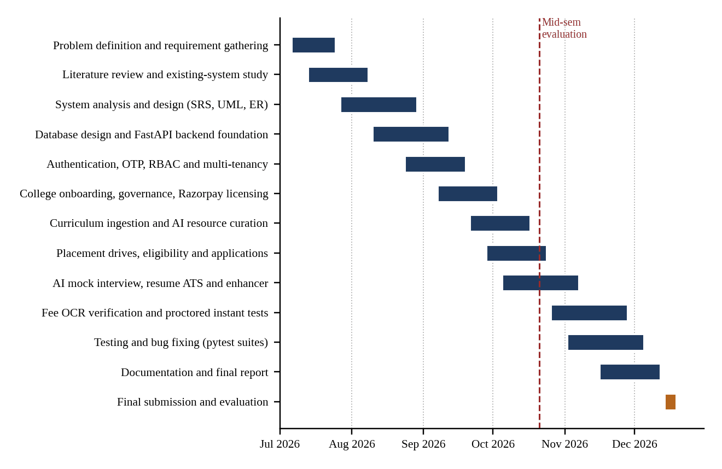
Figure 3.1: Project timeline (Gantt chart), July to December 2026

3.4 Detailed Modules Description
This section describes each of the fifteen modules introduced in Section 1.4: its purpose, the main rules it enforces and the data it touches.

3.4.1 M1: Authentication, OTP, JWT and RBAC
This module is the security foundation of the portal. A student signs up with an institutional email address; the domain is matched against the registered college domains and public providers are rejected. A six-digit OTP, stored only as a bcrypt hash [16], is emailed and expires after ten minutes with a limited number of attempts. After verification the user receives a short-lived signup token and then sets a password to complete registration.
On login the server checks the account state, the college status and the password. Five consecutive failures lock the account for fifteen minutes. A successful login issues a 30-minute access token and a seven-day refresh token [8]. Refresh tokens are stored as SHA-256 hashes, rotated on use and revoked on logout. Every protected route is wrapped in a role guard, and every tenant query is scoped by college_id, as shown in Figure 3.2.
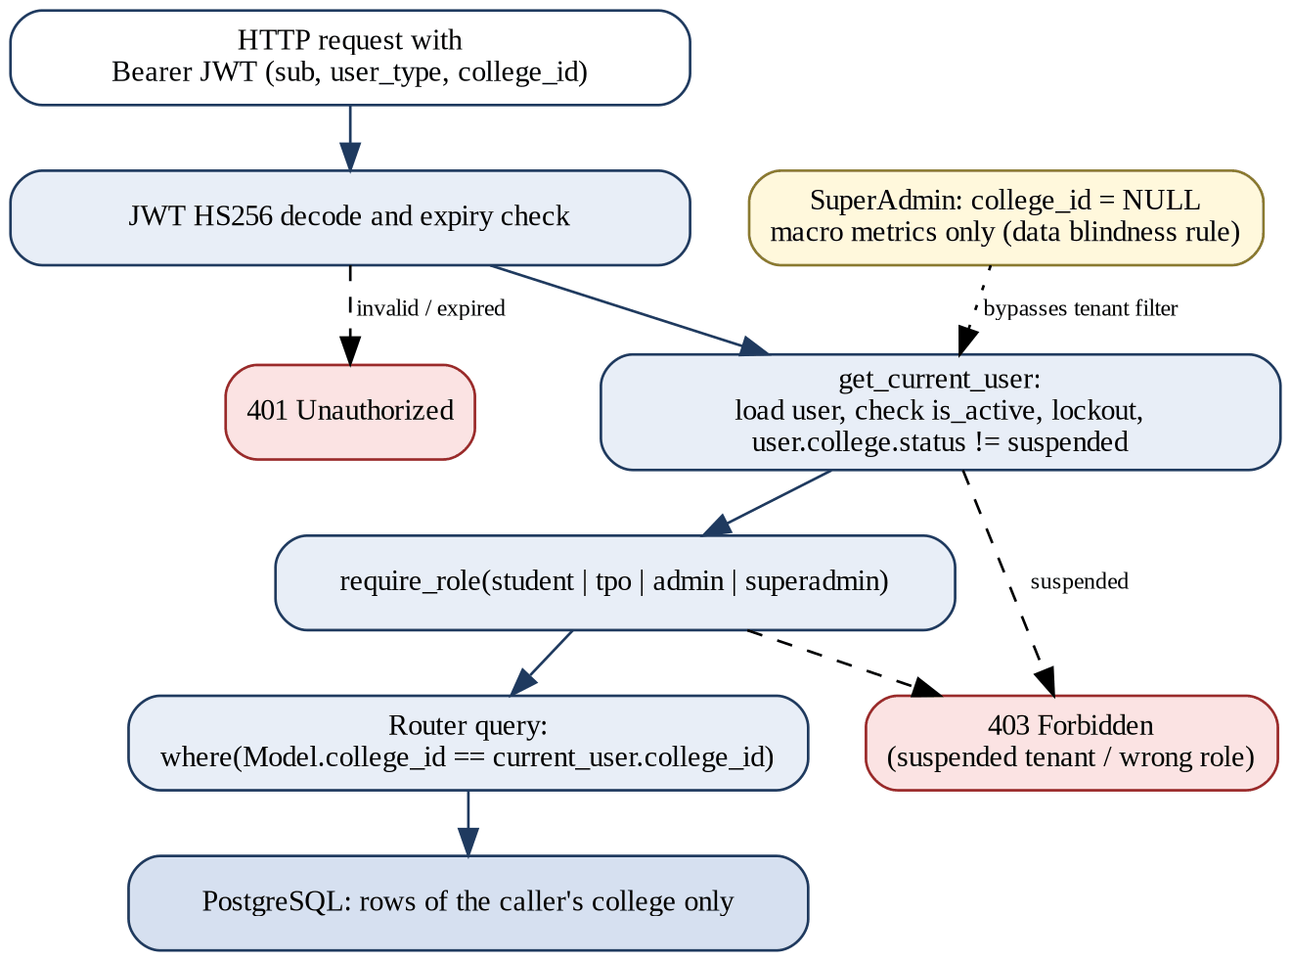
Figure 3.2: Request pipeline enforcing authentication, role and tenant isolation

3.4.2 M2: College SaaS Onboarding
A representative registers a college by providing the college name, administrator details and an official email, verified by OTP. Public email providers and already-registered domains are rejected. The college is created with the status pending_setup and the registration expires after 48 hours if incomplete.
The College Admin then completes a five-item checklist: email domain, departmental branches, fee receipt template, confirmed curriculum and the first TPO account. When all items are satisfied the status becomes ready_for_review and the SuperAdmin approves or rejects the college. Only an active college can use student-facing features.

3.4.3 M3: College Admin Governance Hub
The governance hub gives each College Admin control over their own tenant: managing branches (soft-deleted rather than removed), provisioning and deactivating TPO accounts, viewing the activity feed, sending announcements, reading contact messages and uploading the fee receipt template.

3.4.4 M4: Feature Catalogue and Razorpay Licensing
The SuperAdmin maintains a master catalogue of features, each with a code, price and billing type (monthly, annual or one-time). A College Admin requests a feature; the SuperAdmin approves it, which opens a seven-day payment window. The admin then pays through Razorpay Checkout; the server creates the order in paise and later receives a webhook whose HMAC-SHA256 signature is verified before the feature is activated [14, 11].
Monthly licences last 30 days and annual licences 365 days. A scheduled expiry sweep marks lapsed licences as expired, converts unpaid approvals to approval_expired and sends reminders.

3.4.5 M5: Curriculum Ingestion and AI Curation
The College Admin uploads the syllabus as a PDF of up to 15 MB. Text is extracted with pypdf, with OCR as fallback, and the Groq model converts it into a tree of branch, semester and subject. The admin edits and confirms the tree.
For prioritised subjects the system searches the web for books, articles and videos, then asks the model to select suitable sources and write original summaries, following the retrieval-grounded approach discussed in Chapter 2 [32, 13]. Curated items start as pending_review and become visible to students only after TPO approval.

3.4.6 M6: Fee Receipt OCR Verification
Students upload a placement-fee receipt (PDF, JPG or PNG, up to 5 MB). The file type is validated by extension and content, text is extracted by Tesseract after rendering PDFs at 300 DPI [12], and the Groq model judges the receipt. If the college has an active template the model performs a structural comparison (Path B); otherwise it checks content plausibility (Path A). A verdict with confidence of at least 0.85 marks the student as fee-verified automatically; lower confidence sends the record to the TPO review queue where the original and extracted text can be compared side by side.

3.4.7 M7: Placement Drives and Eligibility Engine
TPOs register companies and create drives with role, job description, package range, deadline, bond details and eligibility criteria (minimum CGPA, maximum active backlogs, allowed branches, 10th and 12th percentages). The eligibility engine evaluates every applicant against these rules and returns the exact failure reasons. A placement lock prevents already placed students from applying unless the TPO grants an override.

3.4.8 M8: Application Tracker and TPO Pipeline
Each application moves through the states applied, eligible or not_eligible, shortlisted, selected, rejected or withdrawn. TPOs update stages individually or in bulk, record the package on selection and the student is notified. Selection sets is_placed, activating the placement lock.

3.4.9 M9: Accreditation Reports
Placement outcomes recorded in drives and applications are aggregated by the reports router into placement statistics that support NBA and NAAC documentation. Reports can be downloaded as CSV or opened as printable HTML.

3.4.10 M10: AI Mock Interview
A student chooses a target company, an interview mode (aptitude, technical, coding, HR or full) and optional skills. The Llama 3.3 70B model [10] generates one question at a time. After each answer the model scores accuracy, clarity and relevance on a 0 to 100 scale and gives feedback before producing the next question. After ten questions the session is closed, an overall score is computed and a weak-area summary is synthesised, following the criterion-based judging approach described in [31].

3.4.11 M11: Resume ATS Analyzer and Enhancer
A student uploads a resume PDF of up to 5 MB. The text layer is read with pypdf and OCR is used for scanned files. The analyzer returns an ATS score from 0 to 100, missing skills and suggestions. The enhancer asks four to five targeted questions to collect measurable achievements and then rebuilds the resume in a STAR style. The new version is stored as an enhanced resume and set active; exactly one resume per student is active at any time.

3.4.12 M12: Weak Areas, Readiness Score and Insights
Scores from resume analysis, mock interviews, profile completeness and application activity are combined into a Placement Readiness Score with the weights shown in Figure 3.3. The insights engine summarises trending skills and external opportunities for the student's branch using web search and the LLM; manual refresh is limited to once every twelve hours to control cost.
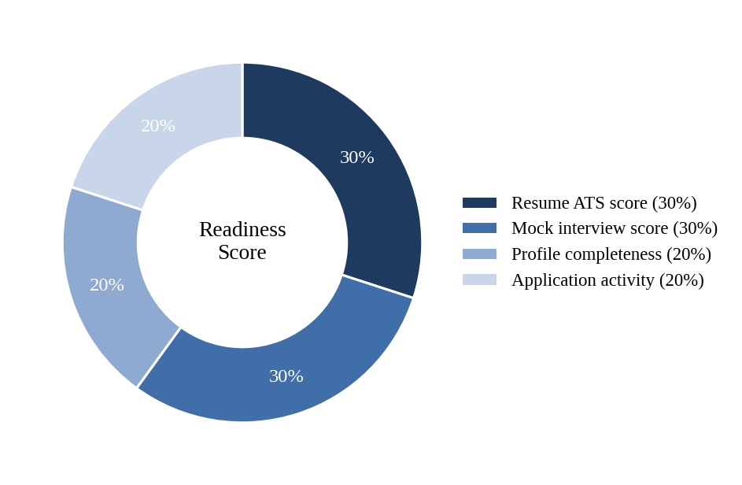
Figure 3.3: Weights used in the Placement Readiness Score

3.4.13 M13: Proctored AI Instant Tests
A TPO configures an instant test with a prompt, duration, passing marks and an optional top-N shortlisting rule; the model generates the questions. Before starting, the student completes a precheck of camera, microphone and fullscreen. During the test, questions and options are randomised per student, answers are auto-saved, and the end time is held by the server so that the client clock cannot extend a test.
Browser sensors report tab switches, fullscreen exits, copy or paste attempts, developer tools, a missing or additional face and sustained noise, using the Page Visibility, Media Capture and Web Audio interfaces [37, 21, 38]. Each report carries a webcam snapshot. The server evaluates strikes as in Figure 3.4: two strikes in one category trigger a warning, and five violations in total end the attempt automatically as auto_ended_violations. The TPO can review the timeline and snapshots and disqualify a candidate.
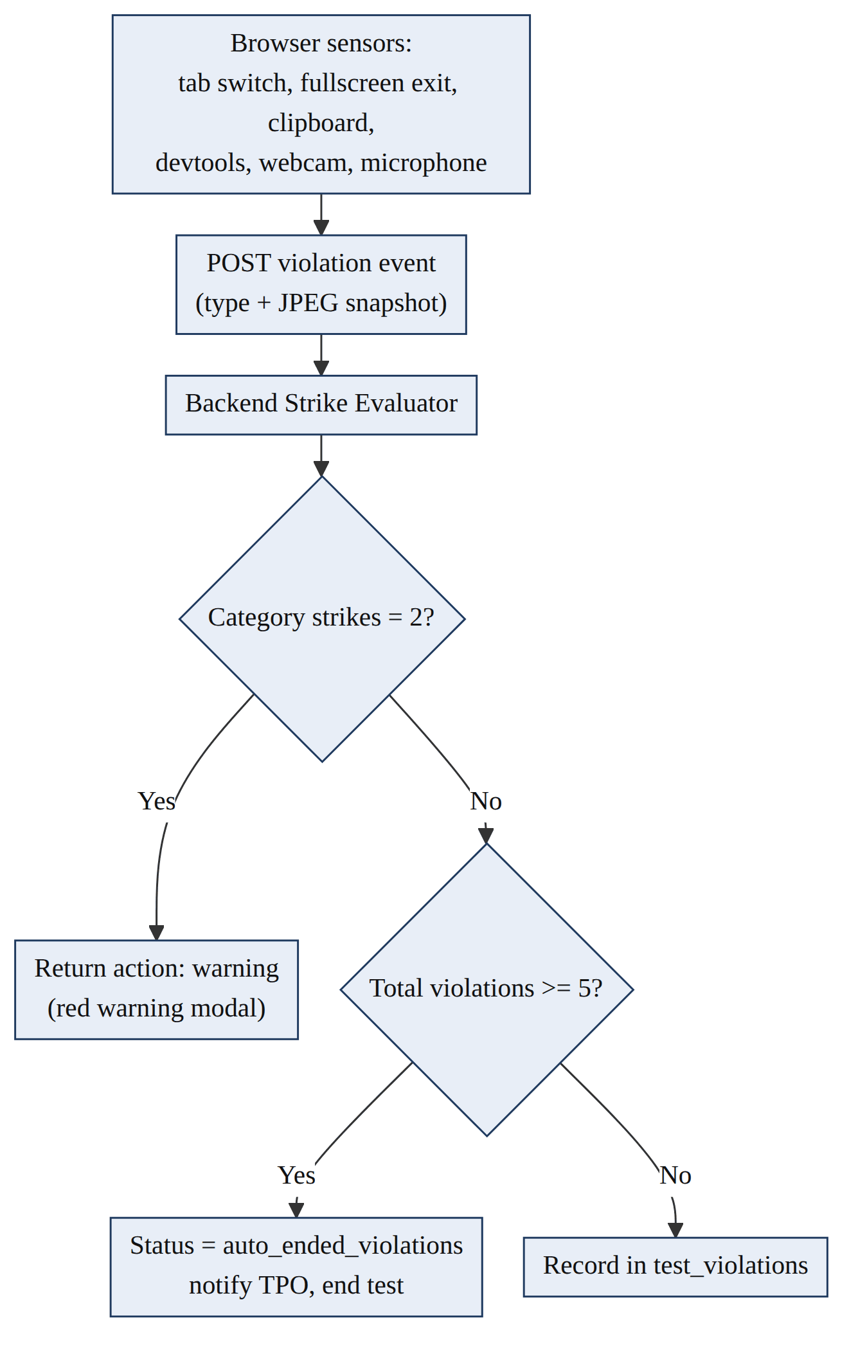
Figure 3.4: Server-side strike evaluation for proctoring violations

3.4.14 M14: SuperAdmin Command Deck
The SuperAdmin governs the platform: approving or rejecting colleges, suspending a tenant instantly (which blocks all its logins), managing the feature catalogue, reviewing feature requests and custom proposals, monitoring subscriptions and transactions, broadcasting announcements and viewing platform-wide analytics and the audit log. The SuperAdmin account has no college_id and sees aggregate data only.

3.4.15 M15: Notifications, Announcements and Audit
In-app notifications (info, warning, notice, system and approval-expired) keep users informed of approvals, payments and application updates. Announcements can be global or scoped to a college. Security and administrative actions go to an append-only audit log; contact messages are routed to the Admin or TPO.

3.5 Project SRS
This section presents the Software Requirements Specification of the portal in the structure suggested by ISO/IEC/IEEE 29148 [24]. The purpose of the system is to provide a secure multi-tenant platform for placement management and AI-assisted career preparation. Its users are the Student, the Training and Placement Officer (TPO), the College Administrator and the platform SuperAdmin, supported by external services (Groq for AI, Razorpay for payments, SMTP for email, Tavily or Serper for search and Tesseract for OCR). Table 3.4 lists the functional requirements, Table 3.5 the non-functional requirements and Table 3.6 the role-based access matrix.
Table 3.4: Functional requirements
ID | Requirement | Module
FR-01 | The system shall verify student email domains against registered colleges and confirm them by OTP. | M1
FR-02 | The system shall authenticate users with JWT and lock an account for 15 minutes after 5 failed logins. | M1
FR-03 | The system shall allow a college to self-register and shall activate it only after SuperAdmin approval. | M2
FR-04 | The system shall track a five-item setup checklist for each pending college. | M2, M3
FR-05 | The system shall let a College Admin manage branches, TPO accounts and announcements. | M3
FR-06 | The system shall support feature request, approval, payment and expiry with Razorpay. | M4
FR-07 | The system shall verify payment webhooks using HMAC-SHA256 before activating a feature. | M4
FR-08 | The system shall convert an uploaded syllabus into an editable subject tree. | M5
FR-09 | The system shall curate resources for prioritised subjects and publish them only after TPO approval. | M5
FR-10 | The system shall verify fee receipts by OCR and AI and escalate confidence below 0.85 to a TPO. | M6
FR-11 | The system shall evaluate every application against the drive eligibility criteria. | M7
FR-12 | The system shall prevent placed students from applying unless a TPO override exists. | M7
FR-13 | The system shall maintain application stages and record the package on selection. | M8
FR-14 | The system shall export placement reports as CSV and printable HTML. | M9
FR-15 | The system shall conduct a ten-question AI mock interview and score each answer. | M10
FR-16 | The system shall score resumes against ATS criteria and generate an enhanced resume. | M11
FR-17 | The system shall compute a Placement Readiness Score and weak-area summary. | M12
FR-18 | The system shall generate and grade AI tests under browser proctoring with a five-strike rule. | M13
FR-19 | The system shall allow the SuperAdmin to suspend a college and revoke its access. | M14
FR-20 | The system shall maintain notifications and an append-only audit log. | M15

Table 3.5: Non-functional requirements
Category | Requirement
Security | Passwords and OTPs are bcrypt-hashed; refresh tokens are stored as SHA-256 hashes; file uploads are validated by size, extension and content; every route is role-guarded [26].
Tenant isolation | Every tenant-owned query is filtered by college_id; SuperAdmin cannot read student-level data.
Performance | Asynchronous FastAPI service with a connection pool of 20 and 10 overflow connections and pre-ping of stale connections.
Reliability | Test end times are server-authoritative; schema changes are versioned with Alembic migrations.
Privacy | Receipts are processed by a local OCR engine; webcam snapshots are captured only during proctored tests.
Usability | Responsive single-page interface with a dedicated dashboard for each role.
Maintainability | Modular routers, typed schemas and nine automated test suites.
Auditability | Administrative and security events are recorded in an append-only audit log.

Table 3.6: Role-based access control matrix
Operation | Student | TPO | Admin | Super-Admin
Sign up and edit own profile | Yes | - | - | -
Upload fee receipt and resume | Yes | - | - | -
Apply to drives and take tests | Yes | - | - | -
Use mock interview and resume tools | Yes | - | - | -
Create companies, drives and tests | - | Yes | - | -
Review applicants and fee receipts | - | Yes | - | -
Curate and approve resources | - | Yes | - | -
Manage branches, domains and TPOs | - | - | Yes | -
Ingest and confirm curriculum | - | - | Yes | -
Request and pay for features | - | - | Yes | -
Approve or suspend colleges | - | - | - | Yes
Manage catalogue and subscriptions | - | - | - | Yes
Global announcements and analytics | - | - | - | Yes

The overall architecture of the system is shown in Figure 3.5. A React client talks only to the FastAPI service through a security gateway that verifies the token, resolves the tenant and checks the role; the service layer then uses PostgreSQL, local file storage and four external services.
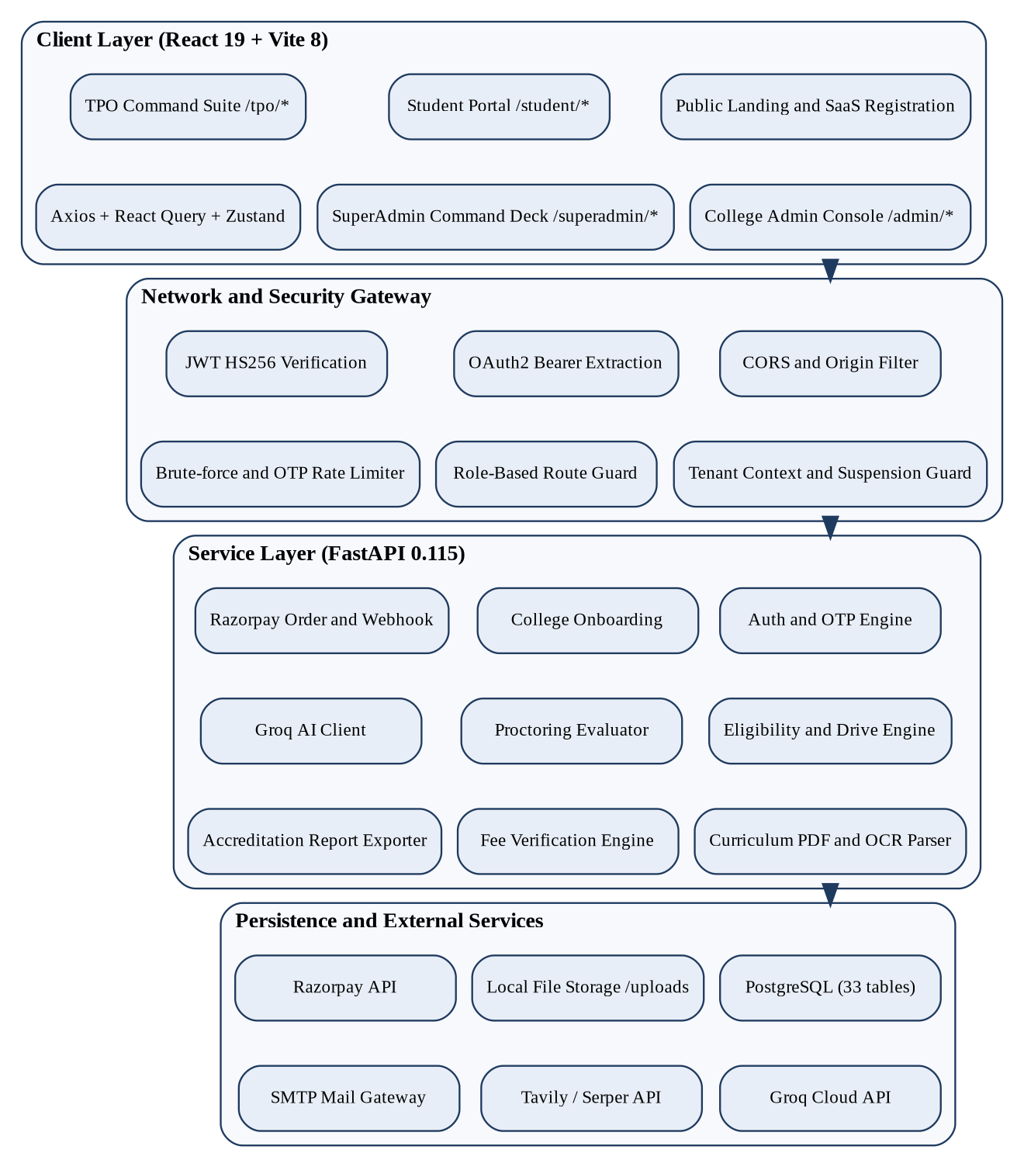
Figure 3.5: Layered system architecture of the portal

3.5.1 Use Case Diagrams
Use case diagrams [23] capture the interaction between each actor and the system; one diagram is given per actor so that the include and extend relationships stay readable. Figure 3.6 shows the Student, 3.7 the TPO, 3.8 the College Admin and 3.9 the SuperAdmin use cases.
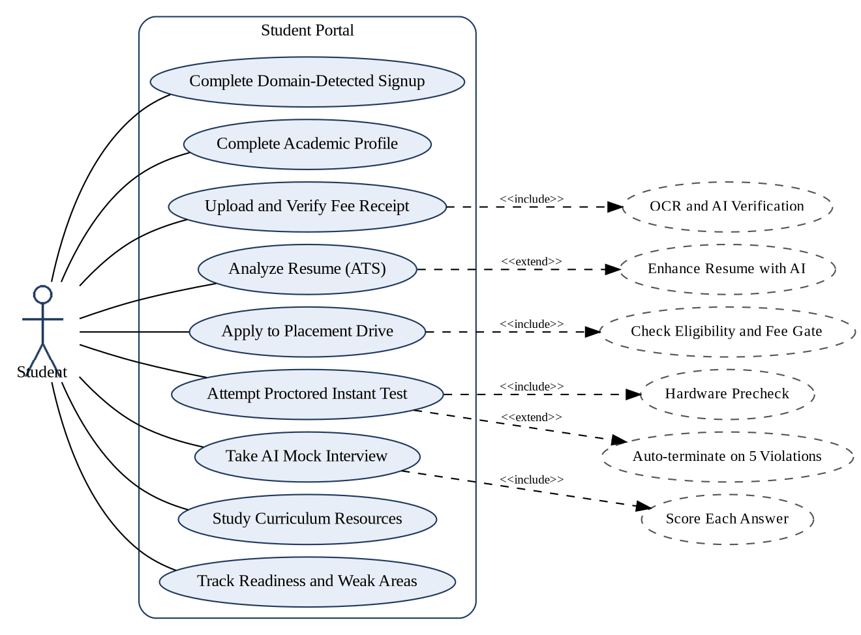
Figure 3.6: Use case diagram of the Student actor
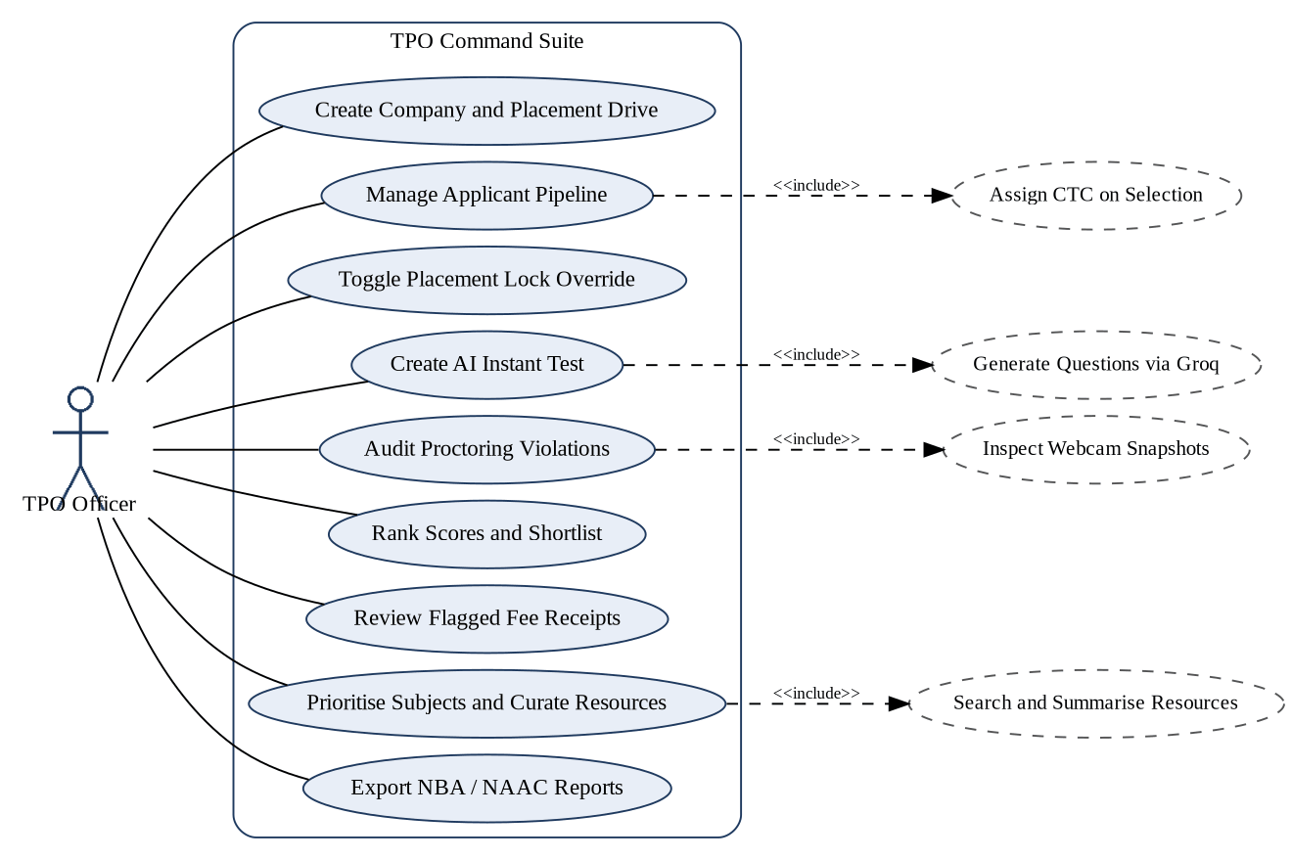
Figure 3.7: Use case diagram of the TPO actor
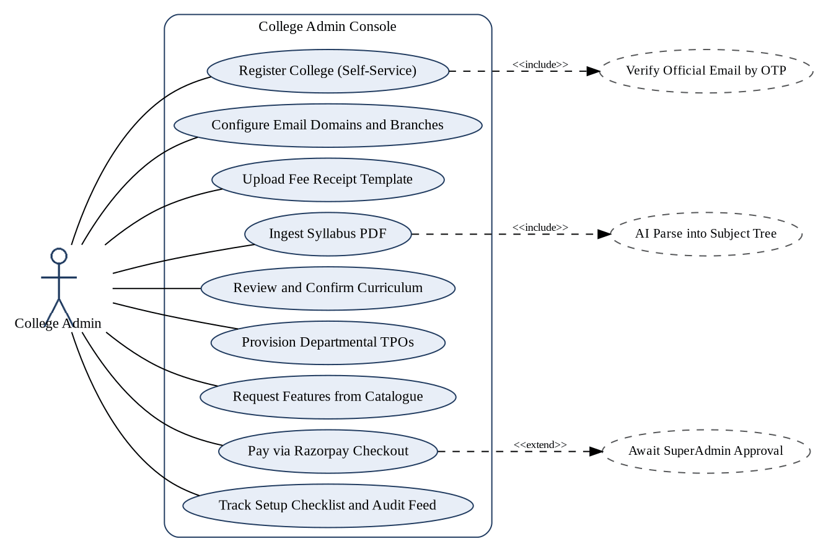
Figure 3.8: Use case diagram of the College Admin actor
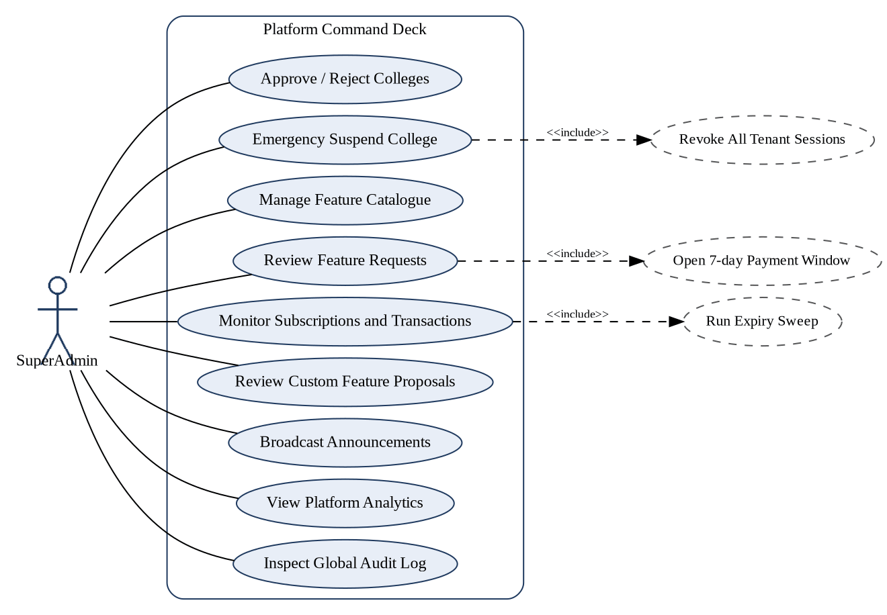
Figure 3.9: Use case diagram of the SuperAdmin actor

3.5.2 Data Flow Diagrams
Figure 3.10 is the context diagram (Level 0), Figure 3.11 the eight main processes (Level 1), and Figures 3.12 and 3.13 the fee verification and proctored test processes (Level 2).
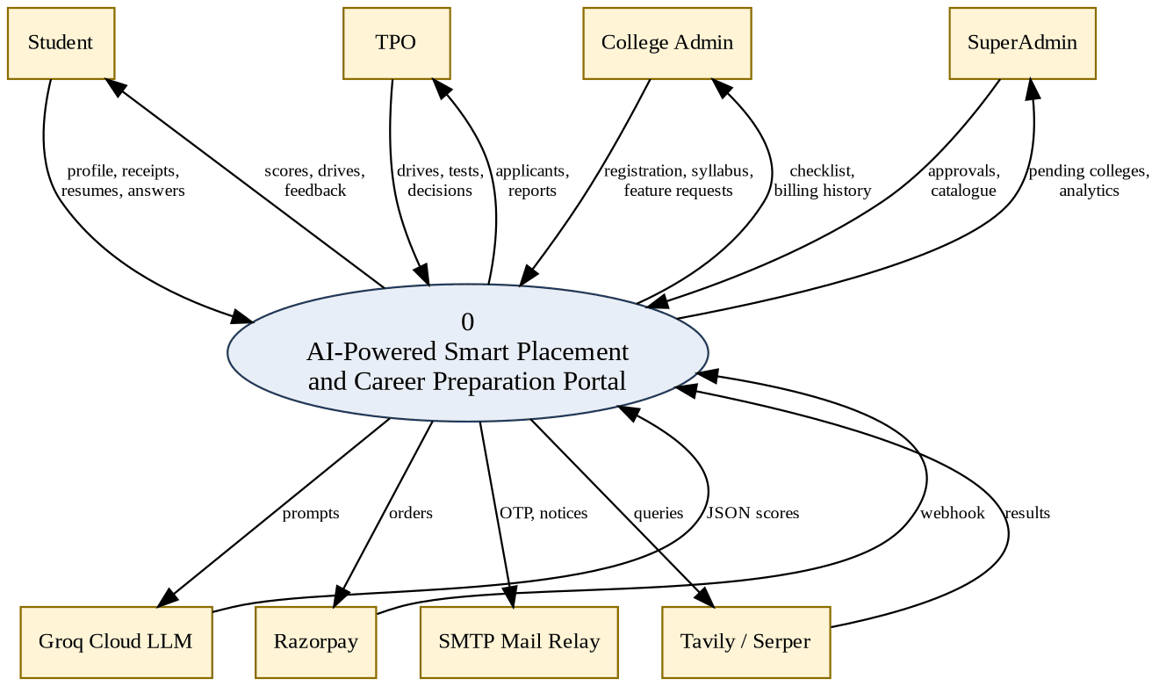
Figure 3.10: Level 0 DFD (context diagram)
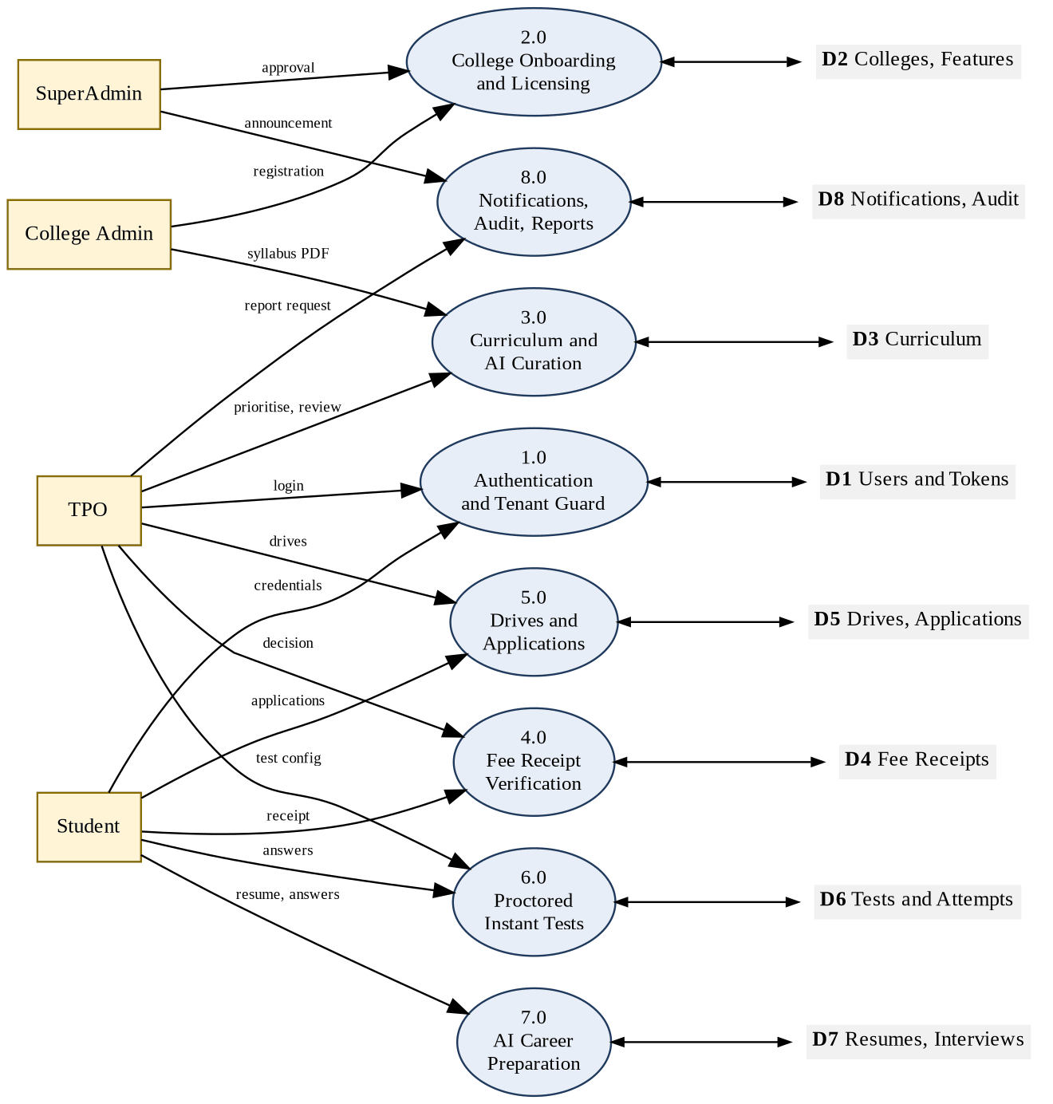
Figure 3.11: Level 1 DFD of the Smart Placement Portal
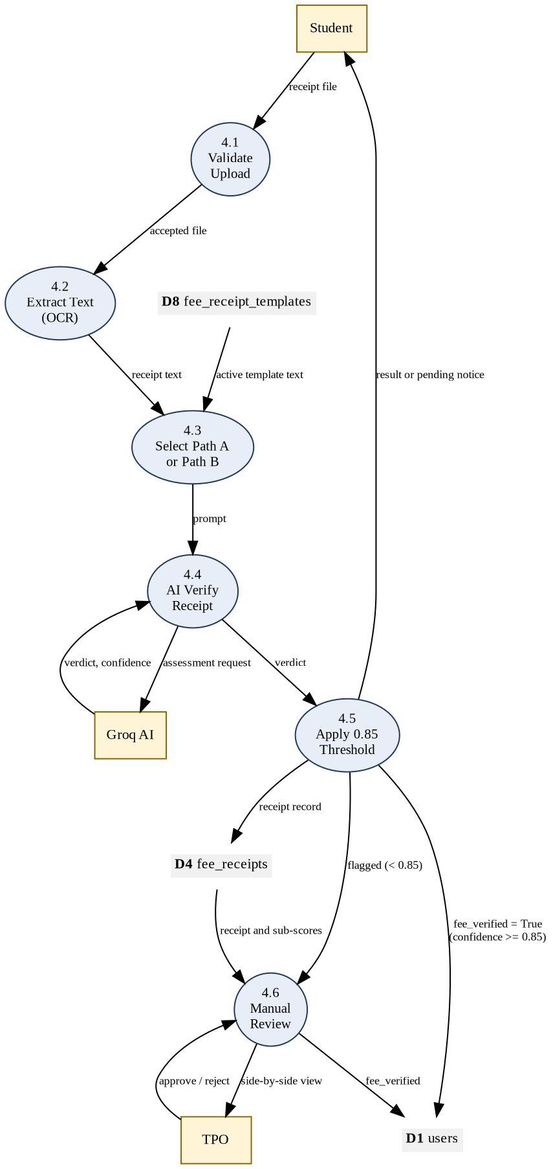
Figure 3.12: Level 2 DFD of Process 4.0: Fee Receipt Verification
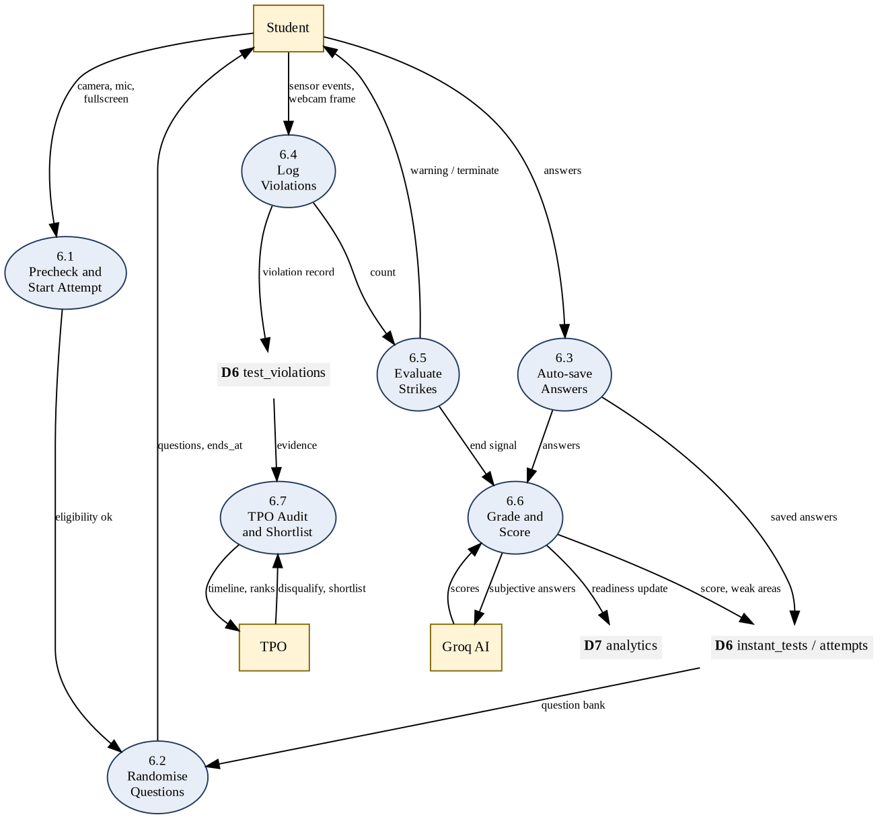
Figure 3.13: Level 2 DFD of Process 6.0: Proctored Instant Tests

3.5.3 Class diagram
The domain model has one class per table, shown in four groups with key attributes and operations; complete attributes are in Section 3.6. Figures 3.14 to 3.17 cover tenancy and billing, the placement pipeline, assessment and AI, and curriculum and communication.
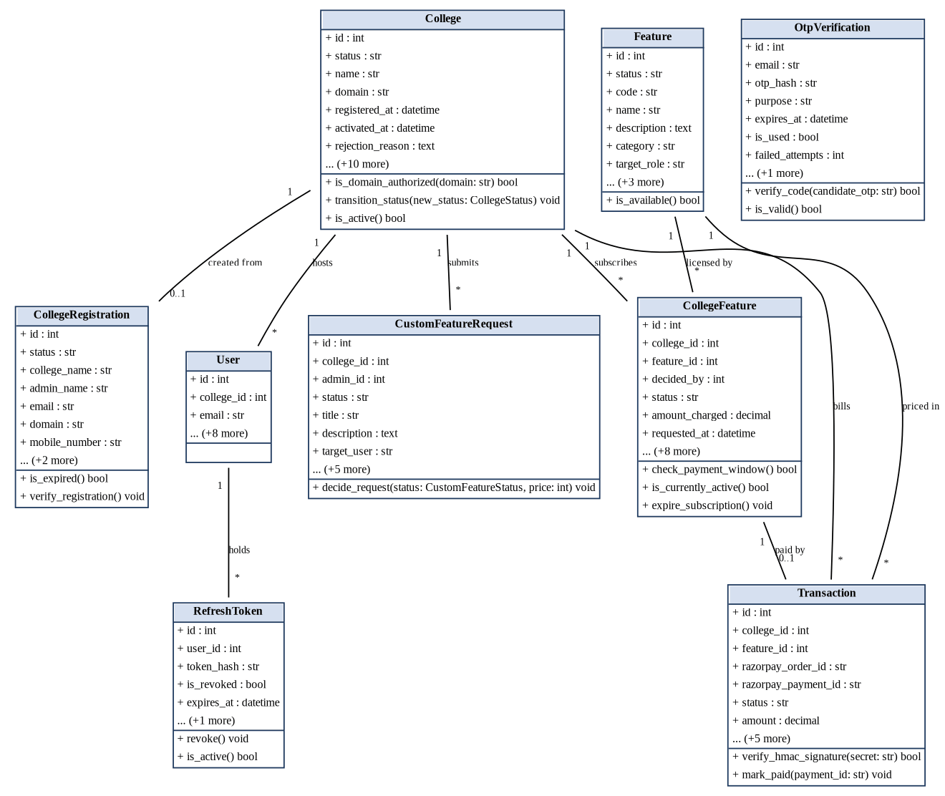
Figure 3.14: Class diagram: tenancy, identity and billing
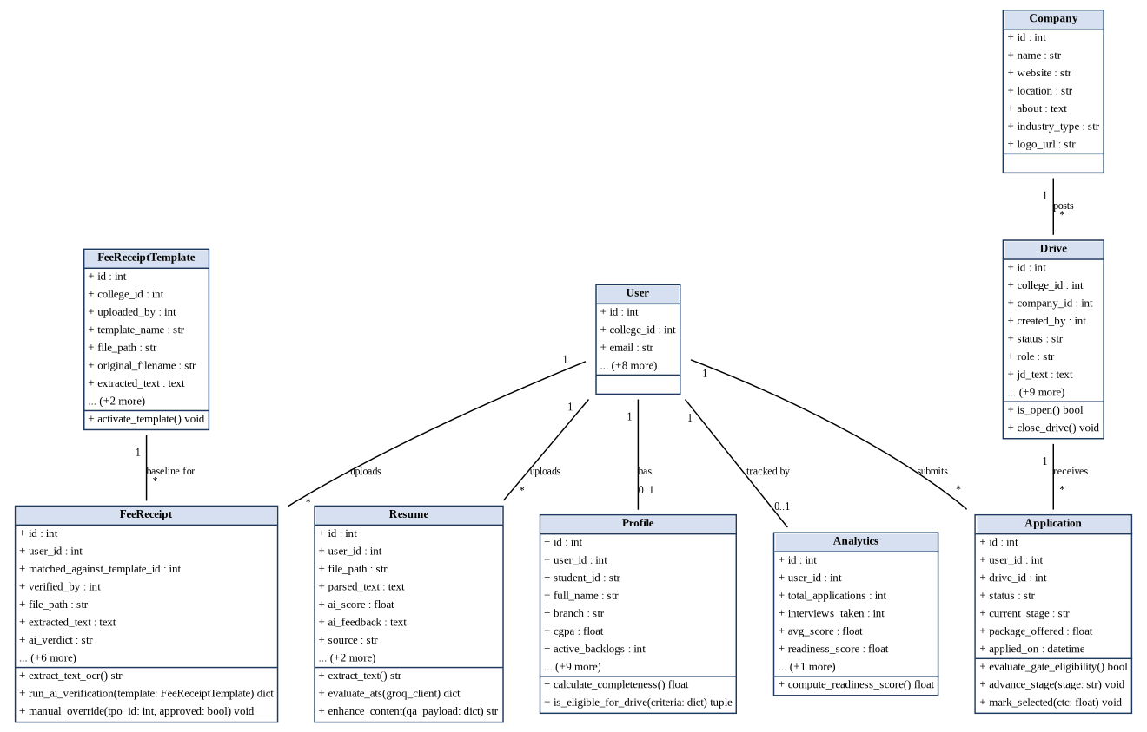
Figure 3.15: Class diagram: student profile and placement pipeline
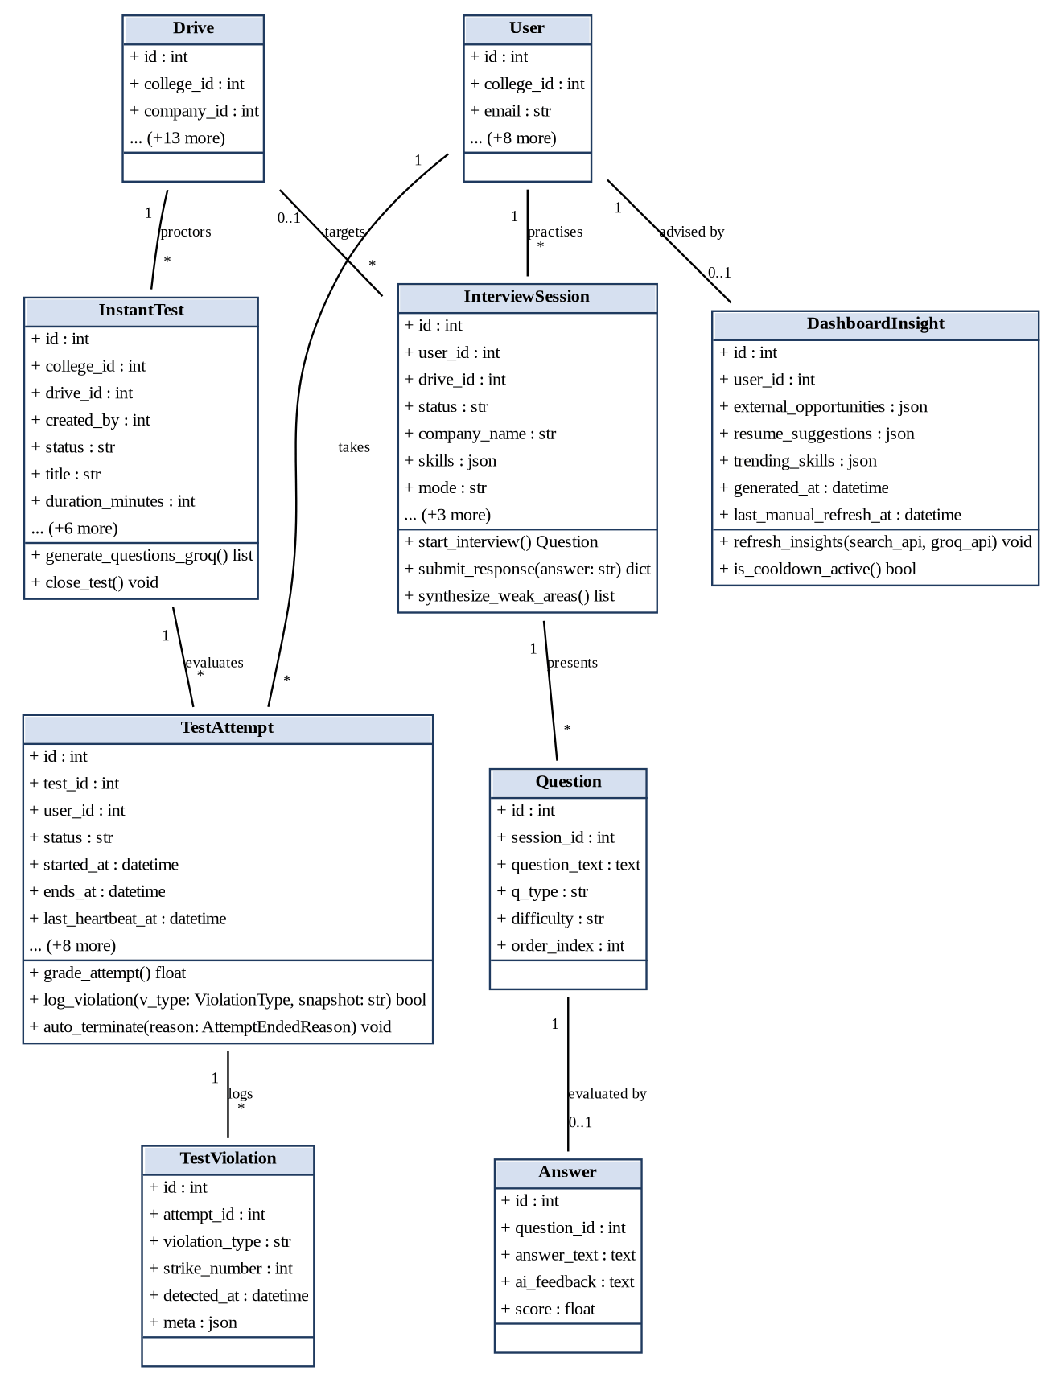
Figure 3.16: Class diagram: assessment and AI preparation
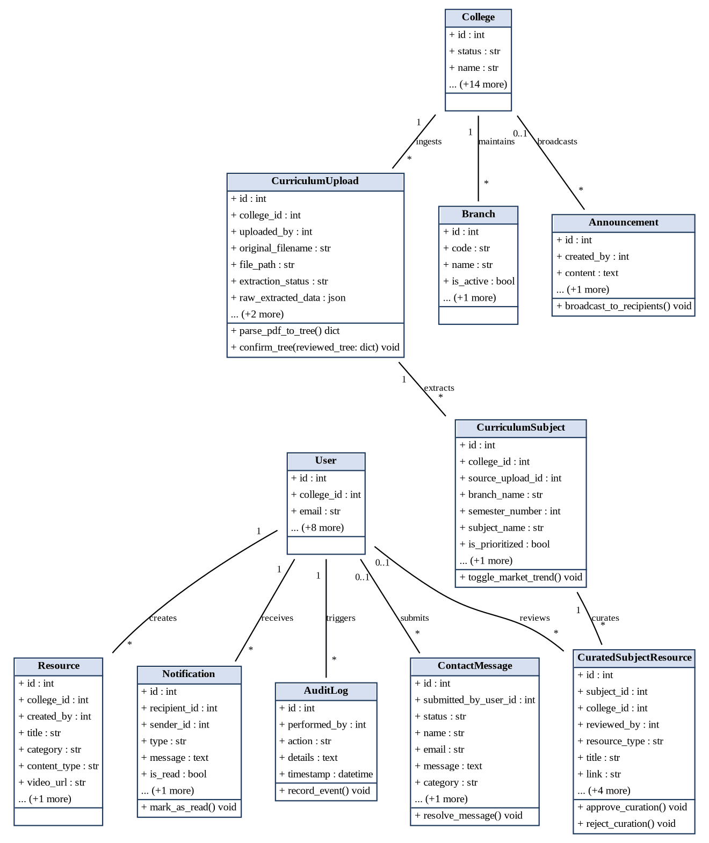
Figure 3.17: Class diagram: curriculum and communication

3.5.4 Entity Relationship Diagrams
The database has 33 tables. Figure 3.18 gives the overall entity relationship diagram with all entities and relationships; crow's foot notation marks the many side of each relationship. Figures 3.19 and 3.20 then show the key attributes of the tenancy and billing group and of the placement group, where PK marks the primary key and FK a foreign key; the attributes of the other groups appear in the class diagrams and in the Data Dictionary (Section 3.6).
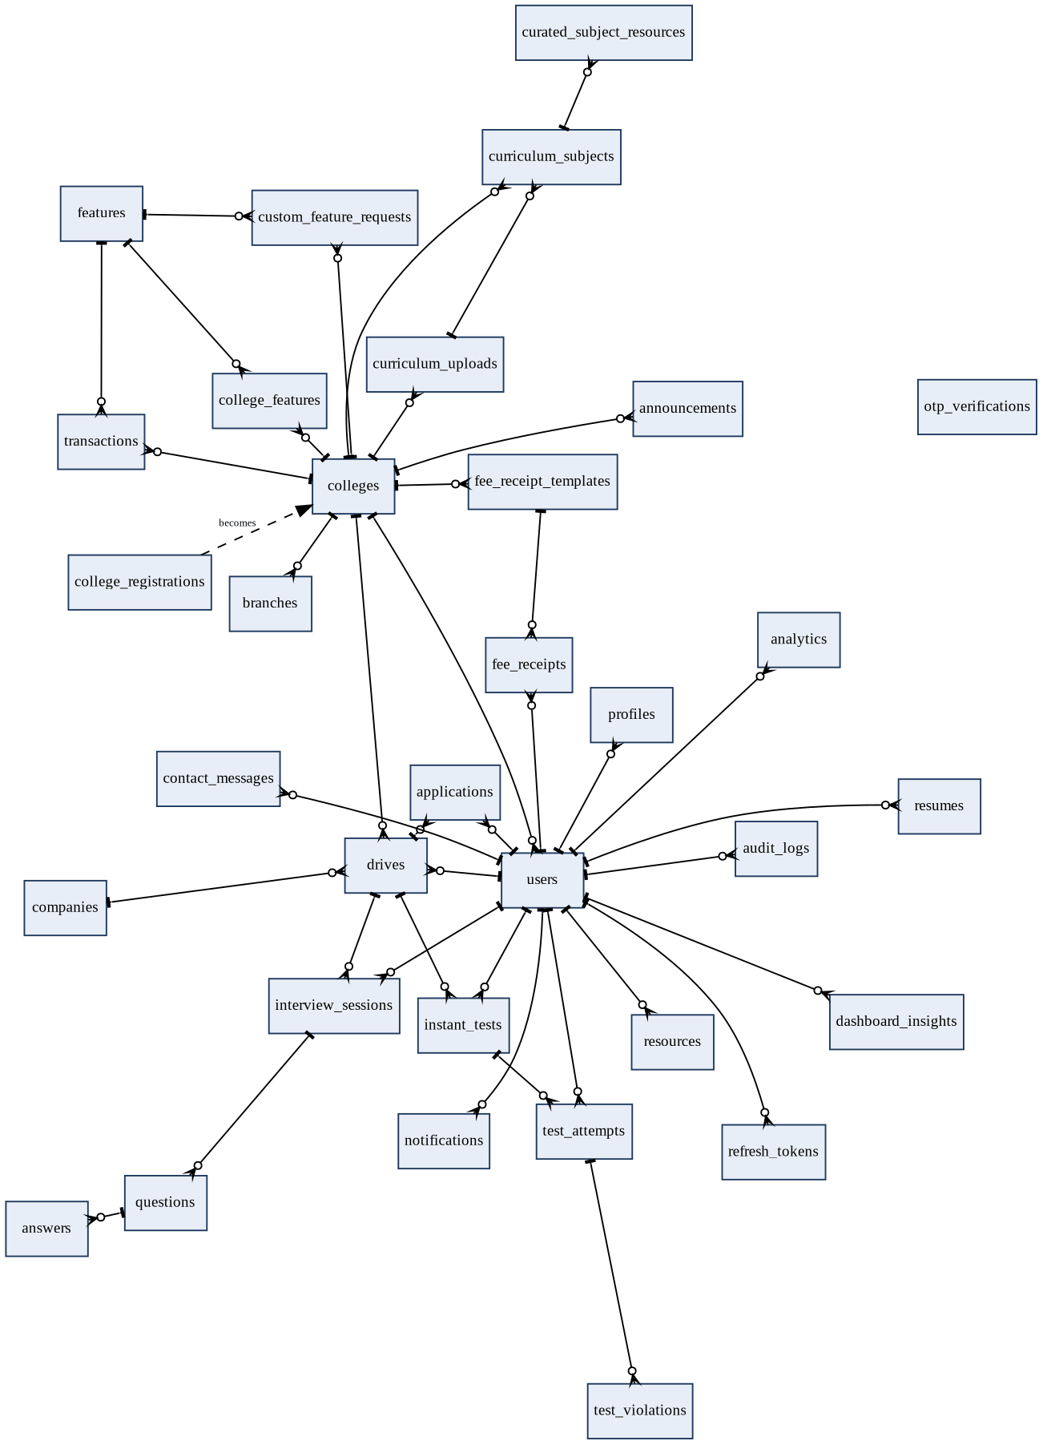
Figure 3.18: Entity relationship diagram of the complete database
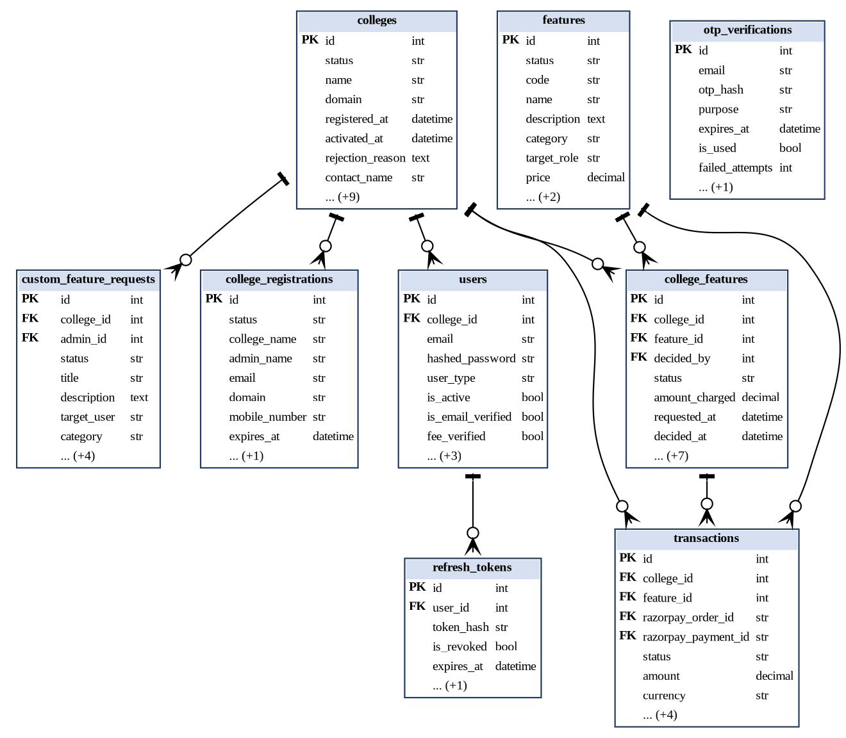
Figure 3.19: ER diagram: tenancy, identity and billing
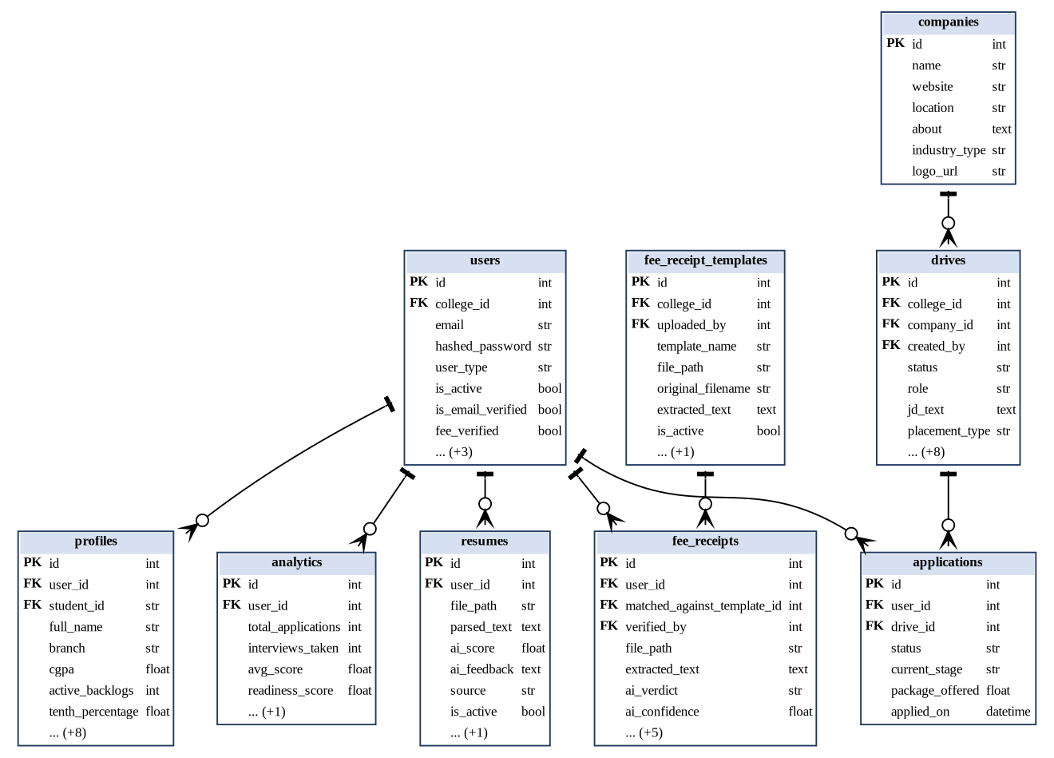
Figure 3.20: ER diagram: student profile and placement pipeline

3.5.5 Sequence Diagrams
Sequence diagrams [23] show the order of messages between participants for the most important workflows. Figure 3.21 is student signup: the domain check precedes any OTP, the OTP is verified against its hash, expiry and attempt limit, and the account is created only after the password is set.
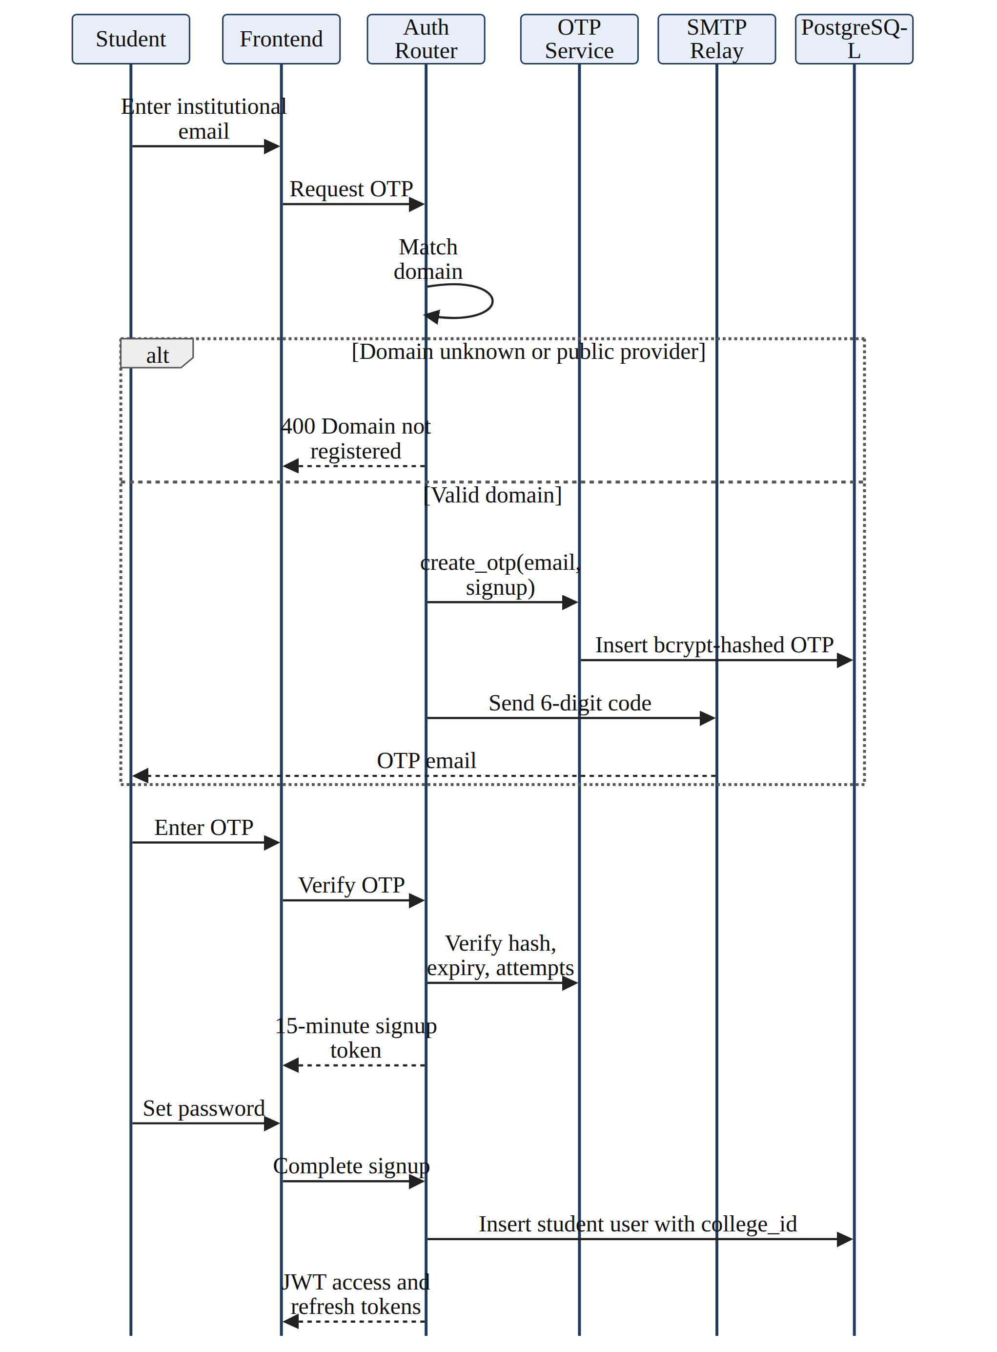
Figure 3.21: Sequence diagram: student signup with OTP verification
Figure 3.22 shows college registration and approval, from the OTP-verified registration to the SuperAdmin's activation.
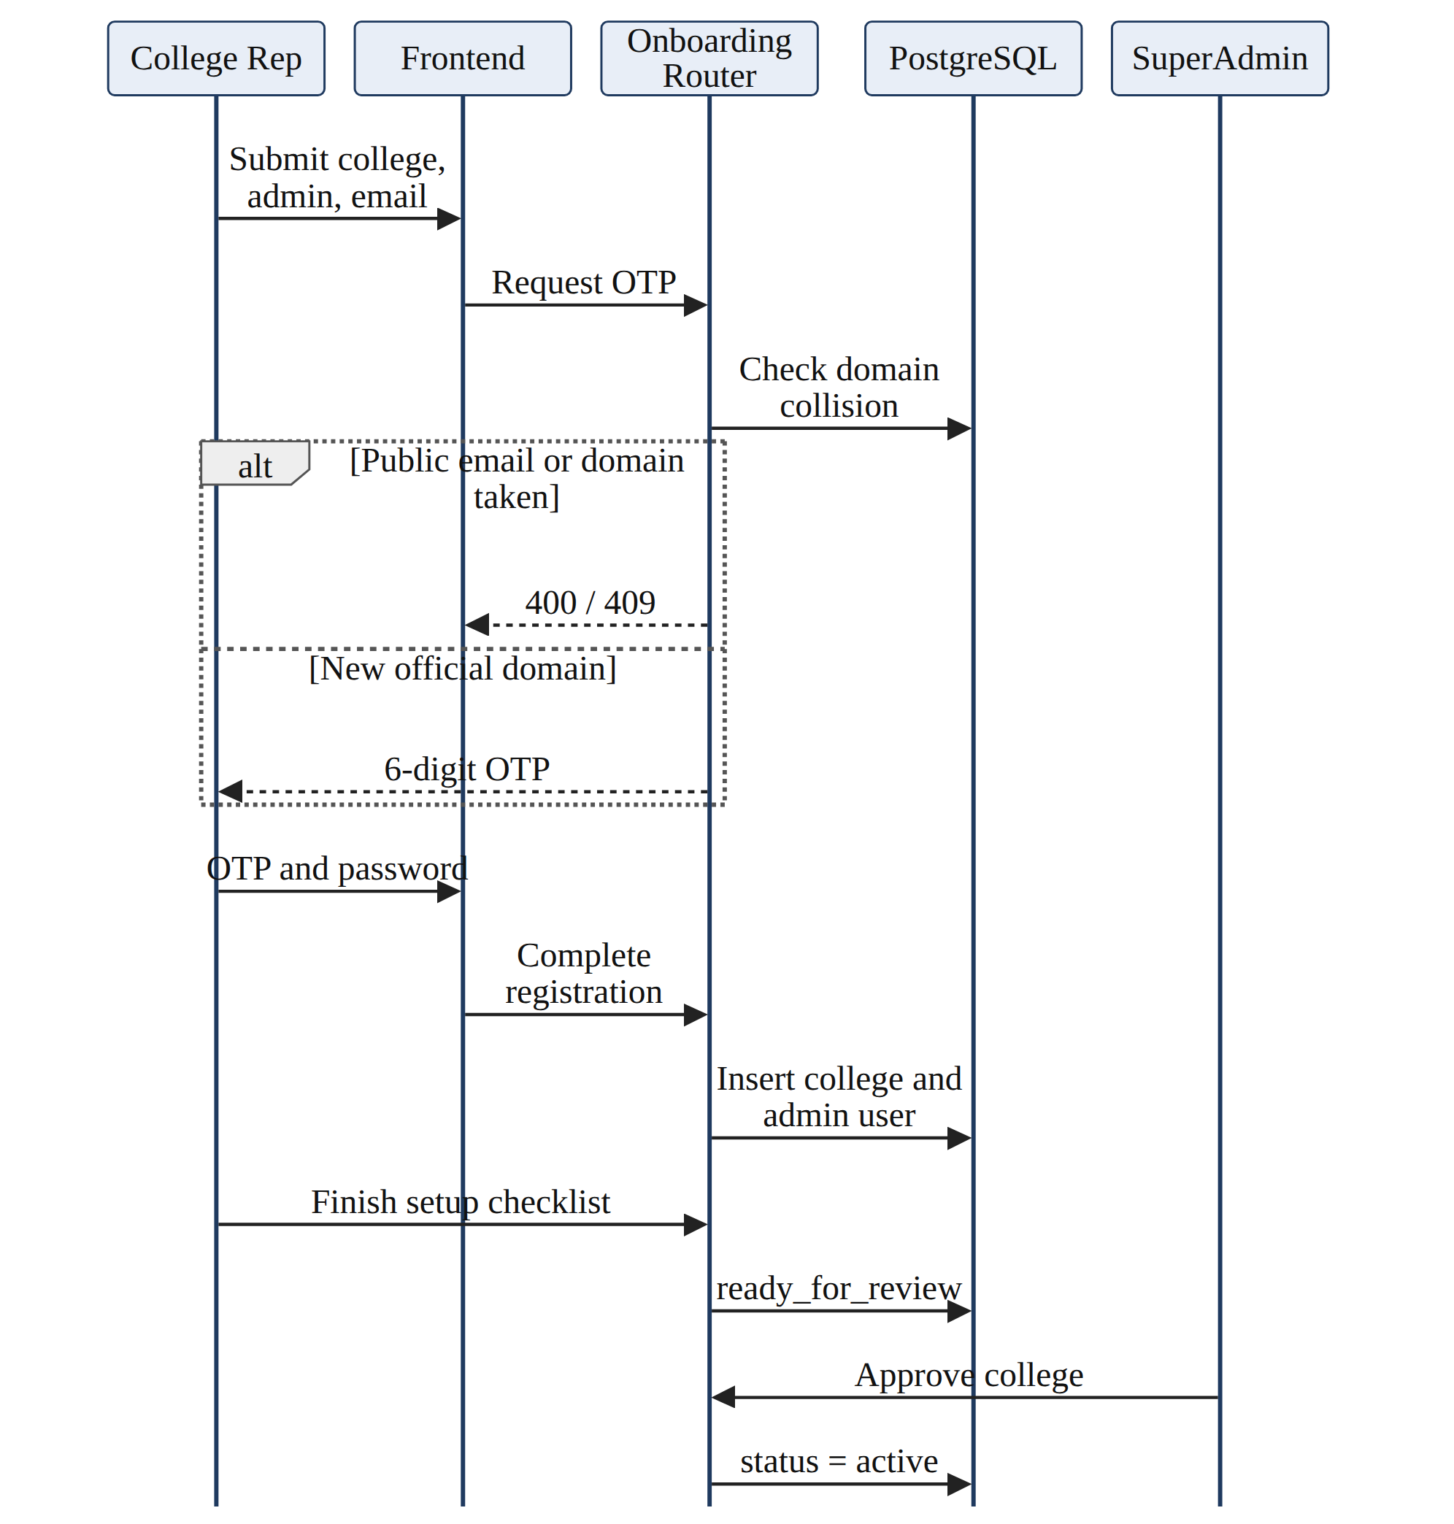
Figure 3.22: Sequence diagram: college registration and approval
Figure 3.23 shows how a college licenses a feature: request, approval, order creation, payment and the signature-verified webhook.
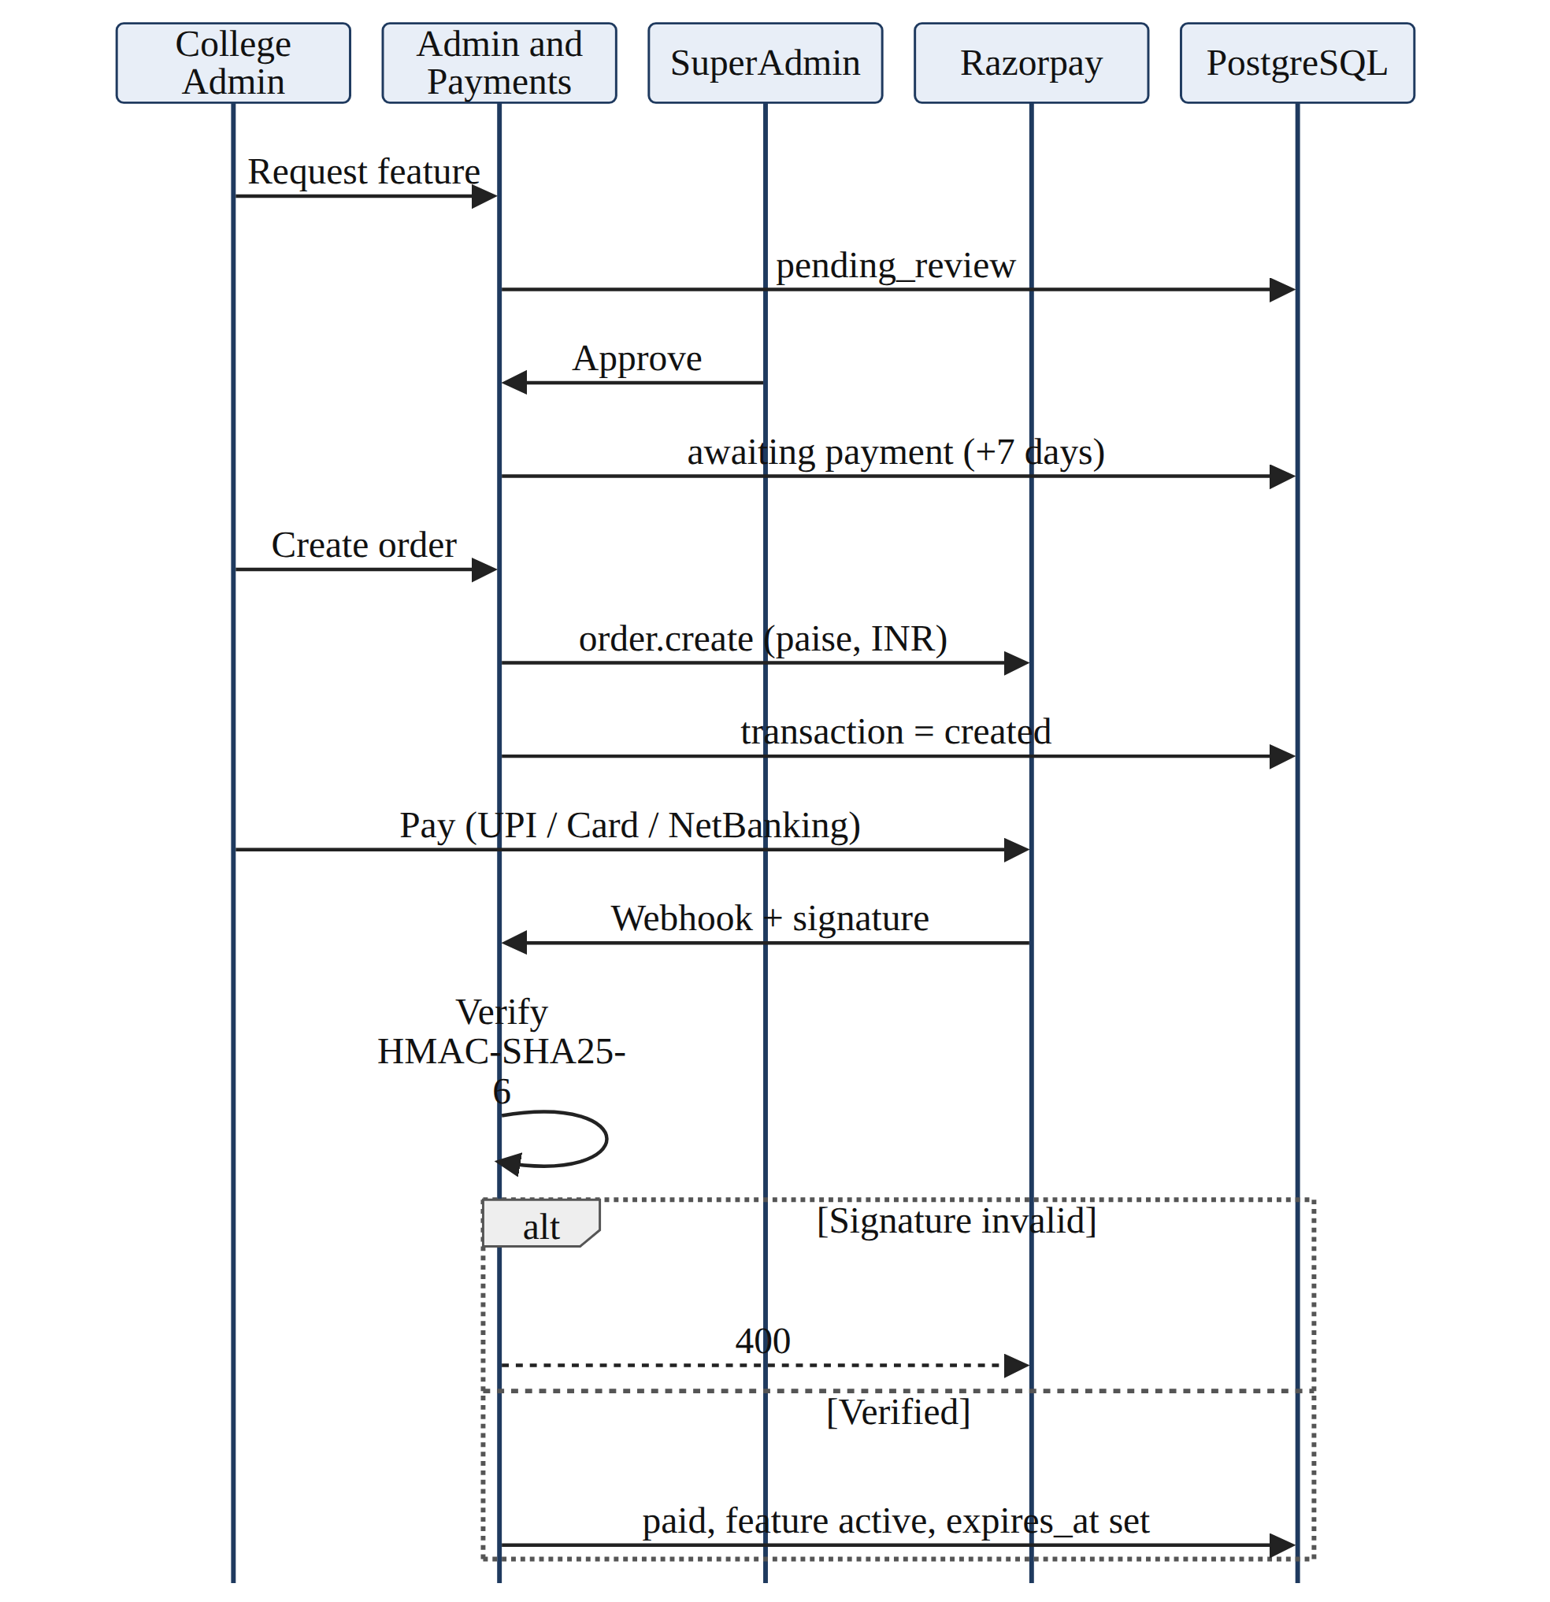
Figure 3.23: Sequence diagram: feature request, payment and activation
Figure 3.24 shows fee receipt verification with its two AI paths and the 0.85 confidence gate.
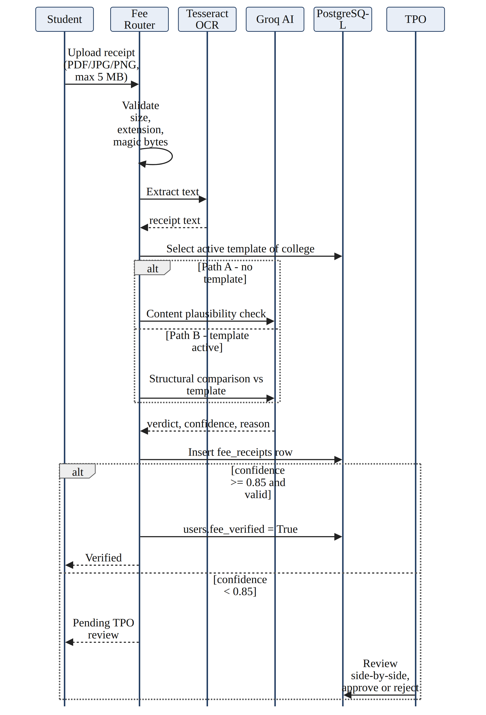
Figure 3.24: Sequence diagram: fee receipt verification
Figure 3.25 shows an application to a drive, including the fee gate and the eligibility engine.
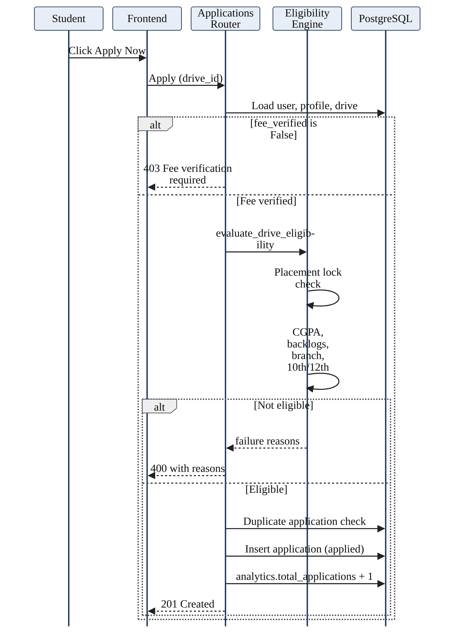
Figure 3.25: Sequence diagram: drive application with eligibility check
Figure 3.26 shows a proctored test from precheck to violation handling and TPO audit.
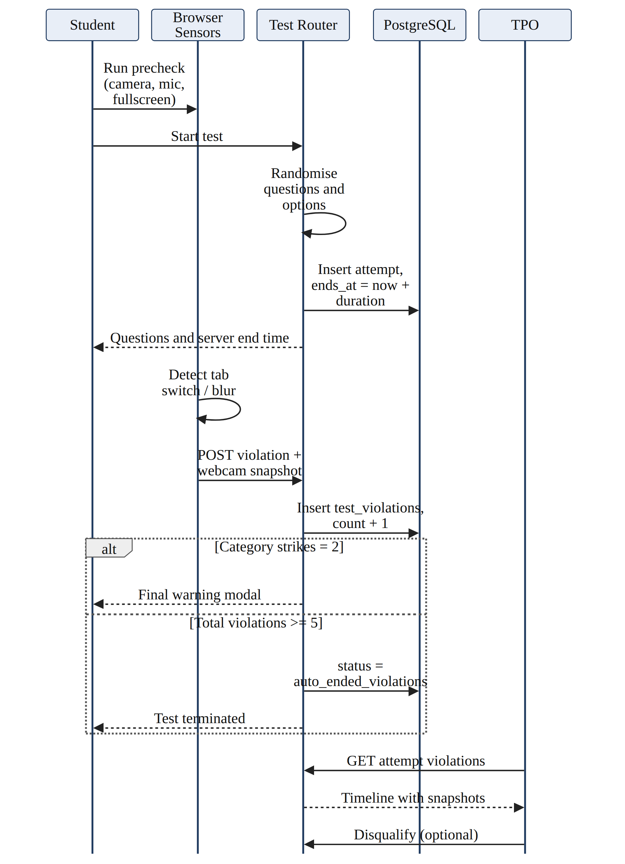
Figure 3.26: Sequence diagram: proctored instant test
Figure 3.27 shows the AI mock interview loop in which each answer is scored and the next question generated.
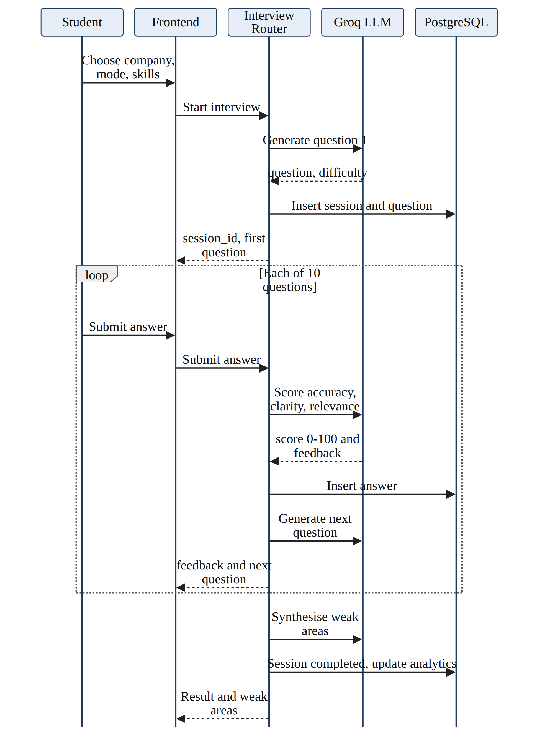
Figure 3.27: Sequence diagram: AI mock interview

3.5.6 State/Activity Diagram (Whichever is applicable)
Both are applicable. State diagrams describe the life cycle of entities that follow a finite state machine: the college tenant and the feature licence (Figure 3.28), the application pipeline and the proctored attempt (Figure 3.29), and the fee receipt and the user account (Figure 3.30).
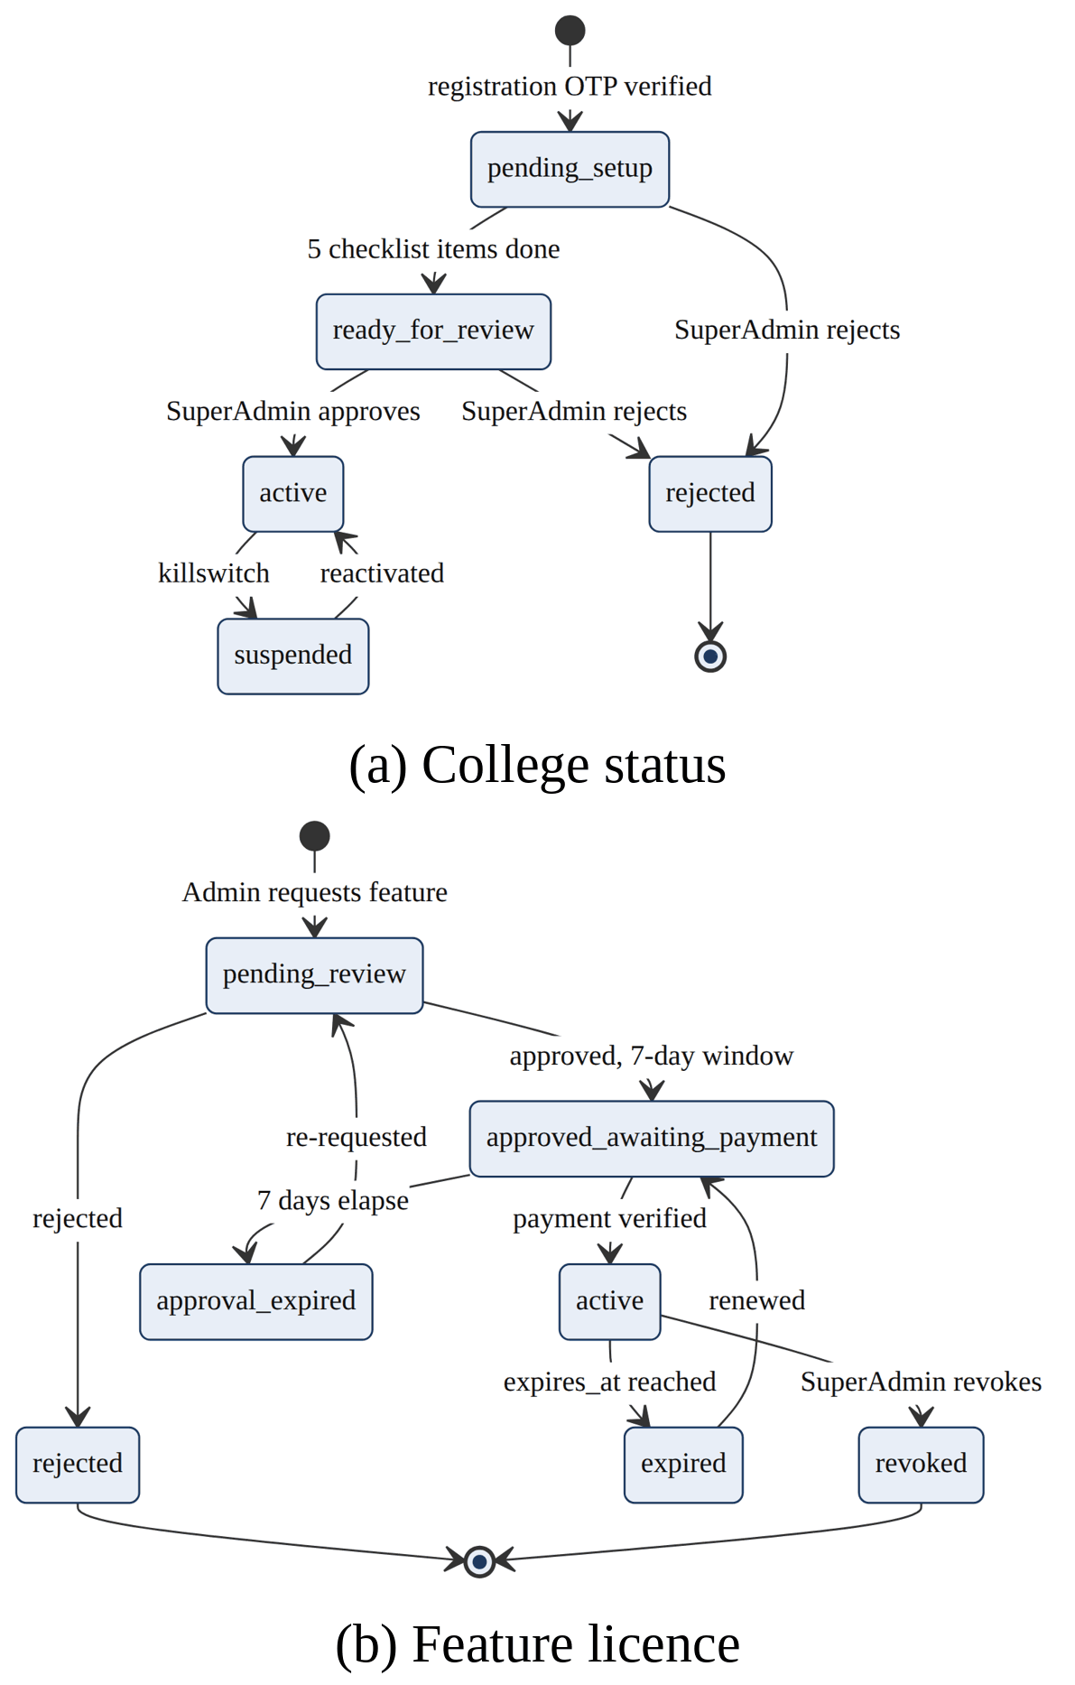
Figure 3.28: State diagrams of the college status and the feature licence
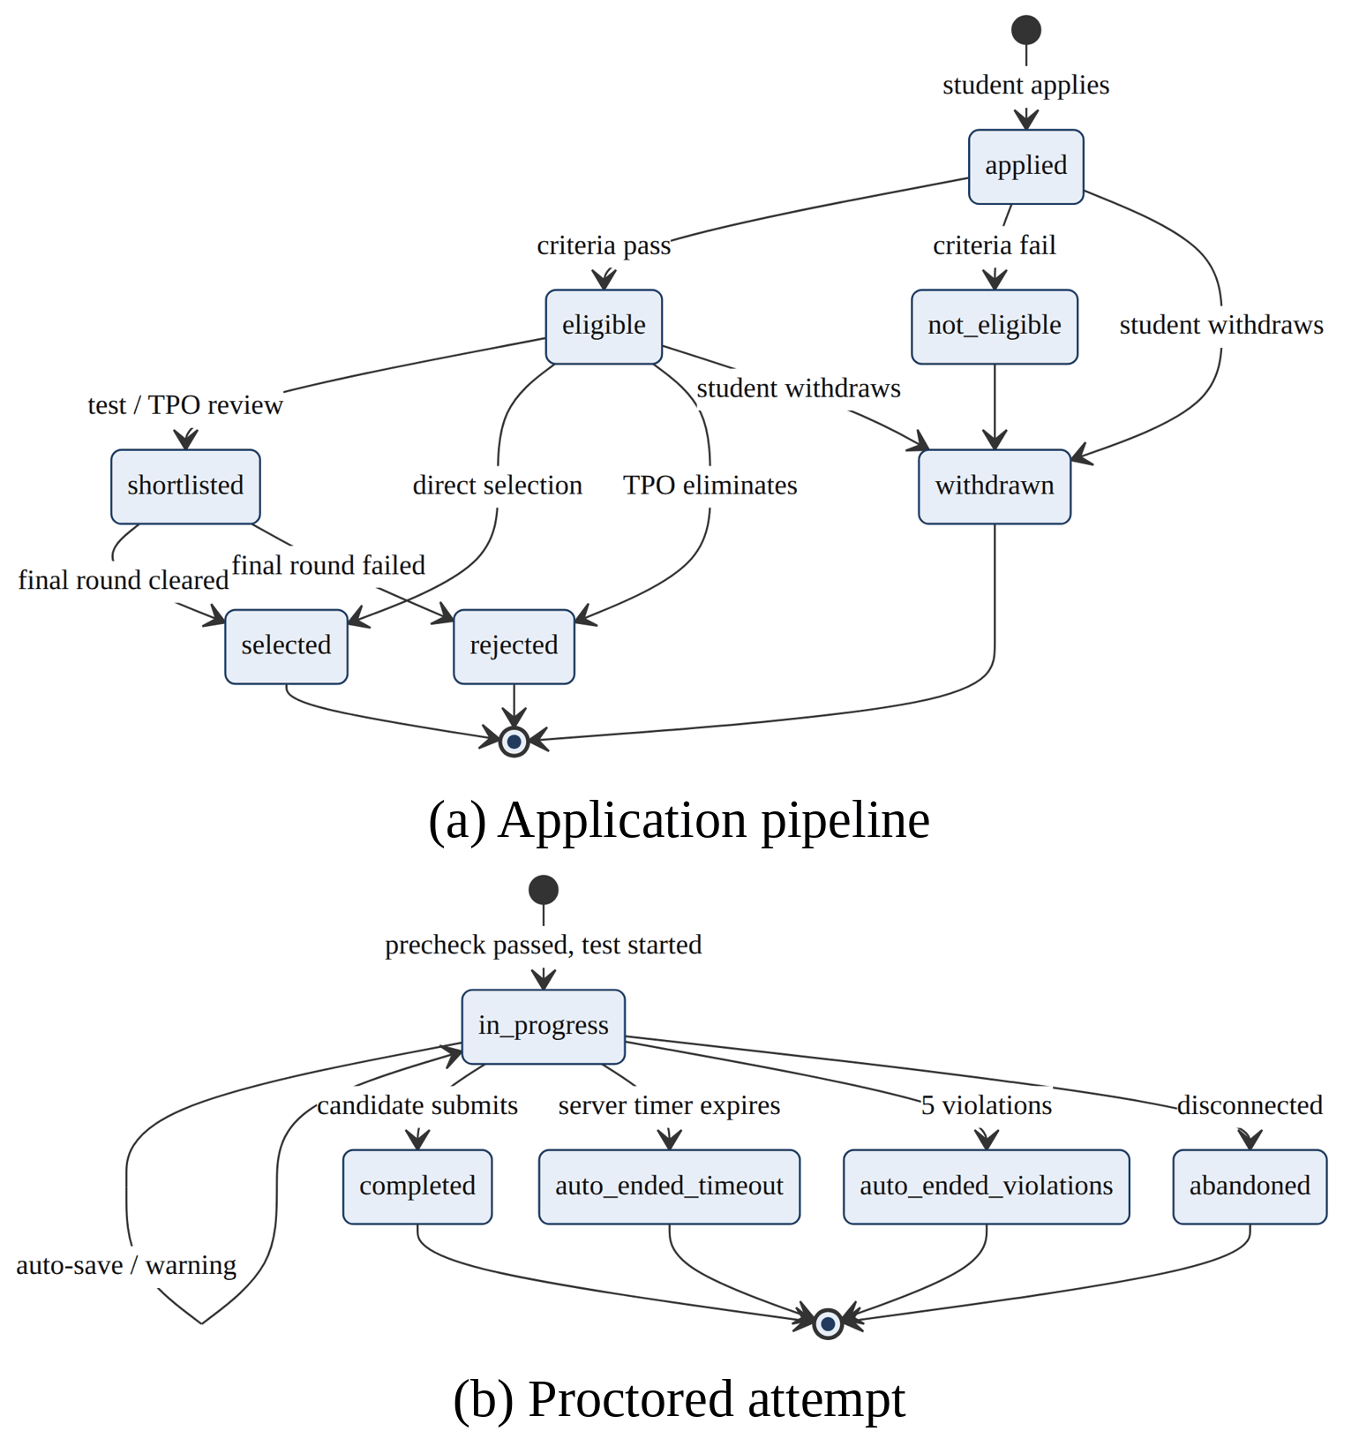
Figure 3.29: State diagrams of the application pipeline and the proctored attempt
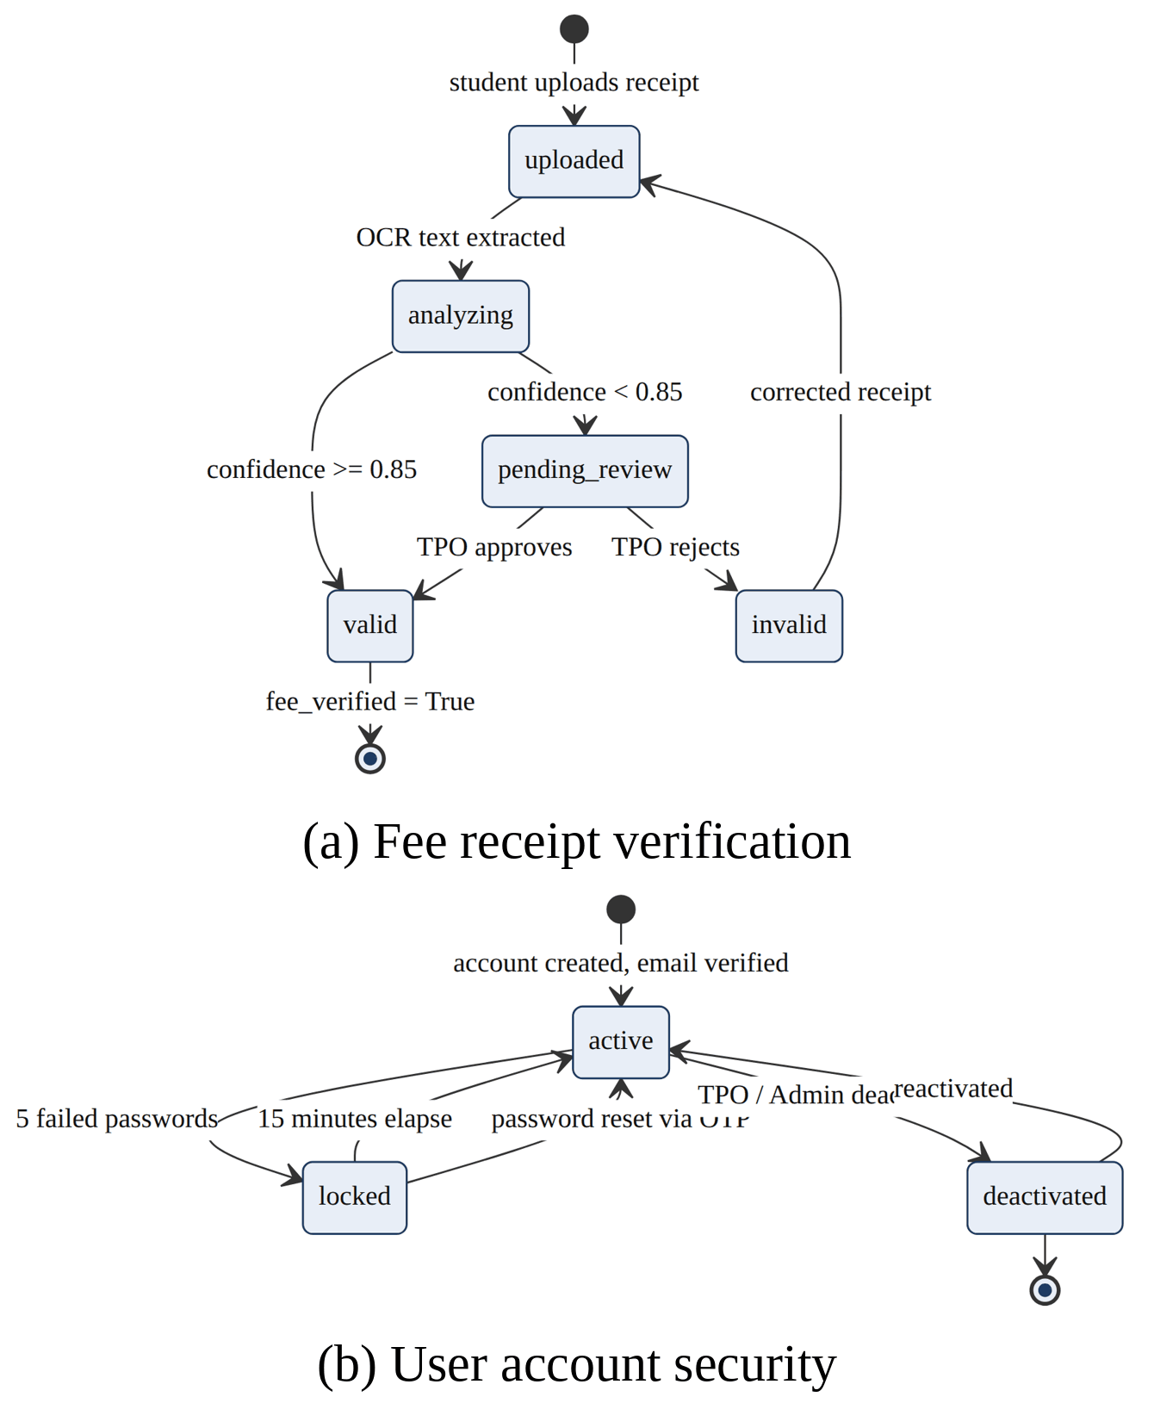
Figure 3.30: State diagrams of the fee receipt and the user account
Activity diagrams describe the business workflows of each role: the student journey (Figure 3.31), the TPO drive and test workflow with college onboarding (Figure 3.32), and feature licensing with curriculum curation (Figure 3.33).
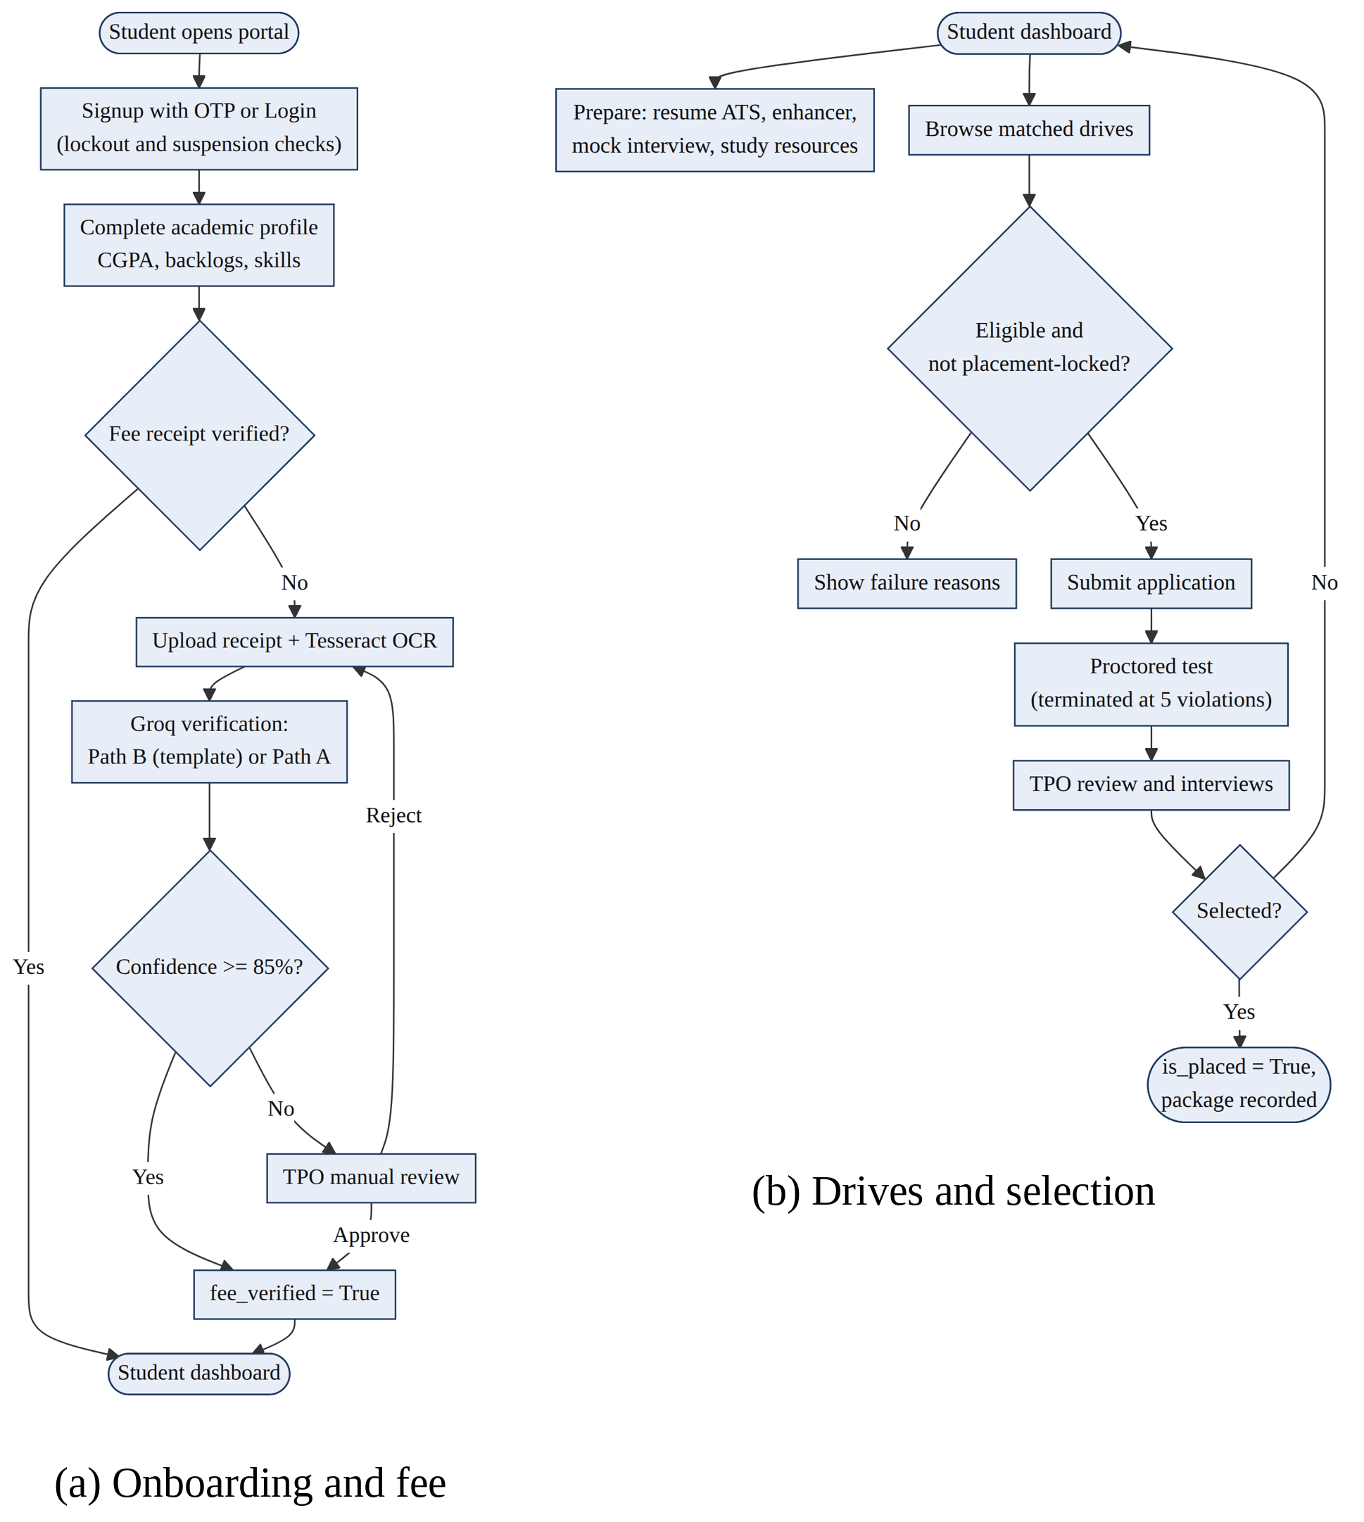
Figure 3.31: Activity diagrams of the student journey
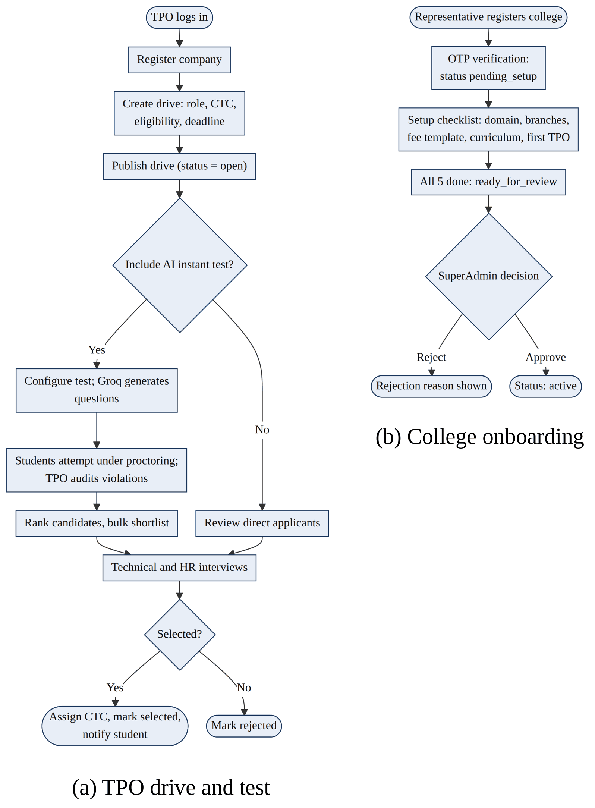
Figure 3.32: Activity diagrams of the TPO workflow and college onboarding
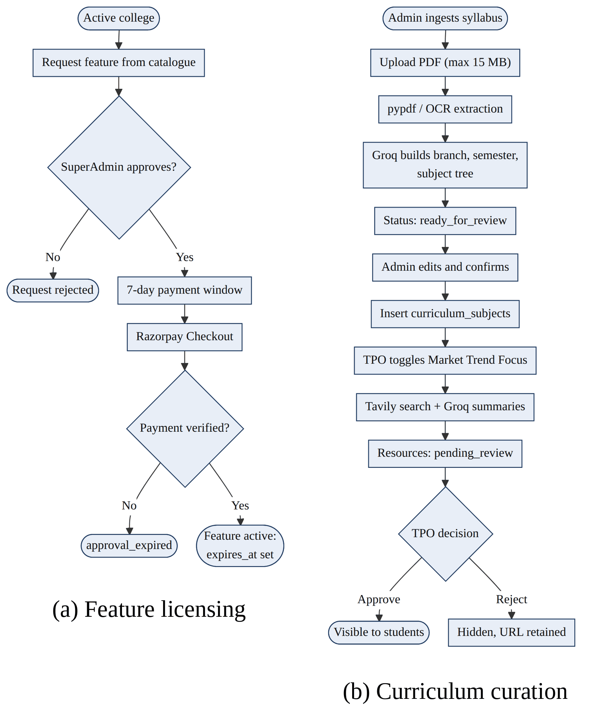
Figure 3.33: Activity diagrams of feature licensing and curriculum curation

3.6 Data Dictionary
The data dictionary describes every table of the PostgreSQL database (33 tables, 316 fields). For each field it gives the data type, the key role (PK primary key, FK foreign key, UQ unique) and NULL where the field is optional, and its meaning. Timestamps are stored in UTC. The tables are grouped as follows: Identity (users, refresh_tokens, otp_verifications); Tenancy (colleges, college_registrations, branches); Billing (features, college_features, transactions, custom_feature_requests); Student (profiles, resumes, analytics, dashboard_insights); Fee verification (fee_receipts, fee_receipt_templates); Placement (companies, drives, applications); Assessment (instant_tests, test_attempts, test_violations, interview_sessions, questions, answers); Curriculum (curriculum_uploads, curriculum_subjects, curated_subject_resources, resources); Communication (notifications, announcements, audit_logs, contact_messages).
3.6.1 analytics – Holds one row of aggregated readiness metrics per student: interviews taken, average score, resume score, applications and the composite readiness score.
Field | Type | Key / Null | Description
id | INTEGER | PK | Surrogate primary key (auto-incrementing integer).
user_id | INTEGER | FK, UQ, NULL | Student account, referencing users.id (one-to-one).
total_applications | INTEGER | - | Number of drive applications submitted.
interviews_taken | INTEGER | - | Number of completed mock interviews.
avg_score | FLOAT | NULL | Average score across completed mock interviews.
readiness_score | FLOAT | NULL | Composite Placement Readiness Score (0 to 100).
updated_at | DATETIME | - | UTC timestamp refreshed automatically on every row modification.

3.6.2 announcements – Stores broadcast messages sent by the SuperAdmin to all colleges or by a College Admin to a single college.
Field | Type | Key / Null | Description
id | INTEGER | PK | Surrogate primary key (auto-incrementing integer).
content | TEXT | - | Announcement text broadcast to the audience.
created_by | INTEGER | FK | Sender (SuperAdmin or College Admin), referencing users.id.
created_at | DATETIME | - | UTC timestamp set automatically when the row is created.

3.6.3 answers – Stores the candidate's answer to each interview question together with the AI score and feedback.
Field | Type | Key / Null | Description
id | INTEGER | PK | Surrogate primary key (auto-incrementing integer).
question_id | INTEGER | FK, UQ | Answered question, referencing questions.id (one-to-one).
answer_text | TEXT | - | Candidate answer submitted for the question.
ai_feedback | TEXT | NULL | Textual feedback generated by the Groq AI engine.
score | FLOAT | NULL | Score assigned by the AI engine (0 to 100).
rating | VARCHAR(50) | NULL | Rating band: interview_ready, good, somewhat_closer, not_relevant.
what_was_missing | TEXT | NULL | Constructive feedback on key points missed by candidate.

3.6.4 applications – Records each student's application to a drive and its progress through the recruitment pipeline.
Field | Type | Key / Null | Description
id | INTEGER | PK | Surrogate primary key (auto-incrementing integer).
user_id | INTEGER | FK | Owning user, referencing users.id.
drive_id | INTEGER | FK | Placement drive, referencing drives.id.
status | VARCHAR(12) | - | applied, eligible, not_eligible, shortlisted, rejected, selected or withdrawn.
current_stage | VARCHAR(100) | NULL | Current recruitment stage (e.g. Online Assessment, HR Round).
package_offered | FLOAT | NULL | CTC offered on selection (LPA).
applied_on | DATETIME | - | Timestamp when the student submitted the application.

3.6.5 audit_logs – Append-only log of security-relevant and administrative actions with actor, action and details.
Field | Type | Key / Null | Description
id | INTEGER | PK | Surrogate primary key (auto-incrementing integer).
action | VARCHAR(255) | - | Action performed (e.g. college approval, fee override).
details | TEXT | NULL | JSON/text details of the audited event.
performed_by | INTEGER | FK, NULL | User who performed the action, referencing users.id.
timestamp | DATETIME | - | UTC time of the event (append-only log).

3.6.6 branches – Lists the academic departments of a college used for eligibility and curriculum mapping.
Field | Type | Key / Null | Description
id | INTEGER | PK | Surrogate primary key (auto-incrementing integer).
code | VARCHAR(50) | UQ | Branch code (e.g. IT, ME); unique within a college.
name | VARCHAR(255) | - | Branch name (e.g. Information Technology).
is_active | BOOLEAN | - | False when the branch is soft-deleted.
created_at | DATETIME | - | UTC timestamp set automatically when the row is created.

3.6.7 college_features – Links a college to a catalogue feature and tracks its request, approval, payment and expiry life cycle.
Field | Type | Key / Null | Description
id | INTEGER | PK | Surrogate primary key (auto-incrementing integer).
college_id | INTEGER | FK | Tenant key referencing colleges.id; enforces logical multi-tenant isolation.
feature_id | INTEGER | FK | Feature, referencing features.id.
status | VARCHAR(25) | - | Feature state: pending_review, approved_awaiting_payment, active, approval_expired, expired, rejected or revoked.
amount_charged | NUMERIC(10, 2) | NULL | Amount charged to the college for the feature licence.
requested_at | DATETIME | - | Time the feature was requested.
decided_at | DATETIME | NULL | Time the SuperAdmin decided on the request.
approved_at | DATETIME | NULL | Time the SuperAdmin approved the feature request.
paid_at | DATETIME | NULL | Time the Razorpay payment succeeded.
expires_at | DATETIME | NULL | Licence expiry (Monthly +30 days, Annual +365 days).
payment_due_at | DATETIME | NULL | Deadline of the 7-day payment window.
reminder_count | INTEGER | - | Number of payment reminders sent.
last_reminder_sent_at | DATETIME | NULL | Time the last payment reminder was sent.
decided_by | INTEGER | FK, NULL | SuperAdmin who decided the request, referencing users.id.
is_auto_granted | BOOLEAN | - | True if the feature was granted automatically.

3.6.8 college_registrations – Temporary record of a college self-registration awaiting OTP completion; expires after 48 hours.
Field | Type | Key / Null | Description
id | INTEGER | PK | Surrogate primary key (auto-incrementing integer).
college_name | VARCHAR(255) | - | Official name of the institution being registered.
admin_name | VARCHAR(255) | - | Full name of the registering college administrator.
email | VARCHAR(255) | - | Official institutional email of the representative.
domain | VARCHAR(255) | - | Authorised institutional email domain (e.g. bvmengineering.ac.in).
mobile_number | VARCHAR(50) | NULL | Mobile number of the registering representative.
status | VARCHAR(50) | - | Registration state (default pending_otp).
created_at | DATETIME | - | UTC timestamp set automatically when the row is created.
expires_at | DATETIME | - | Registration expires 48 hours after creation.

3.6.9 colleges – Directory of tenant institutions with their email domain, status and subscription details.
Field | Type | Key / Null | Description
id | INTEGER | PK | Surrogate primary key (auto-incrementing integer).
name | VARCHAR(255) | UQ | Official legal name of the institution (unique).
domain | VARCHAR(255) | UQ | Authorised email domain used to route student signups (unique).
status | VARCHAR(16) | - | Tenant state: pending_setup, ready_for_review, active, suspended or rejected.
registered_at | DATETIME | - | Time the college registered on the platform.
activated_at | DATETIME | NULL | Time the college tenant was activated by the SuperAdmin.
rejection_reason | TEXT | NULL | Reason recorded when a college is rejected.
contact_name | VARCHAR(255) | NULL | Primary contact person of the college.
contact_mobile | VARCHAR(50) | NULL | Contact mobile number of the college representative.
contact_mobile_verified | BOOLEAN | - | Whether the contact mobile number has been verified.
subscription_status | VARCHAR(50) | - | Subscription state of the college.
subscription_plan | VARCHAR(50) | - | Subscription plan (default campus_monthly).
subscription_amount | NUMERIC(10, 2) | - | Monthly subscription amount in INR (default 10000).
subscription_started_at | DATETIME | NULL | Subscription start date.
subscription_expires_at | DATETIME | NULL | Subscription expiry date.
created_at | DATETIME | - | UTC timestamp set automatically when the row is created.
updated_at | DATETIME | - | UTC timestamp refreshed automatically on every row modification.

3.6.10 companies – Master data of recruiting companies maintained by TPOs.
Field | Type | Key / Null | Description
id | INTEGER | PK | Surrogate primary key (auto-incrementing integer).
name | VARCHAR(255) | - | Name of the recruiting company.
website | VARCHAR(500) | NULL | Official website URL of the company.
location | VARCHAR(255) | NULL | Headquarters / location of the company.
about | TEXT | NULL | Company overview text.
industry_type | VARCHAR(255) | NULL | Industry sector of the company.
logo_url | VARCHAR(500) | NULL | URL of the company logo.

3.6.11 contact_messages – Messages submitted through the contact form and routed to the Admin or TPO by category.
Field | Type | Key / Null | Description
id | INTEGER | PK | Surrogate primary key (auto-incrementing integer).
name | VARCHAR(255) | - | Name of the sender.
email | VARCHAR(255) | - | Email of the sender.
message | TEXT | - | Message text.
category | VARCHAR(9) | - | general (Admin) or placement (TPO).
submitted_by_user_id | INTEGER | FK, NULL | Authenticated sender, if any, referencing users.id.
status | VARCHAR(8) | - | new, read or resolved.
created_at | DATETIME | - | UTC timestamp set automatically when the row is created.

3.6.12 curated_subject_resources – AI-curated books, articles and videos for a subject, awaiting or after TPO review.
Field | Type | Key / Null | Description
id | INTEGER | PK | Surrogate primary key (auto-incrementing integer).
subject_id | INTEGER | FK | Curriculum subject, referencing curriculum_subjects.id.
college_id | INTEGER | FK | Tenant key referencing colleges.id.
resource_type | VARCHAR(7) | - | Resource type: book, article or video.
title | VARCHAR(255) | - | Title of the book, article or video.
link | VARCHAR(1000) | - | URL of the learning resource.
ai_summary | TEXT | - | Original AI-written summary of the learning resource.
approval_status | VARCHAR(14) | - | TPO review status: pending_review, approved or rejected.
reviewed_by | INTEGER | FK, NULL | Reviewing TPO, referencing users.id.
reviewed_at | DATETIME | NULL | Time the TPO reviewed the resource.
generated_at | DATETIME | - | Time the content was generated.

3.6.13 curriculum_subjects – Subjects extracted from a confirmed syllabus, organised by branch and semester.
Field | Type | Key / Null | Description
id | INTEGER | PK | Surrogate primary key (auto-incrementing integer).
college_id | INTEGER | FK | Tenant key referencing colleges.id; enforces logical multi-tenant isolation.
source_upload_id | INTEGER | FK, NULL | Syllabus upload from which the subject was extracted.
branch_name | VARCHAR(255) | - | Department name as per the college curriculum.
semester_number | INTEGER | - | Semester number (1 to 8).
subject_name | VARCHAR(255) | - | Name of the academic subject.
is_prioritized | BOOLEAN | - | Market-trend focus flag set by the TPO.
created_at | DATETIME | - | UTC timestamp set automatically when the row is created.

3.6.14 curriculum_uploads – Syllabus PDFs uploaded by a College Admin together with the AI-extracted subject tree and status.
Field | Type | Key / Null | Description
id | INTEGER | PK | Surrogate primary key (auto-incrementing integer).
college_id | INTEGER | FK | Tenant key referencing colleges.id.
uploaded_by | INTEGER | FK | Uploading admin, referencing users.id.
original_filename | VARCHAR(255) | - | Original name of the uploaded file.
file_path | VARCHAR(500) | - | Path of the uploaded syllabus PDF.
extraction_status | VARCHAR(16) | - | Extraction state: processing, ready_for_review, confirmed or failed.
raw_extracted_data | JSON | NULL | JSON tree of branches, semesters and subjects extracted by AI.
uploaded_at | DATETIME | - | Time of upload.
confirmed_at | DATETIME | NULL | Time the admin confirmed the extracted curriculum.

3.6.15 custom_feature_requests – Custom feature proposals raised by colleges and tracked until completion.
Field | Type | Key / Null | Description
id | INTEGER | PK | Surrogate primary key (auto-incrementing integer).
college_id | INTEGER | FK | Tenant key referencing colleges.id; enforces logical multi-tenant isolation.
admin_id | INTEGER | FK | College Admin who submitted the request, referencing users.id.
title | VARCHAR(255) | - | Short title of the proposed feature.
description | TEXT | - | Functional description and business justification.
target_user | VARCHAR(50) | - | User group the requested feature is meant for.
category | VARCHAR(100) | - | Feature category (default General).
priority | VARCHAR(50) | - | Urgency: low, medium, high or critical.
status | VARCHAR(50) | - | pending, approved, rejected, in_development or completed.
superadmin_feedback | TEXT | NULL | Feedback given by the SuperAdmin on the request.
created_at | DATETIME | - | UTC timestamp set automatically when the row is created.
updated_at | DATETIME | - | UTC timestamp refreshed automatically on every row modification.

3.6.16 dashboard_insights – Cached per-student career insights: trending skills, external opportunities and resume suggestions.
Field | Type | Key / Null | Description
id | INTEGER | PK | Surrogate primary key (auto-incrementing integer).
user_id | INTEGER | FK, UQ | Student account, referencing users.id (one-to-one).
external_opportunities | JSON | NULL | JSON list of external job opportunities for the student.
resume_suggestions | JSON | NULL | JSON list of AI resume improvement suggestions.
trending_skills | JSON | NULL | JSON list of trending skills for the student branch.
generated_at | DATETIME | - | Time the content was generated.
last_manual_refresh_at | DATETIME | NULL | Last manual refresh time (12-hour cool-down).

3.6.17 drives – Placement drives with role, package, eligibility criteria, deadline and test status.
Field | Type | Key / Null | Description
id | INTEGER | PK | Surrogate primary key (auto-incrementing integer).
college_id | INTEGER | FK | Tenant key referencing colleges.id; enforces logical multi-tenant isolation.
company_id | INTEGER | FK | Recruiting company, referencing companies.id.
role | VARCHAR(255) | - | Job role offered in the drive.
jd_text | TEXT | - | Job description text of the drive.
placement_type | VARCHAR(100) | NULL | Type of placement (e.g. Internship + Placement).
student_instructions | TEXT | NULL | Instructions displayed to applicants.
min_ctc | FLOAT | NULL | Minimum CTC offered (LPA).
max_ctc | FLOAT | NULL | Maximum CTC offered (LPA).
eligibility_criteria | JSON | - | JSON rules: min CGPA, max backlogs, branches, 10th/12th cut-offs.
bond_details | TEXT | NULL | Service bond terms attached to the drive.
deadline | DATETIME | - | Application deadline of the drive.
status | VARCHAR(6) | - | Drive state: draft, open or closed.
test_status | VARCHAR(11) | - | Test state of the drive: not_created, open or closed.
created_by | INTEGER | FK | TPO or Admin who created the drive, referencing users.id.
created_at | DATETIME | - | UTC timestamp set automatically when the row is created.

3.6.18 features – Master catalogue of licensable platform features with price and billing type.
Field | Type | Key / Null | Description
id | INTEGER | PK | Surrogate primary key (auto-incrementing integer).
code | VARCHAR(100) | UQ | Unique machine code (e.g. ai_mock_interview).
name | VARCHAR(255) | - | Human-readable feature name.
description | TEXT | - | Marketing and functional description of the feature.
category | VARCHAR(100) | - | Feature category (default General).
target_role | VARCHAR(100) | - | Intended user role of the feature (Student, TPO, Admin).
price | NUMERIC(10, 2) | NULL | Base price of the feature in INR.
billing_type | VARCHAR(8) | - | Billing model of the feature: MONTHLY, ANNUAL or ONE_TIME.
status | VARCHAR(10) | - | Feature availability: DRAFT, ACTIVE or INACTIVE.
created_at | DATETIME | - | UTC timestamp set when the feature is created.

3.6.19 fee_receipt_templates – Reference fee receipt templates uploaded by a College Admin for structural comparison.
Field | Type | Key / Null | Description
id | INTEGER | PK | Surrogate primary key (auto-incrementing integer).
college_id | INTEGER | FK | Tenant key referencing colleges.id; enforces logical multi-tenant isolation.
template_name | VARCHAR(100) | NULL | Display name of the template.
file_path | VARCHAR(500) | - | Path of the reference template file.
original_filename | VARCHAR(255) | NULL | Original name of the uploaded file.
extracted_text | TEXT | NULL | Text extracted from the uploaded document by OCR.
uploaded_by | INTEGER | FK | Uploading College Admin, referencing users.id.
is_active | BOOLEAN | - | Only active templates are used for comparison.
created_at | DATETIME | - | UTC timestamp set automatically when the row is created.

3.6.20 fee_receipts – Fee receipts uploaded by students with OCR text, AI verdict, confidence and review information.
Field | Type | Key / Null | Description
id | INTEGER | PK | Surrogate primary key (auto-incrementing integer).
user_id | INTEGER | FK | Student who uploaded the receipt, referencing users.id.
file_path | VARCHAR(500) | - | Path of the uploaded receipt (PDF/JPG/PNG up to 5 MB).
extracted_text | TEXT | NULL | Text extracted from the receipt by Tesseract OCR.
ai_verdict | VARCHAR(7) | NULL | AI verdict on the receipt: valid or invalid.
ai_confidence | FLOAT | NULL | AI confidence score (0.00 to 1.00); auto-verification needs 0.85 or more.
ai_reason | TEXT | NULL | AI explanation for the verification verdict.
verified_at | DATETIME | NULL | Time the receipt was verified.
created_at | DATETIME | - | UTC timestamp set automatically when the row is created.
matched_against_template_id | INTEGER | FK, NULL | Template used for comparison, referencing fee_receipt_templates.id.
structural_match_result | JSON | NULL | JSON sub-assessment of letterhead/layout match.
content_valid_result | JSON | NULL | JSON sub-assessment of receipt content plausibility.
verified_by | INTEGER | FK, NULL | TPO who verified the receipt manually, referencing users.id.

3.6.21 instant_tests – Proctored AI-generated tests created by a TPO, with duration, passing marks and generated questions.
Field | Type | Key / Null | Description
id | INTEGER | PK | Surrogate primary key (auto-incrementing integer).
college_id | INTEGER | FK, NULL | Tenant key referencing colleges.id.
drive_id | INTEGER | FK, NULL | Optional linked drive, referencing drives.id.
created_by | INTEGER | FK | Creator user, referencing users.id.
title | VARCHAR(255) | - | Test title (default Placement Qualifying Test).
duration_minutes | INTEGER | - | Test duration in minutes.
is_practice | BOOLEAN | - | True for practice tests, false for official drive tests.
prompt_config | JSON | - | JSON prompt configuration used for AI question generation.
questions | JSON | - | JSON array of AI-generated questions (text, options, answer, marks).
min_passing_marks | INTEGER | - | Minimum marks required to qualify.
use_top_n | BOOLEAN | - | Enables top-N shortlisting.
top_n_count | INTEGER | NULL | Number of top scorers to shortlist.
status | VARCHAR(6) | - | Test state: open or closed.

3.6.22 interview_sessions – AI mock interview sessions of a student with mode, skills, status and overall score.
Field | Type | Key / Null | Description
id | INTEGER | PK | Surrogate primary key (auto-incrementing integer).
user_id | INTEGER | FK | Owning user, referencing users.id.
drive_id | INTEGER | FK, NULL | Optional linked drive, referencing drives.id.
company_name | VARCHAR(255) | - | Target company chosen for the interview practice.
skills | JSON | NULL | JSON list of skills the candidate selected.
mode | VARCHAR(9) | - | Interview mode: aptitude, technical, coding, hr or full.
overall_score | FLOAT | NULL | Mean score of all answers in the session (0 to 100).
weak_areas | JSON | NULL | JSON list of synthesised weak areas.
status | VARCHAR(11) | - | in_progress, completed or abandoned.
created_at | DATETIME | - | UTC timestamp set automatically when the row is created.
difficulty_level | VARCHAR(20) | NULL | Selected practice difficulty level: easy, medium, hard.

3.6.23 notifications – In-app notifications delivered to individual users.
Field | Type | Key / Null | Description
id | INTEGER | PK | Surrogate primary key (auto-incrementing integer).
recipient_id | INTEGER | FK | Recipient user, referencing users.id.
sender_id | INTEGER | FK, NULL | Sender user; NULL for system notices.
type | VARCHAR(27) | - | Notification type: info, warning, notice, system or approval_expired.
message | TEXT | - | Notification text shown to the recipient.
is_read | BOOLEAN | - | Whether the notification has been read.
created_at | DATETIME | - | UTC timestamp set automatically when the row is created.

3.6.24 otp_verifications – One-time passwords (hashed) issued for signup, college registration and password flows.
Field | Type | Key / Null | Description
id | INTEGER | PK | Surrogate primary key (auto-incrementing integer).
email | VARCHAR(255) | - | Email address to which the OTP was sent.
otp_hash | VARCHAR(255) | - | Bcrypt hash of the 6-digit OTP (plain code never stored).
purpose | VARCHAR(20) | - | OTP purpose: signup, college registration, forgot or change password.
expires_at | DATETIME | - | OTP expires 10 minutes after creation.
is_used | BOOLEAN | - | True once the OTP has been consumed.
failed_attempts | INTEGER | - | Number of wrong OTP entries recorded.
created_at | DATETIME | - | UTC timestamp set automatically when the row is created.

3.6.25 profiles – Academic and personal profile of a student: CGPA, backlogs, percentages, skills and placement state.
Field | Type | Key / Null | Description
id | INTEGER | PK | Surrogate primary key (auto-incrementing integer).
user_id | INTEGER | FK, UQ | Student account, referencing users.id (one-to-one).
student_id | VARCHAR(50) | - | Institutional roll number of the student.
full_name | VARCHAR(255) | - | Full legal name of the student.
branch | VARCHAR(100) | - | Academic branch / department of the student.
cgpa | FLOAT | - | Cumulative Grade Point Average (0.00 to 10.00).
active_backlogs | INTEGER | - | Number of currently active backlogs of the student.
tenth_percentage | FLOAT | - | 10th standard percentage.
twelfth_percentage | FLOAT | - | 12th standard percentage.
competitive_exam_name | VARCHAR(100) | NULL | Competitive exam taken (e.g. GATE, CAT).
competitive_exam_percentile | FLOAT | NULL | Percentile obtained in the competitive exam.
skills | JSON | NULL | JSON array of technical skills.
is_placed | BOOLEAN | - | True once the student is selected in a drive.
placement_lock_override | BOOLEAN | - | TPO override allowing placed students to apply again.
created_at | DATETIME | - | UTC timestamp set automatically when the row is created.
updated_at | DATETIME | - | UTC timestamp refreshed automatically on every row modification.

3.6.26 questions – Questions generated for an interview session, with type, difficulty and order.
Field | Type | Key / Null | Description
id | INTEGER | PK | Surrogate primary key (auto-incrementing integer).
session_id | INTEGER | FK | Interview session, referencing interview_sessions.id.
question_text | TEXT | - | Text of the interview question.
q_type | VARCHAR(9) | - | Question type: aptitude, technical, coding or hr.
difficulty | VARCHAR(6) | - | Difficulty level: easy, medium or hard.
order_index | INTEGER | - | Sequence position of the question in the session.
interviewer_note | TEXT | NULL | Interviewer evaluation context or intent note.
resume_reference | VARCHAR(255) | NULL | Candidate resume section or project/skill reference.

3.6.27 refresh_tokens – Hashed refresh tokens issued at login, rotated on use and revoked on logout.
Field | Type | Key / Null | Description
id | INTEGER | PK | Surrogate primary key (auto-incrementing integer).
user_id | INTEGER | FK | Token owner, referencing users.id.
token_hash | VARCHAR(255) | UQ | SHA-256 hash of the refresh token (raw token never stored).
is_revoked | BOOLEAN | - | True after logout or token rotation.
expires_at | DATETIME | - | Token expiry (7 days after issue).
created_at | DATETIME | - | UTC timestamp set automatically when the row is created.

3.6.28 resources – General learning resources (blogs, videos, documents) published for students.
Field | Type | Key / Null | Description
id | INTEGER | PK | Surrogate primary key (auto-incrementing integer).
college_id | INTEGER | FK | Tenant key referencing colleges.id; enforces logical multi-tenant isolation.
title | VARCHAR(255) | - | Resource title.
category | VARCHAR(13) | - | Topic: aptitude, communication, os, dbms, cn, interview_qna, java, python or gate_cat_prep.
content_type | VARCHAR(8) | - | Content format: video, blog or document.
video_url | VARCHAR(500) | NULL | Video link (required for video content).
content | TEXT | NULL | Rich text / markdown body (blogs and documents).
created_by | INTEGER | FK | Author user, referencing users.id.

3.6.29 resumes – Student resumes with extracted text, ATS score, AI feedback and active flag.
Field | Type | Key / Null | Description
id | INTEGER | PK | Surrogate primary key (auto-incrementing integer).
user_id | INTEGER | FK | Owning user, referencing users.id.
file_path | VARCHAR(500) | - | Path of the resume file under /uploads/resumes.
parsed_text | TEXT | NULL | Text extracted from the resume PDF.
ai_score | FLOAT | NULL | ATS score (0 to 100) assigned to the resume by the AI engine.
ai_feedback | TEXT | NULL | Textual feedback generated by the Groq AI engine.
source | VARCHAR(8) | - | Resume source: uploaded or enhanced.
is_active | BOOLEAN | - | Exactly one resume per student is active.
created_at | DATETIME | - | UTC timestamp set automatically when the row is created.

3.6.30 test_attempts – A student's attempt of an instant test with randomised order, answers, score and status.
Field | Type | Key / Null | Description
id | INTEGER | PK | Surrogate primary key (auto-incrementing integer).
test_id | INTEGER | FK | Test, referencing instant_tests.id.
user_id | INTEGER | FK | Student taking the test, referencing users.id.
status | VARCHAR(11) | - | in_progress, completed, auto_ended_timeout, auto_ended_violations or abandoned.
started_at | DATETIME | - | Time the attempt started.
ends_at | DATETIME | NULL | Server-authoritative end time of the attempt.
last_heartbeat_at | DATETIME | NULL | Last heartbeat received from the client during the test.
question_order | JSON | NULL | JSON list of the randomised question order.
option_order_map | JSON | NULL | JSON map of the randomised option order per question.
answers | JSON | - | JSON map of the answers selected by the candidate (auto-saved).
score | FLOAT | - | Server-evaluated score of the attempt.
weak_areas | JSON | NULL | JSON list of synthesised weak areas.
total_violation_count | INTEGER | - | Total proctoring violations (5 ends the test).
ended_reason | VARCHAR(16) | NULL | Reason the attempt ended (timeout, violations, submitted).
submitted_at | DATETIME | NULL | Time the attempt was submitted.

3.6.31 test_violations – Proctoring violations recorded during an attempt, with type, strike number and metadata.
Field | Type | Key / Null | Description
id | INTEGER | PK | Surrogate primary key (auto-incrementing integer).
attempt_id | INTEGER | FK | Test attempt in which the violation occurred, referencing test_attempts.id.
violation_type | VARCHAR(12) | - | Type: tab_switch, fullscreen_exit, copy_attempt, devtools, face_missing, multiple_faces or noise_detected.
strike_number | INTEGER | - | Strike count at the time of the violation.
detected_at | DATETIME | - | UTC time at which the violation was detected.
meta | JSON | NULL | JSON payload including blur duration and noise RMS level.

3.6.32 transactions – Razorpay payment orders and their outcomes for feature licences.
Field | Type | Key / Null | Description
id | INTEGER | PK | Surrogate primary key (auto-incrementing integer).
college_id | INTEGER | FK, NULL | Paying college, referencing colleges.id.
feature_id | INTEGER | FK, NULL | Purchased feature, referencing features.id.
amount | NUMERIC(10, 2) | - | Transaction amount in INR (gateway order amount is handled in paise).
currency | VARCHAR(10) | - | Currency code of the transaction (INR).
status | VARCHAR(8) | - | created, paid, failed or refunded.
razorpay_order_id | VARCHAR(255) | UQ | Razorpay order identifier (unique).
razorpay_payment_id | VARCHAR(255) | NULL | Razorpay payment identifier.
razorpay_signature | VARCHAR(512) | NULL | HMAC-SHA256 signature returned by Razorpay.
created_at | DATETIME | - | Time the order was created.
paid_at | DATETIME | NULL | Time the payment was completed.
is_test_data | BOOLEAN | - | Marks transactions created in test mode.

3.6.33 users – Accounts of all four roles with credentials, tenant key and security state.
Field | Type | Key / Null | Description
id | INTEGER | PK | Surrogate primary key (auto-incrementing integer).
college_id | INTEGER | FK, NULL | Tenant key; NULL for SuperAdmin accounts.
email | VARCHAR(255) | UQ | Globally unique login email.
hashed_password | VARCHAR(255) | - | Salted bcrypt hash of the password (never plaintext).
user_type | VARCHAR(10) | - | Role: student, tpo, admin or superadmin.
is_active | BOOLEAN | - | Whether the record is currently active.
is_email_verified | BOOLEAN | - | True after successful OTP email verification.
fee_verified | BOOLEAN | - | True once the placement fee receipt is verified.
failed_login_attempts | INTEGER | - | Consecutive failed logins (locks the account at 5).
locked_until | DATETIME | NULL | Account is locked until this time (15-minute lockout).
created_at | DATETIME | - | UTC timestamp set automatically when the row is created.

Chapter 4: Implementation and Testing

4.1 User Interface and Snapshot
The user interface is a React single-page application with a role-protected area for each actor (/student/*, /tpo/*, /admin/*, /superadmin/*) and public pages for the landing page, login and registration; route guards redirect a user who opens an area outside the role. The data layer uses Axios with automatic token refresh and TanStack Query for caching [19]. The principal screens of each role are shown below.
Student signup with OTP verification (/signup/otp): The college is detected from the email domain; a six-digit OTP confirms the address.
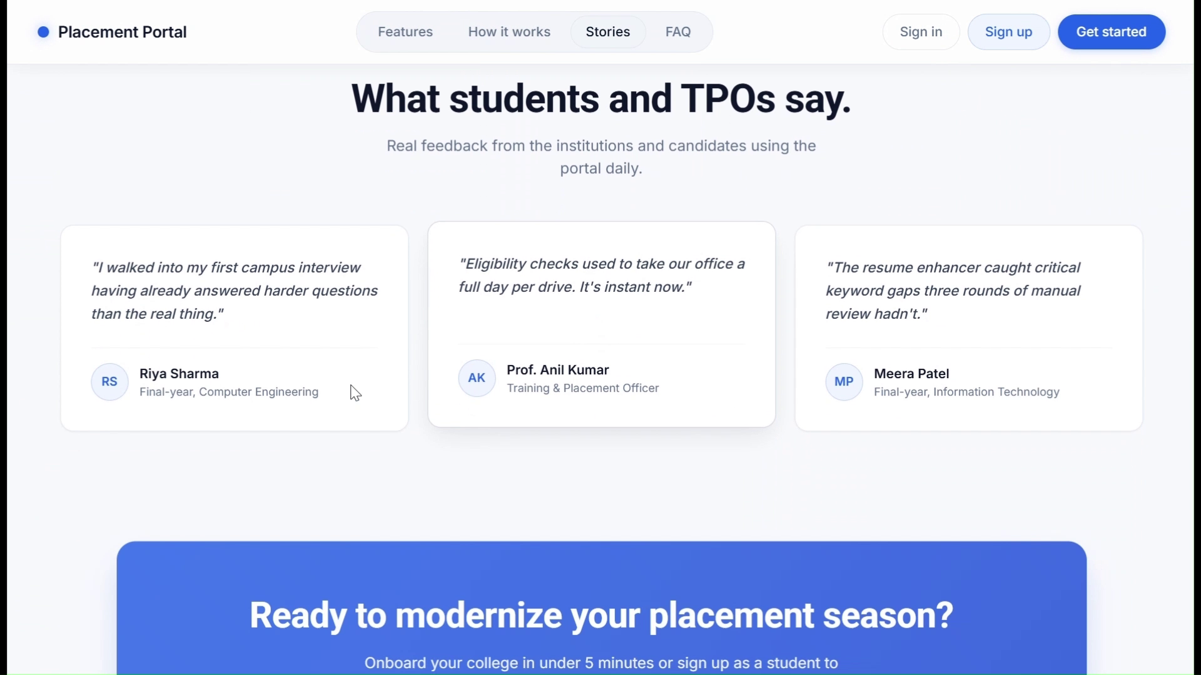
Figure 4.1: Student signup with OTP verification
Student dashboard (/student/dashboard): Readiness score, applications, weak areas and shortcuts to the AI preparation tools.
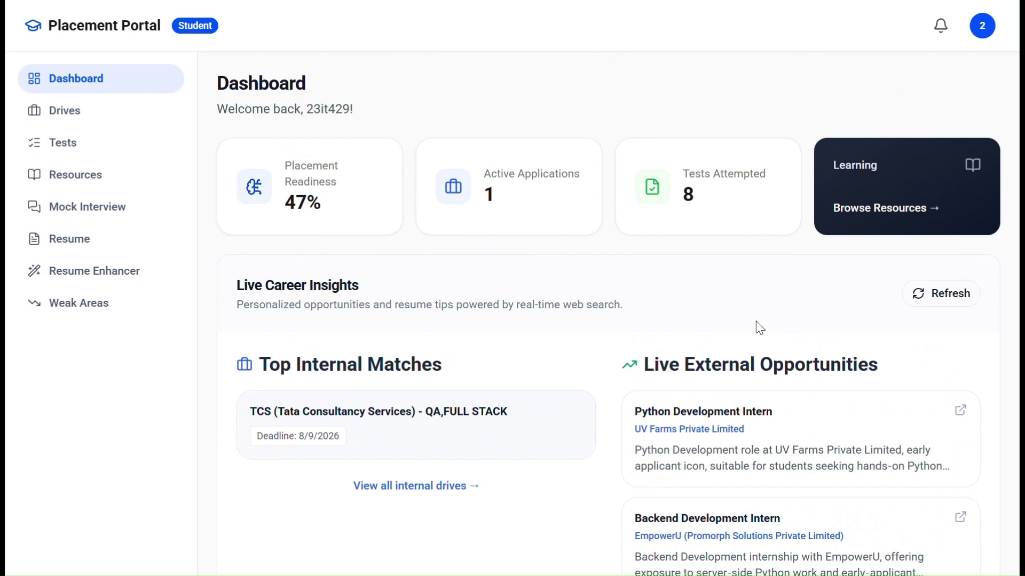
Figure 4.2: Student dashboard
Fee receipt upload and verification (/student/fee-receipt): AI verdict, or the pending-review state when confidence is below 0.85.
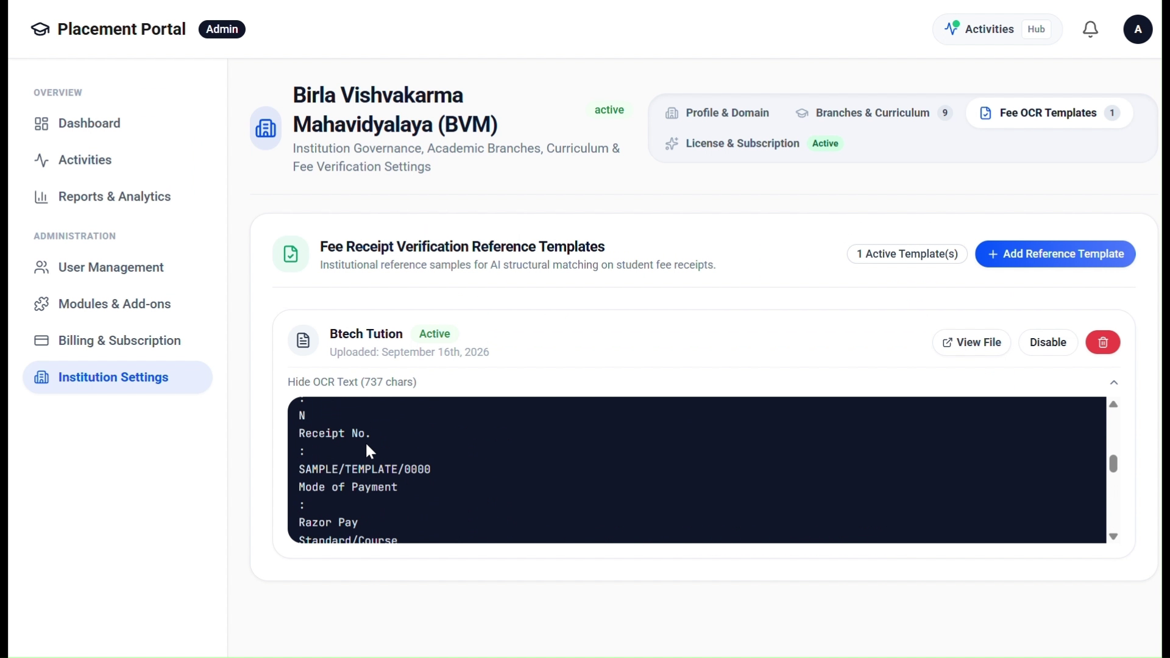
Figure 4.3: Fee receipt upload and verification
Placement drives with eligibility (/student/drives): Open drives with eligibility indicators and exact reasons when a student does not qualify.
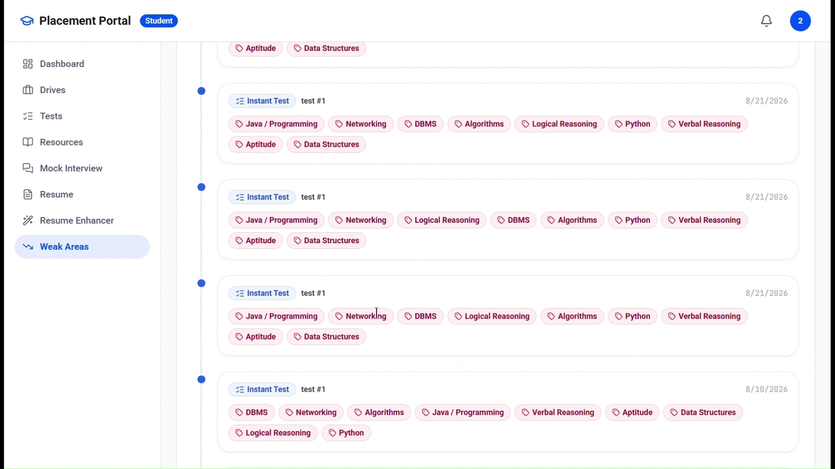
Figure 4.4: Placement drives with eligibility
AI mock interview session (/student/mock-interview/:id): One question at a time; each answer receives a score and feedback.
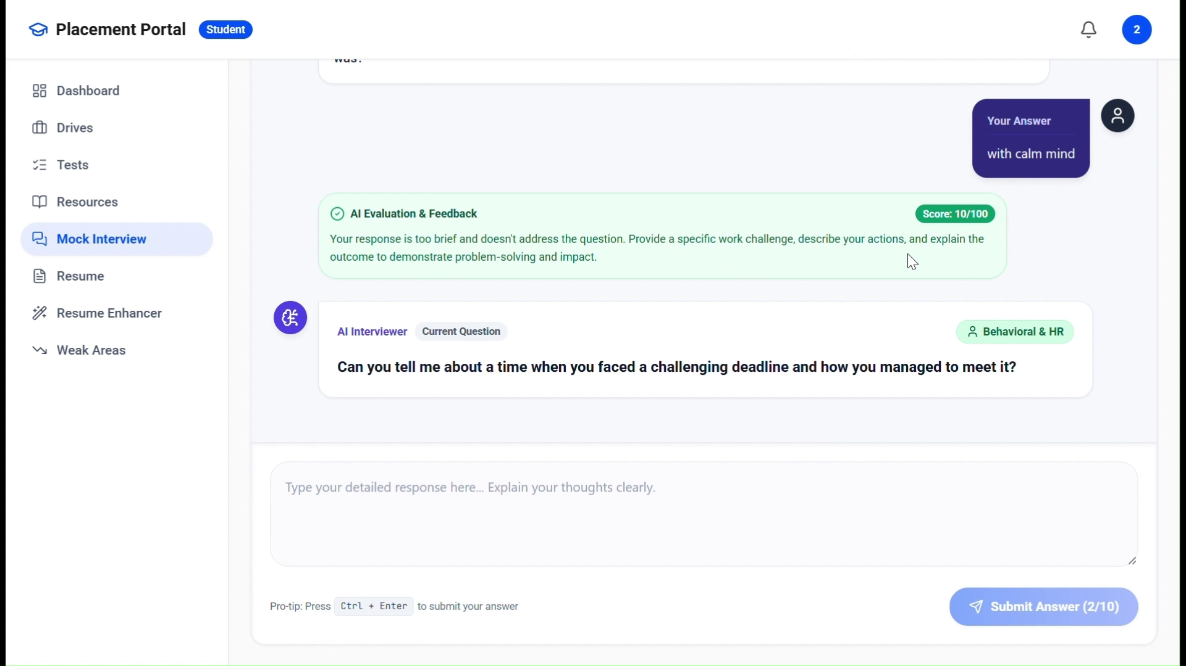
Figure 4.5: AI mock interview session
TPO drive management (/tpo/drives): Create drives, set eligibility, open or close them and review the applicant pipeline.
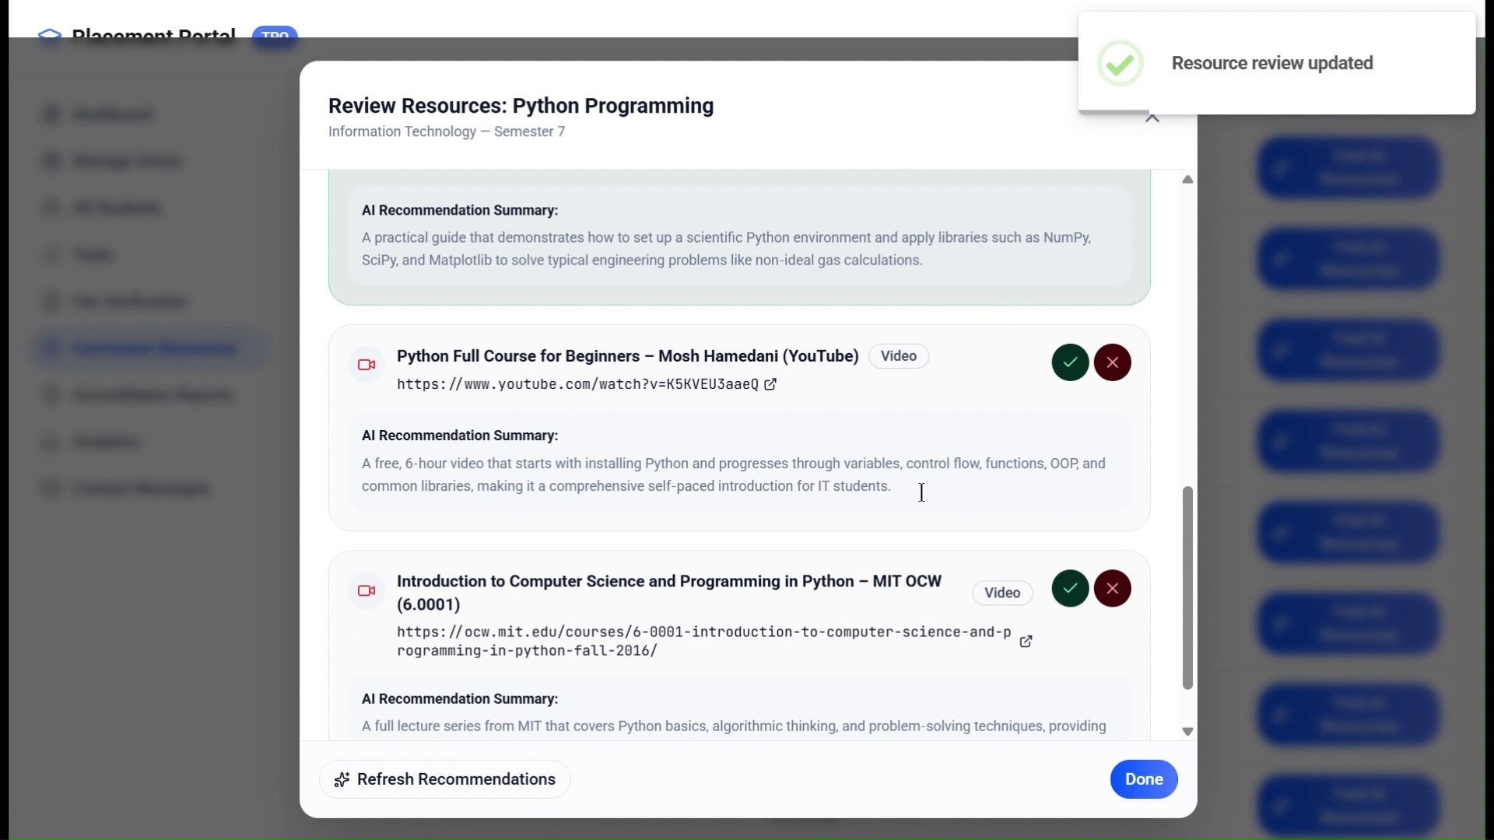
Figure 4.6: TPO drive management
TPO proctoring audit (/tpo/tests/attempts/:id/violations): Violation timeline with webcam snapshots and an option to disqualify.
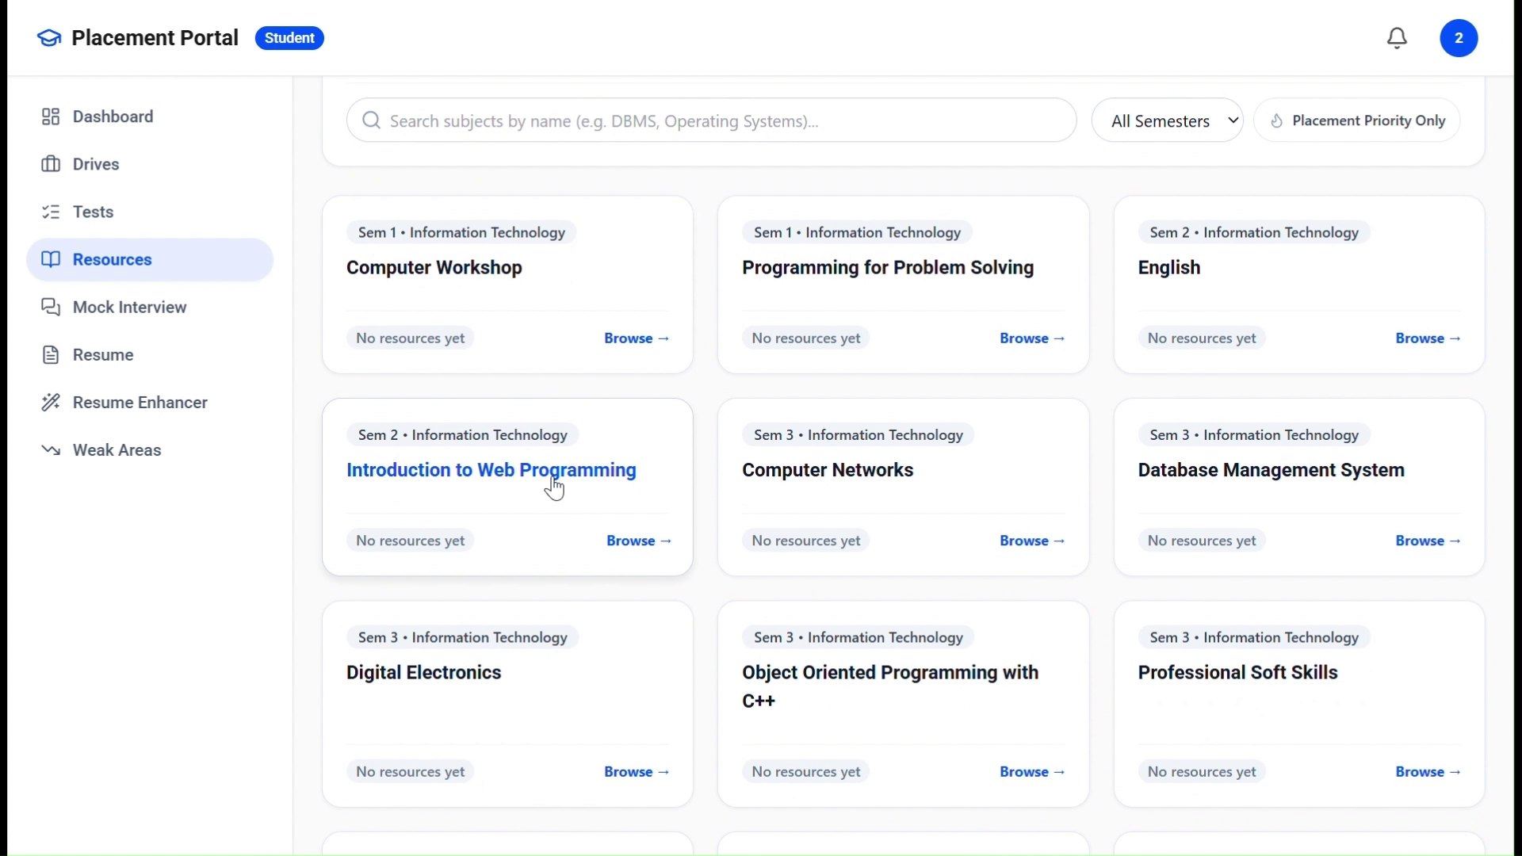
Figure 4.7: TPO proctoring audit
College Admin dashboard and setup checklist (/admin/dashboard): Progress through the five onboarding items and the college status.
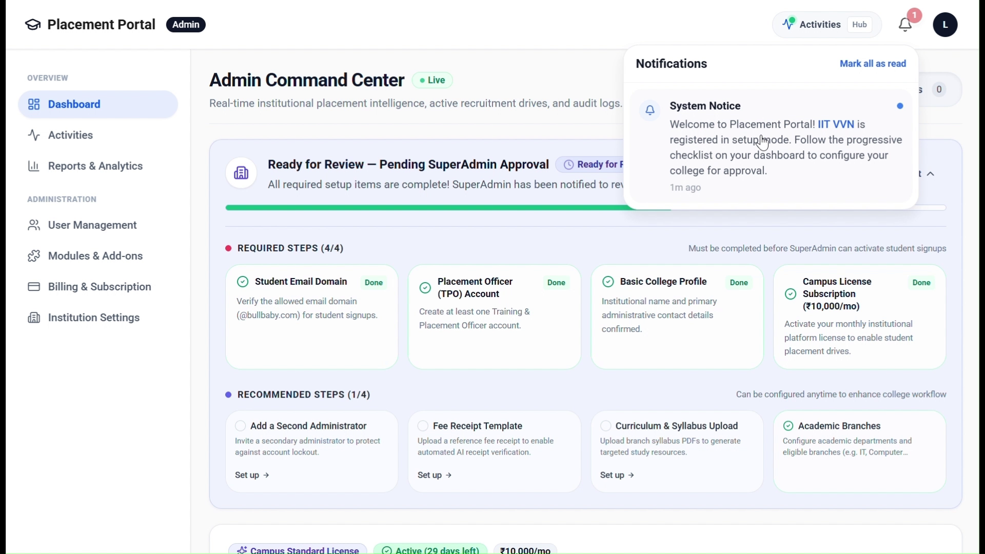
Figure 4.8: College Admin dashboard and setup checklist
SuperAdmin Command Deck (/superadmin/dashboard): Pending colleges, tenants, feature requests, subscriptions and platform analytics.
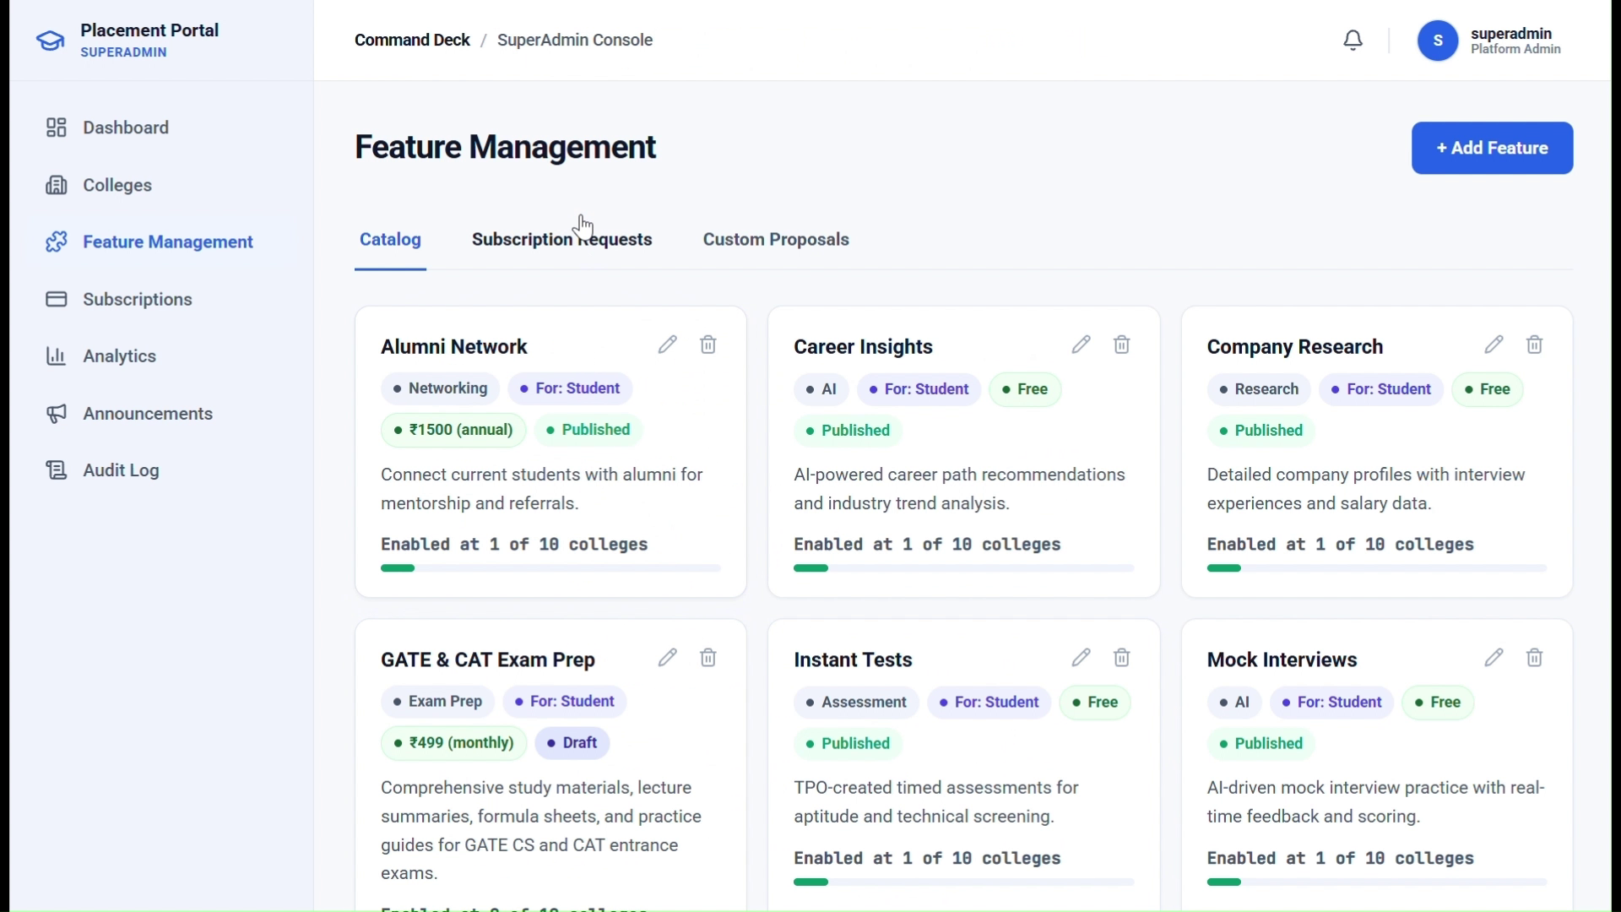
Figure 4.9: SuperAdmin Command Deck

4.2 Testing using Use Cases
Testing followed the use cases of Section 3.5.1. The back end is covered by nine automated pytest suites [20] that exercise the routers and services against a test database. Table 4.1 lists the suites and Figure 4.10 shows the number of tests in each; Tables 4.2 and 4.3 give representative test cases grouped by use case.
Table 4.1: Automated test suites
Suite | Scope | Tests
test_multi_tenant_isolation | Cross-tenant access, college scoping, suspension | 3
test_college_onboarding | Registration, OTP, checklist, approval | 6
test_fee_receipt_template_matching | Receipt validation, template paths A and B | 7
test_curriculum_and_resources | Syllabus parsing, curation, approval | 2
test_eligibility_and_fee_gate | Eligibility rules, placement lock, fee gate | 3
test_subscriptions_and_notifications | Licence life cycle, expiry sweep, notices | 2
test_custom_feature_requests | Custom proposal workflow | 5
test_security_remediations | Lockout, tokens, uploads, role guards | 10
test_phase4_router_flows | End-to-end router flows | 5
test_mock_interview_improvements | AI question generation, evaluation rating, weak areas | 7
test_resume_analyzer_and_enhancer | ATS scoring, gap analysis, STAR rewrites | 2
Total | All automated test suites | 52

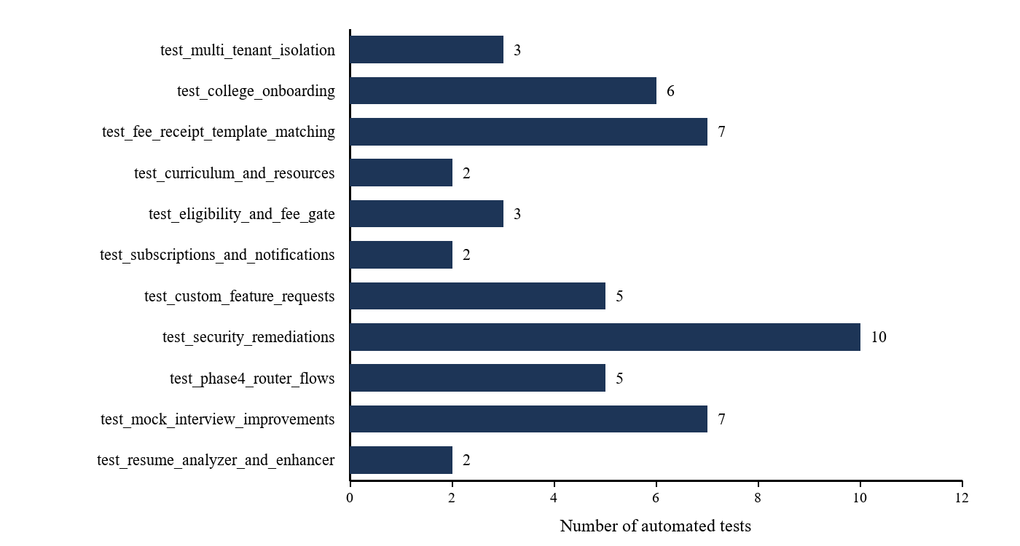
Figure 4.10: Automated tests per suite
Table 4.2: Test cases: authentication, tenant isolation, onboarding and licensing
ID | Use case and scenario | Expected result | Status
TC-01 | Signup with an unregistered or public email domain | Rejected; no OTP is sent | Pass
TC-02 | Verify a correct OTP within ten minutes | Signup token issued | Pass
TC-03 | Login with valid credentials | Access (30 min) and refresh (7 days) tokens issued | Pass
TC-04 | Five consecutive wrong passwords | Account locked for 15 minutes | Pass
TC-05 | Request a record of another college | Not returned; tenant filter applies | Pass
TC-06 | Student calls a TPO-only route | 403 Forbidden | Pass
TC-07 | Register a college with an existing domain | 409 conflict; no college created | Pass
TC-08 | Satisfy all five checklist items | Status becomes ready_for_review | Pass
TC-09 | Request a feature and approve it | Awaiting payment with a 7-day window | Pass
TC-10 | Webhook with an invalid signature | 400; feature not activated | Pass
TC-11 | Webhook with a valid signature | Transaction paid; feature active with expires_at | Pass

Table 4.3: Test cases: fee verification, drives, proctoring, AI and curriculum
ID | Use case and scenario | Expected result | Status
TC-12 | Receipt verified with confidence of 0.85 or more | Student marked fee-verified automatically | Pass
TC-13 | Receipt verified with confidence below 0.85 | Receipt enters the TPO review queue | Pass
TC-14 | Apply to a drive without fee verification | 403; fee verification required | Pass
TC-15 | Apply with CGPA below the drive cut-off | 400 with the failure reasons | Pass
TC-16 | Placed student applies without and with override | Blocked; allowed with override | Pass
TC-17 | TPO selects a candidate | Selected; is_placed set; student notified | Pass
TC-18 | Start a proctored test | Randomised order; server-fixed end time | Pass
TC-19 | Switch browser tab during a test | Violation stored with webcam snapshot | Pass
TC-20 | Two strikes in one category | Warning action returned | Pass
TC-21 | Fifth violation in an attempt | Attempt auto-ended with violation_limit | Pass
TC-22 | Complete an AI mock interview | Ten questions scored 0 to 100; weak areas produced | Pass
TC-23 | Run the resume enhancer | Enhanced resume stored and set active | Pass
TC-24 | Upload a syllabus and confirm the tree | Subjects inserted for the college | Pass

All listed cases produced the expected result, confirming that the tenant boundary, role guards, payment signature check, confidence gate and proctoring strike rules behave as specified in Section 3.5.

Chapter 5: Conclusion & Future work

5.1 Conclusion
This project delivered a working, multi-tenant, AI-powered placement and career preparation portal that brings the complete placement lifecycle of a college onto one secure platform. Colleges can onboard themselves, subscribe to the features they need and manage their students; students receive eligibility-aware drives together with AI mock interviews, resume analysis, weak-area diagnostics and curriculum-aligned resources; and TPOs can run proctored AI-generated tests and verify fee receipts with OCR and AI confidence gating.
The system comprises 15 modules, 33 database tables and 186 REST endpoints, and is protected by role-based access control, tenant-scoped queries, hashed credentials and tokens, signature-verified payments and an append-only audit log. Nine automated test suites with 137 tests, together with the use-case based verification of Chapter 4, confirm that the specified behaviour is met. The work shows that large language models, OCR and browser sensing can be combined with conventional web engineering to give institutions an affordable, integrated alternative to fragmented placement tools.

5.2 Limitations
- AI features depend on an external inference service and payment gateway; an outage of either degrades the related modules.
- Proctoring is browser-based and advisory; it cannot match the strictness of hardware-assisted or human-invigilated systems, and every decision is therefore reviewed by a TPO.
- Uploaded files are stored on local disk, which limits horizontal scaling of the application server.
- LLM output can be imperfect; scores and feedback are guidance for the student and not an official evaluation.
- Large-scale load testing with many concurrent tenants has not been part of this phase.

5.3 Future work
- A recruiter or company portal so that companies can post drives, view shortlisted candidates and give feedback directly.
- Native mobile applications and push notifications for drive alerts and deadlines.
- Cloud object storage for uploads, background job workers and caching to support a larger number of tenants.
- Machine-learning models trained on each college's historical data to estimate placement probability and recommend drives, following the approaches surveyed in Chapter 2.
- Live video interviews and richer proctoring signals such as gaze estimation, with privacy safeguards.
- Accessibility improvements (WCAG compliance, dark mode) and multi-language support.
- Integration with institutional ERP and learning management systems, and containerised deployment with continuous integration.

Chapter 6: References
[1] F. Chong and G. Carraro, "Architecture strategies for catching the long tail," Microsoft Corp., Redmond, WA, USA, Apr. 2006.
[2] C.-P. Bezemer and A. Zaidman, "Multi-tenant SaaS applications: Maintenance dream or nightmare?," in Proc. Joint ERCIM Workshop Softw. Evol. (EVOL) and Int. Workshop Princ. Softw. Evol. (IWPSE), Antwerp, Belgium, 2010, pp. 88-92.
[3] S. Ramírez, "FastAPI documentation." [Online]. Available: https://fastapi.tiangolo.com/ (accessed Oct. 10, 2026).
[4] PostgreSQL Global Development Group, "PostgreSQL documentation." [Online]. Available: https://www.postgresql.org/docs/ (accessed Oct. 10, 2026).
[5] SQLAlchemy Authors, "SQLAlchemy 2.0 documentation." [Online]. Available: https://docs.sqlalchemy.org/en/20/ (accessed Oct. 10, 2026).
[6] Meta Platforms, Inc., "React documentation." [Online]. Available: https://react.dev/ (accessed Oct. 10, 2026).
[7] R. T. Fielding, "Architectural styles and the design of network-based software architectures," Ph.D. dissertation, Dept. Inf. Comput. Sci., Univ. California, Irvine, CA, USA, 2000.
[8] M. Jones, J. Bradley, and N. Sakimura, "JSON Web Token (JWT)," Internet Eng. Task Force (IETF), RFC 7519, May 2015.
[9] Groq, Inc., "GroqCloud documentation." [Online]. Available: https://console.groq.com/docs (accessed Oct. 10, 2026).
[10] A. Grattafiori et al., "The Llama 3 herd of models," arXiv:2407.21783, 2024.
[11] Razorpay, "Razorpay documentation." [Online]. Available: https://razorpay.com/docs/ (accessed Oct. 10, 2026).
[12] R. Smith, "An overview of the Tesseract OCR engine," in Proc. 9th Int. Conf. Document Anal. Recognit. (ICDAR), Curitiba, Brazil, 2007, pp. 629-633.
[13] Tavily, "Tavily documentation." [Online]. Available: https://docs.tavily.com/ (accessed Oct. 10, 2026).
[14] H. Krawczyk, M. Bellare, and R. Canetti, "HMAC: Keyed-hashing for message authentication," Internet Eng. Task Force (IETF), RFC 2104, Feb. 1997.
[15] Pydantic Services Inc., "Pydantic documentation." [Online]. Available: https://docs.pydantic.dev/ (accessed Oct. 10, 2026).
[16] N. Provos and D. Mazières, "A future-adaptable password scheme," in Proc. USENIX Annu. Tech. Conf., FREENIX Track, Monterey, CA, USA, 1999, pp. 81-91.
[17] Vite Contributors, "Vite documentation." [Online]. Available: https://vite.dev/ (accessed Oct. 10, 2026).
[18] Tailwind Labs, "Tailwind CSS documentation." [Online]. Available: https://tailwindcss.com/docs (accessed Oct. 10, 2026).
[19] TanStack, "TanStack Query documentation." [Online]. Available: https://tanstack.com/query/latest (accessed Oct. 10, 2026).
[20] pytest-dev, "pytest documentation." [Online]. Available: https://docs.pytest.org/ (accessed Oct. 10, 2026).
[21] World Wide Web Consortium, "Media Capture and Streams," W3C Recommendation. [Online]. Available: https://www.w3.org/TR/mediacapture-streams/ (accessed Oct. 10, 2026).
[22] I. Sommerville, Software Engineering, 10th ed. Harlow, U.K.: Pearson, 2016.
[23] G. Booch, J. Rumbaugh, and I. Jacobson, The Unified Modeling Language User Guide, 2nd ed. Upper Saddle River, NJ, USA: Addison-Wesley, 2005.
[24] Systems and Software Engineering - Life Cycle Processes - Requirements Engineering, ISO/IEC/IEEE Standard 29148:2018, 2018.
[25] D. Hardt, Ed., "The OAuth 2.0 authorization framework," Internet Eng. Task Force (IETF), RFC 6749, Oct. 2012.
[26] OWASP Foundation, "OWASP Top Ten." [Online]. Available: https://owasp.org/www-project-top-ten/ (accessed Oct. 10, 2026).
[27] L. S. Maurya, M. S. Hussain, and S. Singh, "Developing classifiers through machine learning algorithms for student placement prediction based on academic performance," Appl. Artif. Intell., vol. 35, no. 6, pp. 403-420, 2021.
[28] K. E. Rao, P. R. V. Terlapu, R. Salakapuri, G. Ramakrishna, R. Pemula, and D. P. Rao, "Student placement performance analysis and prediction systems at higher education institutions in South India region: A machine learning approach with ranked features," U.Porto J. Eng., vol. 11, no. 2, pp. 183-219, 2025, doi: 10.24840/2183-6493_0011-002_002916.
[29] N. Mezhoudi, R. Alghamdi, R. Aljunaid, G. Krichna, and D. Düştegör, "Employability prediction: A survey of current approaches, research challenges and applications," J. Ambient Intell. Humaniz. Comput., vol. 14, no. 3, pp. 1489-1505, 2023.
[30] A. Vaswani et al., "Attention is all you need," in Adv. Neural Inf. Process. Syst. (NeurIPS), vol. 30, 2017.
[31] L. Zheng et al., "Judging LLM-as-a-judge with MT-Bench and Chatbot Arena," in Adv. Neural Inf. Process. Syst. (NeurIPS), vol. 36, 2023.
[32] P. Lewis et al., "Retrieval-augmented generation for knowledge-intensive NLP tasks," in Adv. Neural Inf. Process. Syst. (NeurIPS), vol. 33, 2020, pp. 9459-9474.
[33] Jobscan, "ATS resume checker and resume matcher." [Online]. Available: https://www.jobscan.co/ (accessed Oct. 10, 2026).
[34] Pramp, "Practice live technical interviews, for free." [Online]. Available: https://www.pramp.com/ (accessed Oct. 10, 2026).
[35] A. Nigam, R. Pasricha, T. Singh, and P. Churi, "A systematic review on AI-based proctoring systems: Past, present and future," Educ. Inf. Technol., vol. 26, pp. 6421-6445, 2021, doi: 10.1007/s10639-021-10597-x.
[36] Mercer | Mettl, "Online examination platform and AI-enabled remote proctoring." [Online]. Available: https://mettl.com/ (accessed Oct. 10, 2026).
[37] World Wide Web Consortium, "Page Visibility (Second Edition)," W3C Recommendation. [Online]. Available: https://www.w3.org/TR/page-visibility/ (accessed Oct. 10, 2026).
[38] World Wide Web Consortium, "Web Audio API," W3C Recommendation. [Online]. Available: https://www.w3.org/TR/webaudio/ (accessed Oct. 10, 2026).
[39] Superset, "The official campus placement portal." [Online]. Available: https://joinsuperset.com/ (accessed Oct. 10, 2026).
[40] Government of India, "The Digital Personal Data Protection Act, 2023," Act No. 22 of 2023, Aug. 2023.

