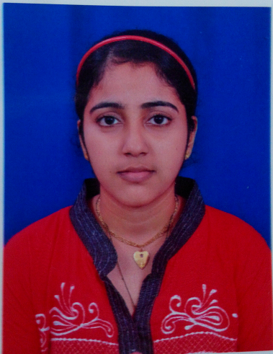

BIO-DATA

NAME : SUPRIYA GAURISH INSULKAR

ADRESS : PLOT NO.63 KADAMBA GOVT HOUSING COLONY

NEAR SAIBABA TEMPLE ,CHIMBEL

TISWADI -GOA

D.O.B : 28/10/1991

NATIONALITY : Indian

CONTACT NO : 8007136387/9518321870

EDUCATIONAL : 1] PASSED X FROM GOA BOARD

QUALIFICATION 2] PASSED XII IN COMMERCE GOA BOARD

3] GRADUATE IN B.COM YESHWANTRAO CHAVAN

UNIVERSITY

4] DIPLOMA IN INFORMATION TECHNOLOGY & TALLY 9.0

WORK EXPERIENCE: 1) CHOWGULE INDUSTRIES PVT LTD

AUTOMOBILE DIVISION [MARUTI SUZUKI]

FOR 1 YR 6 MTH AS A SALES EXECUTIVE & TELECALLER IN INSURANCE

DEPARTMENT

2) GOA HYUNDAI TIVIM AUTOMOBILE FOR 1YR

AS A CUTOMER RELATION EXECUTIVE IN SERVICE

DEPARTMENT

3) DURGA MOTORS (TATA MOTORS) PORVORIM FOR 8MONTH AS A

RECEPTIONIST IN SALES DEPARETMENT

4) V2 VALUE & VARIETY FOR 1YR 4MTH AS A TEAM .

LEADER

CAREER PROFILE : 1) CALLING CUSTOMERS INFORMING ABOUT

INSURANCE , ATTENDING CUSTOMERS EXPLAINING CAR POLICY

DETAIL, LOG IN POLICIES DESPATCHING POLICIES ETC

2) CALLING CUSTOMERS INFORMING ABOUT

SERVICE DUE, ATTENDING CUSTOMER

3) CALLING, TAKING CARE OF CAR DELIVERY ATTENDING CUSTOMER

4) TO ASSIST THE TEAM.

DELIVERY : TO DELIVER WORK ON TIME

OBJECTIVE : TO WORK WITH UTMOST HONESTY & SINCERITY

,