PA - Part 2 Grade Criteria

*how to show data in WorkBench*

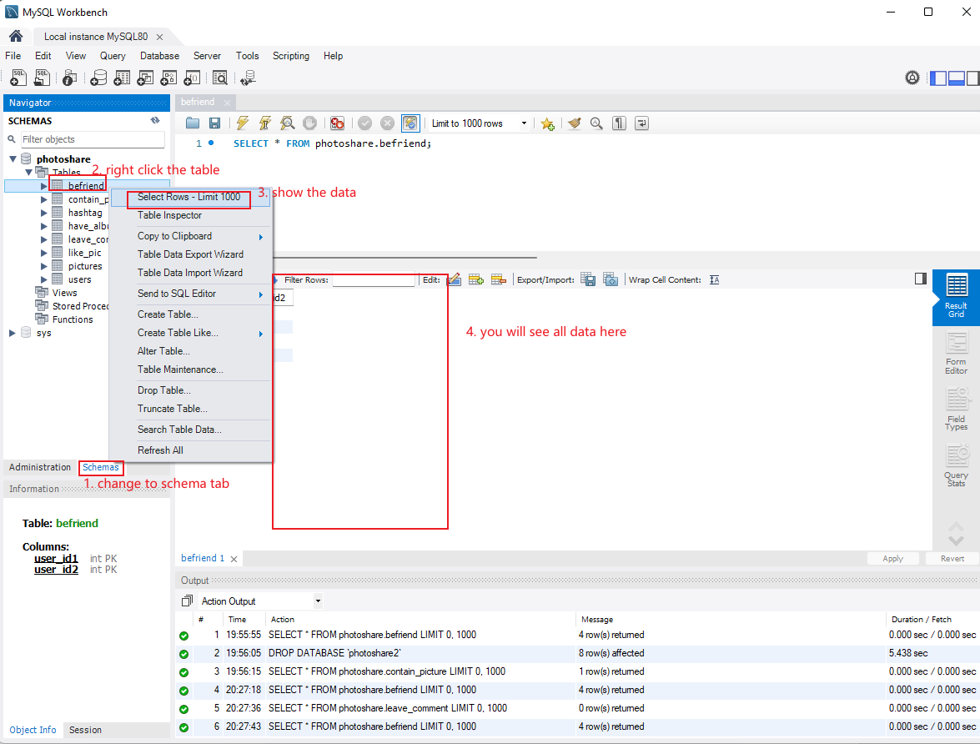

If you did extra work or new functions not showed on the rubric, please tell us.

++++++++++++++++++++++++++++++++++++++++++++++

**5 Types of Use cases (85 pts):**

==============================================

1. **User management (25 pts)**

==============================================

* **Becoming a registered user (5 pts)**
* **Adding and Listing Friends (10 pts)**
* **User activity (10 pts)**
* **Bonus: Unfriend (5 pts)**
* **Bonus: Delete a user (5 pts)**

==============================================

1. **Album and photo management (20 pts)**

==============================================

* **Photo and album browsing (10 pts)**
* **Photo and album creating and** **deleting (10 pts)**

==============================================

1. **Tag management (20 pts)**

==============================================

* **Viewing your photos by tag name (5 pts)**
* **Viewing the most popular tags (10 pts)**
* **Photo search (10 pts)**
* **Bonus: viewing all photos by tag name (5 pts)**
* **Bonus: modify photo caption (5 pts)**
* **Bonus: modify tag (5 pts)**

==============================================

1. **Comments (10 pts)**

==============================================

* **Leaving comments (5 pts)**
* **Like functionality (5 pts)**
* **Bonus: Search on comments (5 pts)**
* **Bonus: unlike photo (5 pts)**
* **Bonus: modify comment (5 pts)**

==============================================

1. **Recommendations (10 pts)**

==============================================

* **'You-may-also-like' functionality (10 pts)**
* **Bonus: Friend recommendation (10 pts)**

+++++++++++++++++++++++++++++++++++++++++++++

**Report (15 pts):**

==============================================