PRACTICAL – 11 Part-A

Problem-1:

Aim:

1. Save/load: make a small class Serializable, save an array of its objects to a file with
ObjectOutputStream, then read it back into fresh objects and confirm the values survived.
Mark one field transient and show it is not saved.

Code Screenshot:

SerializationPractical.java

import java.io.FileInputStream;
import java.io.FileOutputStream;
import java.io.IOException;
import java.io.ObjectInputStream;
import java.io.ObjectOutputStream;
import java.io.Serializable;

class Student implements Serializable {
private static final long serialVersionUID = 1L;

private int rollNumber;
private String name;
private transient String password;

Student(int rollNumber, String name, String password) {
this.rollNumber = rollNumber;
this.name = name;
this.password = password;
}

void display() {
System.out.println("Roll number: " + rollNumber);
System.out.println("Name: " + name);
System.out.println("Password: " + password);
}
}

public class SerializationPractical {
public static void main(String[] args) {
Student[] students = {
new Student(1, "Asha", "pass123"),
new Student(2, "Ravi", "pass456")
};

try (ObjectOutputStream output = new ObjectOutputStream(
new FileOutputStream("students.dat"))) {
output.writeObject(students);
System.out.println("Student objects saved.");
} catch (IOException e) {
System.out.println("Error saving objects: " + e.getMessage());
return;
}

try (ObjectInputStream input = new ObjectInputStream(
new FileInputStream("students.dat"))) {
Student[] loadedStudents = (Student[]) input.readObject();

System.out.println("\nStudent objects loaded:");
for (Student student : loadedStudents) {
student.display();
System.out.println();
}
} catch (IOException | ClassNotFoundException e) {
System.out.println("Error loading objects: " + e.getMessage());
}
}
}

Output Screenshot:
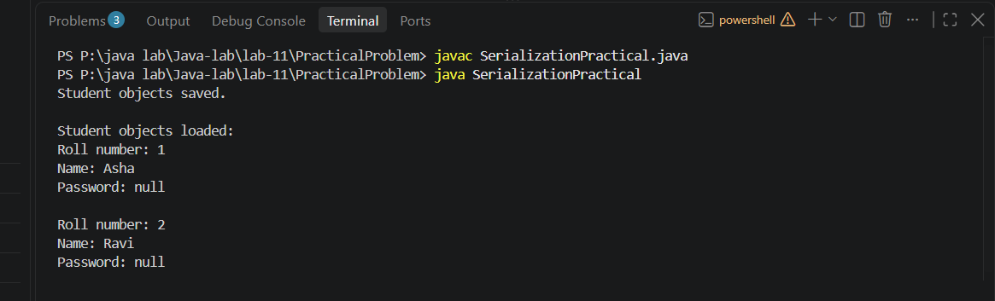

Learning Outcome:

You learn to save and restore an array of Java objects using serialization. You also see that a transient field is not saved and has its default value (null) after deserialization.

Problem-2:
Aim:

2. Log analyzer: create a few text files, then use Path/Files to read each line by line and
count the total lines and how many contain a keyword across all files; also print each
file’s size from its attributes.

Code Screenshot:

LogAnalyzer.java
import java.io.IOException;
import java.nio.file.Files;
import java.nio.file.Path;
import java.nio.file.Paths;
import java.nio.file.attribute.BasicFileAttributes;
import java.util.Arrays;
import java.util.List;

public class LogAnalyzer {
public static void main(String[] args) {
List<Path> files = Arrays.asList(
Paths.get("log1.txt"),
Paths.get("log2.txt"),
Paths.get("log3.txt")
);

String keyword = "ERROR";
int totalLines = 0;
int matchingLines = 0;

for (Path file : files) {
try {
int fileLines = 0;
int fileMatches = 0;

for (String line : Files.readAllLines(file)) {
fileLines++;
if (line.contains(keyword)) {
fileMatches++;
}
}

BasicFileAttributes attributes =
Files.readAttributes(file, BasicFileAttributes.class);

totalLines += fileLines;
matchingLines += fileMatches;

System.out.println("File: " + file.getFileName());
System.out.println("Size: " + attributes.size() + " bytes");
System.out.println("Lines: " + fileLines);
System.out.println("Lines containing \"" + keyword + "\": " + fileMatches);
System.out.println();
} catch (IOException e) {
System.out.println("Could not read " + file + ": " + e.getMessage());
}
}

System.out.println("Total lines across files: " + totalLines);
System.out.println("Total lines containing \"" + keyword + "\": " + matchingLines);
}
}

}

Output Screenshot:

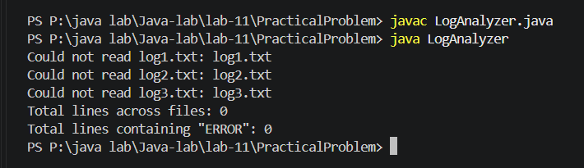
Learning Outcome:

Use Path and Files to read text files line by line.
Count total lines and lines containing a chosen keyword across multiple files.
Read and display each file’s size using BasicFileAttributes.

Problem-3:
Aim:

3. (For Advanced Learners – home) Walk a folder tree with NIO and produce a report of
the files it contains (name, size, modified time), writing the summary to a file; decide
what to include.

Code Screenshot:
FolderTreeReport.java
import java.io.BufferedWriter;
import java.io.IOException;
import java.nio.file.FileVisitResult;
import java.nio.file.Files;
import java.nio.file.Path;
import java.nio.file.Paths;
import java.nio.file.SimpleFileVisitor;
import java.nio.file.attribute.BasicFileAttributes;
import java.time.Instant;

public class FolderTreeReport {
public static void main(String[] args) {
Path folder = Paths.get("sample-folder");
Path report = Paths.get("folder-report.txt");

try (BufferedWriter writer = Files.newBufferedWriter(report)) {
writer.write("File Name | Size (bytes) | Modified Time");
writer.newLine();

Files.walkFileTree(folder, new SimpleFileVisitor<Path>() {
@Override
public FileVisitResult visitFile(Path file, BasicFileAttributes attributes)
throws IOException {
writer.write(file.getFileName() + " | "
+ attributes.size() + " | "
+ Instant.ofEpochMilli(attributes.lastModifiedTime().toMillis()));
writer.newLine();
return FileVisitResult.CONTINUE;
}

@Override
public FileVisitResult visitFileFailed(Path file, IOException exception)
throws IOException {
writer.write("Could not access: " + file + " | " + exception.getMessage());
writer.newLine();
return FileVisitResult.CONTINUE;
}
});

System.out.println("Report saved to " + report.toAbsolutePath());
} catch (IOException e) {
System.out.println("Could not create the report: " + e.getMessage());
}
}
}

Output Screenshot:
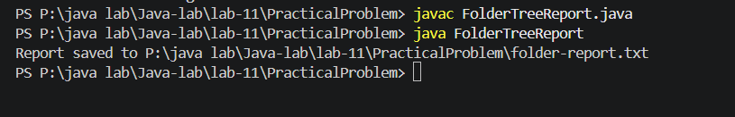
Learning Outcome:
Use NIO to walk through a folder tree and access file attributes.
Create a report containing file names, sizes, and modified times.
Write the report to a text file while handling files that cannot be accessed.

