PRACTICAL – 12 Part-A

Problem-1:

Aim:

1. Word frequency: split a paragraph into words, count each in a HashMap, and print the
words sorted by frequency (highest first) using a Comparator.

Code Screenshot:

WordFrequency.java

import java.util.Comparator;
import java.util.HashMap;
import java.util.Map;

public class WordFrequency {
public static void main(String[] args) {
String paragraph = "Java is simple and Java is powerful. Java is widely used.";

Map<String, Integer> frequency = new HashMap<>();

for (String word : paragraph.toLowerCase().replaceAll("[^a-z0-9\\s]", "").split("\\s+")) {
if (!word.isEmpty()) {
frequency.put(word, frequency.getOrDefault(word, 0) + 1);
}
}

frequency.entrySet().stream()
.sorted(Comparator.comparingInt(
(Map.Entry<String, Integer> entry) -> entry.getValue()
).reversed().thenComparing(Map.Entry::getKey))
.forEach(entry -> System.out.println(
entry.getKey() + " : " + entry.getValue()
));
}
}

Output Screenshot:
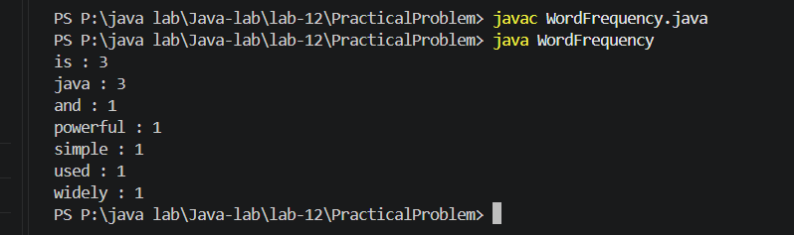

Learning Outcome:

Split paragraph text into words and count each word using a HashMap.
Sort map entries by frequency with a Comparator, from highest to lowest.
Use alphabetical order to break ties between words with equal frequencies.

Problem-2:
Aim:

2. Unique visitors: from a list of login names with repeats, use a HashSet to count unique
users and a LinkedHashSet to keep first-seen order; print the unique count and the first
three distinct names.

Code Screenshot:

UniqueVisitors.java
import java.util.Arrays;
import java.util.HashSet;
import java.util.LinkedHashSet;
import java.util.List;
import java.util.Set;

public class UniqueVisitors {
public static void main(String[] args) {
List<String> loginNames = Arrays.asList(
"maya", "arjun", "maya", "riya", "arjun", "dev", "riya"
);

Set<String> uniqueUsers = new HashSet<>(loginNames);
Set<String> firstSeenOrder = new LinkedHashSet<>(loginNames);

System.out.println("Unique users: " + uniqueUsers.size());

System.out.println("First three distinct names:");
int count = 0;
for (String name : firstSeenOrder) {
System.out.println(name);
count++;
if (count == 3) {
break;
}
}
}
}

Output Screenshot:

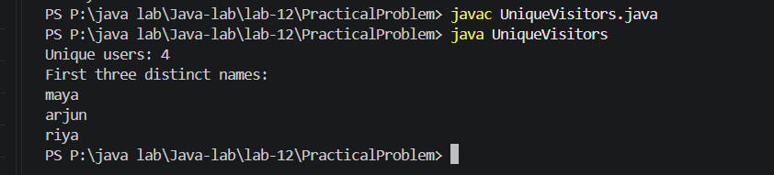
Learning Outcome:

Use a HashSet to count distinct login names.
Use a LinkedHashSet to remove repeats while preserving first-seen order.
Print the first three distinct names from that order.

Problem-3:
Aim:

3. (For Advanced Learners – home) Build a leaderboard from player scores held in a Map
and print the top-N sorted by score (ties broken by name); choose the data and sorting
details.

Code Screenshot:
Leaderboard.java
import java.util.Comparator;
import java.util.HashMap;
import java.util.Map;

public class Leaderboard {
public static void main(String[] args) {
Map<String, Integer> scores = new HashMap<>();
scores.put("Maya", 920);
scores.put("Arjun", 850);
scores.put("Riya", 920);
scores.put("Dev", 780);
scores.put("Anaya", 850);

int topN = 3;

System.out.println("Top " + topN + " players:");
scores.entrySet().stream()
.sorted(Comparator
.comparingInt((Map.Entry<String, Integer> entry) -> entry.getValue())
.reversed()
.thenComparing(Map.Entry::getKey))
.limit(topN)
.forEach(entry -> System.out.println(
entry.getKey() + " - " + entry.getValue()
));
}
}

Output Screenshot:
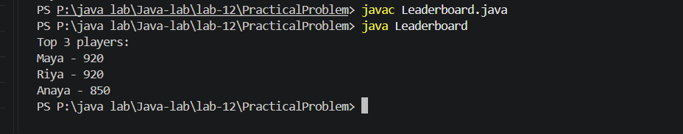
Learning Outcome:
Store player scores as key-value pairs in a Map.
Sort entries by score in descending order and break ties alphabetically by player name.
Limit the output to the top N players.

