PRACTICAL – 13 Part-A

Problem-1:

Aim:

1. Generic containers: a generic Box<T> with get/set and a Pair<A,B>; use them with
different types to show type safety without casts, and write a generic method that returns
the first element of any array.

Code Screenshot:

GenericContainers.java

class Box<T> {
private T value;

public void set(T value) {
this.value = value;
}

public T get() {
return value;
}
}

class Pair<A, B> {
private final A first;
private final B second;

public Pair(A first, B second) {
this.first = first;
this.second = second;
}

public A getFirst() {
return first;
}

public B getSecond() {
return second;
}
}

public class GenericContainers {
public static <T> T firstElement(T[] array) {
if (array == null || array.length == 0) {
throw new IllegalArgumentException("Array must not be null or empty.");
}
return array[0];
}

public static void main(String[] args) {
Box<String> textBox = new Box<>();
textBox.set("Hello");

Box<Integer> numberBox = new Box<>();
numberBox.set(42);

Pair<String, Integer> student = new Pair<>("Asha", 20);

String[] names = {"Maya", "Ravi", "Noah"};
Integer[] numbers = {10, 20, 30};

String firstName = firstElement(names);
Integer firstNumber = firstElement(numbers);

System.out.println("Text box: " + textBox.get());
System.out.println("Number box: " + numberBox.get());
System.out.println("Pair: " + student.getFirst() + ", " + student.getSecond());
System.out.println("First name: " + firstName);
System.out.println("First number: " + firstNumber);
}
}

Output Screenshot:

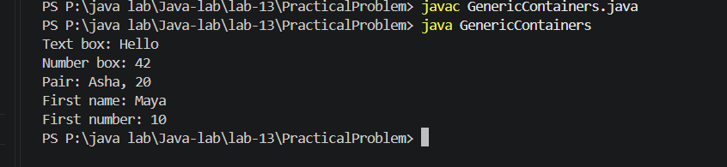

Learning Outcome:

Create reusable generic classes with Box<T> and Pair<A, B>.
Use different types safely without casts.
Write a generic method that returns the first element of an array.

Problem-2:
Aim:

2. Bounded stats: a generic method <N extends Number> double average(N[] values) that
works for Integer[], Double[] and Long[]; note why it refuses non-Number types.

Code Screenshot:

BoundedStats.java
public class BoundedStats {
public static <N extends Number> double average(N[] values) {
if (values == null || values.length == 0) {
throw new IllegalArgumentException("Array must not be null or empty.");
}

double sum = 0.0;
for (N value : values) {
if (value == null) {
throw new IllegalArgumentException("Array values must not be null.");
}
sum += value.doubleValue();
}

return sum / values.length;
}

public static void main(String[] args) {
Integer[] integers = {10, 20, 30};
Double[] doubles = {2.5, 5.0, 7.5};
Long[] longs = {100L, 200L, 300L};

System.out.println("Integer average: " + average(integers));
System.out.println("Double average: " + average(doubles));
System.out.println("Long average: " + average(longs));
}
}

Output Screenshot:

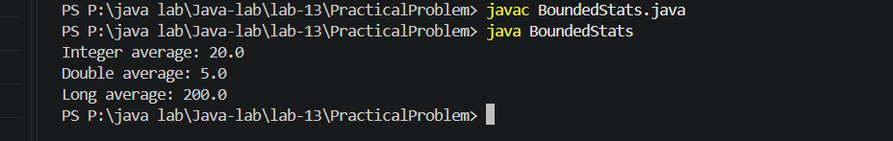
Learning Outcome:

UWrite a bounded generic method that accepts arrays of numeric types.
Convert each value to double to calculate an average.
Understand how extends Number prevents non-numeric types from being passed.

Problem-3:
Aim:

3. (For Advanced Learners – home) Implement a small generic container of your choice
(e.g. a stack) backed by an array, reuse it for two different types, and handle the empty
case sensibly.

Code Screenshot:
GenericStackDemo.java
import java.util.Arrays;
import java.util.EmptyStackException;

class GenericStack<T> {
private Object[] elements;
private int size;

public GenericStack() {
elements = new Object[10];
}

public void push(T item) {
if (size == elements.length) {
elements = Arrays.copyOf(elements, elements.length * 2);
}
elements[size++] = item;
}

@SuppressWarnings("unchecked")
public T pop() {
if (isEmpty()) {
throw new EmptyStackException();
}

T item = (T) elements[--size];
elements[size] = null;
return item;
}

public boolean isEmpty() {
return size == 0;
}

public int size() {
return size;
}
}

public class GenericStackDemo {
public static void main(String[] args) {
GenericStack<String> names = new GenericStack<>();
names.push("Maya");
names.push("Ravi");

GenericStack<Integer> numbers = new GenericStack<>();
numbers.push(10);
numbers.push(20);

System.out.println("Name stack: " + names.pop() + ", " + names.pop());
System.out.println("Number stack: " + numbers.pop() + ", " + numbers.pop());

if (names.isEmpty()) {
System.out.println("Name stack is empty.");
}
}
}

Output Screenshot:
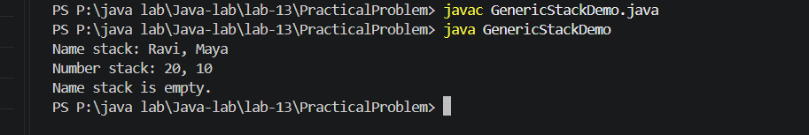
Learning Outcome:
Build a generic stack backed by an array and use it with different types.
Handle an empty stack by checking isEmpty() and reporting the condition.
Use pop() to retrieve items in last-in, first-out order.

