PRACTICAL – 14 Part-A

Problem-1:

Aim:

1. Assemble and test: build a tiny layered app (a model, a service using an ArrayList, and a
menu main), then write two or three JUnit @Test methods checking that adding increases
the count and an invalid action throws — practice before testing MiniBank.

Code Screenshot:

MiniBankApp.java

import java.util.ArrayList;
import java.util.List;
import java.util.Scanner;

class Account {
private final String owner;

public Account(String owner) {
if (owner == null || owner.trim().isEmpty()) {
throw new IllegalArgumentException("Owner name cannot be empty.");
}
this.owner = owner;
}

public String getOwner() {
return owner;
}
}

class AccountService {
private final List<Account> accounts = new ArrayList<>();

public void addAccount(String owner) {
accounts.add(new Account(owner));
}

public int getAccountCount() {
return accounts.size();
}

public Account getAccount(int index) {
if (index < 0 || index >= accounts.size()) {
throw new IllegalArgumentException("Invalid account index.");
}
return accounts.get(index);
}
}

public class MiniBankApp {
public static void main(String[] args) {
AccountService service = new AccountService();

try (Scanner scanner = new Scanner(System.in)) {
while (true) {
System.out.println("\n1. Add account");
System.out.println("2. Show account count");
System.out.println("3. Exit");
System.out.print("Choose an option: ");

String input = scanner.nextLine();

switch (input) {
case "1":
System.out.print("Enter account owner: ");
service.addAccount(scanner.nextLine());
System.out.println("Account added.");
break;
case "2":
System.out.println("Account count: " + service.getAccountCount());
break;
case "3":
System.out.println("Goodbye.");
return;
default:
System.out.println("Invalid action.");
}
}
}
}
}

AccountServiceCheck.java

public class AccountServiceCheck {
public static void main(String[] args) {
AccountService service = new AccountService();

service.addAccount("Maya");
check(service.getAccountCount() == 1, "Adding one account should make the count 1.");

service.addAccount("Ravi");
check(service.getAccountCount() == 2, "Adding two accounts should make the count 2.");

try {
service.getAccount(-1);
throw new AssertionError("An invalid account index should throw an exception.");
} catch (IllegalArgumentException expected) {
System.out.println("Invalid account check passed.");
}

System.out.println("All checks passed.");
}

private static void check(boolean condition, String message) {
if (!condition) {
throw new AssertionError(message);
}
}
}

Output Screenshot:

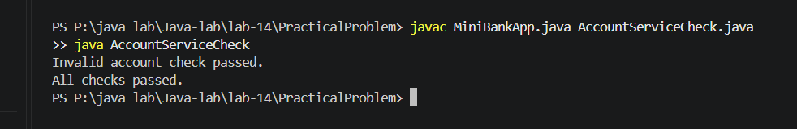

Learning Outcome:

Understand that JUnit must be added separately to compile JUnit tests.
Compile related Java source files together when they share classes.
Check application behavior with a simple standalone program when JUnit is not set up.

Problem-2:
Aim:

2. (For Advanced Learners – home) Organise that app into packages, build a runnable JAR,
and add a test that saves and reloads its data unchanged.

Code Screenshot:

src/com/minibank/model/Account.java
package com.minibank.model;

import java.io.Serializable;

public class Account implements Serializable {
private static final long serialVersionUID = 1L;

private final String owner;

public Account(String owner) {
if (owner == null || owner.trim().isEmpty()) {
throw new IllegalArgumentException("Owner name cannot be empty.");
}
this.owner = owner;
}

public String getOwner() {
return owner;
}
}

src/com/minibank/service/AccountService.java
package com.minibank.service;

import com.minibank.model.Account;
import java.io.Serializable;
import java.util.ArrayList;
import java.util.List;

public class AccountService implements Serializable {
private static final long serialVersionUID = 1L;

private final List<Account> accounts = new ArrayList<>();

public void addAccount(String owner) {
accounts.add(new Account(owner));
}

public int getAccountCount() {
return accounts.size();
}

public Account getAccount(int index) {
if (index < 0 || index >= accounts.size()) {
throw new IllegalArgumentException("Invalid account index.");
}
return accounts.get(index);
}
}

src/com/minibank/Main.java
package com.minibank;

import com.minibank.service.AccountService;
import java.util.Scanner;

public class Main {
public static void main(String[] args) {
AccountService service = new AccountService();

try (Scanner scanner = new Scanner(System.in)) {
while (true) {
System.out.println("\n1. Add account");
System.out.println("2. Show account count");
System.out.println("3. Exit");
System.out.print("Choose an option: ");

switch (scanner.nextLine()) {
case "1":
System.out.print("Enter account owner: ");
service.addAccount(scanner.nextLine());
System.out.println("Account added.");
break;
case "2":
System.out.println("Account count: " + service.getAccountCount());
break;
case "3":
return;
default:
System.out.println("Invalid action.");
}
}
}
}
}

test/com/minibank/AccountServiceCheck.java
package com.minibank;

import com.minibank.service.AccountService;
import java.io.*;

public class AccountServiceCheck {
public static void main(String[] args) throws Exception {
AccountService original = new AccountService();
original.addAccount("Maya");
original.addAccount("Ravi");

try (ObjectOutputStream output =
new ObjectOutputStream(new FileOutputStream("accounts.dat"))) {
output.writeObject(original);
}

AccountService loaded;
try (ObjectInputStream input =
new ObjectInputStream(new FileInputStream("accounts.dat"))) {
loaded = (AccountService) input.readObject();
}

if (loaded.getAccountCount() != original.getAccountCount()
|| !loaded.getAccount(0).getOwner().equals(original.getAccount(0).getOwner())
|| !loaded.getAccount(1).getOwner().equals(original.getAccount(1).getOwner())) {
throw new AssertionError("Data changed after saving and loading.");
}

System.out.println("Save/load check passed. Account data is unchanged.");
}
}

Output Screenshot:

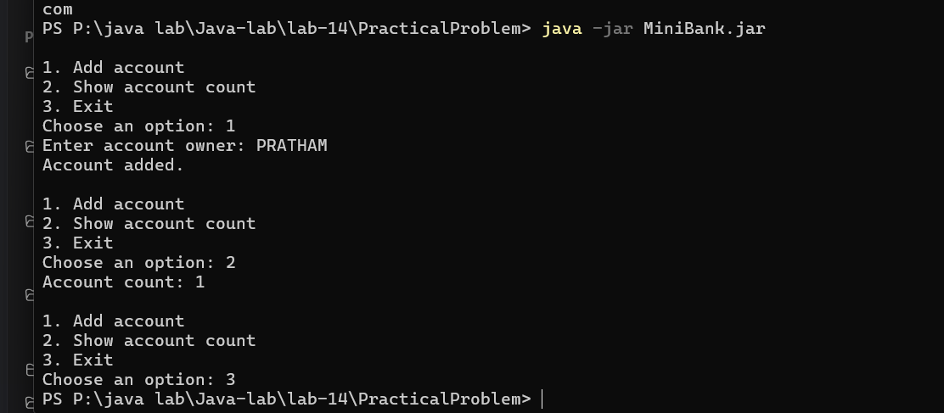
Learning Outcome:

Organize Java classes into packages and compile them into a runnable JAR.
Serialize and reload application data, then compare it to confirm the values are unchanged.
Run a standalone check to verify persistence without requiring a test framework.

