PRACTICAL – 1 Part-A

Problem-1:

Aim:

Vending machine (VendingMachine.java, main in this file)
(a) Define an enum Coin with constants ONE, TWO, FIVE, TEN.
(b) In main, set a snack price of 15 and a running total of 0; create a Scanner.
(c) Loop: read a coin name, use a switch expression to convert the Coin to its value
(ONE→1, TWO→2, FIVE→5, TEN→10), add it to the total, and print the total so
far.
(d) Stop the loop once the total reaches 15 or more.
(e) Print the change to return (total − 15).
Expected output: TEN then FIVE prints “Paid. Change: 0”; TEN then TEN prints
“Paid. Change: 5”.

Code Screenshot:

import java.util.Scanner;

enum Coin {
ONE(1),
TWO(2),
FIVE(5),
TEN(10);

private int value;

Coin(int value) {
this.value = value;
}

public int getValue() {
return value;
}
}

public class VendingMachine {

public static void main(String[] args) {

Scanner sc = new Scanner(System.in);

int snackCost = 15;
int total = 0;
int value = 0;

System.out.println("Snack Cost = " + snackCost);

while (total < snackCost) {

System.out.print("Enter Coin (ONE, TWO, FIVE, TEN): ");

Coin coin = Coin.valueOf(sc.next().toUpperCase());

switch (coin) {
case ONE:
value = coin.getValue();
break;

case TWO:
value = coin.getValue();
break;

case FIVE:
value = coin.getValue();
break;

case TEN:
value = coin.getValue();
break;
}

total += value;
System.out.println("Total = " + total);
}

System.out.println("Paid");
System.out.println("Change = " + (total - snackCost));

sc.close();
}
}

Output Screenshot:

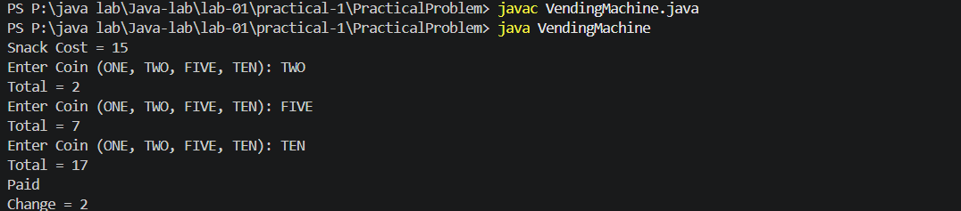

Learning Outcome:

In this practical, I learned how to use enum in Java, take input using Scanner, use a switch expression to convert coin values, use a loop for repeated input, calculate the total amount, and find the change after payment.
Problem-2:
Aim:

Toll booth (TollBooth.java, main in this file)
(a) Define a record Vehicle(String number, String type).
(b) In main, keep a running toll total and three counters (bike, car, truck).
(c) Loop until the user types “done” for the number: build a Vehicle, use a switch
expression on its type for the toll (bike→20, car→50, truck→150), add to the total,
and increment that type’s counter.
(d) After the loop, print the total toll and the type with the highest count.
Expected output: two cars + one bike → “Total toll: 120”, “Most frequent: car”.

Code Screenshot:

import java.util.Scanner;
public class TollBooth {
record Vehicle(String number, String type) {
}
public static void main(String[] args) {
Scanner sc = new Scanner(System.in);
int total = 0;
int bike = 0;
int car = 0;
int truck = 0;
while (true) {
System.out.print("Enter vehicle number (or done): ");
String number = sc.next();
if (number.equalsIgnoreCase("done")) {
break;
}
System.out.print("Enter vehicle type (bike/car/truck): ");
String type = sc.next().toLowerCase();
Vehicle v = new Vehicle(number, type);
int toll = switch (v.type()) {
case "bike" -> 20;
case "car" -> 50;
case "truck" -> 150;
default -> 0;
};
total += toll;
switch (v.type()) {
case "bike":
bike++;
break;
case "car":
car++;
break;
case "truck":
truck++;
break;
}
}
String most = "bike";
if (car > bike && car >= truck) {
most = "car";
} else if (truck > bike && truck > car) {
most = "truck";
}
System.out.println("Total toll: " + total);
System.out.println("Most frequent: " + most);
sc.close();
}
}
Output Screenshot:

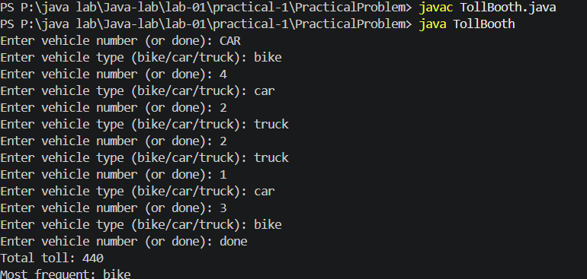
Learning Outcome:

In this practical, I learned how to use a record in Java, take user input using Scanner, use a switch expression to calculate toll charges, keep a running total, count different types of vehicles, and find the vehicle type with the highest count.

Problem-3:
Aim:

(For Advanced Learners – home) Rock-Paper-Scissors-Lizard-Spock (RPSLS.java)
(a) Define an enum Move with ROCK, PAPER, SCISSORS, LIZARD, SPOCK.
(b) Write winner(Move a, Move b) returning 1 if a beats b, -1 if b beats a, 0 for a tie —
use a switch expression listing what each move beats (Scissors cut Paper, Paper
covers Rock, Rock crushes Lizard, Lizard poisons Spock, Spock smashes Scissors,
and the five mirror cases).
(c) In main, play 5 rounds: pick a random computer Move, read the player’s Move, call
winner(), print the round result and keep score.
(d) After 5 rounds, print the overall winner.
Expected output: each round prints both moves and the round winner; ends with a
“You win 3–2” summary.

Code Screenshot:

import java.util.Random;
import java.util.Scanner;
public class RPSLS{
enum Move{
ROCK,
PAPER,
SCISSORS,
LIZARD,
SPOCK
};
public static int winner(Move a, Move b) {
if (a == b) {
return 0;
}
switch (a) {
case ROCK:
if (b == Move.SCISSORS || b == Move.LIZARD) {
return 1;
}
return -1;
case PAPER:
if (b == Move.ROCK || b == Move.SPOCK) {
return 1;
}
return -1;
case SCISSORS:
if (b == Move.PAPER || b == Move.LIZARD) {
return 1;
}
return -1;
case LIZARD:
if (b == Move.PAPER || b == Move.SPOCK) {
return 1;
}
return -1;
case SPOCK:
if (b == Move.ROCK || b == Move.SCISSORS) {
return 1;
}
return -1;
}
return 0;
}
public static void main(String[] args) {
Scanner sc = new Scanner(System.in);
Random random = new Random();
int playerScore = 0;
int computerScore = 0;
for (int round = 1; round <= 5; round++) {
System.out.println("Round " + round);
System.out.print("Enter your move (ROCK, PAPER, SCISSORS, LIZARD, SPOCK): ");
Move playerMove = Move.valueOf(sc.next().toUpperCase());
Move computerMove = Move.values()[random.nextInt(5)];
System.out.println("Player Move : " + playerMove);
System.out.println("Computer Move : " + computerMove);
int result = winner(playerMove, computerMove);
if (result == 1) {
System.out.println("You Win This Round!");
playerScore++;
} else if (result == -1) {
System.out.println("Computer Wins This Round!");
computerScore++;
} else {
System.out.println("Round Tied!");
}
}
System.out.println("Final Result :");
System.out.println("Player Score : " + playerScore);
System.out.println("Computer Score : " + computerScore);
if (playerScore > computerScore) {
System.out.println("You Win " + playerScore + "-" + computerScore);
} else if (computerScore > playerScore) {
System.out.println("Computer Wins " + computerScore + "-" + playerScore);
} else {
System.out.println("Match Tied!");
}
sc.close();
}
}

Output Screenshot:

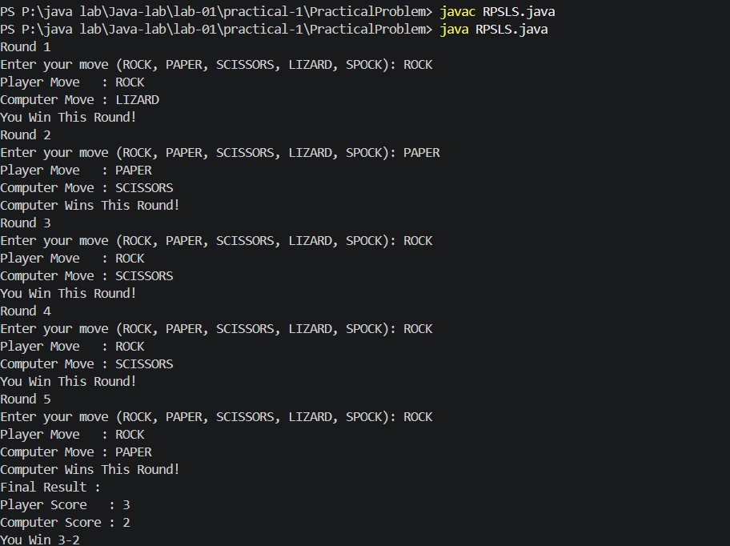
Learning Outcome:
In this practical, I learned how to use enum in Java, generate random values, use a switch expression for game logic, compare different moves, keep the score for multiple rounds, and display the final winner after the game.

