PRACTICAL – 2 Part-A

Problem-1:

Aim:

1. Smart thermostat (Thermostat.java, main in this file)
(a) Create class Thermostat with private String location, private int temperature, private
static final int MIN=16 and MAX=30, and private static int activeCount=0.
(b) Constructor(location, startTemp): store location; set temperature to startTemp if it is
within MIN..MAX else 22; increment activeCount.
(c) Constructor(location): chain with this(location, 22).
(d) raise(): if temperature < MAX add 1, else print “Already at maximum (30)”.
(e) lower(): if temperature > MIN subtract 1, else print “Already at minimum (16)”.
(f) Add getTemperature() (no setter) and static getActiveCount().
(g) In main: create two thermostats, call raise() 10 times then lower() 20 times in loops
(printing the temperature each time), then print getActiveCount().
Expected output: temperature rises to 30 then “Already at maximum”, falls to 16
then “Already at minimum”, count 2.

Code Screenshot:

public class Thermostat {

private String location;
private int temperature;

private static final int MIN = 16;
private static final int MAX = 30;

private static int activeCount = 0;

public Thermostat(String location, int startTemp) {
this.location = location;

if (startTemp >= MIN && startTemp <= MAX) {
this.temperature = startTemp;
} else {
this.temperature = 22;
}

activeCount++;
}

public Thermostat(String location) {
this(location, 22);
}

public void raise() {
if (temperature < MAX) {
temperature++;
} else {
System.out.println("Already at maximum (30)");
}
}

public void lower() {
if (temperature > MIN) {
temperature--;
} else {
System.out.println("Already at minimum (16)");
}
}

public int getTemperature() {
return temperature;
}

public static int getActiveCount() {
return activeCount;
}
public static void main(String[] args) {

Thermostat t1 = new Thermostat("Bedroom", 22);
Thermostat t2 = new Thermostat("Living Room");

System.out.println("Increasing Temperature:");

for (int i = 1; i <= 10; i++) {
t1.raise();
System.out.println("Temperature: " + t1.getTemperature());
}

System.out.println();

System.out.println("Decreasing Temperature:");

for (int i = 1; i <= 20; i++) {
t1.lower();
System.out.println("Temperature: " + t1.getTemperature());
}

System.out.println();

System.out.println("Active Thermostats: " + Thermostat.getActiveCount());
}
}

Output Screenshot:

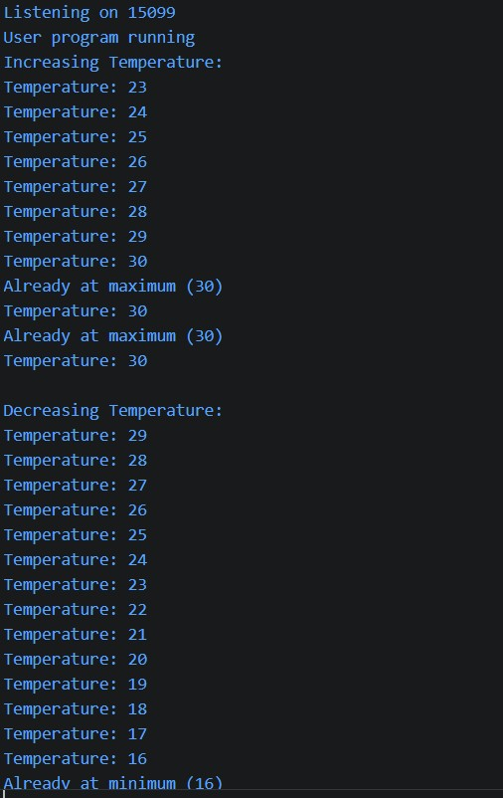
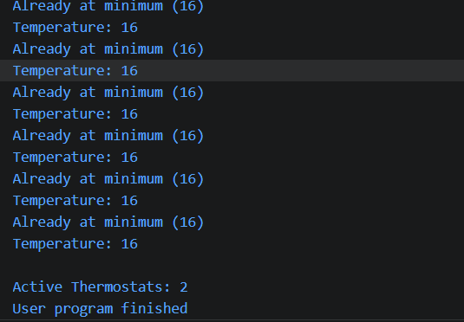

Learning Outcome:

In this practical, I learned how to use constructors, constructor chaining, static variables, and private variables in Java. I also learned how to use methods and loops to increase and decrease the temperature within a fixed limit.

Problem-2:
Aim:

Cinema show (CinemaShow.java, main in this file)
(a) Create class CinemaShow with private String title, private int seatsAvailable, private
final int capacity, and private static int totalBooked=0.
(b) Constructor(title, capacity): set both and seatsAvailable = capacity.
Constructor(title): chain with this(title, 100).
(c) book(int n): if n ≤ seatsAvailable, reduce seatsAvailable by n, add n to totalBooked,
return true; else return false unchanged.
(d) cancel(int n): increase seatsAvailable by n but never above capacity.
(e) Add getSeatsAvailable() and static getTotalBooked().
(f) In main: run a sequence of book and cancel calls, printing the result and seats after
each, then print getTotalBooked().
Expected output: booking more than available prints false and leaves seats
unchanged; totalBooked equals the successful bookings.

Code Screenshot:

public class CinemaShow {

private String title;
private int seatsAvailable;
private final int capacity;

private static int totalBooked = 0;

public CinemaShow(String title, int capacity) {
this.title = title;
this.capacity = capacity;
this.seatsAvailable = capacity;
}

public CinemaShow(String title) {
this(title, 100);
}

public boolean book(int n) {
if (n <= seatsAvailable) {
seatsAvailable -= n;
totalBooked += n;
return true;
} else {
return false;
}
}

public void cancel(int n) {
seatsAvailable += n;

if (seatsAvailable > capacity) {
seatsAvailable = capacity;
}
}

public int getSeatsAvailable() {
return seatsAvailable;
}

public static int getTotalBooked() {
return totalBooked;
}

public static void main(String[] args) {

CinemaShow show1 = new CinemaShow("Avengers", 50);

System.out.println("Booking 20 seats: " + show1.book(20));
System.out.println("Seats Available: " + show1.getSeatsAvailable());

System.out.println();

System.out.println("Booking 25 seats: " + show1.book(25));
System.out.println("Seats Available: " + show1.getSeatsAvailable());

System.out.println();

System.out.println("Booking 10 seats: " + show1.book(10));
System.out.println("Seats Available: " + show1.getSeatsAvailable());

System.out.println();

show1.cancel(15);
System.out.println("Cancelled 15 seats");
System.out.println("Seats Available: " + show1.getSeatsAvailable());

System.out.println();

System.out.println("Booking 10 seats: " + show1.book(10));
System.out.println("Seats Available: " + show1.getSeatsAvailable());

System.out.println();

show1.cancel(100);
System.out.println("Cancelled 100 seats");
System.out.println("Seats Available: " + show1.getSeatsAvailable());

System.out.println();

System.out.println("Total Booked Seats: " + CinemaShow.getTotalBooked());
}
}

Output Screenshot:

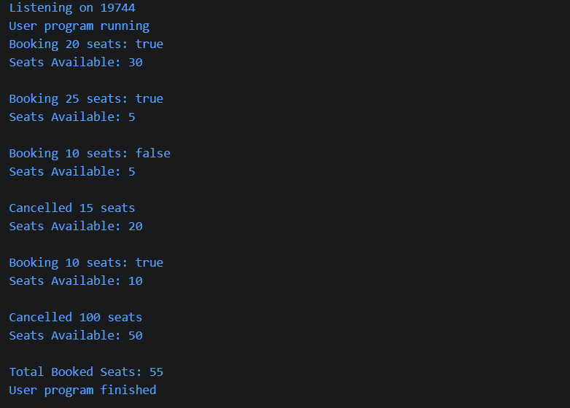
Learning Outcome:

In this practical, I learned how to use constructors, private variables, static variables, and methods in Java. I also learned how to manage available seats, book and cancel seats, and keep track of the total booked seats.

Problem-3:
Aim:

3. (For Advanced Learners – home) Parking lot (ParkingLot.java)
(a) Create class ParkingLot with private int twoWheelers and fourWheelers, private final
int twoCap and fourCap, and private static long revenue=0.
(b) park(String type): for “two”, if twoWheelers < twoCap increment and add 20 to
revenue; for “four”, if fourWheelers < fourCap increment and add 40; otherwise print
“Full” and reject.
(c) leave(String type): decrement the matching count but never below 0.
(d) In main: simulate a sequence of park/leave events, printing each outcome, then print
final occupancy and revenue.
Expected output: parking into a full section is refused; revenue = 20×(two parked)
+ 40×(four parked).

Code Screenshot:
public class ParkingLot {

private int twoWheelers;
private int fourWheelers;

private final int twoCap;
private final int fourCap;

private static long revenue = 0;

public ParkingLot(int twoCap, int fourCap) {
this.twoCap = twoCap;
this.fourCap = fourCap;
this.twoWheelers = 0;
this.fourWheelers = 0;
}

public void park(String type) {

if (type.equalsIgnoreCase("two")) {

if (twoWheelers < twoCap) {
twoWheelers++;
revenue += 20;
System.out.println("Two-wheeler parked.");
} else {
System.out.println("Two-wheeler section Full");
}

} else if (type.equalsIgnoreCase("four")) {

if (fourWheelers < fourCap) {
fourWheelers++;
revenue += 40;
System.out.println("Four-wheeler parked.");
} else {
System.out.println("Four-wheeler section Full");
}

} else {
System.out.println("Invalid vehicle type.");
}
}

public void leave(String type) {

if (type.equalsIgnoreCase("two")) {

if (twoWheelers > 0) {
twoWheelers--;
System.out.println("Two-wheeler left.");
} else {
System.out.println("No two-wheelers to leave.");
}

} else if (type.equalsIgnoreCase("four")) {

if (fourWheelers > 0) {
fourWheelers--;
System.out.println("Four-wheeler left.");
} else {
System.out.println("No four-wheelers to leave.");
}

} else {
System.out.println("Invalid vehicle type.");
}
}

public int getTwoWheelers() {
return twoWheelers;
}

public int getFourWheelers() {
return fourWheelers;
}

public static long getRevenue() {
return revenue;
}

public static void main(String[] args) {

ParkingLot lot = new ParkingLot(3, 2);

lot.park("two");
lot.park("two");
lot.park("two");
lot.park("two");

lot.park("four");
lot.park("four");
lot.park("four");

lot.leave("two");
lot.leave("four");

lot.park("two");
lot.park("four");

System.out.println();

System.out.println("Final Two-Wheelers: " + lot.getTwoWheelers());
System.out.println("Final Four-Wheelers: " + lot.getFourWheelers());
System.out.println("Total Revenue: " + ParkingLot.getRevenue());
}
}

Output Screenshot:

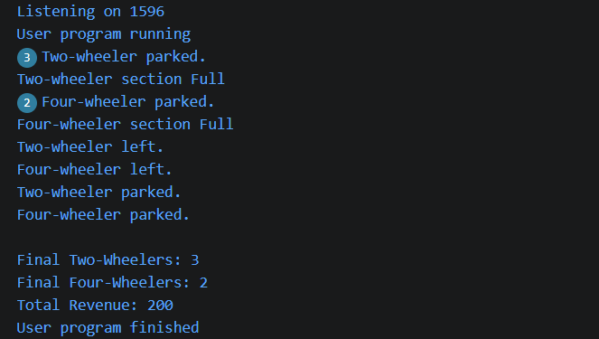
Learning Outcome:
In this practical, I learned how to use classes, constructors, methods, and static variables to manage a parking lot. I also learned how to check parking capacity, handle vehicles entering and leaving, and calculate the total parking revenue.

