PRACTICAL – 3 Part-A

Problem-1:

Aim:

1. Distinct points (Point.java + Driver.java with main)
(a) Create class Point with private int x, y and a constructor.
(b) Override toString() to return “(x, y)”.
(c) Override equals(Object) to be true when both x and y match, and hashCode() to agree
(e.g. Objects.hash(x, y)).
(d) In Driver.main: build a Point[] with some repeated coordinates.
(e) Count distinct points: for each point, use equals() to check whether it already
appeared earlier; count those that did not.
(f) Print “Distinct: N”.
Expected output: 5 points with 2 repeats → “Distinct: 3”.

Code Screenshot:

Point.java
import java.util.Objects;

public class Point {
private int x;
private int y;

public Point(int x , int y){
this.x = x;
this.y = y;
}

@Override
public String toString() {
return "(" + x + "," + y + ")";
}

public boolean equals(Object obj){
if (this == obj)
return true;
if (obj == null || getClass() != obj.getClass())
return false;

Point other = (Point) obj;
return this.x == other.x && this.y == other.y; }

public int hashCode() {
return Objects.hash(x, y);
}
}

Driver.java
public class Driver {
public static void main(String args[]){
Point[] points = {
new Point(5,6),
new Point(7,8),
new Point(5,4),
new Point(5,6),
new Point(8,9)
};

int distinctCount = 0;
for (int i = 0; i < points.length; i++){
boolean alreadySeen = false;
for (int j = 0; j < i; j++) {
if (points[i].equals(points[j])){
alreadySeen = true;
break;
}
}
if (!alreadySeen) {
distinctCount++;
}
}
System.out.println("Distinct: " + distinctCount);
}
}

Output Screenshot:
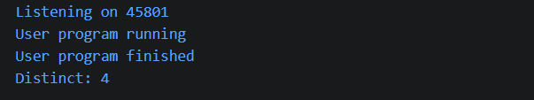

Learning Outcome:

In this practical, I learned how to create a class with a constructor and override toString(), equals(), and hashCode() methods. I also learned how to compare objects and find the number of distinct points.

Problem-2:
Aim:

2. Duplicate card check (Card.java + Driver.java)
(a) Create class Card with private String rank, suit and a constructor.
(b) Override toString() to return rank + “ of ” + suit (e.g. “Queen of Hearts”).
(c) Override equals()/hashCode() by rank + suit.
(d) In Driver.main: add cards to a Card[] one at a time; before adding each, use equals()
to check it against the earlier cards.
(e) Print “Duplicate found: <card>” the first time a repeat appears.
Expected output: a second “Ace of Spades” → “Duplicate found: Ace of Spades”.

Code Screenshot:

Card.java
import java.util.Objects;

public class Card {
private String rank;
private String suit;

public Card(String rank, String suit){
this.rank = rank;
this.suit = suit;
}

@Override
public String toString(){
return rank + "of" + suit;
}

@Override
public boolean equals(Object obj) {
if (this == obj)
return true;

if (obj == null || getClass() != obj.getClass()) return false;

Card other = (Card) obj;
return rank.equals(other.rank) && suit.equals(other.suit);

}

@Override
public int hashCode() {
return Objects.hash(rank, suit);
}
}

Driver.java
public class Driver {
public static void main(String[] args){

Card[] table = new Card[5];
int count = 0;

Card[] card = {
new Card("Queen", "Heart"),
new Card("Jack", "Speads"),
new Card("Queen", "Heart"),
new Card("TEN", "Clubs"),
new Card("NINE","Clubs"),
};

for (Card c : card){
boolean duplicate = false;
for (int i=0; i< count; i++){
if(table[i].equals(c)){
duplicate = true;
break;
}
}
if(duplicate){
System.out.println("Duplicate Found" + c);
}

else{
table[count] = c;
count++;
}
}
}
}

Output Screenshot:

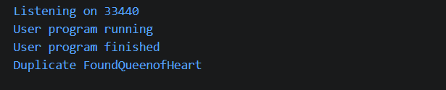
Learning Outcome:

In this practical, I learned how to use classes, constructors, equals(), and hashCode() in Java. I also learned how to compare card objects and find duplicate cards using their rank and suit.

Problem-3:
Aim:

3.(For Advanced Learners – home) Fractions (Fraction.java + Driver.java)
(a) Create class Fraction with private int num, den.
(b) In the constructor, reduce to lowest terms: compute g = gcd(num, den) and divide
both by g.
(c) Override toString() to return num + “/” + den.
(d) Override equals()/hashCode() using the reduced num and den.
(e) In Driver.main: create several equivalent fractions (1/2, 2/4, 3/6) and confirm they
are all equal and print the same.
Expected output: new Fraction(2,4) prints “1/2” and equals new Fraction(1,2).

Code Screenshot:
Fraction.java
public class Fraction {

private int num;
private int den;

public Fraction(int num, int den) {

if (den == 0) {
throw new ArithmeticException("Can't divide by 0");
}

// Keep denominator positive
if (den < 0) {
num = -num;
den = -den;
}

int g = gcd(num, den);

this.num = num / g;
this.den = den / g;
}

private static int gcd(int a, int b) {
return (b == 0) ? Math.abs(a) : gcd(b, a % b);
}

@Override
public String toString() {
return num + "/" + den;
}

@Override
public boolean equals(Object obj) {

if (this == obj) {
return true;
}

if (obj == null || !(obj instanceof Fraction)) {
return false;
}

Fraction other = (Fraction) obj;

return this.num == other.num && this.den == other.den;
}

@Override
public int hashCode() {
return 31 * num + den;
}
}
Driver.java
public class Driver {

public static void main(String[] args) {

Fraction f1 = new Fraction(1, 2);
Fraction f2 = new Fraction(2, 4);
Fraction f3 = new Fraction(3, 6);
Fraction f4 = new Fraction(10, 2);

System.out.println("Fractions:");
System.out.println(f1);
System.out.println(f2);
System.out.println(f3);
System.out.println(f4);

System.out.println();

System.out.println("Equality:");
System.out.println("f1 equals f2: " + f1.equals(f2));
System.out.println("f2 equals f3: " + f2.equals(f3));
System.out.println("f1 equals f3: " + f1.equals(f3));
}
}

Output Screenshot:
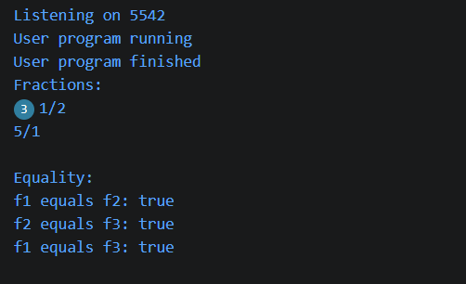
Learning Outcome:
In this practical, I learned how to create a Fraction class and reduce fractions to their simplest form. I also learned how to use gcd, toString(), equals(), and hashCode() to compare equivalent fractions.

