PRACTICAL – 4 Part-A

Problem-1:

Aim:

1. Password strength (PasswordChecker.java + Driver.java)
(a) In PasswordChecker, check four rules — length ≥ 8, contains an uppercase letter,
contains a digit, contains a special character — using regex (e.g. “.*[A-Z].*”) or
String methods.
(b) Write strength(String pw) that counts how many rules pass and returns “Weak” (0–
1), “Medium” (2–3) or “Strong” (4).
(c) In Driver.main: test several passwords; for each, print which rules passed and the
final label.
Expected output: “abc” → Weak; “Abcd1234!” → Strong.

Code Screenshot:

PasswordChecker.java
public class PasswordChecker {

public static boolean lengthCheck(String pw) {
return pw.length() >= 8;
}

public static boolean uppercaseCheck(String pw) {
return pw.matches(".*[A-Z].*");
}

public static boolean digitCheck(String pw) {
return pw.matches(".*[0-9].*");
}

public static boolean specialCheck(String pw) {
return pw.matches(".*[^a-zA-Z0-9].*");
}

public static String strength(String pw) {
int count = 0;

if (lengthCheck(pw)) count++;
if (uppercaseCheck(pw)) count++;
if (digitCheck(pw)) count++;
if (specialCheck(pw)) count++;

if (count <= 1)
return "Weak";
else if (count <= 3)
return "Medium";
else
return "Strong";
}
}

Driver.java
public class Driver {

public static void main(String[] args) {

String[] passwords = {
"abc",
"abcdefgh",
"Abcdefgh",
"Abcd1234",
"Abcd1234!"
};

for (String pw : passwords) {

System.out.println("Password: " + pw);
int count = 0;

if (PasswordChecker.lengthCheck(pw)) {
count++;
System.out.println("Length >= 8: Passed");
} else {
System.out.println("Length >= 8: Failed");
}

if (PasswordChecker.uppercaseCheck(pw)) {
count++;
System.out.println("Uppercase letter: Passed");
} else {
System.out.println("Uppercase letter: Failed");
}

if (PasswordChecker.digitCheck(pw)) {
count++;
System.out.println("Digit: Passed");
} else {
System.out.println("Digit: Failed");
}

if (PasswordChecker.specialCheck(pw)) {
count++;
System.out.println("Special character: Passed");
} else {
System.out.println("Special character: Failed");
}
System.out.println("Strength: " + PasswordChecker.strength(pw));
System.out.println("Passed checks: " + count);
System.out.println();
}
}
}

Output Screenshot:
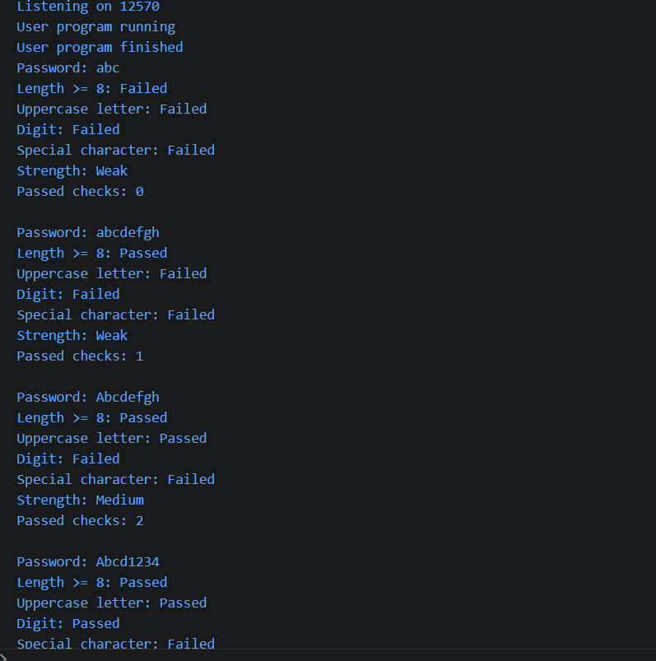
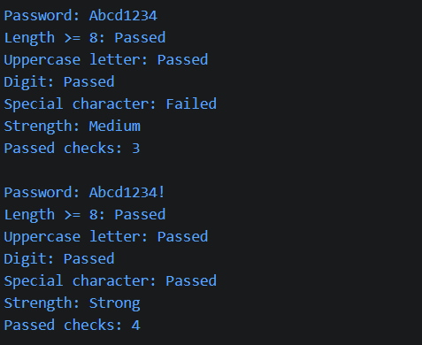

Learning Outcome:

In this practical, I learned how to check different password rules using String methods or regular expressions. I also learned how to count the rules passed and classify a password as Weak, Medium, or Strong.

Problem-2:
Aim:

2. Chat-log filter (ChatFilter.java + Driver.java)
(a) In Driver.main, define a String[] of log lines like “10:05 alice Hello there” (include
one malformed line with fewer than 3 parts).
(b) Read a keyword from the user.
(c) For each line, split into time/user/message with split(“ ”, 3); skip lines that do not
have 3 parts.
(d) If the message contains the keyword (case-insensitive), increment a counter and
append “time user: message” to a StringBuilder.
(e) Print “Matches: N” and the built report.
Expected output: keyword “hello” over 3 lines (1 malformed) → “Matches: 1” and
the matching line.

Code Screenshot:

ChatFilter.java
public class ChatFilter {

public static String filter(String[] logs, String keyword) {
StringBuilder report = new StringBuilder();
int count = 0;

for (String line : logs) {
String[] parts = line.split(" ", 3);

if (parts.length < 3)
continue;

String time = parts[0];
String user = parts[1];
String message = parts[2];

if (message.toLowerCase().contains(keyword.toLowerCase())) {
count++;
report.append(time)
.append(" ")
.append(user)
.append(": ")
.append(message)
.append("\n");
}
}

return "Matches: " + count + "\n" + report;
}
}

Driver.java
import java.util.Scanner;

public class Driver {

public static void main(String[] args) {

String[] logs = {
"10:05 alice Hello there",
"10:06 bob How are you?",
"10:07 Charlie Good morning"
};

Scanner sc = new Scanner(System.in);

System.out.print("Enter keyword: ");
String keyword = sc.nextLine();

String result = ChatFilter.filter(logs, keyword);

System.out.println(result);

sc.close();
}
}

Output Screenshot:

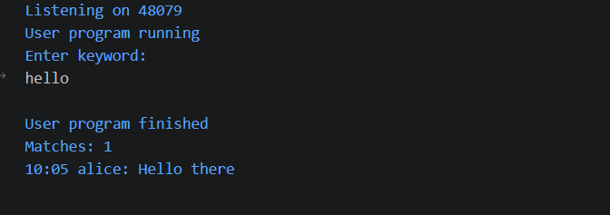
Learning Outcome:

In this practical, I learned how to split strings, search for keywords, and handle invalid input in Java. I also learned how to use StringBuilder to create a simple report from matching chat messages.
Problem-3:
Aim:

3. (For Advanced Learners – home) Template filler (TemplateFiller.java +
Driver.java)
(a) In Driver.main, define a template like “Dear {name}, order {id} ships {date}.” and
two parallel arrays: names {“name”, “id”} and values {“Riya”, “A07”} (note {date}
is not supplied).
(b) Compile a Pattern for \{(\w+)\} and get a Matcher on the template.
(c) Walk the matches with a StringBuilder: for each {placeholder}, look up its value in
the names array and replace with the value, or with “[?]” if not found.
(d) Print the filled template.
Expected output: the unsupplied {date} becomes [?].
Code Screenshot:
TemplateFiller.java
import java.util.regex.Matcher;
import java.util.regex.Pattern;

public class TemplateFilter{

public static String FTemplate(String template, String[] names, String[] values) {

Pattern pattern = Pattern.compile("\\{(\\w+)\\}");
Matcher matcher = pattern.matcher(template);

StringBuilder result = new StringBuilder();

int lastIndex = 0;

while (matcher.find()) {

result.append(template.substring(lastIndex, matcher.start()));

String key = matcher.group(1);

String replacement = "[?]";

for (int i = 0; i < names.length; i++) {
if (names[i].equals(key)) {
replacement = values[i];
break;
}
}

result.append(replacement);

lastIndex = matcher.end();
}

result.append(template.substring(lastIndex));

return result.toString();
}
}

Driver.java
public class Driver {

public static void main(String[] args) {

String template = "Dear {name}, order {id} ships {date}.";

String[] names = {
"name",
"id"
};

String[] values = {
"Rishit",
"089"
};

String output = TemplateFilter.FTemplate(template, names, values);

System.out.println(output);
}
}

Output Screenshot:
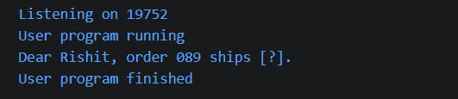
Learning Outcome:
In this practical, I learned how to use Pattern and Matcher to find placeholders in a string. I also learned how to replace the available values and show [?] when a value is not provided.

