PRACTICAL – 5 Part-A

Problem-1:

Aim:

Shape areas: an abstract Shape with abstract area(); subclasses Circle, Rectangle,
Triangle. Put a mix in a Shape[] and loop once to print each area and the running total,
tracking the largest — one loop handling every shape through polymorphism.

Code Screenshot:

abstract class Shape{
abstract double area();
}

class Circle extends Shape{
int radius = 0;
Circle(int radius){
this.radius = radius;
}

@Override
double area() {
return Math.PI*radius*radius;
}
}

class Rectangle extends Shape{
int length = 0;
int width = 0;

Rectangle(int length , int width){
this.length = length;
this.width = width;
}

@Override
double area(){
return length*width;
}
}

class Triangle extends Shape{
int height = 0;
int base = 0;

Triangle(int height, int base){
this.height = height;
this.base = base;
}

@Override
double area(){
return 0.5 * height * base;
}
}

public class Shape1{
public static void main(String[] args){
Shape[] shapes = {
new Circle(5),
new Rectangle(10, 20),
new Triangle(20, 5)
};

double total = 0;
double largest = 0;

for(Shape shape: shapes){
double area = shape.area();
total += area;
System.out.println("Area : " + area);

if(area>largest){
largest = area;
}
}

System.out.println("Total Area :" + total);
System.out.println("Largest :" + largest);

}
}

Output Screenshot:

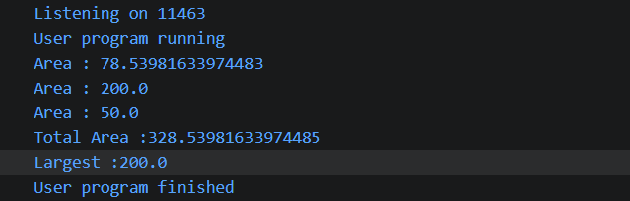

Learning Outcome:

In this practical, I learned how to use abstract classes and methods, create different shape classes, and calculate their areas. I also learned how polymorphism works by using a Shape array to handle different shapes in one loop.

Problem-2:
Aim:

Payroll: an abstract Employee with abstract monthlySalary(); FullTime (fixed), PartTime
(hours × rate) and Intern (stipend), each calling super for the shared name/id. Loop a
mixed array to print each salary and the total; use instanceof to add a note only for
interns.

Code Screenshot:

abstract class Employee {
String name;
int id;

Employee(String name, int id) {
this.name = name;
this.id = id;
}

abstract int monthlySalary();
}

class FullTime extends Employee {
int salary;

FullTime(String name, int id, int salary) {
super(name, id);
this.salary = salary;
}

@Override
int monthlySalary() {
return salary;
}
}

class PartTime extends Employee {
int hoursWorked;
int hourRate;

PartTime(String name, int id, int hoursWorked, int hourRate) {
super(name, id);
this.hoursWorked = hoursWorked;
this.hourRate = hourRate;
}

@Override
int monthlySalary() {
return hoursWorked * hourRate;
}
}

class Intern extends Employee {
int stipend;

Intern(String name, int id, int stipend) {
super(name, id);
this.stipend = stipend;
}

@Override
int monthlySalary() {
return stipend;
}
}

public class Payroll {
public static void main(String[] args) {

Employee[] employees = {
new FullTime("Rishit", 101, 50000),
new PartTime("keval", 102, 80, 200),
new Intern("shreyansh", 103, 10000),
new FullTime("hasti", 104, 45000)
};

int total = 0;

for (Employee employee : employees) {

int salary = employee.monthlySalary();

System.out.println(
employee.name + " (ID: " + employee.id + ") Salary: " + salary
);

total += salary;

if (employee instanceof Intern) {
System.out.println("Note: This employee is an intern.");
}
}

System.out.println("Total Payroll: " + total);
}
}

Output Screenshot:

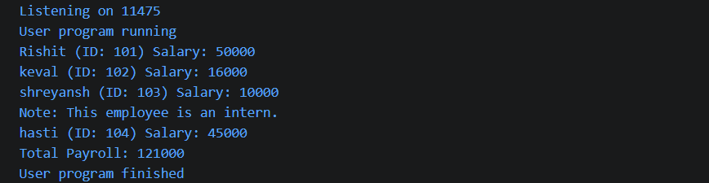
Learning Outcome:

In this practical, I learned how to use abstract classes, inheritance, and method overriding in Java. I also learned how to calculate salaries for different types of employees and use instanceof to identify interns.

Problem-3:
Aim:

(For Advanced Learners – home) Model a few media types that each compute a late fee
differently and total the fees for a returned batch. Design the hierarchy and rules yourself.
Code Screenshot:
abstract class Media {
String title;
int daysLate;

Media(String title, int daysLate) {
this.title = title;
this.daysLate = daysLate;
}

abstract int lateFee();
}

class Movie extends Media {

Movie(String title, int daysLate) {
super(title, daysLate);
}

@Override
int lateFee() {
return daysLate * 20;
}
}

class Game extends Media {

Game(String title, int daysLate) {
super(title, daysLate);
}

@Override
int lateFee() {
return daysLate * 40;
}
}

class Book extends Media {

Book(String title, int daysLate) {
super(title, daysLate);
}

@Override
int lateFee() {
return daysLate * 10;
}
}

public class MediaRental {
public static void main(String[] args) {

Media[] returnedMedia = {
new Movie("Avatar", 3),
new Game("GTA", 2),
new Book("Java OOP", 5),
new Movie("Batman", 2),
new Game("FIFA", 3)
};

int totalFee = 0;

for (Media media : returnedMedia) {

int fee = media.lateFee();

System.out.println(
media.title + " | Days Late: " +
media.daysLate + " | Late Fee: ₹" + fee
);

totalFee += fee;
}

System.out.println("Total Late Fees: ₹" + totalFee);
}
}

Output Screenshot:
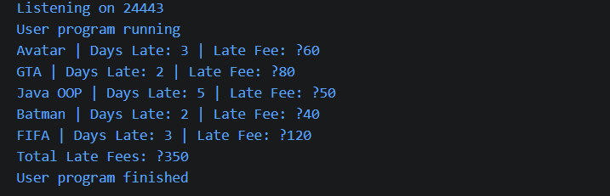

Learning Outcome:
In this practical, I learned how to create a class hierarchy for different media types and apply different late-fee rules. I also learned how to use inheritance and polymorphism to calculate the total late fees.

