PRACTICAL – 6 Part-A

Problem-1:

Aim:

1. Remote control: an interface Switchable with on()/off() and a default toggle(); Fan and
Light implement it. Loop over a Switchable[] toggling each. Then add a functional
interface that decides, given a device and an hour, whether it may switch on, and supply it
once as an anonymous class and once as a lambda.

Code Screenshot:

interface Switchable {
void on();
void off();
boolean isOn();

default void toggle() {
if (isOn()) {
off();
} else {
on();
}
}
}

class Fan implements Switchable {
private boolean running = false;

public void on() {
running = true;
System.out.println("Fan is ON");
}

public void off() {
running = false;
System.out.println("Fan is OFF");
}

public boolean isOn() {
return running;
}
}

class Light implements Switchable {
private boolean glowing = false;

public void on() {
glowing = true;
System.out.println("Light is ON");
}

public void off() {
glowing = false;
System.out.println("Light is OFF");
}

public boolean isOn() {
return glowing;
}
}

@FunctionalInterface
interface SwitchPermission {
boolean maySwitchOn(Switchable device, int hour);
}

public class RemoteControl {
public static void main(String[] args) {
Switchable[] devices = {new Fan(), new Light()};

System.out.println("First toggle:");
for (Switchable device : devices) {
device.toggle();
}

System.out.println("\nSecond toggle:");
for (Switchable device : devices) {
device.toggle();
}

SwitchPermission anonymousRule = new SwitchPermission() {
public boolean maySwitchOn(Switchable device, int hour) {
if (device instanceof Fan) {
return hour >= 6 && hour < 22;
}
return hour >= 17 && hour < 23;
}
};

System.out.println("\nAnonymous class at 20:00:");
for (Switchable device : devices) {
if (anonymousRule.maySwitchOn(device, 20)) {
device.on();
}
}

for (Switchable device : devices) {
device.off();
}

SwitchPermission lambdaRule = (device, hour) ->
device instanceof Fan || (hour >= 6 && hour < 18);

System.out.println("\nLambda at 23:00:");
for (Switchable device : devices) {
if (lambdaRule.maySwitchOn(device, 23)) {
device.on();
} else {
System.out.println(
device.getClass().getSimpleName() + " is not allowed ON"
);
}
}
}
}

Output Screenshot:

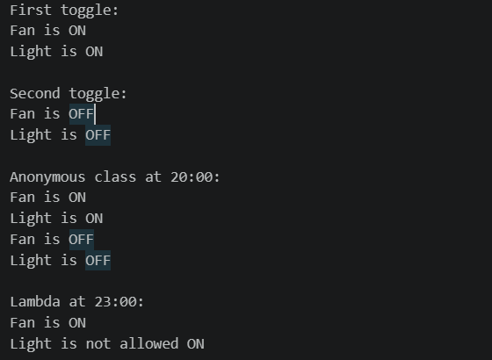

Learning Outcome:

Remote Control: I learned how to create an interface with a default toggle() method and implement it in Fan and Light. I used a Switchable[] to handle both devices in one loop. I also learned to write a switching rule using an anonymous class and a lambda expression.
Problem-2:
Aim:

2. Notification senders: a functional interface Notifier with send(String); make email and
SMS senders as lambdas, hold them in an array, and broadcast one message through all.
Add a marker interface Urgent and send twice for senders marked urgent.
Code Screenshot:

@FunctionalInterface
interface Notifier {
void send(String message);
}

interface Urgent {
}

public class NotificationSenders {
public static void main(String[] args) {
Notifier email = message ->
System.out.println("Email sent: " + message);

Notifier sms = (Notifier & Urgent) message ->
System.out.println("SMS sent: " + message);

Notifier[] senders = {email, sms};
String message = "Lab practical starts at 10 AM.";

for (Notifier sender : senders) {
sender.send(message);

if (sender instanceof Urgent) {
sender.send(message);
}
}
}
}
Output Screenshot:

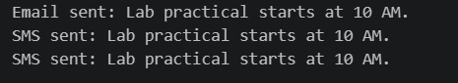
Learning Outcome:

Notification Senders: I learned how to create email and SMS senders using a functional interface and lambdas. I stored the senders in an array and sent one message through both. I used the Urgent marker interface to identify the SMS sender and send its message twice.
Problem-3:
Aim:

3. (For Advanced Learners – home) Build a small discount engine where each rule is a
lambda the user picks at runtime and applies to a list of prices; organise it into packages
and ship it as a runnable JAR.
Code Screenshot:
Main.java
package com.shop.app;

import java.util.ArrayList;
import java.util.List;
import java.util.Scanner;
import com.shop.rules.DiscountRule;
import com.shop.service.DiscountEngine;

public class Main {
public static void main(String[] args) {
Scanner sc = new Scanner(System.in);
List<Double> prices = new ArrayList<>();

System.out.print("How many products? ");
int count = sc.nextInt();

for (int i = 0; i < count; i++) {
System.out.print("Enter price " + (i + 1) + ": ");
prices.add(sc.nextDouble());
}

DiscountRule[] rules = {
price -> price * 0.90,
price -> Math.max(0, price - 100),
price -> price >= 1000 ? price * 0.80 : price
};

System.out.println("\nChoose a discount:");
System.out.println("1. 10% off");
System.out.println("2. Rs.100 off");
System.out.println("3. 20% off if price is Rs.1000 or more");
System.out.print("Enter choice: ");

int choice = sc.nextInt();

if (choice < 1 || choice > 3) {
System.out.println("Invalid choice");
sc.close();
return;
}

DiscountRule selectedRule = rules[choice - 1];
DiscountEngine engine = new DiscountEngine();
List<Double> finalPrices = engine.applyDiscount(prices, selectedRule);

System.out.println("\nFinal prices:");

for (int i = 0; i < prices.size(); i++) {
System.out.printf("Rs.%.2f -> Rs.%.2f%n",
prices.get(i), finalPrices.get(i));
}

sc.close();
}
}
DiscountRule.java
package com.shop.rules;

@FunctionalInterface
public interface DiscountRule {
double apply(double price);
}
DiscountEngine.java

Output Screenshot:

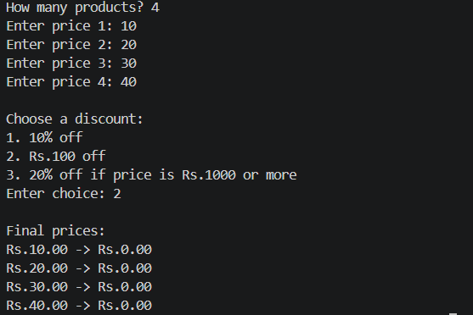
Learning Outcome:
Discount Engine: I learned how to let the user choose a discount rule while the program is running. I applied the selected lambda to every price in a list. I also learned to organise Java files into packages and build a runnable JAR file.

