PRACTICAL – 7 Part-A

Problem-1:

Aim:

1. Form validator: define @NotBlank and @MaxLength(int) for fields and annotate a SignupForm. Write a checker that uses reflection to read each field’s annotations and returns the list of validation errors for a given object.

Code Screenshot:
import java.lang.annotation.*;
import java.lang.reflect.Field;
import java.util.ArrayList;
import java.util.List;
import java.util.Scanner;

@Retention(RetentionPolicy.RUNTIME)
@Target(ElementType.FIELD)
@interface NotBlank {
}

@Retention(RetentionPolicy.RUNTIME)
@Target(ElementType.FIELD)
@interface MaxLength {
int value();
}

class SignupForm {
@NotBlank
@MaxLength(15)
private String username;

@NotBlank
@MaxLength(30)
private String email;

@NotBlank
@MaxLength(12)
private String password;

SignupForm(String username, String email, String password) {
this.username = username;
this.email = email;
this.password = password;
}
}

class Checker {
public static List<String> validate(Object object) {
List<String> errors = new ArrayList<>();
Field[] fields = object.getClass().getDeclaredFields();

for (Field field : fields) {
field.setAccessible(true);

try {
Object value = field.get(object);

if (field.isAnnotationPresent(NotBlank.class)) {
if (value == null || value.toString().trim().isEmpty()) {
errors.add(field.getName() + " cannot be blank");
}
}

MaxLength max = field.getAnnotation(MaxLength.class);

if (max != null && value != null) {
if (value.toString().length() > max.value()) {
errors.add(
field.getName() + " cannot exceed "
+ max.value() + " characters"
);
}
}
} catch (IllegalAccessException e) {
errors.add("Cannot access " + field.getName());
}
}

return errors;
}
}

public class FormValidator {
public static void main(String[] args) {
Scanner sc = new Scanner(System.in);

System.out.print("Enter username: ");
String username = sc.nextLine();

System.out.print("Enter email: ");
String email = sc.nextLine();

System.out.print("Enter password: ");
String password = sc.nextLine();

SignupForm form = new SignupForm(username, email, password);
List<String> errors = Checker.validate(form);

if (errors.isEmpty()) {
System.out.println("Form submitted successfully");
} else {
System.out.println("Validation errors:");

for (String error : errors) {
System.out.println(error);
}
}

sc.close();
}
}

Output Screenshot:

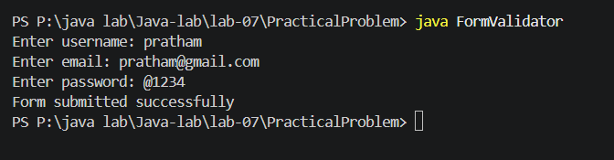

Learning Outcome:

I learned how to create custom field annotations like @NotBlank and @MaxLength. I used reflection to read annotations and validate the fields of an object. I also learned to collect multiple validation errors in a list.
Problem-2:
Aim:

2. Mini test runner: define a @Run annotation and mark some no-arg methods of a class with it. Use reflection to find and invoke only the @Run methods and report how many ran — the idea behind how JUnit finds @Test methods.

Code Screenshot:
import java.lang.annotation.*;
import java.lang.reflect.Method;

@Retention(RetentionPolicy.RUNTIME)
@Target(ElementType.METHOD)
@interface Run {
}

class TestCases {
@Run
public void loginTest() {
System.out.println("Login test completed");
}

@Run
public void paymentTest() {
System.out.println("Payment test completed");
}

public void normalMethod() {
System.out.println("Normal method completed");
}

@Run
public void logoutTest() {
System.out.println("Logout test completed");
}
}

public class MiniTestRunner {
public static void main(String[] args) {
TestCases testObject = new TestCases();
Method[] methods = TestCases.class.getDeclaredMethods();
int count = 0;

for (Method method : methods) {
if (method.isAnnotationPresent(Run.class)
&& method.getParameterCount() == 0) {
try {
System.out.println("Running: " + method.getName());
method.invoke(testObject);
count++;
} catch (Exception e) {
System.out.println(method.getName() + " failed");
}
}
}

System.out.println("Total methods run: " + count);
}
}

Output Screenshot:

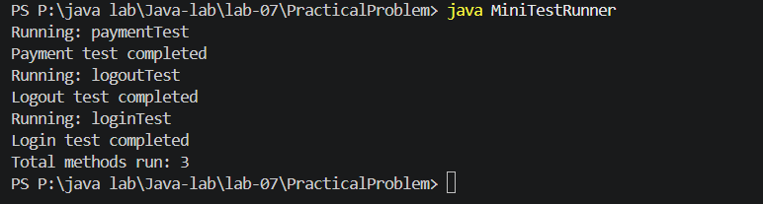
Learning Outcome:

I learned how to create a method annotation named @Run. I used reflection to find and execute only the annotated methods. I also understood the basic working of test frameworks like JUnit.
Problem-3:
Aim:

3. (For Advanced Learners – home) Define a @Column(name) annotation and, by reflection, populate an object’s fields from a header row and a data row by matching column names; decide how to handle a missing column.
Code Screenshot:
import java.lang.annotation.*;
import java.lang.reflect.Field;
import java.util.Scanner;

@Retention(RetentionPolicy.RUNTIME)
@Target(ElementType.FIELD)
@interface Column {
String name();
}

class Student {
@Column(name = "student_id")
private int id;

@Column(name = "student_name")
private String name;

@Column(name = "marks")
private double marks;

public String toString() {
return "Student ID: " + id
+ "\nStudent Name: " + name
+ "\nMarks: " + marks;
}
}

class ObjectMapper {
public static <T> T createObject(
Class<T> className,
String[] headers,
String[] data) throws Exception {

T object = className.getDeclaredConstructor().newInstance();
Field[] fields = className.getDeclaredFields();

for (Field field : fields) {
Column column = field.getAnnotation(Column.class);

if (column == null) {
continue;
}

int columnIndex = -1;

for (int i = 0; i < headers.length; i++) {
if (headers[i].trim().equalsIgnoreCase(column.name())) {
columnIndex = i;
break;
}
}

if (columnIndex == -1 || columnIndex >= data.length) {
System.out.println(
"Missing column: " + column.name()
+ ". Default value is used."
);
continue;
}

String value = data[columnIndex].trim();
field.setAccessible(true);

if (field.getType() == int.class) {
field.setInt(object, Integer.parseInt(value));
} else if (field.getType() == double.class) {
field.setDouble(object, Double.parseDouble(value));
} else if (field.getType() == String.class) {
field.set(object, value);
}
}

return object;
}
}

public class ColumnMapper {
public static void main(String[] args) throws Exception {
Scanner sc = new Scanner(System.in);

System.out.println("Enter column names separated by commas:");
String[] headers = sc.nextLine().split(",");

System.out.println("Enter data values separated by commas:");
String[] data = sc.nextLine().split(",");

Student student = ObjectMapper.createObject(
Student.class, headers, data
);

System.out.println("\nMapped object:");
System.out.println(student);

sc.close();
}
}

Output Screenshot:

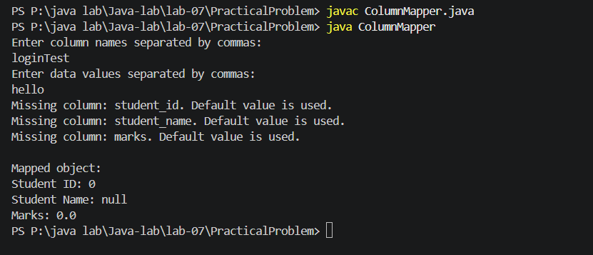
Learning Outcome:
I learned how to create a @Column annotation and match column names with object fields. I used reflection to populate an object from header and data rows. I also learned to handle missing columns by displaying a message and keeping the default field value.

