PRACTICAL – 8 Part-A

Problem-1:

Aim:

1. Guarded calculator: read two numbers and an operator; throw a custom
DivideByZeroException and catch invalid-number input separately, printing a clear
message each time; loop until a valid calculation succeeds and use finally to log each
attempt.

Code Screenshot:
import java.util.Scanner;

class DivideByZeroException extends Exception {
DivideByZeroException(String message) {
super(message);
}
}

public class GuardedCalculator {
public static void main(String[] args) {
Scanner sc = new Scanner(System.in);
boolean success = false;
int attempt = 0;

while (!success) {
attempt++;

try {
System.out.print("Enter first number: ");
double first = Double.parseDouble(sc.nextLine());

System.out.print("Enter second number: ");
double second = Double.parseDouble(sc.nextLine());

System.out.print("Enter operator (+, -, *, /): ");
String operator = sc.nextLine();

double result;

switch (operator) {
case "+":
result = first + second;
break;

case "-":
result = first - second;
break;

case "*":
result = first * second;
break;

case "/":
if (second == 0) {
throw new DivideByZeroException(
"Division by zero is not allowed"
);
}
result = first / second;
break;

default:
throw new IllegalArgumentException(
"Please enter a valid operator"
);
}

System.out.println("Result: " + result);
success = true;

} catch (NumberFormatException e) {
System.out.println(
"Invalid number. Please enter numeric values."
);

} catch (DivideByZeroException e) {
System.out.println(e.getMessage());

} catch (IllegalArgumentException e) {
System.out.println(e.getMessage());

} finally {
System.out.println("Attempt " + attempt + " logged.");
System.out.println();
}
}

sc.close();
}
}

Output Screenshot:

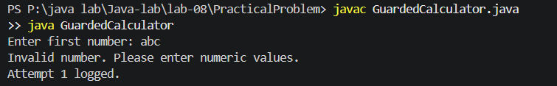

Learning Outcome:

I learned how to create and throw a custom DivideByZeroException. I handled invalid numbers and invalid operators using separate catch blocks. I also used a loop to continue until a valid calculation succeeds and finally to record every attempt.
Problem-2:
Aim:

2. Stock issue: a Warehouse where issue(item, qty) throws a custom checked
OutOfStockException carrying the shortfall, and InvalidQuantityException for qty ≤ 0.
Process a list of requests, catching and reporting each failure without stopping the run.

Code Screenshot:
import java.util.ArrayList;
import java.util.HashMap;
import java.util.List;
import java.util.Map;

class OutOfStockException extends Exception {
private int shortfall;

OutOfStockException(String message, int shortfall) {
super(message);
this.shortfall = shortfall;
}

public int getShortfall() {
return shortfall;
}
}

class InvalidQuantityException extends Exception {
InvalidQuantityException(String message) {
super(message);
}
}

class Warehouse {
private Map<String, Integer> stock = new HashMap<>();

Warehouse() {
stock.put("Pen", 10);
stock.put("Notebook", 5);
stock.put("Mouse", 2);
}

public void issue(String item, int quantity)
throws OutOfStockException, InvalidQuantityException {

if (quantity <= 0) {
throw new InvalidQuantityException(
"Quantity must be greater than zero"
);
}

int available = stock.getOrDefault(item, 0);

if (quantity > available) {
throw new OutOfStockException(
item + " has insufficient stock",
quantity - available
);
}

stock.put(item, available - quantity);

System.out.println(
quantity + " " + item + " issued. Remaining: "
+ stock.get(item)
);
}
}

class Request {
String item;
int quantity;

Request(String item, int quantity) {
this.item = item;
this.quantity = quantity;
}
}

public class StockIssue {
public static void main(String[] args) {
Warehouse warehouse = new Warehouse();
List<Request> requests = new ArrayList<>();

requests.add(new Request("Pen", 4));
requests.add(new Request("Notebook", 8));
requests.add(new Request("Mouse", 0));
requests.add(new Request("Pen", 7));
requests.add(new Request("Mouse", 1));

for (Request request : requests) {
try {
warehouse.issue(request.item, request.quantity);

} catch (OutOfStockException e) {
System.out.println(
"Request failed: " + e.getMessage()
+ ". Shortfall: " + e.getShortfall()
);

} catch (InvalidQuantityException e) {
System.out.println(
"Request failed: " + e.getMessage()
);
}
}

System.out.println("All requests processed");
}
}

Output Screenshot:

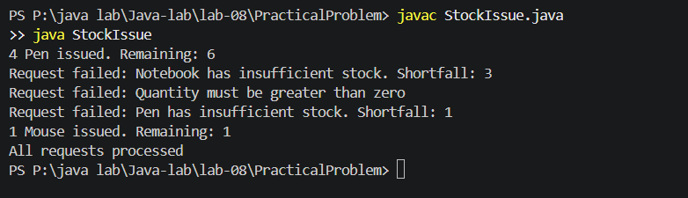
Learning Outcome:

I learned how to create checked exceptions for invalid quantity and insufficient stock. The OutOfStockException also stores and returns the stock shortfall. I processed every request separately so one failed request does not stop the remaining requests.
Problem-3:
Aim:

3. (For Advanced Learners – home) Create an AutoCloseable resource and use try-with-
resources to prove it always closes — even when an exception is thrown inside the block

— and that the original error is the one reported. Decide what to model as the resource.Code Screenshot:
class DatabaseConnection implements AutoCloseable {
private boolean open;

DatabaseConnection() {
open = true;
System.out.println("Database connection opened");
}

public void readData() throws Exception {
if (!open) {
throw new Exception("Connection is already closed");
}

System.out.println("Reading data from database");
throw new Exception("Original error while reading data");
}

@Override
public void close() throws Exception {
open = false;
System.out.println("Database connection closed");
throw new Exception("Error while closing connection");
}
}

public class AutoCloseableDemo {
public static void main(String[] args) {
try (DatabaseConnection connection =
new DatabaseConnection()) {

connection.readData();

} catch (Exception e) {
System.out.println("Reported error: " + e.getMessage());

for (Throwable error : e.getSuppressed()) {
System.out.println(
"Suppressed error: " + error.getMessage()
);
}
}
}
}

Output Screenshot:

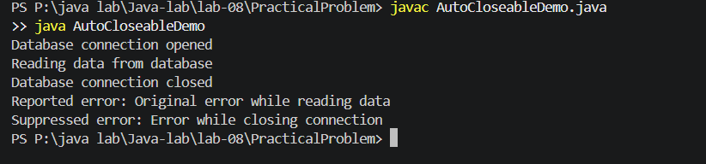
Learning Outcome:
I learned how to create a custom resource by implementing AutoCloseable. I used try-with-resources to close the database connection automatically when an exception occurred. I also learned that the original error remains the main exception, while a closing error becomes a suppressed exception.

