PRACTICAL – 9 Part-A

Problem-1:

Aim:

1. Counter race: several threads each increment a shared counter many times. Run it
without synchronization to watch the total come out too low, then make the increment
synchronized and confirm it is exactly right every run.

Code Screenshot:

CounterRace.java

class UnsafeCounter {
private int count = 0;

public void increment() {
count++;
}

public int getCount() {
return count;
}
}

class SafeCounter {
private int count = 0;

public synchronized void increment() {
count++;
}

public int getCount() {
return count;
}
}

public class CounterRace {
static final int THREAD_COUNT = 8;
static final int INCREMENTS = 500000;

static void runThreads(Runnable task)
throws InterruptedException {

Thread[] threads = new Thread[THREAD_COUNT];

for (int i = 0; i < THREAD_COUNT; i++) {
threads[i] = new Thread(() -> {
for (int j = 0; j < INCREMENTS; j++) {
task.run();
}
});

threads[i].start();
}

for (Thread thread : threads) {
thread.join();
}
}

static int runWithoutSynchronization()
throws InterruptedException {

UnsafeCounter counter = new UnsafeCounter();
runThreads(counter::increment);
return counter.getCount();
}

static int runWithSynchronization()
throws InterruptedException {

SafeCounter counter = new SafeCounter();
runThreads(counter::increment);
return counter.getCount();
}

public static void main(String[] args)
throws InterruptedException {

int expected = THREAD_COUNT * INCREMENTS;

System.out.println("Expected total: " + expected);

System.out.println("\nWithout synchronization:");

for (int i = 1; i <= 3; i++) {
int result = runWithoutSynchronization();
System.out.println("Run " + i + ": " + result);
}

System.out.println("\nWith synchronization:");

for (int i = 1; i <= 3; i++) {
int result = runWithSynchronization();
System.out.println("Run " + i + ": " + result);
}
}
}

Output Screenshot:
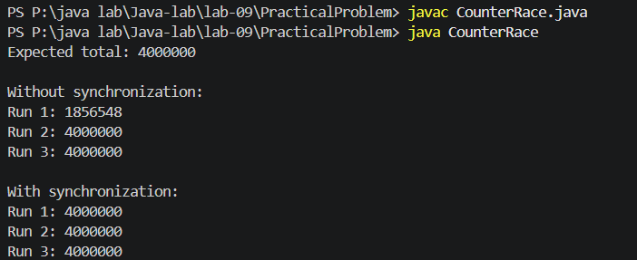

Learning Outcome:

I learned that multiple threads updating the same variable can create a race condition and lose some increments. I used the synchronized keyword to allow only one thread to increment the counter at a time. After synchronization, the final count becomes exactly equal to the expected count in every run.

Problem-2:
Aim:

2. Seat booking race: a shared seatsLeft of 5 with about 10 threads each trying to book one
seat. Without synchronization show that more than 5 can succeed (oversell); with a
synchronized book() exactly 5 do.

Code Screenshot:

SeatBookingRace.java
interface BookingSystem {
boolean book(String customer);
int getSeatsLeft();
}

class UnsafeBooking implements BookingSystem {
private int seatsLeft = 5;

public boolean book(String customer) {
if (seatsLeft > 0) {
try {
Thread.sleep(100);
} catch (InterruptedException e) {
Thread.currentThread().interrupt();
return false;
}

seatsLeft--;
System.out.println(customer + " booked a seat");
return true;
}

System.out.println(customer + " failed to book");
return false;
}

public int getSeatsLeft() {
return seatsLeft;
}
}

class SafeBooking implements BookingSystem {
private int seatsLeft = 5;

public synchronized boolean book(String customer) {
if (seatsLeft > 0) {
try {
Thread.sleep(100);
} catch (InterruptedException e) {
Thread.currentThread().interrupt();
return false;
}

seatsLeft--;
System.out.println(customer + " booked a seat");
return true;
}

System.out.println(customer + " failed to book");
return false;
}

public int getSeatsLeft() {
return seatsLeft;
}
}

public class SeatBookingRace {
static final int CUSTOMERS = 10;

static void runBooking(BookingSystem booking)
throws InterruptedException {

Thread[] threads = new Thread[CUSTOMERS];
boolean[] results = new boolean[CUSTOMERS];

for (int i = 0; i < CUSTOMERS; i++) {
int index = i;
String customer = "Customer " + (i + 1);

threads[i] = new Thread(() ->
results[index] = booking.book(customer)
);

threads[i].start();
}

for (Thread thread : threads) {
thread.join();
}

int successfulBookings = 0;

for (boolean result : results) {
if (result) {
successfulBookings++;
}
}

System.out.println(
"Successful bookings: " + successfulBookings
);
System.out.println(
"Seats left: " + booking.getSeatsLeft()
);
}

public static void main(String[] args)
throws InterruptedException {

System.out.println("Without synchronization:");
runBooking(new UnsafeBooking());

System.out.println("\nWith synchronization:");
runBooking(new SafeBooking());
}
}

Output Screenshot:

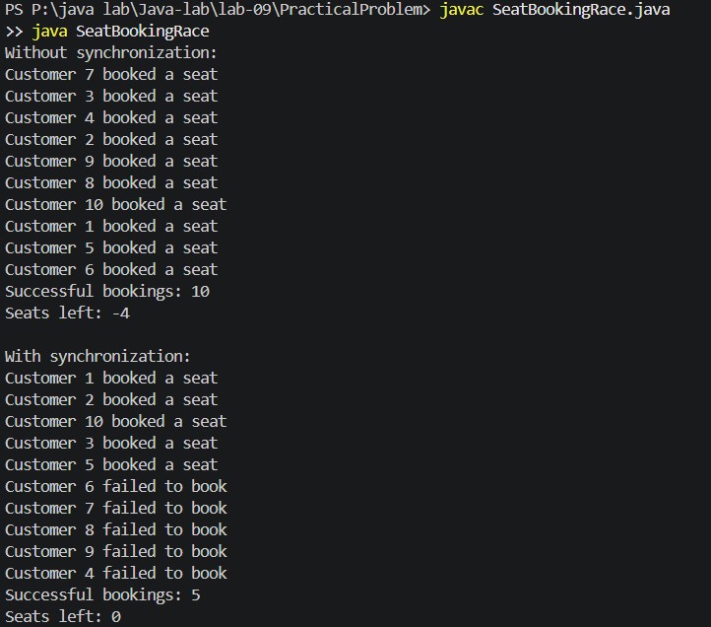
Learning Outcome:

I learned how unsynchronized threads can check and update the same seat count at the same time, causing overselling. I used a synchronized book() method so only one customer can check and book at a time. After synchronization, exactly five customers successfully book the five available seats.
Problem-3:
Aim:

3. (For Advanced Learners – home) Split a large array of numbers across several threads
that add into one shared total, show the wrong result, then fix it two ways and compare;
decide how to measure the difference.
Code Screenshot:
ArraySumRace.java
import java.util.concurrent.CountDownLatch;
import java.util.concurrent.atomic.AtomicLong;

interface TotalCounter {
void add(int number);
long getTotal();
}

class UnsafeTotal implements TotalCounter {
private long total = 0;

public void add(int number) {
total += number;
}

public long getTotal() {
return total;
}
}

class SynchronizedTotal implements TotalCounter {
private long total = 0;

public synchronized void add(int number) {
total += number;
}

public long getTotal() {
return total;
}
}

class AtomicTotal implements TotalCounter {
private AtomicLong total = new AtomicLong(0);

public void add(int number) {
total.addAndGet(number);
}

public long getTotal() {
return total.get();
}
}

class TestResult {
long total;
long time;

TestResult(long total, long time) {
this.total = total;
this.time = time;
}
}

public class ArraySumRace {
static final int THREADS = 8;

static TestResult calculate(
int[] numbers,
TotalCounter counter) throws InterruptedException {

Thread[] workers = new Thread[THREADS];
CountDownLatch start = new CountDownLatch(1);
int partSize = numbers.length / THREADS;

for (int i = 0; i < THREADS; i++) {
int startIndex = i * partSize;
int endIndex;

if (i == THREADS - 1) {
endIndex = numbers.length;
} else {
endIndex = startIndex + partSize;
}

workers[i] = new Thread(() -> {
try {
start.await();

for (int j = startIndex; j < endIndex; j++) {
counter.add(numbers[j]);

if (j % 10000 == 0) {
Thread.yield();
}
}
} catch (InterruptedException e) {
Thread.currentThread().interrupt();
}
});

workers[i].start();
}

long startTime = System.nanoTime();
start.countDown();

for (Thread worker : workers) {
worker.join();
}

long endTime = System.nanoTime();

return new TestResult(
counter.getTotal(),
endTime - startTime
);
}

static void display(
String method,
TestResult result,
long expected) {

long error = Math.abs(expected - result.total);
double milliseconds = result.time / 1_000_000.0;

System.out.println("\nMethod: " + method);
System.out.println("Calculated total: " + result.total);
System.out.println("Difference: " + error);
System.out.printf("Time: %.3f ms%n", milliseconds);
}

public static void main(String[] args)
throws InterruptedException {

int[] numbers = new int[1000000];
long expected = 0;

for (int i = 0; i < numbers.length; i++) {
numbers[i] = (i % 10) + 1;
expected += numbers[i];
}

TestResult unsafeResult =
calculate(numbers, new UnsafeTotal());

TestResult synchronizedResult =
calculate(numbers, new SynchronizedTotal());

TestResult atomicResult =
calculate(numbers, new AtomicTotal());

System.out.println("Expected total: " + expected);

display(
"Without synchronization",
unsafeResult,
expected
);

display(
"Synchronized method",
synchronizedResult,
expected
);

display(
"AtomicLong",
atomicResult,
expected
);
}
}

Output Screenshot:
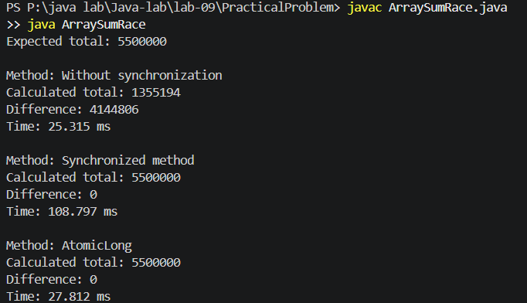
Learning Outcome:
I learned how race conditions can produce an incorrect total when multiple threads update the same variable. I fixed the problem using a synchronized method and AtomicLong. I compared the methods using their calculation difference and execution time measured with System.nanoTime().

