PRACTICAL – 10 Part-A

Problem-1:

Aim:

1. Thread-pool runner: with a fixed pool of 3 (ExecutorService), submit about 10 Runnable
tasks that print their id and sleep briefly; shut down and await completion, observing the
few threads being reused.

Code Screenshot:

ThreadPoolRunner.java

import java.util.concurrent.ExecutorService;
import java.util.concurrent.Executors;
import java.util.concurrent.TimeUnit;

public class ThreadPoolRunner {
public static void main(String[] args)
throws InterruptedException {

ExecutorService pool =
Executors.newFixedThreadPool(3);

for (int i = 1; i <= 10; i++) {
int taskId = i;

pool.submit(() -> {
String threadName =
Thread.currentThread().getName();

System.out.println(
"Task " + taskId
+ " started by " + threadName
);

try {
Thread.sleep(500);
} catch (InterruptedException e) {
Thread.currentThread().interrupt();
}

System.out.println(
"Task " + taskId
+ " completed by " + threadName
);
});
}

pool.shutdown();

boolean completed =
pool.awaitTermination(1, TimeUnit.MINUTES);

if (completed) {
System.out.println("All tasks completed");
} else {
System.out.println("Time limit exceeded");
pool.shutdownNow();
}
}
}

Output Screenshot:
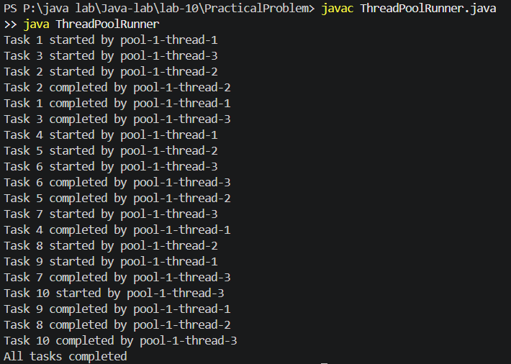

Learning Outcome:

I learned how to create a fixed thread pool using ExecutorService. I submitted multiple Runnable tasks and observed that three worker threads were reused to execute ten tasks. I also used shutdown() and awaitTermination() to wait until all tasks completed..

Problem-2:
Aim:

2. Producer–consumer: one thread adds numbers to a small shared buffer and another
removes them, coordinated with wait()/notify(); produce and consume a fixed number of
items in order with none lost.

Code Screenshot:

ProducerConsumer.java
import java.util.LinkedList;
import java.util.Queue;

class SharedBuffer {
private Queue<Integer> buffer = new LinkedList<>();
private int capacity;

SharedBuffer(int capacity) {
this.capacity = capacity;
}

public synchronized void produce(int number)
throws InterruptedException {

while (buffer.size() == capacity) {
wait();
}

buffer.add(number);

System.out.println(
"Produced: " + number
+ " | Buffer: " + buffer
);

notifyAll();
}

public synchronized int consume()
throws InterruptedException {

while (buffer.isEmpty()) {
wait();
}

int number = buffer.remove();

System.out.println(
"Consumed: " + number
+ " | Buffer: " + buffer
);

notifyAll();
return number;
}
}

public class ProducerConsumer {
public static void main(String[] args)
throws InterruptedException {

SharedBuffer buffer = new SharedBuffer(3);
int totalItems = 10;

Thread producer = new Thread(() -> {
try {
for (int i = 1; i <= totalItems; i++) {
buffer.produce(i);
Thread.sleep(100);
}
} catch (InterruptedException e) {
Thread.currentThread().interrupt();
}
});

Thread consumer = new Thread(() -> {
try {
for (int i = 1; i <= totalItems; i++) {
buffer.consume();
Thread.sleep(200);
}
} catch (InterruptedException e) {
Thread.currentThread().interrupt();
}
});

producer.start();
consumer.start();

producer.join();
consumer.join();

System.out.println("All items produced and consumed");
}
}

Output Screenshot:

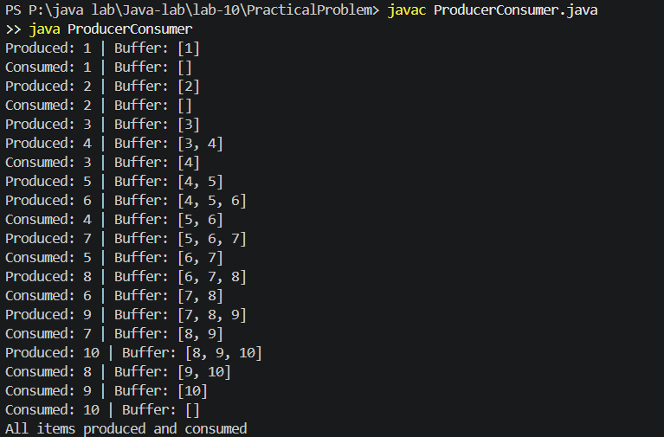
Learning Outcome:

I learned how producer and consumer threads share a small buffer. I used wait() when the buffer was full or empty and notifyAll() to wake the waiting thread. I also learned how synchronization prevents items from being lost or consumed in the wrong order.
Problem-3:
Aim:

3. (For Advanced Learners – home)Reproduce a deadlock between two threads that lock
two objects in opposite order, then remove it with a consistent lock order. Choose the
scenario yourself.

Code Screenshot:
DeadlockDemo.java
import java.util.concurrent.CountDownLatch;

class BankAccount {
private int id;
private String name;
private int balance;

BankAccount(int id, String name, int balance) {
this.id = id;
this.name = name;
this.balance = balance;
}

public int getId() {
return id;
}

public String getName() {
return name;
}

public int getBalance() {
return balance;
}

public void withdraw(int amount) {
balance -= amount;
}

public void deposit(int amount) {
balance += amount;
}
}

public class DeadlockDemo {
static void unsafeTransfer(
BankAccount from,
BankAccount to,
int amount,
CountDownLatch firstLocks) {

synchronized (from) {
System.out.println(
Thread.currentThread().getName()
+ " locked " + from.getName()
);

firstLocks.countDown();

try {
firstLocks.await();
} catch (InterruptedException e) {
Thread.currentThread().interrupt();
return;
}

System.out.println(
Thread.currentThread().getName()
+ " waiting for " + to.getName()
);

synchronized (to) {
from.withdraw(amount);
to.deposit(amount);
}
}
}

static void safeTransfer(
BankAccount from,
BankAccount to,
int amount) {

BankAccount first;
BankAccount second;

if (from.getId() < to.getId()) {
first = from;
second = to;
} else {
first = to;
second = from;
}

synchronized (first) {
synchronized (second) {
from.withdraw(amount);
to.deposit(amount);

System.out.println(
Thread.currentThread().getName()
+ " transferred Rs." + amount
+ " from " + from.getName()
+ " to " + to.getName()
);
}
}
}

public static void main(String[] args)
throws InterruptedException {

BankAccount accountA =
new BankAccount(1, "Account A", 1000);

BankAccount accountB =
new BankAccount(2, "Account B", 1000);

CountDownLatch firstLocks = new CountDownLatch(2);

Thread thread1 = new Thread(
() -> unsafeTransfer(
accountA, accountB, 100, firstLocks
),
"Thread 1"
);

Thread thread2 = new Thread(
() -> unsafeTransfer(
accountB, accountA, 100, firstLocks
),
"Thread 2"
);

thread1.setDaemon(true);
thread2.setDaemon(true);

System.out.println("Opposite lock order:");

thread1.start();
thread2.start();

thread1.join(1000);
thread2.join(1000);

if (thread1.isAlive() && thread2.isAlive()) {
System.out.println("Deadlock detected");
}

BankAccount safeA =
new BankAccount(1, "Account A", 1000);

BankAccount safeB =
new BankAccount(2, "Account B", 1000);

Thread safeThread1 = new Thread(
() -> safeTransfer(safeA, safeB, 100),
"Safe Thread 1"
);

Thread safeThread2 = new Thread(
() -> safeTransfer(safeB, safeA, 100),
"Safe Thread 2"
);

System.out.println("\nConsistent lock order:");

safeThread1.start();
safeThread2.start();

safeThread1.join();
safeThread2.join();

System.out.println("Both transfers completed");
System.out.println(
"Account A balance: Rs." + safeA.getBalance()
);
System.out.println(
"Account B balance: Rs." + safeB.getBalance()
);
}
}

Output Screenshot:
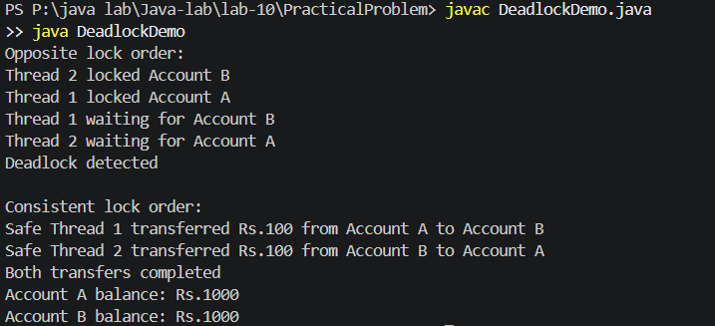
Learning Outcome:
I learned how opposite lock order can cause two threads to wait permanently for each other. I reproduced and detected this deadlock using two bank account transfers. I removed it by making every thread acquire the account locks in the same order.

