Adaptive Direction of Arrival Estimation of Signals using Enhanced Bias Compensated Log-Cosh Algorithm.

*Project Report Submitted*

by

Burri Sai Prathap Reddy

(2101EE21)

*Supervisor:*

Dr. Somanath Pradhan

*Asst. Professor, EEE Dept.*

DEPARTMENT OF ELECTRICAL ENGINEERING

INDIAN INSTITUTE OF TECHNOLOGY PATNA

**THESIS CERTIFICATE**

This is to certify that the thesis titled Adaptive Direction of Arrival Estimation of Signals using Enhanced Bias Compensated Log Cosh Algorithm, submitted by Burri Sai Prathap Reddy (Roll No. 2101EE21), to the Indian Institute of Technology, Patna, for the award of the degree of Bachelor of Technology, is a bona fide record of the research work done by him under our supervision. The contents of this thesis, in full or in parts, have not been submitted to any other Institute or University for the award of any degree or diploma.

Dr. Somanath Pradhan

Supervisor Assistant Professor

Dept. of Electrical Engineering IIT-Patna

Place: Patna

Date: May 2025

## Introduction:

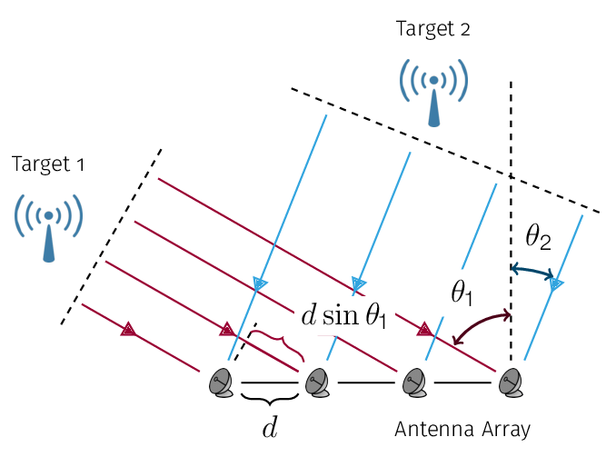**The direction of Arrival (DOA)** refers to the technique or process of determining the direction from which a received signal, such as a sound wave or electromagnetic wave, originates relative to a reference point (such as an antenna array or microphone array). DOA is crucial in applications like radar, sonar, wireless communication, and navigation systems, where identifying the source of a signal is necessary for tasks like locating objects or enhancing signal reception. In DOA estimation, sensors, such as antennas or microphones, are arranged in an array, and the signals received by each sensor are analysed.

Figure *1:* Antenna Array with two targets [9]

In modern communication and sensing systems, accurately determining the direction from which a signal arrives—commonly known as direction-of-arrival (DOA) estimation—is critical for applications ranging from radar and sonar to wireless communications and robotics. Traditional high-resolution DOA estimation techniques, such as MUSIC and ESPRIT, while powerful, often require complex eigenvalue decompositions and prior knowledge about the number of sources. This complexity poses significant challenges, especially for real-time or resource-constrained applications.

Adaptive filtering techniques, offer a promising alternative due to their lower computational requirements and ease of implementation. However, one of the major challenges in adaptive DOA estimation is the presence of noise, which introduces bias into the filter weight estimates and degrades overall performance. To overcome this limitation, recent research has focused on bias-compensated adaptive algorithms that can more accurately estimate DOAs by effectively mitigating noise-induced errors.

This project implements an enhanced bias-compensated NLMS (Normalised LMS) and Log Cosh algorithm for adaptive DOA estimation. The proposed methods not only compensates for the bias caused by noise but also incorporates an adaptive noise variance estimation scheme based solely on the error signal of the adaptive process.

## Methodology:

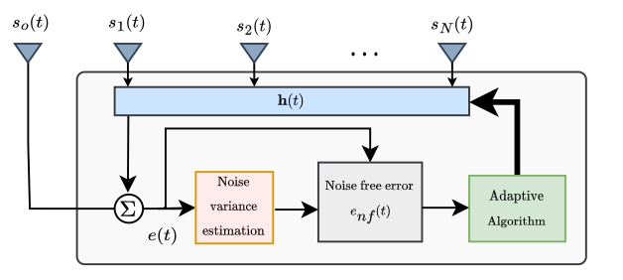The methodology spans the formulation of the signal model, the design of the adaptive filtering framework, the bias-compensation strategy, noise variance estimation, and algorithm enhancements for dynamic tracking.

Figure *2: Architecture of Estiamtion of DOA.*

### 1. Signal Model and Array Configuration

A uniform linear array (ULA) is employed, consisting of one reference sensor and (N–1) auxiliary sensors. The received signals are modelled as follows:

The signal at the reference sensor is given by

|  |  |  |
| --- | --- | --- |
|  | $$s^{0}\left(t\right)= z^{0}\left(t\right)+ n^{0}\left(t\right),$$ | (1) |

where z₀(t) represents the aggregated source signal and n₀(t) is the additive noise.

The auxiliary sensors capture the signal

|  |  |  |
| --- | --- | --- |
|  | $$s(t) = z(t) + n(t), z(t) = ∑ₘ xₘ(t )ṽ(θₘ),$$ | (2) |

where xₘ(t) are the source signals arriving from directions {θₘ}, and ṽ(θₘ) denotes the corresponding steering vector accounting for the relative propagation delays. The noise components n(t) are assumed to be uncorrelated across sensors and have equal variance.

### 2. Adaptive DOA Estimation Framework

The core idea is to estimate DOAs by forming a spatial spectrum through adaptive filtering. The auxiliary sensor signal s(t) is passed through a complex filter h(t) ∈ ℂ^(N–1) that is updated over time. The filter output is given by

|  |  |  |
| --- | --- | --- |
|  | $y(t) = hᴴ(t)s(t),$ | (3) |

and the error signal is computed as,

|  |  |  |
| --- | --- | --- |
|  | $e(t) = s₀(t) – y(t)$ | (4) |

By considering the overall array weight vector, w = [1; –h], the condition wHv(θm) = 0 is satisfied for all desired source directions. Therefore the spatial spectrum is obtained using,

|  |  |  |
| --- | --- | --- |
|  |  | (5) |

where v(θ) is the complete steering vector, and the peaks in p(θ) correspond to the estimated DOAs.

### 3. Bias Compensation Strategy

In practical settings, the input signals are contaminated by noise, which introduces bias into the weight update. The methodology for bias compensation involves:

* Noise corrupts both the reference and auxiliary signals, leading to a biased error signal. In order to correct this, the bias term associated with the noise must be estimated and removed.
* The conventional cost function is modified by incorporating the noise variance. Instead of using the raw error e(t), the algorithm seeks a noise-free error, denoted as e_nf(t).
* To estimate the noise-free error, the shrinkage technique is applied:

|  |  |  |
| --- | --- | --- |
|  |  | (6) |

where q(t) is the estimated noise variance. This step effectively removes the component of e(t) that is attributable to noise.

### 4. Iterative Noise Variance Estimation

The noise variance is updated using a moving average of the squared noise-free error:

|  |  |  |
| --- | --- | --- |
|  |  | (7) |

where β (close to 1) is the weighting factor, ensuring that the estimate evolves smoothly over time. In steady state, as the adaptive process converges, the expectation of |e_nf(t)|² tends to the true noise variance because the uncorrelated noise is not filtered by the adaptive algorithm. This provides a robust mechanism for tracking noise changes.

### 4. Adaptive Algorithm

To update the filter weights, a complex Log Cosh algorithm is employed. In a noise-free scenario, the update is derived from minimising a constrained cost function that penalises deviations from the previous weight vector while enforcing an error constraint. The basic Log Cosh weight update is expressed as:

|  |  |
| --- | --- |
| $$h\left(t\right) = h\left(t–1\right) +μ.\frac{\text{λ}.tanh\left(\text{λ}.R\left(e_{nf}\left(t\right)\right)\right).s\left(t\right)}{ \left(sᴴ\left(t\right)s\left(t\right)\right).}$$ | (8) |

where μ is the step-size parameter, and the denominator ensures normalization.

|  |  |  |
| --- | --- | --- |
|  | $h\left(t\right)= h\left(t–1\right)+ \frac{μ e*\left(t\right)s\left(t\right)}{\left(sᴴ\left(t\right)s\left(t\right)\right)},$ | (9) |

Similarly for NLMS algorithm,

Gradients of above functions respectively are:

$∇J(e)=tanh(λ⋅R(e))⋅x\left(n\right)$

$∇J_{NLMS}​=-e\left(n\right).x(n)$

**Comparison of Bias-Compensated NLMS and Log-Cosh-Based EBC Algorithms:**

The **Bias-Compensated NLMS (EBC-NLMS)** algorithm performs reasonably well under low levels of impulsive noise. However, it lacks reliability in more severe conditions. This is primarily because its gradient is linearly dependent on the error, which can lead to divergence in high-noise environments.

On the other hand, the **Log-Cosh-based cost function** is better suited for handling outliers, such as impulsive noise, due to its robustness to large errors. Nevertheless, its overall performance can still be limited unless the error is appropriately normalised. Normalizing the error significantly improves the algorithm’s stability and convergence.

A key tuning parameter in the Log-Cosh function is **λ (lambda)**. This parameter controls the sensitivity of the cost function to the error:

* A **small λ** value is ideal for Gaussian noise, making the algorithm more sensitive to small deviations.
* A graph of a function

  AI-generated content may be incorrect.A **larger λ** is preferred for impulsive noise environments, as it reduces the impact of large, erratic error values.By incorporating **noise-free error** into the Log-Cosh framework (referred to as **EBC-LogCosh**), the algorithm achieves **faster and more stable convergence**. This improvement is clearly evident in the gradient vs. error plots presented.

Figure *3: Variation of Gradient for various lambda values.*

|  |  |  |
| --- | --- | --- |
| **λ Value** | **Behavior** | **Effect** |
| **Small λ** | Log-cosh behaves like **L2-norm** (quadratic error) | Less robust, similar to NLMS; sensitive to large errors |
| **Large λ** | Log-cosh behaves like **L1-norm** (linear error) | More robust to **outliers** and **impulsive noise** |
| **Optimal λ** | Intermediate value | Balances between **sensitivity to small errors** and **robustness to large ones** |

Table *1: Information about Sensitivity parameter behaviour and effect.*

| **Feature** | **NLMS** | **Log-Cosh** |
| --- | --- | --- |
| **Cost Function** |  |  |
| **Noise Robustness** | Low (sensitive to outliers) | High (resistant to outliers) |
| **Computational Simplicity** | Very simple | Slightly more complex |
| **Gradient Behavior** | Linear in error | Saturates for large errors |
| **Best for** | Gaussian noise environments | Impulsive / alpha-stable noise |

Table *2: Comparison of NLMS and Log-Cosh Cost functions.*

## Simulations/Results:

Signals are generated using the above formulations, and the parameters taken are,

* Number of Sensors, N = 12,
* Number of Sources, M = 3,
* Step size, μ = 0.7,
* Weighting factor, β = 0.999,
* Number of trails 1000,

Figure *4(a,b,c): Error Signals for various algorithms at alpha=1.9, 1.7, 1.5*

Figure *4(d): Spacial Spectrum plot for various algorithms.*

## Observations and Conclusions:

* **EBC-NLMS** performs well under mild impulsive noise but may diverge in high-noise settings due to its gradient being linearly dependent on the error.
* **Log-Cosh** handles outliers (impulsive noise) better, but its robustness significantly improved when the error is normalized.
* **Lambda (λ)** in Log-Cosh controls sensitivity: small λ for Gaussian noise, large λ for impulsive noise environments.
* **EBC-LogCosh**, using noise-free error, achieves faster and more robust convergence, as seen in the error plots.
* Except for alpha=1.9, NLMS, Log-Cosh are diverging and not useful. In all the plots, we see enhanced bias compensated Log-Cosh is performing good in all conditions.
* Depending on the noisy conditions/environment, algorithm can be easily made suitable for gaussian/impulsive noise by making sensitive parameter low/high respectively.

## References:

[1] Kun Guo, Longxiang Guo, “Efficient DOA estimation based on variable least Lncosh algorithm under impulsive noise interferences”, Digital Signal Processing, Volume 122, 2022,103383, ISSN 1051-2004.

[2] S. Joel, Shekhar Kumar Yadav, and Nithin V. George, ‘‘Enhanced Bias-Compensated NLMS for Adaptive DOA Estimation,’’ *IEEE Trans. Instrum*. Meas., vol. 8, NO. 5, MAY 2024.

[3] C. Liu and H. Zhao, “Efficient DOA estimation method using bias-compensated adaptive filtering,” *IEEE Trans. Veh. Technol*., vol. 69, no. 11, pp. 13087–13097, Nov. 2020.

[4] P. Chen, Z. Chen, L. Liu, Y. Chen, and X. Wang, ‘‘SDOA-Net: An efficient deep-learning-based DOA estimation network for imperfect array,’’ *IEEE Trans. Instrum*. Meas., vol. 73, pp. 1–12, 2024.

[5] P. Chen, Z. Chen, Z. Cao, and X. Wang, “A new atomic norm for DOA estimation with gain-phase errors,” IEEE Trans. Signal Process., vol. 68, pp. 4293–4306, 2020.

[6] L. Zhu, S. Qiu, and Y. Han, “Combined constrained adaptive sum and difference beamforming in monopulse angle estimation,” IEEE Antennas Wireless Propag. Lett., vol. 17, no. 12, pp. 2314–2318, Dec. 2018.

[7] J.-D. Lin, W.-H. Fang, Y.-Y. Wang, and J.-T. Chen, “FSF MUSIC for joint DOA and frequency estimation and its performance analysis,” IEEE Trans. Signal Process., vol. 54, no. 12, pp. 4529–4542, Dec. 2006.

[8] F. Yan, M. Jin, and X. Qiao, “Low-complexity DOA estimation based on compressed MUSIC and its performance analysis,” IEEE Trans. Signal Process., vol. 61, no. 8, pp. 1915–1930, Apr. 2013.

[9]https://www.researchgate.net/publication/326854927_A_Review_of_Distributed_Algorithms_for_Principal_Component_Analysis