1) Name the three Leads of a common transistor

a)collector,bias,omitter

b)base,collector,case

c)emitter,collector,base

d)collector,base,emitter

2) connecting a lead from negative to positive of a battery will produce

a) A high resistance circuit

b) a short circuit

c)A low current path

d)An open circuit

**3) What is the approximate characteristic voltage that develops**    **across a red LED?**a) 1.7v

b) 3.4v

c)0.6v

d)none

**4) If two resistors are placed in series, is the final resistance:**

a) higher

b) lower

c) same

d) cannot be determined

**.**

**5) If a small value of capacitance is connected in parallel  
   with a large value, the combined capacitance will be:**

The same  
Higher  
Lower

**6) The resistor identified in brown is called the:**

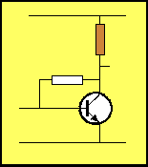       
  
  
Base Bias Resistor  
**Load Resistor**Emitter Feedback Resistor  
Bypass Resistor

7)**The lead marked with the arrow is:**

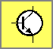The Collector  
The Base  
**The Emitter**

The case

8) **. To obtain a higher value of resistance, resistors are   
      connected in:**a) reverse

b) parallel

c) series

d)forward

**9) The current in a circuit is 45mA. This is:**

a)0.045amp

b)0.00045a

c)0.0045a

d)0.45a

10) What device is used to convert direct current to alternating current?

A: Oscillator

11)What is the resistance of a lamp which draws 120 mA when connected to a

12.6-V battery?

A: 105 Ω

12) Which of the following is represented by the symbol XL?

a) impedance of a load

b) reactance of a coil

c) resonant frequency of a filter

d) output level of a source

13)The frequency of a signal is INVERSELY proportional to __________

a)amplitude

b)period

c)phase

d)power

14)A power amplifier has a gain of 20dB and an input level of 2 volts.Assuming that the

output and the input impedances are same ,what is the voltage level at the amplifier output

a)10v

b)20v

c)30v

d)40v

|  |  |
| --- | --- |
|  | 15)If the input to a comparator is a sine wave, the output is a |
| |  |  | | --- | --- | | a) | ramp voltage | | b) | sine wave | | c) | rectangular wave | | d) | sawtooth wave |   16) Refer to the given figure. This circuit is known as |

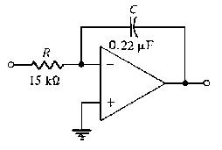

|  |
| --- |
| a) noninverting amplifier. |
| b) differntiator |  |
| c) an integrator. |  |
| d) a summing amplifier. |  |

17) Refer to the given figure. This circuit is known as

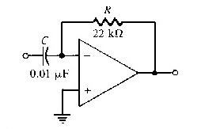

|  |
| --- |
| 1. a noninverting amplifier. |
| 1. a differentiator. |  |
| 1. an integrator. |  |
| 1. a summing amplifier. |  |
| 18) The basic logic gate whose output is the complement of the input is the: | |
| |  |  | | --- | --- | |  | 1. OR gate | |  | b) AND gate | |  | c) INVERTER gate | |  | 1. Comparator | | |

|  |
| --- |
| 19) The logic gate that will have HIGH or "1" at its output when any one of its inputs is HIGH is |
|  |
| |  |  | | --- | --- | |  | OR gate | | b) | AND gate | | c) | NOR gate | | d) | NOT gate | |

20)What type of logic gate does this symbol represent?

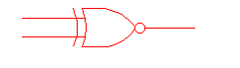

1. Exclusive OR
2. Exclusive NOR
3. OR
4. NOR

21) What does an EXOR gate do?

a) Give a high output when one or more of its inputs are high

b) Give a high output when only one of its inputs are high

c) Give a low output when one or more of its inputs are high

d) Give a low output when only one of its inputs are high

22) Flow of electrons is generally termed as _____________.

a) electric currentb) electric shock c) semiconductor d) none of the above

|  |  |
| --- | --- |
| 23. What is a RISC architecture? 24. What is the startup code? 25. What is Embedded system? |  |
|  |
|  | |
|  | |