MoDEL SCREENSHOT:-
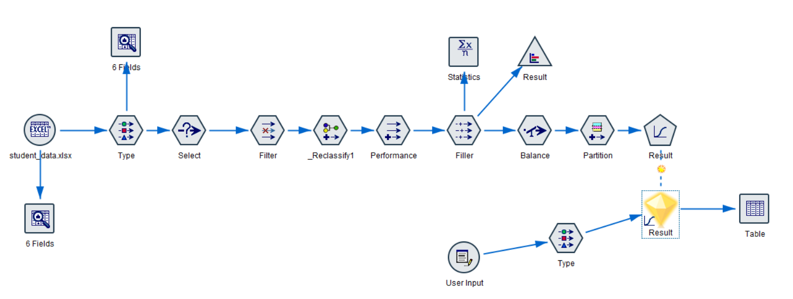
USER INPUT:-
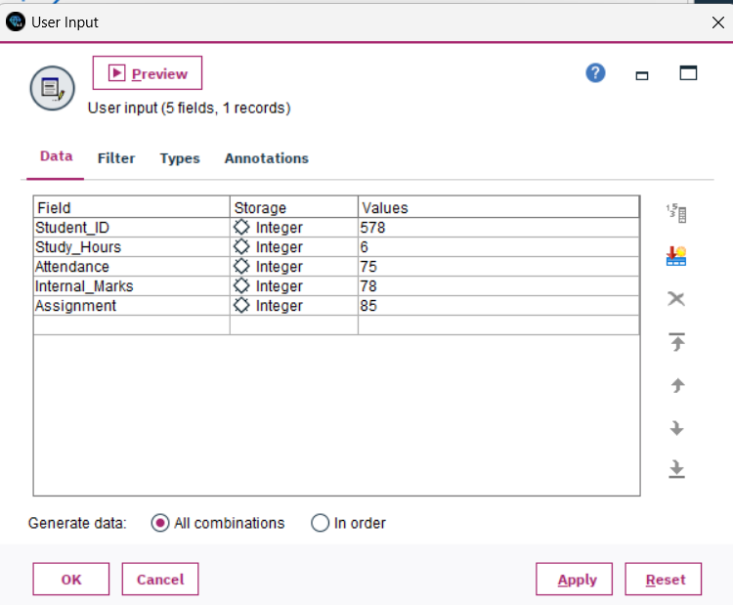
OUTPUT:-
