**Chapter 1 : INTRODUCTION**

**1.1 Subjectivity Classification**

Subjectivity refers to expression of some personal feelings or beliefs by the author. Subjectivity Classification, which is a part of Opinion mining, is a task to investigate whether a given text presents the opinion of its author or reports facts. Subjectivity in natural language refers to aspects of language used to express opinions and evaluations. Subjectivity classification is stated as follows: Let S = {s1, . . . , sn} be a set of sentences in document D. The problem of subjectivity classification is to distinguish sentences used to present opinions and other forms of subjectivity (subjective sentences set Ss) from sentences used to objectively present factual information (objective sentences set So), where Ss U So = S. This task is especially relevant for news reporting and Internet forums, in which opinions of various agents are expressed.

Consider the following examples of textual documents:

*Example 1:*

In the second expansion in three days, Karnataka Chief Minister D V Sadananda Gowda today inducted five ministers of cabinet rank into his ministry, but kept out the controversial Reddy brothers. Gowda managed to shrug off pressure by mining magnet G Janardhana Reddy, his brother Karunakara Reddy and their family associate B Sreeramulu to regain ministerial berth.

In today's exercise that took the strength of the ministry to 27, Balachandra Laxmanrao Jarkiholi, Anand Vasanth Asnotikar, Raju Gowda (Narasimha Naik), C P Yogeshwar and Varthur Prakash (Ind) were administered oath of office and secrecy by Governor H R Bhardwaj at Raj Bhavan.

Yogeshwar, Raju Gowda and Prakash are first timers into the ministry. Jarkiholi and Asnotikar had served in the previous B S Yeddyurappa government. Gowda, who was sworn-in as chief minister on August 4, has still kept seven ministerial berths vacant, keeping the hopes of many ministerial aspirants alive.

On August 8, Gowda, inducted 21 cabinet rank ministers, all of whom were in the Yeddyurappa ministry. Gowda who came under intense pressure for ministerial slot, rushed to New Delhi this morning, sought the nod of his party high command for the second instalment of ministry expansion and returned by evening to complete the exercise.The BJP high command has decided to keep away the Reddy brothers following their indictment by the Lokayukta report on illegal mining. Jarkiholi and Asnotikar, the rebels-turned loyalists of former chief minister B S Yeddyurappa, return to the ministry after a gap of about 10 months.

Yeddyurappa had sacked both of them along with other rebel ministers last October, after they joined dissidents and withdrew support to his government. Jarkiholi and Asnotikar were among the 11 disqualified rebel BJP MLAs, whose membership was restored by the Supreme Court in May. All the 11 MLAs later supported Yeddyurappa.

*Example 2:*

I've never been much for cell phones. I don't have kids, a lot of friends, or a big shot career, so there's no need for anyone to call me when I'm not at home. By and large, it's kind of liberating not to be a slave to a cell phone, but I will admit that they do come in handy sometimes. When my husband Bill and I came back to the States from a two year stint in Germany, Bill decided to pick up a couple of iPhone 3G (8GB) smartphones. I have to admit, after using this phone for the past couple of months, I really like it... but not so much for the sake of making phone calls.

The iPhone obviously can be used to make phone calls. However, because it's a smart phone, it can be used for a lot of other things, too. For instance, I tend to use mine for texting, something I never really did with the other cell phones I've had. It's very handy to be able to type a message to Bill when he's on his way home from work, asking him to pick up something from the store. I can also check email, surf the Net, listen to Internet radio, take pictures, check the weather, or play games with my iPhone. It really is a handy gadget to have around.

The iPhone is small, lightweight, and made of plastic. Bill uses a case for his, which he purchased separately at the Apple store. He claims that he bought the case because he's always dropping things. I, on the other hand, prefer not to use a case. So far, I haven't had too much trouble with the phone getting scratched up or dented, but then, I can carry it in my purse This phone will also hold iTunes, though I have so many of them that I never download them to my phone because I would burn through 8Though we haven't quite switched over from PCs to Apples yet, my husband and I are slowly turning into an Apple family. I find the iPhone works great with other Apple products such as the iPod, iTunes, and Apple TV. Moreover, it also works great in my new MINI Cooper S Convertible, which is specially equipped to handle Apple products. I like my iPhone 3G (8GB) phone. I don't think I'm quite at the point at which I can't live without it, but I do find it to be very practical, relatively affordable, easy to use, and all around fun to have. Maybe soon, I will be at the point at which I will want to upgrade to more memory, but for my purposes, this model of the iPhone works just fine. I highly recommend it.

*Example 3:*

The Anna Hazare Team today expressed satisfaction over the venue offered to them by police for holding the indefinite fast against Lokpal Bill even as they denied any going back on their stand on

the legislation.

The Core Committee of the Hazare team met here this morning. The meeting was attended by Hazare and others including, activist Arvind Kejriwal.

"We are satisfied with the venue provided by Delhi Police. It is at a good location. Core committee is chalking out the plan on how to go about the fast," he told reporters.

Delhi Police last night offered Jai Prakash Narain Park adjacent to Firoz Shah Kotla Ground as the venue for his protest against the Lokpal Bill subject to permission from the land owning agency.

Kejriwal said there was no going back on the demands raised by them.

"We are not ready to compromise with anyone till our demands are met. The deadlock continues. We are open for any dialogue but there is no invitation from the government yet," he said.

His comments came when asked about activist Swami Agnivesh's comments that the Hazare team was "very very flexible" on issues like inclusion of prime minister or higher judiciary under ambit of the ombudsman but the sticking point is bringing lower bureaucracy in it.

By thorough reading of above the examples, it can be concluded that example 1 is factual, example 2 is opinionated and example 3 is a factual document quoting opinions.

The above classification can be made systematically by

* By checking for polar word counts
* Checking for presence of cues like “According to me”, “In my opinion”, “Frankly speaking” etc., which clearly classify text as opinion.

But the problem arises when Document has both opinionated polar words and factual sentences in it, For example Document 3. Here, we need to choose the best method to classify the document.

Classification of Texts are done based on threshold approach where the count of polar words and cue presence play an important role. This finds its applications in search engines where there is a need to classify factual and opinionated documents and get the documents related to search topic. It is also used in blogs and review sites to differentiate facts and opinions.

**1.2 Synopsis**

**1.2.1 Problem Statement**

To classify the given text or document as opinionated or factual based on threshold value computed by evaluating results of various methods of classification.

**1.2.2 Scope of the Project**

Subjectivity classification classifies a document into factual and opinionated based on polar word count, adjective word count and presence of cues.

The project uses opinionated and factual documents collected from

[www.epinions.com](http://www.epinions.com)

[www.deccanheraldepaper.com](http://www.deccanheraldepaper.com)

[www.thehindu.com](http://www.thehindu.com)

websites. The documents are arranged into different input directories.

The subjectivity classification can be achieved using Adjective, Voting, Cue Based and OtherPOS methods.

**Adjective Method**: This method uses the adjectives in the document to classify the text.

**Voting Method:** This uses the set of pre-defined words (polar words classified as positive and negative) to classify the document.

**Cue Based Method**: This method uses the cues pre-defined in a document to classify the document as opinionated. The Cues form a significant method in classification.

**OtherPOS Method**: This method makes use of Adjective Tagger – **Monty Tagger**. The Tagger is used to find pattern of POS in document (APPENDIX A). This pattern is used to classify the documents.

The methods specified above can take various input types. The input types can be Whole document, First Sentence, Last Sentence, Significant Sentence or First, Last and significant(FLS) sentences together.

**First Sentence**: The first sentence in the document is given as input to the document

**Last Sentence**: The last sentence of the document is given as input to the document

**Significant Sentence**: The significant sentence in the document is used to compute the accuracy using the method. The significant sentence is found by computing the sentence with highest adjective count in it.

**1.2.3 Applications**

* The text classification approach can be used in review sites to classify and use opinion documents.
* It can be used in search engines to get opinionated or factual documents related to search topic.
* It has applications in sub-component technology i.e., to detect the parts of web pages.
* To detect the flames (antagonistic language) in webpages and mails.

**Chapter 2 : LITERATURE SURVEY**

Textual information in the world can be broadly classified into two main categories, facts and opinions. Facts are objective statements about entities and events in the world. Opinions are subjective statements that reflect people’s sentiments or perceptions about the entities and events. Much of the existing research on text information processing has been (almost exclusively) focused on mining and retrieval of factual information, e.g., information retrieval, Web search, and many other text mining and natural language processing tasks. Little work has been done on the processing of opinions until only recently. Yet, opinions are so important that whenever one needs to make a decision one wants to hear others’ opinions. This is not only true for individuals but also true for organizations. One of the main reasons for the lack of study on opinions is that there was little opinionated text before the World Wide Web.

“What other people think” has always been an important piece of information for most of us during the decision-making process. Long before awareness of the World Wide Web became widespread, many of us asked our friends to recommend an auto mechanic or to explain who they were planning to vote for in local elections, requested reference letters regarding job applicants from colleagues, or consulted *Consumer Reports* to decide what dishwasher to buy. But the Internet and theWeb have now (among other things) made it possible to find out about the opinions and experiences of those in the vast pool of people that are neither our personal acquaintances nor well-known professional critics — that is, people we have never heard of. And conversely, more and more people are making their opinions available to strangers via the Internet.

Although the area of sentiment analysis and opinion mining has recently enjoyed a huge burst of research activity, there has been a steady undercurrent of interest for quite a while. One could count early projects on beliefs as forerunners of the area . Later work focused mostly on interpretation of metaphor, narrative, point of view, affect, evidentiality in text, and related areas.

The year 2001 or so seems to mark the beginning of widespread awareness of the research problems and opportunities that sentiment analysis and opinion mining raise and subsequently there have been literally hundreds of papers published on the subject.

Factors behind this “land rush” include:

• the rise of machine learning methods in natural language processing and information retrieval;

• the availability of datasets for machine learning algorithms to be trained on, due to the blossoming of the World Wide Web and, specifically, the development of review-aggregation web-sites; and, of course

• realization of the fascinating intellectual challenges and commercial and intelligence applications that the area offers.

Hatzivassiloglou and McKeown have attempted to predict semantic orientation of adjectives by analyzing pairs of adjectives (i.e., adjective pair is adjectives conjoined by and, or, but, either-or, neither-nor) extracted from a large unlabelled document set.

Turney has obtained remarkable results on the sentiment classification of terms by considering the algebraic sum of the orientations of terms as representative of the orientation of the document. Turney and Littman have bootstrapped from a seed set, containing seven positive and seven negative words, and determined semantic orientation according to Point wise Mutual Information-Information Retrieval (PMI-IR) method.

Wang and Araki proposed a variation of the Semantic Orientation-PMI algorithm for Japanese for mining opinion in weblogs. They applied Turney method to Japanese webpage and found results slanting heavily towards positive opinion. They proposed balancing factor and neutral expression detection method and report a well balanced result.

Kamps et al have focused on the use of lexical relations, deﬁned in Word Net. They deﬁned a graph on the adjectives contained in the intersection between the Turney’s seed set and Word Net, adding a link between two adjectives whenever WordNet indicate the presence of a synonymy relation between them. The author’s deﬁned a distance measure d (t1, t2) between terms t1 and t2, which amounts to the length of the shortest path that connects t1 and t2. The orientation of a term is then determined by its relative distance from the seed terms good and bad. Esuli and Sebastiani proposed semi-supervised learning method started from expanding an initial seed set based on Turney and Littman’s seed set , by using WordNet. Their basic assumption is terms with similar orientation tend to have similar glosses. They determined the expanded seed term’s semantic orientation through gloss classiﬁcation by statistical technique.

Kim and Hovy [5] presents orientation detection system that assigns to each term, a positive score and a negative score, the terms may have both a positive and a negative correlation, with different degrees, and some terms may carry a stronger positive or negative orientation than others. Their system starts from a set of positive and negative seed terms, and expands the positive and negative seed set by adding to it the synonyms of positive and negative seed terms and the antonyms of negative and positive seed terms. The system classiﬁes then a target term t into either positive or negative by means of two alternative learning-free methods based on the probabilities that synonyms of t also appear in the respective expanded seed sets.

Popescu and Etzioni [6] introduced OPINE. It is an unsupervised information extraction system that outputs set of features which is accompanied by a list of opinions that are ranked based on strength for a given product and corresponding reviews. To ﬁnd features, it ﬁrst extracts the noun phrases from reviews and retains those with frequency greater than an experimentally set threshold. OPINE’s Feature Assessor evaluates each noun phrase by computing the PMI scores between the phrase and meronymy discriminators associated with the product. It extracts opinion phrases, which are adjective, noun; verb or adverb phrases representing customer opinions and uses relaxation labeling, unsupervised classiﬁcation technique, for ﬁnding the semantic orientation of words.

Pang and Lee [7] report of work in progress on using simple statistics in an unsupervised fashion to re-rank search engine results for a review oriented query. They report that their proposed technique performs comparably to methods that rely on sophisticated pre encoded linguistic knowledge. Many researchers have proposed various prototypes that provide an opinion of the product. We list a few of them which are worth considering related to our proposed work.

Review Seer is a tool that automates the work done by aggregation sites. It uses various methods such as metadata and statistical substitutions, linguistic substitutions, language based medications, n-gram and proximity for feature extraction. Naive Bayes classiﬁer is used with positive and negative review sets for assigning a score to the extracted feature terms. The classiﬁer performed well for reviews collected from CNet and Amazon for training and testing. The classiﬁer did not perform well for web pages crawled from the result of a search engine. It displays attributes and score of the attribute along with review sentences.

Red Opal is a tool that assumes online shoppers are highly task driven and have certain goal in mind and that they are looking for product with features that are consistent with that goal. This system enables users to ﬁnd products based on features. It scores each product based on features from the customer reviews. It uses frequent nouns and noun phrases for feature extraction and user ratings are used to compute product score for features mentioned in reviews. The results are shown in descending order for each feature along with the URL.

Opinion observer is a sentiment analysis system for analyzing and comparing opinions on the web. The product features are extracted from noun or noun phrases by the association miner. They use adjectives as opinion words and assign prior polarity of these by WordNet exploring method. The polarity of an opinion expression which is a sentence containing one or more feature terms and one or more opinion words is as signed a dominant orientation. The extracted features are stored in a database in the form of feature, number of positive expression and number of negative expression. The system shows the results in a graph format showing opinion of the product feature by feature.

The development of any opinion related application involves the first step as determining which documents are topically relevant to an opinion-oriented query, an additional challenge we face in our new setting is simultaneously or subsequently determining which documents or portions of documents contain review-like or opinionated material. Sometimes this is relatively easy, as in texts fetched from review aggregation sites in which review-oriented information is presented in relatively stereotyped format: examples include Epinions.com and Amazon.com. However, blogs also notoriously contain quite a bit of subjective content and thus are another obvious place to look (and are more relevant than shopping sites for queries that concern politics, people, or other non-products), but the desired material within blogs can vary quite widely in content, style, presentation, and even level of grammaticality.

In the field of text classification, in particular, subjectivity classification of text as subjective(opinion) or objective(fact), significant work has been done by Janyce M. Wiebe [4 ] .In his paper ‘Recognizing subjectivity: a case study in manual tagging’, ’Tracking Point of View in Narrative’ and other research outcomes, Wiebe has introduced many new techniques for recognizing subjective sentences which can be used to classify text. Some more related works include research by Raaijmakers & Kraaij [ 8] , Bing Liu [9 ], Wang, Spencer, Ling, & Zhang [ 10] and many other.

**Chapter 3 : SYSTEM REQUIREMENTS SPECIFICATION**

**3.1 Introduction:**

Sentiment analysis also called Opinion Mining is used to classify words/senses, texts, documents according to the opinion, emotion, or sentiment they express.

The applications of opinion mining include determining critics’ opinions of products, track attitudes toward political candidates etc., among the many other areas of uses.

The sub-tasks in any sentiment analysis application include the first step as determining Subjective-Objective polarity of given input i.e., identify if the text or language factual or an expression of an opinion.

Our approach follows the below path:

* Collecting data sets i.e., directories of inputs with various text documents. It includes opinion texts (reviews, blogs etc.,) and factual texts (news articles, reports etc.,).
* Executing the different classification methods (adjective count or other patterns etc.,) with input types (full document or sentence based etc.,) on the collected data sets.
* For each of the above combination, calculate suitable thresholds and compute their accuracies of correct classification.
* Visualize the above experimental results with the help of plots.
* From the experimental results, we need to deduce the best method and use this method to classify any given user input as opinion or fact.

**3.2 Functional Requirements:**

This section lists the functional requirements of the project in order of the three modules the project is constituted of :

* Module 1: Experimenting different classification methods and observing the results
* *Input:* The input to this module includes method of classification, input type and the directory of collected text documents to work on.
* *Processing*: The chosen combination of method and input type is applied on the given directory to calculate suitable thresholds. For each of the calculated threshold, we find the accuracy of correct classification.
* *Output*: Display calculated thresholds and accuracies as a graph.
* Module 2: Classifying the entered input text into fact or opinion
* *Input*: The input to this module will be user entered text.
* *Processing*: We infer the best method from the experimental results and use the same to classify the entered text.
* *Output:* Display input text as opinion or fact
* Module 3: Considering number of input files as a factor in determining accuracy of any method
* *Input*: The input to this module includes method of classification and input type.
* *Processin*g: Run specified experiment combination on varying number of files with different classification thresholds.
* *Output:* Display the result of number of files experimented and their corresponding accuracies.

**3.3 External Interface Requirements**

This section defines the external interface requirements of the project

* Hardware requirements:
* A simple basic computer system.
  + Any Intel or AMD x86 processor.
  + Minimum of 512 MB RAM is required.
* Software requirements:
  + Windows xp or higher.
  + Java Virtual Machine(JVM) required and JDK 1.6 or above.
  + Gnuplot (gnu graph plotter) required.
* User requirements:
  + Java based front end displaying gnuplot graphs.

**3.4 Design Constraints :**

a)Standards complaince**:** Report format either in .PDF or A word document.

b)Hardware limitations**:** No limitation as such.

c) Reliabilty and Fault Tolerance: Save the program as and when completed in order to avoid loss of data due to failures and system should recover data lost.

d) Security: The Program and files should be made accessible to only the concerned users.

**Chapter 4 : SYSTEM** **DESIGN SPECIFICATION**

**4.1 Introduction**

The design document explains the design of the various experimental methods of text classification that are implemented in the project. With this document, we first provide a brief look at the overall design of the project and then the detailed design of each experiment technique with the help of flow diagrams.

**4.2 Overall Design Of The Project**

The following flow diagram illustrates the overall diagram of the project.

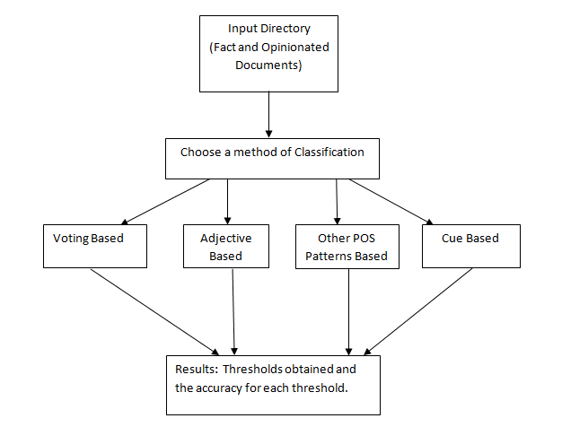**Figure 4.1 Over-all design of the project**

The user first chooses input directory that consists of a set of opinion and factual documents. Next, the method of classification which is to be experimented with is chosen. The method can be one of the following : Voting based, Adjective Based, Other POS pattern based or Cue Based. The experiment is performed on the chosen directory. The result will be a set of thresholds computed and their accuracies. In the following sections we explore the flow of the project considering each method of classification

**4.3 Detailed Design Of The Voting Based Method**

The voting based approach can be experimented with three input types: Full document, First Sentence or Last Sentence. After choosing one of the mentioned input types, we find the count of polar words. We then calculate the threshold in accordance to the type of input chosen as illustrated. Multiple such thresholds and their corresponding accuracies are computed.

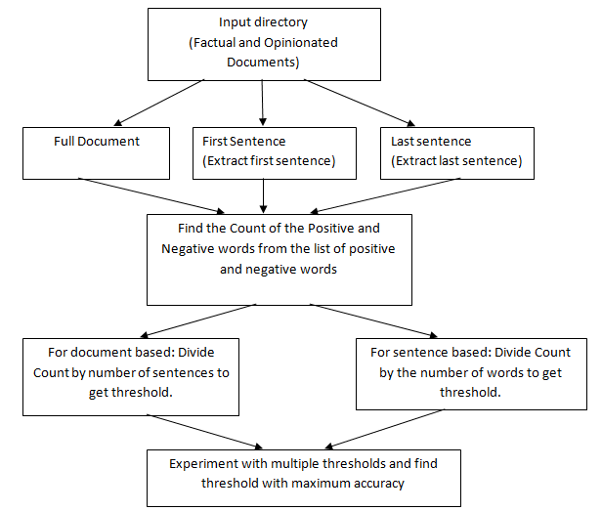

**Figure 4.2 Design of Voting method**

**4.4 Detailed Design Of The Adjective Based Method**

The adjective based approach can be experimented with five input types: Full document, First Sentence, Last Sentence, Significant or First, Last and Significant together. The input is then passed into the Parts Of Speech tagger. Next, we find the count of adjectives in the tagged text. We then calculate the threshold in accordance to the type of input chosen as illustrated. Multiple such thresholds and their corresponding accuracies are computed.

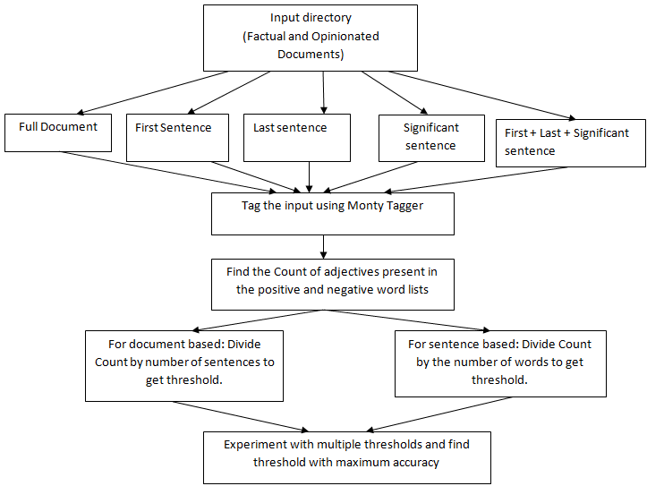

**Figure 4.3 Design of adjective based method**

**4.5 Detailed Design Of The Cue Based Method**

The cue based approach can be experimented with Full document input type. The entire document is scanned for presence of the predefined cues. If a cue is present, we classify the text as opinion. If no cues are found, we classify the text as factual. The accuracy of the method is determined by the number of correct classifications. The process is as shown in figure.

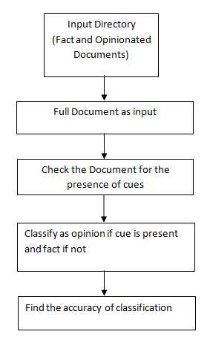

**Figure 4.4 Design of Cue based method**

**4.6 Detailed Design Of The Other Pos Method**

The other Parts Of Speech approach can be experimented with five input types: Full document, First Sentence, Last Sentence, Significant or First, Last and Significant together. The input is then passed into the Parts Of Speech tagger. Next, we find the count of matching patterns in the tagged text. We then calculate the threshold in accordance to the type of input chosen as illustrated. Multiple such thresholds and their corresponding accuracies are computed. Accuracies are calculated as a measure of correct classifications.

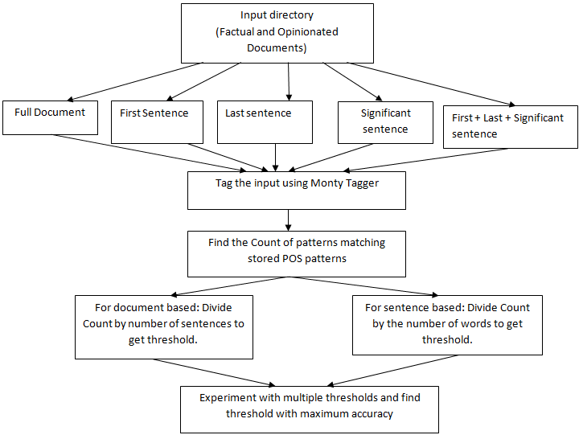

**Figure 4.5 Design of OtherPOS method**

**Chapter 5 : SYSTEM IMPLEMENTATION**

This chapter covers the implementation details of the various methods such as Voting, Adjective, Cue Based and OtherPOS methods used for text classification. The algorithms used are explained as follows.

**5.1 Voting method:**

This method finds the polar words in the input file using two lists of positive and negative polar words. The resultant ratio for full document input is computed using

Resultant ratio = Σ(Polar words)/No. of sentences

The resultant ratio for sentence based input is computed using

Resultant ratio = Σ(Polar words)/No. of words in the sentence

Algorithm 5.1 describes the steps involved

**Algorithm 5.1**ForEach(input file)   
{  
//Input is the whole document, the first sentence or the last sentence   
ExtractWord(Input)  
{  
IfPresent(Positive.txt) || IfPresent(Negative.txt)  
         PolarWordCount[file]++  
//for full document input  
If(EndOfSentence)  
         SentenceCount[file]++  
//for sentence based input  
If(EndOfWord)  
        WordCount[file]++  
}  
  
//For full document input  
ResultantRatio[file] = Sum(PolarWordCount[file])/SentenceCount[file]  
//For sentence based input  
ResultantRatio[file] = Sum(PolarWordCount[file])/WordCount[file]  
}  
AvgResultantRatio = Threshold  
for(Range Of Thresholds)  
{  
 Accuracy = CorrectlyClassifiedTexts by program / Total number texts  
}

**5.2 Adjective Count method**

The input is assigned Part Of Speech tags using the Monty Tagger. The adjective count in the input is found.

The resultant ratio for full document input is computed using

Resultant ratio = Σ(Adjectives)/ No. of sentences

The resultant ratio for sentence based input is computed using

Resultant ratio = Σ(Adjectives)/ No. of words in the sentence

Algorithm 6.2 describes the steps involved.

**Algorithm 5.2**

ForEach(input file)  
{  
//Input is the whole document, the first sentence, last sentence, significant sentence or combination of first, last, significant sentences.  
InputString = StoreToString(Input)  //MontyTagger takes String input  
OutputString = Tag(InputString)  
ExtractWord(OutputString)  
{  
if(word == adjective && (IfPresent(Positive.txt) || IfPresent(Negative.txt))  
         AdjectiveCount[file]++  
  
//for full document input  
If(EndOfSentence)  
         SentenceCount[file]++  
//for sentence based input  
If(EndOfWord)  
        WordCount[file]++  
}  
//For full document input  
ResultantRatio[file] = Sum(AdjectiveCount[file])/SentenceCount[file]  
//For sentence based input  
ResultantRatio[file] = Sum(AdjectiveCount[file])/WordCount[file]  
}  
AvgResultantRatio = Threshold  
for(Range Of Thresholds)  
{

Accuracy = CorrectlyClassifiedTexts by program/ Total number of texts  
}

**5.3 Other Parts of Speech method**

Theinput is assigned Part Of Speech tags using the Monty Tagger. The count of specific POS patterns in Fig 5.1 is found

The resultant ratio for full document input is computed using

Resultant ratio = Σ(Patterns)/ No. of sentences

The resultant ratio for sentence based input is computed using

Resultant ratio = Σ(Patterns)/ No. of words in the sentence

Algorithm 5.3 describes the steps involved.

**Table 5.1 POS Patterns**

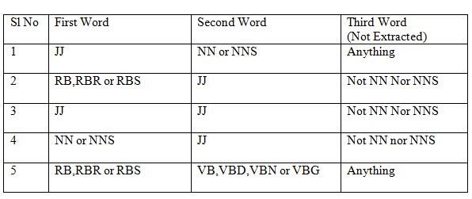

**Algorithm 5.3**

ForEach(input file)  
{  
//Input is the whole document, the first sentence, last sentence, significant sentence or combination of first, last, significant sentences.  
InputString = StoreToString(Input)  //MontyTagger takes String input  
OutputString = Tag(InputString)  
ExtractPatternsOfThreeWords(OutputString)  
{  
if(pattern.matches(PatternInFile) && (IfPresent(Positive.txt) || IfPresent(Negative.txt))  
         PatternCount[file]++  
//for full document input  
If(EndOfSentence)  
         SentenceCount[file]++  
//for sentence based input  
If(EndOfWord)  
        WordCount[file]++  
}  
//For full document input  
ResultantRatio[file] = Sum(PatternCount[file])/SentenceCount[file]  
  
//For sentence based input  
ResultantRatio[file] = Sum(PatternCount[file])/WordCount[file]  
}  
AvgResultantRatio = Threshold  
for(Range Of Thresholds)  
{  
 Accuracy = CorrectlyClassifiedTexts by program / Total number of texts  
}

**5.4 Cue Based method**

The possible cues which indicate opinionated documents are stored in a file. For eg: I feel, According to me etc . The presence of these cues is checked in the input files. If any cue is present, the file is classified as opinion and if not it is classified as fact.

Algorithm 5.4 describes this method

**Algorithm 5.4**

Begin:

ForEach(Input File)  
{  
//Input refers to the full document  
InputString = StoreToString(Input)  
    if(Cue.Present(InputString))  
          Opinion = true  
}  
Accuracy = CorrectlyClassifiedTexts by program / Total number of texts

End:

**5.5 Other Algorithms:**

These are some of the other algorithms which are used for implementing the functionality of obtaining the first sentence, the last sentence and the significant sentence. The significant sentence is defined as the sentence with the maximum adjective count.

**5.5.1 Finding the first sentence:**  
ForEach(Input File)  
Extract words till the first end of sentence delimiter.  
  
**5.5.2 Finding the last sentence:**ForEach(Input File)  
Extract sentence by sentence till end of file and return last extracted sentence.  
  
**5.5.3 Finding the significant sentence:**  
ForEach(Input File)  
{  
 ForEach( Sentence)  
 {  
     Find(AdjectiveCount)  
     SignificantSentence = Sentence.MaxAdjectiveCount()  
 }  
}  
     
**5.5.4 First , Last and Significant Sentence as input:**  
 This method is referred to as ‘allmethod’ and re-uses the code which finds the First , Last and Significant Sentences.  
It applies the chosen method on all of these as input.

**5.5.5 Algorithm applied for text classification on the User Input obtained from the GUI:**

The user enters his text to be classified into a text area in the GUI. The program must capture this text and run the most accurate method of classification on it. In this case it is the method including first, last and significant sentence. We are also looking up the cue list for cues. The threshold obtained by running program this is compared with the threshold which gave maximum accuracy. If the threshold obtained is greater than the reference threshold, the text is classified as opinionated. If it is lesser, the text is classified as fact.

**Algorithm 5.5.6**

StoreToFile(User input string)  
{  
  Run Cue based method.  
     If(CuePresent)  
        Result = opinionated  
        Print(Result)  
        return  
 Run First, Last, Significant sentence method  
 Use threshold giving maximum accuracy for classification. (0.2)  
 if(ResultantRatio(input) > = 0.2)  
    Result = opinionated  
 else  
    Result = factual  
Print(Result)  
}

**5.6 A Note On The Project Usage Guidelines:**

* Input directory and its format is predefined.
* The input directories are classified based of number of files in the directories. The input to the program is the directory with pre-defined set of files in them.
* The time of execution of project depends on the number of input files.
* The number of input files vary for the methods used to compute accuracy and hence does the execution time.
* The accuracy of method depends on the number of input files.
* The number of input files vary for the methods used to compute accuracy and hence does the accuracy.
* The textual document with set of cues is pre-defined.
* The cues to classify the document as opinionated is pre-defined.
* The textual documents with list of opinionated documents and factual documents is needed.
* The opinionated.txt and factual.txt textual documents are pre-defined with list of all opinionated and factual documents to compute accuracy of methods..
* In GUI, the input directory and method should be chosen correctly from the menu without which the result and graph will not be displayed correctly.

**5.7 The User Interaction Component**

Three key modules:

1. Input : User chooses experiment method, type of input and the input directory.

Output : The front end displays the experiment results in the form of a graph (thresholds vs accuracies).

2. Input : User enters text to be classified

Output: Text entered is displayed to be opinionated/factual.

3. Input :User chooses experiment method and type of input

Output : View the graph showing behavior of the chosen combination with respect to Module 2 applies the inferred best method to classify input text as opinion or fact.

**Chapter 6 : SYSTEM TESTING**

This chapter covers all the testing details, test cases successfully tested for all the methods such as Voting, Adjective, Cue Based and OtherPOS methods in the Project. The testing methods used are explained as follows.

**Unit testing** is a method by which individual units of source code, sets of one or more computer program modules together with associated control data, usage procedures, and operating procedures, are tested to determine if they are fit for use. The goal of unit testing is to isolate each part of the program and show that the individual parts are correct. **Integration testing** is the phase in software testing in which individual software modules are combined and tested as a group. It occurs after unit testing. The purpose of this level of testing is to expose faults in the interaction between integrated units.

**6.1 Project Testing**

**6.1.1 Unit testing**

**6.1.1.1 Module Monty Tagger**

**Table 6.1 Test cases for module monty tagger**

|  |  |  |  |
| --- | --- | --- | --- |
| Sl No. | Input | Output | Remarks |
| 1 | String  (Ex: I love this product) | Tagged String  (Ex: : I\NN love\VBG this\DT product\NN) | String correctly Tagged |
| 2 | Null String | Null String | Null string raises no exception |
| 3 | String containing emoticons  Ex:  Nice features :) | Tagged String:  Nice/JJ features/NNS :/: )/) | Emoticons are not recognised |

**6.1.1.2 Module Cue Based**

**Table 6.2 Test cases for module cue based**

|  |  |  |  |
| --- | --- | --- | --- |
| Sl No. | Input | Output | Remarks |
| 1 | String  (Ex: Frankly speaking, the product is bad) | Result: Opinion | Correctly classified |
| 2 | String  (Ex: In my case the service was very bad) | Result: Factual | Mis-classification as “in my case” is not in the list of cues |

**6.1.1.3 Module Adjective Based**

**Table 6.3 Test cases for module Adjective based**

|  |  |  |  |
| --- | --- | --- | --- |
| Sl No. | Input | Output | Remarks |
| 1 | Directory with input files(opinions and facts) | List of thresholds with accuracy | Thresholds and accuracy correctly obtained |
| 2 | Directory  (with no opinionated.txt and factual.txt) | List of thresholds with accuracies as zero | Thresholds and accuracies not correctly obtained |

**6.1.1.4 Module Voting Based**

**Table 6.4 Test cases for module Voting based**

|  |  |  |  |
| --- | --- | --- | --- |
| Sl No. | Input | Output | Remarks |
| 1 | Directory with input files(opinions and facts) | List of thresholds with accuracy | Thresholds and accuracy correctly obtained |
| 2 | Directory  (with no opinionated.txt and factual.txt) | List of thresholds with accuracies as zero | Thresholds and accuracies not correctly obtained |

**6.1.1.5 Module OtherPOS Based**

**Table 6.5 Test cases for module OtherPOS based**

|  |  |  |  |
| --- | --- | --- | --- |
| Sl No. | Input | Output | Remarks |
| 1 | Directory with input files(opinions and facts) | List of thresholds with accuracy | Thresholds and accuracy correctly obtained |
| 2 | Directory  (with no opinionated.txt and factual.txt) | List of thresholds with accuracies as zero | Thresholds and accuracies not correctly obtained |

**6.1.1.6 Module Classify User Input**

**Table 6.6 Test cases for module Classify User Input**

|  |  |  |  |
| --- | --- | --- | --- |
| Sl No. | Input | Output | Remarks |
| 1 | File containing the user input | Result as opinion or fact | Accuracy of classification depends on the input entered |
| 2 | Blank file | Prompt for user to enter text | User correctly informed to enter the input |
| 3 | File containing junk data  Ex: wltj35 356t0 dfhg | Result: Factual | No adjectives or cues are detected. So it is classified as factual |

**6.1.2 Integration Testing**

**6.1.2.1 Integration of monty tagger with code**

**Table 6.7 Test cases for integration of monty tagger with code**

|  |  |  |  |
| --- | --- | --- | --- |
| Sl No. | Input | Output | Remarks |
| 1 | Input to program:File containing the user input  Input to Monty Tagger: Input file as string | Output of MontyTagger: Tagged String  Output of program: Classification of text | Information correctly passed from user input to MontyTagger and vice-versa |
| 2 | Input to program:Blank file  Input to Monty Tagger: Input file as string(null string) | Output of MontyTagger: Null String  Output of program: Nil | Program gives Null pointer exception. However, when the code is integrated with GUI, this case is handled and message is displayed to user to enter input |

**6.1.2.2 Integration of code with GUI**

**Table 6.8 Test cases for integration of code with GUI**

|  |  |  |  |
| --- | --- | --- | --- |
| Sl No. | Input | Output | Remarks |
| 1 | Input to GUI: The input in the text area of the GUI  Input to Program: Input file containing the input to GUI | Output of Program: Result as opinion of fact written to file  Output in GUI: Result read from file and displayed in text box | Information correctly passed from code to GUI and vice-versa via files |
| 2 | Input to GUI: Blank  Input to program: Not sent by GUI | Output of GUI: Prompt to user to enter input(Ex: input directory or input text) | GUI correctly filters input and prevents null pointer exception |

**6.2 Experiments and Results**

The performance metric used in the project is the accuracy of classification of texts into opinions or facts. Accuracy of classification of texts is defined as the following

**Accuracy = Σ(Correct classifications by Program)/No. of Texts Classified**

For every method and input type we have one of the thresholds giving the maximum accuracy. This is recorded as the threshold with max accuracy against the number of input files.

The results of the described methods is available in Table 6.9

**Table 6.9: Threshold and Accuracy for methods with different no. of input files**

|  |  |  |  |
| --- | --- | --- | --- |
| Method | Number of Doc | Threshold | Accuracy |
| Voting Full Document | 20 | Threshold : 0.0 Threshold : 0.1 Threshold : 0.2  Threshold : 0.3  Threshold : 0.4  Threshold : 0.5  Threshold : 0.6  Threshold : 0.7  Threshold : 0.8000001  Threshold : 0.9000001  Threshold : 1.0000001  Threshold : 1.1000001  Threshold : 1.2000002  Threshold : 1.3000002  Threshold : 1.4000002  Threshold : 1.5000002  **Threshold : 1.6000003** | Accuracy : 0.5 Accuracy : 0.5 Accuracy : 0.5  Accuracy : 0.5  Accuracy : 0.5 Accuracy : 0.55 Accuracy : 0.55  Accuracy : 0.55  Accuracy : 0.6  Accuracy : 0.6 Accuracy : 0.6  Accuracy : 0.55  Accuracy : 0.6 Accuracy : 0.6  Accuracy : 0.6  Accuracy : 0.6  **Accuracy : 0.65** |
| 40 | Threshold : 0.0  Threshold : 0.1  Threshold : 0.2  Threshold : 0.3  Threshold : 0.4  Threshold : 0.5  Threshold : 0.6  Threshold : 0.7  Threshold : 0.8  Threshold : 0.9000001  Threshold : 1.0000001  Threshold : 1.1000001  Threshold : 1.2000002  Threshold : 1.3000002  **Threshold : 1.4000002** | Accuracy : 0.5  Accuracy : 0.5  Accuracy : 0.5 Accuracy : 0.5 Accuracy : 0.5 Accuracy : 0.525  Threshold : 0.6 Accuracy : 0.575  Accuracy : 0.6  Accuracy : 0.65 Accuracy : 0.675  Accuracy : 0.725 Accuracy : 0.7  Accuracy : 0.75 **Accuracy : 0.75** |
| 60 | Threshold : 0.0  Threshold : 0.1  Threshold : 0.2  Threshold : 0.3  Threshold : 0.4  Threshold : 0.5  Threshold : 0.6  Threshold : 0.7  Threshold : 0.8000001  Threshold : 0.9000001  Threshold : 1.0000001  Threshold : 1.1000001  Threshold : 1.2000002  **Threshold : 1.3000002** | Accuracy : 0.5  Accuracy : 0.5  Accuracy : 0.51666665  Accuracy : 0.51666665  Accuracy : 0.51666665 Accuracy : 0.53333336  Accuracy : 0.56666666  Accuracy : 0.5833333  Accuracy : 0.6166667  Accuracy : 0.6333333  Accuracy : 0.68333334  Accuracy : 0.6666667  Accuracy : 0.68333334  **Accuracy :0.68333334** |
| 100 | Threshold : 0.0 Threshold : 0.1  Threshold : 0.2  Threshold : 0.3  Threshold : 0.4  Threshold : 0.5  Threshold : 0.6  Threshold : 0.7  Threshold : 0.8000001  Threshold : 0.9000001  Threshold : 1.0000001 Threshold : 1.1000001  Threshold : 1.2000002  Threshold : 1.3000002  Threshold : 1.4000002  Threshold : 1.5000002  **Threshold : 1.6000003** | Accuracy : 0.48  Accuracy : 0.48  Accuracy : 0.49  Accuracy : 0.5  Accuracy : 0.51  Accuracy : 0.52  Accuracy : 0.54  Accuracy : 0.55  Accuracy : 0.57  Accuracy : 0.58  Accuracy : 0.63  Accuracy : 0.63  Accuracy : 0.65  Accuracy : 0.65  Accuracy : 0.64  Accuracy : 0.66  **Accuracy : 0.66** |
| Adjective Count Full Document | 20 | Threshold : 0.0  Threshold : 0.1  Threshold : 0.2  Threshold : 0.3  Threshold : 0.4  **Threshold : 0.5** | Accuracy : 0.5  Accuracy : 0.5  Accuracy : 0.65 Accuracy : 0.7  Accuracy : 0.7  **Accuracy : 0.75** |
| 40 | Threshold : 0.0  Threshold : 0.1  Threshold : 0.2  **Threshold : 0.3** | Accuracy : 0.5  Accuracy : 0.55  Accuracy : 0.725  **Accuracy : 0.8** |
| 60 | Threshold : 0.0  Threshold : 0.1  Threshold : 0.2  Threshold : 0.3  Threshold : 0.4  **Threshold : 0.5** | Accuracy : 0.5  Accuracy : 0.55  Accuracy : 0.6666667  Accuracy : 0.71666664  Accuracy : 0.7  **Accuracy :0.71666664** |
| 100 | Threshold : 0.0  Threshold : 0.1  Threshold : 0.2  Threshold : 0.3  Threshold : 0.4  **Threshold : 0.5** | Accuracy : 0.48979592  Accuracy : 0.56122446 Accuracy : 0.63265306  Accuracy : 0.70408165  Accuracy : 0.7346939 **Accuracy : 0.75510204** |
| CueBased Full Document | 20 | - | Accuracy:0.5 |
| 40 | - | Accuracy:0.5 |
| 60 | - | Accuracy:0.5 |
| 100 | - | Accuracy:0.49 |
| OtherPOS Full Document | 20 | Threshold : 0.0  Threshold : 0.1  Threshold : 0.2  Threshold : 0.3  Threshold : 0.4  Threshold : 0.5  Threshold : 0.6  **Threshold : 0.7** | Accuracy : 0.5  Accuracy : 0.5  Accuracy : 0.5  Accuracy : 0.5  Accuracy : 0.55  Accuracy : 0.6  Accuracy : 0.65  **Accuracy : 0.7** |
| 40 | Threshold : 0.0  Threshold : 0.1  Threshold : 0.2  Threshold : 0.3  Threshold : 0.4  Threshold : 0.5  Threshold : 0.6  **Threshold : 0.7** | Accuracy : 0.5  Accuracy : 0.5  Accuracy : 0.5  Accuracy : 0.525  Accuracy : 0.525  Accuracy : 0.6  Accuracy : 0.675  **Accuracy : 0.725** |
| 60 | Threshold : 0.0  Threshold : 0.1  Threshold : 0.2  Threshold : 0.3  Threshold : 0.4  Threshold : 0.5  Threshold : 0.6  Threshold : 0.700  Threshold : 0.8000001  **Threshold : 0.9000001** | Accuracy : 0.5  Accuracy : 0.5  Accuracy : 0.5  Accuracy : 0.51666665  Accuracy : 0.51666665  Accuracy : 0.5833333  Accuracy : 0.6166667  Accuracy : 0.65  Accuracy : 0.65  **Accuracy :0.68333334** |
| 100 | Threshold : 0.0  Threshold : 0.1  Threshold : 0.2  Threshold : 0.3  Threshold : 0.4  Threshold : 0.5  **Threshold : 0.6** | Accuracy : 0.48979592  Accuracy : 0.48979592  Accuracy : 0.5102041 Accuracy : 0.52040815 Accuracy : 0.53061223  Accuracy : 0.5816327  **Accuracy : 0.6020408** |
| Voting FirstSentence | 20 | Threshold : 0.0  Threshold : 0.1  **Threshold : 0.2** | Accuracy : 0.5 Accuracy : 0.45  **Accuracy : 0.6** |
| 40 | Threshold : 0.0  Threshold : 0.1  **Threshold : 0.2** | Accuracy : 0.5  Accuracy : 0.45  **Accuracy : 0.55** |
| 60 | Threshold : 0.0  Threshold : 0.1  **Threshold : 0.2** | Accuracy : 0.5  Accuracy : 0.51666665  **Accuracy :0.51666665** |
| 100 | Threshold : 0.0  Threshold : 0.1 **Threshold : 0.2** | Accuracy : 0.48979592  Accuracy : 0.5408163  **Accuracy : 0.5408163** |
| Adjective Count firstSentence | 20 | Threshold : 0.0  **Threshold : 0.1** | Accuracy : 0.5  **Accuracy : 0.6** |
| 40 | Threshold : 0.0  **Threshold : 0.1** | Accuracy : 0.5  **Accuracy : 0.525** |
| 60 | Threshold : 0.0  **Threshold : 0.1** | Accuracy : 0.5  **Accuracy : 0.6** |
| 100 | Threshold : 0.0  Threshold : 0.1 Threshold : 0.2  **Threshold : 0.3** | Accuracy : 0.48979592  Accuracy : 0.59183675  Accuracy : 0.5102041  **Accuracy :0.52040815** |
| OtherPOS FirstSentence | 20 | Threshold : 0.0  Threshold : 0.1  Threshold : 0.2  Threshold : 0.3  Threshold : 0.4  **Threshold : 0.5** | Accuracy : 0.5  Accuracy : 0.5  Accuracy : 0.5  Accuracy : 0.5  Accuracy : 0.5  **Accuracy : 0.5** |
| 40 | Threshold : 0.0  Threshold : 0.1  Threshold : 0.2  Threshold : 0.3  Threshold : 0.4  **Threshold : 0.5** | Accuracy : 0.5  Accuracy : 0.5  Accuracy : 0.5  Accuracy : 0.5  Accuracy : 0.5  **Accuracy : 0.5** |
| 60 | Threshold : 0.0  **Threshold : 0.1**  Threshold : 0.2  Threshold : 0.3  Threshold : 0.4  Threshold : 0.5 | Accuracy : 0.5  **Accuracy : 0.533**  Accuracy : 0.516  Accuracy : 0.5  Accuracy : 0.5  Accuracy : 0.5 |
| 100 | Threshold : 0.0  Threshold : 0.1  **Threshold : 0.2**  Threshold : 0.3  Threshold : 0.4  Threshold : 0.5 | Accuracy : 0.48979592  Accuracy : 0.52040815  **Accuracy :0.52040815**  Accuracy : 0.5102041  Accuracy : 0.5102041  Accuracy : 0.5102041 |
| Voting LastSentence | 20 | Threshold : 0.0 **Threshold : 0.1** Threshold : 0.2 | Accuracy : 0.5  **Accuracy : 0.7**  Accuracy : 0.55 |
| 40 | Threshold : 0.0 **Threshold : 0.1** Threshold : 0.2 | Accuracy : 0.5  **Accuracy : 0.7**  Accuracy : 0.575 |
| 60 | Threshold : 0.0 **Threshold : 0.1** Threshold : 0.2 | Accuracy : 0.5  **Accuracy :0.68333334**  Accuracy : 0.56666666 |
| 100 | Threshold : 0.0  **Threshold : 0.1** Threshold : 0.2 Threshold : 0.3 | Accuracy :0.48979592  **Accuracy :0.67346936**  Accuracy : 0.5510204  Accuracy : 0.5102041 |
| Adjective Count LastSentence | 20 | Threshold : 0.0 **Threshold : 0.1** Threshold : 0.2 | Accuracy : 0.5  **Accuracy : 0.6**  Accuracy : 0.5 |
| 40 | Threshold : 0.0 **Threshold : 0.1** Threshold : 0.2 | Accuracy : 0.5  **Accuracy : 0.575**  Accuracy : 0.5 |
| 60 | Threshold : 0.0 **Threshold : 0.1**  Threshold : 0.2 | Accuracy : 0.5  **Accuracy :0.56666666**  Accuracy : 0.5 |
| 100 | Threshold : 0.0 **Threshold : 0.1** Threshold : 0.2 | Accuracy : 0.48979592  **Accuracy :0.56122446**  Accuracy : 0.5102041 |
| OtherPOS LastSentence | 20 | Threshold : 0.0 Threshold : 0.1 **Threshold : 0.2** Threshold : 0.3 | Accuracy : 0.5  Accuracy : 0.55  **Accuracy : 0.55**  Accuracy : 0.5 |
| 40 | Threshold : 0.0 **Threshold : 0.1** Threshold : 0.2 | Accuracy : 0.5  **Accuracy : 0.625**  Accuracy : 0.525 |
| 60 | Threshold : 0.0  **Threshold : 0.1** Threshold : 0.2 | Accuracy : 0.5  **Accuracy : 0.6**  Accuracy : 0.53333336 |
| 100 | Threshold : 0.0 **Threshold : 0.1** Threshold : 0.2 | Accuracy : 0.48979592  **Accuracy : 0.5816327**  Accuracy : 0.5408163 |
| Adjective Count Significant | 20 | Threshold : 0.0 Threshold : 0.1  **Threshold : 0.2** Threshold : 0.3 | Accuracy : 0.5 Accuracy : 0.7  **Accuracy : 0.85**  Accuracy : 0.7 |
| 40 | Threshold : 0.0 Threshold : 0.1 **Threshold : 0.2** Threshold : 0.3 | Accuracy : 0.5  Accuracy : 0.75  **Accuracy : 0.75**  Accuracy : 0.65 |
| 60 | Threshold : 0.0 **Threshold : 0.1** Threshold : 0.2 | Accuracy : 0.5  **Accuracy :0.76666665**  Accuracy : 0.75 |
| 100 | Threshold : 0.0 Threshold : 0.1 **Threshold : 0.2** Threshold : 0.3 | Accuracy : 0.48979592  Accuracy : 0.7755102  **Accuracy :0.81632656**  Accuracy : 0.64285713 |
| OtherPOS Significant | 20 | Threshold : 0.0 Threshold : 0.1 Threshold : 0.2 Threshold : 0.3 Threshold : 0.4 Threshold : 0.5 **Threshold : 0.6** | Accuracy : 0.5  Accuracy : 0.35  Accuracy : 0.45  Accuracy : 0.45  Accuracy : 0.5  Accuracy : 0.5  **Accuracy : 0.5** |
| 40 | Threshold : 0.0 Threshold : 0.1 Threshold : 0.2 Threshold : 0.3 Threshold : 0.4  Threshold : 0.5  **Threshold : 0.6** | Accuracy : 0.5  Accuracy : 0.45  Accuracy : 0.45 Accuracy : 0.475  Accuracy : 0.5  Accuracy : 0.5  **Accuracy : 0.5** |
| 60 | Threshold : 0.0 Threshold : 0.1 Threshold : 0.2 Threshold : 0.3 Threshold : 0.4 Threshold : 0.5 **Threshold : 0.6** | Accuracy : 0.5  Accuracy : 0.48333332  Accuracy : 0.45 Accuracy : 0.48333332  Accuracy : 0.5  Accuracy : 0.5  **Accuracy : 0.5** |
| 100 | Threshold : 0.0 Threshold : 0.1 Threshold : 0.2 Threshold : 0.3 Threshold : 0.4 Threshold : 0.5 **Threshold : 0.6** | Accuracy : 0.48979592  Accuracy : 0.47959185  Accuracy : 0.46938777  Accuracy : 0.5  Accuracy : 0.5102041  Accuracy : 0.5102041  **Accuracy : 0.5102041** |
| Adjective Count All(FLS) | 20 | Threshold : 0.0  Threshold : 0.1 **Threshold : 0.2**  Threshold : 0.3 | Accuracy : 0.5  Accuracy : 0.65  **Accuracy : 0.85**  Accuracy : 0.7 |
| 40 | Threshold : 0.0 Threshold : 0.1 **Threshold : 0.2**  Threshold : 0.3 | Accuracy : 0.5  Accuracy : 0.675  **Accuracy : 0.725**  Accuracy : 0.675 |
| 60 | Threshold : 0.0  Threshold : 0.1 **Threshold : 0.2** Threshold : 0.3 | Accuracy : 0.5  Accuracy : 0.6666667  **Accuracy :0.76666665**  Accuracy : 0.71666664 |
| 100 | Threshold : 0.0 Threshold : 0.1 **Threshold : 0.2**  Threshold : 0.3 | Accuracy : 0.48979592  Accuracy : 0.68367344  **Accuracy :0.82653064**  Accuracy : 0.7755102 |
| OtherPOS All(FLS) | 20 | Threshold : 0.0  Threshold : 0.1  Threshold : 0.2  Threshold : 0.3  Threshold : 0.4  **Threshold : 0.5** | Accuracy : 0.5  Accuracy : 0.45  Accuracy : 0.5  Accuracy : 0.5  Accuracy : 0.5  **Accuracy : 0.5** |
| 40 | Threshold : 0.0 **Threshold : 0.1** | Accuracy : 0.5  **Accuracy : 0.55** |
| 60 | Threshold : 0.0 **Threshold : 0.1** | Accuracy : 0.5  **Accuracy : 0.55** |
| 100 | Threshold : 0.0  **Threshold : 0.1**  Threshold : 0.2 | Accuracy : 0.48979592 **Accuracy : 0.5408163**  Accuracy : 0.5102041 |

The table 6.9 summarizes the table 6.10 and gives the highest accuracy and its threshold for all the methods – Voting, Adjective Count, Cue Based and OtherPOS methods.

**Table 6.10 Summarization - Threshold and Accuracy for methods with different no. of input files**

|  |  |  |  |
| --- | --- | --- | --- |
| **Method** | **Number of input files** | **Threshold** | **Accuracy** |
| Voting Full Document | 20 | Threshold : 1.6000003 | Accuracy : 0.65 |
|  | *40* | *Threshold : 1.4000002* | *Accuracy : 0.75* |
| 60 | Threshold : 1.3000002 | Accuracy : 0.68333334 |
| 100 | Threshold : 1.6000003 | Accuracy : 0.66 |
| Adjective Count Full Document | 20 | Threshold : 0.5 | Accuracy : 0.75 |
|  | *40* | *Threshold : 0.3* | *Accuracy : 0.8* |
|  | 60 | Threshold : 0.5 | Accuracy : 0.71666664 |
|  | 100 | Threshold : 0.5 | Accuracy : 0.75510204 |
| CueBased Full Document | *20* |  | *Accuracy : 0.5* |
|  | *40* |  | *Accuracy : 0.5* |
|  | *60* |  | *Accuracy : 0.5* |
|  | 100 |  | Accuracy : 0.48979592 |
| OtherPOS Full Document | 20 | Threshold : 0.7 | Accuracy : 0.7 |
|  | *40* | *Threshold : 0.7* | *Accuracy : 0.725* |
|  | 60 | Threshold : 0.9000001 | Accuracy : 0.68333334 |
|  | 100 | Threshold : 0.6 | Accuracy : 0.6020408 |
| Voting FirstSentence | *20* | *Threshold : 0.2* | *Accuracy : 0.6* |
|  | 40 | Threshold : 0.2 | Accuracy : 0.55 |
|  | 60 | Threshold : 0.2 | Accuracy : 0.51666665 |
|  | 100 | Threshold : 0.2 | Accuracy : 0.5408163 |
| Adjective Count FirstSentence | *20* | *Threshold : 0.1* | *Accuracy : 0.6* |
|  | 40 | Threshold : 0.1 | Accuracy : 0.525 |
|  | *60* | *Threshold : 0.1* | *Accuracy : 0.6* |
|  | 100 | Threshold : 0.3 | Accuracy : 0.52040815 |
| OtherPOS FirstSentence | 20 | Threshold : 0.5 | Accuracy : 0.5 |
|  | 40 | Threshold : 0.5 | Accuracy : 0.5 |
|  | *60* | *Threshold : 0.1* | *Accuracy : 0.533* |
|  | 100 | Threshold : 0.2 | Accuracy : 0.52040815 |
| Voting LastSentence | *20* | *Threshold : 0.1* | *Accuracy : 0.7* |
|  | *40* | *Threshold : 0.1* | *Accuracy : 0.7* |
|  | 60 | Threshold : 0.1 | Accuracy : 0.68333334 |
|  | 100 | Threshold : 0.1 | Accuracy : 0.67346936 |
| Adjective Count LastSentence | *20* | *Threshold : 0.1* | *Accuracy : 0.6* |
|  | 40 | Threshold : 0.1 | Accuracy : 0.575 |
|  | 60 | Threshold : 0.1 | Accuracy : 0.56666666 |
|  | 100 | Threshold : 0.1 | Accuracy : 0.56122446 |
| OtherPOS LastSentence | 20 | Threshold : 0.2 | Accuracy : 0.55 |
|  | *40* | *Threshold : 0.1* | *Accuracy : 0.625* |
|  | 60 | Threshold : 0.1 | Accuracy : 0.6 |
|  | 100 | Threshold : 0.1 | Accuracy : 0.5816327 |
| Adjective Count Significant | *20* | *Threshold : 0.2* | *Accuracy : 0.85* |
|  | 40 | Threshold : 0.2 | Accuracy : 0.75 |
|  | 60 | Threshold : 0.1 | Accuracy : 0.76666665 |
|  | 100 | Threshold : 0.2 | Accuracy : 0.81632656 |
| OtherPOS Significant | *20* | *Threshold : 0.6* | *Accuracy : 0.5* |
|  | *40* | *Threshold : 0.6* | *Accuracy : 0.5* |
|  | *60* | *Threshold : 0.6* | *Accuracy : 0.5* |
|  | 100 | Threshold : 0.6 | Accuracy : 0.5102041 |
| Adjective Count All(FLS) | *20* | *Threshold : 0.2* | *Accuracy : 0.85* |
|  | 40 | Threshold : 0.2 | Accuracy : 0.725 |
|  | 60 | Threshold : 0.2 | Accuracy : 0.76666665 |
|  | 100 | Threshold : 0.2 | Accuracy : 0.82653064 |
| OtherPOS All(FLS) | 20 | Threshold : 0.5 | Accuracy : 0.5 |
|  | *40* | *Threshold : 0.1* | *Accuracy : 0.55* |
|  | *60* | *Threshold : 0.1* | *Accuracy : 0.55* |
|  | 100 | Threshold : 0.1 | Accuracy : 0.5408163 |

From the tables 6.1 and 6.2, the following results can be concluded

* Average threshold to classify documents:

Tagged full document based : 0.45

Tagged sentence based : 0.14375

OtherPOS full document based : 0.78

OtherPOS sentence based : 0.3125

Voting full document based : 1.475

Voting sentence based : 0.15

* The number of input files as a factor has also been explored.
* Maximum accuracy of 85% has been achieved by the first, last, significant method for 20 documents at a threshold of 0.2 while in set of 100 documents accuracy is 82%. This is because of the type of documents present in input directory.
* The results of the research are applied on any random input given by the user and tested and satisfactory results are obtained.

Some observed reasons for mis-classification:

* Factual documents containing quoted text with opinion words, are mis-classified as opinions.
* Opinionated documents like reviews which use fewer opinionated words and concentrate more on the technical aspect of the product or service offered.
* Cue Based method gives a low accuracy when the input file is opinionated. This is because opinions need not necessarily make use of the cues present in our list of cues.
* Results vary with the number of documents. This is because the input data set varies and can contain documents of the type discussed above which affect the accuracies.
* In the case of first and last sentence input, mis-classification of opinionated documents is possible if the first or last sentence does not express opinion. Eg: “I bought an iPhone. It is amazing..” This fails to be correctly classified in case of first sentence input.

**6.3 Test Cases for the user input classification module:**

**6.3.1 Test Case 1**:

Input Text:

While I was still a Verizon customer, I waited a good 8 months beyond my contract expiration for the first version of the Blackberry Storm. Then it came out, and sucked a fatty...At the time, I was a working musician, and needed the ability to access my business emails from my "real" job.

The old LG flip phone that I had was just not cutting it. So I was in the market for a smart phone. A friend turned me on to the iPhone, and I decided to give it a go!Instantly, I was amazed with what this phone could do! A very simple interface between the phone and iTunes (both mobile, and PC versions) made adding songs a breeze. And the apps... Oh the apps!When you see the commercial that says they have an app for everything, they are not kidding. Some cost a few bucks, but there are plenty of free apps out there that are helpful and easily functional.

The thing that I have probably used the most, is the built in GPS courtesy of Google Maps. This has saved many a trip for my family, with easy-to-follow turn by turn directions.There were drawbacks, intially. It was impossible to send a picture message with the original OS for the phone. Even a run of the mill Tracfone that you buy at the local mini-mart could do this! But when OS 3 came out last year, this was fixed.

Also, the phone did not take video (the later model, 3GS did this out of the box). This is still somethign you can't do without downloading an app, but the app is free, so no harm done.Voice memos, notes to self, games, reference tools... All come in plenty handy. The ability to synch multiple email addresses into one inbox is also VERY helpful.Improvement on this have been made in later models, but I still love the one I bought. I would recommend buying a hardshell case for the thing, as it would easily be scratched up if you drop it. Plus, constantly having to buy new screen protector decals just doesn't sound fun to me.You can find one of these pretty cheap these days... even a refurb... if you are looking to upgrade to a new phone, give the ol' iPhone 3G a look!

**Result: Test Case 1**

* Expected Result: Opinionated
* Obtained Result: Opinionated

**6.3.2 Test Case 2:**Input Text:

The Karnataka State Road Transport Corporation (KSRTC) on Wednesday launched buses run on bio-fuel to mark World Bio-fuel Day. Painted by students of Karnataka Chitrakala Parishat, the KSRTC?buses carried the message of urgent need to switch from fossil fuels to eco-friendly fuels.

Speaking on the occasion, Karnataka State Bio-fuel Development Board (KSDB) Executive Chairman Y B Ramakrishna said the department has planned to set up information centres to popularise bio-fuel in district headquarters across the State by December.

The quantity of ethanol used in mixed fuels will be increased from five per cent to 10 per cent by the year end.

“A unit in Peenya has already been producing 3,000 litre of bio-fuel everyday. We plan to start another unit with higher capacity in Devanahalli,” Ramakrishna said.

Flagging off the buses on Doddaballapur and Chikmagalur routes, Transport Minister R Ashoka said both BMTC and KSRTC will encourage the use of bio-fuel. “More buses will have advertisements on bio-fuels,” he said.

Besides, the KSDB announced its aim to plant 1.5 crore bio-fuel yielding saplings by 2013.

Drawings by children aged around 10 and the students of the Chitrakala Parishat on the theme of bio-fuel were on display. A book. ‘Kusu Kanda Kanasinalli’ and a CD titled ‘Halakki Nudidaite’, comprising poems on the same theme were released on the occasion.

**Result: Test Case 2**

* Expected Result: Factual
* Obtained Result: Factual

**6.3.3 Test Case 3:**Input Text:

I got this phone for my birthday. I love the size of the screen. The email application loads very quickly. Over time the applications on the phone start to take longer to load, except for the email one.

I have found that the Ipod sometimes will turn on at random times and play music by itself. I have also called people accidentally a number of times due to the fact that the phone is touch screen.

Apps also use a lot of the battery very quickly. The battery only holds about 10 hours at best if you dont use it frequently. This is not worth the cost. If you need this phone for business then dont buy it because your battery will run out because you are using it for its intended purpose. Make sure to buy icare so you are insured incase you drop it and crack the screen.

Most people i know who have had an Iphone, including me, have cracked the screen. In my case with this phone, it will cost me more money to fix the screen than to buy a new phone. Make sure you consider your options when buying this product. If it is purely for entertainment, then it wont hurt to buy it, but if its for business, go with a Blackberry.

**Result: Test Case 3**

* Expected Result: Opinionated
* Obtained Result: Factual
* Comments:

The text has few adjectives and is more technical than descriptive of a user’s feelings. Also none of the cues present in our list are found in the text. This has lead to misclassification.

**6.3.4 Test Case 4:**Input Text:

The Anna Hazare Team today expressed satisfaction over the venue offered to them by police for holding the indefinite fast against Lokpal Bill even as they denied any going back on their stand on the legislation.

The Core Committee of the Hazare team met here this morning. The meeting was attended by Hazare and others including, activist Arvind Kejriwal.

"We are satisfied with the venue provided by Delhi Police. It is at a good location. Core committee is chalking out the plan on how to go about the fast," he told reporters.

Delhi Police last night offered Jai Prakash Narain Park adjacent to Firoz Shah Kotla Ground as the venue for his protest against the Lokpal Bill subject to permission from the land owning agency.

Kejriwal said there was no going back on the demands raised by them.

"We are not ready to compromise with anyone till our demands are met. The deadlock continues. We are open for any dialogue but there is no invitation from the government yet," he said.

His comments came when asked about activist Swami Agnivesh's comments that the Hazare team was "very very flexible" on issues like inclusion of prime minister or higher judiciary under ambit of the ombudsman but the sticking point is bringing lower bureaucracy in it.

**Result: Test Case 4**

* Expected Result: Factual
* Obtained Result: Opinionated
* Comments:

The text is a news article and hence is considered a fact. But it expresses an opinion of the people. The sentences within quotes are opinionated and have resulted in such a classification

**6.4 Graphical Representation of Experiment Results**

* For any valid combination of experiment method and input type, the output of the method is presented in the form of a graph
* Graph x-axis : range of thresholds, Graph y-axis : obtained accuracies.

The graphical representation of experimental results of all the methods viz Voting, Adjective Based, Cue Based and OtherPOS methods with different no. of input files are as follows:

**Voting Full Document method:**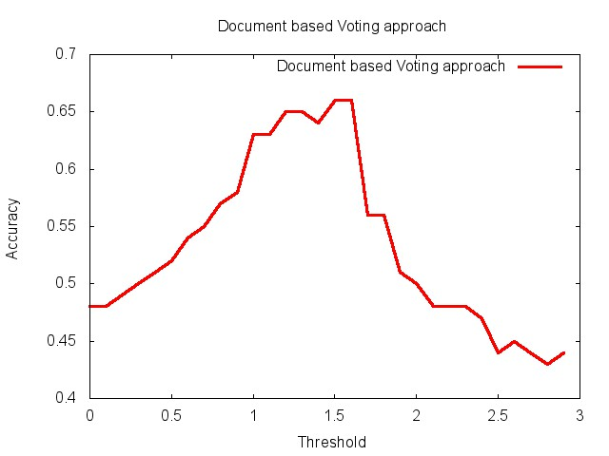

**Fig 6.1 Threshold Vs Accuracy for Voting full document method**

Inference: Threshold ranges around 1.5 give high accuracies. Indicating that documents that contain sentences with average 1.5 or greater as number of polar words per sentence are more probable to be opinion oriented.

**Voting FirstSentence method:**

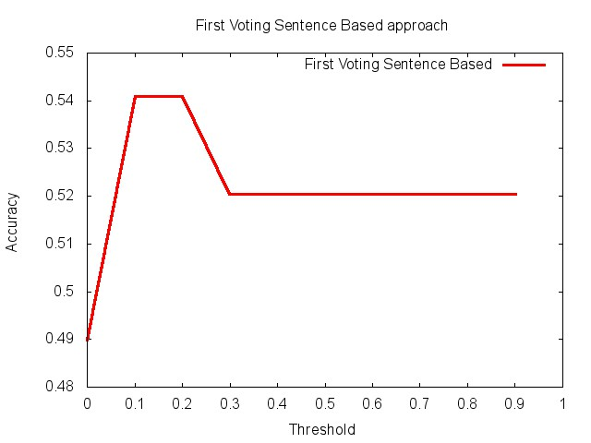

**Fig 6.2 Threshold Vs Accuracy for Voting FirstSentence method**

Inference:Threshold ranges around 0.2 give high accuracies. Indicating that documents with their first sentence containing 20 percent or more words to be polar are more probable to be opinion oriented.

**Voting LastSentence method:**

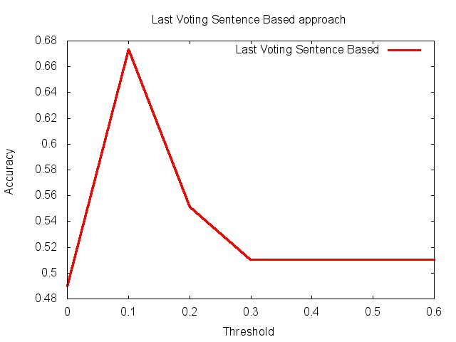

**Fig 6.3 Threshold Vs Accuracy for Voting LastSentence method**

Inference: Threshold ranges around 0.1 give high accuracies. Indicating that documents with their first sentence containing an average 10 percent or greater words to be polar are more probable to be opinion oriented.

**Adjective Count Full Document method:**

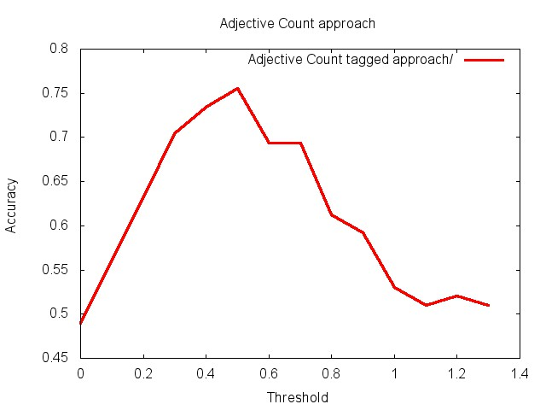

**Fig 6.4 Threshold Vs Accuracy for Adjective Count Full Document method** Inference: Threshold ranges around 0.5 give high accuracies. Indicating that documents that contain sentences with average 0.5 and greater as number of adjectives per sentence are more probable to be opinion oriented.

**Adjective Count FirstSentence method:**

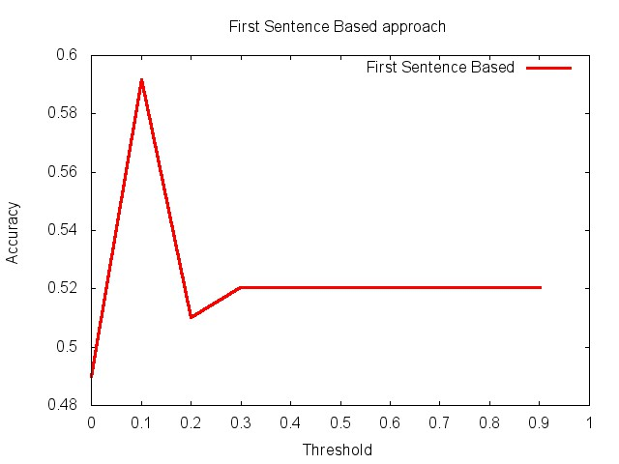

**Fig 6.5 Threshold Vs Accuracy for Adjective Count FirstSentence method**

Inference: Threshold ranges around 0.1 give high accuracies. Indicating that documents with their first sentence containing an average 10 percent and higher number of words to be adjectives are more probable to be opinion oriented.

**Adjective Count LastSentence method:**

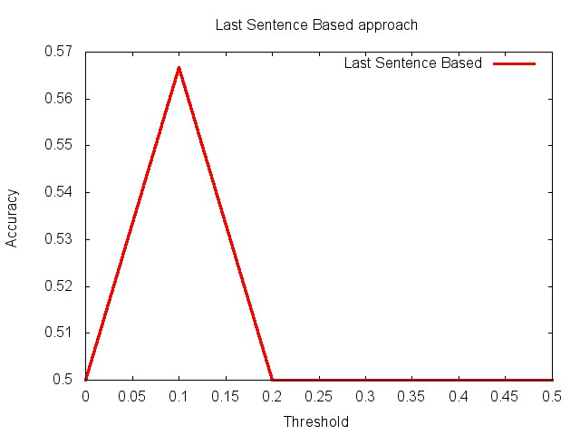

**Fig 6.6 Threshold Vs Accuracy for Adjective Count LastSentence method**

Inference: Threshold ranges around 0.1 give high accuracies. Indicating that documents with their last sentence containing an average 10 percent and higher number of words to be adjectives are more probable to be opinion oriented

**Adjective Count Significant Sentence method:**

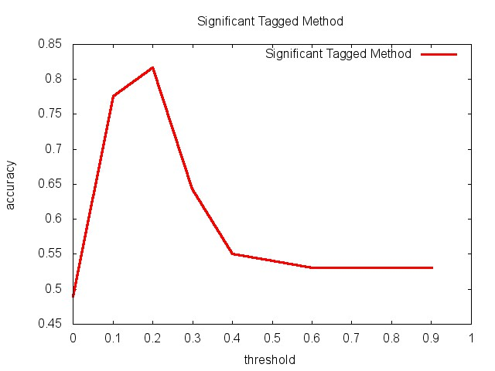

**Fig 6.7 Threshold Vs Accuracy for Adjective Count Significant Sentence method** Inference:Threshold ranges around 0.2 give high accuracies. Indicating that documents with their significant sentence containing an average 20 percent or higher number of words to be adjectives are more probable to be opinion oriented

**Adjective Count First+Last+Significant Sentence method:**

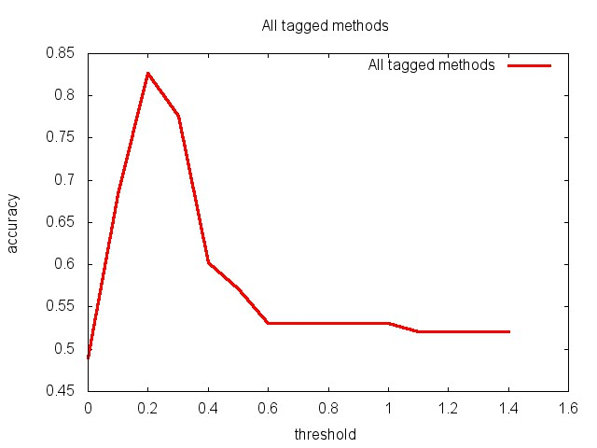

**Fig 6.8 Threshold Vs Accuracy for Adjective Count First+Last+Significant(FLS) Sentence method**

Inference:Threshold ranges around 0.2 give high accuracies. It considers the contribution of the first last and significant sentences in the text. This method gives a high accuracy since it’s scope of consideration is more and very relevant.

**CueBased Full Document method:**

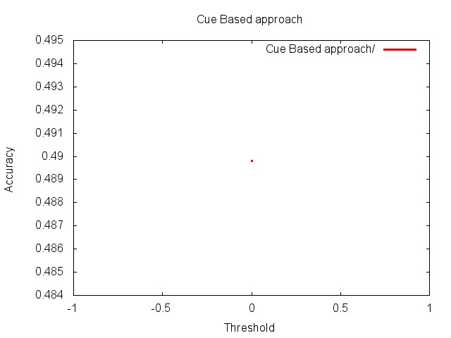

**Fig 6.9 Threshold Vs Accuracy for CueBased Full Document method**

Inference**:** Gives an accuracy of 50%. Indicates that presence of cues give a 50% probability of the text being opinionated.

**OtherPOS Full Document method:**

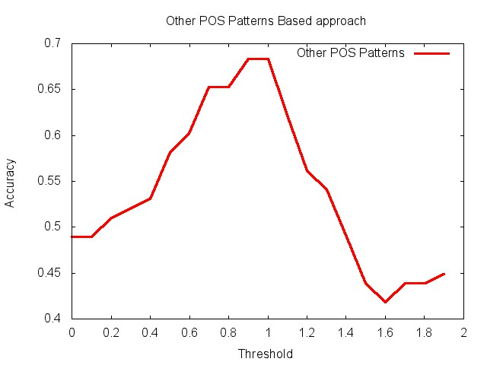

**Fig 6.10 Threshold Vs Accuracy for OtherPOS Full Document method**

Inference:Threshold ranges around 1 give high accuracies. Indicating that documents that contain sentences with average 1 and greater as number of matching POS patterns per sentence are more probable to be opinion oriented.

**OtherPOS FirstSentence method:**

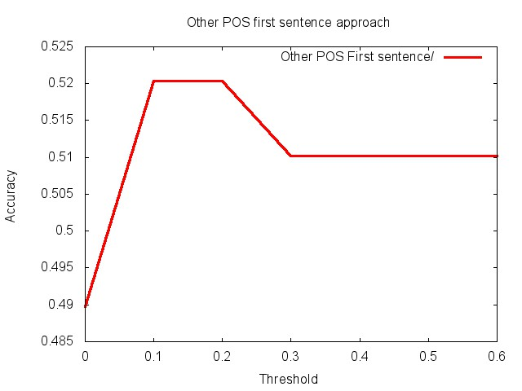

**Fig 6.11 Threshold Vs Accuracy for the OtherPOS FirstSentence method**

Inference:Threshold ranges around 0.1 to 0.2 give high accuracies. This matches patterns only in the first sentence.

**OtherPOS LastSentence method:**

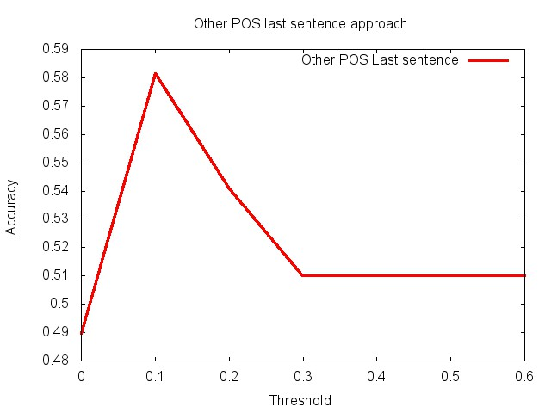

**Fig 6.12 Threshold Vs Accuracy for the OtherPOS LastSentence method**

Inference: Threshold ranges around 0.1 give high accuracies. This matches patterns only in the last sentence.

**OtherPOS Significant Sentence method:**

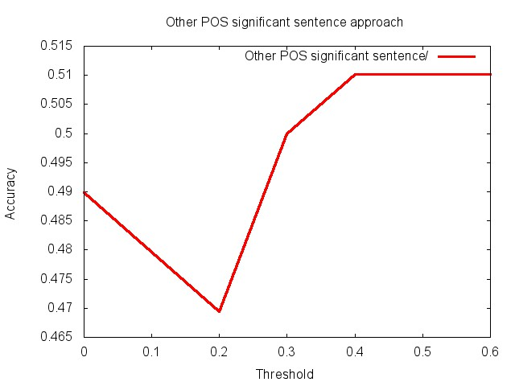

**Fig 6.13 Threshold Vs Accuracy for OtherPOS Significant Sentence method**

Inference: Threshold ranges around 0.5 give high accuracies. This matches patterns only in the significant sentence.

**OtherPOS First+Last+Significant Sentence method:**

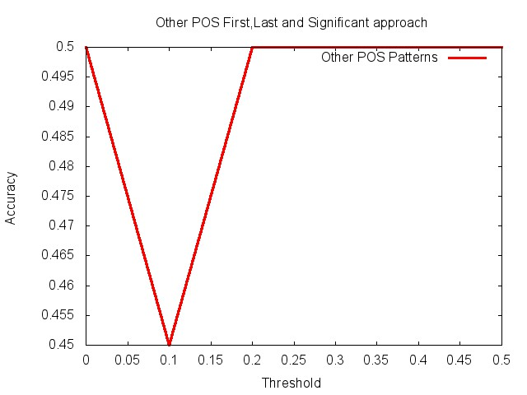

**Fig 6.14 Threshold Vs Accuracy for the OtherPOS First+Last+Significant Sentence method**

Inference: Threshold ranges around 0.3 give high accuracies. This matches patterns in the first, last and significant sentences.

Graph of the maximum accuracies obtained for different number of input files.

* Graph x-axis : Number of input documents
* Graph y-axis : Maximum accuracy obtained.

The graphical representation of experimental results of all the methods viz Voting, Adjective Based, Cue Based and OtherPOS methods with Maximum Accuracy vs No. of input files are as follows

**Voting Full Document method:**

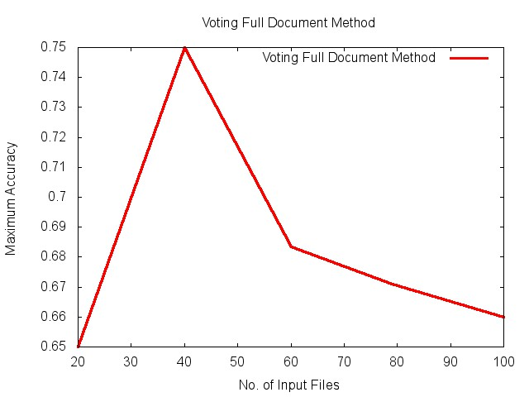

**Fig 6.15 No of files Vs Maximum Accuracy for Voting Full Document method**

Inference: A maximum accuracy of 80 percent can be achieved with this method for an input size of around 40 files.

**Voting FirstSentence method: ­**

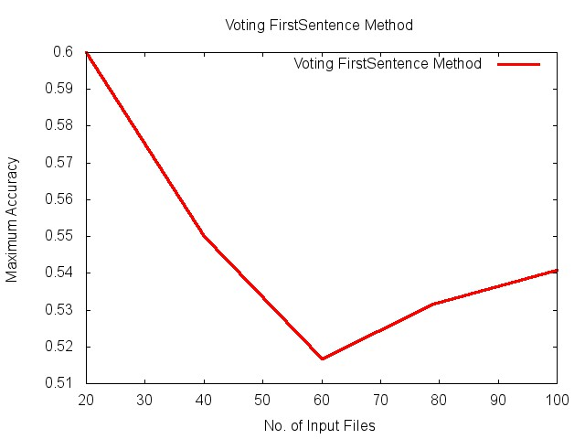

**Fig 6.16 No of files Vs Maximum Accuracy for Voting FirstSentence method**

Inference: A maximum accuracy of 80 percent can be achieved with this method for an input size of around 40 files.

**Voting LastSentence method:**

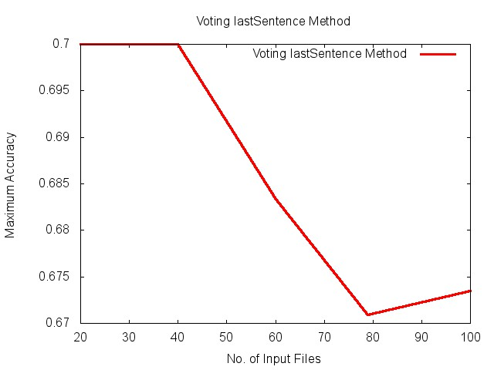

**Fig 6.17 No of files Vs Maximum Accuracy for Voting LastSentence method**

Inference: A maximum accuracy of 60 percent can be achieved with this method for an input size of around 20 files.

**Adjective Count Full Document method:**

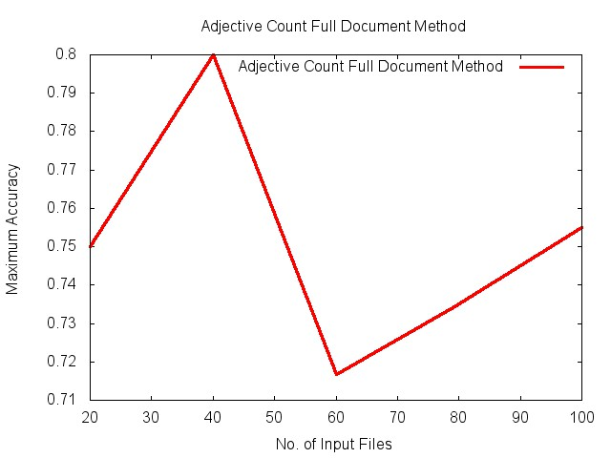

**Fig 6.18 No of files Vs Maximum Accuracy for Adjective Count Based Full Document method**

Inference: A maximum accuracy of 70 percent can be achieved with this method for an input size of around 20 to 40 files.

**Adjective Count FirstSentence method:**

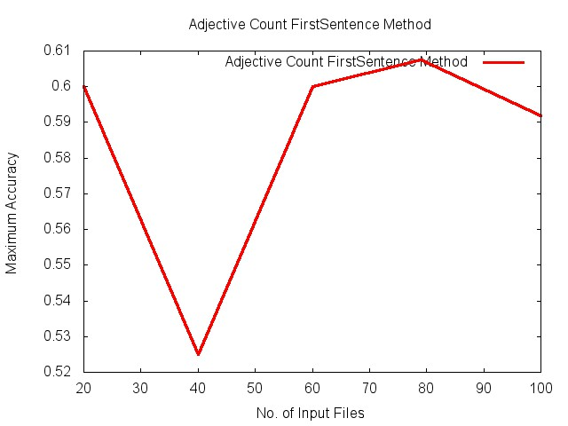

**Fig 6.19 No of files Vs Maximum Accuracy for Adjective Count First Sentence method**

Inference: A maximum accuracy of 80 percent can be achieved with this method for an input size of around 40 files.

**Adjective Count LastSentence method:**

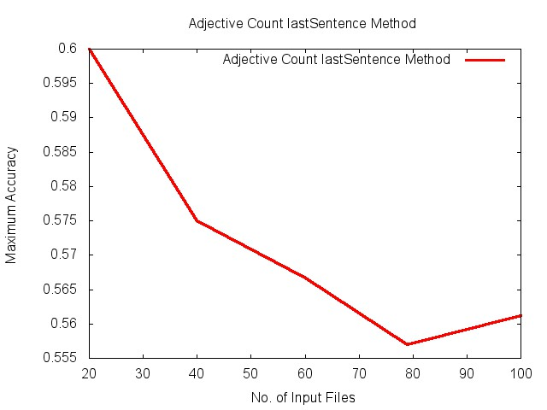

**Fig 6.20 No of files Vs Maximum Accuracy for Adjective Count Last Sentence method**

Inference: A maximum accuracy of more than 60 percent can be achieved with this method for an input size of around 80 files.

**Adjective Count Significant Sentence method:**

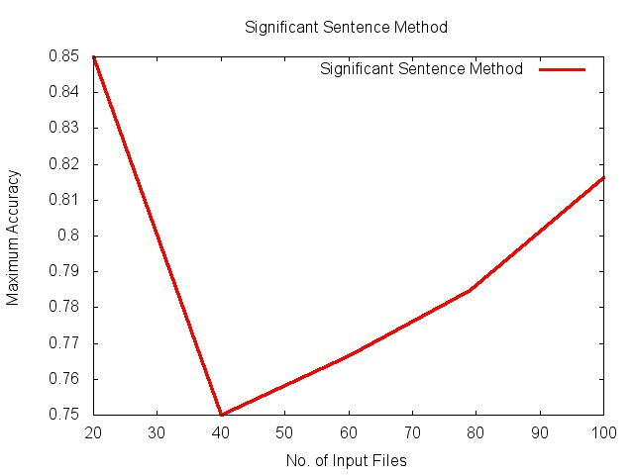

**Fig 6.21 No of files Vs Maximum Accuracy for Adjective Count Significant Sentence method**

Inference: A maximum accuracy of 60 percent can be achieved with this method for an input size of around 20 files.

**Adjective Count First+Last+Significant Sentence method:**

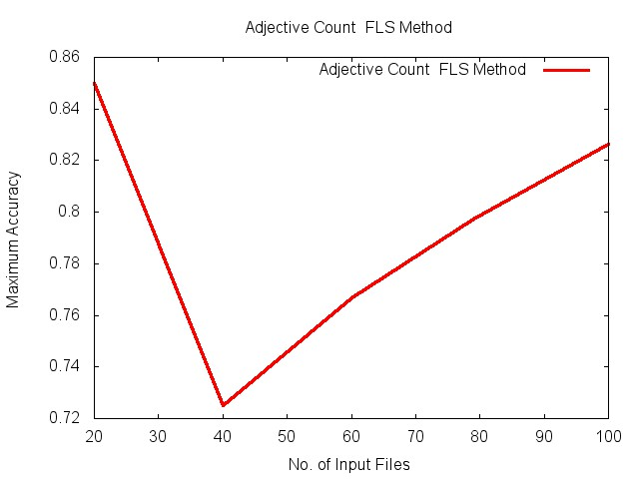

**Fig 6.22 No of files Vs Maximum Accuracy for Adjective Count Based FLS method**

Inference: A maximum accuracy of 85 percent can be achieved with this method for an input size of around 20 files.

**CueBased Full Document method:**

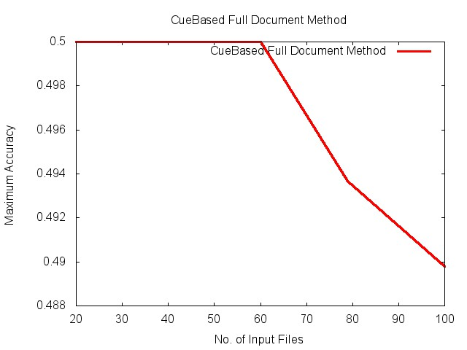

**Fig 6.23 No of files Vs Maximum Accuracy for CueBased Full Document method**

Inference: A maximum accuracy of 50 percent can be achieved with this method for an input size of around 20 to 60 files.

**OtherPOS Full Document method:**

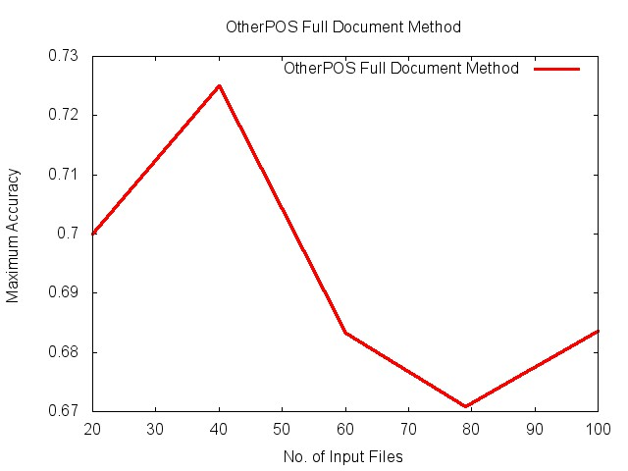

**Fig 6.24 No of files Vs Maximum Accuracy for OtherPOS Full Document method**

Inference: A maximum accuracy of more than 72 percent can be achieved with this method for an input size of around 40 files.

**OtherPOS FirstSentence method:**

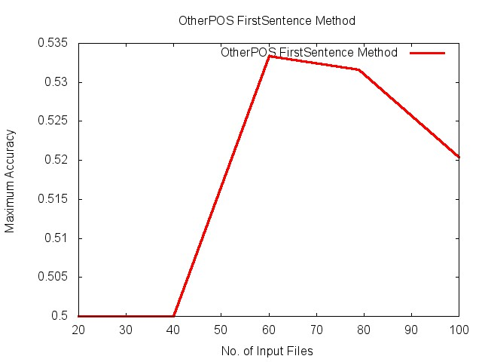

**Fig 6.25 No of files Vs Maximum Accuracy for OtherPOS FirstSentence method**

Inference: A maximum accuracy of more than 53 percent can be achieved with this method for an input size of around 60 files.

**OtherPOS LastSentence method** :

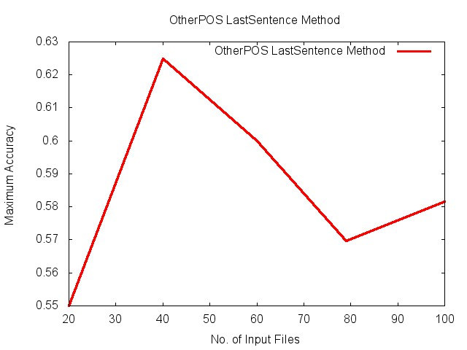

**Fig 6.26 No of files Vs Maximum Accuracy for OtherPOS LastSentence method**

Inference: A maximum accuracy of more than 62 percent can be achieved with this method for an input size of around 40 files.

**OtherPOS Significant method:**

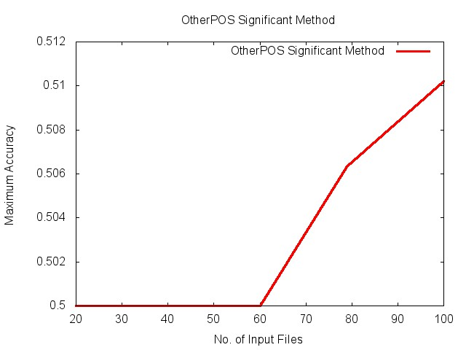

**Fig 6.27 No of files Vs Maximum Accuracy for OtherPOS Significant method**

Inference: A maximum accuracy of more than 51 percent can be achieved with this method for an input size of around 100 files.

**OtherPOS First+Last+Significant Sentence method:**

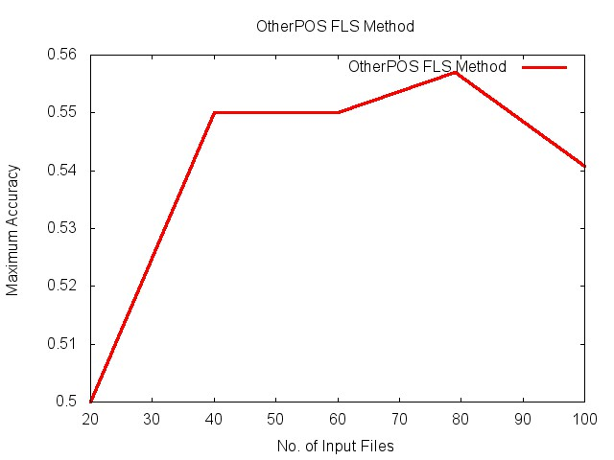

**Fig 6.28 No of files Vs Maximum Accuracy for OtherPOS First+Last+significant method**

Inference: A maximum accuracy of more than 55 percent can be achieved with this method for an input size of around 80 files.

**Chapter 7 : CONCLUSION AND FUTURE ENHANCEMENTS**

**7.1 Conclusion**

The main aim of the project was to classify given text as opinion or factual using a threshold based approach. To achieve this goal the path followed can be compactly concluded as below:

* Collection of data: Collection of several sets of input text files. The sets consisted of both opinionated and factual text documents.
* Implementation: Identifying and implementing different methods of threshold based classification with different input types. The following list shows the classification methods experimented along with the input types they support:
  + Voting based – Count of polar words in sentence(s). Supports input types – Full document, First Sentence, last Sentence.
  + Adjective Count Based – Count of adjectives in POS tagged sentence(s). Supports input types - Full document, First Sentence, last Sentence, Significant Sentence, First-last-significant sentence.
  + Cue Based – find opinion oriented cues in the document. Supports input types – Full document
  + Other POS – find opinion oriented POS patterns in the document. Supports input types - Full document, First Sentence, last Sentence, Significant Sentence, First-last-significant sentence.
* Experimentation: Execution of all the above mentioned methods with inputs consisting of varying number of text documents. The results were recorded with a range of thresholds and their accuracies for each method experimented.
* Visualization of results as graphs.
* Inference: Study of the results and determination of the most accurate method to classify any input text. Also observing the behavior of the accuracy of classification against number of input files as a factor.
* Front End: Creation of front end for user interaction with three modules – to view experiment results, to classify user entered text as opinion or fact and to view the accuracy of classification against number of input files.
* Documentation: Detailed report of the project consisting of explanation of methods and phases followed during building of the project.

The project has been able to determine an optimal classification technique with a threshold giving satisfying accuracy. This can be applied in the process of extracting opinion oriented text documents from large collection data documents, which can serve as input to other opinion mining applications like opinion-search engines etc.,

**7.2 Future enhancements**

The presence of quoted statements in a news article puts it in an ambiguous category. The statement may or may not express opinion and if it does, it could result in the document being classified as opinionated.

Also it is observed that most reviews are written in the first person and contain patterns like 'I find' etc. This follows a general pattern of 'I' followed by a verb in the base, past or past participle frm. These patterns can be identified using the Monty Tagger.  
  
Combining the above two ideas, we could eliminate the ambiguous quoted sentences and then look for the above mentioned patterns in the text to classify it as an opinion.  
More cues can be added to the list of cues to make it exhaustive.

Also we can include more words in the list of polar words.

**Chapter 8 : BIBLIOGRAPHY**

1. Monty Tagger: Author: Hugo Liu <hugo at media dot mit dot edu> <http://web.media.mit.edu/~hugo/montytagger/>
2. Tang Survey – sentiment detection of reviews 2009 by Huifeng Tang, Songbo Tan, Xueqi Cheng
3. Opinion Mining and sentiment analysis by Bo Pang, Lillian Lee
4. Tracking point of view narrative for subjectivity classification methods by Janyce wiebe <http://www.cs.titt.edu/~wiebe/tubs/papers/CL94.pdf>
5. S.M. Kim and E. Hovy, “Automatic detection of opinion bearing words and sentences,”in Companion Volume to the Proceedings of the International Joint Conference on Natural Language Processing (IJCNLP).
6. Popescu and Etzioni, “Extracting product features and opinions from reviews”, Proceedings of Conference on Human Language Technology and Empirical Methods in Natural Language Processing, pp. 339-346, Vancouver, British Columbia, Canada, 2005.
7. Bo Pang and Lillian Lee, “Using very simple statistics for review search: An Exploration”,Coling 2008: Companion volume Posters and Demonstrations, pp. 75-78, Manchester, UK,2008.
8. Raaijmakers & Kraaij , "A Shallow Approach to Subjectivity Classification" - mediaminer.telecom.tno.nl/papers/ICWSM-Raaijmakers.pdf
9. Bing Liu, "Sentiment Analysis and Subjectivity" http://www.google.co.in/url?sa=t&rct=j&q=&esrc=s&source=web&cd=1&ved=0CFwQFjAA&url=http%3A%2F%2Fciteseerx.ist.psu.edu%2Fviewdoc%2Fdownload%3Fdoi%3D10.1.1.216.5533%26rep%3Drep1%26type%3Dpdf&ei=VAjWT8qmI9HLrQeM4LD7Dw&usg=AFQjCNGlIEx2-18_RFIfCe09Le8ScuTVrQ&sig2=a7o67Ixmp-e8IYq8kWA-UQ
10. B. Wang, B. Spencer, C.X. Ling and H. Zhang " Semi-supervised Self-training for Sentence Subjectivity Classification"

**APPENDIX**

**Appendix A – POS tags assigned by the Monty Tagger**

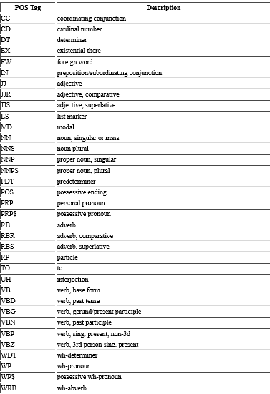

**Appendix B – GUI screenshots**

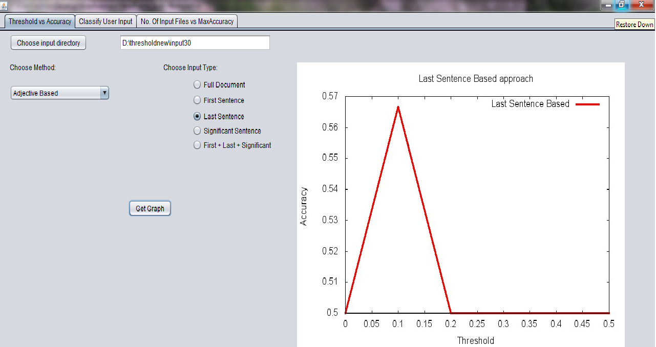

**Fig B.1 Screen Shot of LastSentence Based approach Threshold Vs Accuracy**

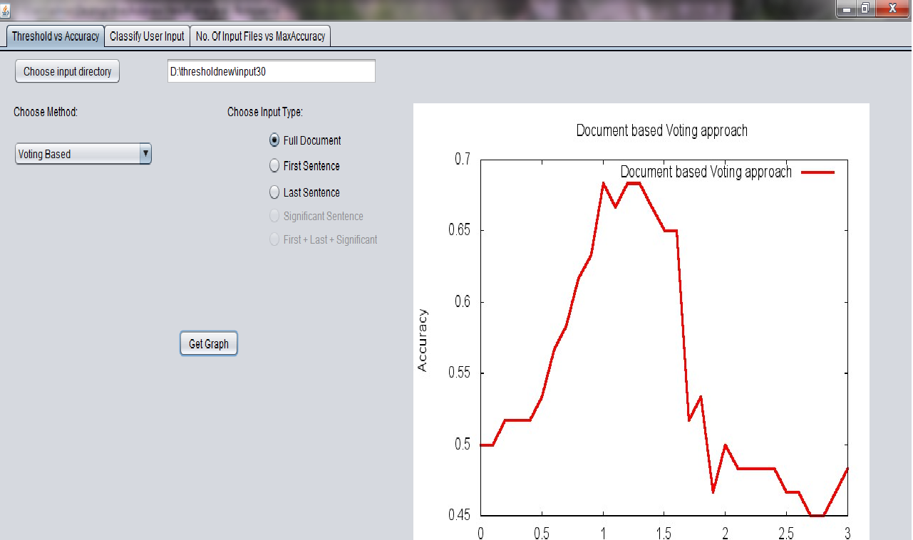

**Fig B.2 Screen Shot of Voting Full Document based approach Threshold Vs Accuracy**

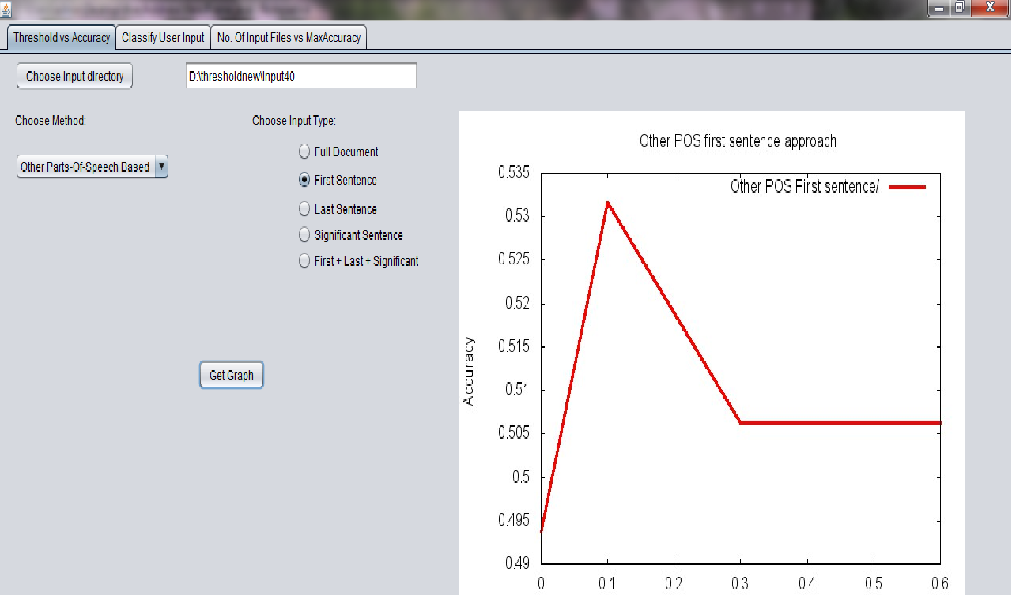

**Fig B.3 Screen Shot of OtherPOS FirstSentence based approach Threshold Vs Accuracy**

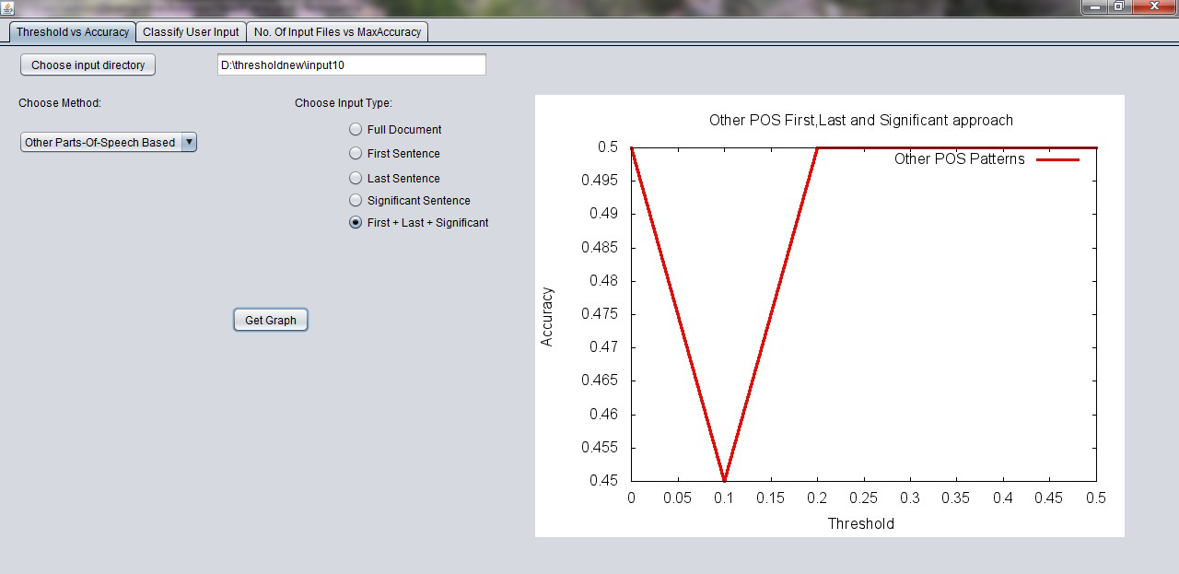

**Fig B.4 Screen Shot of OtherPOS First+Last+significant Sentence based approach Threshold Vs Accuracy**

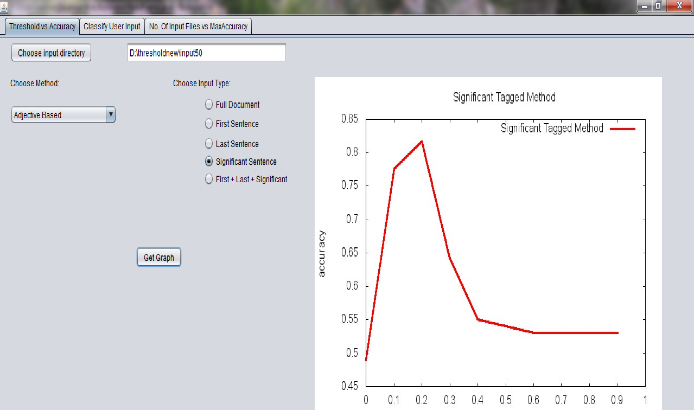

**Fig B.5 Screen Shot of Adjective Significant Sentence based approach Threshold Vs Accuracy**

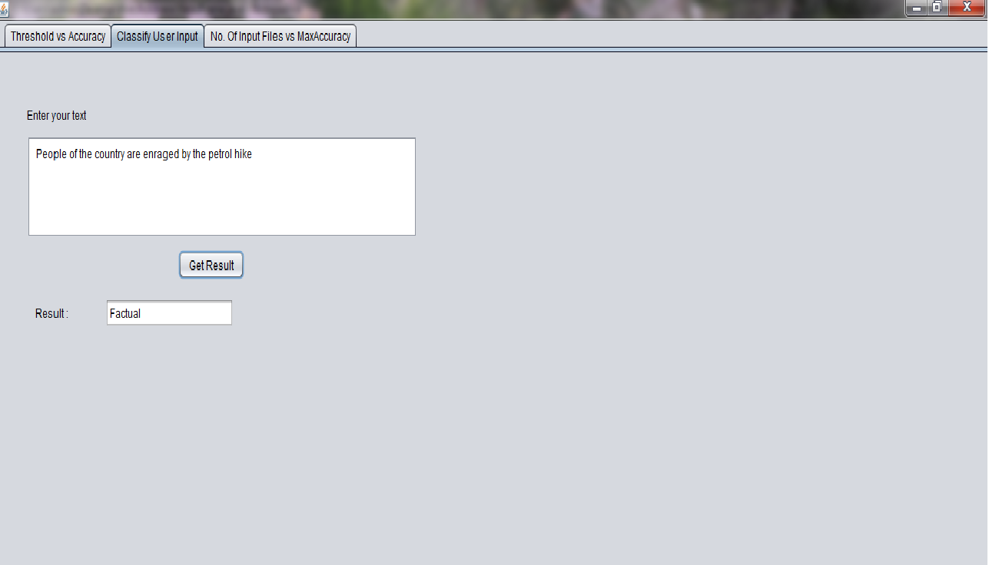

**Fig B.6 Screen Shot of Classification of text of user input**

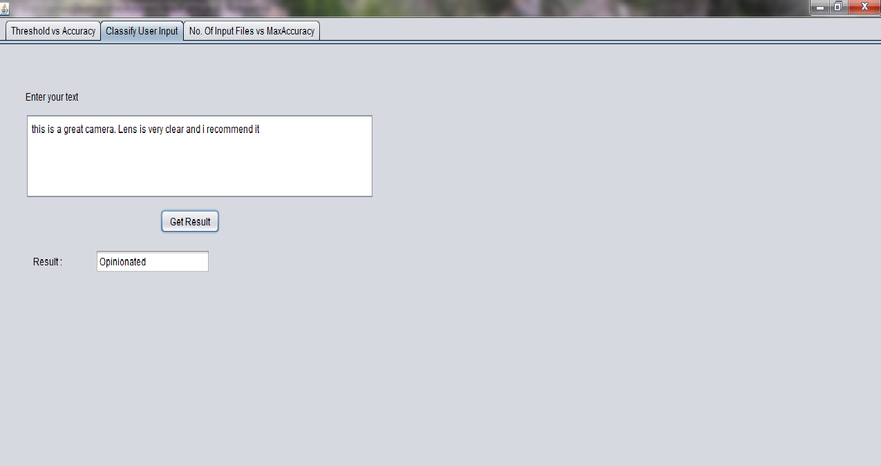

**Fig B.7 Screen Shot of Classification of text of user input**

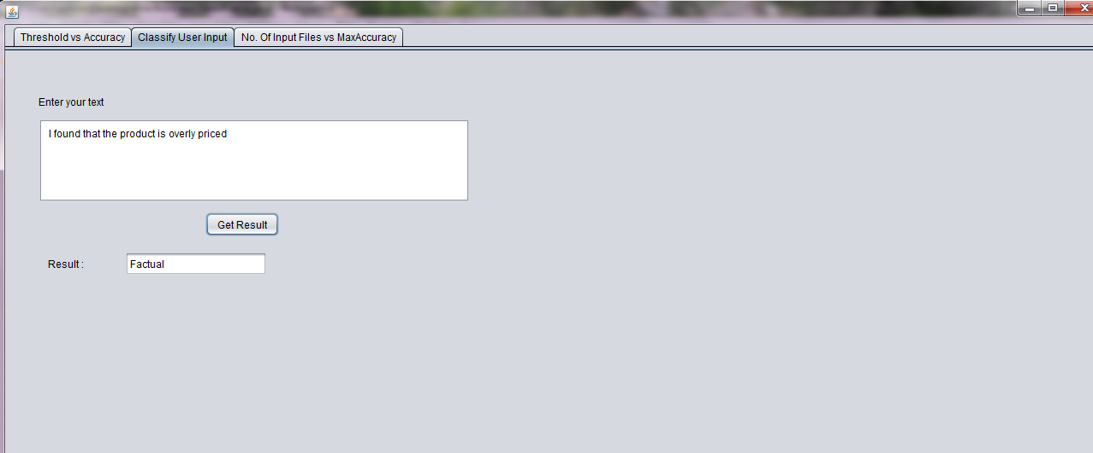

**Fig B.8 Screen Shot of Classification of text of user input**

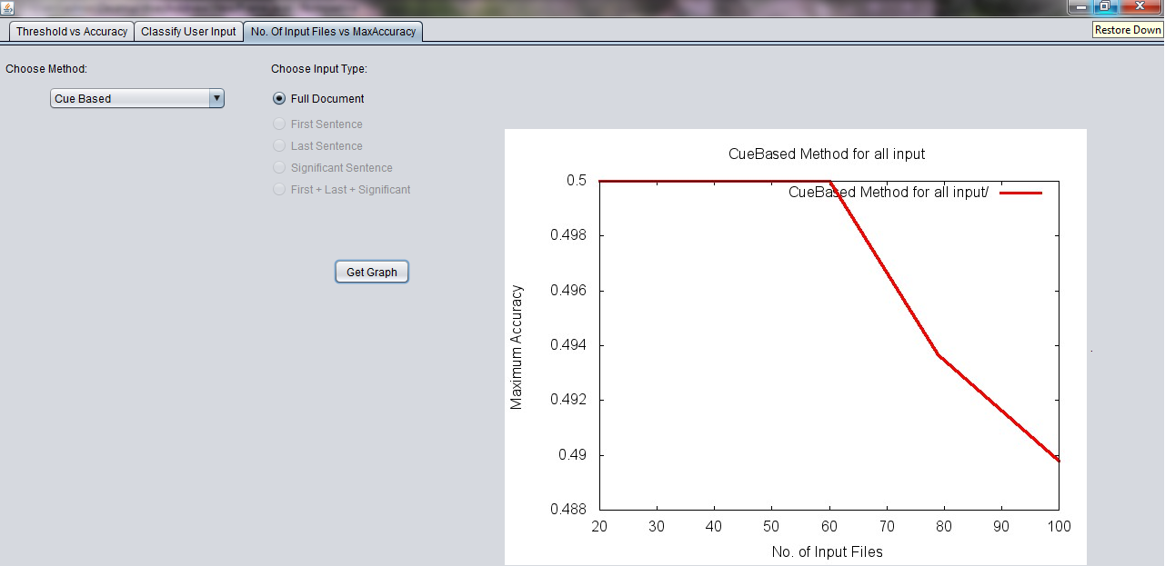

**Fig B.9 Screen Shot of No. of Files vs MaxAccuracy for CueBased method**

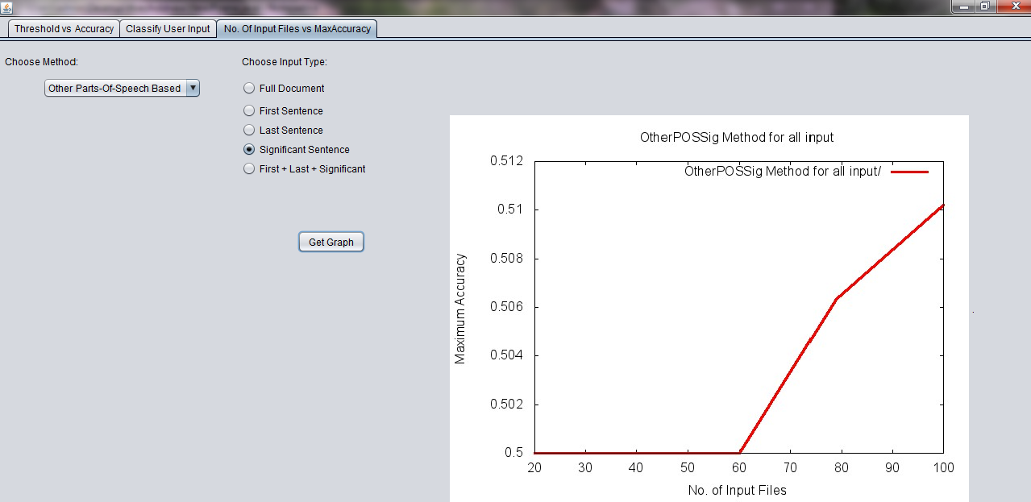

**Fig B.10 Screen Shot of No. of Files vs MaxAccuracy for OtherPOSSignificant method**