The image shows a pie chart representing the "Sum of Exchange by Currency." The chart provides a visual breakdown of the total exchange amounts for different currencies.

**Key Insights:**

* **Currency Distribution:** The pie chart illustrates the proportion of each currency in the total exchange sum. The most dominant currency is "AUD" (Australian Dollar), followed by "USD" (United States Dollar), "EUR" (Euro), "CAD" (Canadian Dollar), and "GBP" (British Pound Sterling).
* **Exchange Value:** The chart also displays the specific exchange amounts for each currency. For instance, "AUD" accounts for 3.07K units of exchange, while "GBP" has 1.68K units.
* **Percentage Breakdown:** The chart provides the percentage contribution of each currency to the total exchange sum. This information allows for easy comparison and understanding of the relative importance of each currency.

**Additional Observations:**

* The chart does not provide the specific time period or date range for the exchange data.
* The units of exchange (e.g., "K") are not explicitly defined, but they likely represent a specific unit of currency or value.

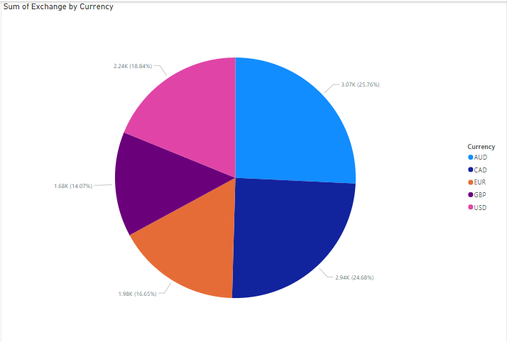

The image you provided is a world map with various colored pins scattered across different regions. These pins likely represent different countries or locations, and the colors may indicate specific categories or data points associated with each location.

**Key Insights:**

* **Geographic Distribution:** The map shows a global distribution of the pins, suggesting that the data represented by the pins is spread across different continents and regions.
* **Clustering:** There seem to be clusters of pins in certain areas, such as Europe and North America. This could indicate a higher concentration of the data points or a specific pattern in their distribution.
* **Color Coding:** The different colors used for the pins likely represent different categories or data points. Without additional context, it's difficult to determine the exact meaning of each color.
* 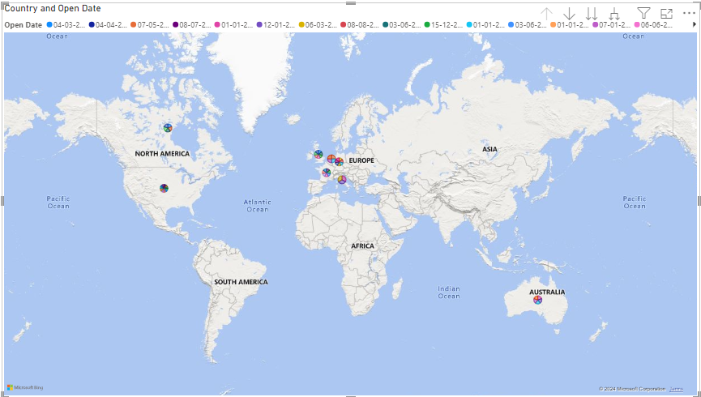**Open Dates:** The title "Country and Open Date" suggests that the pins might represent countries or locations and the corresponding dates at which they were "opened" or established. However, the specific format of the dates is unclear.

The image shows a bar chart titled "Sum of Square Meters and Count of StoreKey by State." The chart compares two metrics for various states: the total square meters and the count of store keys.

**Key Insights:**

* **State Comparison:** The chart allows for a comparison of the sum of square meters and count of store keys across different states.
* **Ranking:** The states are ranked in descending order based on the sum of square meters.
* **Data Distribution:** The chart reveals that there is a wide range in the values of both metrics among the states. Some states have significantly higher sums of square meters and counts of store keys compared to others.
* **Outliers:** There are a few states with noticeably higher or lower values, which might indicate outliers or anomalies in the data.
* **Correlations:** While the chart does not explicitly show a correlation between the two metrics, it can be observed that there is a general trend where states with higher sums of square meters tend to have higher counts of store keys. However, there are also exceptions to this trend.

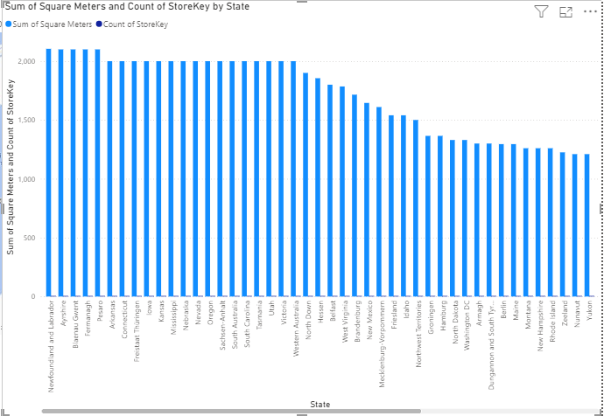

The provided data appears to be a transactional dataset related to sales of various products in different regions. It includes information such as the year, quarter, month, day, brand, category, count of category key, city, color, continent, country, and currency code.

**Key Insights:**

* **Product Sales:** The data contains information about sales of different product categories, including computers, home appliances, TV and video, cameras and camcorders, cell phones, music, movies and audio books, games and toys, and audio.
* **Geographic Distribution:** The data covers sales in different regions, including North America (United States and Canada), Europe (Germany), and Asia (Japan).
* **Brand Analysis:** The dataset includes information about various brands, allowing for analysis of brand performance and market share.
* **Time Series Analysis:** The data can be used to analyze sales trends over time, such as seasonal patterns or year-over-year growth.
* **Customer Segmentation:** The data can be used to segment customers based on their purchasing behavior, geographic location, or other factors.
* 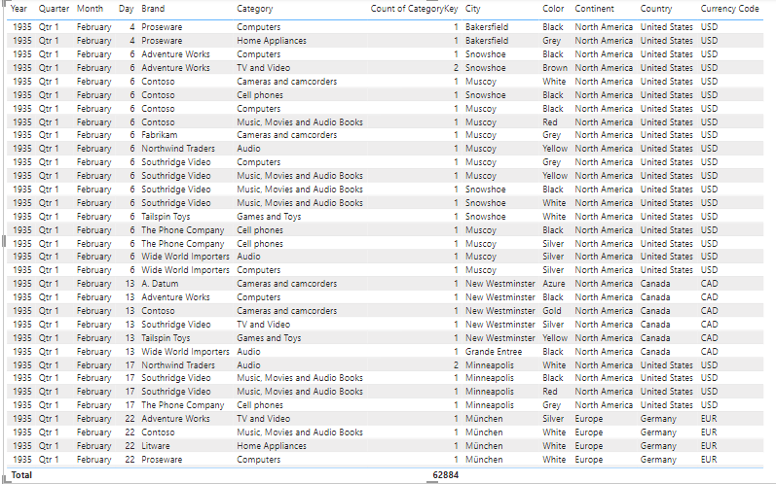

The image shows a clustered bar chart comparing two metrics, "Count of Customerkey" and "Sum of Line Item," for two genders, "Male" and "Female."

**Key Insights:**

* **Gender Comparison:** The chart allows for a comparison of the count of customer keys and the sum of line items between male and female customers.
* **Data Distribution:** The chart reveals that there is a significant difference in the count of customer keys between the two genders, with males having a higher count. However, the sum of line items is relatively similar between males and females.
* **Outliers:** There are no noticeable outliers in the data.
* **Correlations:** While the chart does not explicitly show a correlation between the two metrics, it can be observed that there is no strong correlation between the customer keys and the sum of line items.

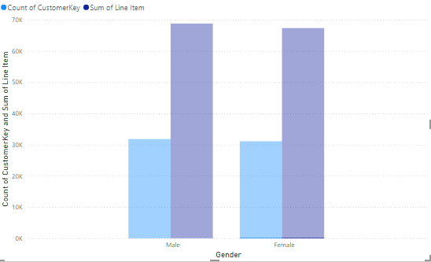

The image shows a line chart titled "Sum of Order Number, Count of ProductKey and Sum of Quantity by Product Name, Year, Quarter, Month and Day." The chart displays the trends of three metrics over time for a specific product.

**Key Insights:**

* **Time Series Analysis:** The chart allows for a visual analysis of the trends of the three metrics over time.
* **Seasonal Patterns:** The chart reveals seasonal patterns in the data, with peaks and troughs occurring at specific times of the year.
* **Correlation Analysis:** While the chart does not explicitly show correlations between the three metrics, it can be observed that there is a general correlation between the sum of order number and the sum of quantity, suggesting that higher order numbers are associated with higher quantities sold.
* **Anomalies:** There are a few anomalies in the data, such as a significant spike in the sum of quantity in the first quarter of 2019.
* **Product Performance:** The chart provides insights into the sales performance of the specific product over time, including peak sales periods, seasonal fluctuations, and potential anomalies.

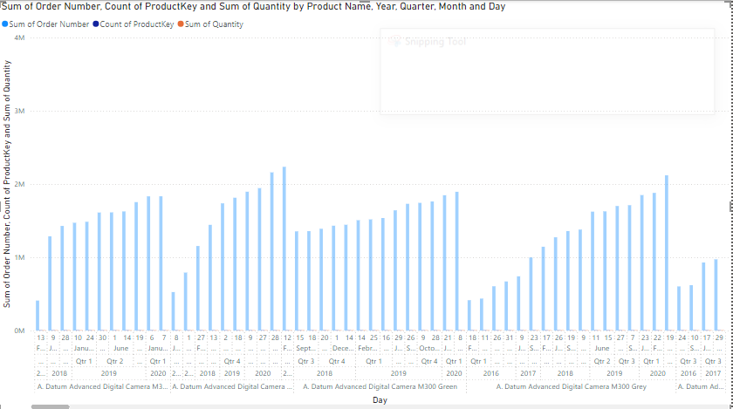

The image shows a clustered bar chart titled "Sum of Unit Price USD, Sum of Unit Cost USD and Count of SubcategoryKey by Zip Code." The chart compares three metrics for various zip codes: the sum of unit price USD, the sum of unit cost USD, and the count of subcategory keys.

**Key Insights:**

* **Zip Code Comparison:** The chart allows for a comparison of the three metrics across different zip codes.
* **Data Distribution:** The chart reveals a wide range in the values of all three metrics among the zip codes. Some zip codes have significantly higher sums of unit price USD, sum of unit cost USD, and count of subcategory keys compared to others.
* **Outliers:** There are a few zip codes with noticeably higher or lower values, which might indicate outliers or anomalies in the data.
* **Correlations:** While the chart does not explicitly show correlations between the three metrics, it can be observed that there is a general trend where zip codes with higher sums of unit price USD tend to have higher sums of unit cost USD and higher counts of subcategory keys. However, there are exceptions to this trend

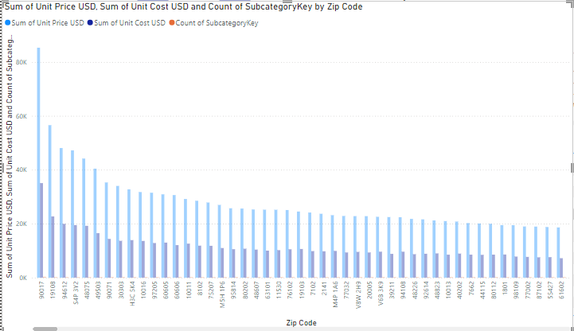

The image shows a map of the United States with a blue circle highlighting the state of West Virginia. The title indicates that the data being analyzed is related to the "Count of StoreKey," "Sum of Quantity," and "Count of ProductKey" for each state code and state.

**Key Insights:**

* **Focus on West Virginia:** The map specifically highlights West Virginia, suggesting that the analysis is focused on this particular state.
* **Data Relationship:** The title indicates that the data being analyzed involves three metrics: the count of store keys, the sum of quantity, and the count of product keys. These metrics likely pertain to sales or inventory data.
* **State-Level Analysis:** The analysis appears to be at a state level, comparing these metrics across different states, with a particular focus on West Virginia.

