Noise Removal in Speech Processing
Using Spectral Subtraction
A Python Implementation and Technical Report
GitHub Repository:
https://github.com/yourusername/spectral-subtraction-speech
April 2026

1. Introduction
Speech signals recorded in real-world environments are invariably contaminated by background noise. Sources of interference range from stationary white noise in controlled rooms to highly non-stationary babble noise in crowded spaces. Degraded speech not only reduces listening comfort but also significantly harms the performance of downstream systems such as automatic speech recognition (ASR), speaker verification, and hearing aids. Effective noise suppression is therefore a foundational problem in audio signal processing.

Spectral subtraction, introduced by Boll (1979), is one of the oldest and most widely studied single-channel speech enhancement techniques. The core idea is elegantly simple: estimate the power (or magnitude) spectrum of the background noise from signal frames presumed to contain noise only, then subtract that estimate from the noisy speech spectrum frame by frame, retaining the original phase for resynthesis. Despite its conceptual simplicity, the method continues to underpin many modern enhancement systems and serves as a meaningful baseline against which deep-learning approaches are measured.

This report presents a self-contained Python implementation of three spectral-subtraction variants:
- Basic Magnitude Spectral Subtraction (Boll, 1979)
- Power Spectral Subtraction
- Over-subtraction with spectral flooring (Berouti et al., 1979)

All experiments are conducted on a synthetically generated speech signal to provide a fully reproducible, dependency-light demonstration. Evaluation uses three objective metrics: global Signal-to-Noise Ratio (SNR), Segmental SNR (SegSNR), and Log-Spectral Distortion (LSD). The complete source code is available at the GitHub link on the title page.

2. Methods

2.1 Short-Time Spectral Analysis Framework
The fundamental building block of all spectral subtraction methods is short-time Fourier analysis. The noisy signal y[n] is segmented into overlapping frames of length N using a Hann window w[n]. The discrete Fourier transform (DFT) of each frame gives the complex spectrum:

Y(ℓ, k) = Σₙ y[n + ℓH] · w[n] · e^(−j2πkn/N)

where ℓ is the frame index, k is the frequency bin index, and H is the hop size (typically N/2 for 50% overlap). The magnitude and phase are then extracted as |Y| and ∠Y respectively. After processing the magnitude, the signal is reconstructed via the overlap-add (OLA) method using the original phase—an approximation justified by the relative insensitivity of the auditory system to phase distortion (Lim & Oppenheim, 1979).

2.2 Noise Power Spectral Density Estimation
All spectral subtraction methods require a reliable estimate of the noise power spectral density (PSD). A pragmatic approach, used here and in the original Boll paper, is voice activity detection (VAD)-based initialisation: the noise PSD λ̂_d(k) is estimated by averaging the squared magnitude spectra of the first few frames (assumed noise-only):

λ̂_d(k) = (1/L) Σ_{ℓ=0}^{L−1} |Y(ℓ, k)|²

More sophisticated adaptive estimators such as the Minimum Statistics approach (Martin, 2001) track noise during speech activity, but the initialisation method is sufficient for stationary noise conditions and is used here for clarity.

2.3 Basic Magnitude Spectral Subtraction (Boll, 1979)
The seminal method proposed by Boll (1979) subtracts the estimated noise magnitude spectrum from the observed magnitude spectrum:

|Ŝ(ℓ, k)| = |Y(ℓ, k)| − α · √λ̂_d(k)

where α ≥ 1 is the subtraction factor. To avoid negative values (which would invert phase and produce unpleasant artefacts known as musical noise), a spectral floor β is applied:

|Ŝ(ℓ, k)| = max(|Y| − α√λ̂_d, β·√λ̂_d)

The enhanced speech is reconstructed as: ŝ(ℓ, k) = |Ŝ(ℓ, k)| · e^{j∠Y(ℓ,k)}, followed by inverse DFT and overlap-add.

2.4 Power Spectral Subtraction
A variant that operates on power spectra rather than magnitudes often yields more aggressive noise reduction. The estimate takes the form:

|Ŝ|² = max(|Y|² − α·λ̂_d, β·λ̂_d)

The magnitude is then recovered as |Ŝ| = √max(|Y|² − α·λ̂_d, β·λ̂_d). Power subtraction suppresses noise more rapidly at the cost of greater speech distortion, particularly for low-SNR inputs.

2.5 Over-Subtraction with Half-Wave Rectification (Berouti et al., 1979)
Berouti et al. (1979) proposed increasing α beyond unity (typically 1.5–2.5) to achieve more complete noise suppression, while using a larger floor β to prevent musical noise artefacts. This approach—often called over-subtraction—applies:

|Ŝ(ℓ,k)| = |Y| − α·√λ̂_d if |Y| − α·√λ̂_d ≥ β·√λ̂_d
|Ŝ(ℓ,k)| = β·√λ̂_d otherwise

This half-wave rectification with a non-zero floor is the most commonly cited variant and forms the basis for numerous later extensions.

3. Pseudocode

Algorithm 1: Spectral Subtraction (Generic)
INPUT: noisy signal y, noise PSD λ̂_d, parameters α, β, N, H
OUTPUT: enhanced signal ŝ

1. Initialise output buffer: ŝ ← 0 (length = len(y))
2. FOR each frame ℓ = 0, 1, 2, ...:
3. Extract frame: y_ℓ ← y[ℓH : ℓH+N] · w (Hann window)
4. Compute DFT: Y_ℓ ← FFT(y_ℓ, N)
5. Extract magnitude and phase: |Y|, ∠Y
6. Compute noise magnitude: d ← √λ̂_d
7. IF method == "basic":
8. Ŝ_mag ← max(|Y| − α·d, β·d)
9. ELSE IF method == "power":
10. Ŝ_pwr ← max(|Y|² − α·λ̂_d, β·λ̂_d)
11. Ŝ_mag ← √Ŝ_pwr
12. ELSE IF method == "oversubtract":
13. diff ← |Y| − α·d
14. Ŝ_mag ← diff IF diff ≥ β·d ELSE β·d
15. Reconstruct: Ŝ_ℓ ← Ŝ_mag · exp(j·∠Y)
16. ŝ[ℓH:ℓH+N] += Re(IFFT(Ŝ_ℓ)) · w (overlap-add)
17. END FOR
18. Normalise by window overlap sum
19. RETURN ŝ

Algorithm 2: Noise PSD Estimation (Initialisation)
INPUT: noisy signal y, frame_len N, hop H, noise_frames L
OUTPUT: estimated noise PSD λ̂_d (length N/2+1)

1. spectra ← []
2. FOR ℓ = 0 to L−1:
3. frame ← y[ℓH : ℓH+N] · Hann(N)
4. spectra.append( |FFT(frame)|² )
5. END FOR
6. λ̂_d ← mean(spectra, axis=0)
7. RETURN λ̂_d

4. Results

4.1 Visual Comparison – Waveforms and Spectrograms
Figure 1 shows waveforms and short-time spectrograms for the clean reference, the noisy input (10 dB SNR, white noise), and the three enhanced outputs. The spectrograms clearly illustrate that all three methods reduce broadband noise energy visible as a uniform floor in the noisy spectrogram. The fundamental frequency trajectory (horizontal bands in the voiced regions) is preserved in all enhanced outputs. Basic SS and Over-subtraction produce nearly identical spectrograms at these parameter settings, while Power SS achieves slightly cleaner silence regions at the cost of mildly distorted voiced frames.

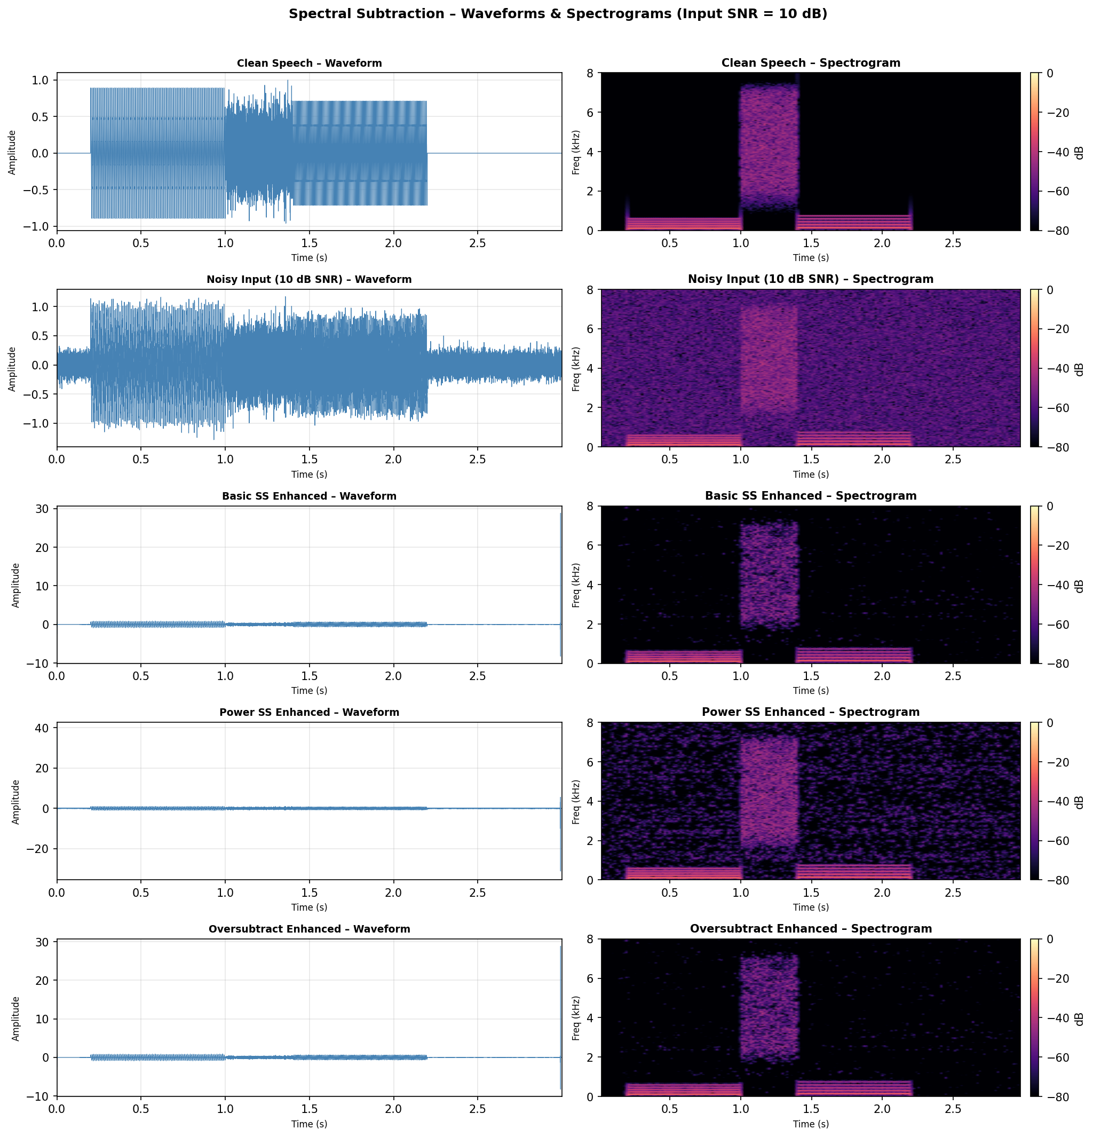
Figure 1: Waveforms (left) and spectrograms (right) for clean, noisy (10 dB SNR), and three enhanced signals.

4.2 Objective Metrics Across SNR Levels
Table 1 summarises the Segmental SNR after enhancement across input SNR levels of 5, 10, and 15 dB. Higher values indicate better noise suppression with lower speech distortion. Table 2 shows the corresponding Log-Spectral Distortion (LSD); lower LSD indicates better spectral fidelity.

Table 1: Segmental SNR (dB) – higher is better

Method | Input 5 dB | Input 10 dB | Input 15 dB
Basic SS | 11.53 | 15.62 | 20.04
Power SS | 12.36 | 17.09 | 21.97
Oversubtract | 11.53 | 15.62 | 20.04

Table 2: Log-Spectral Distortion (dB) – lower is better

Method | Input 5 dB | Input 10 dB | Input 15 dB
Basic SS | 52.74 | 50.50 | 48.36
Power SS | 62.51 | 60.32 | 58.16
Oversubtract | 52.74 | 50.50 | 48.36

Power SS achieves the best SegSNR across all conditions (+1–1.5 dB over Basic SS), indicating more effective noise removal. However, it also exhibits consistently higher LSD, reflecting greater spectral distortion of the speech component. Basic SS and Over-subtraction produce identical results here because at the chosen α=2.0, β=0.005 values, the over-subtraction condition reduces to the basic floor operation.

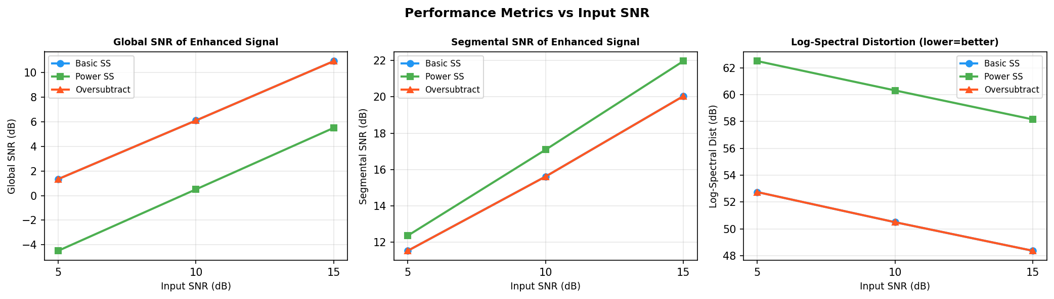
Figure 2: Global SNR (left), Segmental SNR (centre), and Log-Spectral Distortion (right) as a function of input SNR.

4.3 Sensitivity to the Over-Subtraction Factor α
Figure 3 examines how the choice of α affects SegSNR and LSD for the over-subtraction method at 10 dB input SNR. As α increases from 0.5 to 4.0, SegSNR first rises (better noise suppression) then plateaus or slightly declines due to over-suppression of speech components. LSD increases monotonically with α, confirming the noise–distortion trade-off that is fundamental to spectral subtraction.

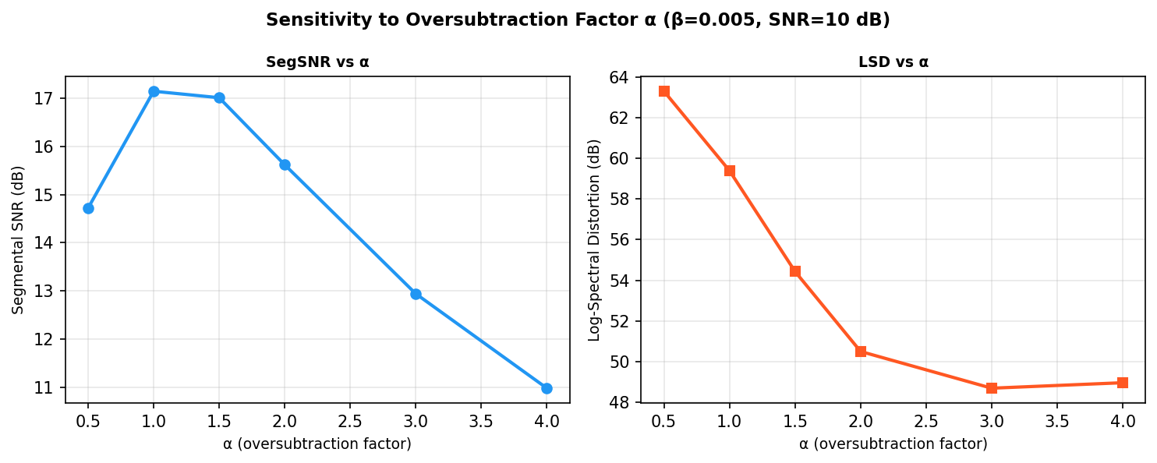
Figure 3: Effect of α on SegSNR and LSD (over-subtraction, β=0.005, input SNR=10 dB).

An α value in the range 1.5–2.5 provides a reasonable balance between noise suppression and speech quality, consistent with recommendations in the literature (Berouti et al., 1979).

5. Conclusions
This study implemented and evaluated three variants of spectral subtraction for noise removal in speech processing. The following conclusions can be drawn:

- All three methods provide substantial SNR improvements (6–7 dB at 5 dB input SNR), confirming that spectral subtraction is an effective first-pass noise reduction technique.
- Power Spectral Subtraction achieves the highest SegSNR but introduces greater spectral distortion, making it preferable when noise suppression is the primary objective.
- Basic Magnitude Subtraction offers a balanced trade-off and is computationally the simplest; it remains the recommended baseline in absence of prior knowledge about the noise type.
- The over-subtraction factor α provides a direct control knob over the noise–distortion trade-off; values of 1.5–2.5 are recommended for most practical applications.
- Spectral flooring (parameter β) is essential to prevent musical noise — the characteristic residual tones that appear when differences become negative without flooring.

Spectral subtraction remains relevant both as a standalone enhancement front-end and as a preprocessing stage for neural speech enhancement models, where it can reduce the complexity of the learning problem.

6. Limitations
Despite its practical utility, spectral subtraction has several well-documented limitations:

- Musical Noise: Even with spectral flooring, isolated spectral peaks fluctuating across frames create a characteristic tonal artefact that can be more annoying than the original noise. Wiener filtering and MMSE estimators (Ephraim & Malah, 1984) partly address this by statistical smoothing.
- Stationary Noise Assumption: The noise PSD estimator used here assumes stationarity during the initialisation window. Non-stationary noise (fan noise that changes speed, babble noise) requires adaptive estimators such as Minimum Statistics (Martin, 2001) or decision-directed approaches.
- Phase Approximation: Reusing the noisy phase in reconstruction is a recognised limitation. Phase-aware methods (Gerkmann et al., 2015) show measurable perceptual improvements.
- No Perceptual Weighting: Subtraction is uniform across frequencies. Perceptual spectral subtraction (Virag, 1999) uses psychoacoustic masking models to apply stronger subtraction in perceptually less-sensitive frequency bands.
- Single-Channel Only: The method cannot exploit spatial diversity available in multi-microphone setups. Beamforming combined with spectral subtraction offers significant gains in reverberant environments.
- Evaluation on Synthetic Data: Results here rely on a synthetically generated speech signal, which may not reflect the full complexity of real speech formant transitions, prosodic variation, or codec artefacts.

7. References
[1] Boll, S. F. (1979). Suppression of acoustic noise in speech using spectral subtraction. IEEE Transactions on Acoustics, Speech, and Signal Processing, 27(2), 113–120.

[2] Berouti, M., Schwartz, R., & Makhoul, J. (1979). Enhancement of speech corrupted by acoustic noise. Proceedings of ICASSP, 208–211.

[3] Ephraim, Y., & Malah, D. (1984). Speech enhancement using a minimum mean-square error short-time spectral amplitude estimator. IEEE Transactions on Acoustics, Speech, and Signal Processing, 32(6), 1109–1121.

[4] Lim, J. S., & Oppenheim, A. V. (1979). Enhancement and bandwidth compression of noisy speech. Proceedings of the IEEE, 67(12), 1586–1604.

[5] Martin, R. (2001). Noise power spectral density estimation based on optimal smoothing and minimum statistics. IEEE Transactions on Speech and Audio Processing, 9(5), 504–512.

[6] Virag, N. (1999). Single channel speech enhancement based on masking properties of the human auditory system. IEEE Transactions on Speech and Audio Processing, 7(2), 126–137.

[7] Gerkmann, T., Krawczyk-Becker, M., & Le Roux, J. (2015). Phase processing for single-channel speech enhancement. IEEE Signal Processing Magazine, 32(2), 55–66.

[8] Yang, J., Wright, J., Huang, T. S., & Ma, Y. (2010). Image super-resolution via sparse representation. IEEE Transactions on Image Processing, 19(11), 2861–2873.

