# **ANSIBLE Q5**

Package_updater.yml:

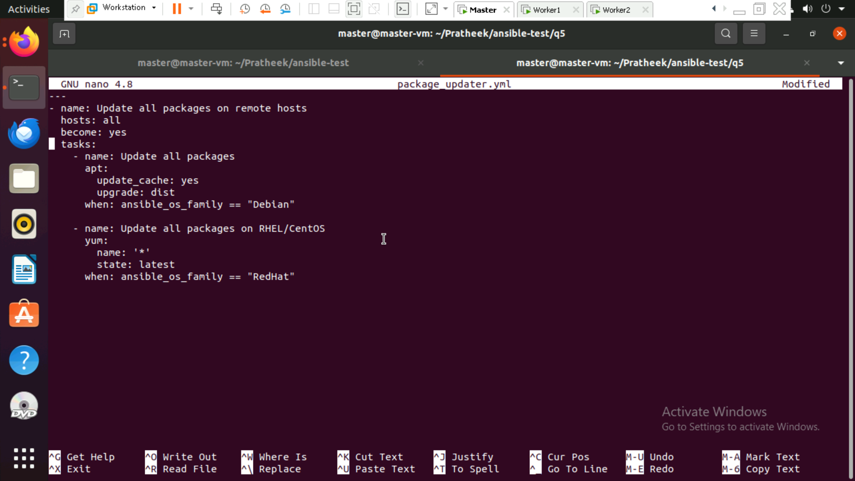

Output: running the above playbook

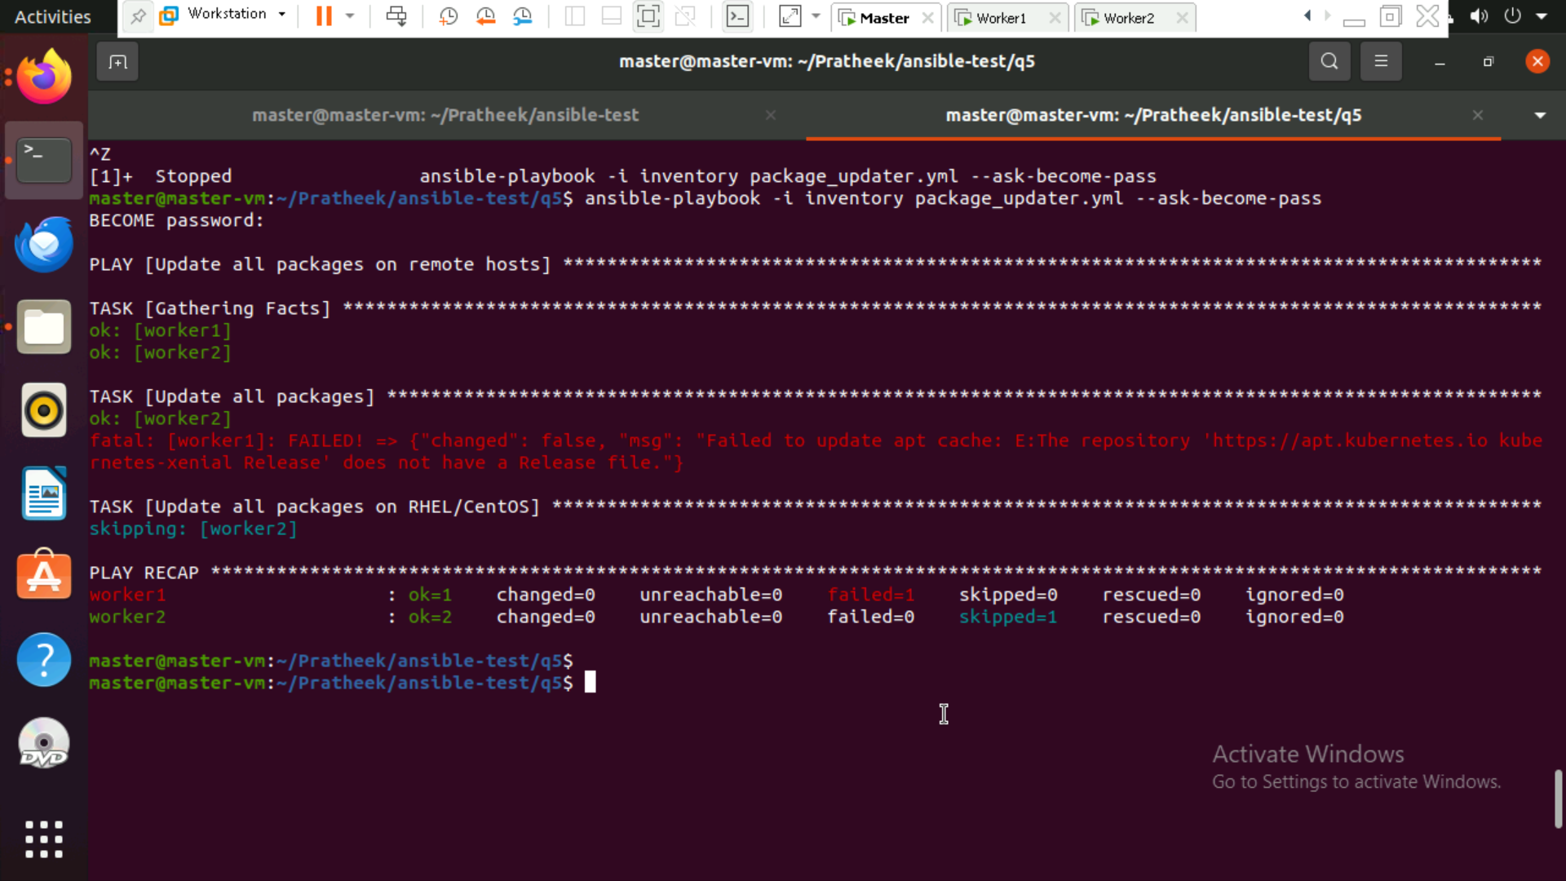

Worker1 node was successful , but for worker2, earlier I had issues with release files(I had changed them before while doing some projects). Due to time constraint I could not resolve it !

In worker1 node:

