# Q2. DOCKERS

1. **Pulling the image**

* Docker pull ubuntu – pulling ubuntu image from dockerhub
* Docker images -

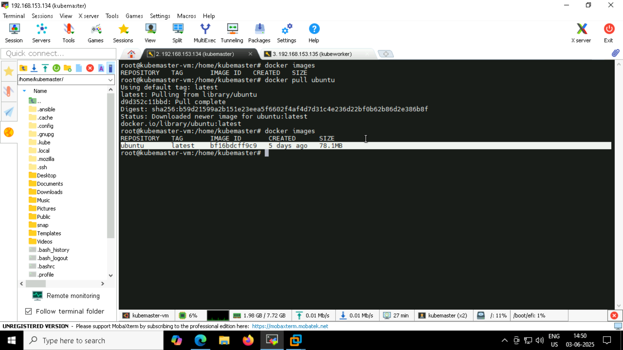

1. **Running the container:**

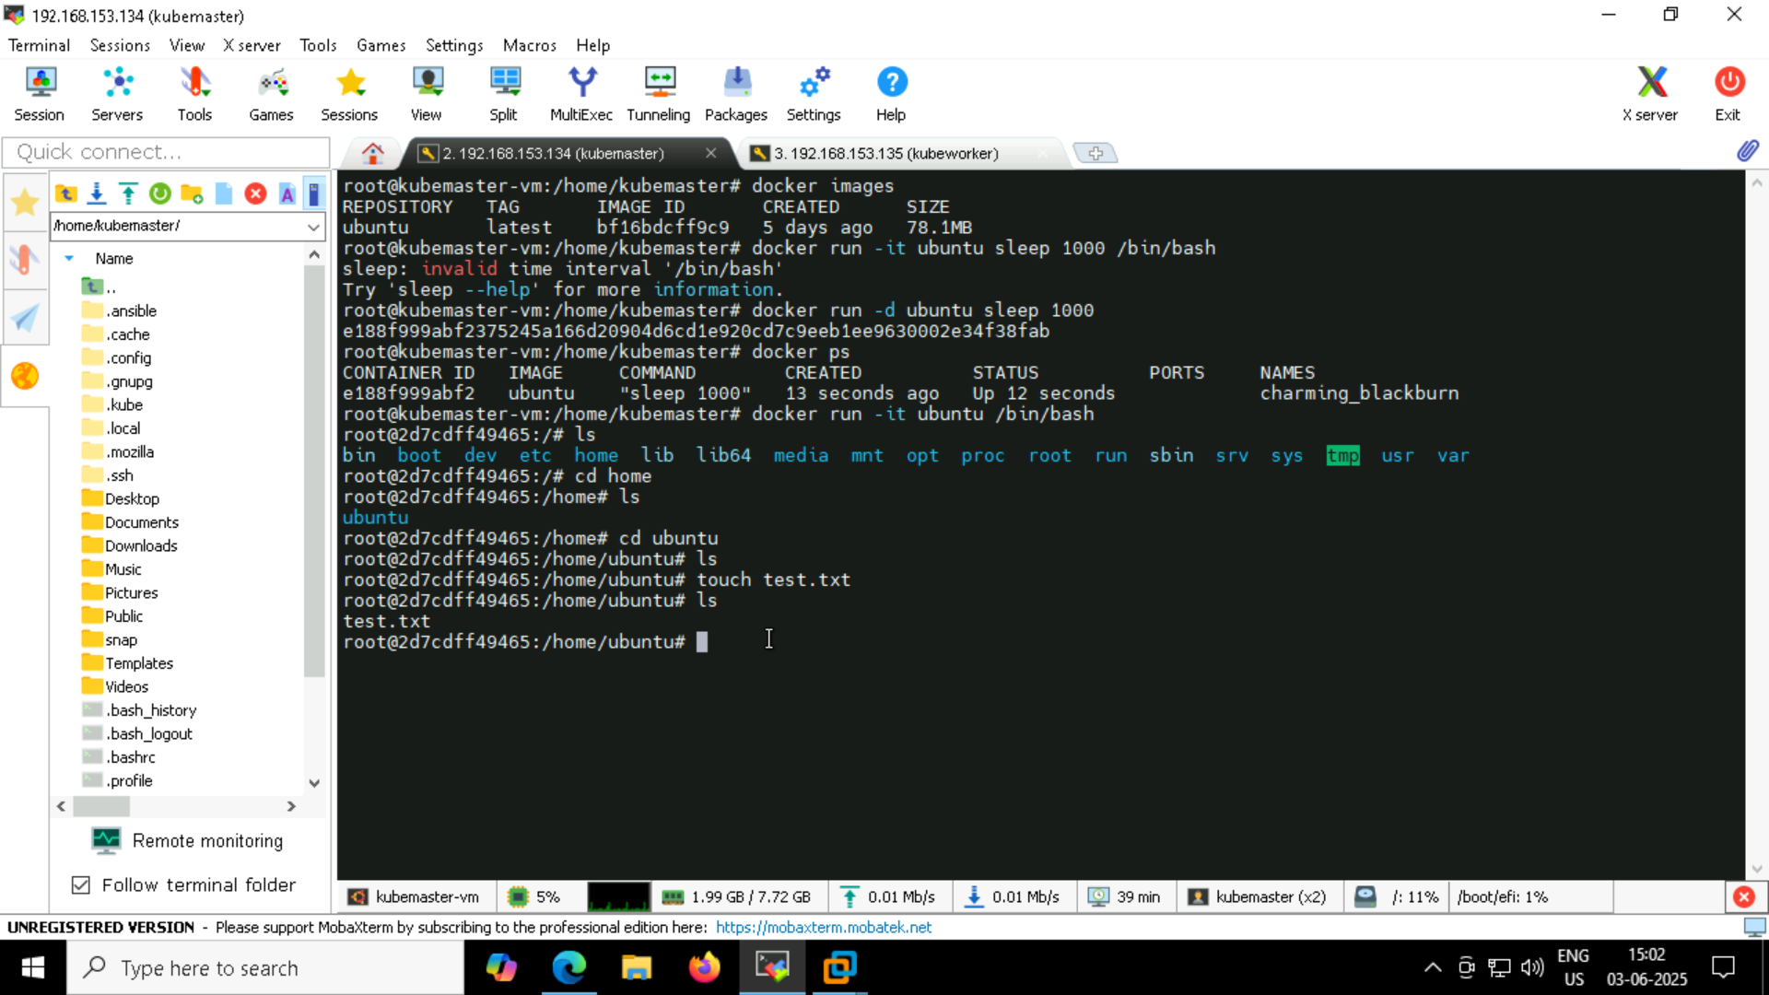



**Running the container and executing inside it-**

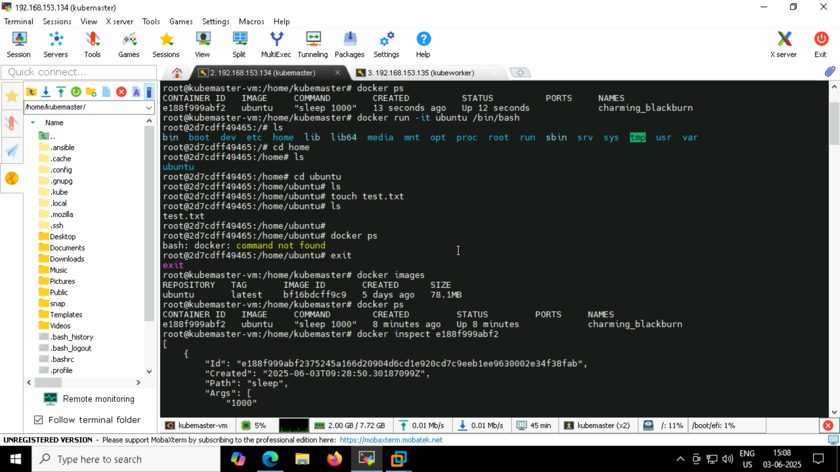

**Verifying container resources by inspecting the container-**

**Docker inspect e188**

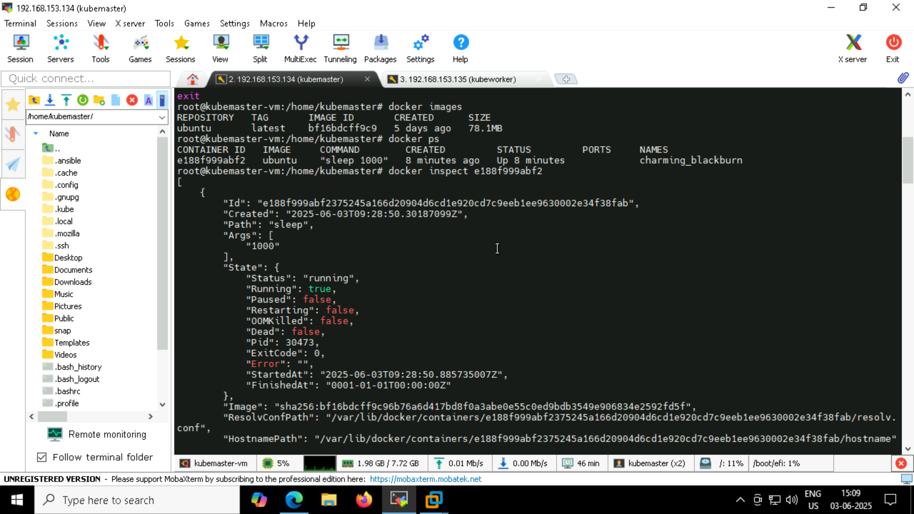

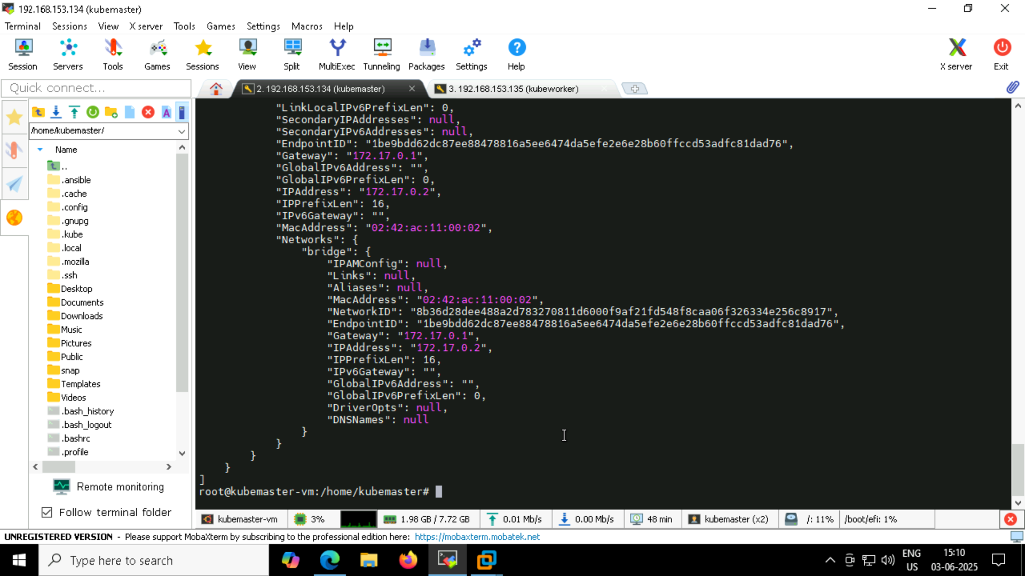

**Docker stats e1**

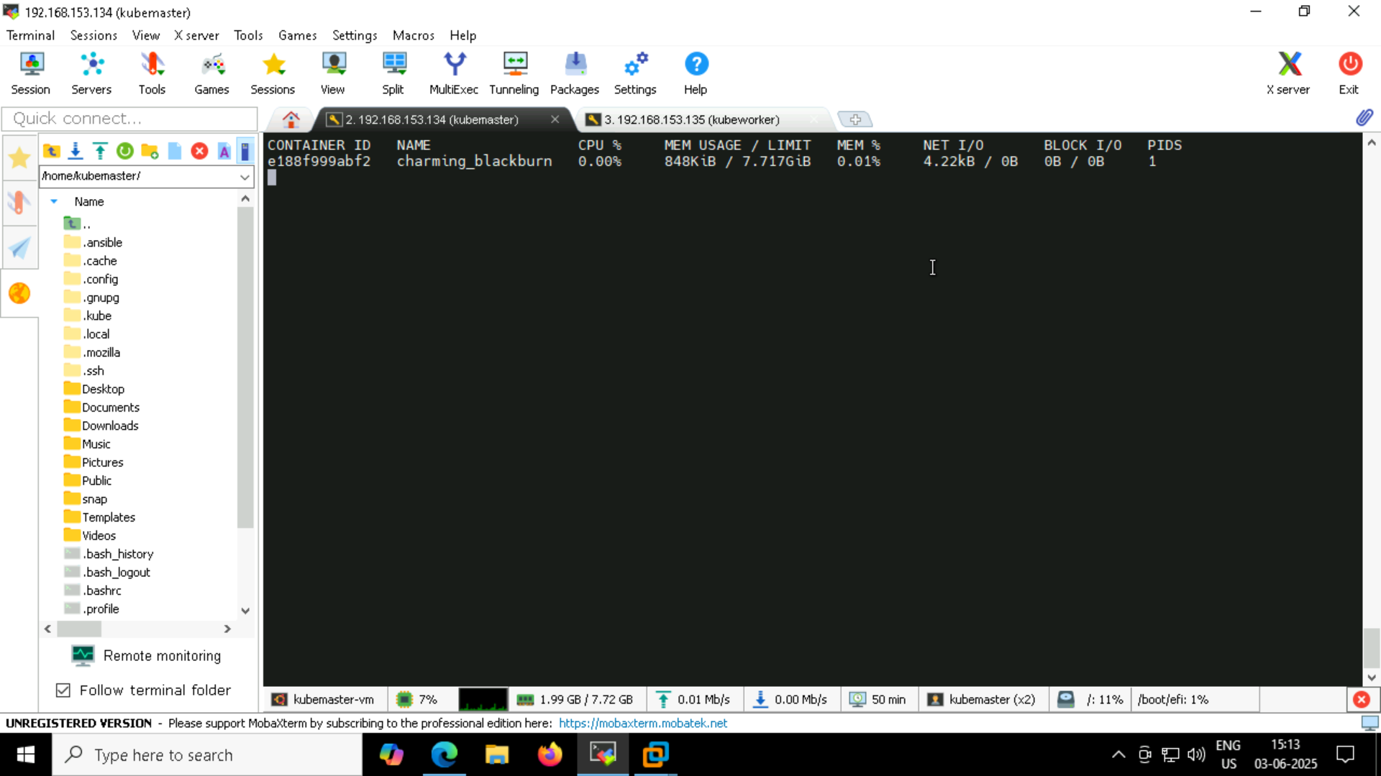

**Docker top e188**

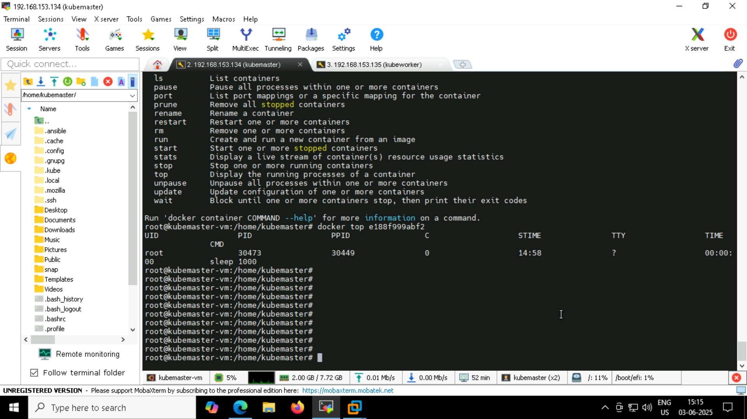

**Stopping the container:**

(the container was stopped. So ran again,my new containerID - cfe )

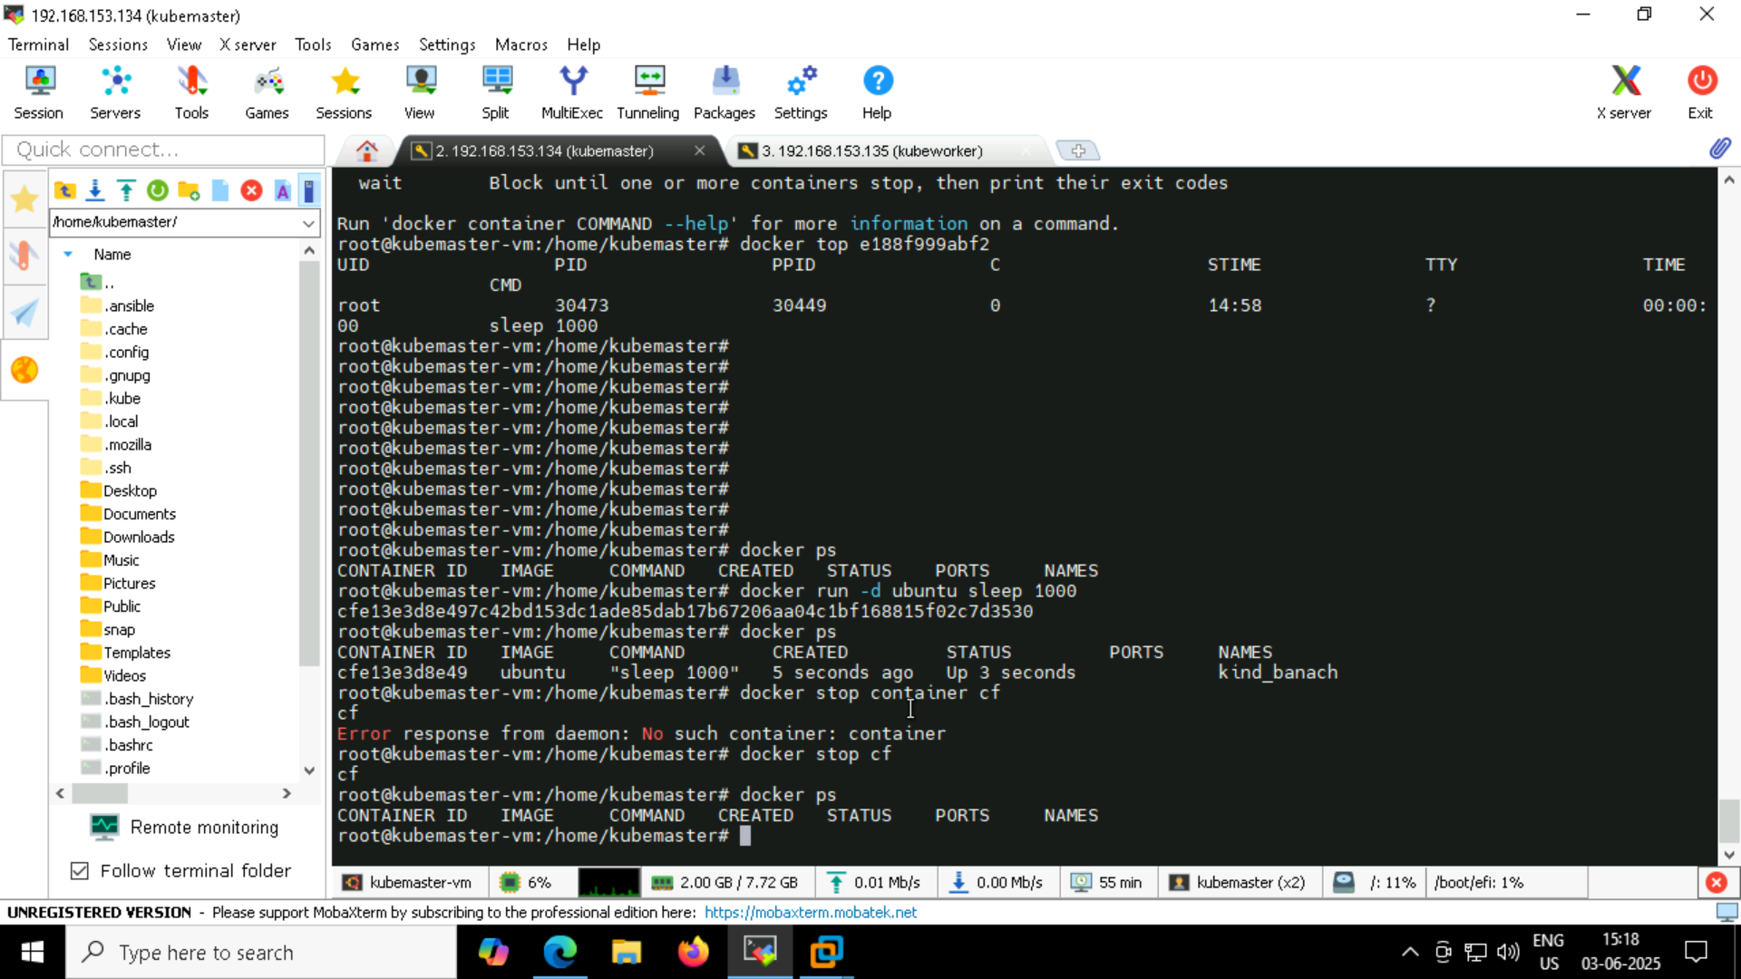

**Removing all container:**

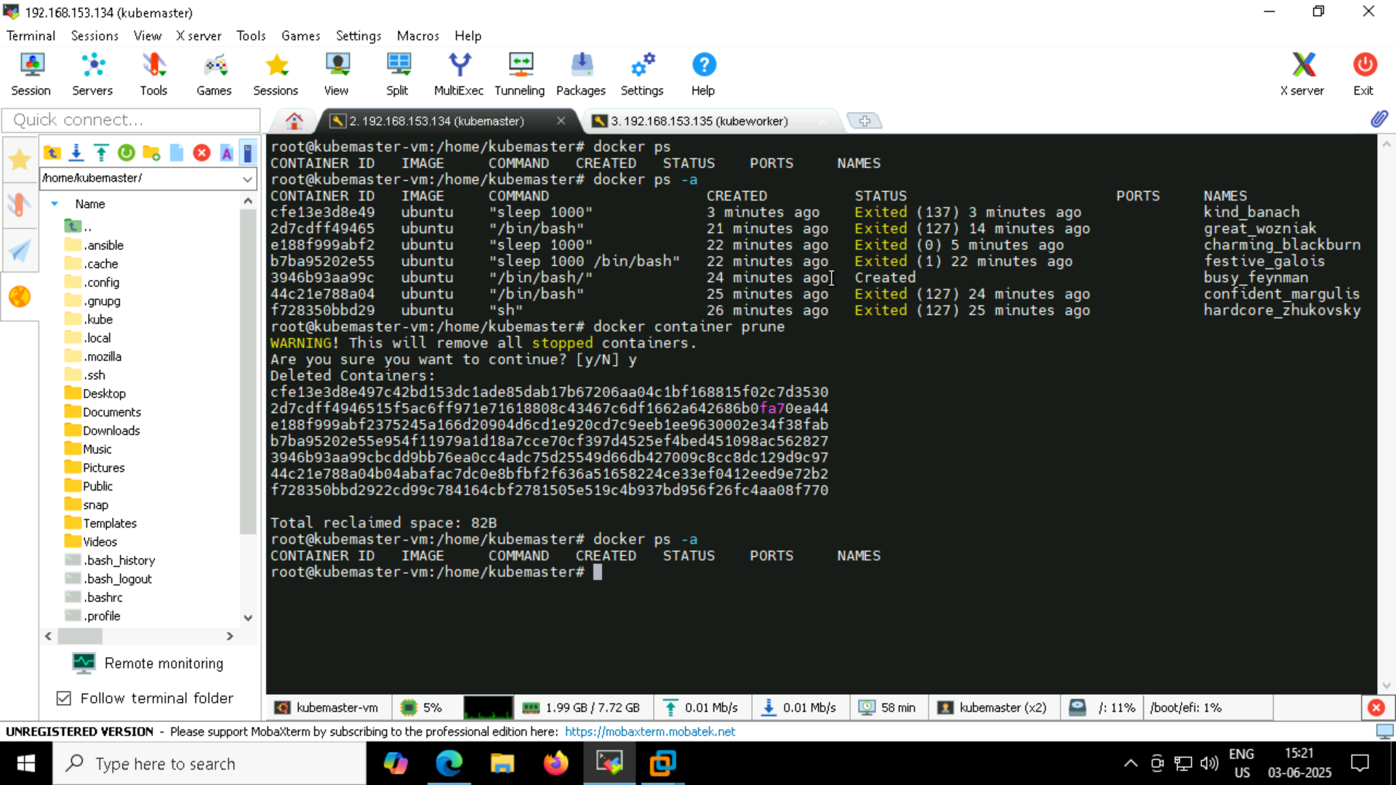

**Remove docker images:**

