# Q3. YAML CONFIGURATION

**Yaml configuration for pod -**

**Pod.yaml**

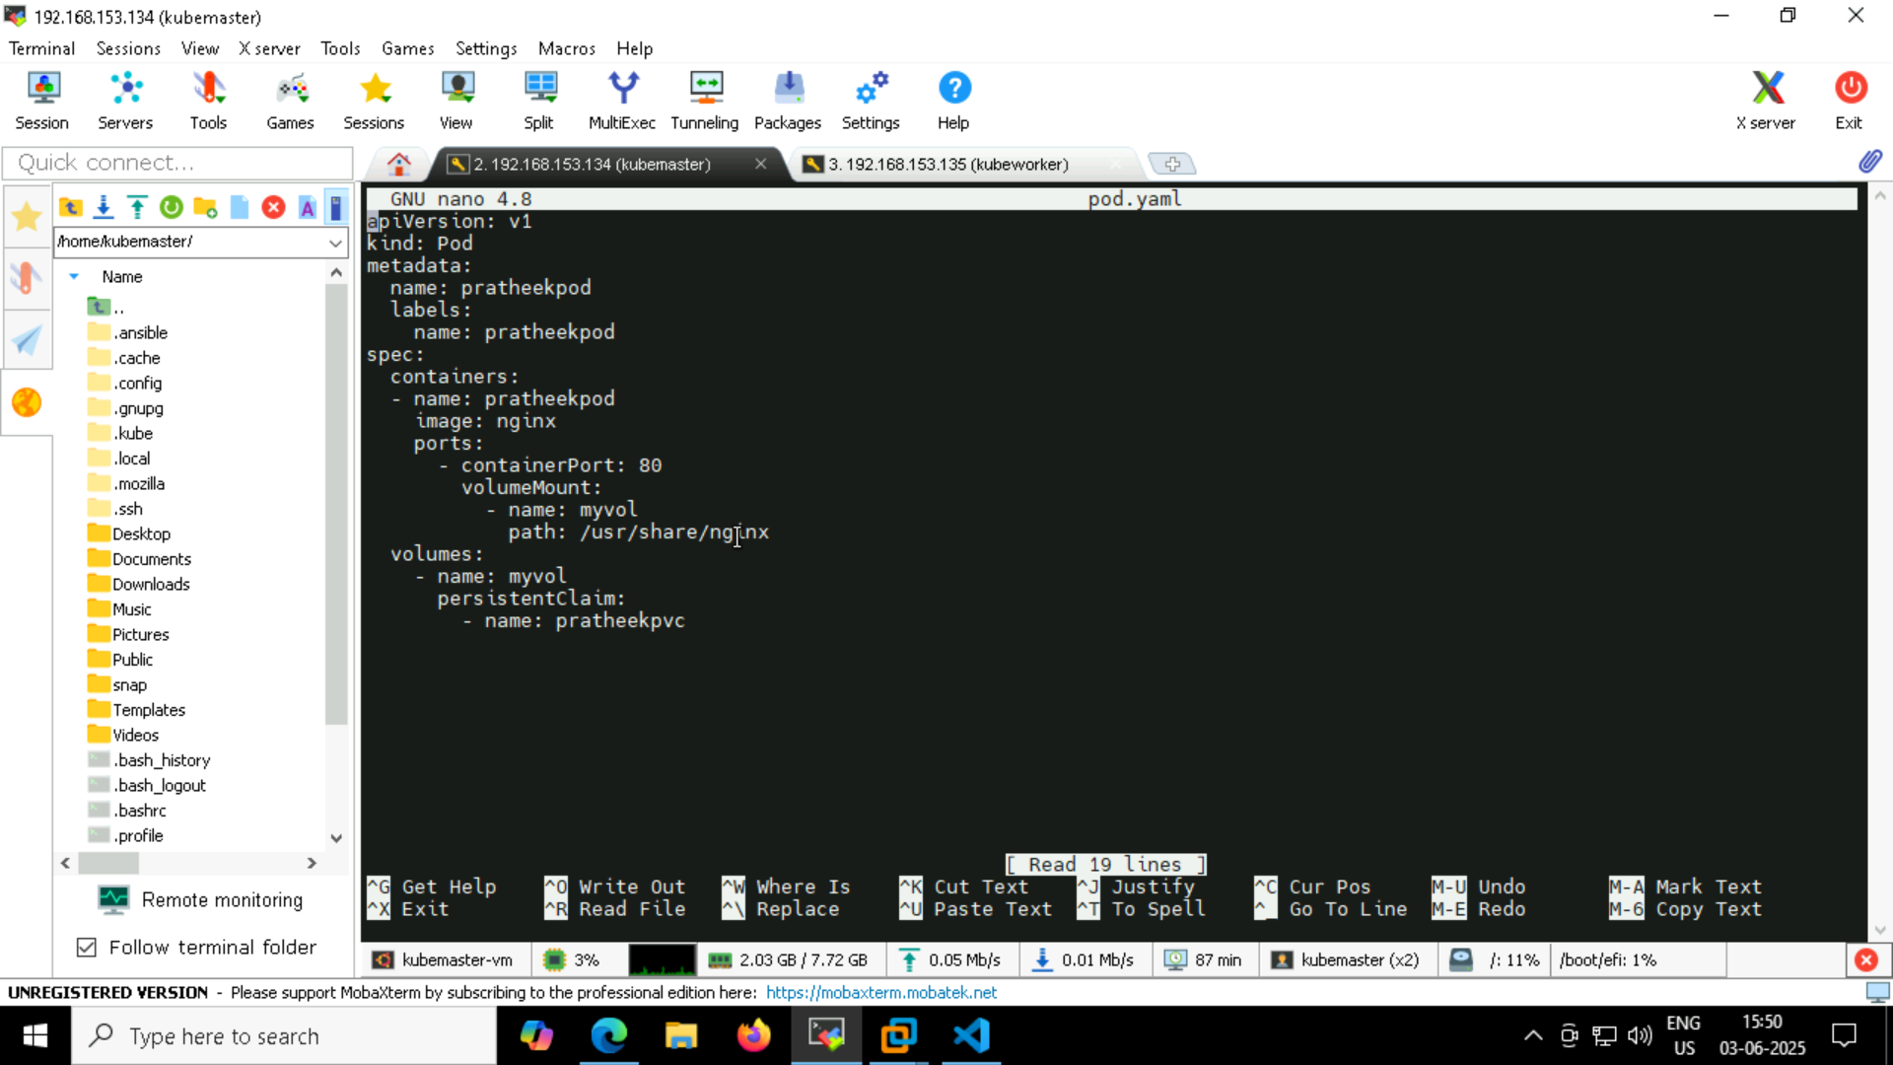

**Volume configuration –**

**Pv.yaml**

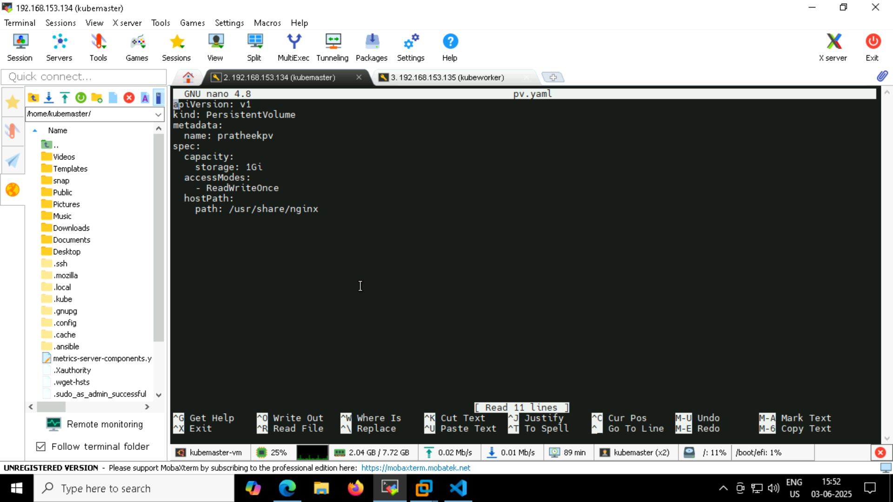

**Pvc.yaml**

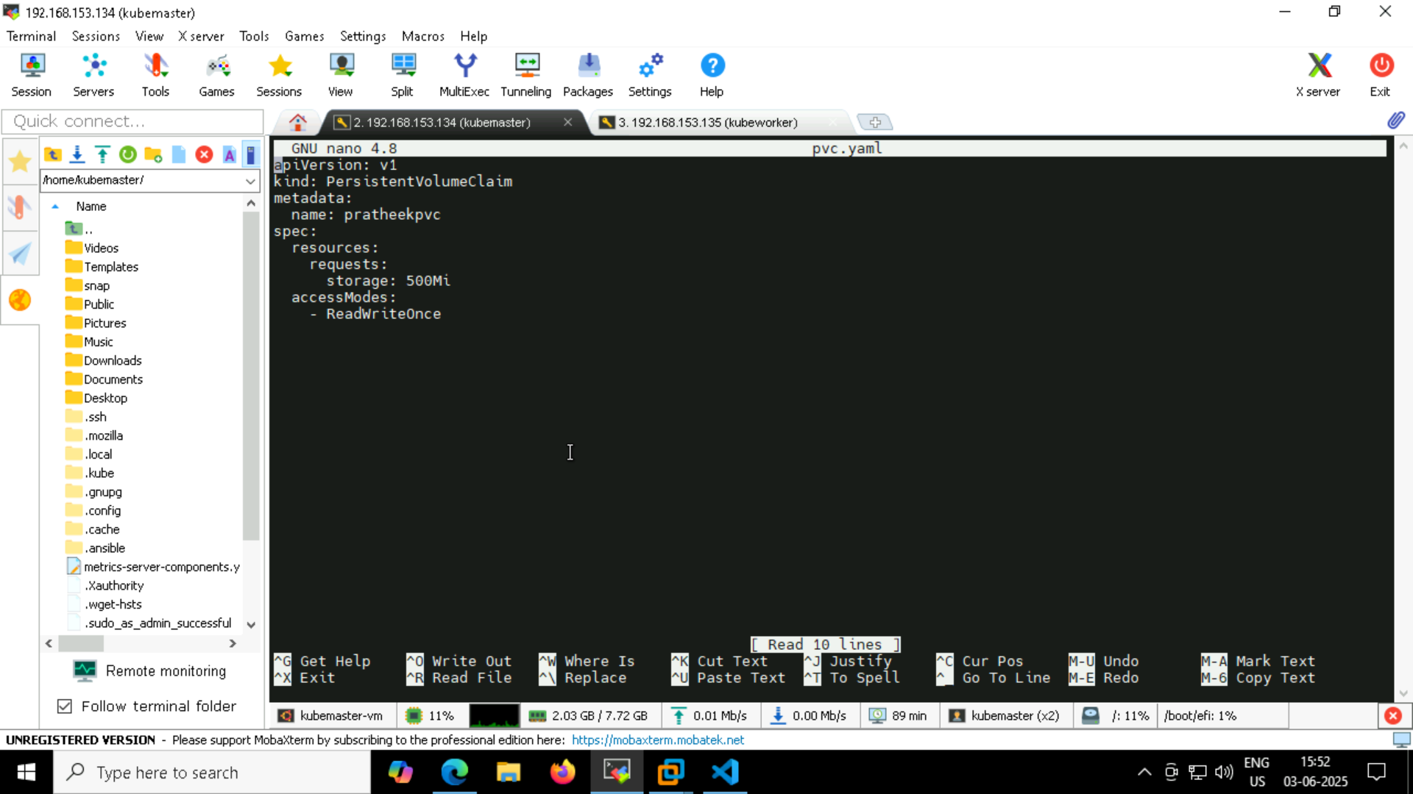

**Applying pv.yaml**

* **Kubetcl get pv, pvc (to check volume bound)**

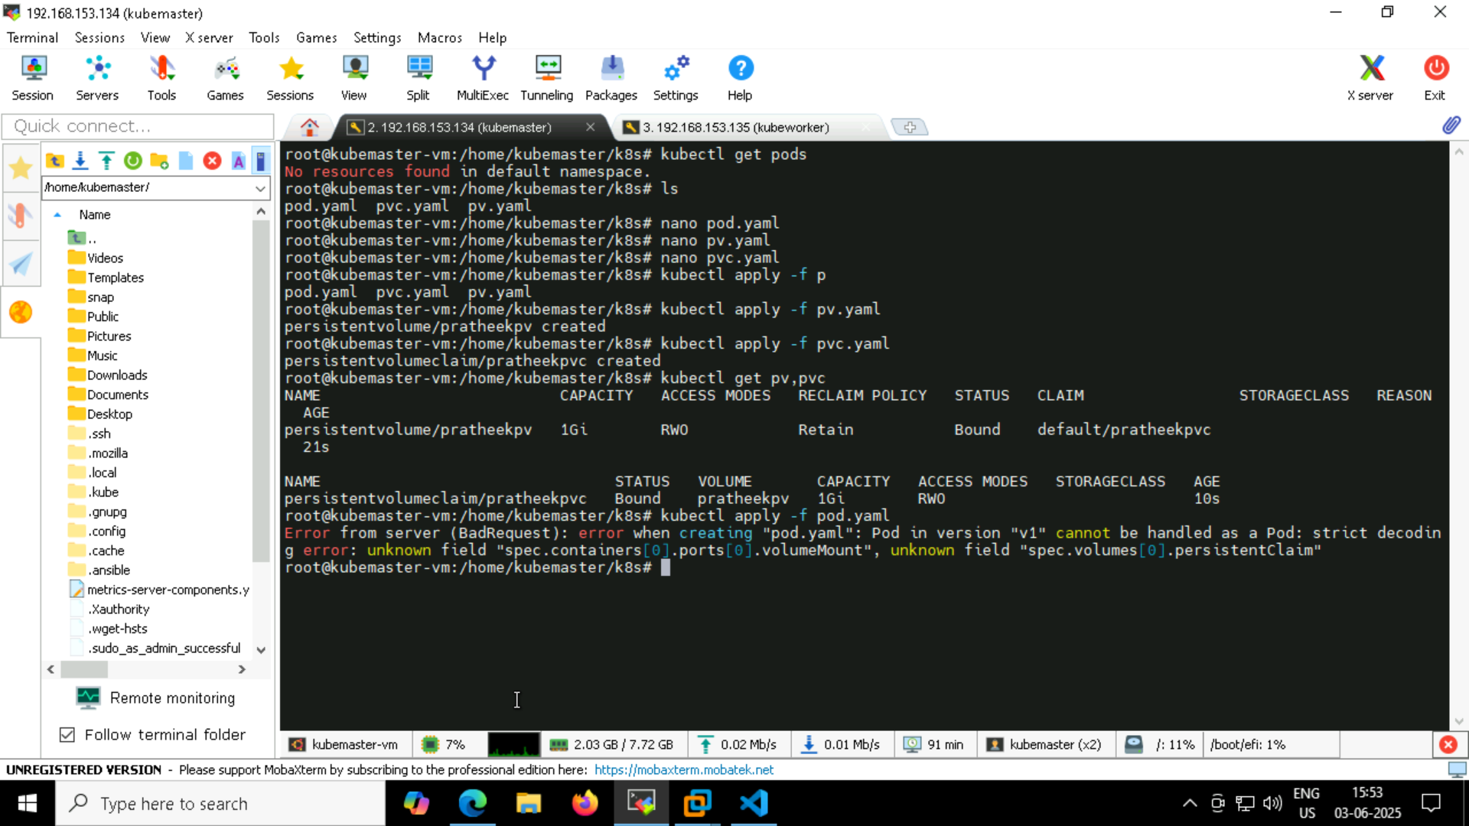

I had indentation issue in pod.yaml so couldn’t apply pod.yaml

I had fixed later , deployed my pod.yaml

**Deploying pod.yaml**

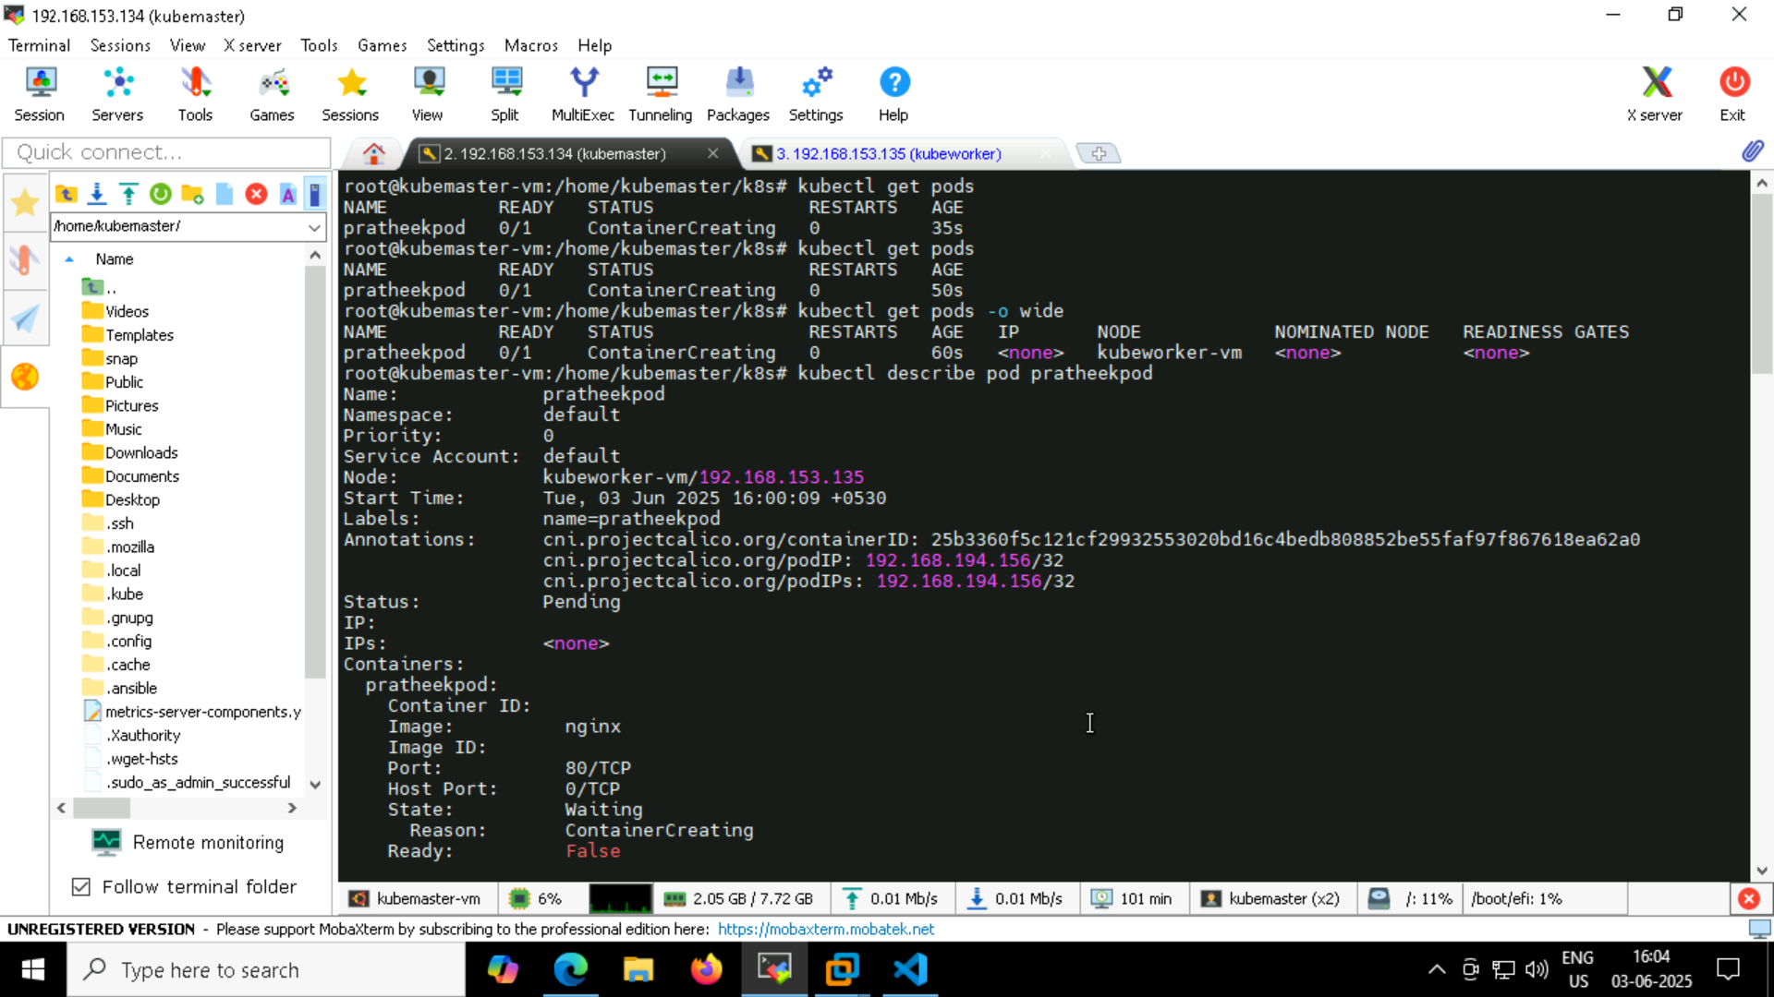

**File serving & validation -**

