# **Docker & container internals**

Docker build:

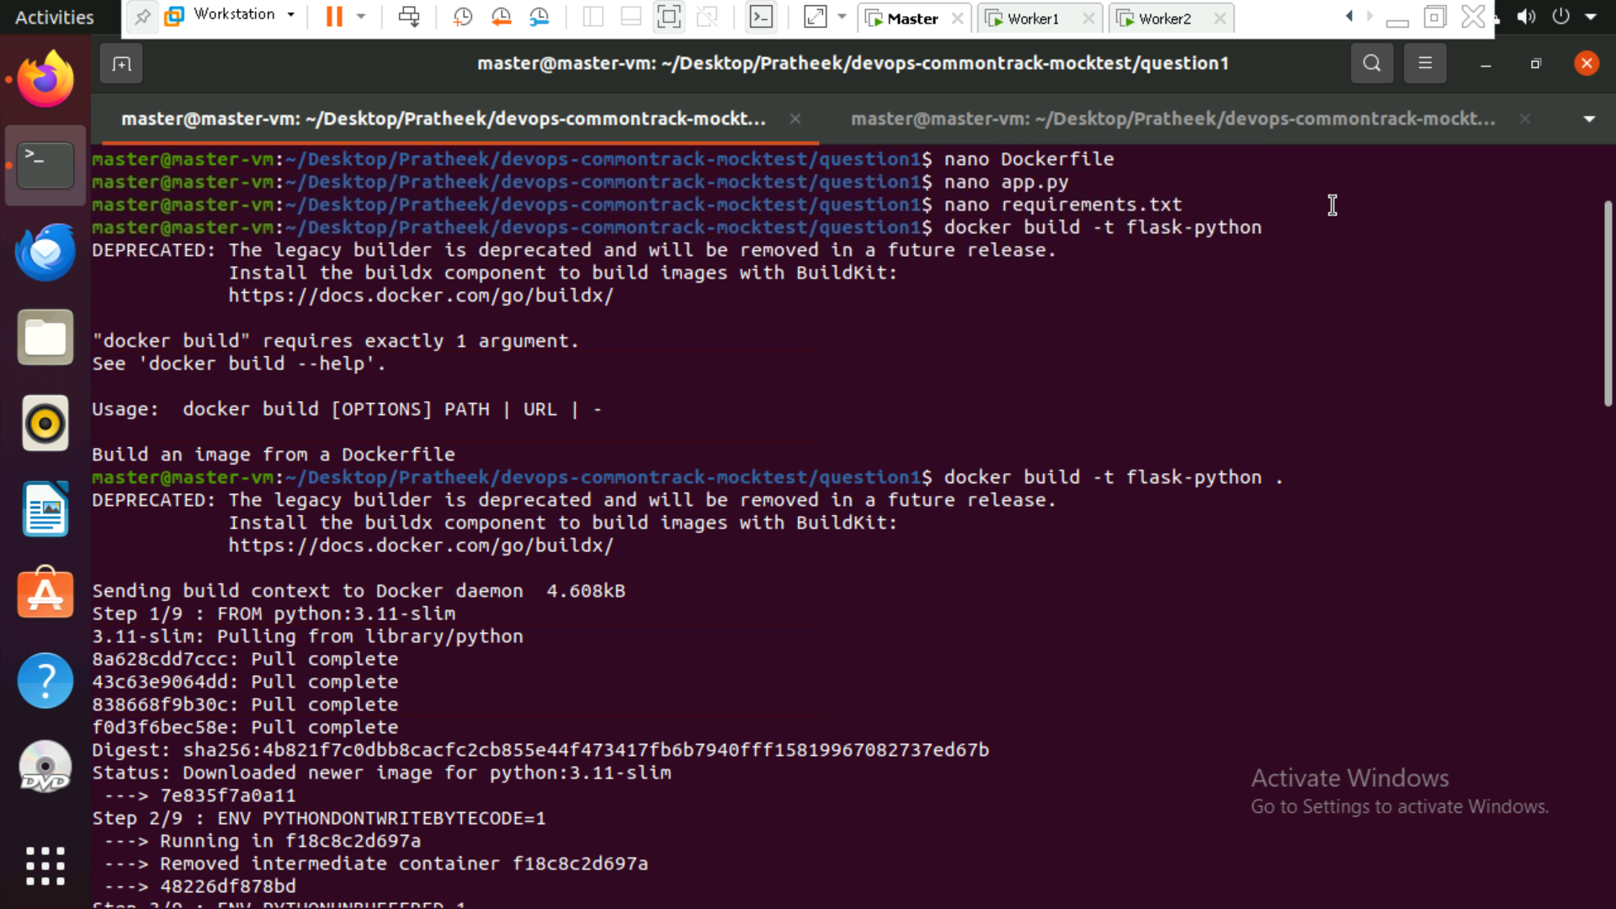

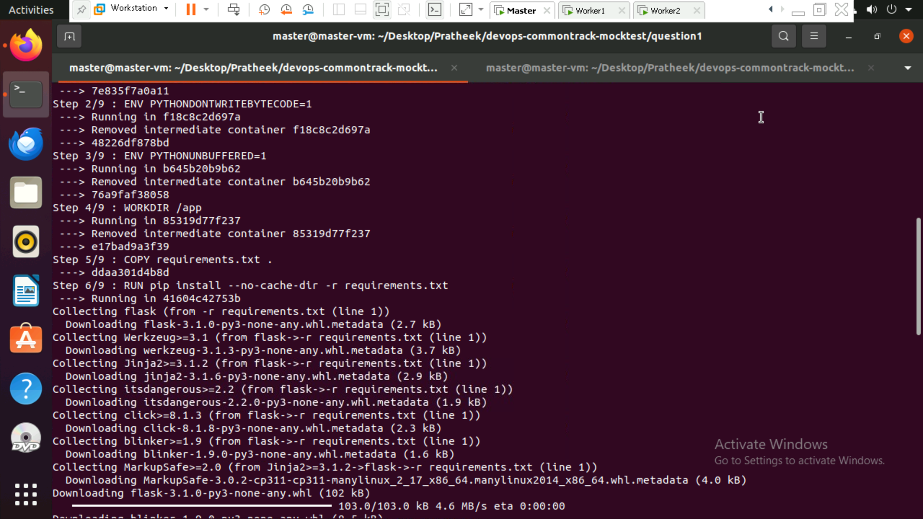

Docker run and container id:

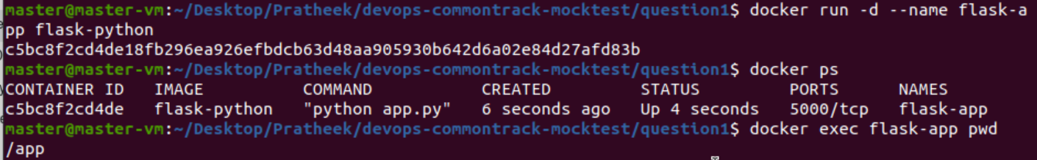

Docker inspect:



Dockerfile:

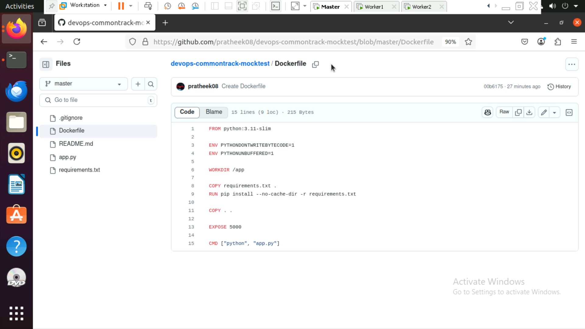

Output:

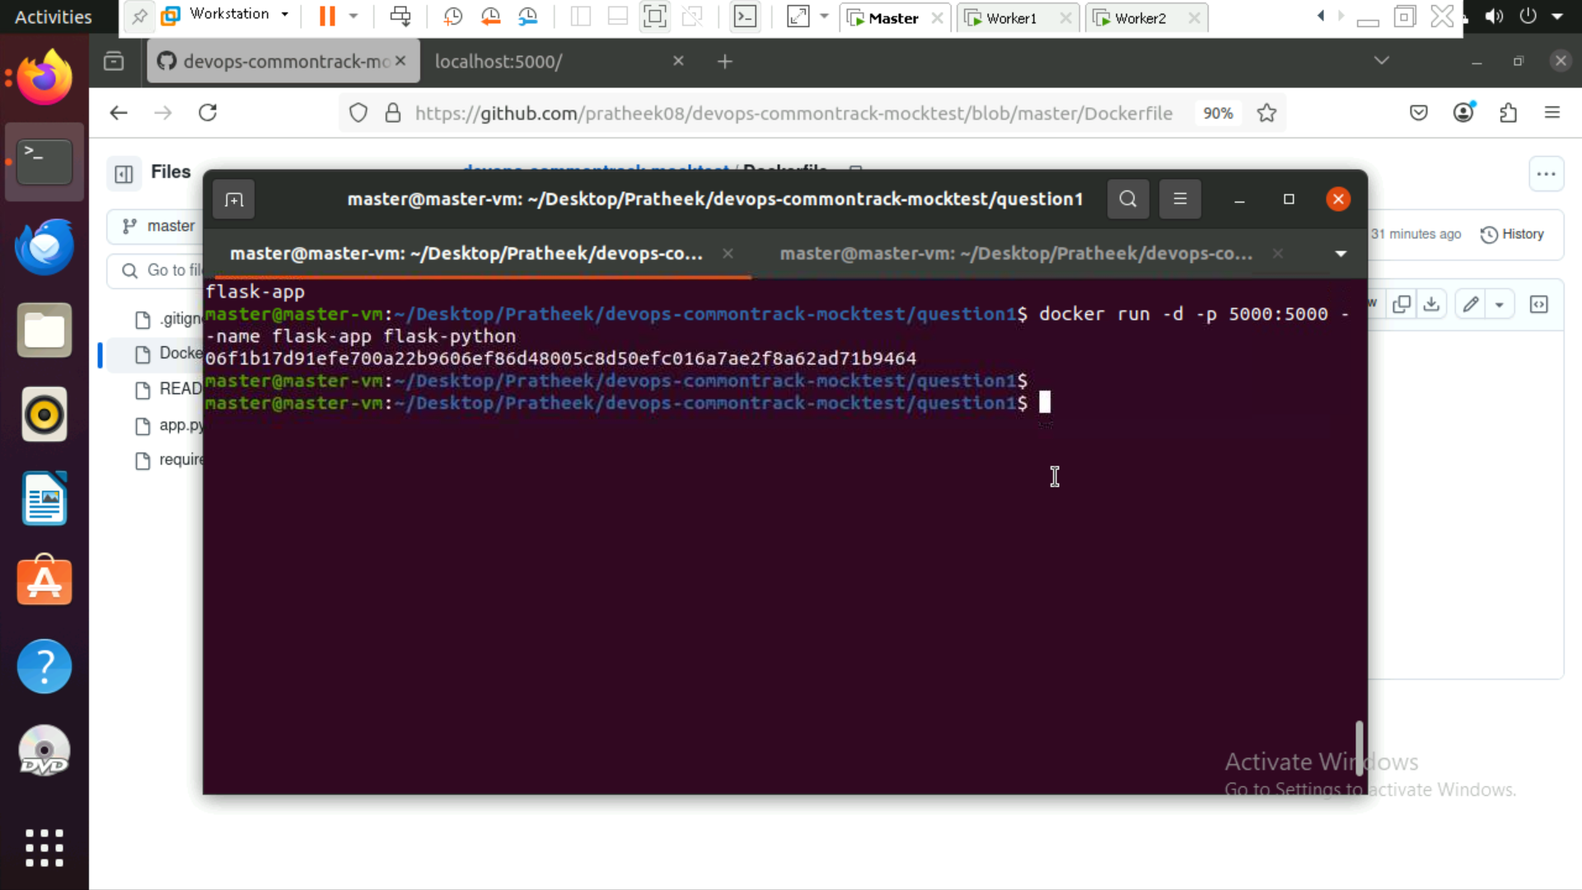

Localhost:5000/

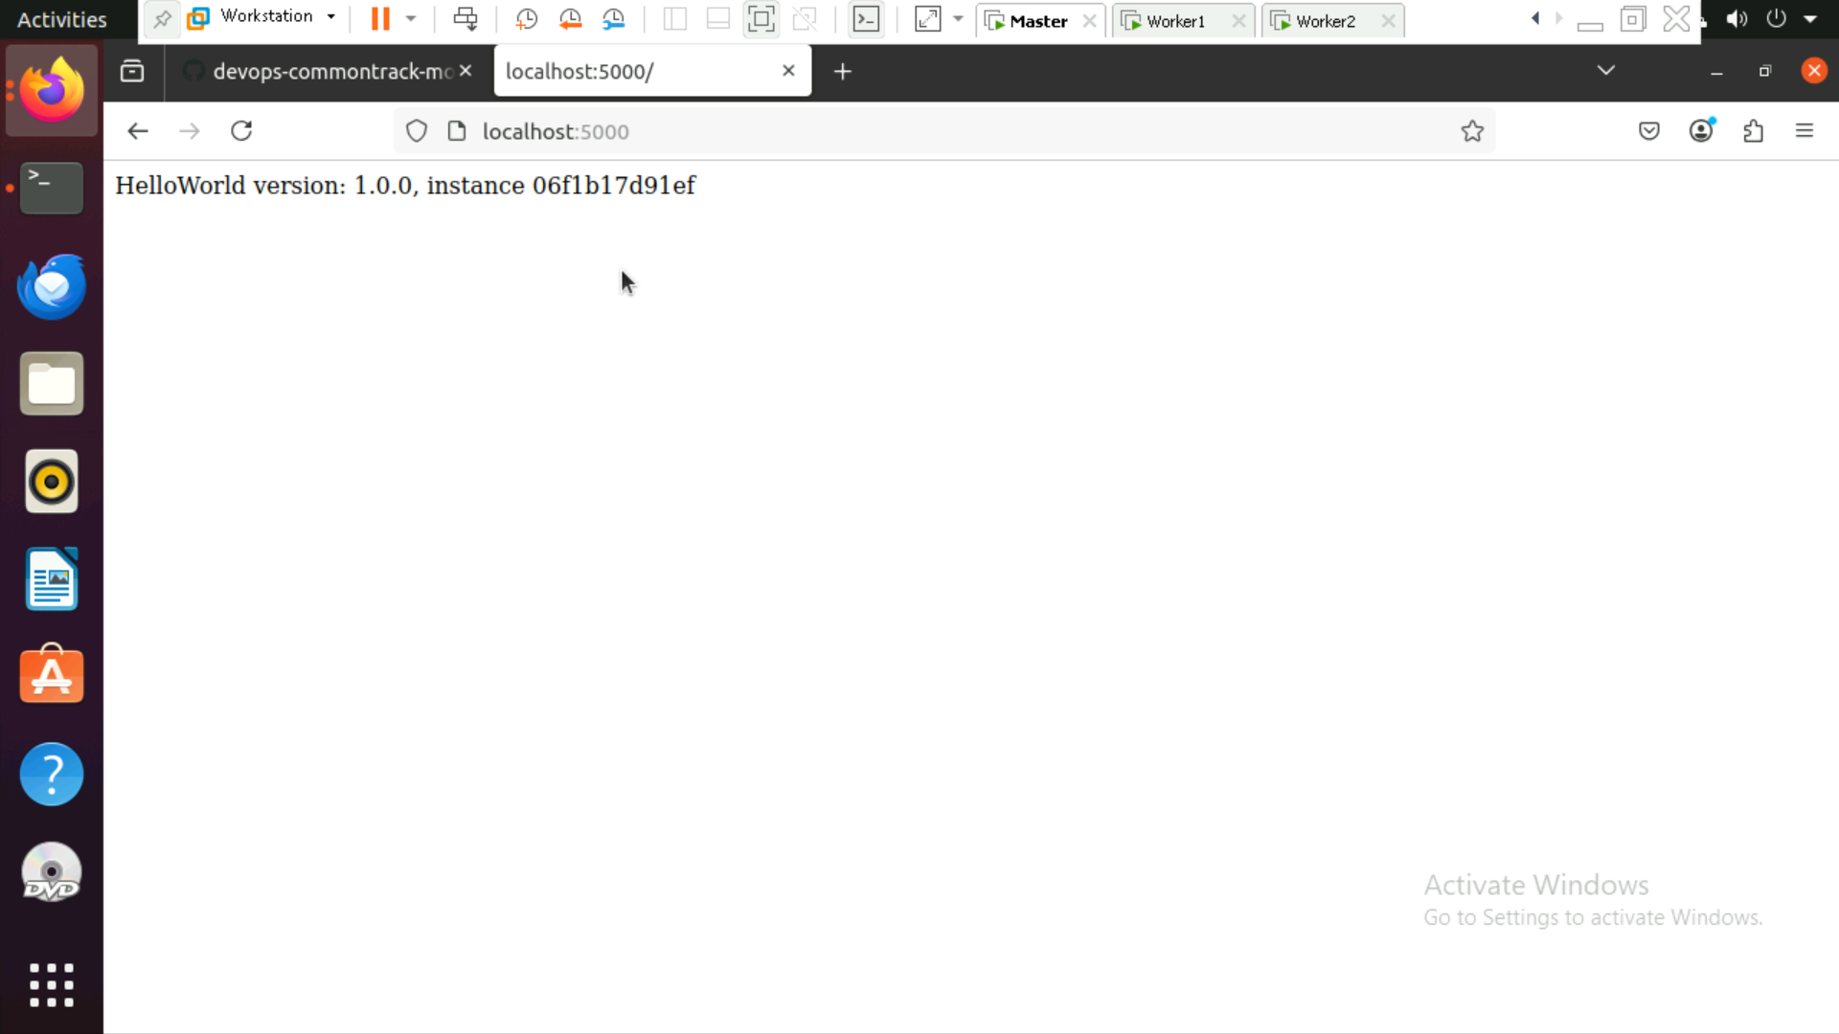

**Commands used:**

*Docker build -t flask-python .*

*Dokcer run – d –name flask-app flask-python*

*docker run -d -p 5000:5000 --name flask-app flask-python*

*Docker ps*

*docker inspect $CONTAINER_ID --format='{{.GraphDriver.Data.UpperDir}}'*