THE STEPS FOLLOWED TO TROUBLESHOOT THE PROBLEM GIVEN IN ASSIGNMENT 1:

1. Followed the steps given for creating the Keypair.
2. Created a New stack with the created key pair.
3. Then After the status turned create_complete, I checked the Instance which was created.
4. Logged onto my terminal and got onto ssh ec2-user. Before doing this I was prompted to change the inbound status of ssh to open. I changed it to my ip on port 22.
5. I tried opening the public ip on the browser which showed cant be found.
6. I tried the service httpd status which gave me the status of the httpd whether it is running or stopped.
7. I changed it to running and tried opening the public IP which gave me the same error.
8. I tried using the command sudo netstat -plnt which showed me the port numbers running on the corresponding services.
9. Here I figured out that httpd was running on port 8080 whereas we had specified port 80. Hence, that was the main culprit.
10. I navigated to the html directory and then changed to etc directory so that I could edit the httpd script in config
11. After I changed the port number from 8080 to 80 in the script.
12. I was able to run the Public IP and could see the image You did it!!

It was an exciting troubleshooting assignment. Thankyou.

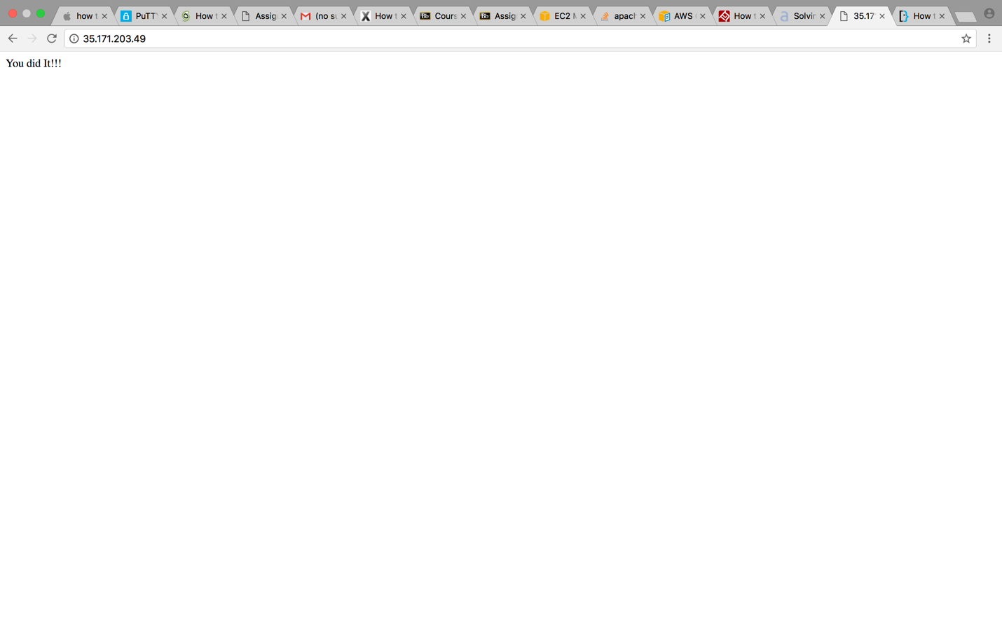

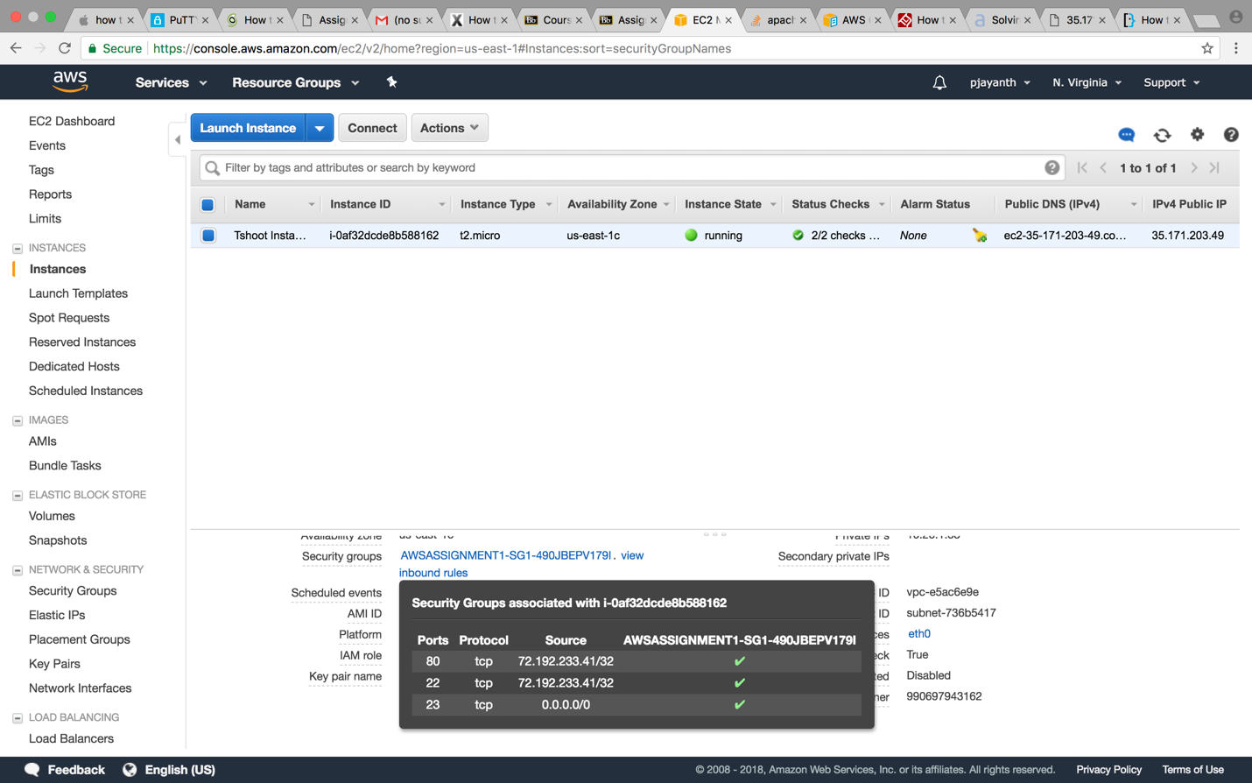

Before changing the httpd port:

[ec2-user@ip-10-26-1-83 conf]$ sudo netstat -plnt

Active Internet connections (only servers)

Proto Recv-Q Send-Q Local Address               Foreign Address             State       PID/Program name

tcp        0      0 0.0.0.0:43937               0.0.0.0:*                   LISTEN      2334/rpc.statd

tcp        0      0 0.0.0.0:111                 0.0.0.0:*                   LISTEN      2309/rpcbind

tcp        0      0 0.0.0.0:22                  0.0.0.0:*                   LISTEN      2542/sshd

tcp        0      0 127.0.0.1:25                0.0.0.0:*                   LISTEN      2572/sendmail

tcp        0      0 :::48801                    :::*                        LISTEN      2334/rpc.statd

tcp        0      0 :::111                      :::*                        LISTEN      2309/rpcbind

tcp        0      0 :::8080                     :::*                        LISTEN      2810/httpd

tcp        0      0 :::22                       :::*                        LISTEN      2542/sshd

[ec2-user@ip-10-26-1-83 conf]$ sudo service httpd stop

Stopping httpd:                                            [  OK  ]

After changing the httpd port:

[ec2-user@ip-10-26-1-83 conf]$ sudo netstat -plnt

Active Internet connections (only servers)

Proto Recv-Q Send-Q Local Address               Foreign Address             State       PID/Program name

tcp        0      0 0.0.0.0:43937               0.0.0.0:*                   LISTEN      2334/rpc.statd

tcp        0      0 0.0.0.0:111                 0.0.0.0:*                   LISTEN      2309/rpcbind

tcp        0      0 0.0.0.0:22                  0.0.0.0:*                   LISTEN      2542/sshd

tcp        0      0 127.0.0.1:25                0.0.0.0:*                   LISTEN      2572/sendmail

tcp        0      0 :::48801                    :::*                        LISTEN      2334/rpc.statd

tcp        0      0 :::111                      :::*                        LISTEN      2309/rpcbind

tcp        0      0 :::80                       :::*                        LISTEN      2971/httpd

tcp        0      0 :::22                       :::*                        LISTEN      2542/sshd