**Steps taken to solve Assignment-2**

1. Followed the instructions given in the blackboard.
2. Created a new key pair and a new stack.
3. After the CREATE_COMPLETE was seen , I was able to see two running instances in my ec2 dashboard.
4. I then followed the instructions given in  <https://docs.aws.amazon.com/AWSEC2/latest/UserGuide/ebs-using-volumes.html>. Which directed me in adding the UUID in the etc/fstab file.
5. After this, I restarted the httpd service .

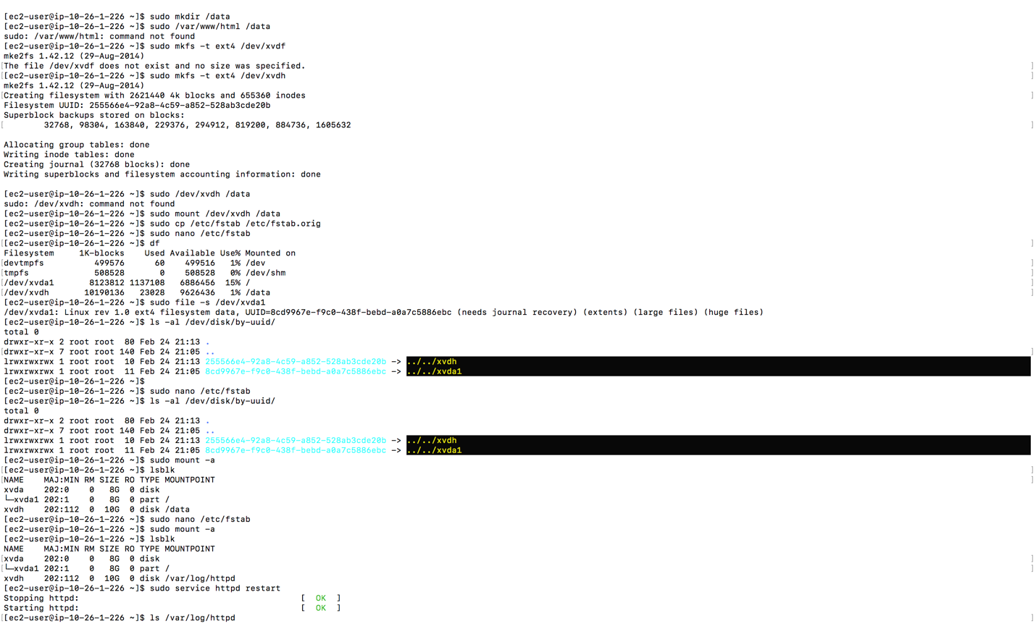

1. I had to change the mountpoint from /data to /var/log/httpd which catered my needs.
2. I was able to match the the first expected output.
3. Now I tried solving the second Sub question .

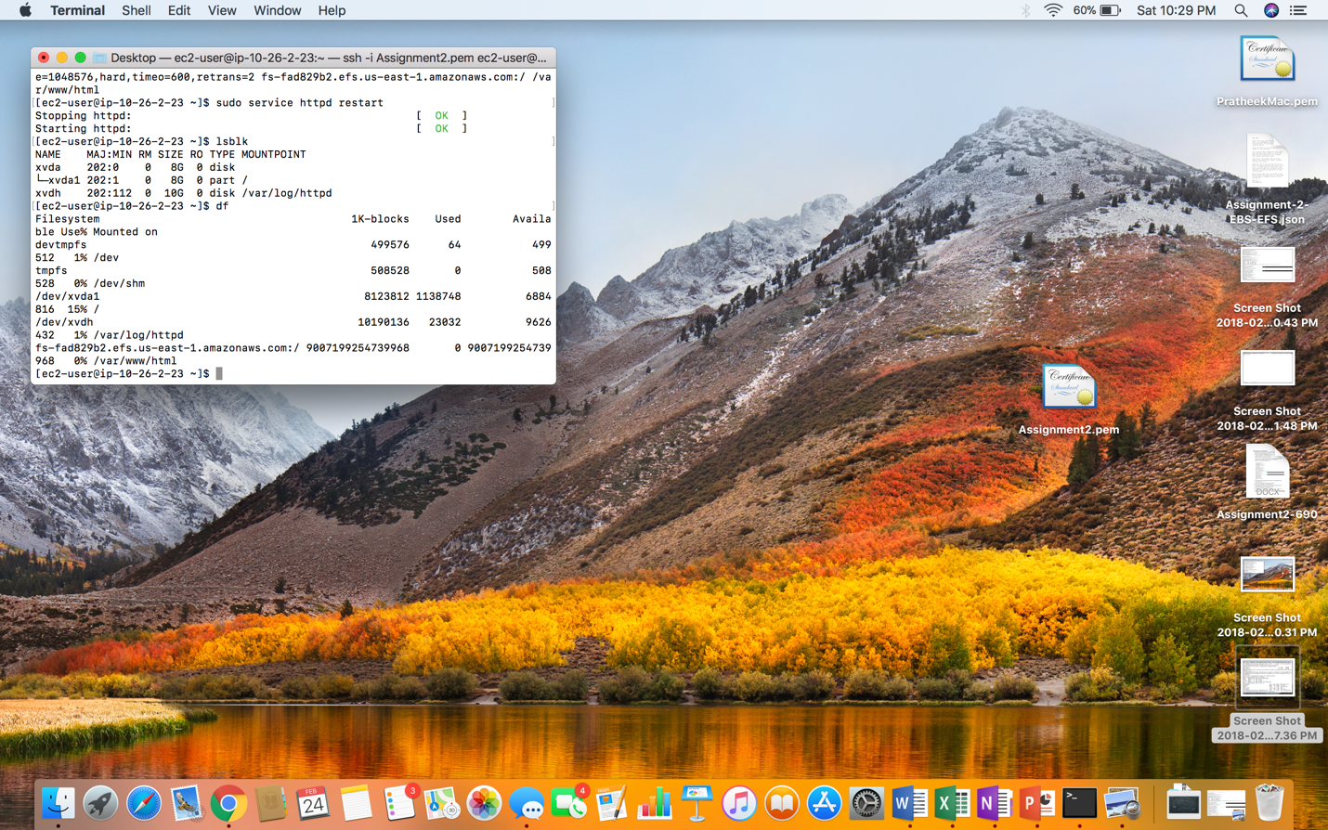

1. I changed the inbound rules in the security groups and added a rule called NFS which took a default port of 2049.
2. I tried using the command df -h which showed me this.

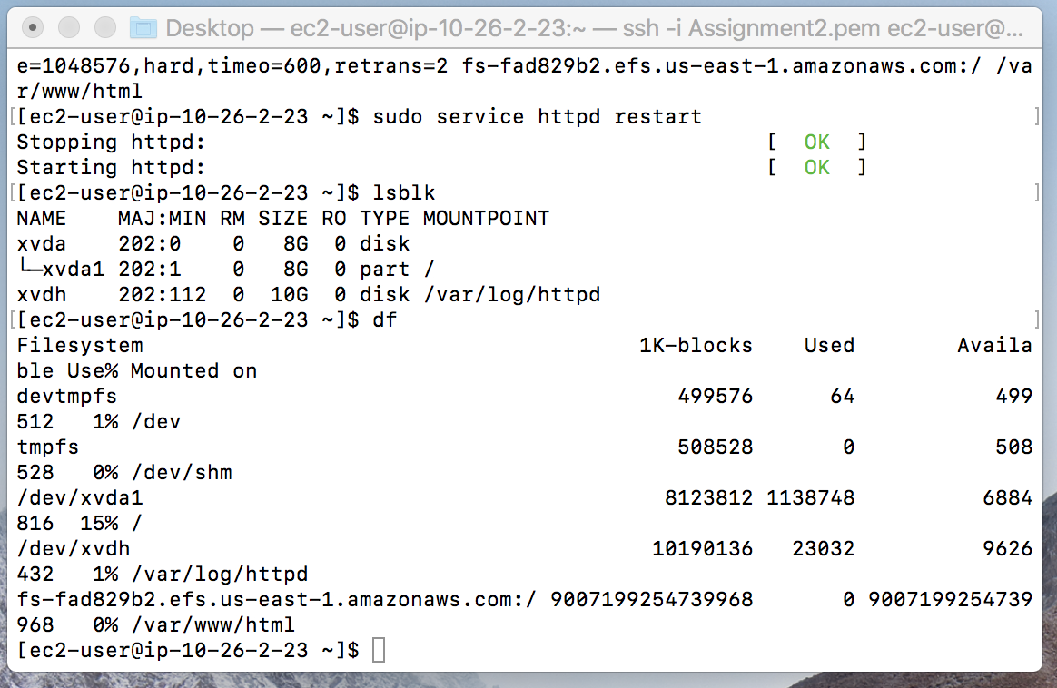

1. I Then created a file index.html in the html directory and then wrote a message you did it which I could see in the browser using the public ip.
2. Atlast when I tried Browsing the public IP, I was able to see the message you did it!!

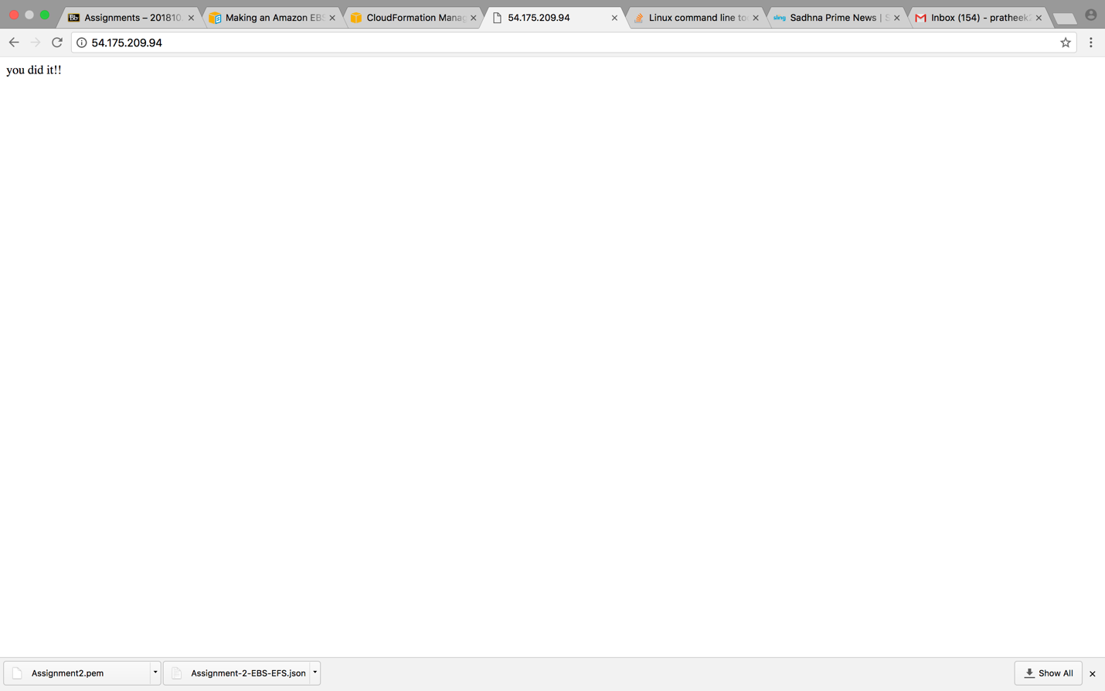

I did the same for webserver1 and webserver2. Got the same results

Thank you!!