**ASSIGNMENT 2.3 SQL**

1. **Retrieve the names of passengers who survived the Titanic disaster:**

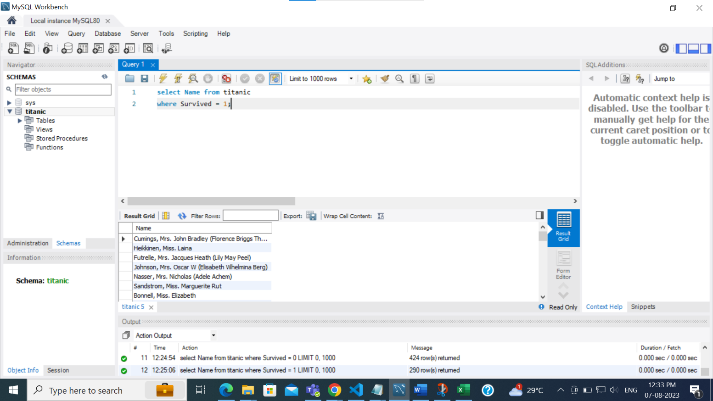

**b. Find the names and ages of the five oldest survivors:**

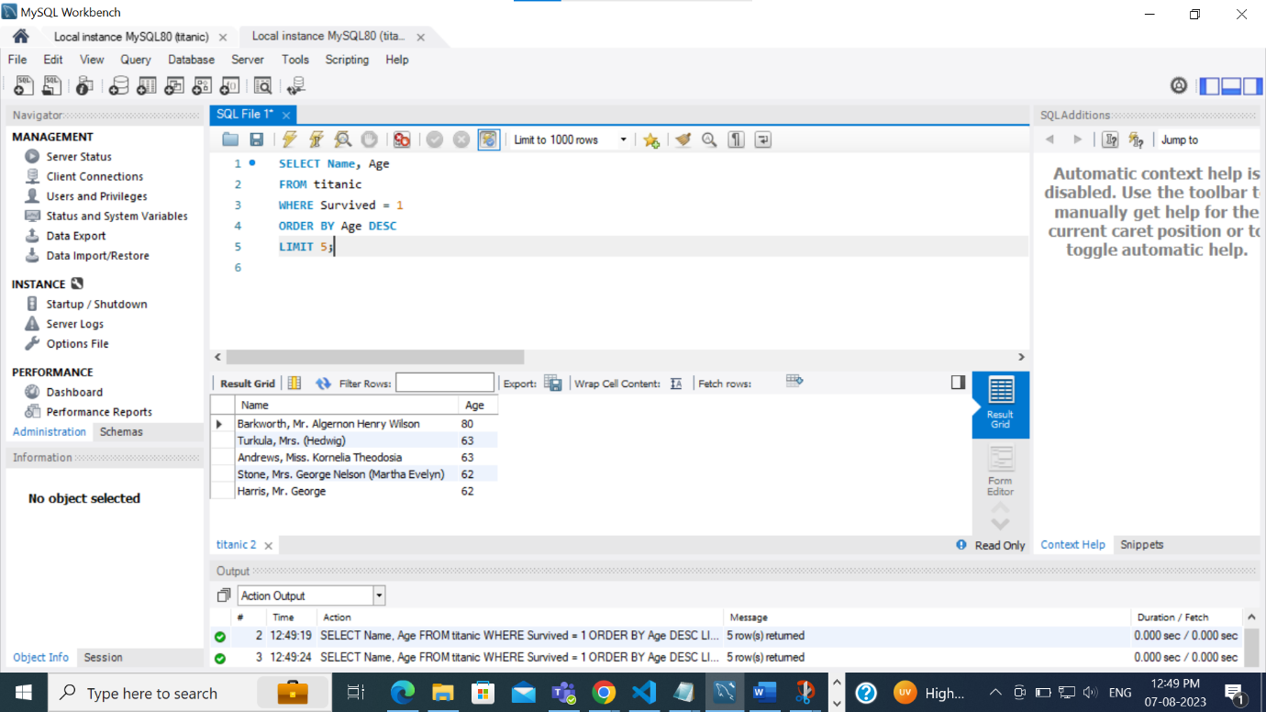

**c. Calculate the average age of passengers who did not survive, and also the**

**average age of passengers who survived, grouped by sex.**

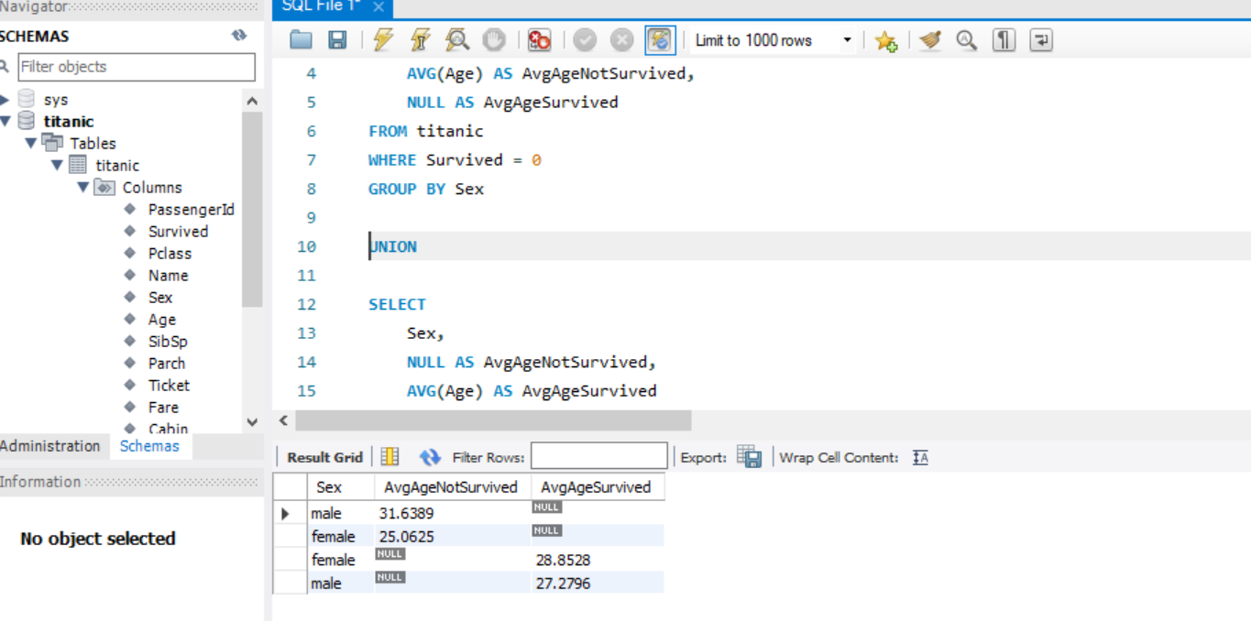

**d. Count the number of males and females**

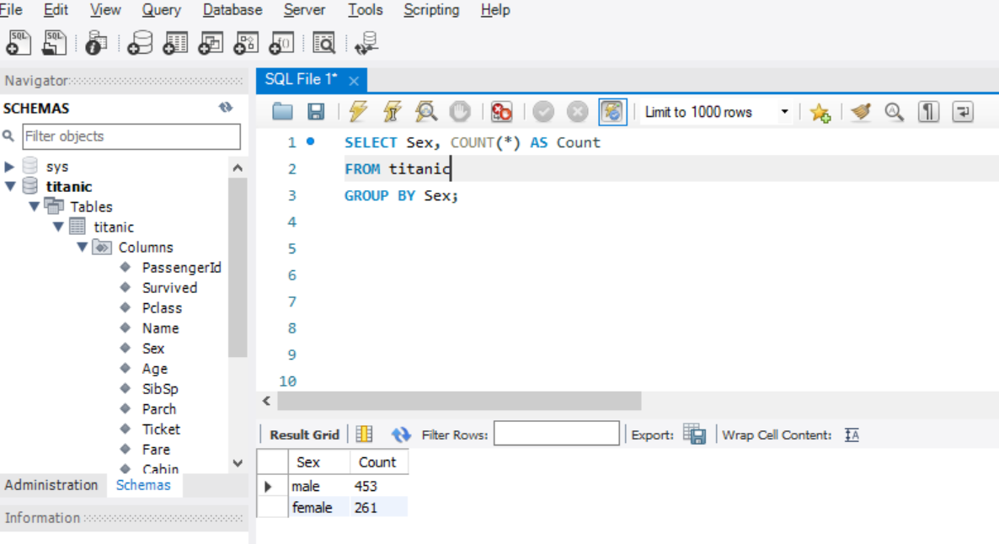

**e. Update the cabin class of a Futrelle, Mrs. Jacques Heath (Lily May Peel) to 3rd class**

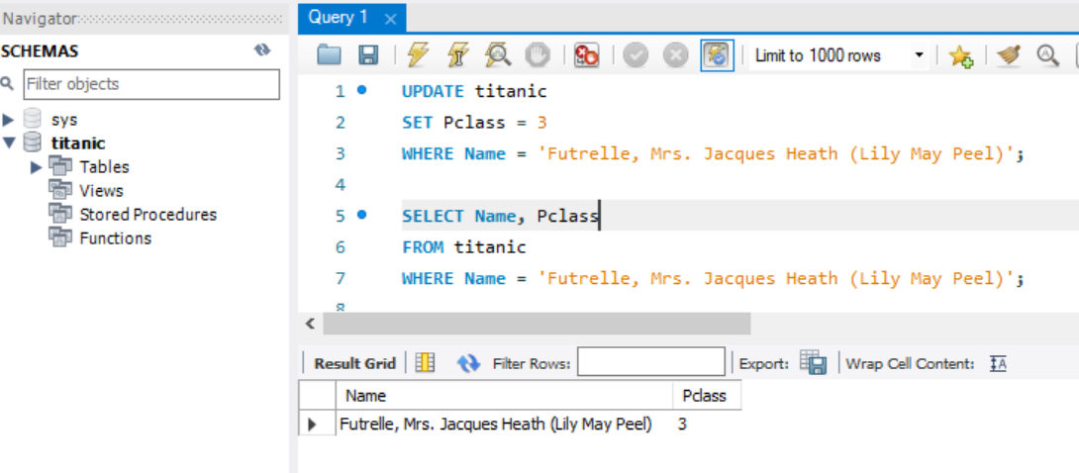

**f. Delete all passengers who did not have a recorded age**

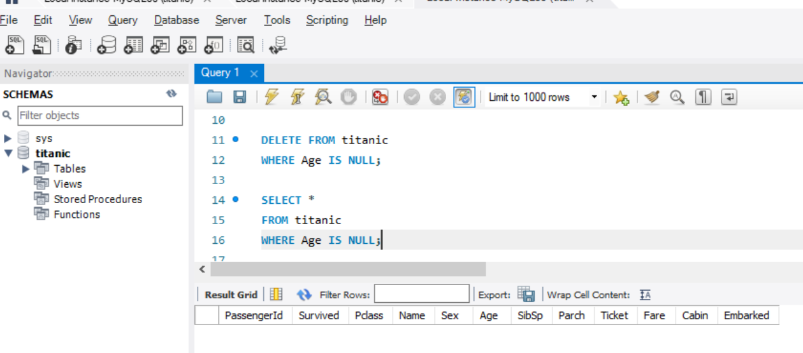

**g. Retrieve the names of passengers who survived and have siblings or**

**spouses on board, along with the count of their siblings or spouses.**

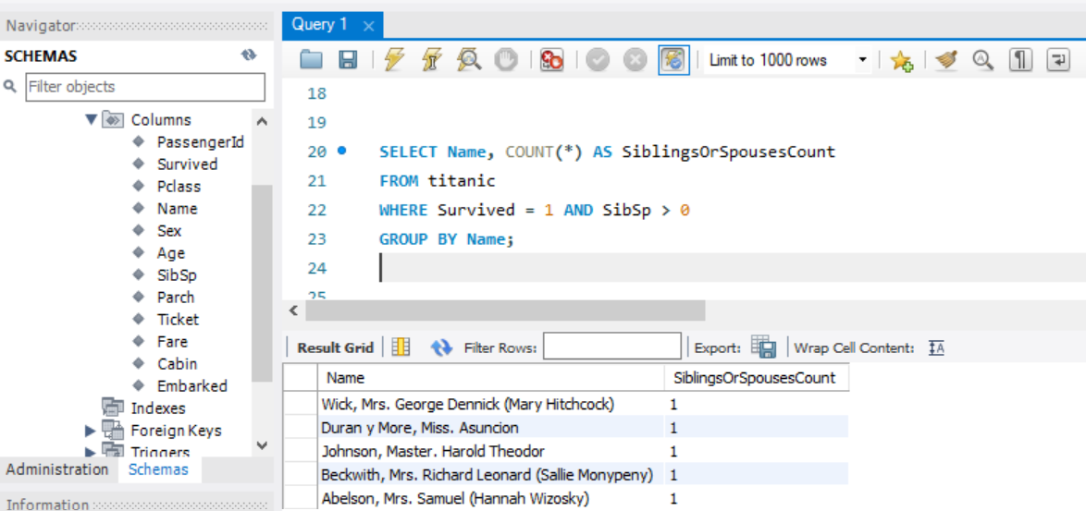

**h. Find the top 10 oldest passengers who did not survive, along with their ages and ticket numbers**

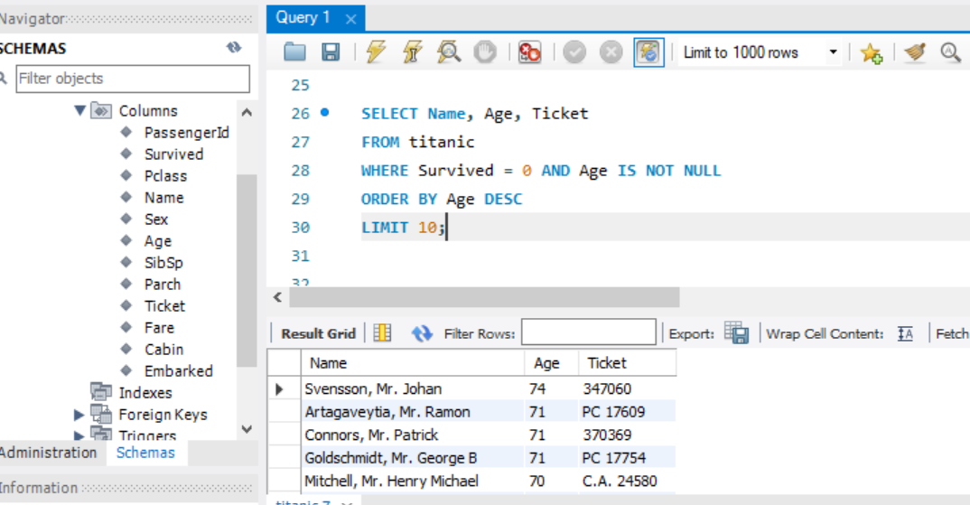

1. **. Calculate the survival counts for passengers in each cabin class (1st, 2nd 3rd), and display the results in descending order.**

