**Airline Management System**

**Team Members:**

19BAI1068 Doma Pratheek

19BAI1045 P. Sai Pavan Guru Jayanth

19BAI1015 K. Uttej Kumar

**Required Specifications:**

This is a typical and brief Airline Management. To Begin, the airline runs airplanes where each airplane has different journeys to different cities and at different times. These airplanes, journeys are typically managed by a staff. There are different roles played by these staff in proper functioning of the airline. They play just an important role as anything else in the airline and are very codependent. These staff members are registered in the airline and their works are usually mentioned in the online portal of the airline to which each working member has a login to. These login credentials are registered by the airline to identify each working member of the staff. Based in their availability and their experience, the staff are allotted different works in the online portal of the airline. The online portal is not discussed in this database but the credentials of each and every staff member are safely recorded. The staff members are referred in the database as ‘Users’, indicating they are the users of the online service of the airline designed to inform them their tasks. The jobs of the staff members are referred to as ‘roles’ as they are the roles they play in the functioning of the airline. Each user has a unique ‘user_id’ to be identified in case two users have same personal details. Users details such as user’s Full name, email, phone number are recorded by the database. Each role has a unique identity key in the same way called ‘role_id’. In the Login of the user, each user has a unique username just like any other portal, registered from the user input while registration. Note that the parameters for a secure password are defined by the portal. Airlines are mainly for journeys, so the travel part of the database or in other words, the airline customer part is defined on the right side of the E-R diagram. There are different models of passenger airplanes, for example, Airbus 370, Boeing 747, etc. Because the airplanes are manufactured by a different company and the model numbers of airplanes are important to be noted since each modeled airplane are similar in features and efficiency since they are manufactured in the same factory at the same time with same models. Whereas airplane numbers are allotted to airplanes by the airline for passengers and the airline users(staff) to identify the airplane they are registered to. There are cases where two different flights are used under the same flight number in case of emergencies to replace one by another but not using both at the same time. Hence, airplane number is not unique in some cases. So, a unique id ‘airplane_id’ is used to identify each airplane. Airplanes are used for different journeys. It is equally important to record the journeys to get details of flights moving from a particular city to another and also find the journeys of different flights since all airplanes don’t have same schedule and route every day. Each journey is unique which means each trip of each plane is recorded instead of regular schedule being recorded to record exact timings due to technical or human error. Since each journey is unique, a unique id ‘journey_id’ is used to identify each trip which can be used to identify the airplane, to and from cities along with departure and arrival times. Journey is also used to record the destination and beginning cities along with their airports differently because a city may have many airports and mentioning only city would cause mishap as to which is the destination airport. Passengers are able to travel with their booking. It is important for passengers to travel in an airline and booking usually has many details to be noted. Each booking made by a passenger is unique even if he/she does the same flight and same time on a different day. So, a primary key ‘booking_id’ which also refers to the bar code number on passenger’s ticket is recorded for every booking. The booking records the booking details like the class of booking (e.g. Business class, economy class, Premium Economy, First Class), Seat number, and the journey to which the booking is done. Here, the airplane details can be obtained from booking using its link to the journey which is related to airplane. Booking also records the booking date, time and the status of booking (in case the booking is cancelled or transaction pending or the booking seat is overlapped to another booked seat), cost of the booking. Passenger details are separately noted. Since a customer can have multiple flights which may be in the past or connecting flights, passenger details are unique and a unique passenger is linked to each of his bookings. For this, booking has ‘booking_passenger_id’ to link it to passenger. Passenger details such as his/her Name, age, physical challenges (if any), gender.

So, the description of the E-R diagram is as follows:

Airplane entity has attributes ‘airplane_id’, ‘airplane_type’, and ‘airplane_number’. Airplane is maintained by (relation) Users. User entity has attributes of ‘user_id’, ‘user_name’, ‘user_phone’, ‘user_email’, ‘user_role_id’ (foreign key- Roles – role_id). Users have (relation) roles. Roles entity has attributes of ‘role_id’ and ‘role_name’. Users also have (relation) login. Login entity has attributes of login_user_id(Foreign Key- User – user_id ) , username , password.

Airplanes have (relation) booking. Booking entity has attributes booking_id, booking_class, booking_journey_id (Foreign Key – Journey – journey_id), booking_status, booking_date, booking_total_fare, seat_no. Airplanes also has (relation) Journey. Journey entity has attributes journey_id, journey_airplane_id(Foreign Key – Airplane - airplane_id), from_airport , to_airport, from_city, to_city .

Booking is for or done by (relation) passengers. Passengers entity has attributes of passenger_id, passenger_age, passenger_name, passenger_type, passenger_gender.

Here, the Airplane – User relation in many to many i.e., the cardinality ratio is m: n. Whereas, the User – roles and User – login relations are many to one relations with cardinalities m: 1 for both. Similarly, the Airplane – Booking and Airplane – Journey relations are one to many with cardinalities 1: m, 1: n respectively. The Booking – Passenger relation is many to one relation with cardinality ratio of m: 1.

**ER Diagram**

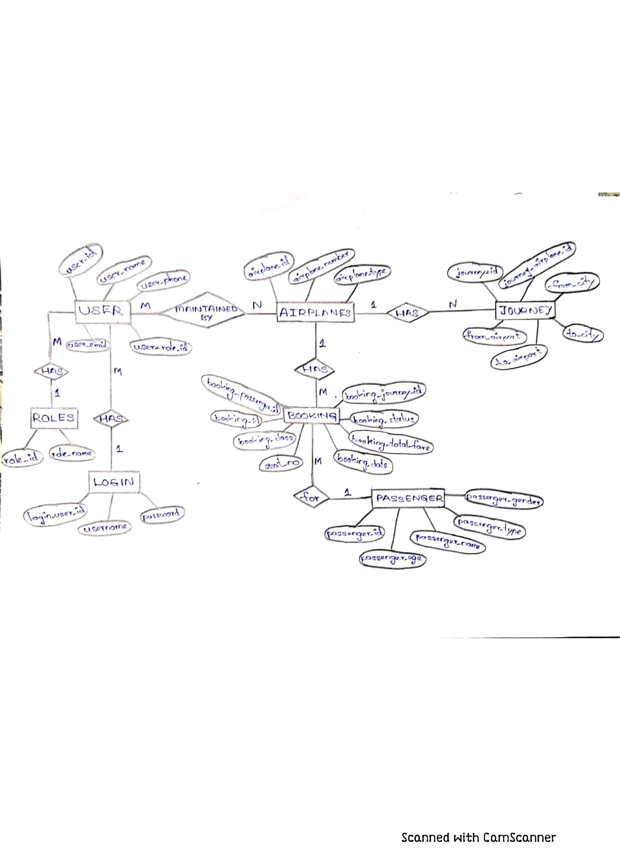

**Relational Schema**

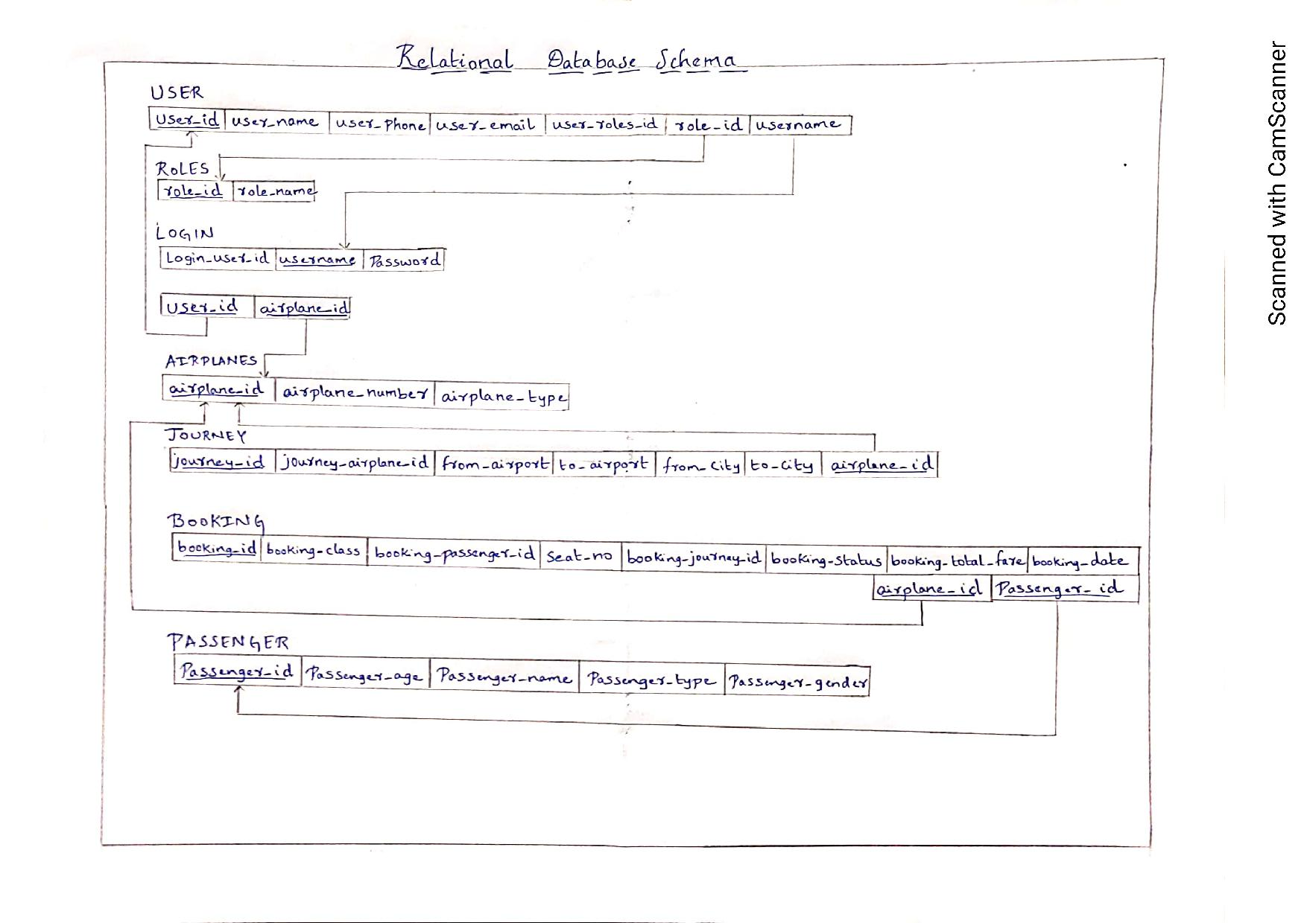

**Implementation Details**

For database Management, programme used is MySQL. For programming, any python environment can be used. Here, PyCharm has been used. Although PyCharm requires additional free plugin to be downloaded to be connected to a Database. All the data input in the Database are native to the USA. So, names, places, are American. The programme works only when used in the system which is using the same the same database server as we used with our credentials to login.

**Screenshots of the application (Frontend):**

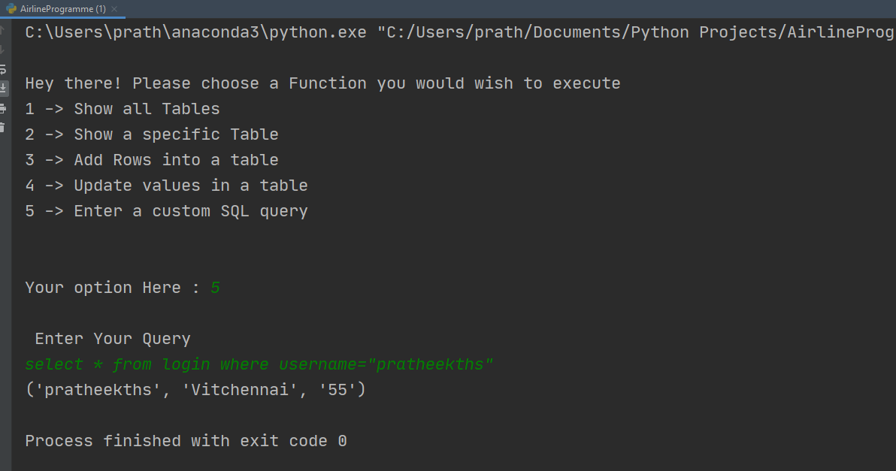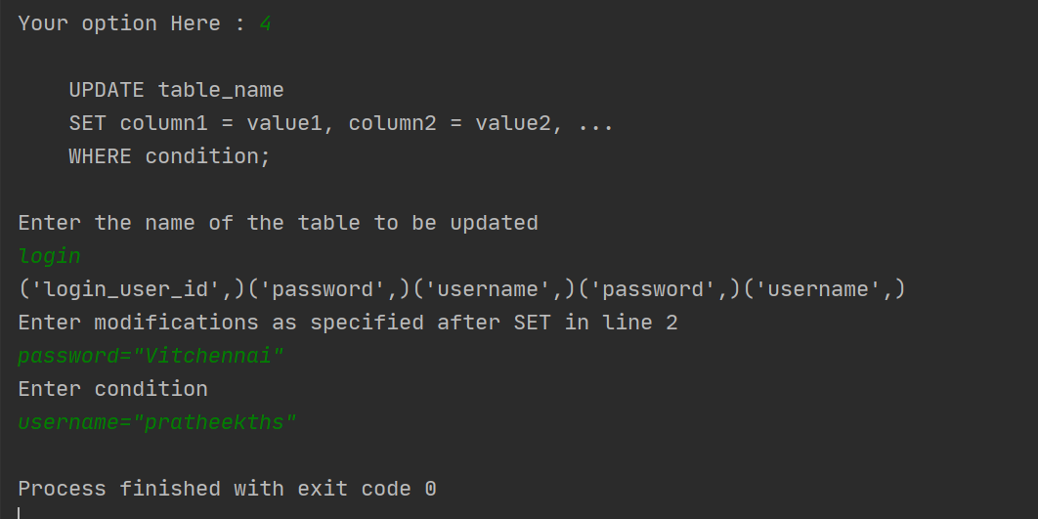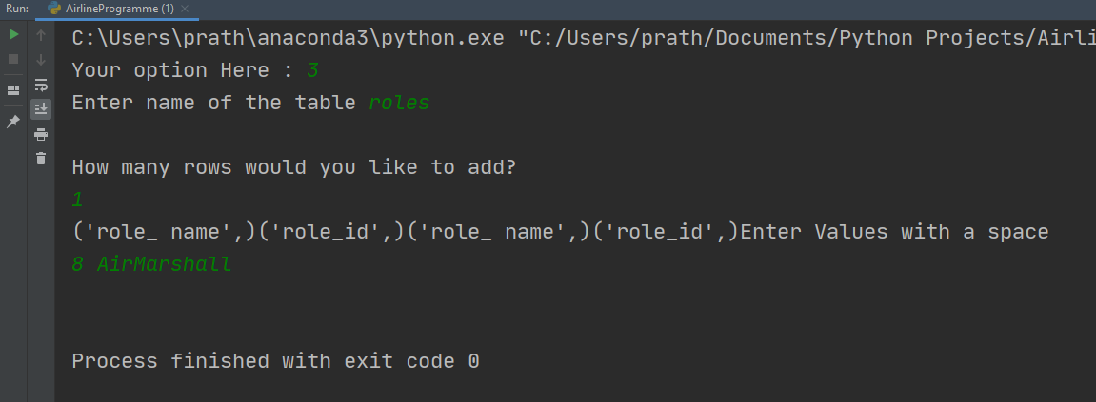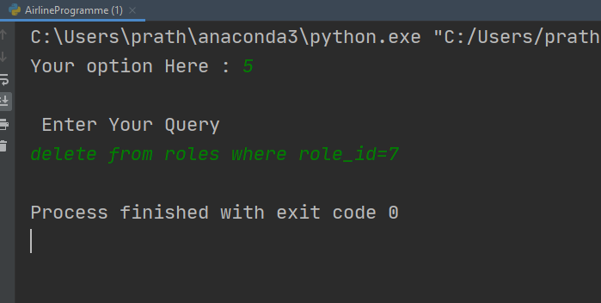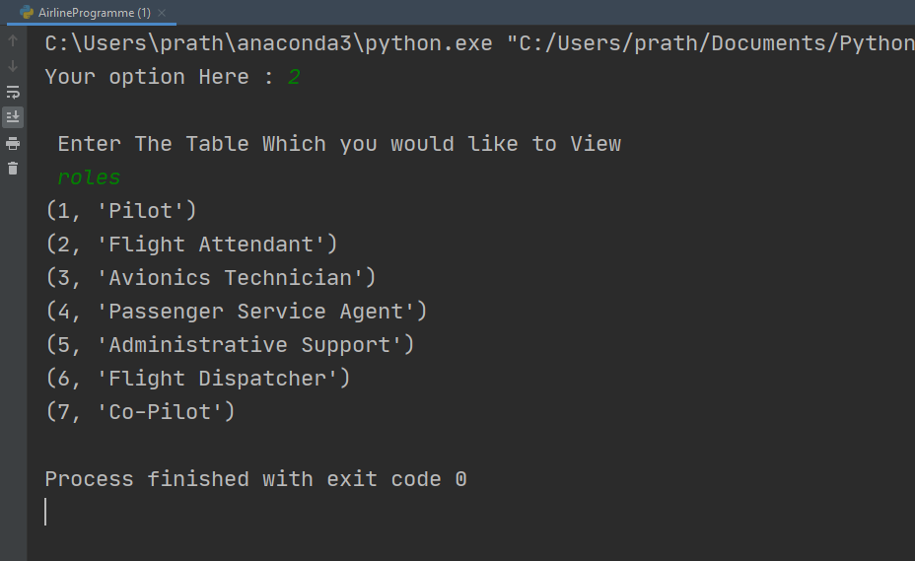

Screenshots of the Database (Backend):

