PRATHEEKSHA SHAJU  SCIENCE TEACHER | PRIMARY & MIDDLE SCHOOL  Biology • Environmental Science • General Science  Abu Dhabi, UAE | Family Visa | Immediate Joiner  +971 58 173 9058 | pratheekshashaju123@gmail.com | 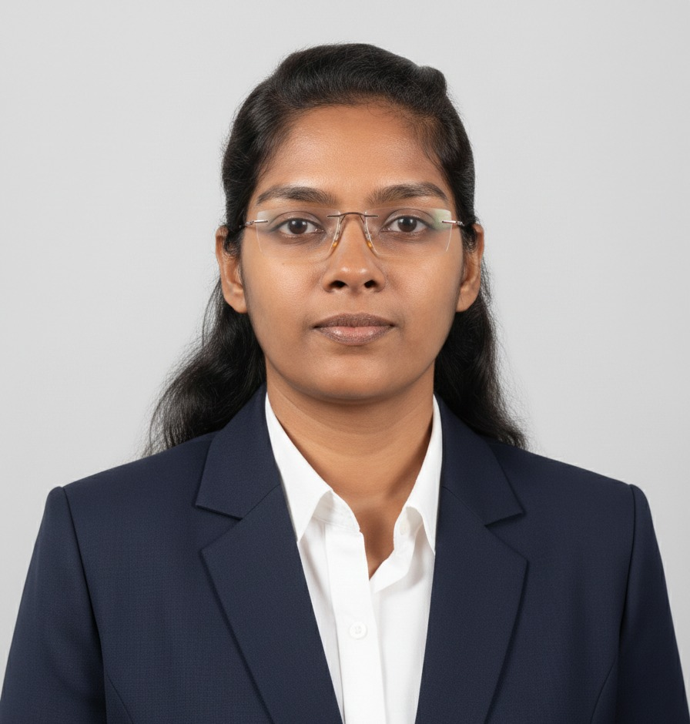
INTERNATIONAL SCHOOL CANDIDATE
PROFESSIONAL PROFILE
Qualified Science Teacher with 3+ years of experience across classroom instruction, science education, curriculum support and educational outreach. Holds a B.Ed. in Natural Science, MSc in Environmental Science and BSc in Zoology, supported by CTET and K-TET qualifications. Skilled in inquiry-based, activity-based and student-centred learning, with experience in lesson planning, assessment, classroom management, practical science demonstrations and differentiated instruction.
B.Ed.  Natural Science | MSc  Environmental Science | CTET  Primary Stage | K-TET  Category II
CAPABILITIES
CORE TEACHING STRENGTHS
SCIENCE INSTRUCTION  General Science, Biology and Environmental Science | LESSON DESIGN  Clear objectives, structured activities and curriculum-aligned resources | LEARNER ENGAGEMENT  Inquiry-based, experiential and activity-based methods
CAREER
PROFESSIONAL EXPERIENCE
Junior Programme Executive - Science Education | Feb 2021 - Jul 2024
Mazhavillu: Teach Science for Kerala | Kerala Development & Innovation Strategic Council (K-DISC), Kerala, India
• Delivered science education and structured learning activities for school-age learners under the Mazhavillu programme.
• Developed lesson plans, instructional modules and curriculum-aligned science learning resources.
• Applied inquiry-based, experiential and student-centred strategies to strengthen engagement and understanding.
• Assessed learner progress, adapted activities to different needs and supported mentoring and educational outreach.
Institutional Assignment - Science Education | Feb 2021 - Jul 2023
KSCSTE - Kerala Forest Research Institute (KFRI), Peechi, Kerala, India
• Designed science education content and delivered learning activities to students aged 9-13 years.
• Created learning resources covering biodiversity, ecology, environmental science and conservation.
• Conducted workshops and interactive sessions in collaboration with scientists, educators and programme coordinators.
Institutional Assignment - Science Teaching | Jul 2023 - Feb 2024
Indira Gandhi Memorial Model Residential Higher Secondary School, Nilambur, Kerala, India
• Taught Standard 6 learners through structured science instruction and activity-based learning.
• Planned lessons, practical demonstrations, worksheets and assessments to support understanding and participation.
• Applied classroom management and differentiated strategies to provide individual learner support.

PRATHEEKSHA SHAJU | SCIENCE TEACHER | ABU DHABI, UAE
ACADEMIC FOUNDATION
EDUCATION
B.Ed. - Natural Science  Mahatma Gandhi University, Kerala, India | 2026 | 96.1%
MSc - Environmental Science  University of Calicut, Kerala, India | 2020 | 77.8%
BSc - Zoology  University of Calicut, Kerala, India | 2018 | 79.2%
Diploma - Computer Applications  India | 2019 | 93.8%
CREDENTIALS
TEACHING CERTIFICATIONS
CTET - Primary Stage  Central Board of Secondary Education (CBSE), India | K-TET - Category II  Department of General Education, Government of Kerala
CLASSROOM PRACTICE
TEACHING APPROACH
Inquiry & Discovery  Encourages questioning, observation and evidence-based reasoning. | Active Learning  Uses demonstrations, activities and real-world science connections.
Differentiation  Adapts instruction to learner readiness, pace and support needs. | Assessment for Learning  Uses formative checks, worksheets and feedback to guide progress.
CONTINUOUS LEARNING
SELECTED PROFESSIONAL DEVELOPMENT
• General Education Seminar - 5th International Congress on Kerala Studies, 3-5 May 2023.
• Three-day Workshop for MRS Students of Kerala, KSCSTE-KFRI, 8-10 Nov 2023.
• Remote Sensing, GIS & GNSS Applications - Indian Institute of Remote Sensing (IIRS) / ISRO.
• GIS Training Programme - Central University of Karnataka.
• Data Analytics with Python - IIT Roorkee.
SUBJECT EXPERTISE
ACADEMIC & RESEARCH CONTRIBUTIONS
• MSc Dissertation: Environmental Studies of the Chalakudy River Basin - National Centre for Earth Science Studies (NCESS).
• Undergraduate Research Project: Spider Diversity Survey in Mangrove Ecosystems.
PROFILE DETAILS
LANGUAGES & AVAILABILITY
LANGUAGES  English - Fluent  Malayalam - Native  Hindi - Fluent | CURRENT STATUS  Abu Dhabi, UAE  Family Visa  Immediate Joiner | TARGET ROLES  Primary Science Teacher  Middle School Science Teacher  General Science Teacher

