**Task 1**: Check whether **/user/acadgild** directory exists or not in the HDFS. If it doesn't exist, then create a directory **/user/acadgild/hadoop**.

**Solution:-**

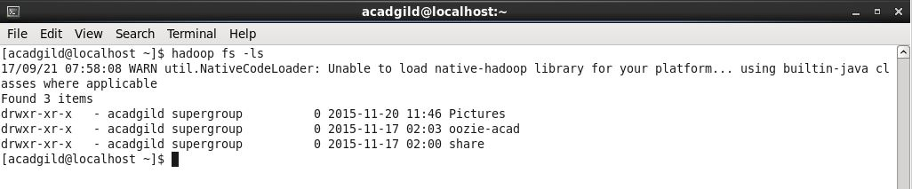

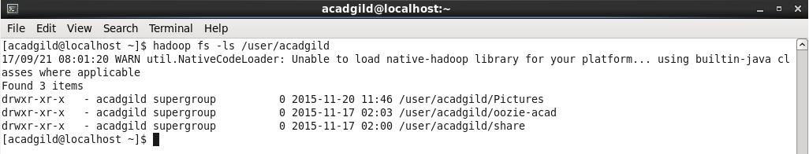

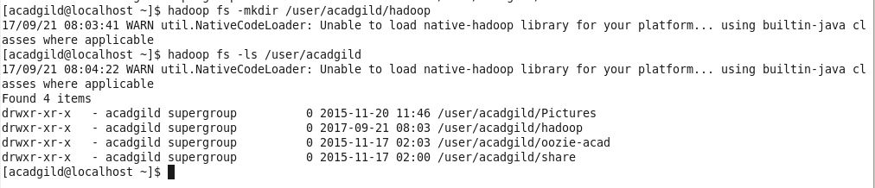

**Task 2** : Create a file in HDFS under directory **/user/acadgild/hadoop**, with name word-count.txt. Whatever we type on screen should get appended to the file. Try to type (on screen) few lines from any online article or textbook.

**Solution**:-

