**Task 3**: Create a file max-temp.txt in local FS. Put some 10-15 records of date and temperature example:

**dd-mm-yyyy, temperature**

10-01-1990, 10

10-02-1991, 20

Move this file to HDFS at **/user/acadgild/hadoop**.

**Solution** :-

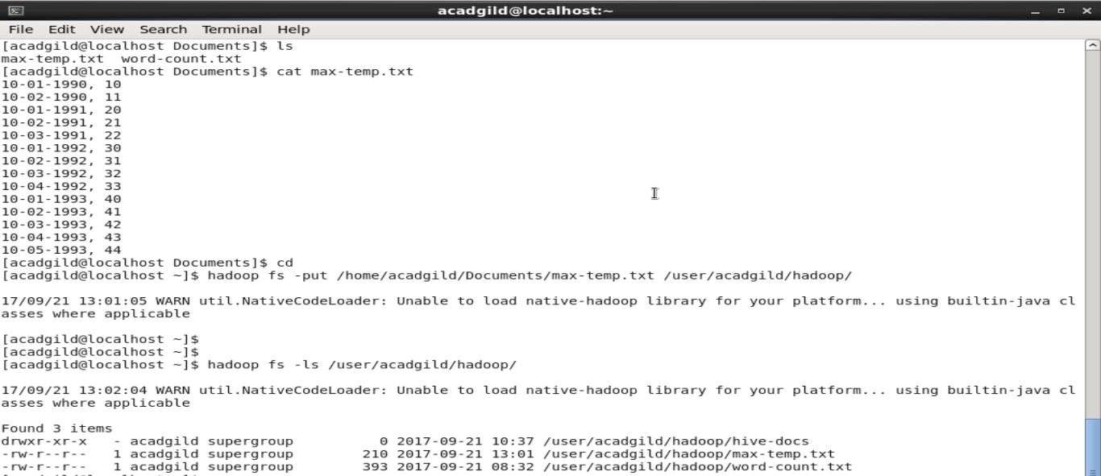

**Task 4**: Change the permission of the file **/user/acadgild/hadoop/max-temp.txt**, such that only the owner and the group members have full control over the file. Others do not have any control over it.

**Solution** :-

