Assignment_5

Pratheek Sreerangam

2022-12-30

## R Markdown

getwd()

## [1] "C:/Users/prath/OneDrive/Documents/ML"

setwd("C:/Users/prath/Downloads")

# installing required packages  
library(ISLR)  
library(caret)

## Loading required package: ggplot2

## Warning: package 'ggplot2' was built under R version 4.2.2

## Loading required package: lattice

## Warning: package 'lattice' was built under R version 4.2.2

library(dplyr)

##   
## Attaching package: 'dplyr'

## The following objects are masked from 'package:stats':  
##   
## filter, lag

## The following objects are masked from 'package:base':  
##   
## intersect, setdiff, setequal, union

library(cluster)

## Warning: package 'cluster' was built under R version 4.2.2

library(factoextra)

## Warning: package 'factoextra' was built under R version 4.2.2

## Welcome! Want to learn more? See two factoextra-related books at https://goo.gl/ve3WBa

library(NbClust)  
library(ppclust)

## Warning: package 'ppclust' was built under R version 4.2.2

library(dendextend)

## Warning: package 'dendextend' was built under R version 4.2.2

##   
## ---------------------  
## Welcome to dendextend version 1.16.0  
## Type citation('dendextend') for how to cite the package.  
##   
## Type browseVignettes(package = 'dendextend') for the package vignette.  
## The github page is: https://github.com/talgalili/dendextend/  
##   
## Suggestions and bug-reports can be submitted at: https://github.com/talgalili/dendextend/issues  
## You may ask questions at stackoverflow, use the r and dendextend tags:   
## https://stackoverflow.com/questions/tagged/dendextend  
##   
## To suppress this message use: suppressPackageStartupMessages(library(dendextend))  
## ---------------------

##   
## Attaching package: 'dendextend'

## The following object is masked from 'package:stats':  
##   
## cutree

library(tidyverse)

## Warning: package 'tidyverse' was built under R version 4.2.2

## ── Attaching packages  
## ───────────────────────────────────────  
## tidyverse 1.3.2 ──

## ✔ tibble 3.1.8 ✔ purrr 0.3.4  
## ✔ tidyr 1.2.1 ✔ stringr 1.4.1  
## ✔ readr 2.1.3 ✔ forcats 0.5.2

## Warning: package 'forcats' was built under R version 4.2.2

## ── Conflicts ────────────────────────────────────────── tidyverse_conflicts() ──  
## ✖ dplyr::filter() masks stats::filter()  
## ✖ dplyr::lag() masks stats::lag()  
## ✖ purrr::lift() masks caret::lift()

library(ggplot2)  
library(proxy)

##   
## Attaching package: 'proxy'  
##   
## The following objects are masked from 'package:stats':  
##   
## as.dist, dist  
##   
## The following object is masked from 'package:base':  
##   
## as.matrix

# To import the data set "cereal"  
Cereals <- read.csv("Cereals.csv")  
# Using head getting the first few rows of the data collection  
head(Cereals)

## name mfr type calories protein fat sodium fiber carbo  
## 1 100%_Bran N C 70 4 1 130 10.0 5.0  
## 2 100%_Natural_Bran Q C 120 3 5 15 2.0 8.0  
## 3 All-Bran K C 70 4 1 260 9.0 7.0  
## 4 All-Bran_with_Extra_Fiber K C 50 4 0 140 14.0 8.0  
## 5 Almond_Delight R C 110 2 2 200 1.0 14.0  
## 6 Apple_Cinnamon_Cheerios G C 110 2 2 180 1.5 10.5  
## sugars potass vitamins shelf weight cups rating  
## 1 6 280 25 3 1 0.33 68.40297  
## 2 8 135 0 3 1 1.00 33.98368  
## 3 5 320 25 3 1 0.33 59.42551  
## 4 0 330 25 3 1 0.50 93.70491  
## 5 8 NA 25 3 1 0.75 34.38484  
## 6 10 70 25 1 1 0.75 29.50954

# Using str to examine the data set's organization  
str(Cereals)

## 'data.frame': 77 obs. of 16 variables:  
## $ name : chr "100%_Bran" "100%_Natural_Bran" "All-Bran" "All-Bran_with_Extra_Fiber" ...  
## $ mfr : chr "N" "Q" "K" "K" ...  
## $ type : chr "C" "C" "C" "C" ...  
## $ calories: int 70 120 70 50 110 110 110 130 90 90 ...  
## $ protein : int 4 3 4 4 2 2 2 3 2 3 ...  
## $ fat : int 1 5 1 0 2 2 0 2 1 0 ...  
## $ sodium : int 130 15 260 140 200 180 125 210 200 210 ...  
## $ fiber : num 10 2 9 14 1 1.5 1 2 4 5 ...  
## $ carbo : num 5 8 7 8 14 10.5 11 18 15 13 ...  
## $ sugars : int 6 8 5 0 8 10 14 8 6 5 ...  
## $ potass : int 280 135 320 330 NA 70 30 100 125 190 ...  
## $ vitamins: int 25 0 25 25 25 25 25 25 25 25 ...  
## $ shelf : int 3 3 3 3 3 1 2 3 1 3 ...  
## $ weight : num 1 1 1 1 1 1 1 1.33 1 1 ...  
## $ cups : num 0.33 1 0.33 0.5 0.75 0.75 1 0.75 0.67 0.67 ...  
## $ rating : num 68.4 34 59.4 93.7 34.4 ...

# utilizing the summary to analyze the data set  
summary(Cereals)

## name mfr type calories   
## Length:77 Length:77 Length:77 Min. : 50.0   
## Class :character Class :character Class :character 1st Qu.:100.0   
## Mode :character Mode :character Mode :character Median :110.0   
## Mean :106.9   
## 3rd Qu.:110.0   
## Max. :160.0   
##   
## protein fat sodium fiber   
## Min. :1.000 Min. :0.000 Min. : 0.0 Min. : 0.000   
## 1st Qu.:2.000 1st Qu.:0.000 1st Qu.:130.0 1st Qu.: 1.000   
## Median :3.000 Median :1.000 Median :180.0 Median : 2.000   
## Mean :2.545 Mean :1.013 Mean :159.7 Mean : 2.152   
## 3rd Qu.:3.000 3rd Qu.:2.000 3rd Qu.:210.0 3rd Qu.: 3.000   
## Max. :6.000 Max. :5.000 Max. :320.0 Max. :14.000   
##   
## carbo sugars potass vitamins   
## Min. : 5.0 Min. : 0.000 Min. : 15.00 Min. : 0.00   
## 1st Qu.:12.0 1st Qu.: 3.000 1st Qu.: 42.50 1st Qu.: 25.00   
## Median :14.5 Median : 7.000 Median : 90.00 Median : 25.00   
## Mean :14.8 Mean : 7.026 Mean : 98.67 Mean : 28.25   
## 3rd Qu.:17.0 3rd Qu.:11.000 3rd Qu.:120.00 3rd Qu.: 25.00   
## Max. :23.0 Max. :15.000 Max. :330.00 Max. :100.00   
## NA's :1 NA's :1 NA's :2   
## shelf weight cups rating   
## Min. :1.000 Min. :0.50 Min. :0.250 Min. :18.04   
## 1st Qu.:1.000 1st Qu.:1.00 1st Qu.:0.670 1st Qu.:33.17   
## Median :2.000 Median :1.00 Median :0.750 Median :40.40   
## Mean :2.208 Mean :1.03 Mean :0.821 Mean :42.67   
## 3rd Qu.:3.000 3rd Qu.:1.00 3rd Qu.:1.000 3rd Qu.:50.83   
## Max. :3.000 Max. :1.50 Max. :1.500 Max. :93.70   
##

Now I am scaling the data to remove NA values from the data set.

# For planning purposes I'm creating a duplicate of this data collection here.  
Scaled_Cereals <- Cereals  
# I'm scaling the data set right now to fit it into a clustering method.  
Scaled_Cereals[ , c(4:16)] <- scale(Cereals[ , c(4:16)])  
# Here, I'm removing the NA values from the data collection using the omit function.  
Preprocessed_Cereal <- na.omit(Scaled_Cereals)  
# using head to display the first few rows after removing NA  
head(Preprocessed_Cereal)

## name mfr type calories protein fat  
## 1 100%_Bran N C -1.8929836 1.3286071 -0.01290349  
## 2 100%_Natural_Bran Q C 0.6732089 0.4151897 3.96137277  
## 3 All-Bran K C -1.8929836 1.3286071 -0.01290349  
## 4 All-Bran_with_Extra_Fiber K C -2.9194605 1.3286071 -1.00647256  
## 6 Apple_Cinnamon_Cheerios G C 0.1599704 -0.4982277 0.98066557  
## 7 Apple_Jacks K C 0.1599704 -0.4982277 -1.00647256  
## sodium fiber carbo sugars potass vitamins shelf  
## 1 -0.3539844 3.29284661 -2.5087829 -0.2343906 2.5753685 -0.1453172 0.9515734  
## 2 -1.7257708 -0.06375361 -1.7409943 0.2223705 0.5160205 -1.2642598 0.9515734  
## 3 1.1967306 2.87327158 -1.9969238 -0.4627711 3.1434645 -0.1453172 0.9515734  
## 4 -0.2346986 4.97114672 -1.7409943 -1.6046739 3.2854885 -0.1453172 0.9515734  
## 6 0.2424445 -0.27354112 -1.1011705 0.6791317 -0.4071355 -0.1453172 -1.4507595  
## 7 -0.4136273 -0.48332864 -0.9732057 1.5926539 -0.9752315 -0.1453172 -0.2495930  
## weight cups rating  
## 1 -0.1967771 -2.1100340 1.8321876  
## 2 -0.1967771 0.7690100 -0.6180571  
## 3 -0.1967771 -2.1100340 1.1930986  
## 4 -0.1967771 -1.3795303 3.6333849  
## 6 -0.1967771 -0.3052601 -0.9365625  
## 7 -0.1967771 0.7690100 -0.6756899

The total number of observations dropped from 77 to 74 after pre-processing and scaling the data. Only 3 records had the value “NA”. ## Q) Apply hierarchical clustering to the data using Euclidean distance to the normalized measurements. Use Agnes to compare the clustering from single linkage, complete linkage, average linkage, and Ward. Choose the best method.

## Single Linkage:

# The dissimilarity matrix is produced using Euclidean distance calculations for each numerical value in the data set.  
Cereal_Euclidean <- dist(Preprocessed_Cereal[ , c(4:16)], method = "euclidean")  
# Using the single linkage method, a hierarchical clustering is carried out.  
HC_Single <- agnes(Cereal_Euclidean, method = "single")  
# Here, I'm displaying the results of different strategies.  
plot(HC_Single,   
 main = "Ratings of Customers' Cereals by AGNES Using the Single Linkage Method",  
 xlab = "Cereal",  
 ylab = "Height",  
 cex.axis = 2,  
 cex = 0.60)

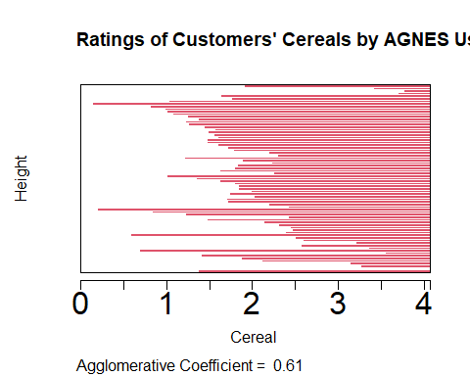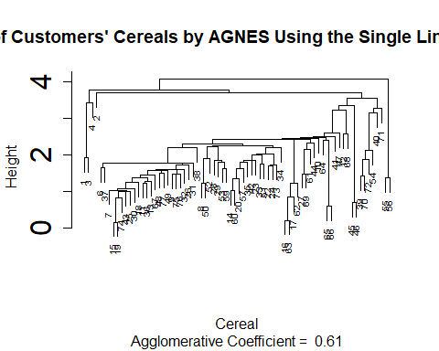

# Complete Linkage:

# utilizing all linking techniques to produce hierarchical clustering  
HC_Complete <- agnes(Cereal_Euclidean, method = "complete")  
# Here, I'm displaying the results of different strategies.  
plot(HC_Complete,   
 main = "Ratings of Customers' Cereals by AGNES Using the Complete Linkage Method",  
 xlab = "Cereal",  
 ylab = "Height",  
 cex.axis = 2,  
 cex = 0.60)

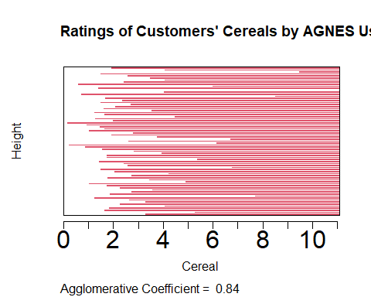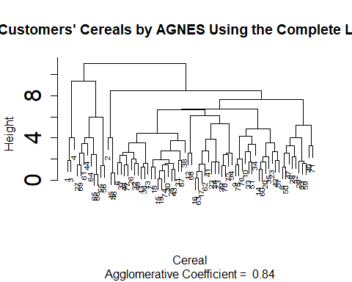

# Average Linkage:

# Performing the average linkage method for hierarchical clustering  
HC_Average <- agnes(Cereal_Euclidean, method = "average")  
# Here I am Plotting the results of the different methods  
plot(HC_Average,   
 main = "Customer Cereal Ratings - AGNES using Average Linkage Method",  
 xlab = "Cereal",  
 ylab = "Height",  
 cex.axis = 2,  
 cex = 0.60)

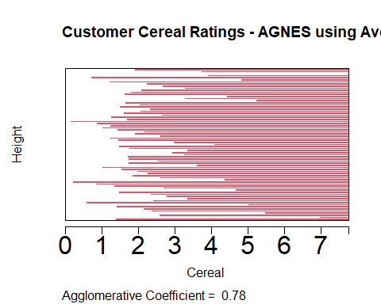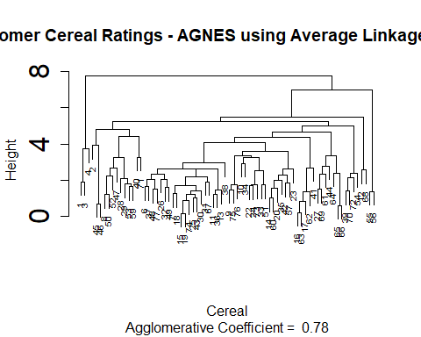

# Ward Method:

# Performing the ward linkage method for hierarchical clustering  
HC_Ward <- agnes(Cereal_Euclidean, method = "ward")  
# I am Plotting the outcomes of the different methods  
plot(HC_Ward,   
 main = "Customer Cereal Ratings Using the Ward Linkage Method for the AGNES",  
 xlab = "Cereal",  
 ylab = "Height",  
 cex.axis = 2,  
 cex = 0.56)

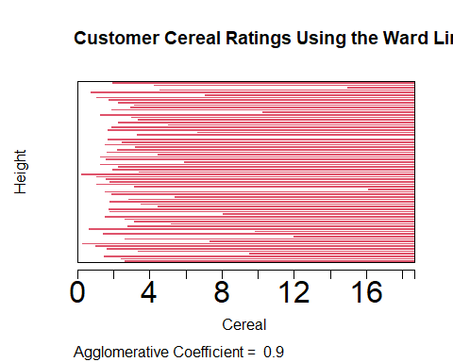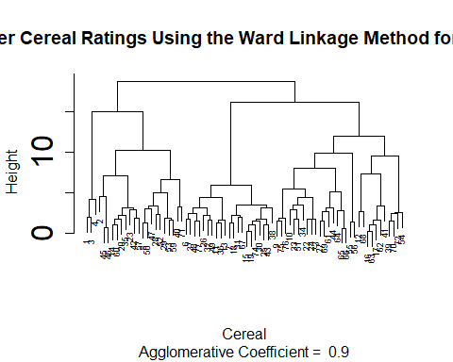 The clustering structure is closer if the value is close to 1.0. Therefore, the method with the value closest to 1.0 will be chosen. Single Linkage: 0.62 Complete Linkage: 0.85 Average Linkage: 0.79 Ward Method: 0.91 The Ward method is the best clustering model based on the results in this case.

## Q) How many clusters would you choose?

# Here, I’m calculating the right number of clusters using the elbow and silhouette methods.

## Elbow Method:

fviz_nbclust(Preprocessed_Cereal[ , c(4:16)], hcut, method = "wss", k.max = 26) +  
 labs(title = "Optimal Number of Clusters using Elbow Method") +  
 geom_vline(xintercept = 13, linetype = 3)

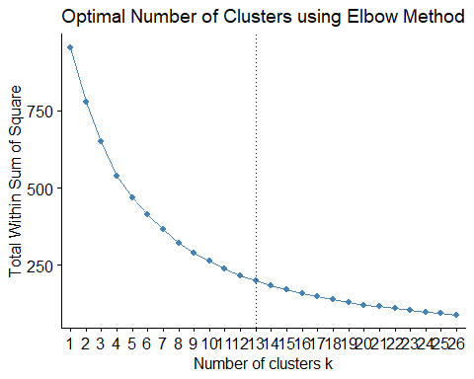

##Silhouette Method:

fviz_nbclust(Preprocessed_Cereal[ , c(4:16)],   
 hcut,   
 method = "silhouette",   
 k.max = 26) +  
 labs(title = "Optimal Number of Clusters using Silhouette Method")

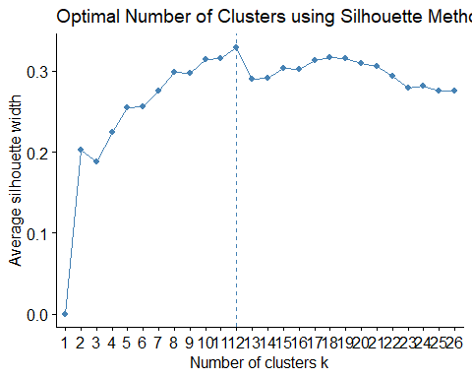 The results of the elbow and silhouette approaches suggest that the ideal number of clusters would be twelve.

# I've highlighted the 12 groups in this Ward hierarchical tree plot for easy reference.  
plot(HC_Ward,   
 main = "Using 12 Clusters, the AGNES Ward Linkage Method is outlined",  
 xlab = "Cereal",  
 ylab = "Height",  
 cex.axis = 2,  
 cex = 0.60,)

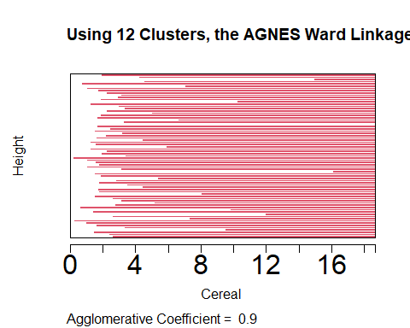

rect.hclust(HC_Ward, k = 13, border = 1:13)

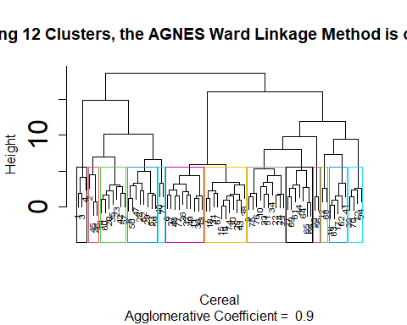

## Q) The elementary public schools would like to choose a set of Cereals to include in their daily cafeterias. Every day a different cereal is offered, but all Cereals should support a healthy diet. For this goal, you are requested to find a cluster of “healthy Cereals.” Should the data be normalized? If not, how should they be used in the cluster analysis?

Because the nutritional information for cereal is standardized based on the sample of cereal being evaluated, normalizing the data would not be appropriate in this situation.

Therefore, the information gathered could only iclude cereals with extremely high sugar content and very little fiber, iron, or other nutritional information. After the cereal has been normalized for the entire sample set, it is difficult to predict how much nutrition the cereal will give a child.

But it’s possible that a cereal with an iron content of 0.999 is just the best of the worst in the sample set and is completely nutritionally worthless. We may assume that a cereal with an iron content of 0.999 contains nearly all of the dietary iron that a child requires.

The ratio of the daily recommended amounts of calories, fiber, carbohydrates, and other nutrients for a child would be a better way to preprocess the data. This would allow analysts to make more informed cluster decisions during the review phase by preventing a small number of significant variables from overriding the distance estimates.

When examining the clusters, an analyst may consider the cluster average to determine what portion of a student’s daily nutritional needs would be met by XX cereal. This would enable employees to choose “healthy” cereal clusters in an informed manner.