Flask and MongoDB Assignment — Pratheesh Babu
1. Objective
Develop a Flask application that returns JSON data through an API and stores submitted form data in MongoDB Atlas.
2. Technologies Used
- Python
- Flask
- PyMongo
- MongoDB Atlas
- HTML
- python-dotenv
3. Task 1: JSON API
The /api route reads data from data.json and returns it as a JSON response using Flask's jsonify() function.
Test URL: http://127.0.0.1:5000/api
Screenshot:

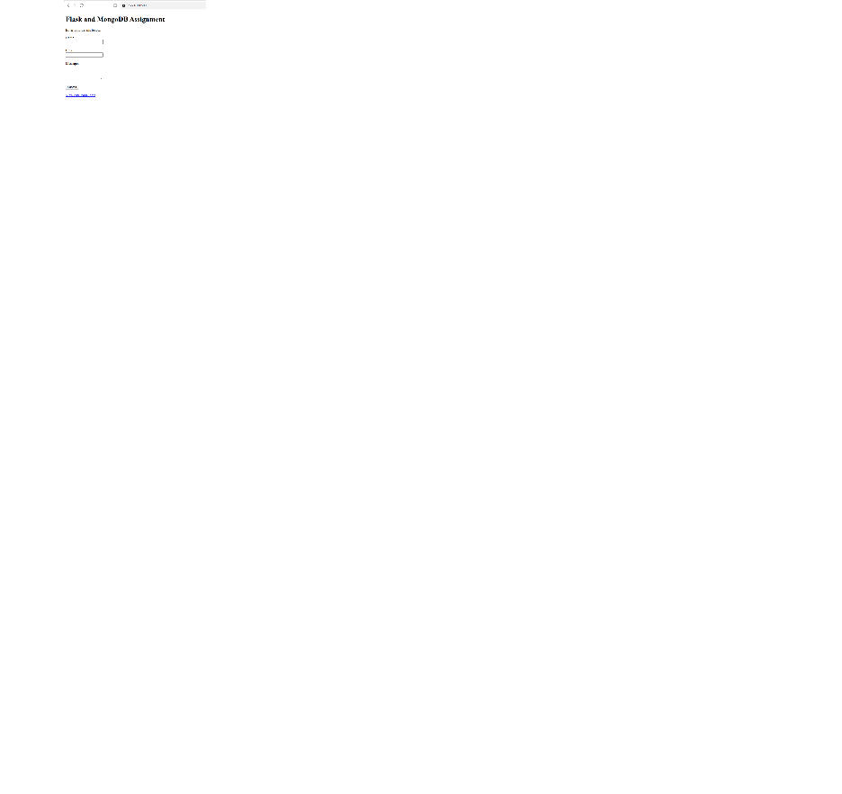

4. Task 2: Form Submission to MongoDB
The home page provides a form with name, email, and message fields. When the form is submitted, Flask validates the fields and inserts the data into the form_submissions collection in the flask_mongodb_assignment database.
Successful submission
After the record is inserted successfully, the application redirects to /success, which displays “Data submitted successfully”.

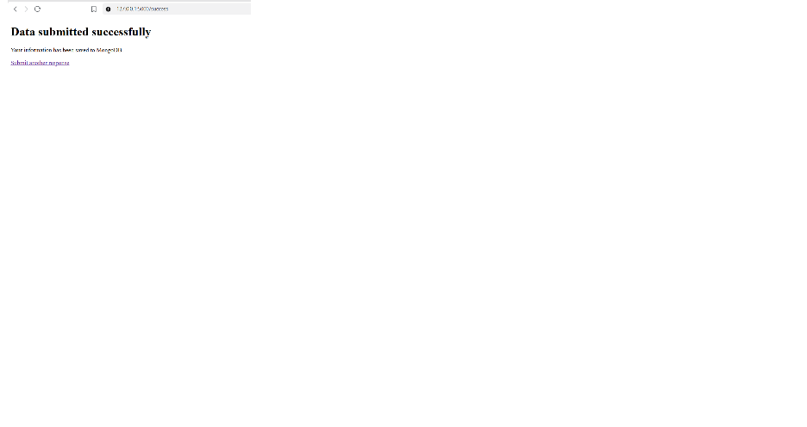

MongoDB record
The submitted data was verified in MongoDB Atlas.

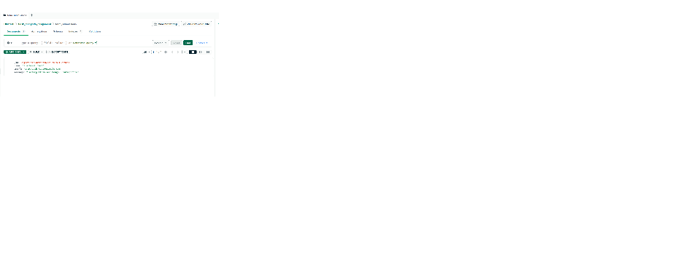

Error handling
When the database connection fails, the application displays an error message on the form page without redirecting to the success page.

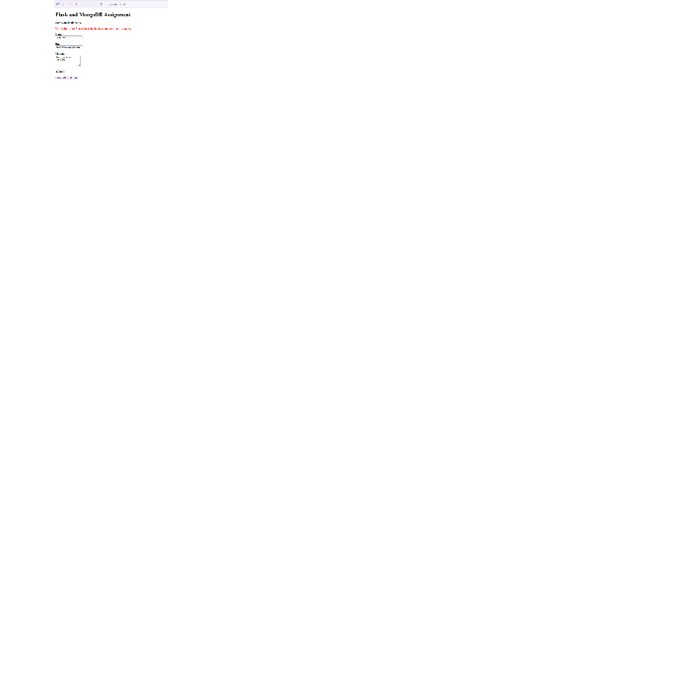

5. Commands Used
Create a virtual environment:
python -m venv .venv
Activate the environment in Windows Command Prompt:
.venv\Scripts\activate.bat
Install dependencies:
python -m pip install -r requirements.txt
Start the Flask application:
python app.py
6. Configuration and Security
MongoDB connection settings are stored in a local .env file. The .env file is excluded from Git using .gitignore. The .env.example file provides a template for configuration.
7. Result
Both assignment tasks were tested successfully. The JSON API returned data from the backend JSON file, and form submissions were stored in MongoDB Atlas. Successful submissions redirected to the success page, while database errors were displayed on the form page.
8. GitHub Repository
Repository URL: https://github.com/pratheeshbabus/Flask_and_MongoDB_PratheeshBabu

9. Author
Pratheesh Babu

