Install Go IPFS

We recommend installing IPFS from a prebuilt package. You can obtain those from dist.ipfs.io.
For convenience here are the latest versions linked directly

installation Link ----->> https://ipfs.io/docs/install/ select one below

- Mac OS X 32bit
- Mac OS X 64bit
- Linux 32bit
- Linux 64bit
- Windows 32bit
- Windows 64bit
- FreeBSD 64bit

Installing from a Prebuilt Package

Mac OS X and Linux
After downloading, untar the archive, and move the ipfs binary somewhere in your executables $PATH:
#tar xvfz go-ipfs.tar.gz
#mv go-ipfs/ipfs /usr/local/bin/ipfs
Test it out:
#ipfs help

next check link ------->>>>> https://ipfs.io/docs/getting-started

init the repo
ipfs uses a global local object repository, added to ~/.ipfs:
#ipfs init

initializing ipfs node at /Users/jbenet/.go-ipfs
generating 2048-bit RSA keypair...done
peer identity: Qmcpo2iLBikrdf1d6QU6vXuNb6P7hwrbNPW9kLAH8eG67z
to get started, enter:

ipfs cat /ipfs/QmYwAPJzv5CZsnA625s3Xf2nemtYgPpHdWEz79ojWnPbdG/readme
Note the hash there may differ. If it does, use the one you got.
Now, try running:
#ipfs cat /ipfs/QmYwAPJzv5CZsnA625s3Xf2nemtYgPpHdWEz79ojWnPbdG/readme
You should see something like this:
Hello and Welcome to IPFS!

██╗██████╗ ███████╗███████╗
██║██╔══██╗██╔════╝██╔════╝
██║██████╔╝█████╗ ███████╗
██║██╔═══╝ ██╔══╝ ╚════██║
██║██║ ██║ ███████║
╚═╝╚═╝ ╚═╝ ╚══════╝

If you're seeing this, you have successfully installed
IPFS and are now interfacing with the ipfs merkledag!

-------------------------------------------------------
| Warning: |
| This is alpha software. use at your own discretion! |
| Much is missing or lacking polish. There are bugs. |
| Not yet secure. Read the security notes for more. |
-------------------------------------------------------

Check out some of the other files in this directory:

./about
./help
./quick-start <-- usage examples
./readme <-- this file
./security-notes
You can explore other objects in there. In particular, check out quick-start:
#ipfs cat /ipfs/QmYwAPJzv5CZsnA625s3Xf2nemtYgPpHdWEz79ojWnPbdG/quick-start
Which will walk you through several interesting examples.

Going Online
Once you're ready to take things online, run the daemon in another terminal:
#ipfs daemon

Initializing daemon...
API server listening on /ip4/127.0.0.1/tcp/5001
Gateway server listening on /ip4/127.0.0.1/tcp/8080
#ipfs swarm peers

Fancy Web Console
We also have a web console you can use to check the state of your node. On your favorite web browser, go to:
http://localhost:5001/webui
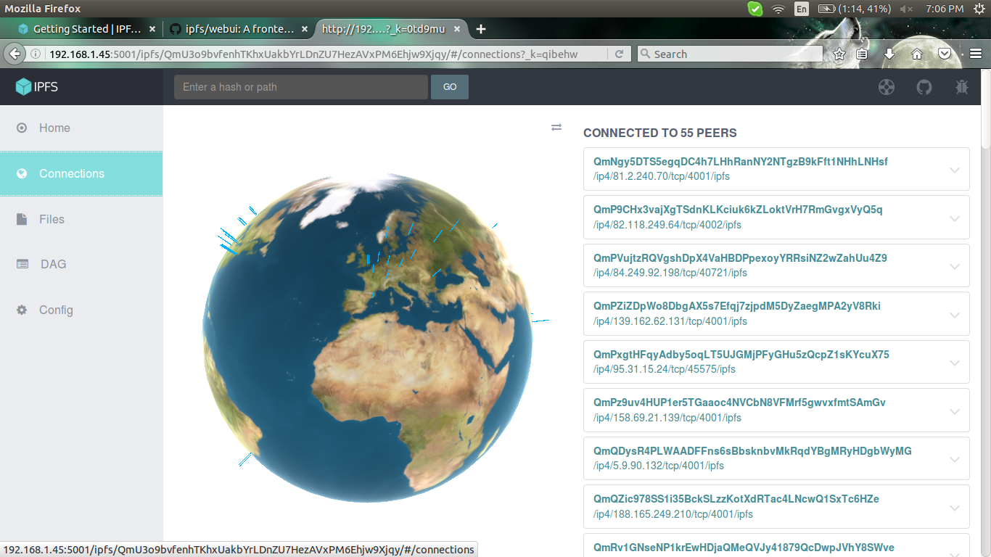

for changing localhost to the network ip change the following content first

$ ipfs config --json API.HTTPHeaders.Access-Control-Allow-Origin '["http://ipaddress of the host:5001"]'
$ ipfs config --json API.HTTPHeaders.Access-Control-Allow-Methods '["PUT", "GET", "POST"]'
$ ipfs config --json API.HTTPHeaders.Access-Control-Allow-Credentials '["true"]'

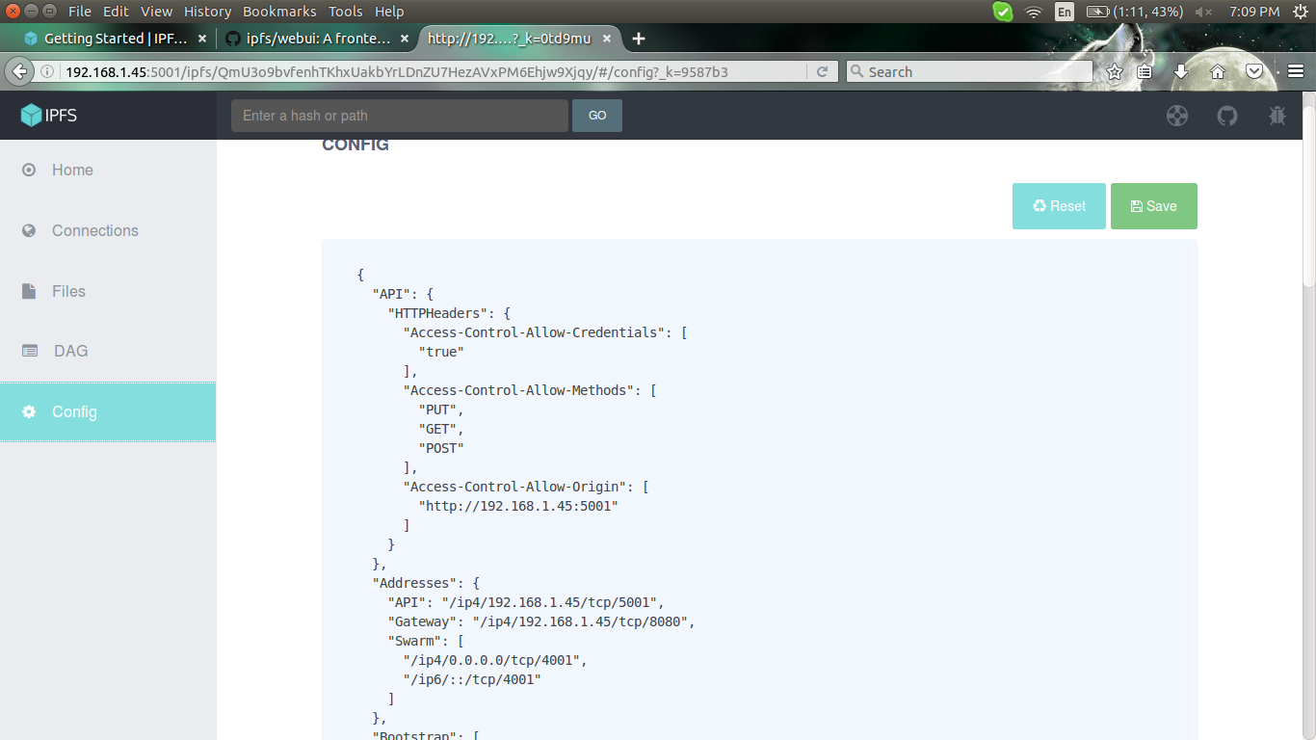

change only the API and Gateway......and disired port

Home window

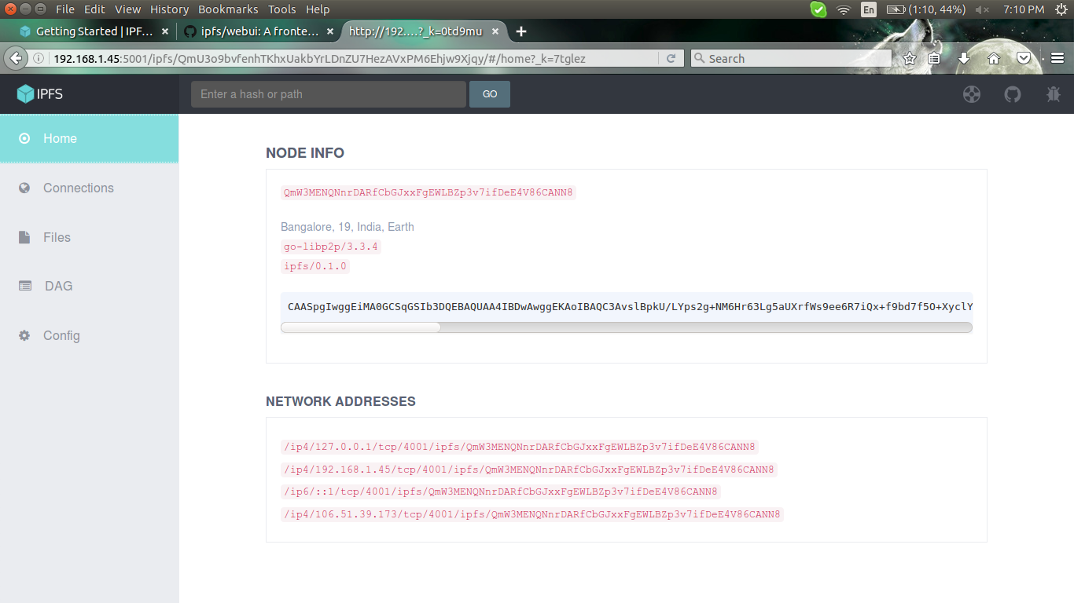

connection window

connecting peer should be seen ith right side
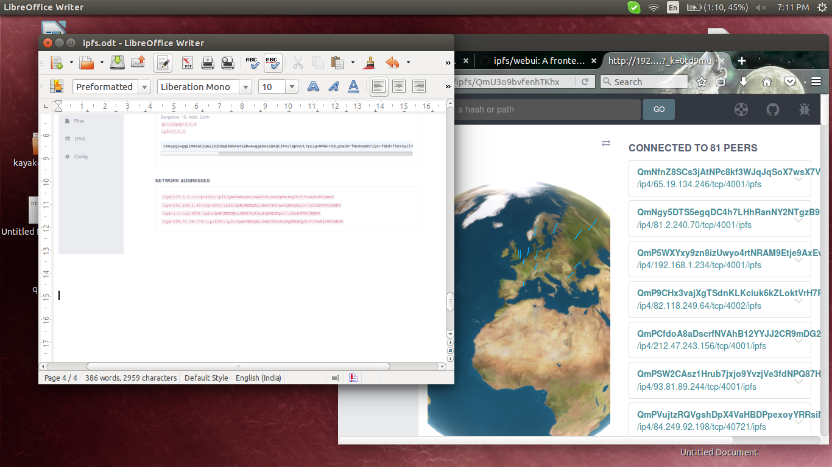

files window we can upload file in to this

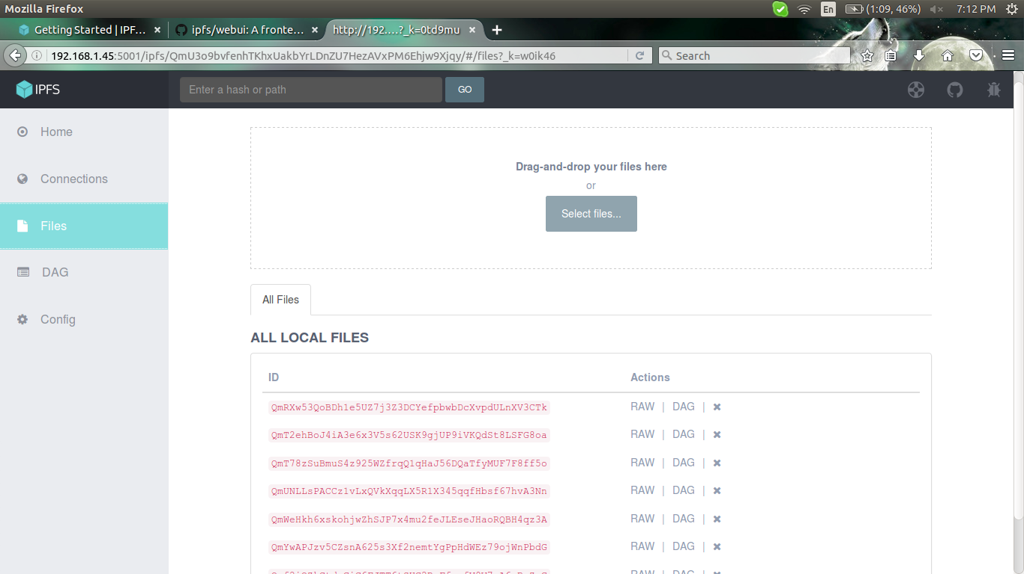

note this same is doing with next ipfs server
with other ip in config in other pc

and chek the file accessing from other machine with hash key of that file

in the DAG window we can search this

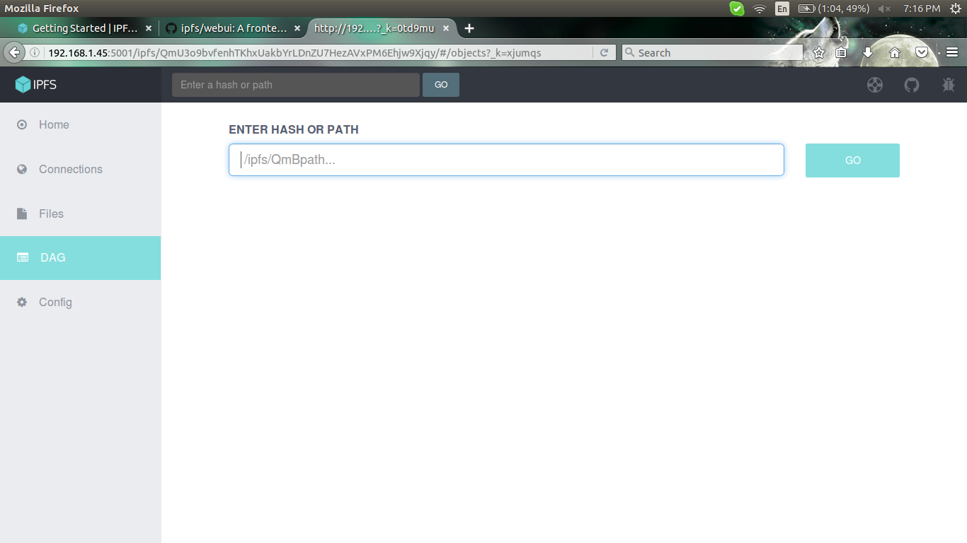

or from the browser we will get that file by url

https://ipfs.io/ipfs/QmU3o9bvfenhTKhxUakbYrLDnZU7HezAVxPM6Ehjw9Xjqy

ipfs commands link in the command line

https://ipfs.io/docs/commands/

other link for studing

http://www.makeuseof.com/tag/goodbye-http-faster-safer-decentralized-internet-ipfs/

http://motherboard.vice.com/read/the-interplanetary-file-system-wants-to-create-a-permanent-web

https://techcrunch.com/2015/10/04/why-the-internet-needs-ipfs-before-its-too-late/

https://ipfs.io/#how

https://github.com/ipfs/ipfs

http://searchstorage.techtarget.com/definition/content-addressed-storage

https://github.com/ipfs/webui

