1.AD DC

name :Bizruntime
ip 192.168.1.56
domain name :biz.local

Inwindows server 2012 R@2

set Active Directory ,Domain Name

2.Delivary Controller
name:deliverycontroller
ip 192.168.1.81
add domain:biz.local

3.Store Front

name:storefront
ip:192.168.1.80
add in domain :biz.local

4.Delivry Agent

name:deliveryagent
ip:192.168.1.39
add in domain:biz.local

5.Citrix Reciever

name:windows8
ip:192.168.1.89
add in domain:biz.local

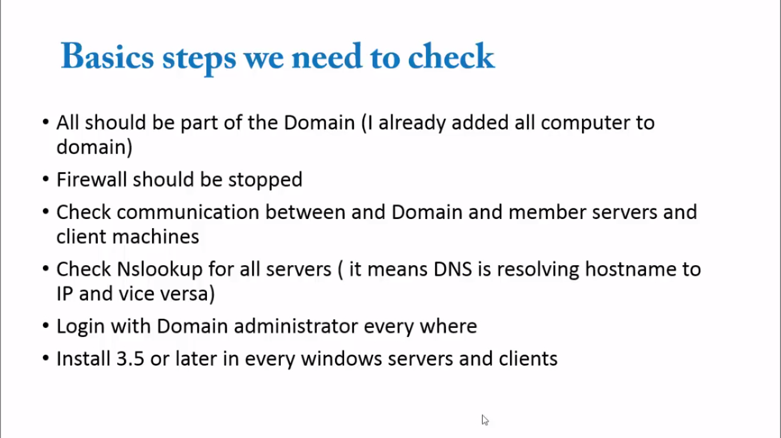

system

1.Delivery Controller

install sql server on this server for database
so first check .net framework installed or not

install sql server 2012 service pack 1

the installation in citrix1.mp4 video

importent
note the named instance and id for further installation

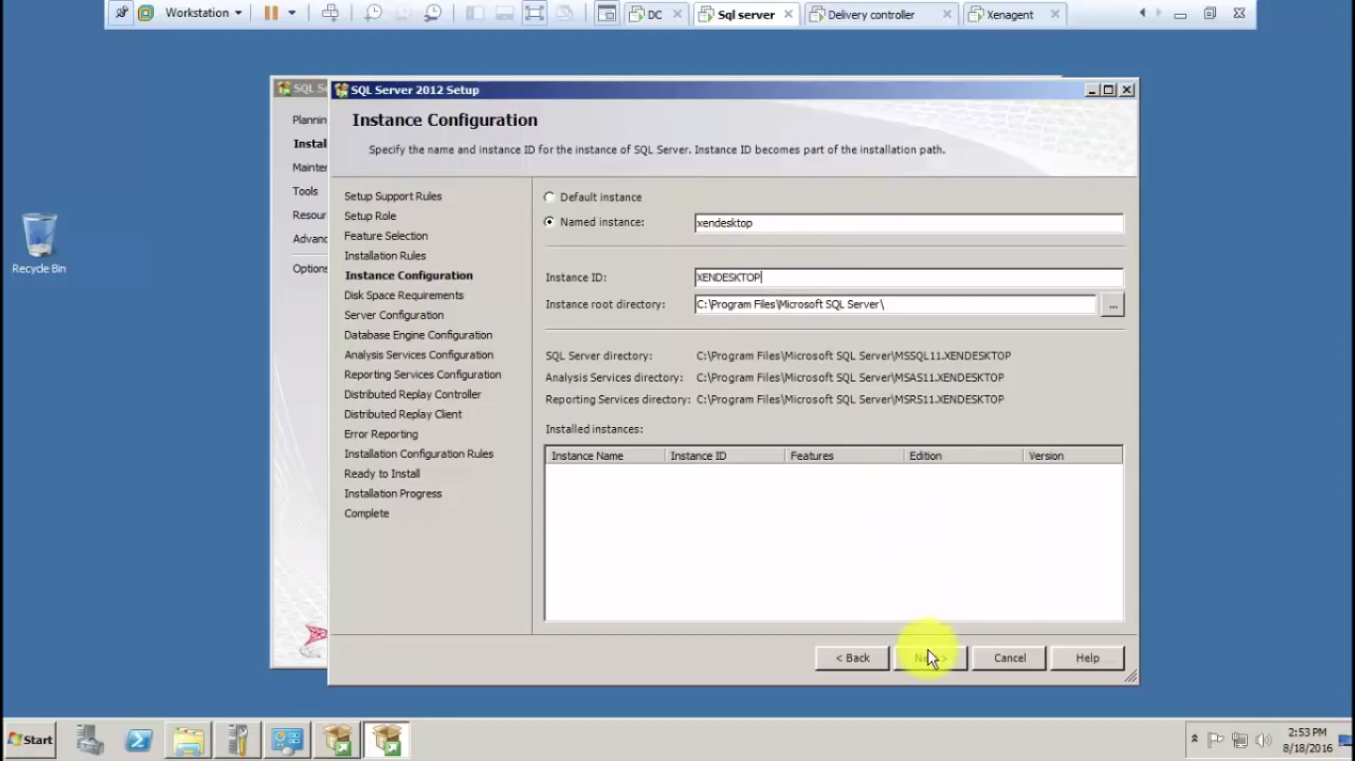

all installation and configuration in citrix1.mp4 video..after installation reboot the system and check its ok or not

Next install Xen desktop and app software in this system

so we want to register incitrix.com we will get 90 days free trail app
it is in .iso extension
so install it

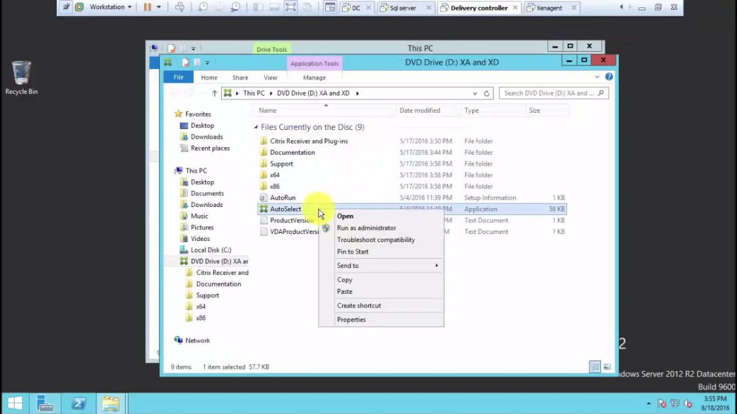

select XenDesktop

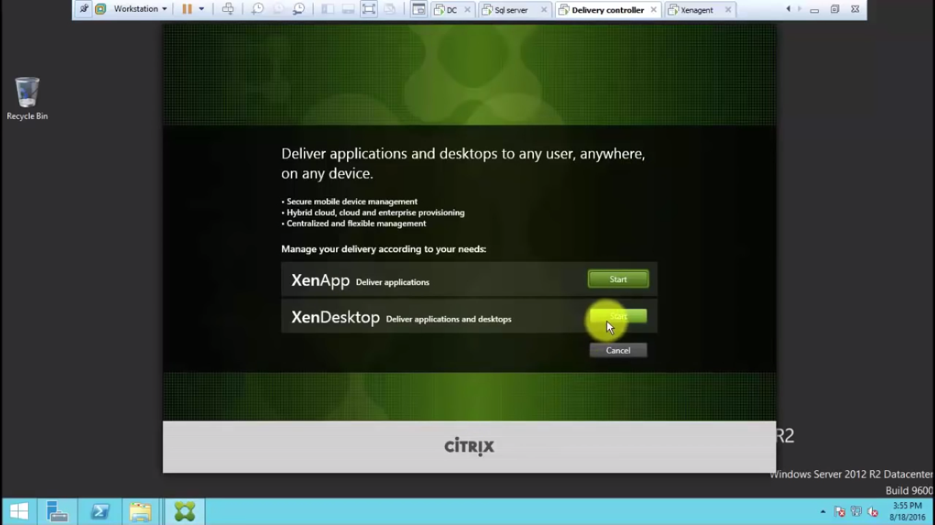

select Delivary controller

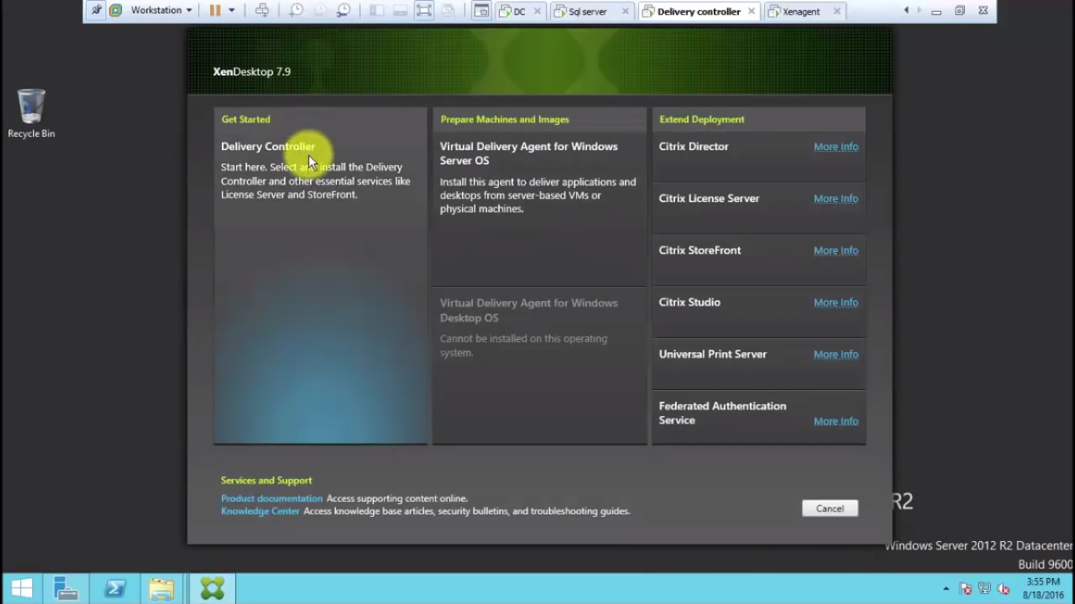

select license accept

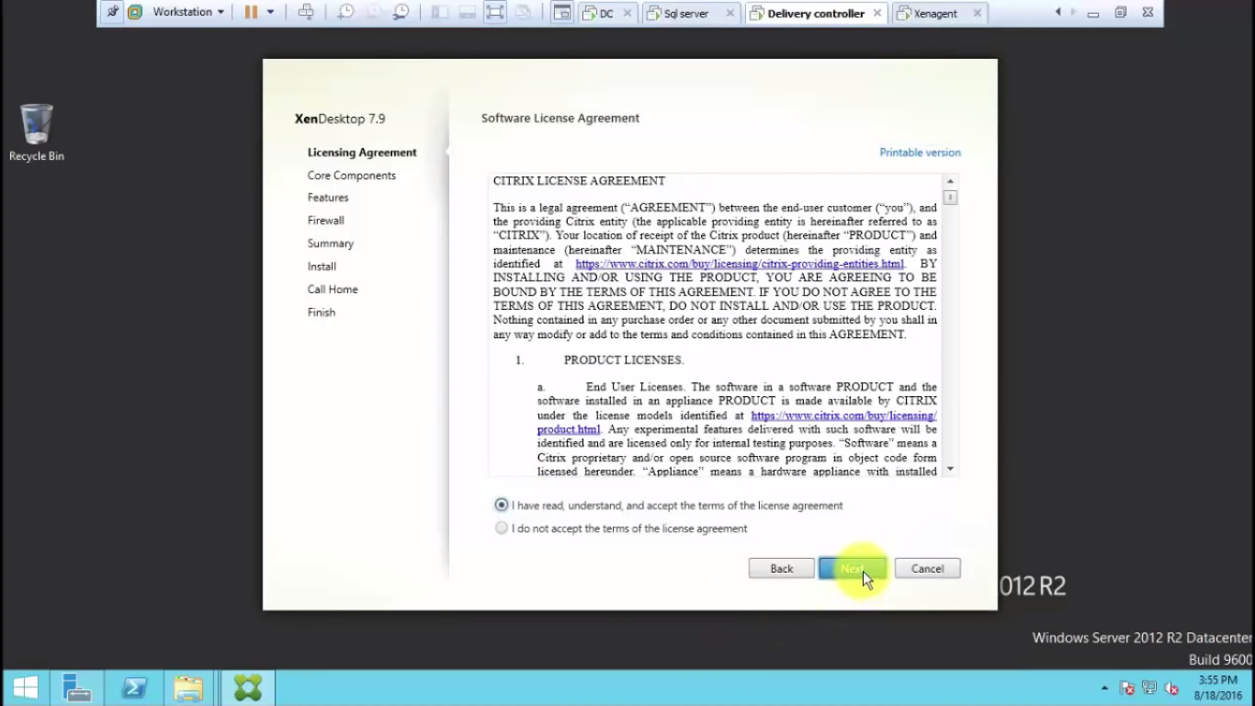

all core component select

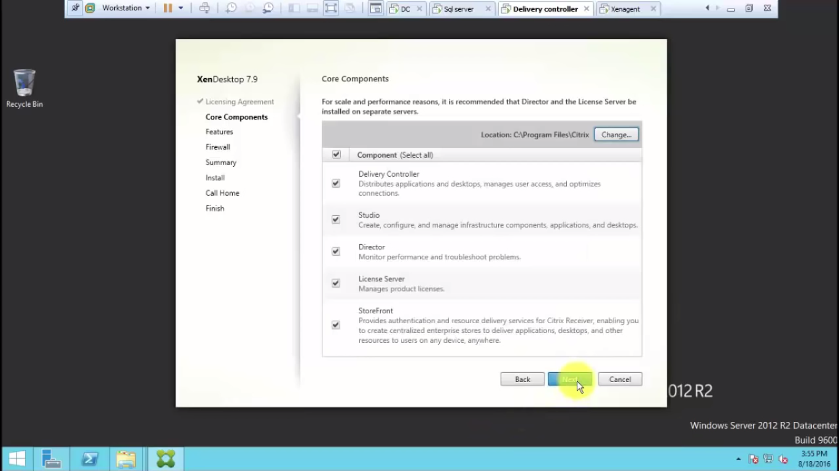

uncheck sql server installation and select next

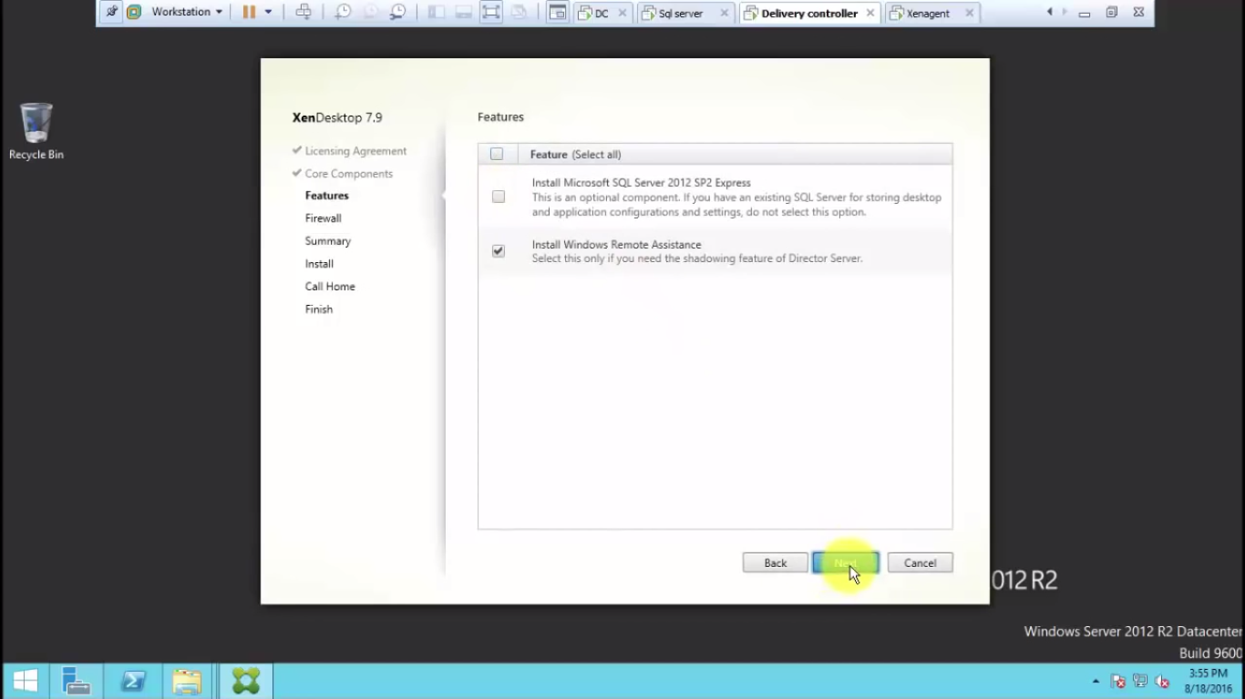

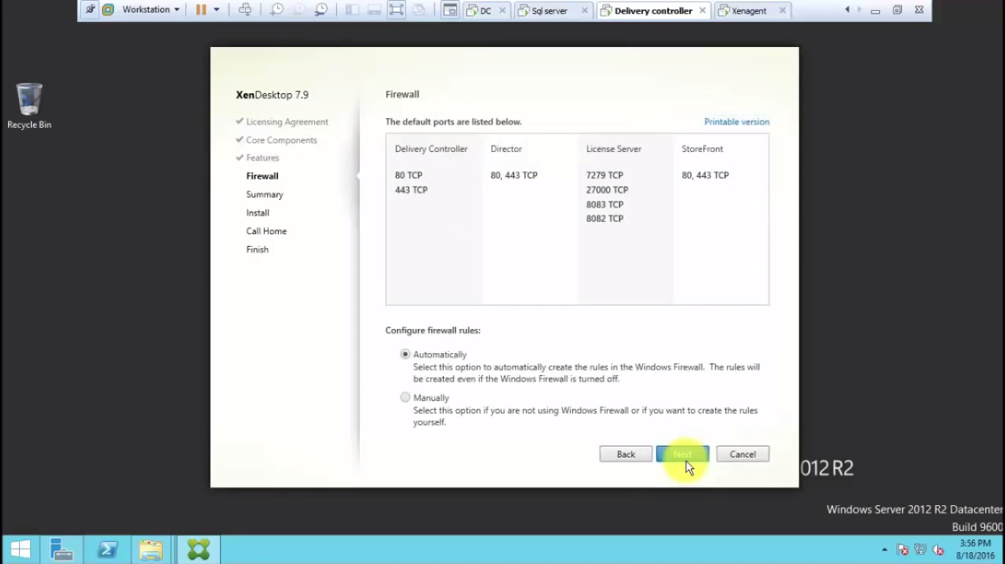

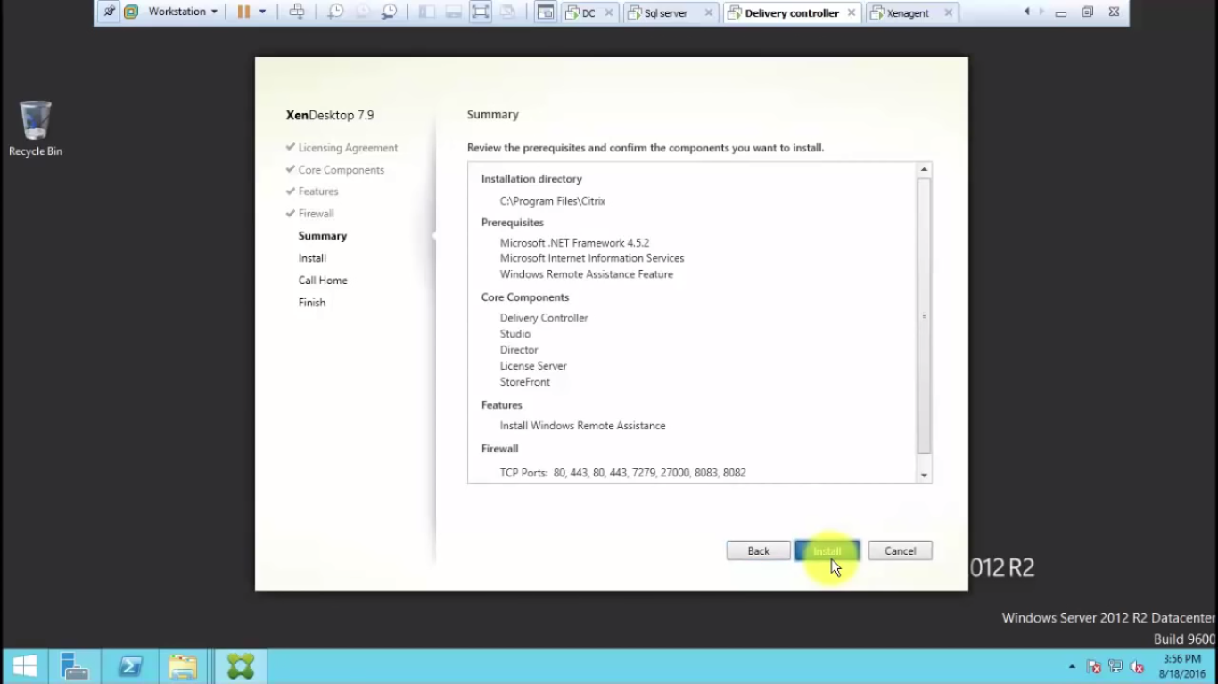

after installation of prerequests it will restart automatically

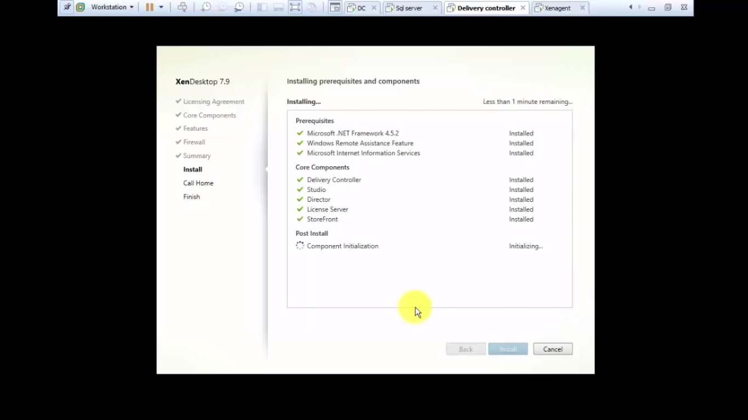

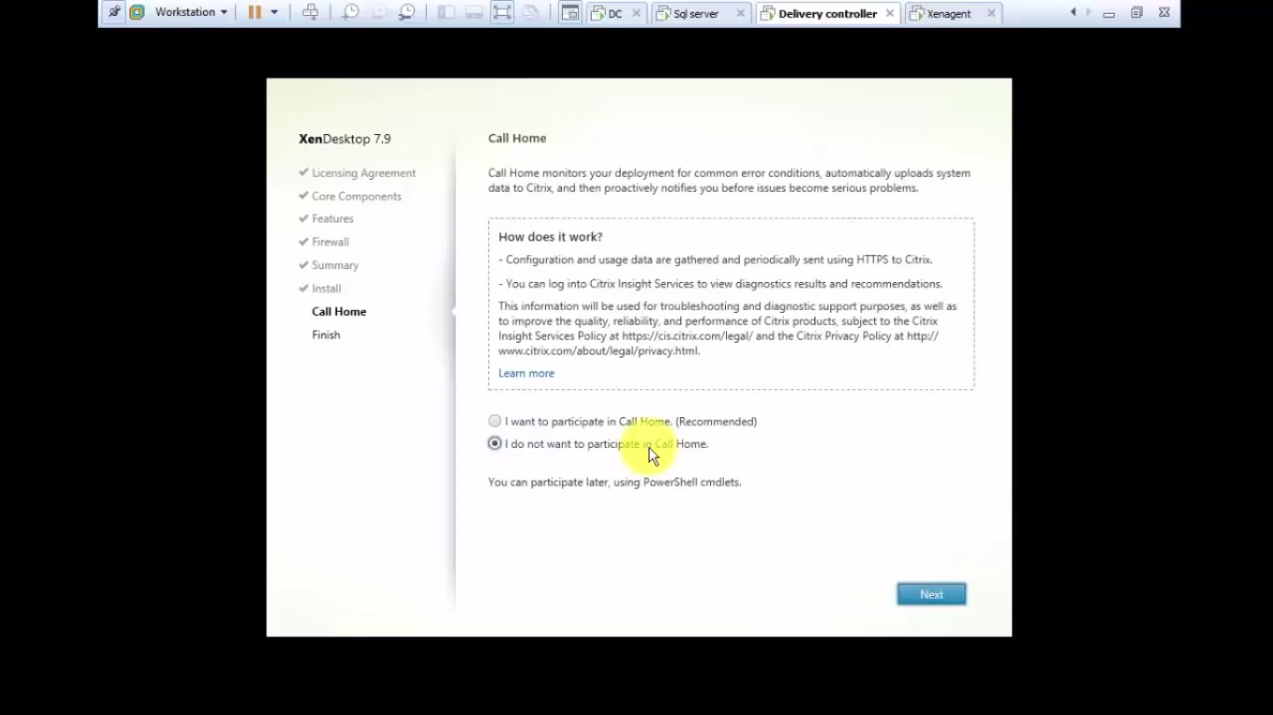

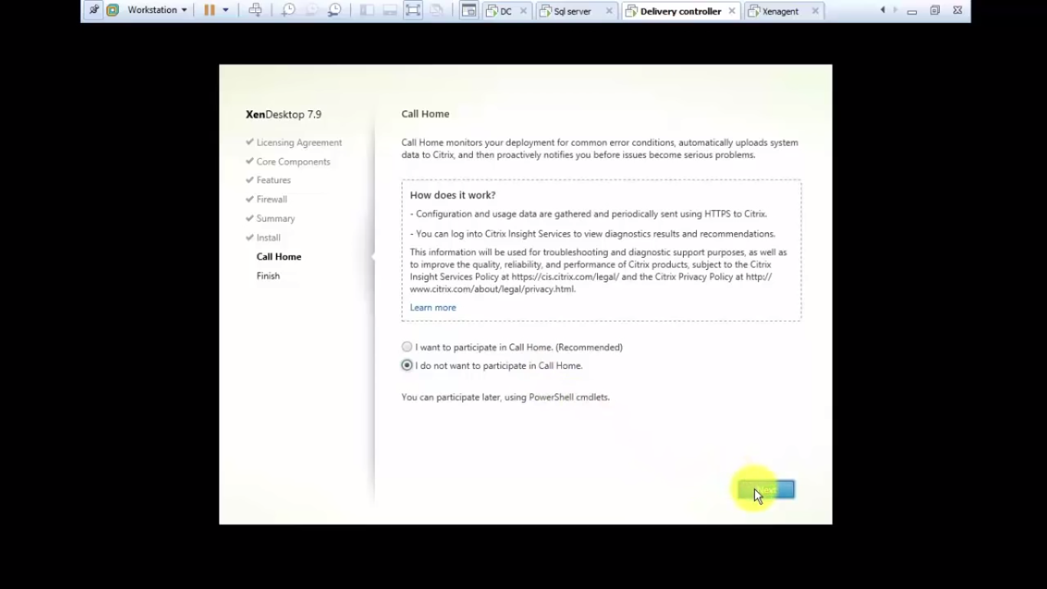

finish
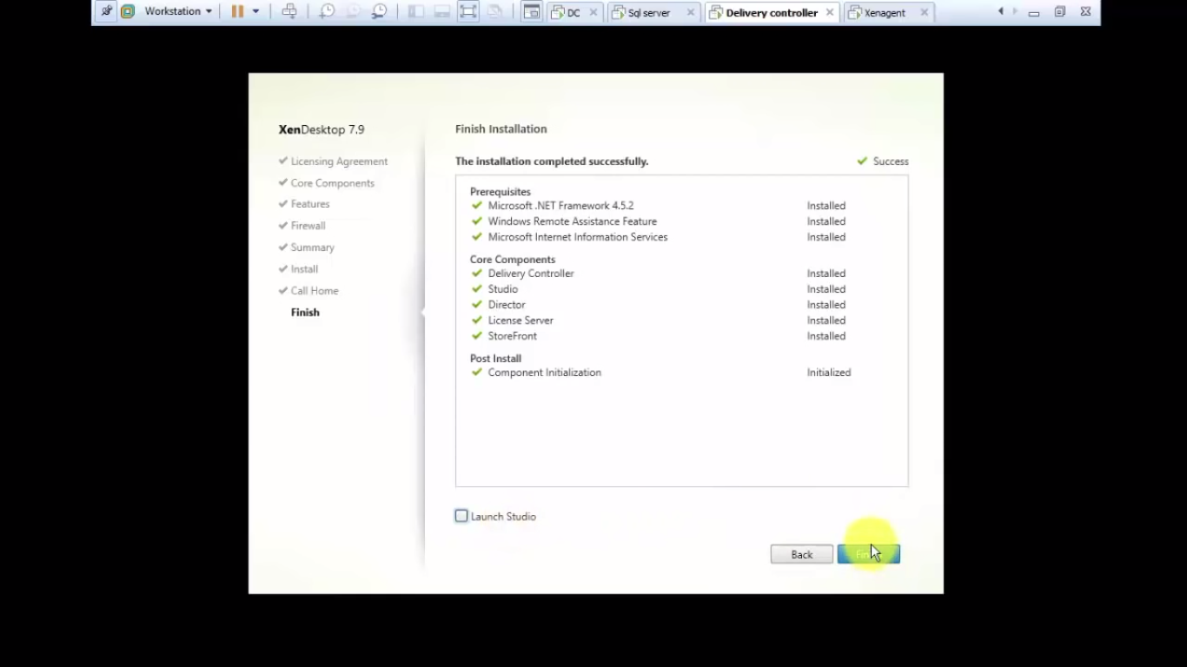

SITE SETUP

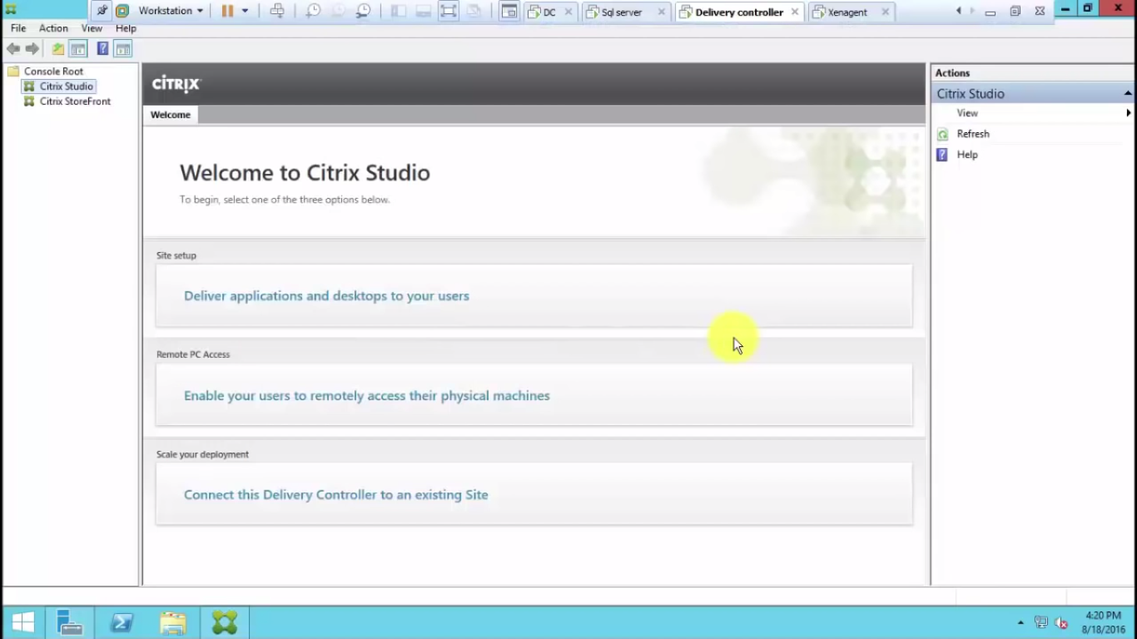

click on site setup

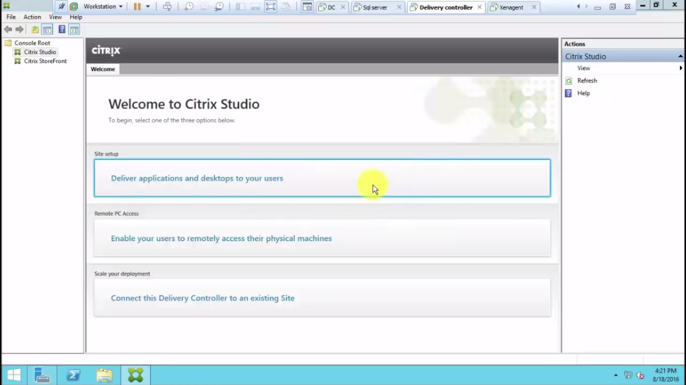

give the site name

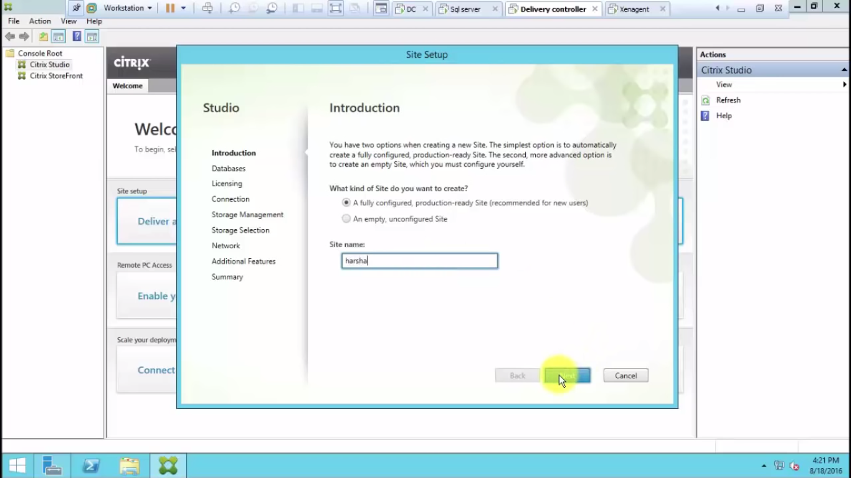
give the database system and instance name here
in the 3 columns here delivarycontroller\xendesktop
delivary controller is the system name ,xendesktop is the database instance name

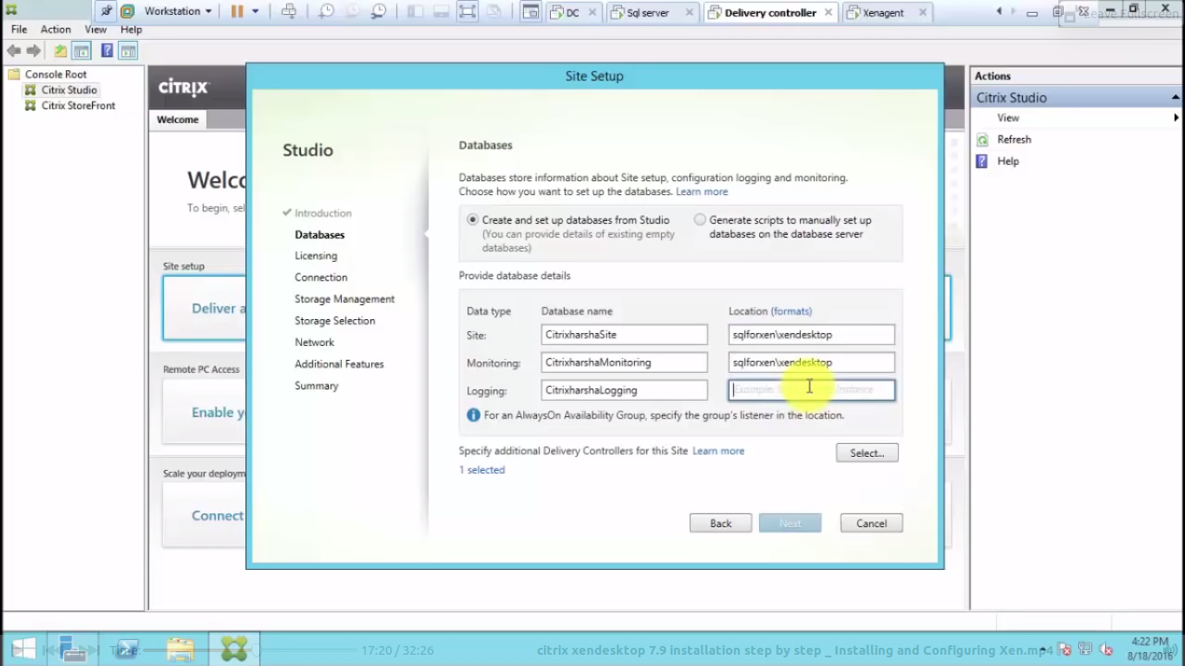

click next

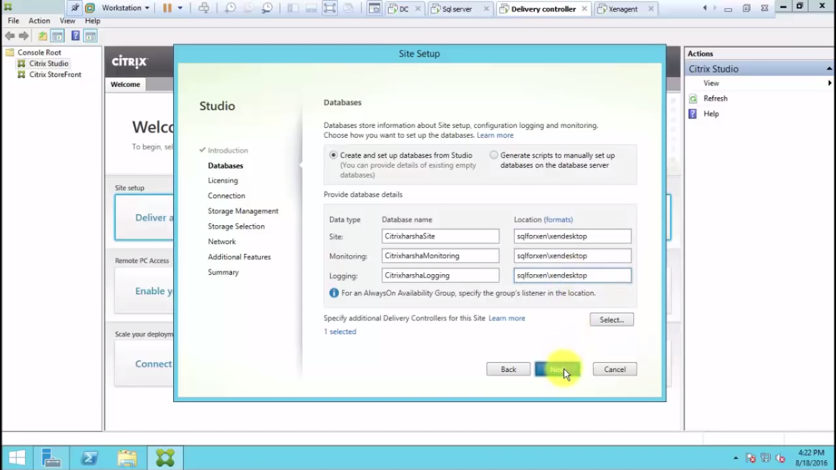

give the free trail as below

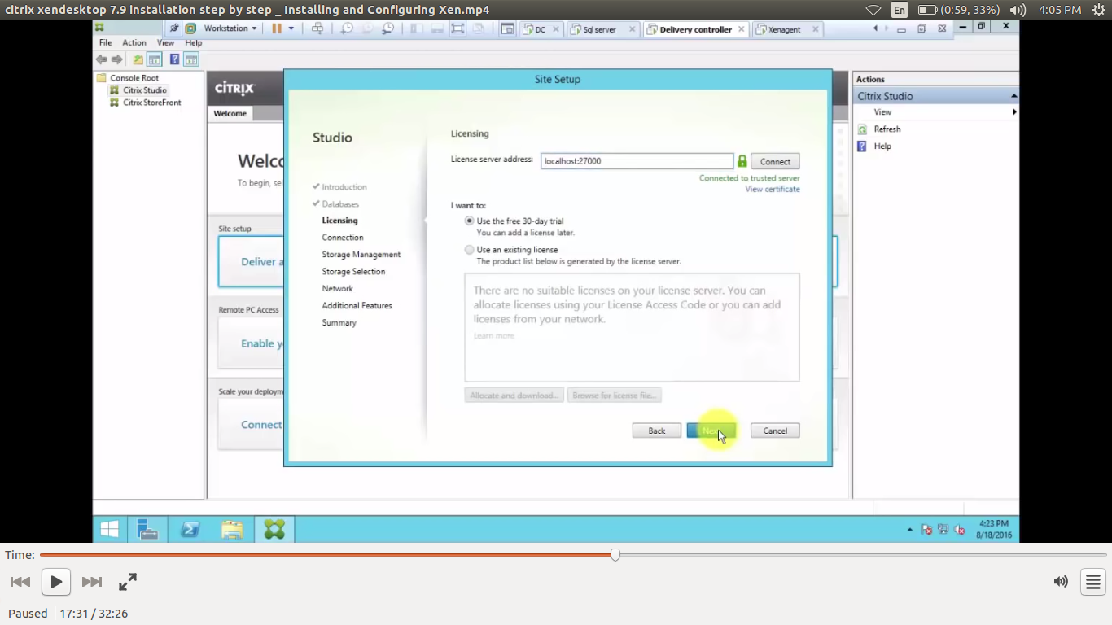

click next

select connection type :no machine management
as fig

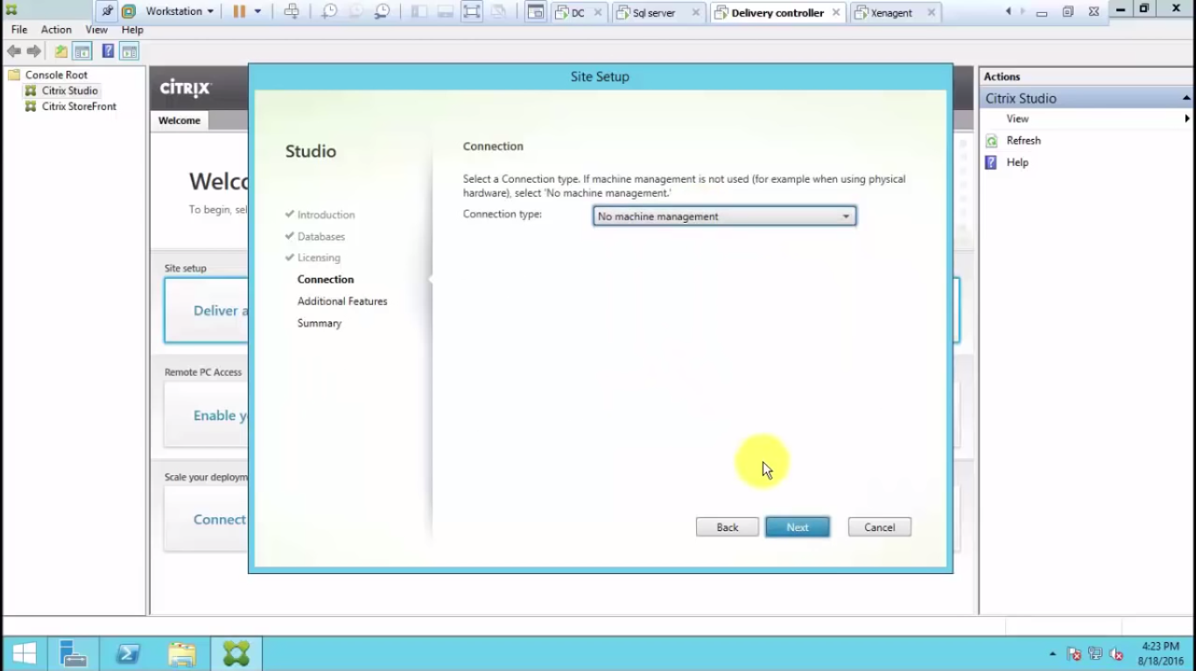

click next

additional freatures just click next
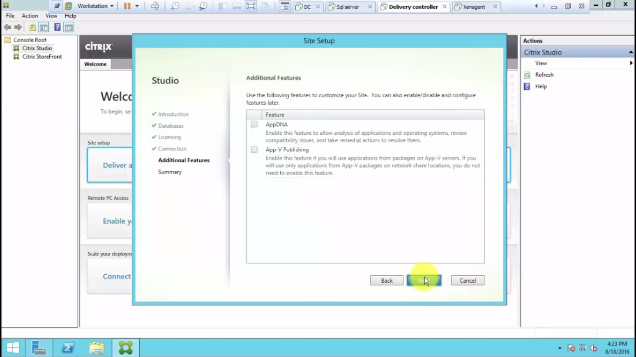

we get full summary on next screen
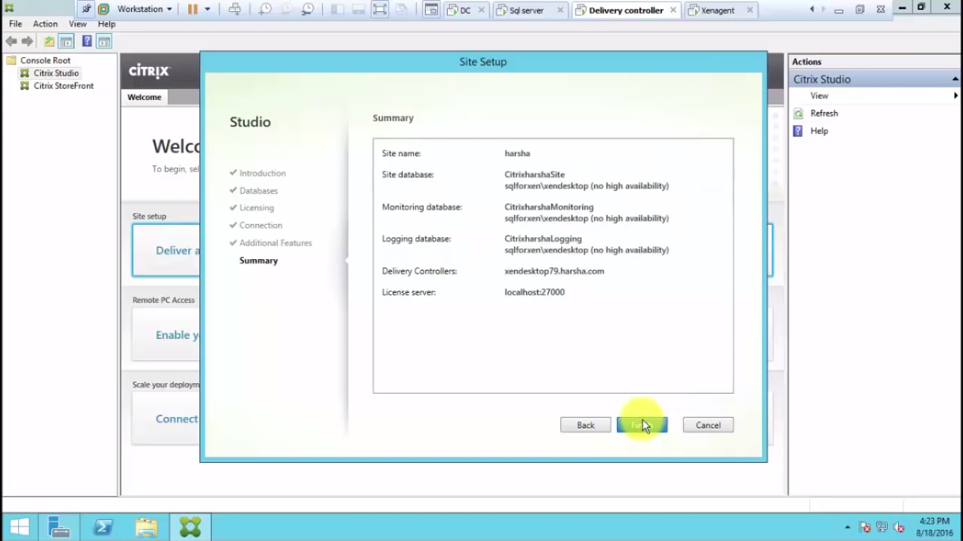

click next

site installation is completed

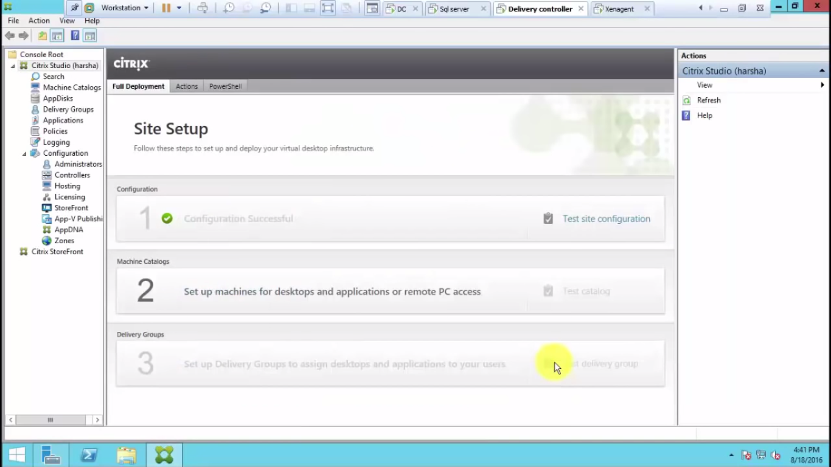

system
2.DELIVARYAGENT

install microsoft .net framework 4.6.1 setup

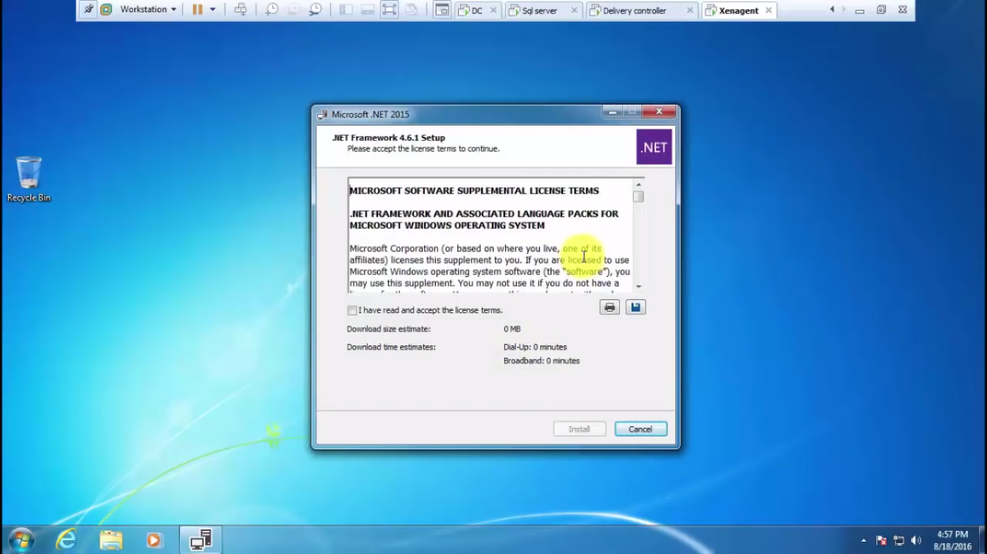
and restart

install xen app and desktop here
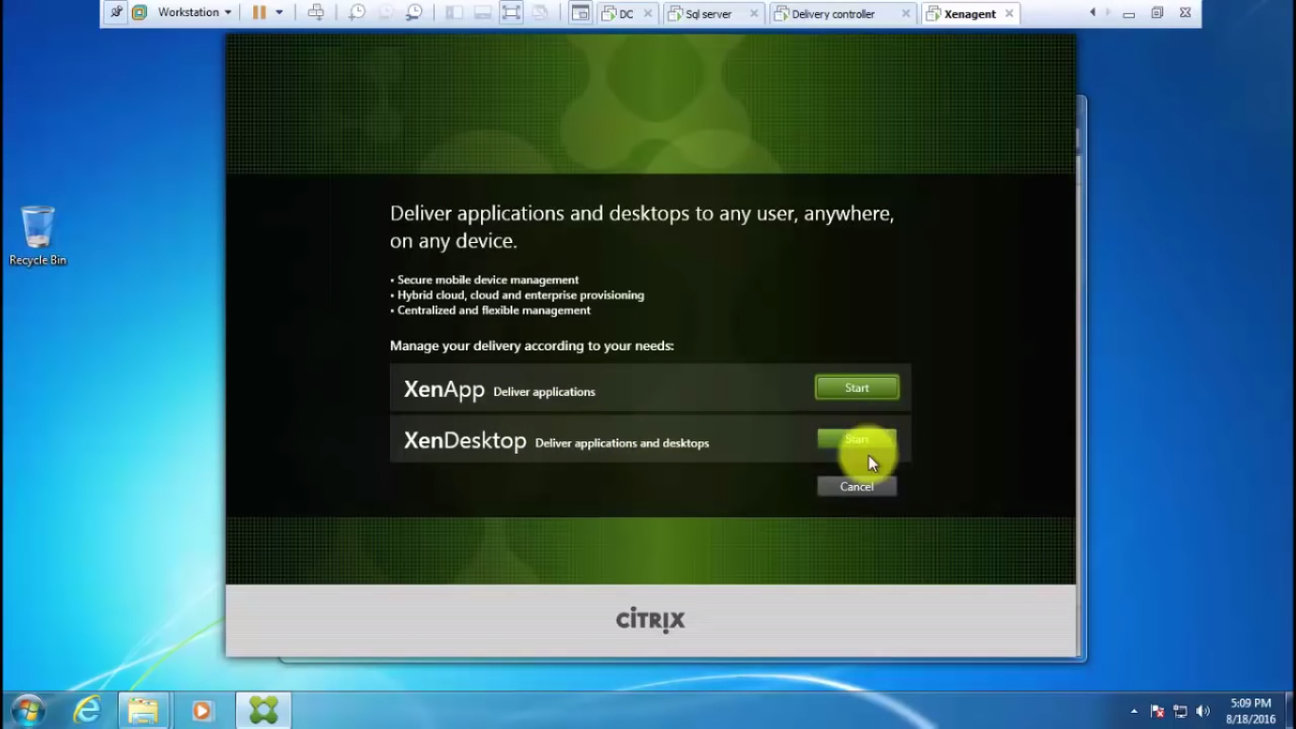

select xen desktop and next

select virtual delivary agent for windows desktop os
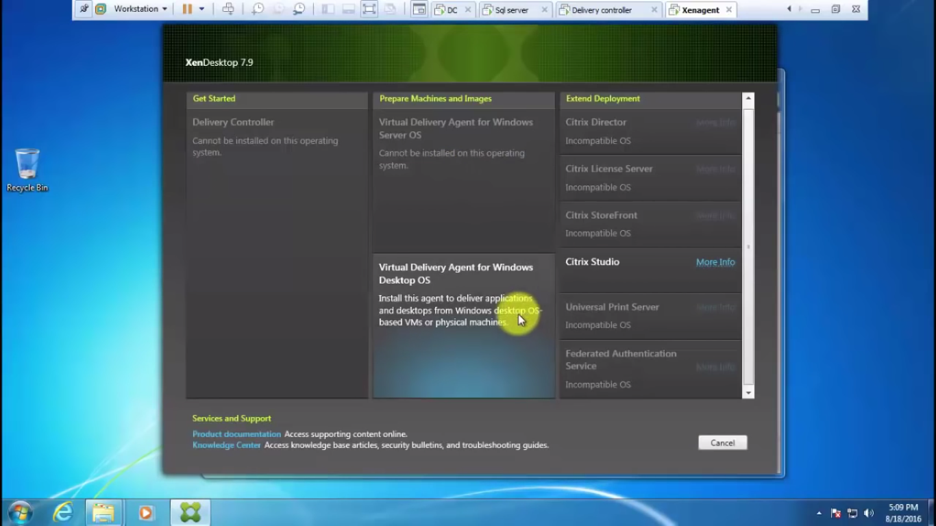
create master image and next
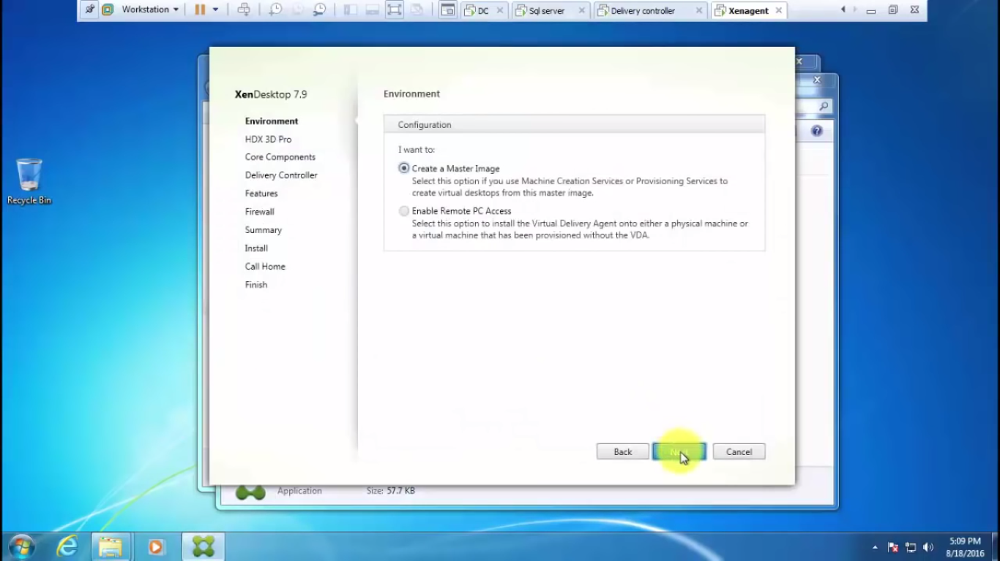

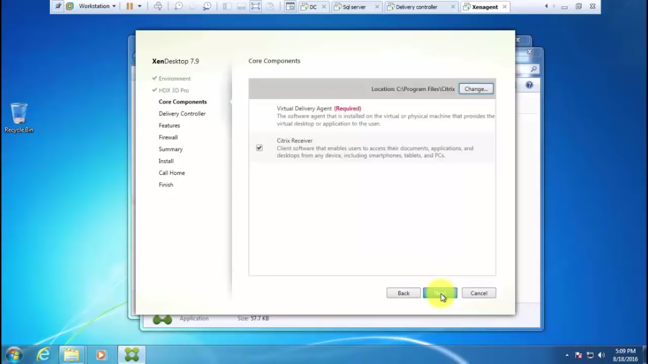

give the controller address as below fig

we can give:delivarycontroler.biz.local
click test connection
if green tick -----then add
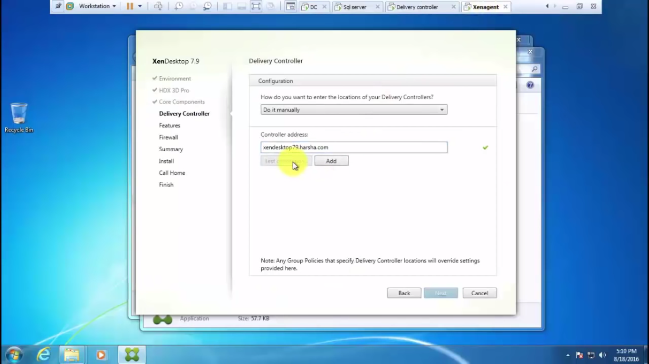

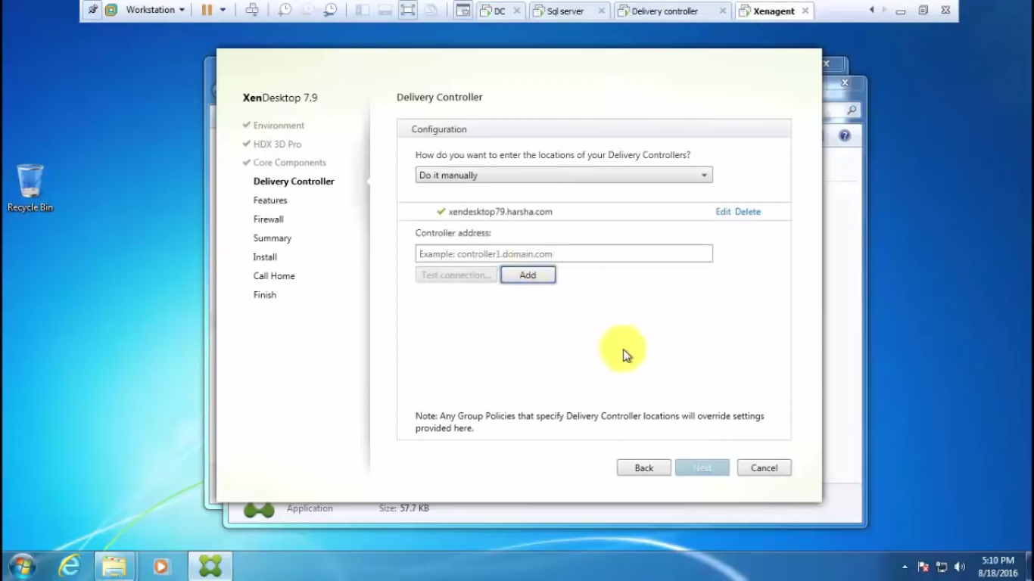
click next and install features
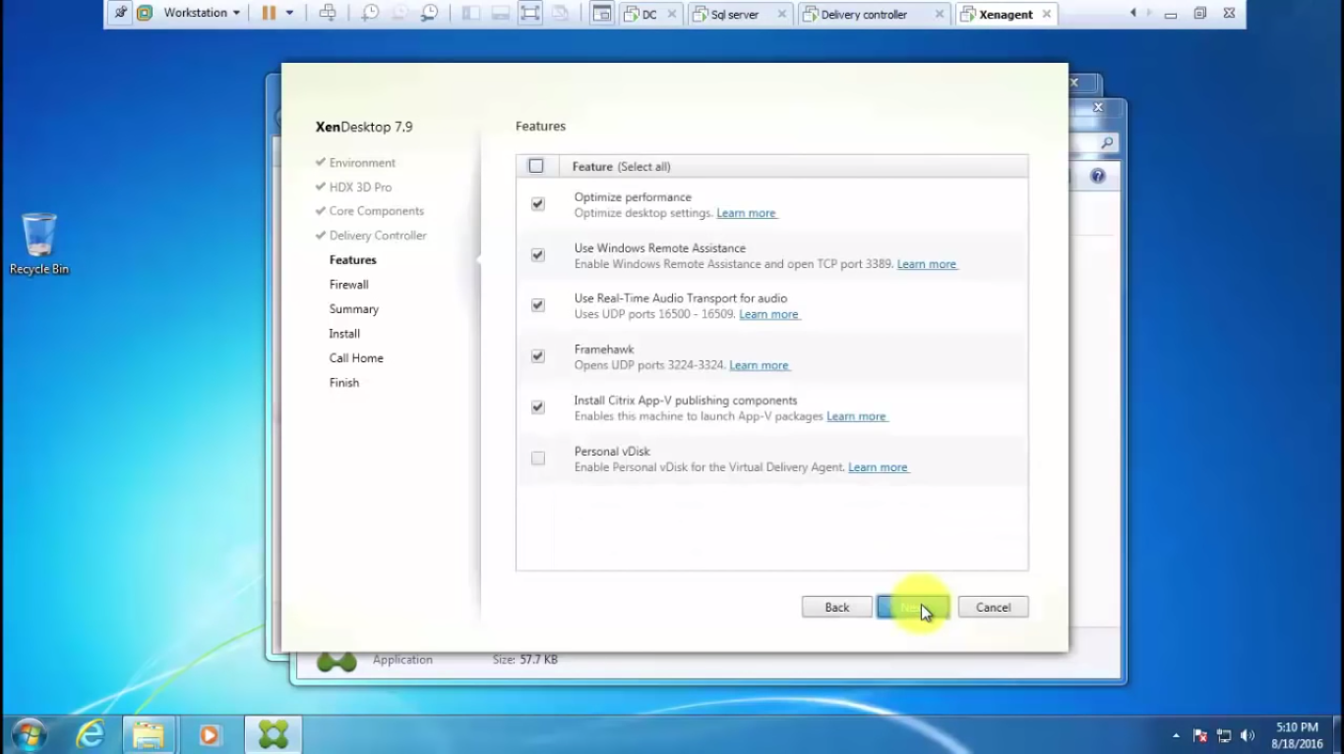

next
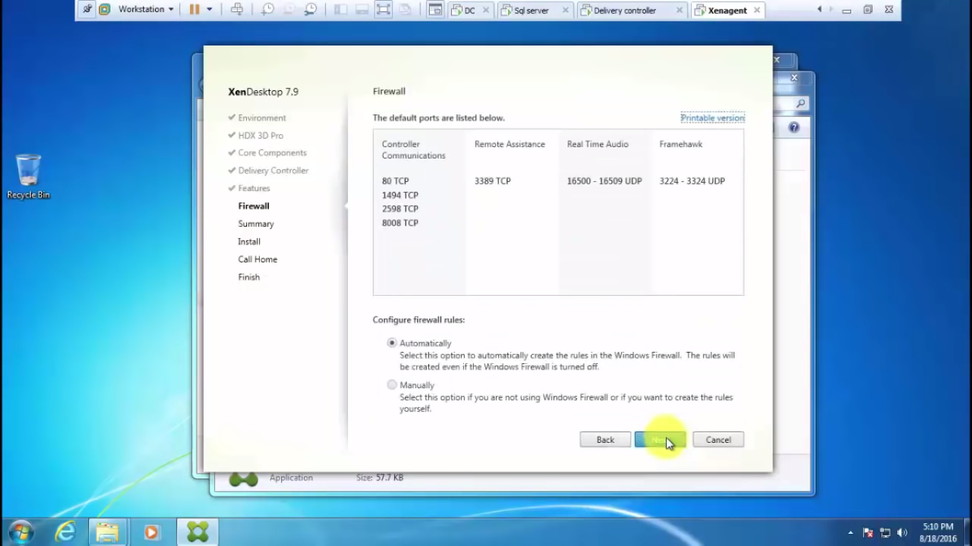
select automatic and click next

and install
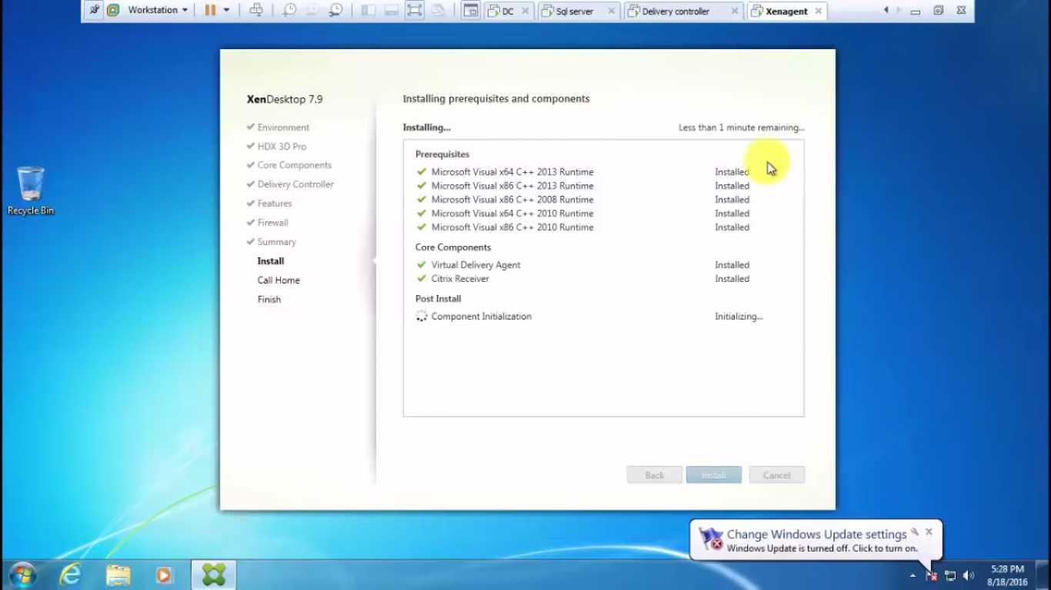

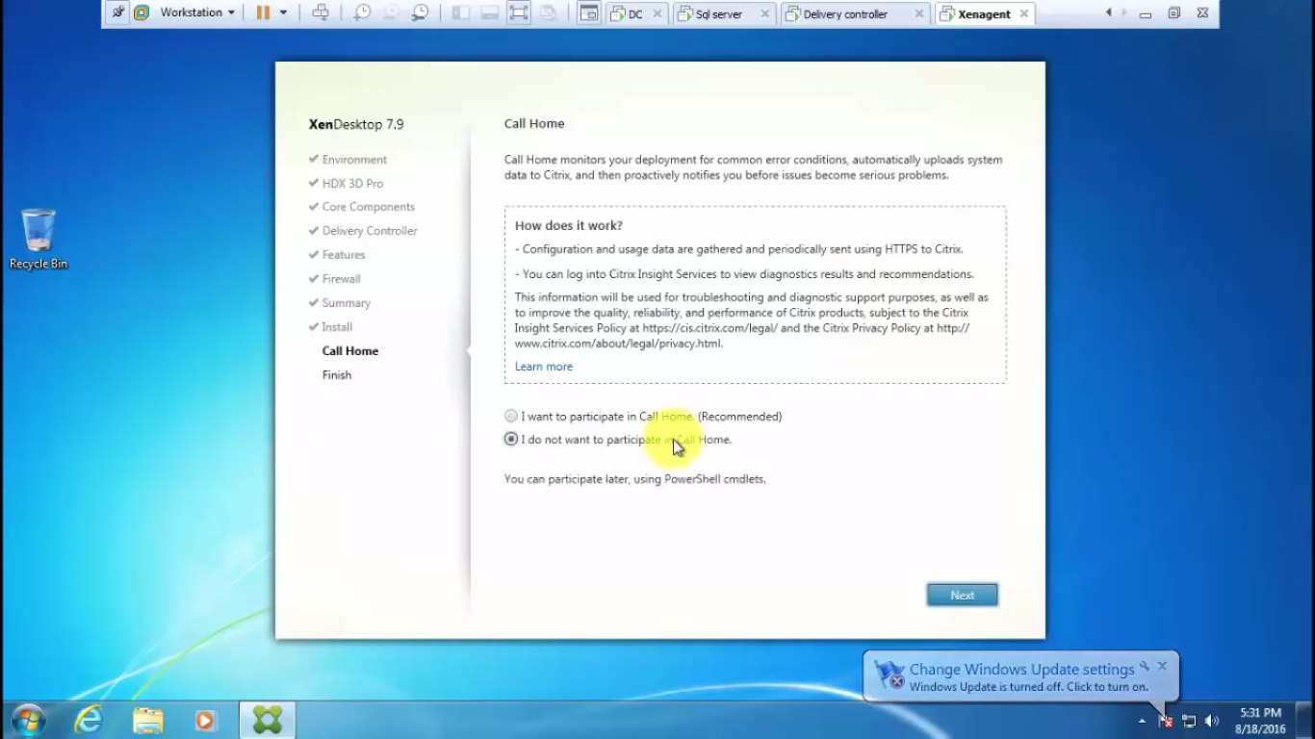
select i donot want participate home ...click finish

restart the system and login in to the system

then ------------------->logoff the deleveryagent system

system
3.deliverycontroller

in citrix studio create machine catalogs

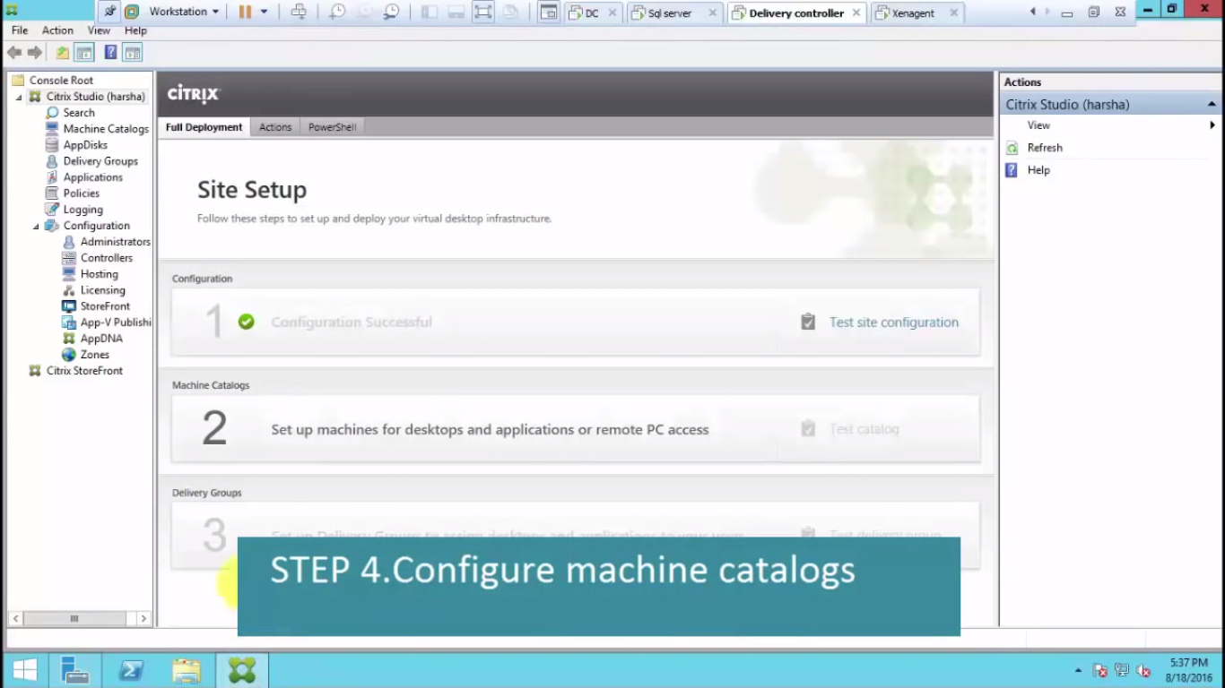

click on the machine catalog and next
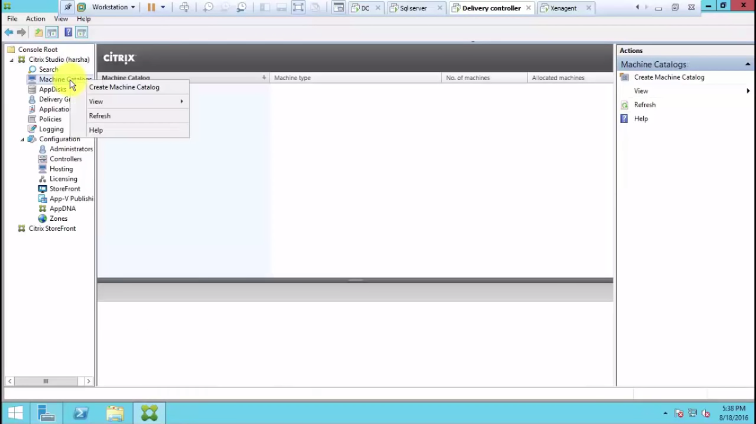

note click on the desktop os

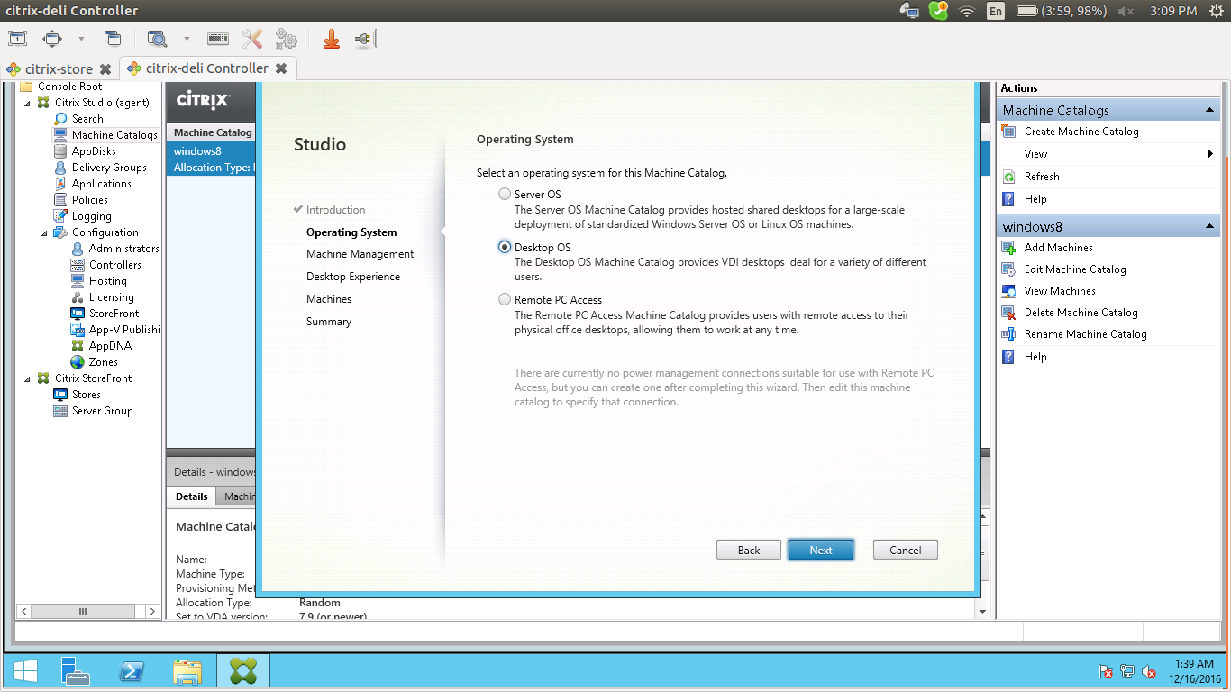

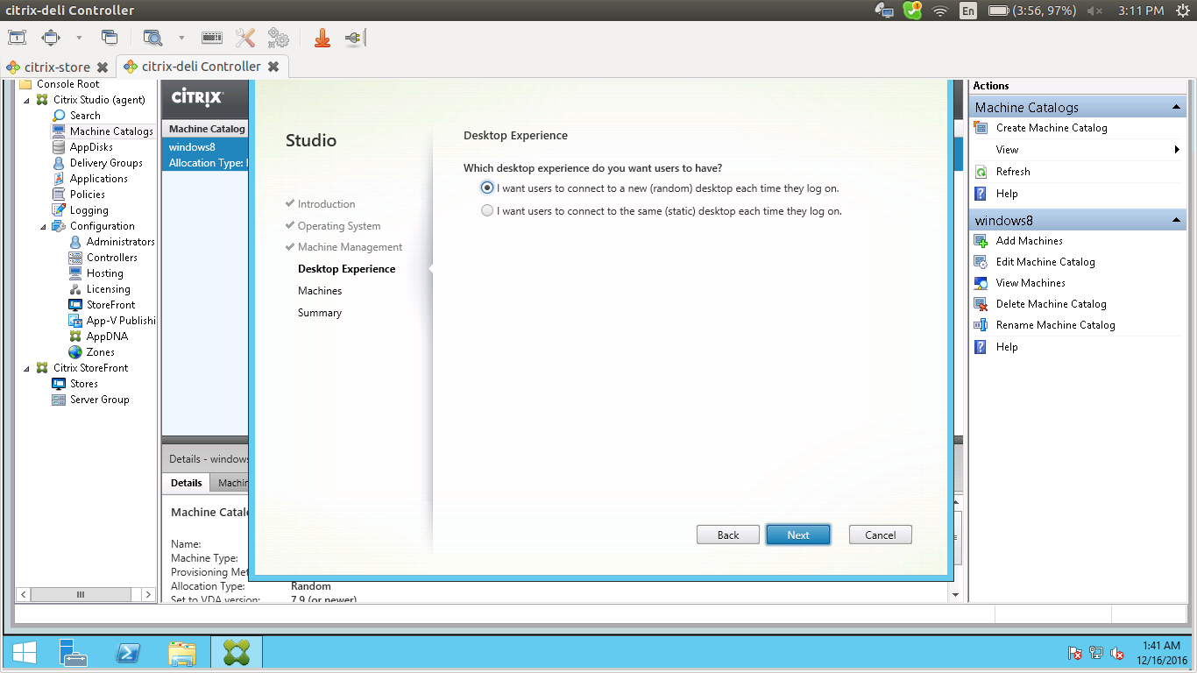
select the checked option random
click next
click add computers
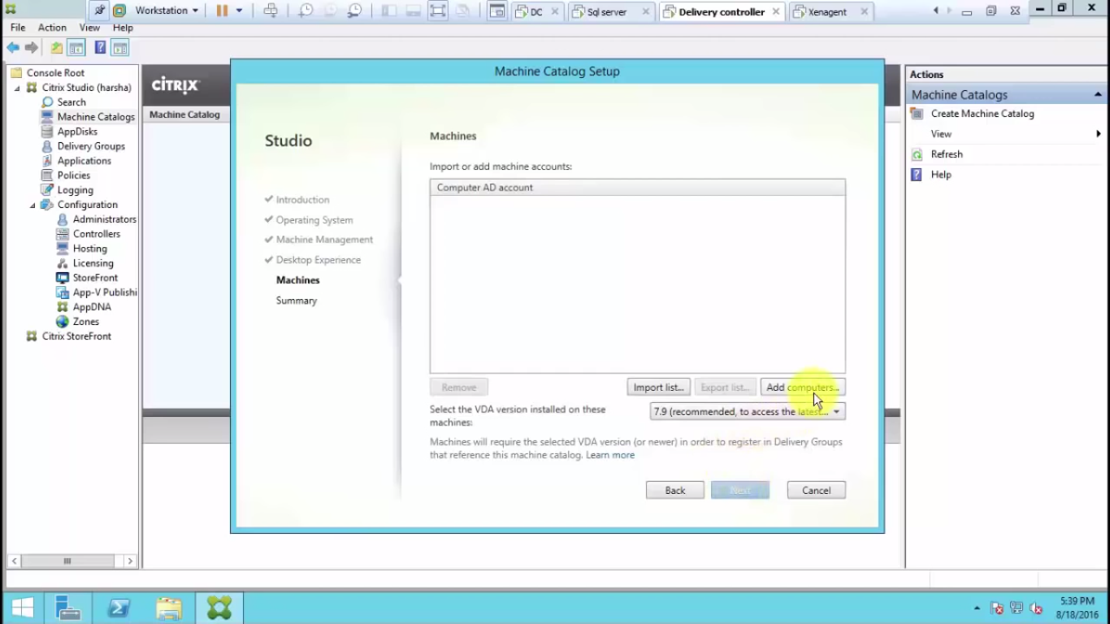

the add our delevary agent desktop name here

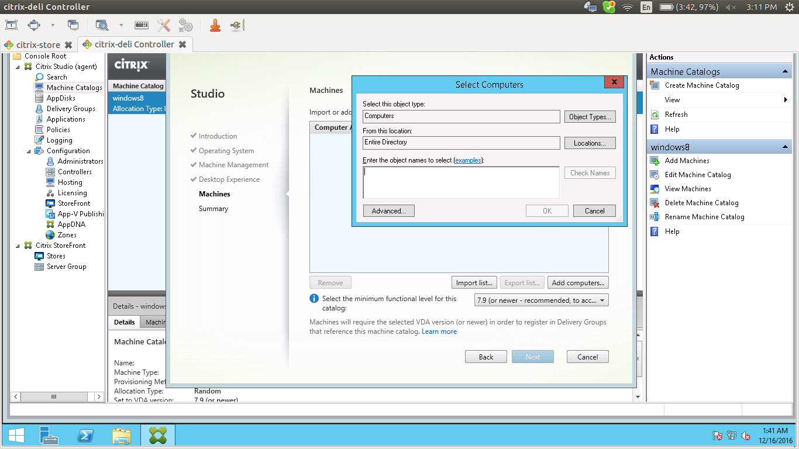
check whether it is our delivery agent name

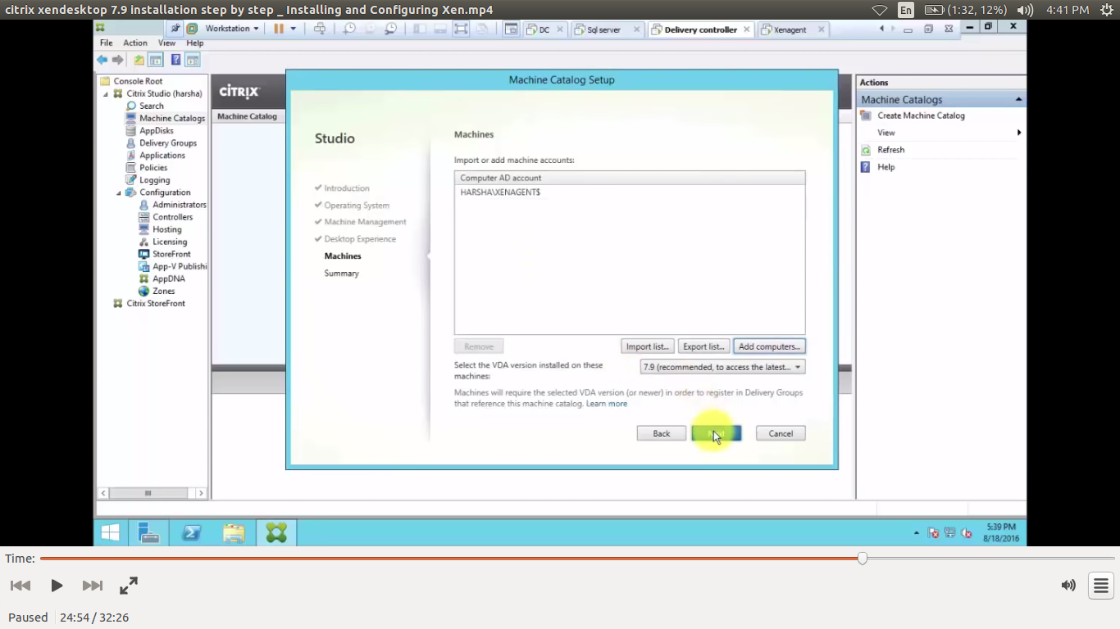

give the name and finish

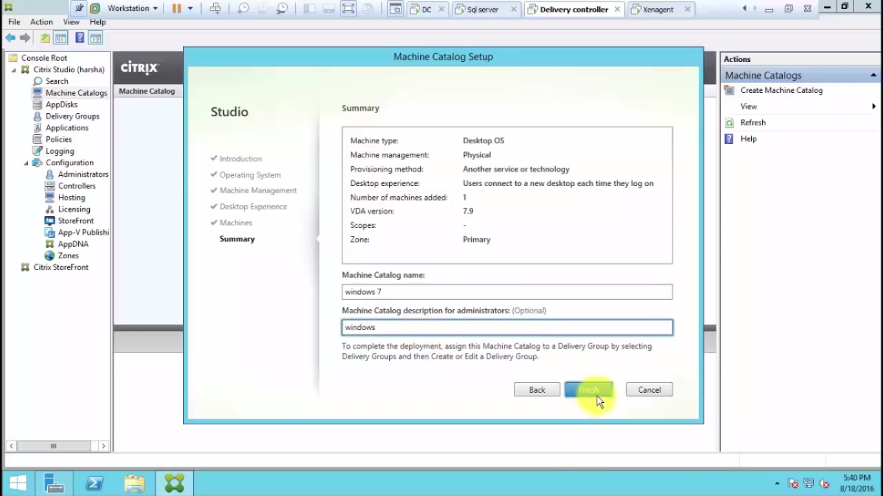

then we will see that the machine catalog is registerd
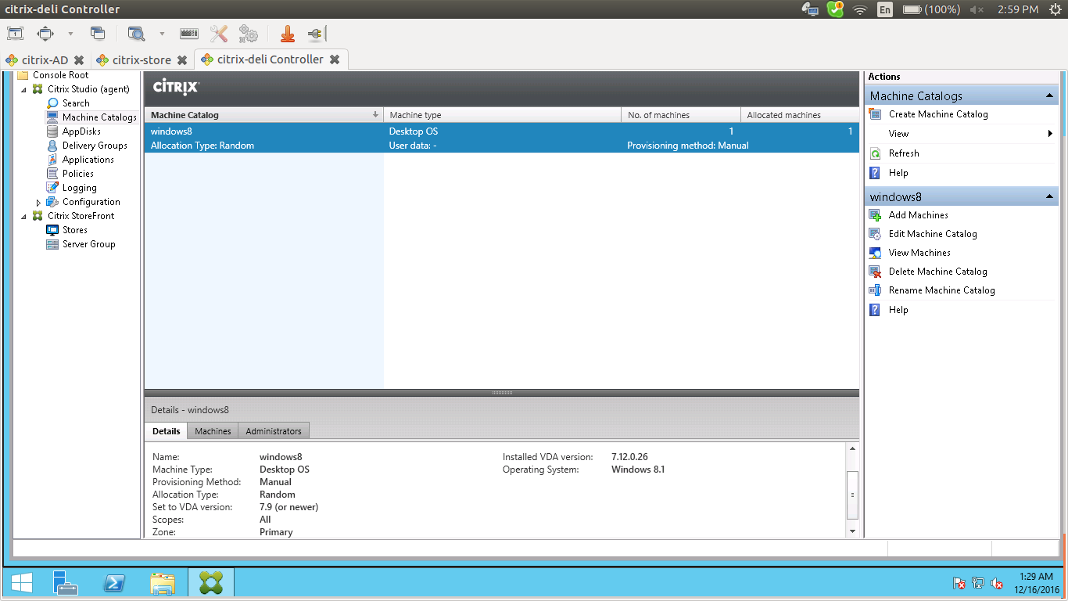

just click on the blue line for get more details.

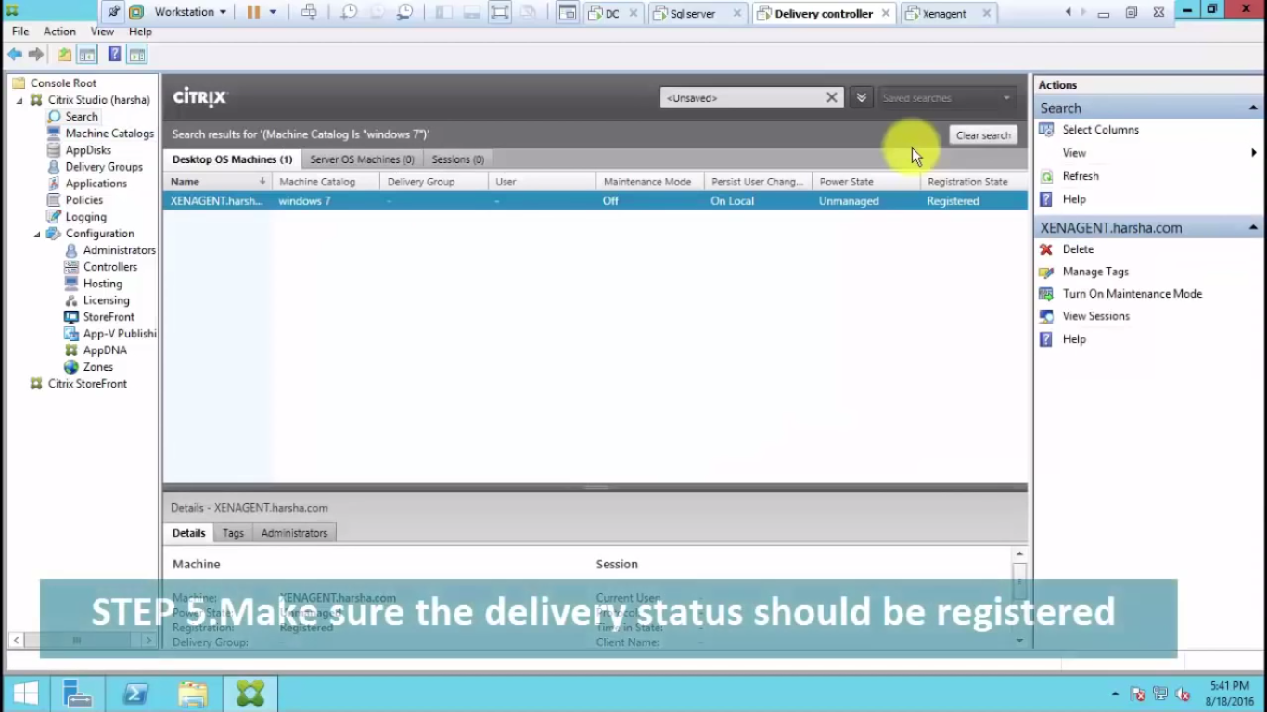

DELIVERY GROUP CREATION

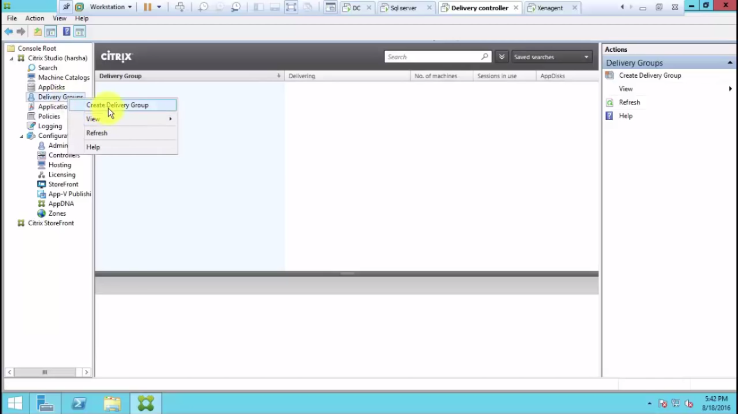

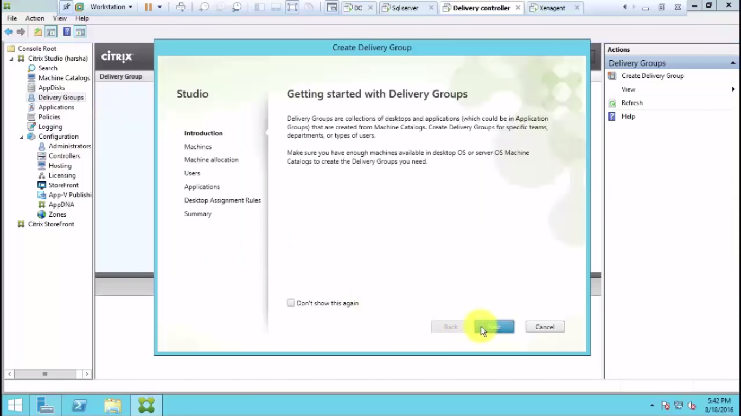

click next
selct the machine

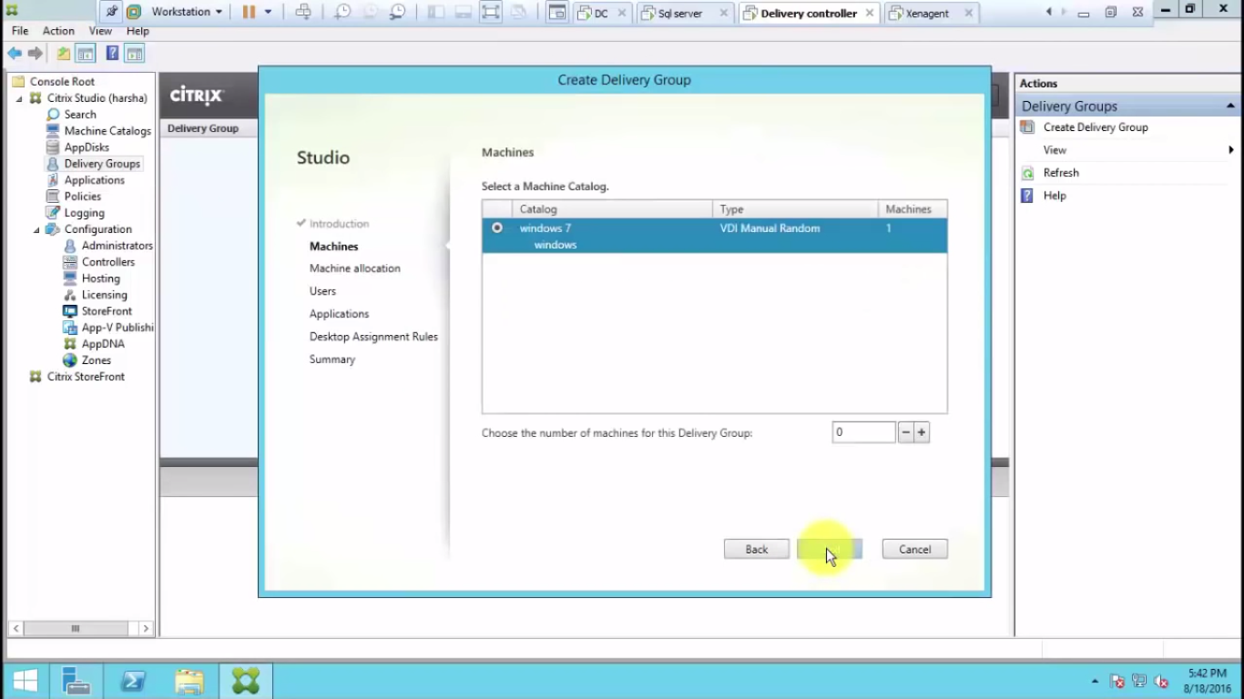

select the number of system we want depending on hardware cpu ram

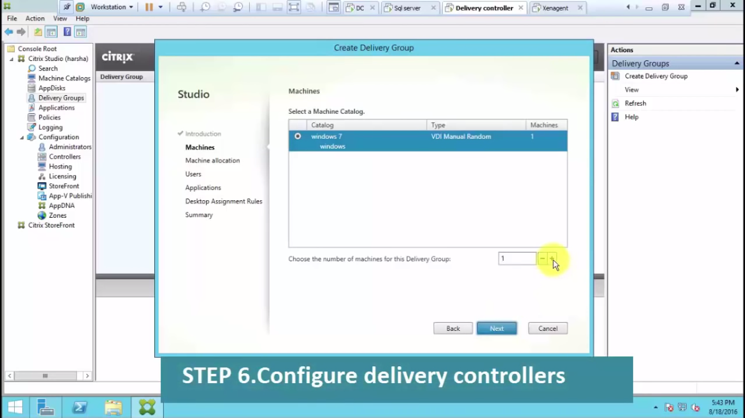
click next

next we can add applications here

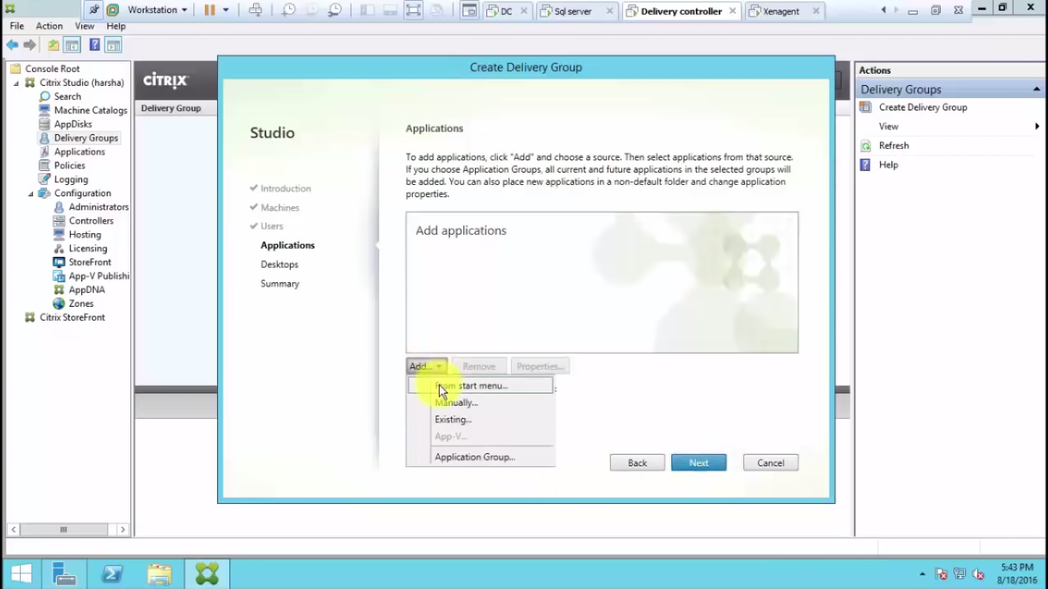

select the application that we want to deliver
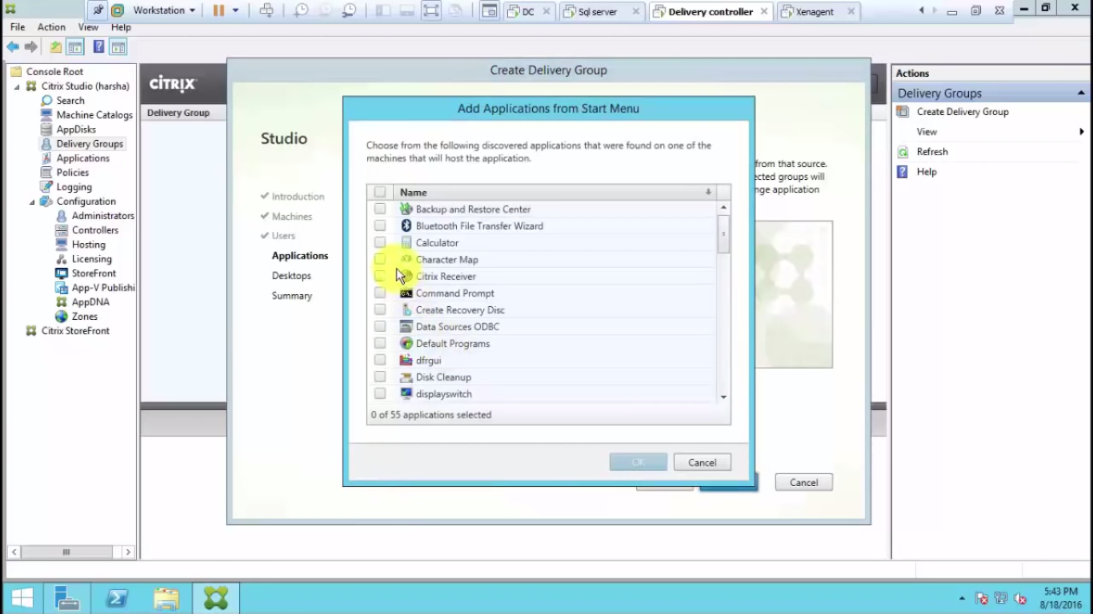
click next we can add users domain users here

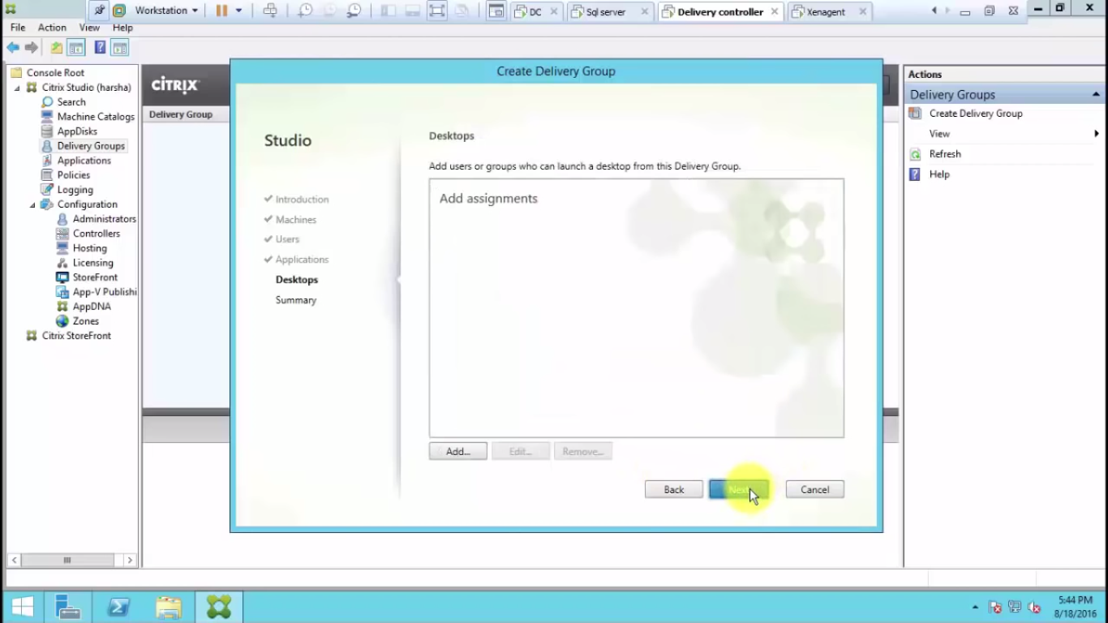
click on add and confie
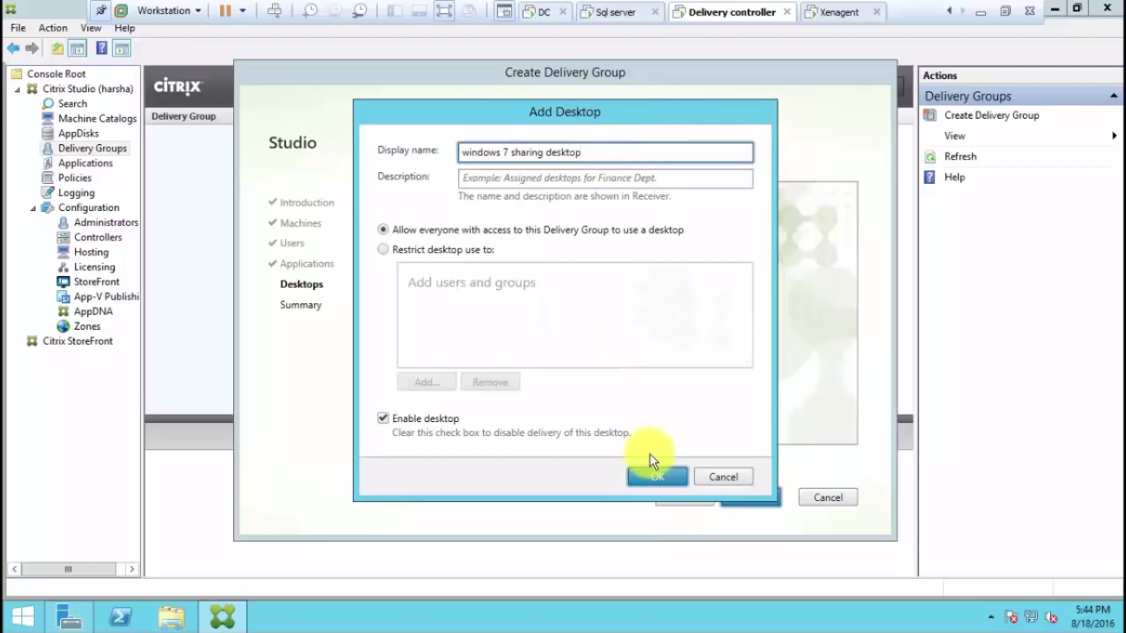
tick enable desktop

give the displayname and description click ok and click next
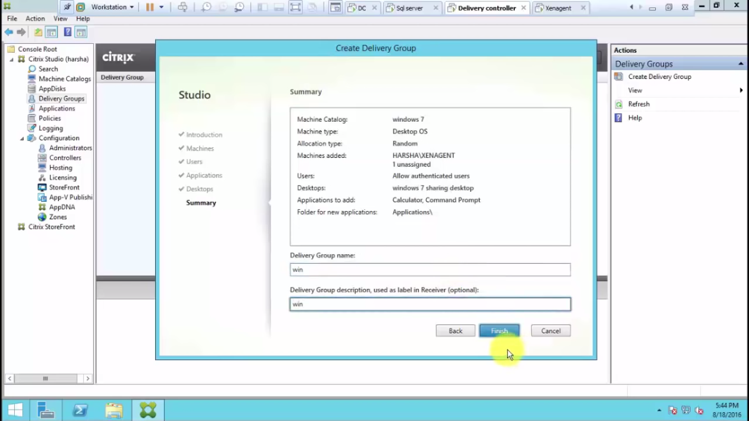
give the delivry group name,finish

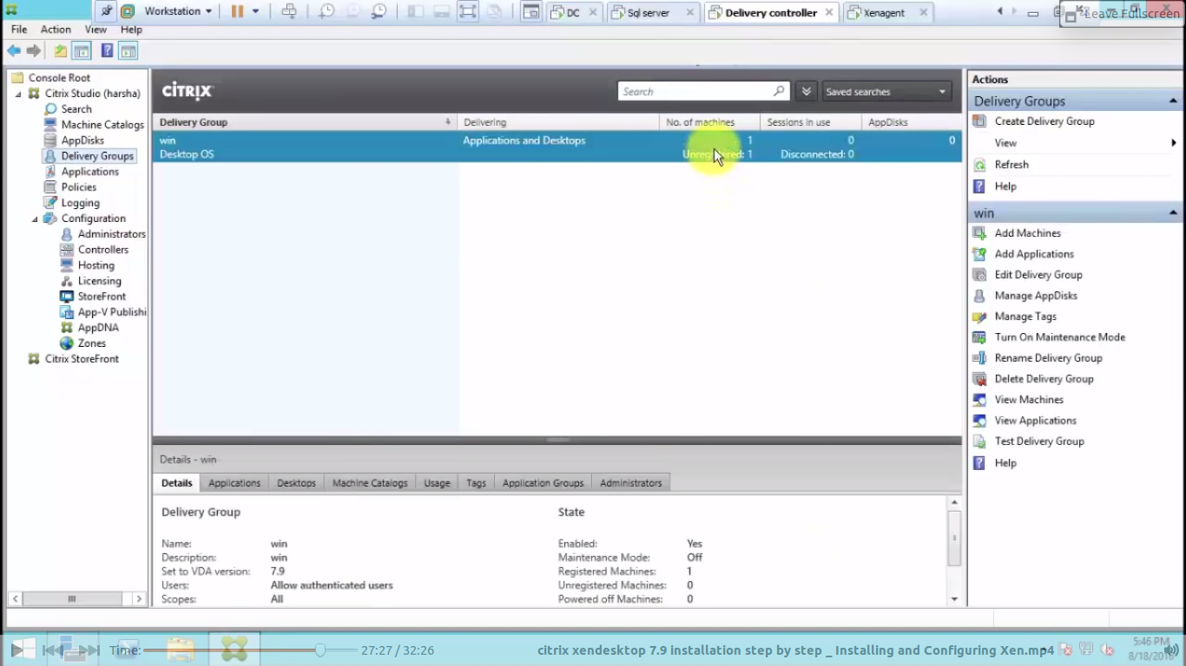

check the delivary grup registerd or not by click the blue line

system
4.storefront

install .net framework
install citrix store front from ctrix xendesktop and app software
take citrix store and create storefront

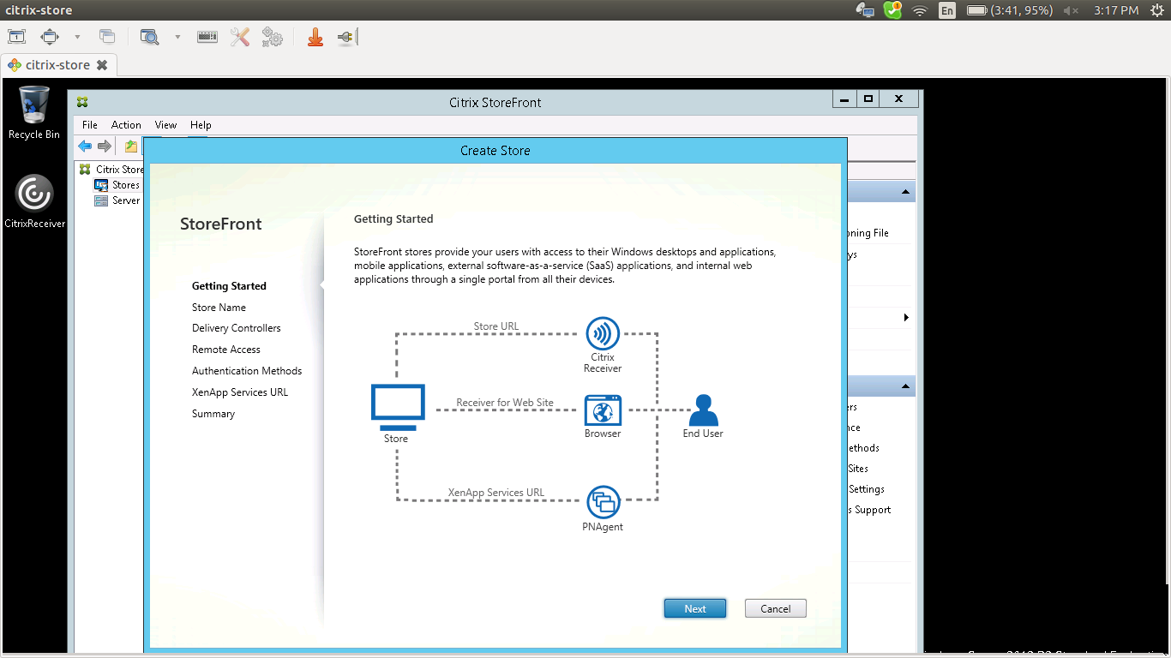
click next

give the storefront name

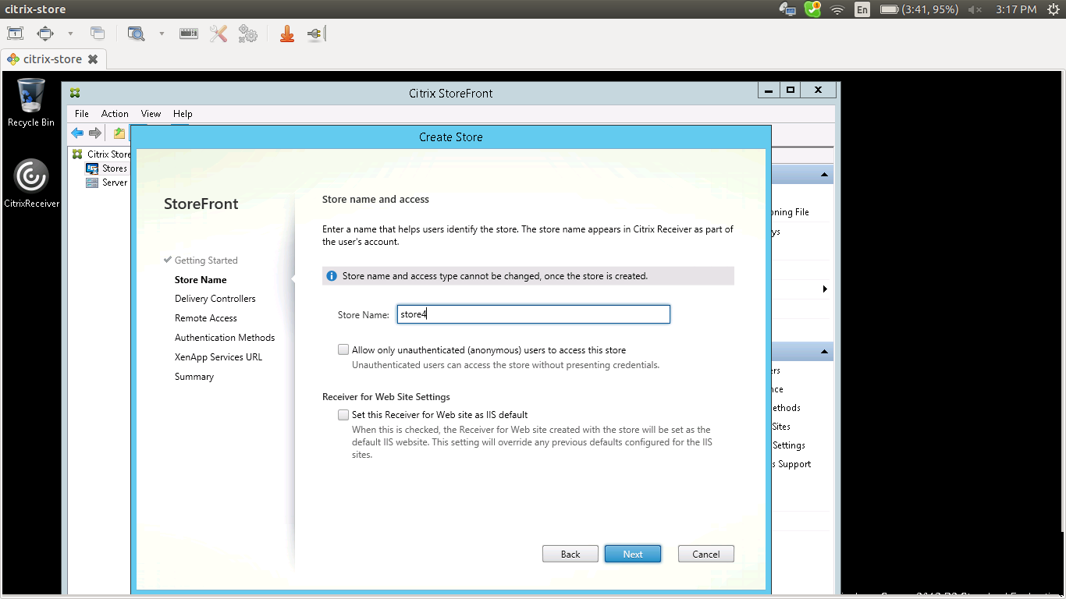
click next

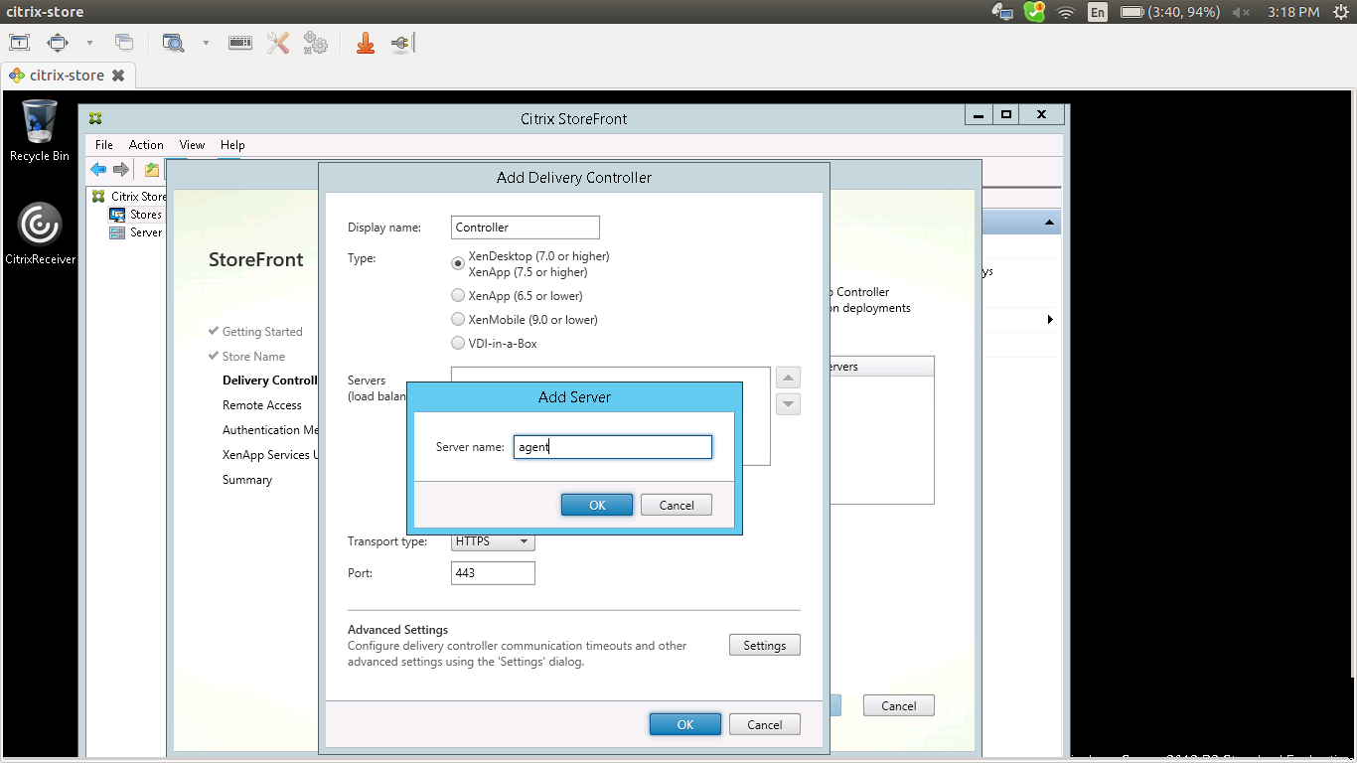
add the server name ie here :delivary controller server name

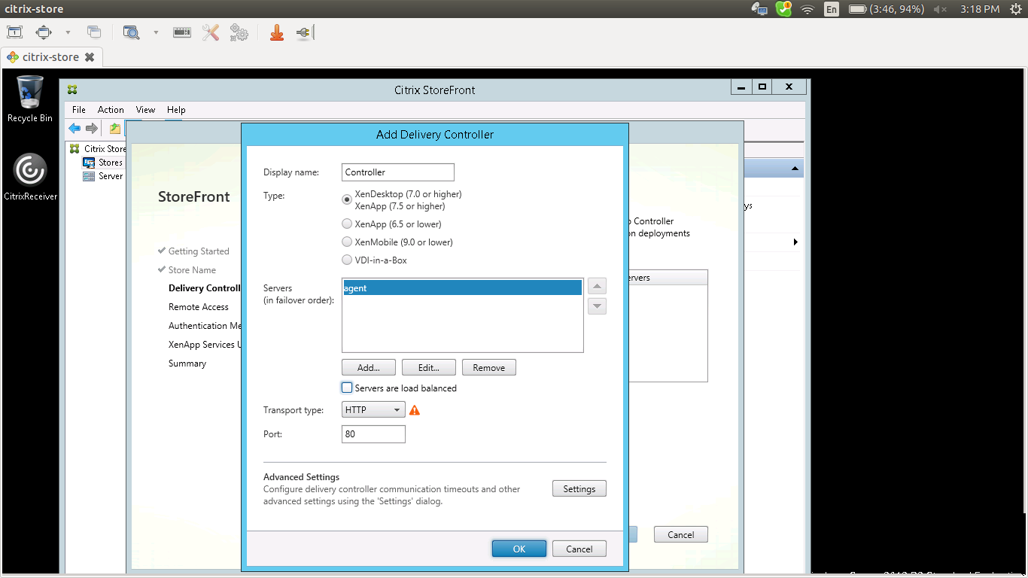
un tick server load balance
and give httpthen click ok

click next

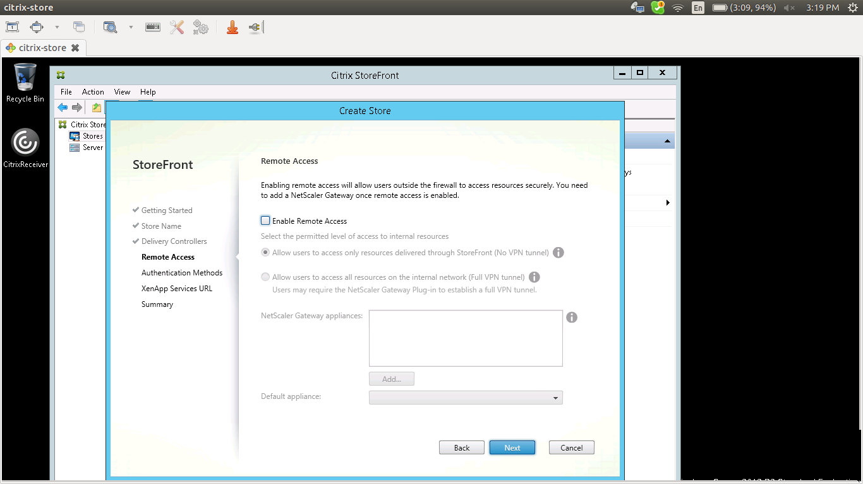
click next

authentication user name n password

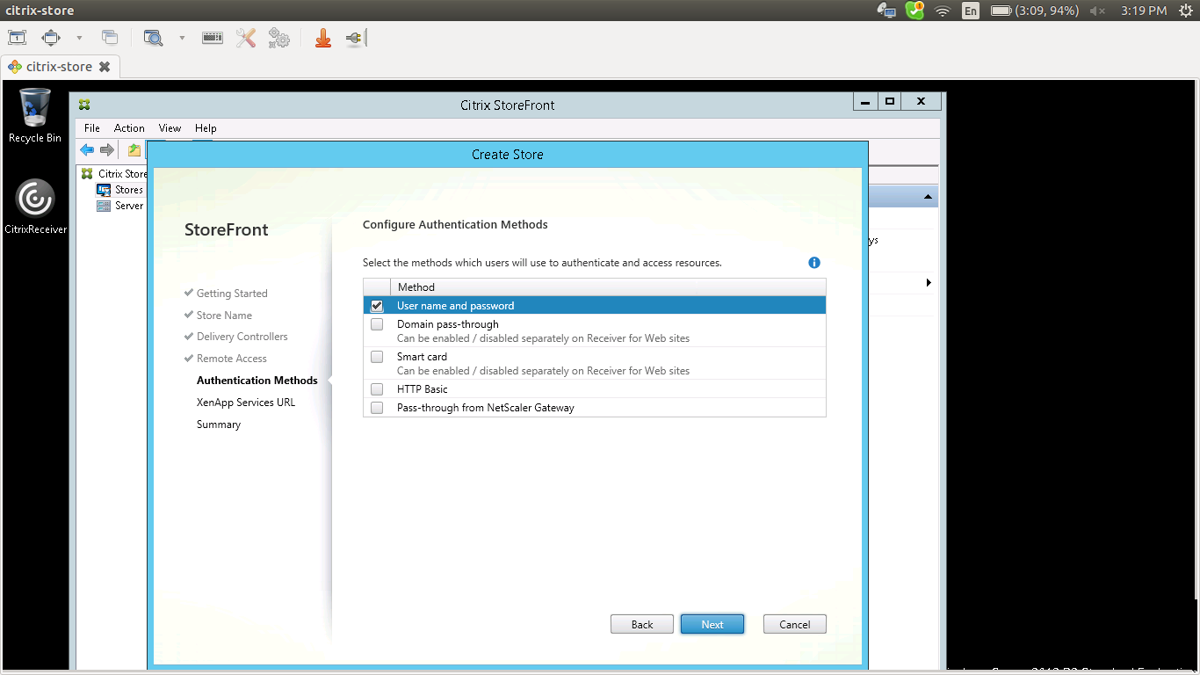
click next
click create
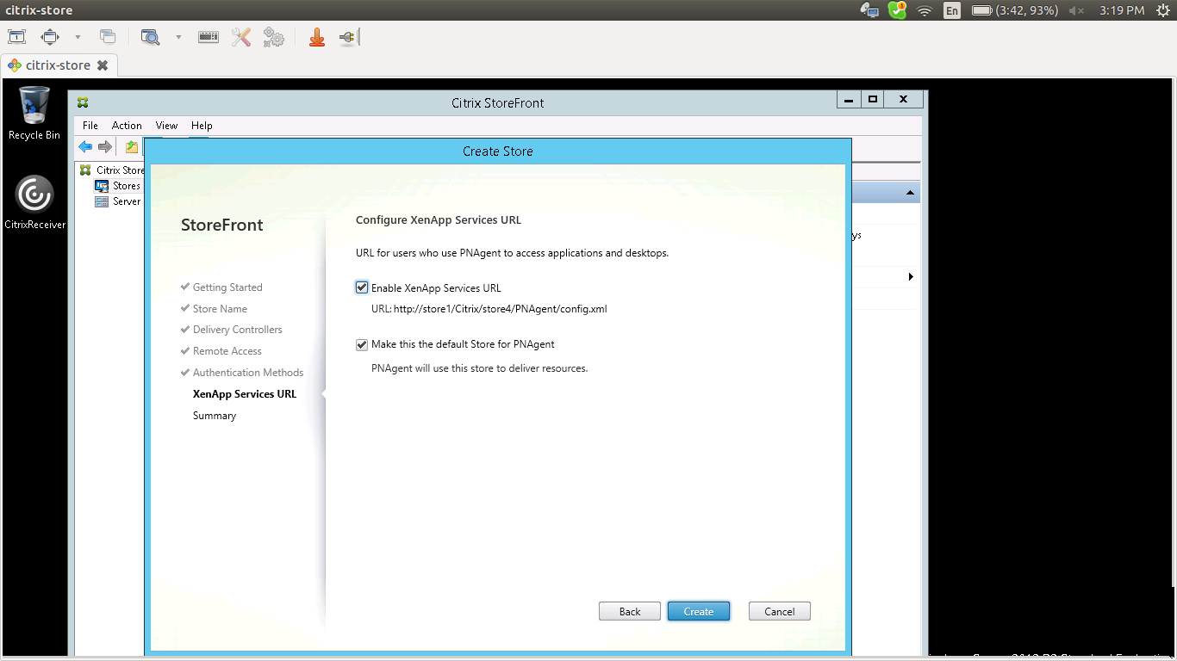

finish
then we will get the webstore url and full information of store front
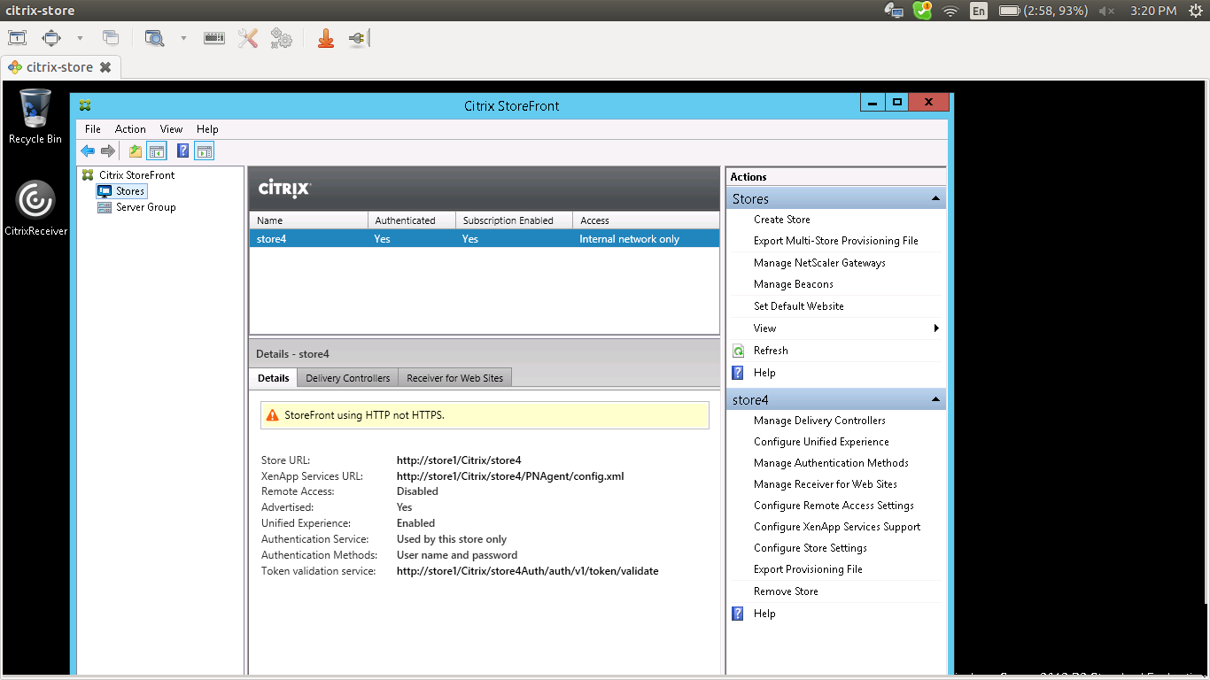
we can access the storefront by url here:http://store/Citrix/store4Web

SYSTEM
5.DELIVARYCONTROLLER

in the store front tab create store front
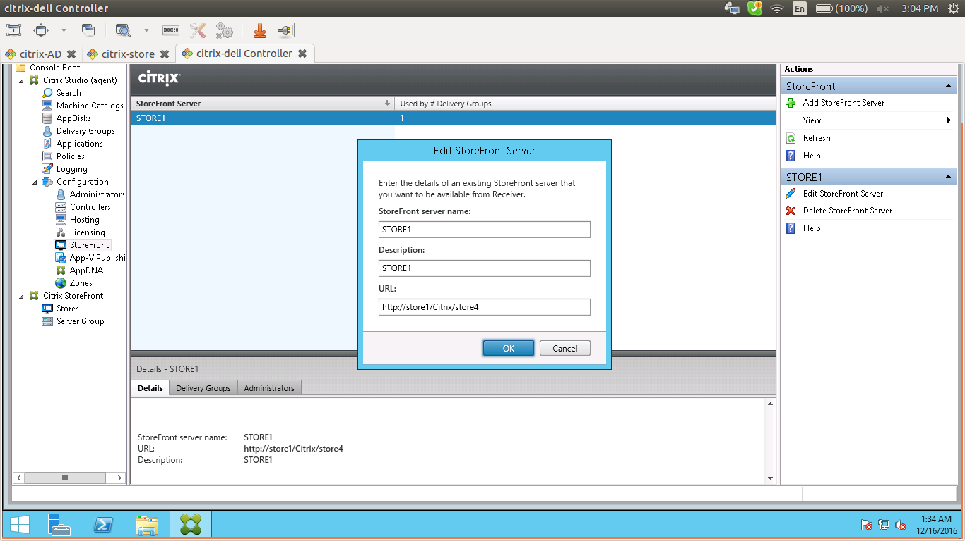
give the storefront server name and url

click ok finish

next is editing delivry group

and change the store front to

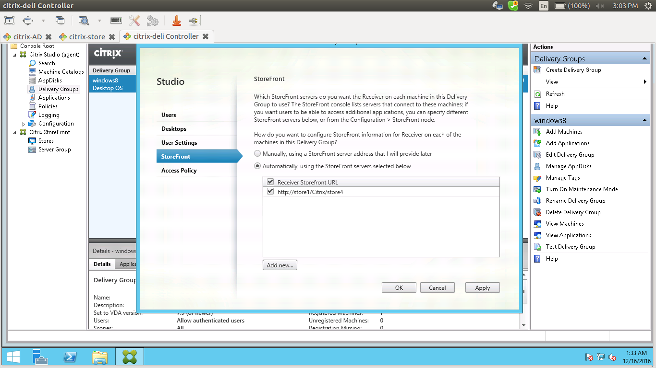
apply and ok

system
6.windos8

citrix reciever setting
install .net frame work
install citrix reciever
for installing citrix reciever that shows
launch this store front http://store/Citrix/store4Web
aive the domain username and password
launch the desktop.

