********************************************************************************

Install and Configure Ansible on Ubuntu 14.04
********************************************************************************

Configuration management systems are designed to make controlling large numbers of servers easy for administrators and operations teams. They allow you to control many different systems in an automated way from one central location.

While there are many popular configuration management systems available for Linux systems, such as Chef and Puppet, these are often more complex than many people want or need. Ansible is a great alternative to these options because it has a much smaller overhead to get started.

It communicates over normal SSH channels in order to retrieve information from remote machines, issue commands, and copy files. Because of this, an Ansible system does not require any additional software to be installed on the client computers.

Any computer that you can administer through SSH, you can also administer through Ansible.

Configuration files are mainly written in the YAML data serialization format due to its expressive nature and its similarity to popular markup languages. Ansible can interact with clients through either command line tools or through its configuration scripts called Playbooks.

********************************************************************************

Install Ansible
********************************************************************************

To do this effectively, we need to install the software-properties-common package, which will give us the ability to work with PPAs easily. (This package was called python-software-properties on older versions of Ubuntu.)

# sudo apt-get update

# sudo apt-get install software-properties-common

Once the package is installed, we can add the Ansible PPA by typing the following command:

# sudo apt-add-repository ppa:ansible/ansible

Press ENTER to accept the PPA addition.
Next, we need to refresh our system's package index so that it is aware of the packages available in the PPA. Afterwards, we can install the software:

# sudo apt-get update

# sudo apt-get install ansible

We now have all of the software required to administer our servers through Ansible.

Edit /etc/hosts

# nano /etc/hosts

172.17.0.2 ansible-master
172.17.0.3 ansible-agent1
172.17.0.4 ansible-agent2
172.17.0.5 ansible-agent3

add the all clients-hostname in here with ip

also add ansible-master hostname and ip in each client's /etc/hosts

# nano /etc/hosts

172.17.0.2 ansible-master

********************************************************************************

Set Up SSH Keys
********************************************************************************

As we mentioned above, Ansible primarily communicates with client computers through SSH. While it certainly has the ability to handle password-based SSH authentication, SSH keys help keep things simple.
Create a user (create the same user for all machines so that make work more easy)

# adduser ansible

# usermod -aG sudo ansible

# visudo

ansible ALL=(ALL) NOPASSWD: ALL

# sudo su ansible

# cd /home/ansible/

# ssh-keygen

# ssh-copy-id client-hostname

# ssh ansible@ansible-master # it will not ask password

same steps done in master for other client-hosts and also in each client-hosts for communicating client to master.

Install ssh on clients and starts all services

********************************************************************************

Configuring Ansible Hosts
********************************************************************************

Ansible keeps track of all of the servers that it knows about through a "hosts" file. We need to set up this file first before we can begin to communicate with our other computers.

# sudo nano /etc/ansible/hosts

The hosts file is fairly flexible and can be configured in a few different ways. The syntax we are going to use though looks something like this:

[group_name]
hostname or ip
eg:

[mygroup-1] # group
ansible-agent1
ansible-agent2

[mygroup-2] # group
ansible-agent3

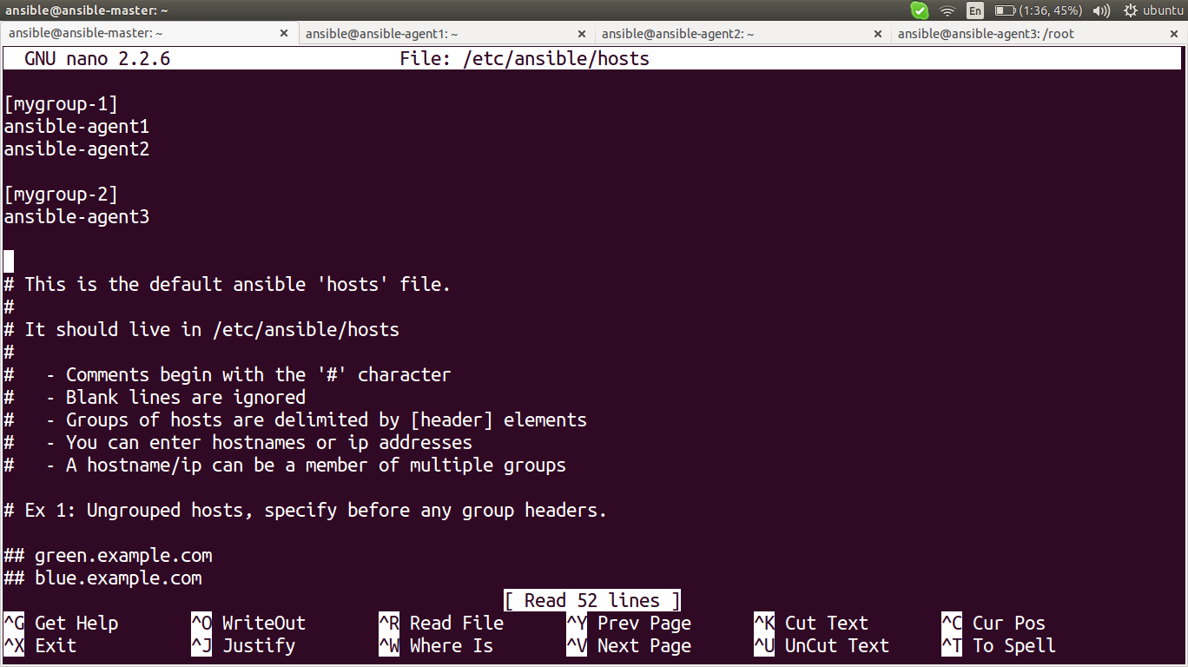

We can create a file that tells all of the servers in the particular group to connect using the particular user.
To do this, we will create a directory in the Ansible configuration structure called group_vars. Within this folder, we can create YAML-formatted files for each group we want to configure:

# sudo mkdir /etc/ansible/group_vars

# sudo nano /etc/ansible/group_vars/mygroup-1

---
ansible_ssh_user: ansible

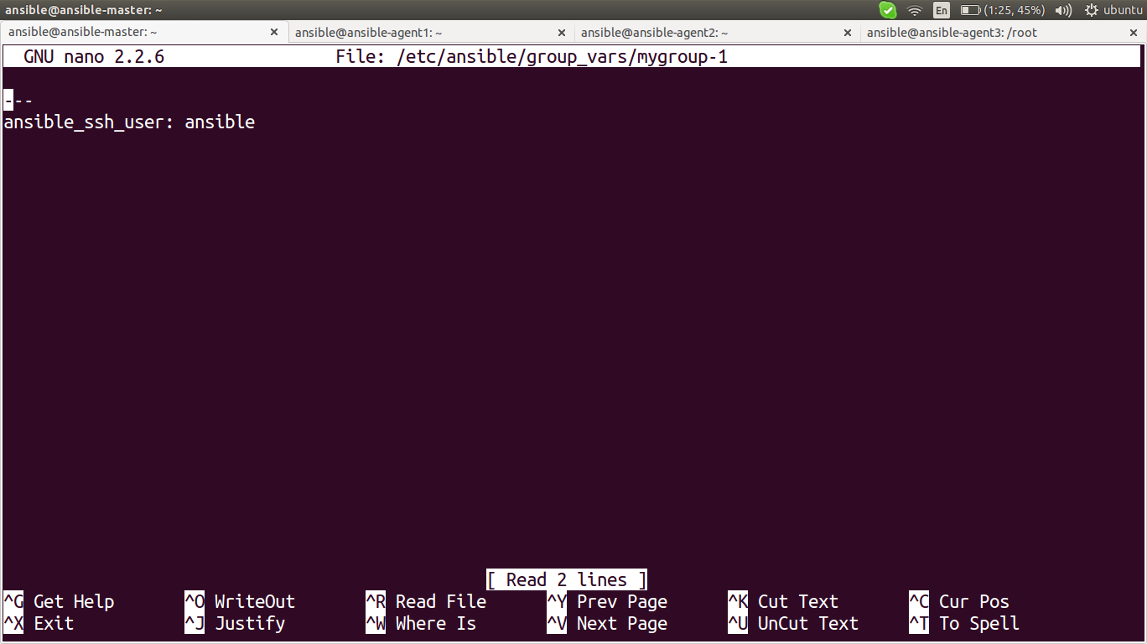

We can put our configuration in here. YAML files start with "---", so make sure you don't forget that part.

If you want to specify configuration details for every server, regardless of group association, you can put those details in a file at /etc/ansible/group_vars/all. Individual hosts can be configured by creating files under a directory at /etc/ansible/host_vars.

For different user in hosts

sudo nano /etc/ansible/hosts

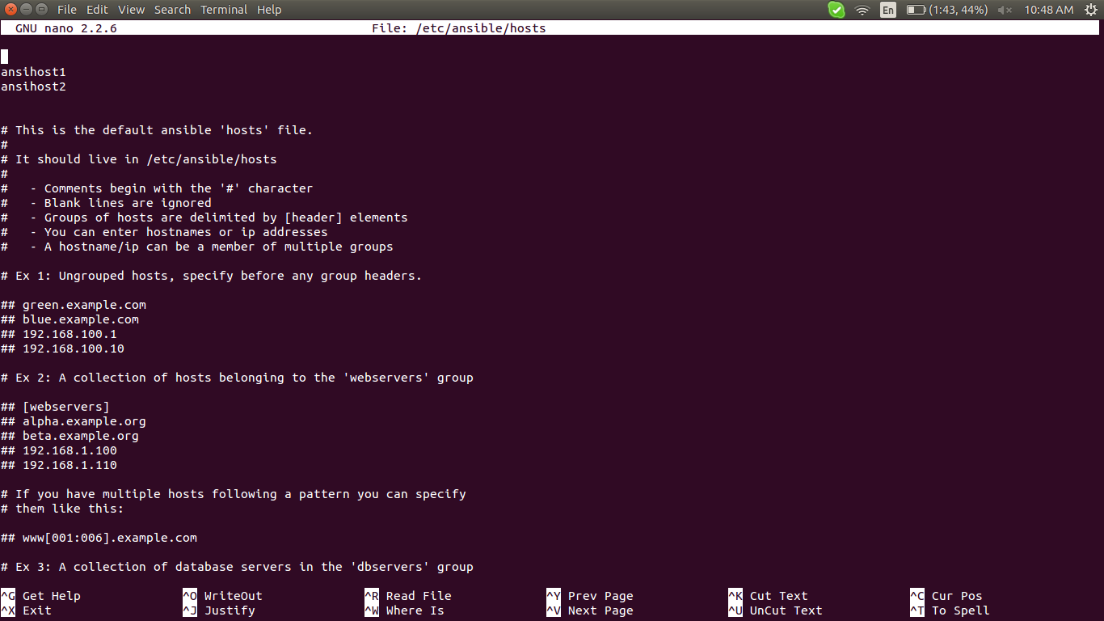

make the directory host_vars
sudo nano /etc/ansible/host_vars/ansihost2

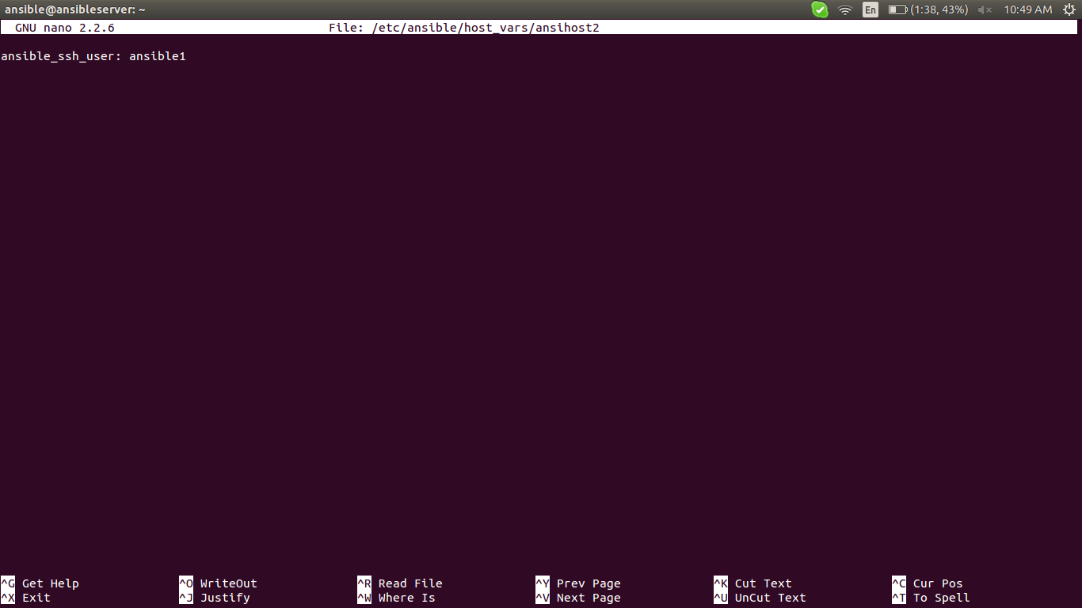
create each differents users in diffrent hosts folder and file as above

********************************************************************************

Using Simple Ansible Commands
********************************************************************************

Now that we have our hosts set up and enough configuration details to allow us to successfully connect to our hosts, we can try out our very first command.
Ping all of the servers you configured by typing:
# ansible -m ping all
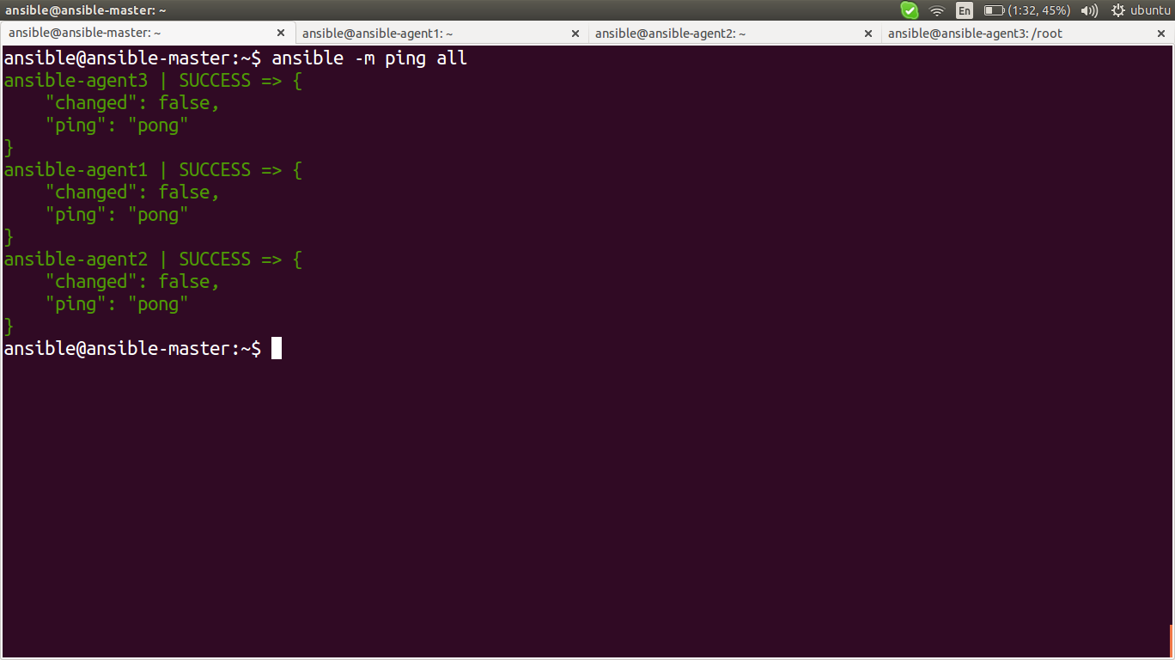
to ping to particular group

# ansible -m ping mygroup-1

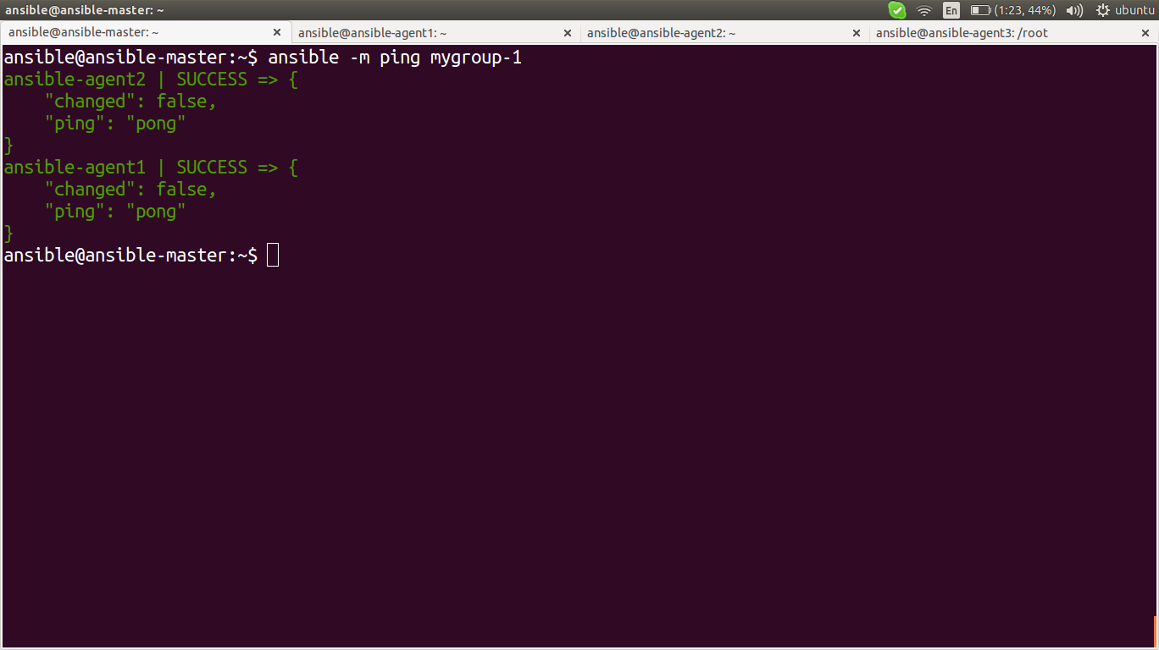

The "shell" module lets us send a terminal command to the remote host and retrieve the results. For instance, to find out the memory usage on our host1 machine, we could use:

# ansible -m shell -a 'free -m' mygroup-1

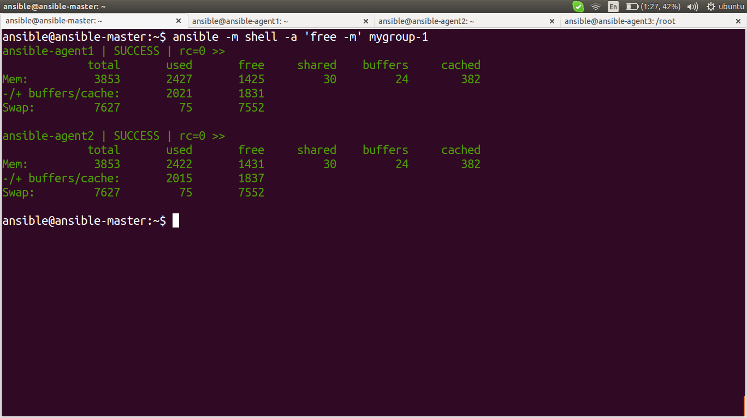

disk usage remotely
ansible -m command -a "df -h" group1
uptime
ansible -m command -a "uptime" group1
Hostname of both nodes:
ansible -m command -a "hostname" group1
installing some software directly by command
ansible -m command -a "sudo apt-get install nginx" group1

links::

installation and configuration>>
https://www.digitalocean.com/community/tutorials/how-to-install-and-configure-ansible-on-ubuntu-14-04

