HA Proxy

install process front end

Instructions for latest release
You need to enable a dedicated PPA with the following command:
# apt-get install software-properties-common
# add-apt-repository ppa:vbernat/haproxy-1.6
Then, use the following commands:
# apt-get update
# apt-get install haproxy
You will get the latest release of HAProxy 1.6.

install link .....>>>> https://haproxy.debian.net/#?distribution=Ubuntu&release=trusty&version=1.6

just check the ha proxy service status

#service haproxy status

if shows #ha proxy is not running

then its ok.....or no show anything after running that status command

then edit
#nano /etc/default/haproxy

set
enable =1

install process back end

for testing purpose create 2 webservers named webserver1 and webserver2
install apache2 and create a site for checking
check with other pcs the site is available or not

###############################################################################

configuration in ha proxy

#nano /etc/haproxy/haproxy.cfg

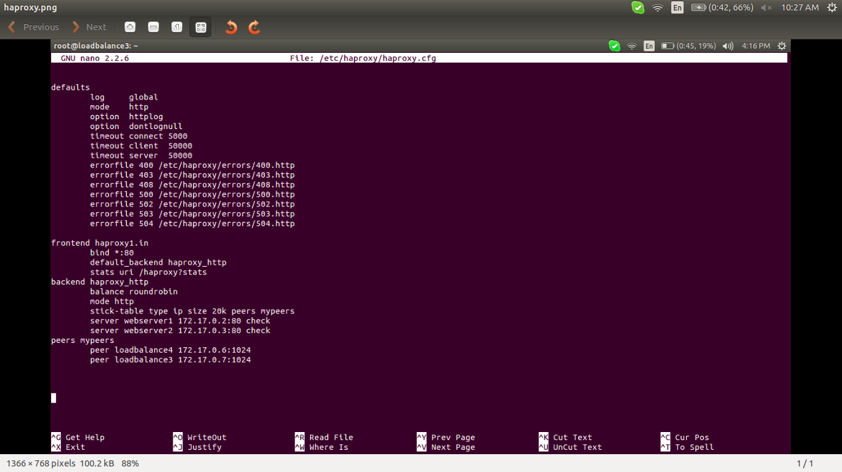

here loadbalancer 4 and load balancer 3 are the haproxy
we can give stats password in the front end for graphical access
stats enable
stats auth admin:admin

there is also peer connections describing ..ie two load balancer front end i configure here
is for backup of 1 load balacer when one faild

after this configuration reload the hroxy

#/etc/init.d/haproxy reload

#######################################################################
check this configuration with other host

in the web browser

http://haproxy ip or dn
or curl it
by giving stats uri in haproxy.cfg then it will got a grafical site

http://haproxy ip/haproxy/?stats

ceck if the sites both webserver1 and 2 sites are available with a cpu time
round robin
########################################################################

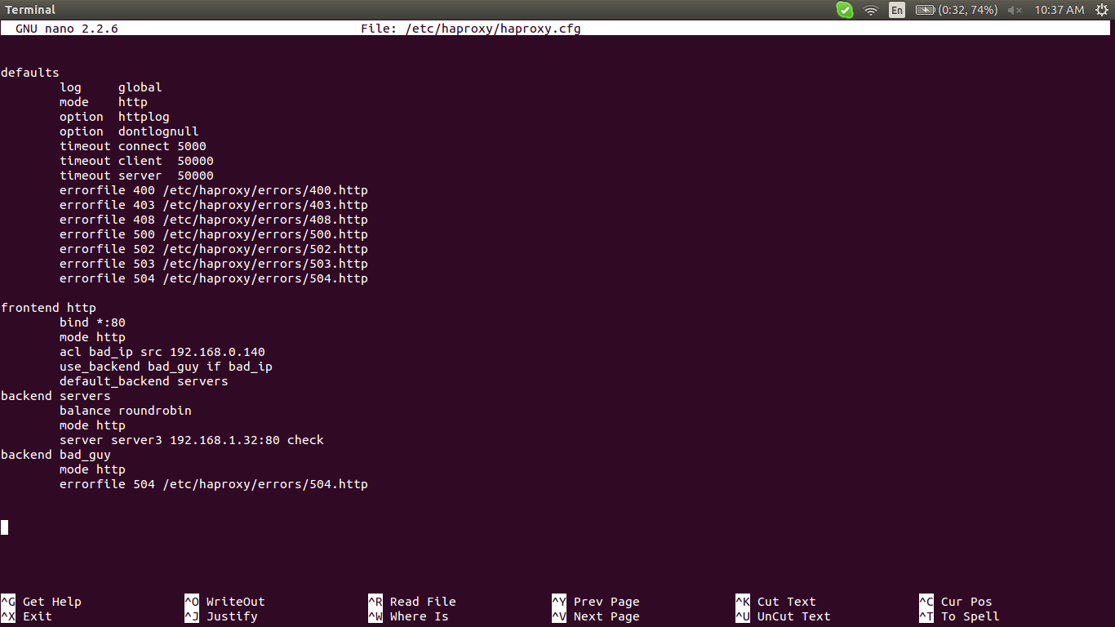

restricting an ip with with acl
when 192.168.0.140 ip access the haproxy that got the 504 error

check https://www.digitalocean.com/community/tutorials/an-introduction-to-haproxy-and-load-balancing-concepts

