Upgrading your kayako (HelpDesk)

Links:
https://kayako.atlassian.net/wiki/display/DOCS/Upgrading+your+helpdesk

1 . Backups

* create database backup
link: http://blog.winhost.com/using-mysqldump-to-backup-and-restore-your-mysql-databasetables/
in windows
# D:\
# cd Program Files\MySQL\MySQL Server 5.6\bin
# mysqldump –all-databases -uuser -ppaswword > dump.sql

* kayako folder helpdesk backup
backup from document root ..
D:\Inetpub\wwwroot\pub (helpdesk folder) >>>>>>>>> copy to destination folder for security

2. Download and extract the latest release product archive
Direct your browser towards my.kayako.com, obtain the latest Kayako 4 release and download it to your server. Extract the compressed tar file which have a ".tar.gz" extension, as described here.
Once the archive is extracted, you will get a directory which has the following directory:
upload | Contains the product files

Upload the product files(all files in the upload folder) to document root D:\Inetpub\wwwroot\pub\HelpDesk
The procedure to upload product files using an FTP client is as explained here.
Upgrading to 4.50 or later?
You are advised to upload a fresh copy of the helpdesk files, or in other words, remove the old files and after the upgrade copy back old ones as necessary, such as __swift/files/, __swift/geoip.
Add old backuped key.php to document root D:\Inetpub\wwwroot\pub\HelpDesk
4. Setting file permissions __swift,_app

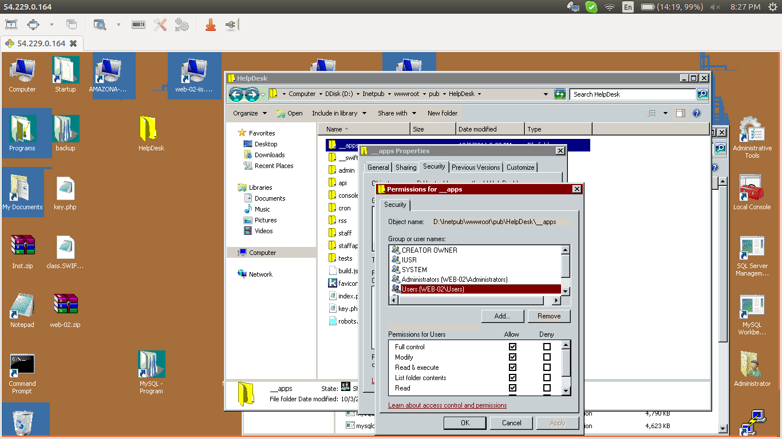

5. Go to https://helpdesk.weh.com/setup/

check link :
https://kayako.atlassian.net/wiki/display/DOCS/Upgrading+your+helpdesk

there will instructions for upgrading as pics

6.
once it done delete setup folder from documentroot helpdesk

7.
Now copy/move the following backed up directories/files to the document root, replacing them with the existing directories/files:
- __swift/files
- __swift/geoip
8. restore templates and langauges in gui

check link : https://kayako.atlassian.net/wiki/display/DOCS/Upgrading+your+helpdesk

for template install 3 things
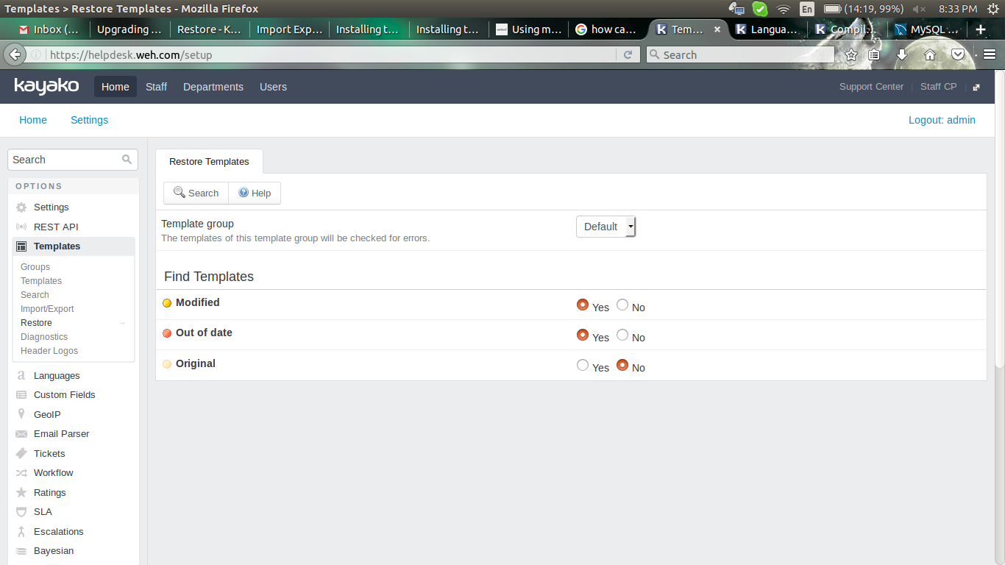

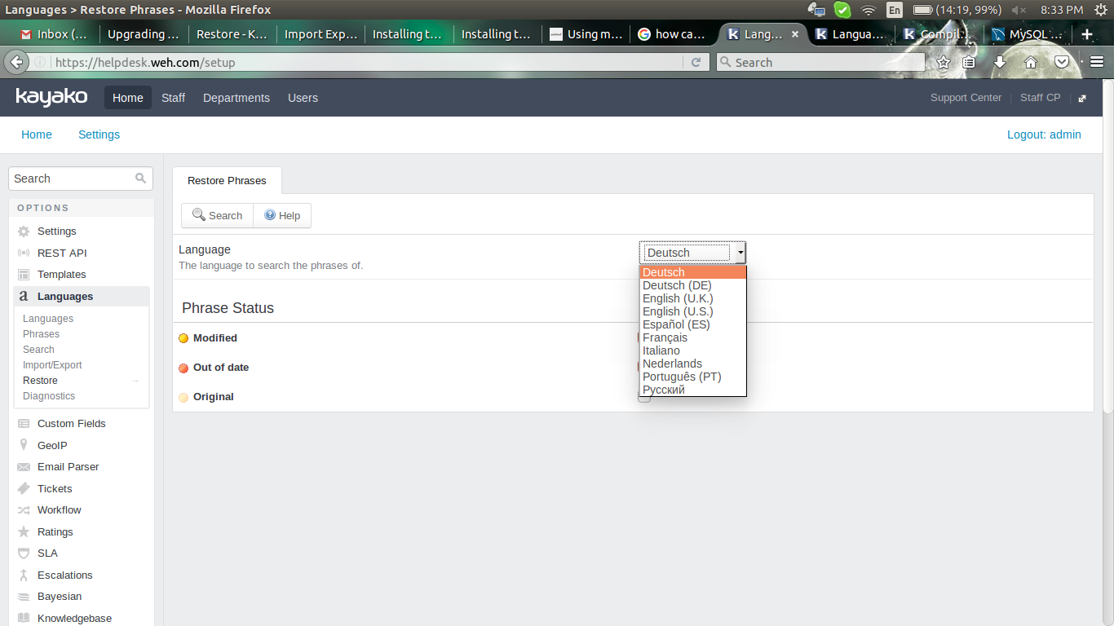
individually install all langauges

finally

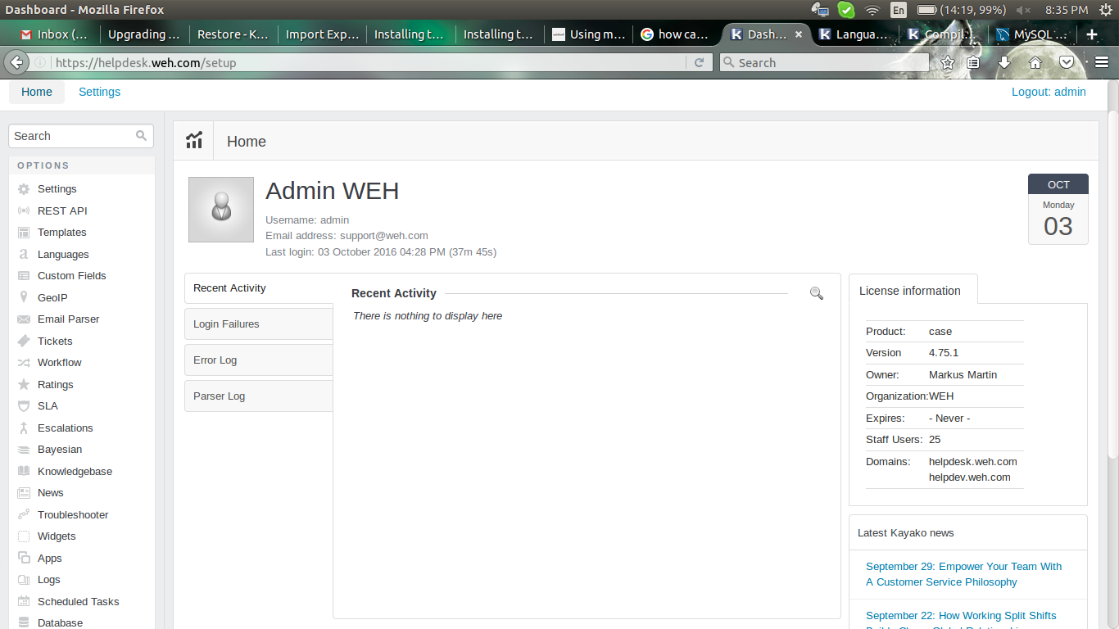

Diagonistics > rebuild cache check all success

