Create a Sharded Cluster in MongoDB

"sharding". Sharding is the process of writing data across different servers to distribute the read and write load and data storage requirements.

Config Servers :config0.example.com

Query Routers:query0.example.com

Shard Servers:shard0.example.com

shard1.example.com

verify /etc/hosts and add all servers entry to that

Mongodb installation

install mongodb in all servers

1. apt-get update
2. sudo apt-key adv --keyserver hkp://keyserver.ubuntu.com:80 --recv 7F0CEB10
3. echo 'deb http://downloads-distro.mongodb.org/repo/ubuntu-upstart dist 10gen' | sudo tee /etc/apt/sources.list.d/mongodb.list
4. sudo apt-get update
5. sudo apt-get install mongodb-10gen

Initialize the Config Servers

config0.example.com

run as root

for db storing(metadata info)

#mkdir /mongo-metadata

nano /etc/mongodb.conf

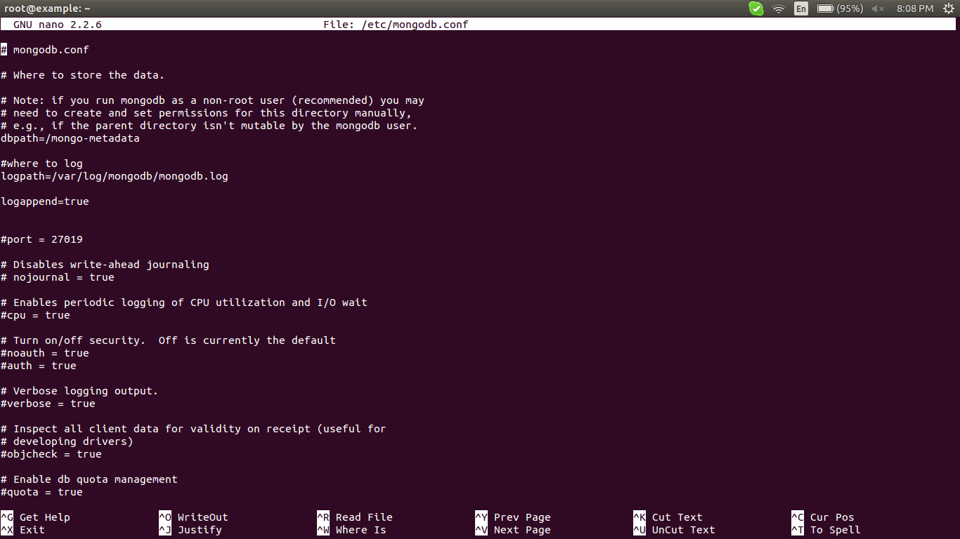

We can start the configuration server with the following command:
#mongod --configsvr --dbpath /mongo-metadata --port 27019
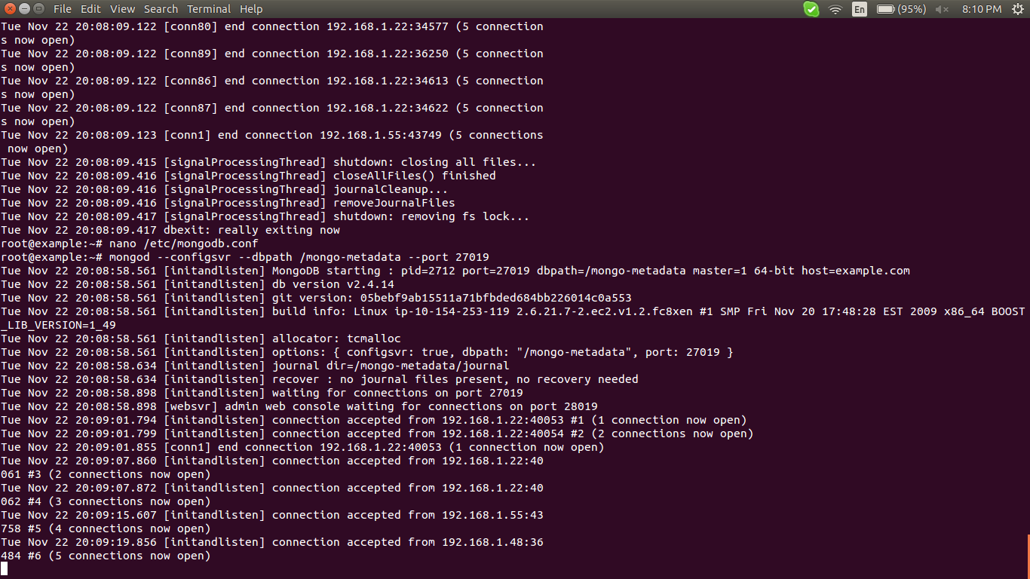

Configure Query Router Instances

query0.example.com

run as root

#service mongodb stop

#mongos --configdb config0.example.com

then shows

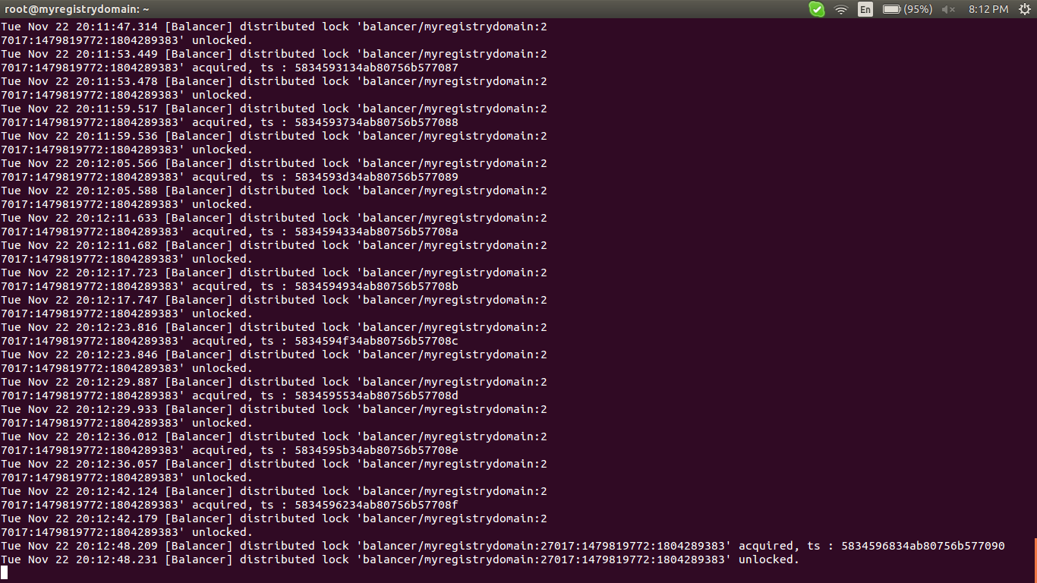

we can add multiple configuration servers by

#mongos –configdb config1.example.com:27019,config2.example.com:27019

if any error running query router just check
error: couldn't connect to server at src/mongo/shell/mongo.js:147exception: connect failed iptables all

solution

sudo iptables -A INPUT -p tcp --destination-port 27017 -m state --state NEW,ESTABLISHED -j ACCEPT
sudo iptables -A OUTPUT -p tcp --source-port 27017 -m state --state ESTABLISHED -j ACCEPT

Add Shards to the Cluster
Run as a root
Log into one of your shard servers as root.

shard0.example.com
or
shard1.example.com

To actually add the shards to the cluster, we will need to go through the query routers, which are now configured to act as our interface with the cluster. We can do this by connecting to any of the query routers like this:
#mongo --host query0.example.com --port 27017
mongos>

To add our first shard, type:
mongos>sh.addShard( "shard0.example.com:27017" )
mongos>sh.addShard( "shard1.example.com:27017" )

####If you are configuring a production cluster, complete with replication sets, you have to instead specify the replication set name and a replication set member to establish each set as a distinct shard. The syntax would look something like this:
sh.addShard( "rep_set_name/rep_set_member:27017" )
description on other document#########

Enable Sharding on the Database Level

mongos>use test_db
mongos>db

mongos>show dbs
You may notice that the database that we just created does not show up. This is because it holds no data so it is not quite real yet.

We can enable sharding on this database by issuing this command:
mongos>sh.enableSharding("test_db")

if we switch to the config database which is generated automatically, and issue a find() command, our new database will be returned:
mongos>use config
mongos>db.databases.find()
{ "_id" : "admin", "partitioned" : false, "primary" : "config" }
{ "_id" : "test_db", "partitioned" : true, "primary" : "shard0003" }

Your database will show up with the show dbs command when MongoDB has added some data to the new database.

Enable Sharding on the Collections Level

We can create a collection called test_collection and hash its "id" field. Make sure we're using our testdb database and then issue the command:
mongos>use test_db
mongos>db.test_collection.ensureIndex( { _id : "hashed" } )
We can then shard the collection by issuing this command:
mongos>sh.shardCollection("test_db.test_collection", { "_id": "hashed" } )

Insert Test Data into the Collection

mongos>use test_db
mongos>for (var i = 1; i <= 500; i++) db.test_collection.insert( { x : i } )
mongos>db.test_collection.find()

show all object 1 to 500

{ "_id" : ObjectId("529d082c488a806798cc30d3"), "x" : 1 }
{ "_id" : ObjectId("529d082c488a806798cc30d0"), "x" : 2 }
{ "_id" : ObjectId("529d082c488a806798cc30d2"), "x" : 3 }
{ "_id" : ObjectId("529d082c488a806798cc30ce"), "x" : 4 }
{ "_id" : ObjectId("529d082c488a806798cc30d6"), "x" : 5 }
{ "_id" : ObjectId("529d082c488a806798cc30d1"), "x" : 6 }
{ "_id" : ObjectId("529d082c488a806798cc30d8"), "x" : 7 }
......
To get more values, type:
it

mongos>sh.status()

shows the sharding status

--- Sharding Status ---
sharding version: {
"_id" : 1,
"version" : 3,
"minCompatibleVersion" : 3,
"currentVersion" : 4,
"clusterId" : ObjectId("529cae0691365bef9308cd75")
}
shards:
{ "_id" : "shard0000", "host" : "162.243.243.156:27017" }
{ "_id" : "shard0001", "host" : "162.243.243.155:27017" }
. . .

check the sharding process
shard0.example.com

shard1.example.com
on both

shard0.example.com

#mongo
>show dbs
>use test_db
switch to test_db
search the collection by
db.test_collection.find()

{ "_id" : ObjectId("529d082c488a806798cc30d3"), "x" : 1 }
{ "_id" : ObjectId("529d082c488a806798cc30d0"), "x" : 3 }
{ "_id" : ObjectId("529d082c488a806798cc30d2"), "x" : 5 }
{ "_id" : ObjectId("529d082c488a806798cc30ce"), "x" : 7 }
{ "_id" : ObjectId("529d082c488a806798cc30d6"), "x" : 9 }
{ "_id" : ObjectId("529d082c488a806798cc30d1"), "x" : 11 }
{ "_id" : ObjectId("529d082c488a806798cc30d8"), "x" : 13 }
. . .
To get more values, type:
it

shard1.example.com

#mongo
>show dbs
>use test_db
switch to test_db
search the collection by
db.test_collection.find()

{ "_id" : ObjectId("529d082c488a806798cc30d3"), "x" : 2 }
{ "_id" : ObjectId("529d082c488a806798cc30d0"), "x" : 4 }
{ "_id" : ObjectId("529d082c488a806798cc30d2"), "x" : 6 }
{ "_id" : ObjectId("529d082c488a806798cc30ce"), "x" : 8 }
{ "_id" : ObjectId("529d082c488a806798cc30d6"), "x" : 10 }
{ "_id" : ObjectId("529d082c488a806798cc30d1"), "x" : 12 }
{ "_id" : ObjectId("529d082c488a806798cc30d8"), "x" : 14 }
. . .

sharding with diffrent regions

sharding with diffrent country data with name....one contrys storage is going to that counties shard with depending on it name

assume

shard0000", "USA"
"shard0001", "EU"
on one of the shard server
shard0.example.com:

#mongo --host query0.example.com --port 27017
mongos>
I have 2 shards:
i taged that

mongos> sh.addShardTag("shard0000", "USA")
mongos> sh.addShardTag("shard0001", "EU")
create a database test_db
mongos>use test_db
enable the shard by

mongos>sh.enableSharding("test_db")

just check the status

mongos>sh.status()

eg:shardingversion: {
"_id": 1,
"version": 3,
"minCompatibleVersion": 3,
"currentVersion": 4,
"clusterId": ObjectId("555df7f4f6506e6ba07e1f20")
}shards: {
"_id": "shard0000",
"host": "127.0.0.1:27000",
"tags": [
"USA"
]
}{
"_id": "shard0001",
"host": "127.0.0.1:270001",
"tags": [
"EU"
]
}databases: {
"_id": "admin",
"partitioned": false,
"primary": "config"
}{
"_id": "test_db",
"partitioned": true,
"primary": "shard0000"
}

>use admin
Then add shard key to collection we'll use....run as admin then only this command work
>db.runCommand({shardCollection: "test_db.items", key: {"country": 1}})

Add tag ranges for our shards:
>use test_db
> sh.addTagRange("test_db.items", {country: "MX"}, {country: "USA"}, "USA")
>sh.addTagRange("test_db.items", {country: "ES"}, {country: "GER"}, "EU")
>sh.status()

eg:

sharding version: {
"_id" : 1,
"minCompatibleVersion" : 4,
"currentVersion" : 5,
"clusterId" : ObjectId("556376557b13cb3ac8b90b49")
}
shards:
{ "_id" : "shard0000", "host" : "127.0.0.1:27000", "tags" : [ "USA" ]
}
{ "_id" : "shard0001", "host" : "127.0.0.1:27001", "tags" : [ "EU" ] }

databases:
{ "_id" : "admin", "partitioned" : false, "primary" : "config" }
{ "_id" : "test_db", "partitioned" : true, "primary" : "shard0000" }
test_db.items
shard key: { "country" : 1 }
chunks:
shard0000 2
shard0001 1
{ "country" : { "$minKey" : 1 } } -->> { "country" : "ES
" } on : shard0000 Timestamp(2, 1)
{ "country" : "ES" } -->> { "country" : "MX" } on : shar
d0001 Timestamp(2, 0)
{ "country" : "MX" } -->> { "country" : { "$maxKey" : 1
} } on : shard0000 Timestamp(1, 2)
tag: EU { "country" : "ES" } -->> { "country" : "GER"
}
tag: USA { "country" : "MX" } -->> { "country" : "USA"
}

Ok, let's add elements to collection

mongos>use test_db
mongos>for(var i=0; i<1000; i++) db.items.insert({"model": "One", "country":"EU"});
mongos>for(var i=0; i<1000; i++) db.items.insert({"model": "iPhone", "country": "US"});

See the result:
mongos>db.items.stats()

eg:

{
"sharded" : true,
"userFlags" : 1,
"ns" : "test_db.items",
"count" : 2010,
"numExtents" : 6,
"size" : 225120,
"storageSize" : 344064,
"totalIndexSize" : 155344,
"indexSizes" : {
"_id_" : 81760,
"country_1" : 73584
},
"avgObjSize" : 112,
"nindexes" : 2,
"nchunks" : 3,
"shards" : {
"shard0000" : {
"ns" : "test_db.items",
"count" : 1000,
"size" : 112000,
"avgObjSize" : 112,
"numExtents" : 3,
"storageSize" : 172032,
"nindexes" : 2,
"lastExtentSize" : 131072,
"paddingFactor" : 1,
"userFlags" : 1,
"totalIndexSize" : 81760,
"indexSizes" : {
"_id_" : 40880,
"country_1" : 40880
},
"ok" : 1
},
"shard0001" : {
"ns" : "test_db.items",
"count" : 1010,
"size" : 113120,
"avgObjSize" : 112,
"numExtents" : 3,
"storageSize" : 172032,
"nindexes" : 2,
"lastExtentSize" : 131072,
"paddingFactor" : 1,
"userFlags" : 1,
"totalIndexSize" : 73584,
"indexSizes" : {
"_id_" : 40880,
"country_1" : 32704
},
"ok" : 1
}
},
"ok" : 1
}

check the all the parameters count and country key all
in shard 0 shard0.example.com
check
#mongo
>use test_db
>db.items.find()
shows

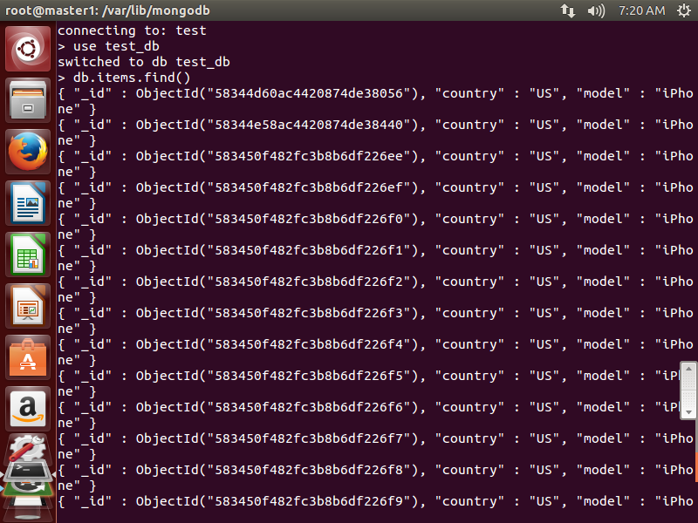

in shard 1 shard1.example.com
check
#mongo
>use test_db
>db.items.find()
shows

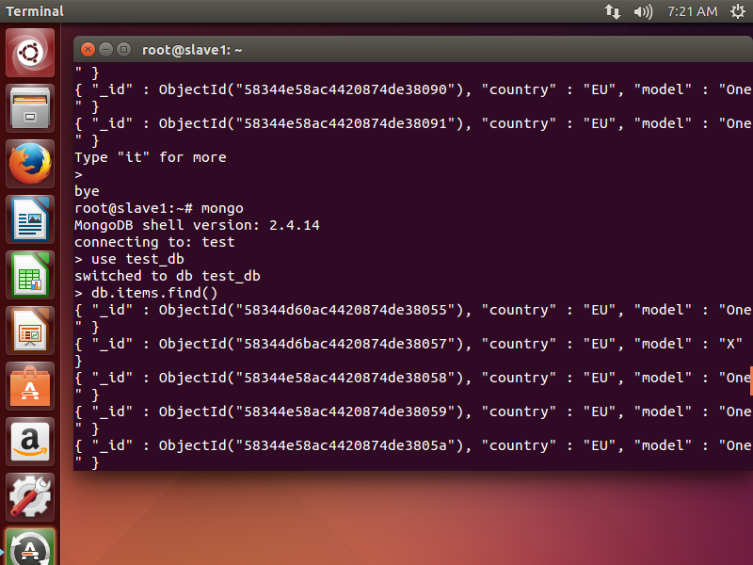

reffer link

http://stackoverflow.com/questions/30415387/mongodb-stores-data-only-to-primary-shard-in-case-choosing-tagging-shard-key

https://www.digitalocean.com/community/tutorials/how-to-create-a-sharded-cluster-in-mongodb-using-an-ubuntu-12-04-vps
https://www.digitalocean.com/community/tutorials/how-to-implement-replication-sets-in-mongodb-on-an-ubuntu-vps

