Background:
The task here was to take a text file and use the information to rebuild a hand. This is expected to be a 3D model with the highest possible resolution.
Method:
This process is similar to the bunny and this model was built using lessons learned from the model of the bunny. Some parts that remained, are the center and the fact that a sphere being used to encircle the surface points. Thus, the sphere is again centered over the hand. The following figures show the process of selecting the radius of the sphere.
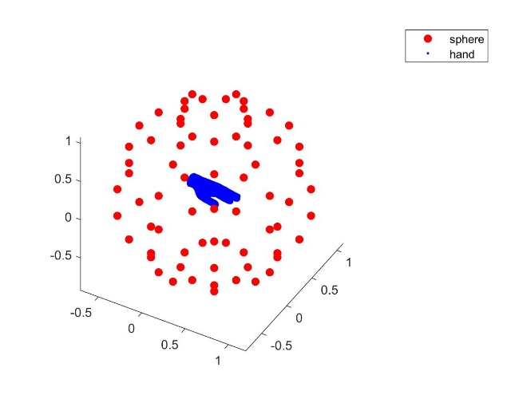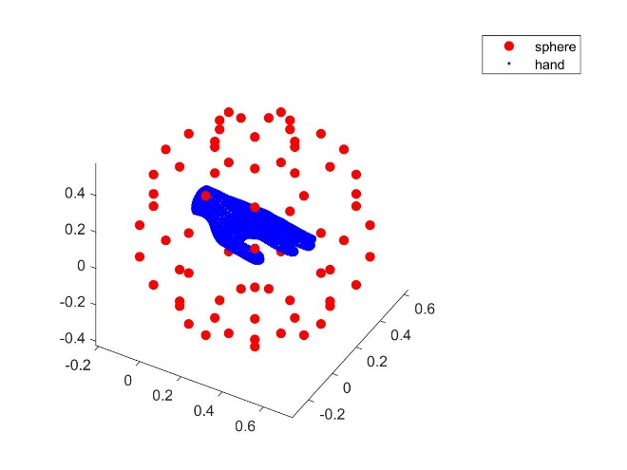
Figure 1: Sphere with Radius of 1 Figure 2: Sphere with Radius of 0.5
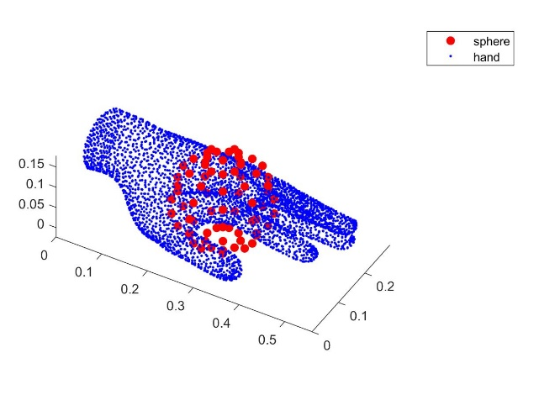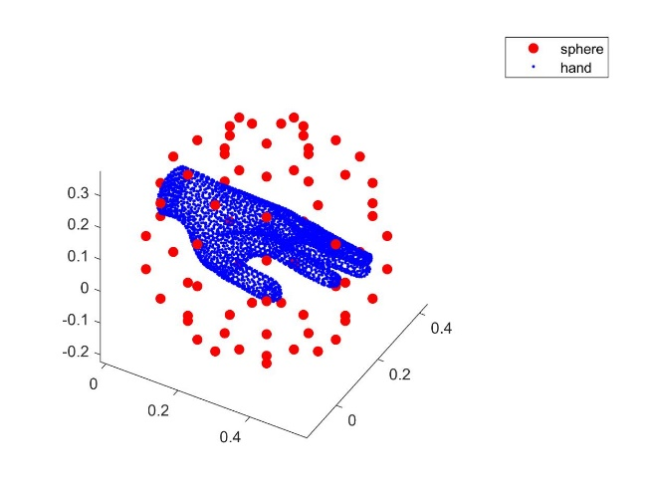
Figure 3: Sphere with Radius of 0.1 Figure 4: Sphere with Radius of 0.3
In this case, the radius of 0.3 encircled the entire hand without much extra space.
Now, that the radius has been selected, an ideal shape parameter needs to be identified. Through a process of trial of error, it was found that a value of 1/150 should be used. The results of that can be viewed below, and the neval value here is set at 30.
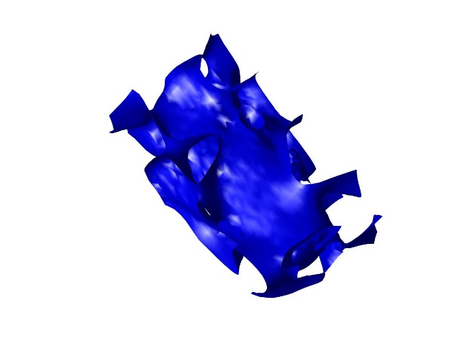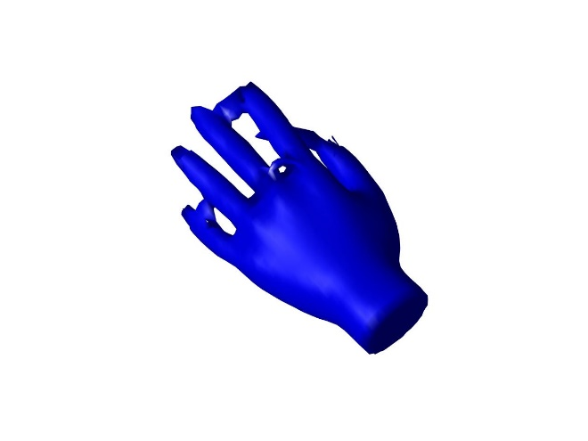
Figure 5: 3D Model with Shape Parameter of 0.5 Figure 6: 3D Model with Shape Parameter of 1/50
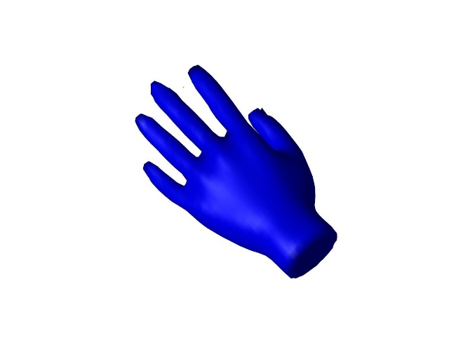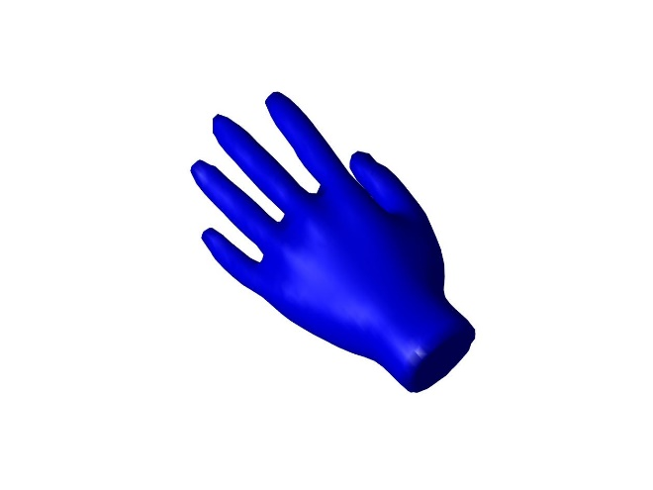
Figure 7: 3D Model with Shape Parameter of 1/75 Figure 8: 3D Model with Shape Parameter of 1/150
Looking at the figures above, a value of 1/150 for the shape parameter gives the best results.
Finally, the last value to check is whether the neval value plays a role on the figures. In Figures 5 through 8 the neval value was set at 30. So, the figures below will show what different neval values do to 3D model.
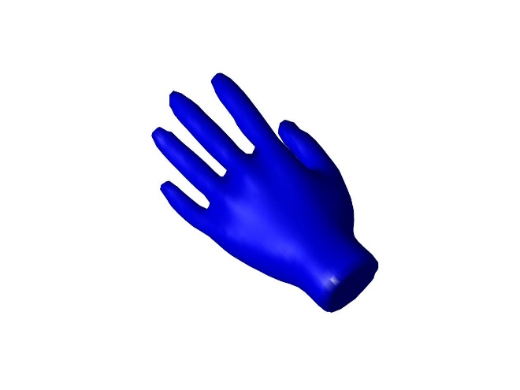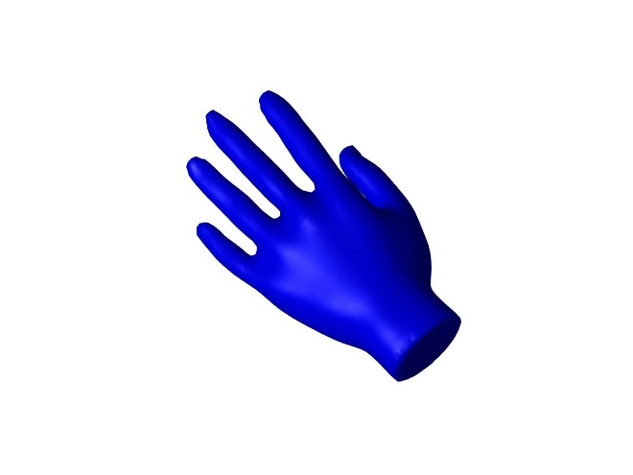
Figure 9: 3D Model with Neval Value of 30 Figure 10: 3D Model with Neval Value of 50
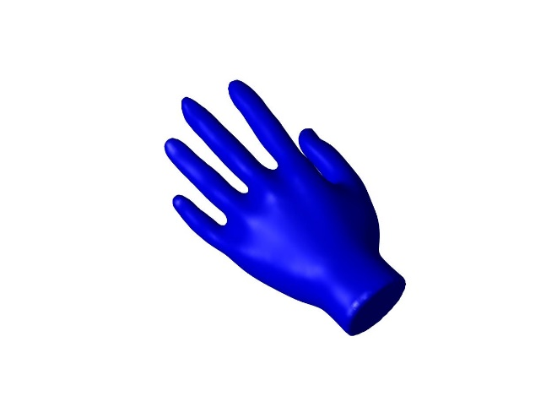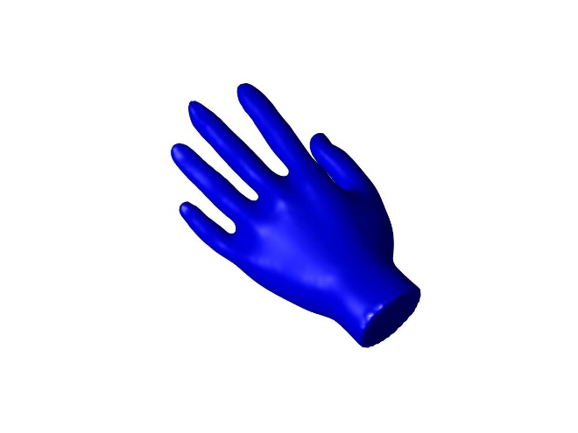
Figure 11: 3D Model with Neval Value of 80 Figure 12: 3D Model with Neval Value of 120
Conclusions:
In this case, a sphere with a radius of 0.3, a shape parameter set to 1/150 and a neval value of 120 produces a high-resolution 3D model of a hand. Also, with the higher resolutions you can see more details of the hand with the best showing the details of the knuckles. However, for fun, one more test was run with the neval value set to 200. The resulting figure from that can be viewed below.
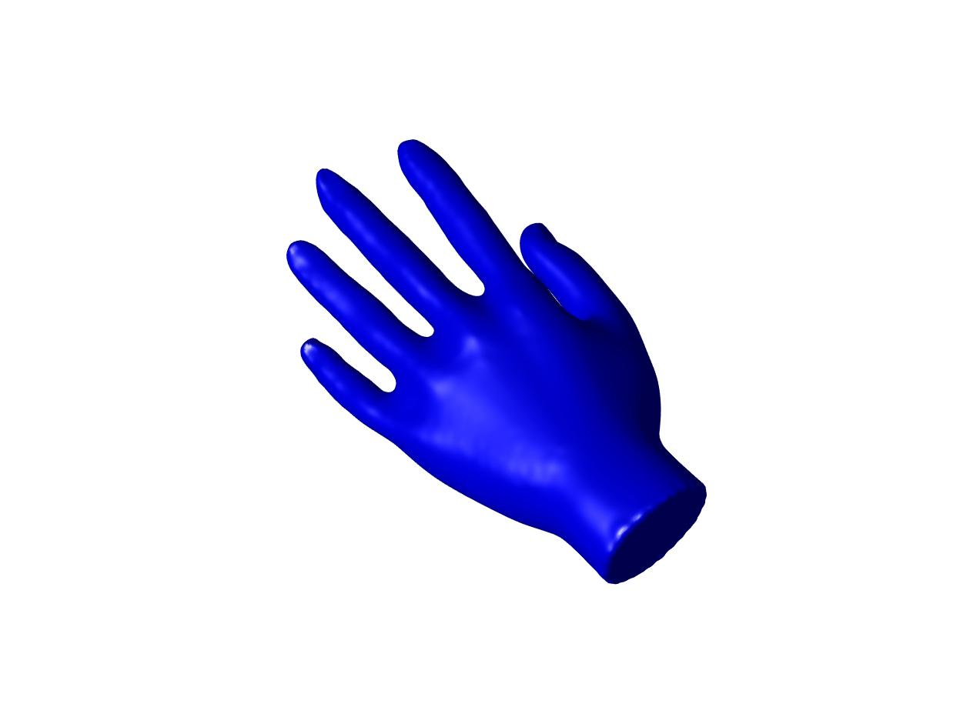
Figure 13: 3D Hand Model with Neval Value of 200
This is the best my laptop can do and even here there is a bit more detail in the hand.

