Background
During assignment three, we were tasked with plotting a function within the domain of a unit circle. This plot was also supposed to show a non-concentric hole within the interior of the function. This non-concentric hole is centered at (0.3, 0.3), with a radius of 0.3.
Method:
For this assignment, we started by defining a variable called t because it is a stand-in for $θ$, to produce our first vector. This vector was defined using linspace in the range $[0, 2π]$ divided into 200 equally spaced points. Now that we have our values of t, we can use these to create the vectors Xt and Yt. These new vectors will help remove the points outside our unit circle.
So, we have the points to build our unit circle; we now need the points to plug into our function. For this assignment, the function we will be using is $f\left(x,y\right)=exp⁡(-\frac{84}{4}\left(x^{2}+y^{2}\right))$. Here, we will use meshgrid to build these points. Using meshgrid, we will create two vectors, x, and y, ranging from $[-1,1]$ with a spacing of 0.01 between each value. This range was selected because we have a unit circle with a range of these values in both directions. So now we have a range of x and y values, we can now define our function and use those values to get a vector of Z values.
The next step is to start building our grid. Now is when we use the griddata function to get a z vector. Here griddata takes in the values from x, y, and Z to create the xyz coordinates for our plot. These points are determined with the vectors of x and y and by using the cubic interpolation method. It should be noted that right now, we have a plot that contains points outside the unit circle. Therefore, we will use the inpolygon function to create a logical statement called in. This function will compare the values in x and y to Xt and Yt to determine whether or not the points are inside the unit circle. Now, we can use the statement “z(~in)=NaN” to remove any values outside the unit circle. If we were to stop at this point, the following figure is the graph to obtain the following graph.
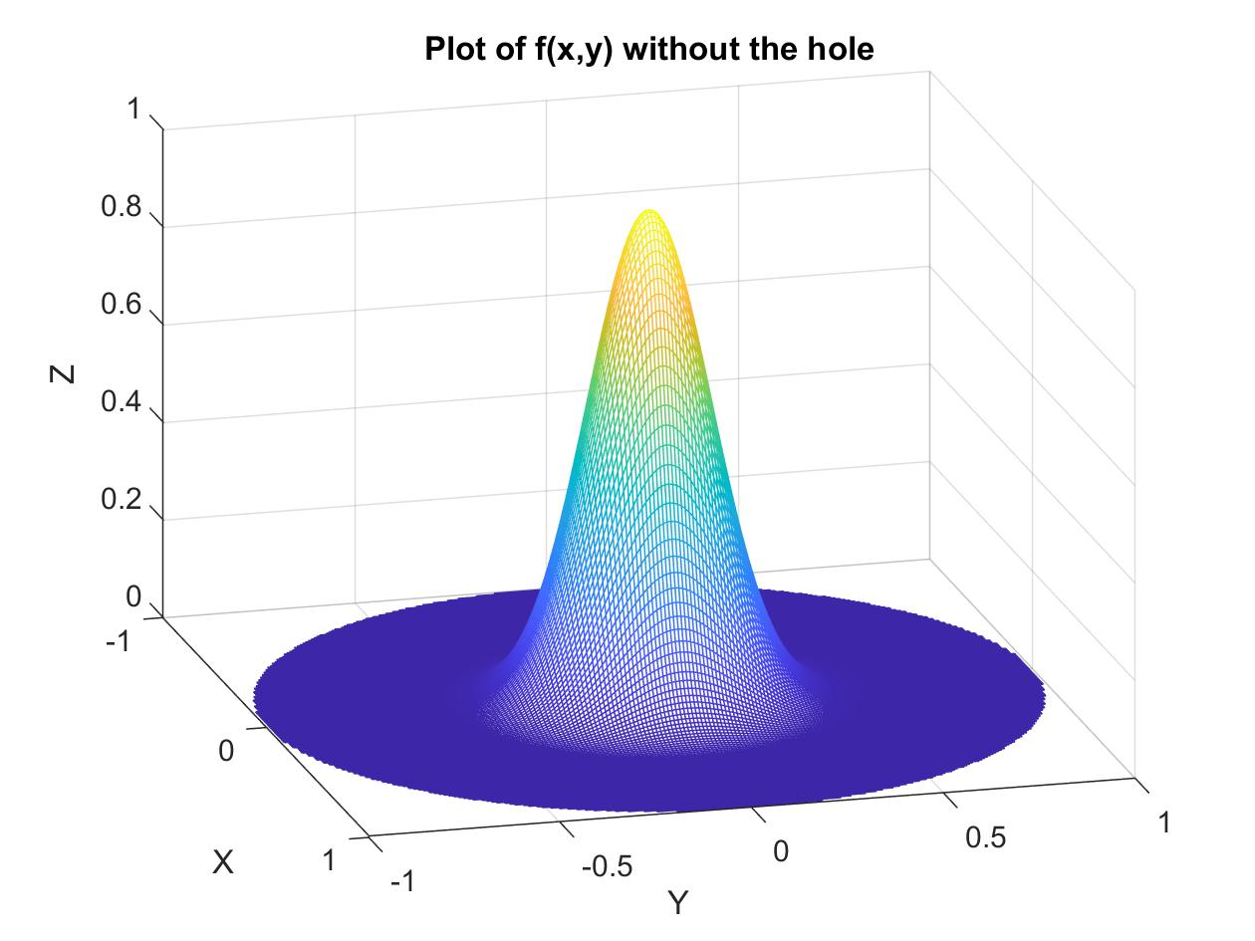
However, as stated previously, we are not done just yet. Our next task was to cut out a hole in the graph using a circle centered at (0.3, 0.3) with a radius of 0.3. This process is relatively similar to what has already been done using the inpolygon function. However, we will use the vectors inX and inY in the function this time. The importance of using these new vectors is because there are defined as “inX=0.3+0.3*cos(t),” and “inY=0.3+0.3*sin(t).” These vectors build the points that lie along the boundary of the smaller circle. We can now use inpolygon on the x and y vectors but this time view them in respect to inX and inY. Again, we will create a logical statement that identifies if values are less than or equal to the boundary of the smaller circle. Finally, we will use the statement “z(In)=NaN” to remove these values to create a plot described by the assignment.
Conclusion:
If you follow the above method, you will plot the x and y values within the unit circle. However, at the same time, we want to remove points from the circle centered at (0.3, 0.3) with a radius of 0.3. Then, by extension, you will also see the z values that correspond to these points. To see what the plot looks like, we turn to the following.
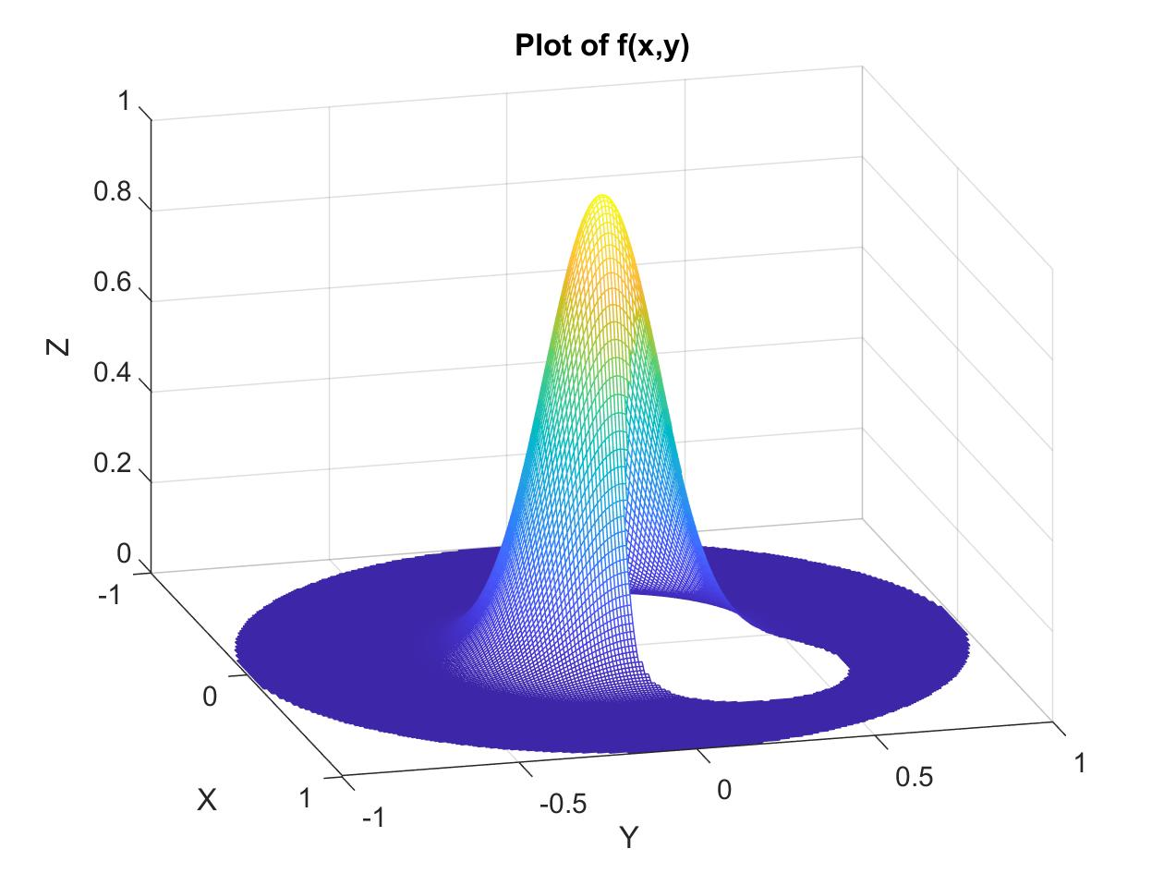
You can use the command pcolor to produce a top-down view of this same plot if one is so inclined. I removed the gridlines that would typically accompany this command to clean up this plot. Since I created two different plots, in the end, I did use the commands “figure(1)” to produce the plot above. The following figure is the top-down view of the plot of f(x,y), which I used the command “figure(2)” to generate using the same code. 