Background
We were tasked with completing two different codes using a least squares method in this assignment. The purpose of this was to take some given data and produce a curve that would best fit the data. In the first part, we were given a specific basis, while in the second part, we were required to use a polynomial basis.

Method
The starting point for this assignment was similar to the last one. Once we used the command clear to remove any potential inputs, this was done at the start of both codes; we had to import a given data set into the code. The first part used a file called HW4.txt, while the second part used the file HW4a.txt. After importing the data, we used the columns to create the starting x and y vectors. We also needed the length of the vectors, so we used the command “n=length(x)” to get that value.
It should be noted that we could have used x or y for this. The final step shared between the two codes was using that n value to create a vector of length n populated with just ones. Now, the code related to HW4.txt also needed a vector of length n that is populated with zeros.

Part One – Relating Solely to HW4.txt
Here is where we can start discussing the differences between the two codes. The first one is the code relating to HW4.txt and the first spot for a difference in the linspace part of the code. With this part of the code, we are working with a periodic boundary and reflecting that the linspace here ranges from 0 to $2π$ where each point is divided into n+1 equal parts. Also, the basis that we will use in this example of the least-squares method is $\{\cos^{3}\left(x\right),\sin^{3}\left(x\right)\}$. So, we now have a vector of t values that we can use later in our code.
Now, we can build a matrix to help us identify the parameters needed to produce a curve to fit the data. The equations that we need to find the parameters of are $x\left(t\right)=c_{1}+c_{3}cos^{3}(t)$ and $y\left(t\right)=c_{2}+c_{4}\sin^{3}{(t)}$. Here, the t values will come from the vector we build using linspace. So, first, we start by building A using the vector of ones, then the vector of zeros, followed by $\cos^{3}{(t)}$, then finish it off with the vector of zeros. These represent the coefficients of the c’s in our x(t) equation. We mark the first row’s end in A and repeat the process to build the second row. However, in the second row, we will have the vector of zeros, then the vector of ones, next will be a vector of zeros, and then we will have $\sin^{3}{(t)}$. So, this time we represent the coefficients of the c’s for the y(t) equation.
Now, we have all the pieces required to find the coefficients of the parametric equations above. We will use the command “c=A\[x;y] to find these values.” We are almost ready to produce the curve that best fits the data. First, we have to use the command “t2=linspace(0,2*pi,200)” to produce a new vector of t values. The reason for producing the t2 vector is that we will then plug these values into the parametric equations to produce the curve. Finally, we will use the commands “Xt=c(1)+c(3)*cos(t2).^3” and “Yt=c(2)+c(4)*sin(t2).^3” to produce two new vectors. These vectors together will give us the points of the curve.
The final step for this part of the code was to produce the plot. Here, we identified this plot as figure one. Then, we plotted the points from the original x and y vectors, giving us just the points from the text file we imported. Next, we used the hold command. The reasoning behind this is that it will retain the plot we just made while letting us add the curve using our least-squares method. Therefore, the next command we used was “plot(Xt,Yt,'-b','LineWidth',2).” This plot is the points from the parametric equations with a line connecting all the points. We finished figure one by labeling the axes, setting them equal length, and finally turning off the hold command. Thus, our figure one was complete, and we finished the first part.

Part Two – Relating Solely to HW4a.txt
We can now start discussing the process to build the curve for the data from the import of HW4a.txt. In the first paragraph of the “Method” section, we outlined how to start this code. So, here we will pick up where this part of the code differs. Therefore, the last piece shared between the codes was the vector of length n that is populated with ones.
The first difference we can notice is that we are using a polynomial basis in this least-squares method. Therefore, we can immediately build our matrix A using the command “A=[nOnes x (x.^2) (x.^3) (x.^4)].” The reasoning for this is because we have a polynomial that is represented as $y=c_{0}+c_{1}x+c_{2}x^{2}+c_{3}x^{3}+c_{4}x^{4}$ for our parametric equation. We now have everything we need to find our coefficients to use the command “c=A\y.”
So, we have our c’s; we need some x’s to input into our parametric equation. So, we will use linspace again, but it will range from 0 to 10 with 600 equally spaced points throughout. Which will give us the X vector populated with points we can plug into our equation. So, in order to get the corresponding y values, we will use the command “Y=c(1)+c(2)*X+c(3)*X.^2+c(4)*X.^3+c(5)*X.^4” which will give us the Y vector populated with the y values of the equation. We have all the pieces we need to produce the plot this time, named figure 2.
We will plot the x and y values straight from the imported data, much like before. Then we will repeat the hold command and plot the X and Y values will a line connecting the points to produce our curve, and much like before, we will label the axes. A difference here is that we will set the x-axis to range from 0 to 10, and the y-axis will range from -1.5 to 1.5. Finally, we turned off the hold command, and now we have completed the figure.

Conclusions
As we can see, these two codes are similar at times. However, they are also different since we needed to fit the data into two plots. Below you can view the plots from both codes without the curves from the least-squares method.
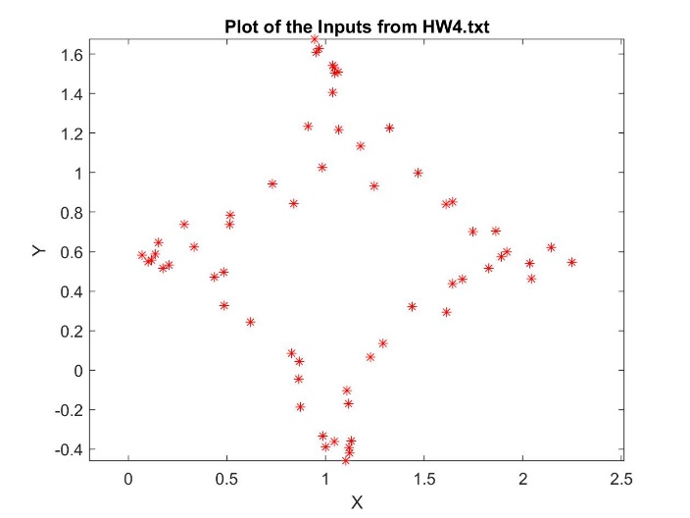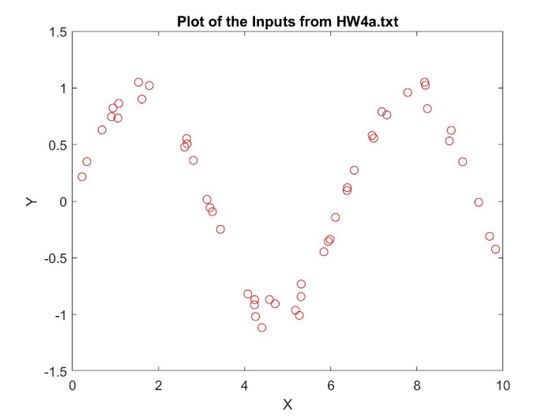
As you can see, the figure on the left has a shape that would be better described in a circular sense, while the figure on the right appears to be more polynomial in its shape. The figure on the right appears to be more in line with a polynomial of degree 4 based on what we can see. Therefore, each data set needed its basis since no one type fits all.
So, focusing on the figure on the left, we used the basis $\{\cos^{3}\left(x\right),\sin^{3}{(x)}\}$ to produce a curve to fit this data. The result of that curve overlayed with the data points can be found below. 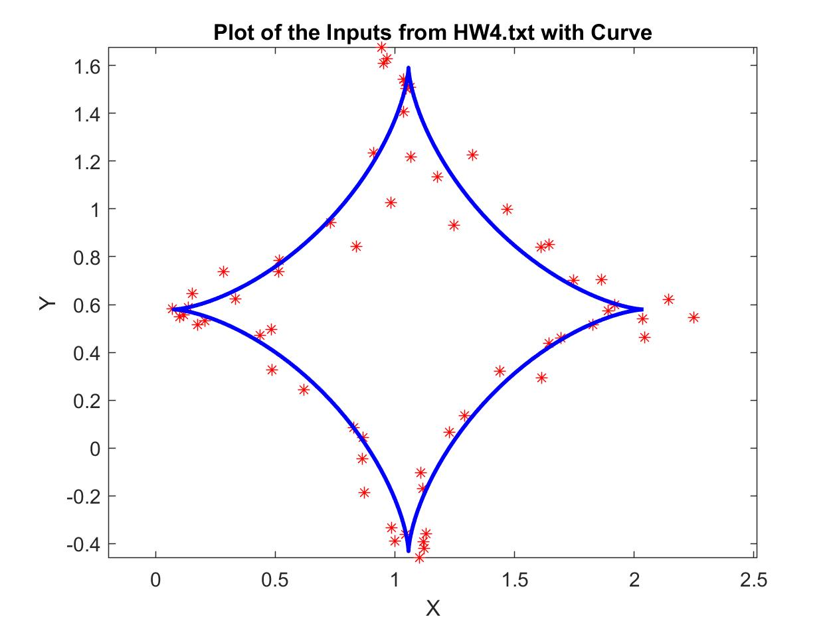
We should keep in mind that this curve best fits the data, which means that the curve will not touch every data point. However, we can see that the points are mostly populated around the curve. Naturally, there will be some outliers, but the curve and data points appear to match up. Experimenting with different types of periodic basis could result in a curve that might better fit the data.
Now, moving on the right-hand figure, we used a fourth degree polynomial basis to produce our curve without a curve. The result of the curve overlayed with the data points can be found below. 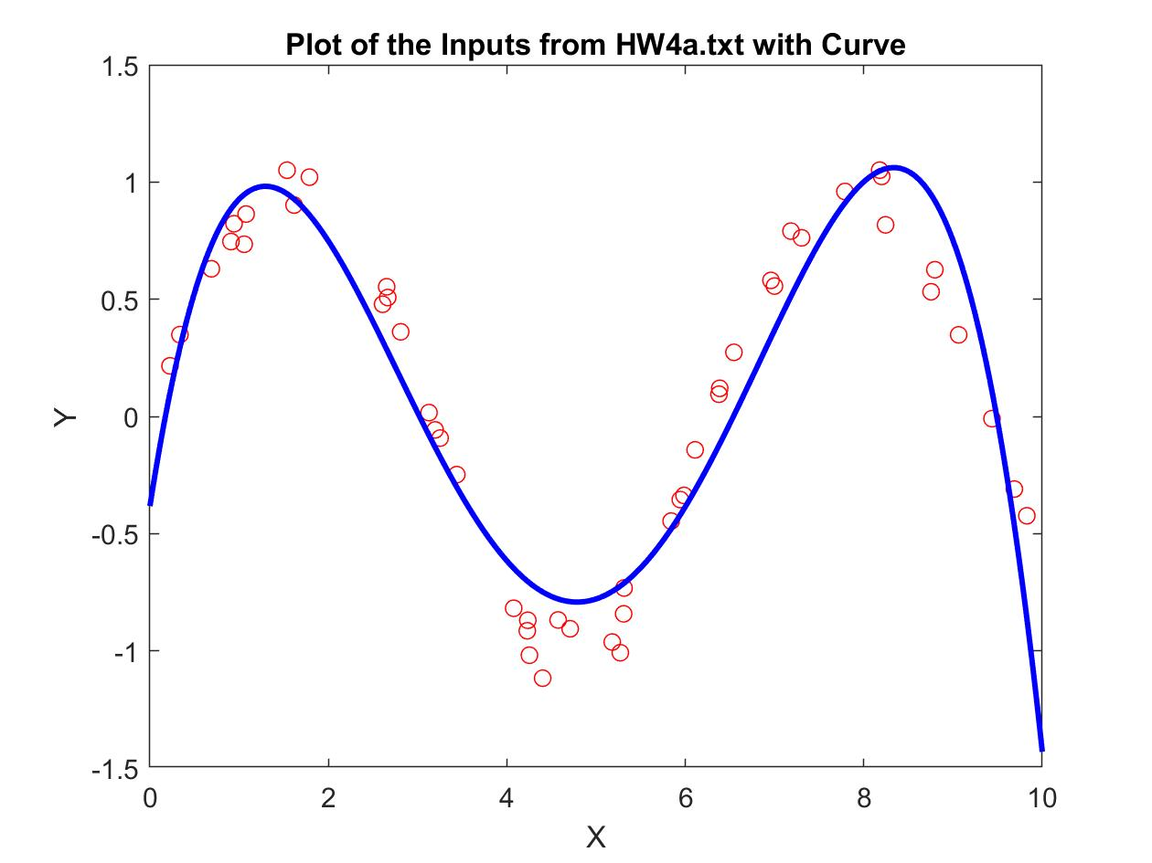
Like before, we see a curve that tends to follow the data points throughout the plot window with some outliers. Again, it should be noted that there could be a basis that produces a better fit for this data. However, overall, the curve matches the flow of the data points even with the outliers.

