Background:
The task here is to import data and use that data to create some figures. Specifically, the data would be used to create an abdomen and a uterus. There will be five figures total, a boundary point plot for each, an isosurface for each and finally a figure that contains both surfaces.
Method:
The first step in this assignment, is to load in the data. Here, the file “GeometryEmmi26.mat” will be loaded into MATLAB. In this code, the “Body” structure will be used to build the abdomen which is what will be built first. Within this structure, there is a pts matrix which will be used to create the boundary points. However, at least one interior point is required. For the purposes here, the interior points for the abdomen are selected to be (0, 0, -100), (0, 0, 0), and (0, 0, 100). This is enough to build the first figure which can be viewed below. 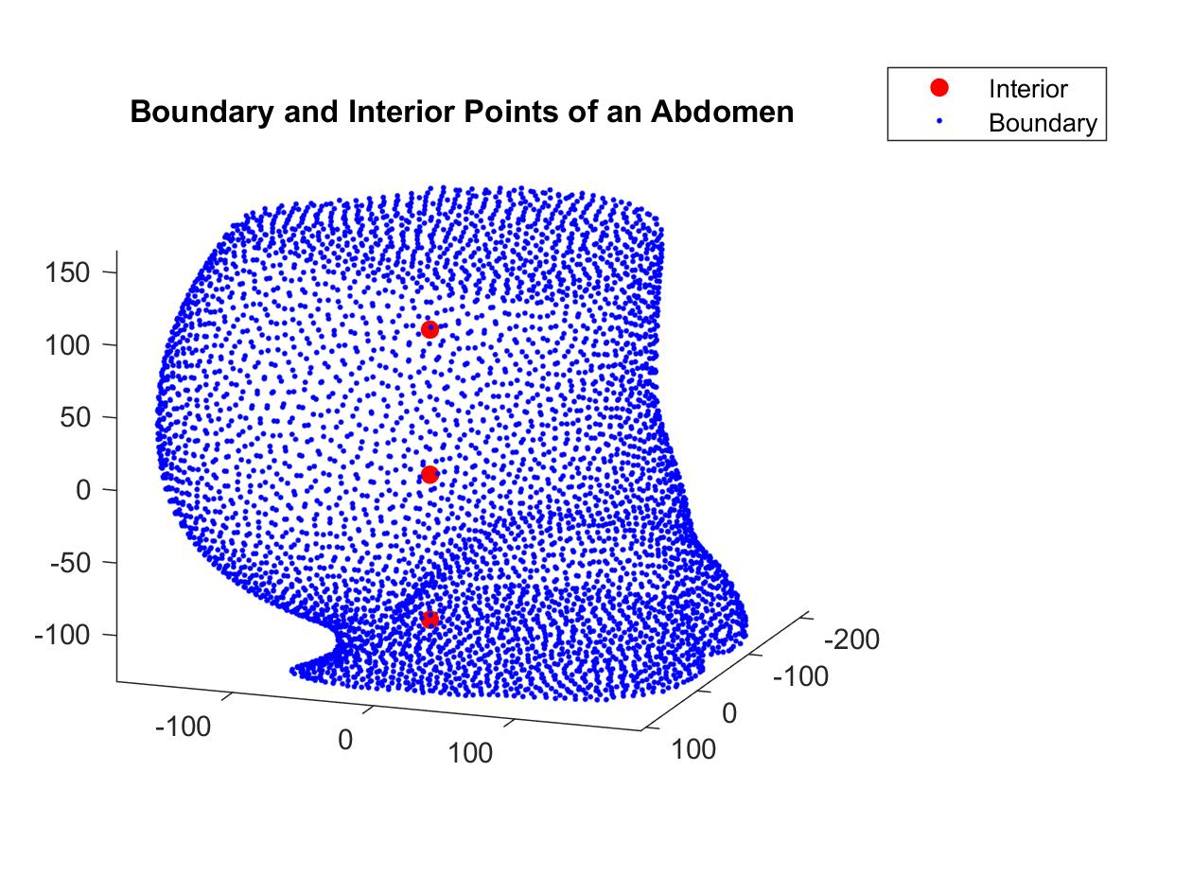
Next, the focus is turned to building the iso-surface using the points outlined above. The interior points and boundary points are used to create a new matrix. This new matrix will have the form:
$$\left|\begin{matrix}{x_{i}}_{1} & {y_{i}}_{1} & {z_{i}}_{1} \\ ⋮ & ⋮ & ⋮ \\ {x_{i}}_{n} & {y_{i}}_{n} & {z_{i}}_{n} \\ {x_{b}}_{1} & {y_{b}}_{1} & {z_{b}}_{1} \\ ⋮ & ⋮ & ⋮ \\ {x_{b}}_{m} & {y_{b}}_{m} & {z_{b}}_{m}\end{matrix}\right|$$
This matrix is then used to find the distance matrix which is then passed through the radial basis function to get $A=\sqrt{r^{2}+c^{2}}$. Where, r is the distance matrix and c is the shape parameter. Regarding the shape parameter, the values 0.25, 0.5, 0.75, 0.95, and 10 were tested and all values resulted in the same figure. However, the larger values increased the time it took for the code to run. Therefore, in this case, the selection of the shape parameter is not overly important but a value of 0.5 was selected. Finally, we use the backslash operator to get the coefficients.
The next step is to build a $30×30×30$ meshgrid from the boundary points. The reasoning for this is because there are 4,307 points that make up the boundary. This would be very computationally heavy and quite inefficient. So, the meshgrid reduces the load on the memory while improving the efficiency of the code. Using the meshgrid, we create a second distance matrix. Then the process of running it through the radial basis function and obtaining the coefficients using the backslash operator is repeated.
This is enough to build the isosurface for the abdomen. However, this figure is meant to have an isocap to visualize the volume. To use the isocaps function, the isosurface cannot be closed. To allow for this, any z-values that are greater than 150 are removed. This cuts off the top of isosurface and allows fir the isocap to be added to the figure, which can be viewed below. 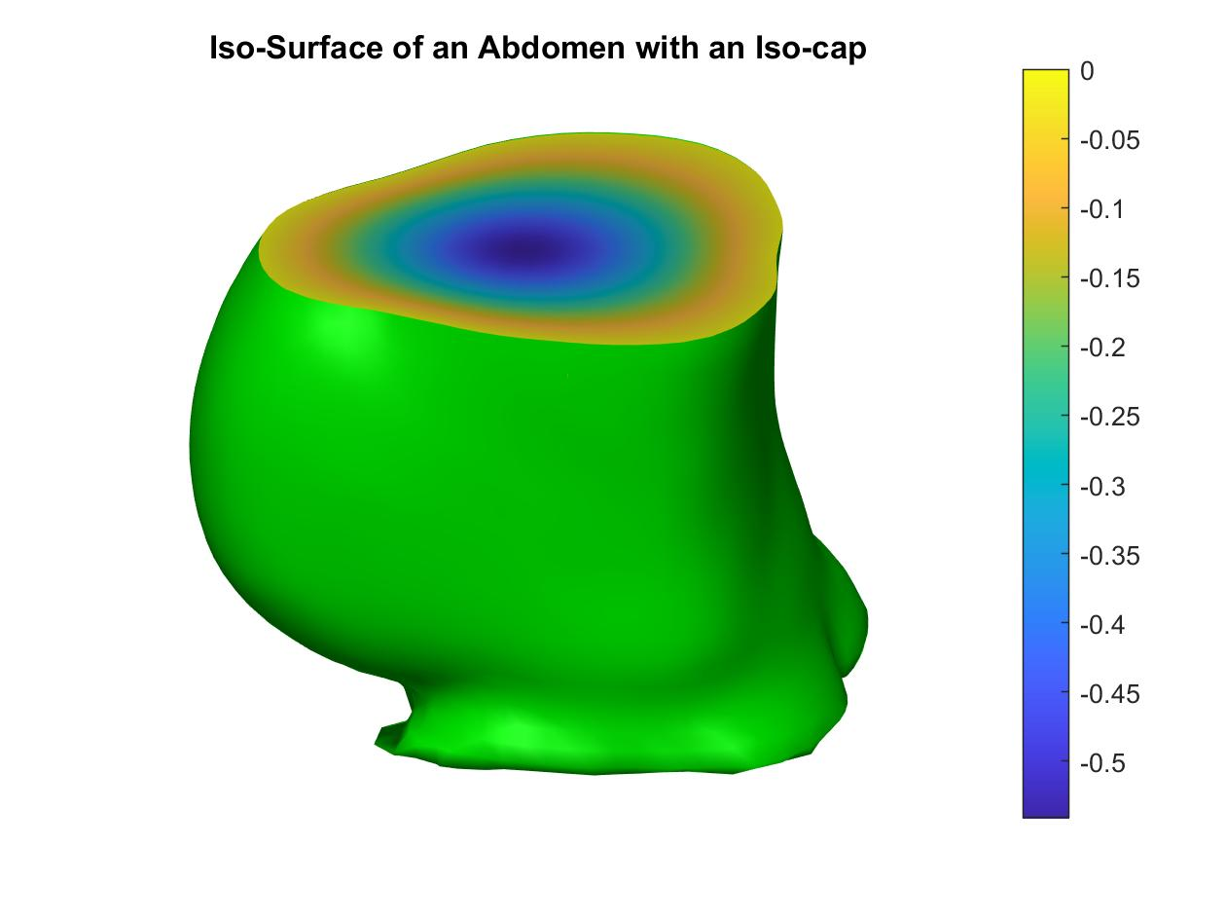
The steps outlined above are repeated on the Uterus structure to build the figures relating to the uterus. However, the interior points for the uterus are different than before and this time they are selected to be (0, -120, 0), (0, -30, 0), and (0, 10, 0). Also, it should be noted that this time there are only 325 boundary points. The figure of the uterus boundary points, and interior points can be viewed below. 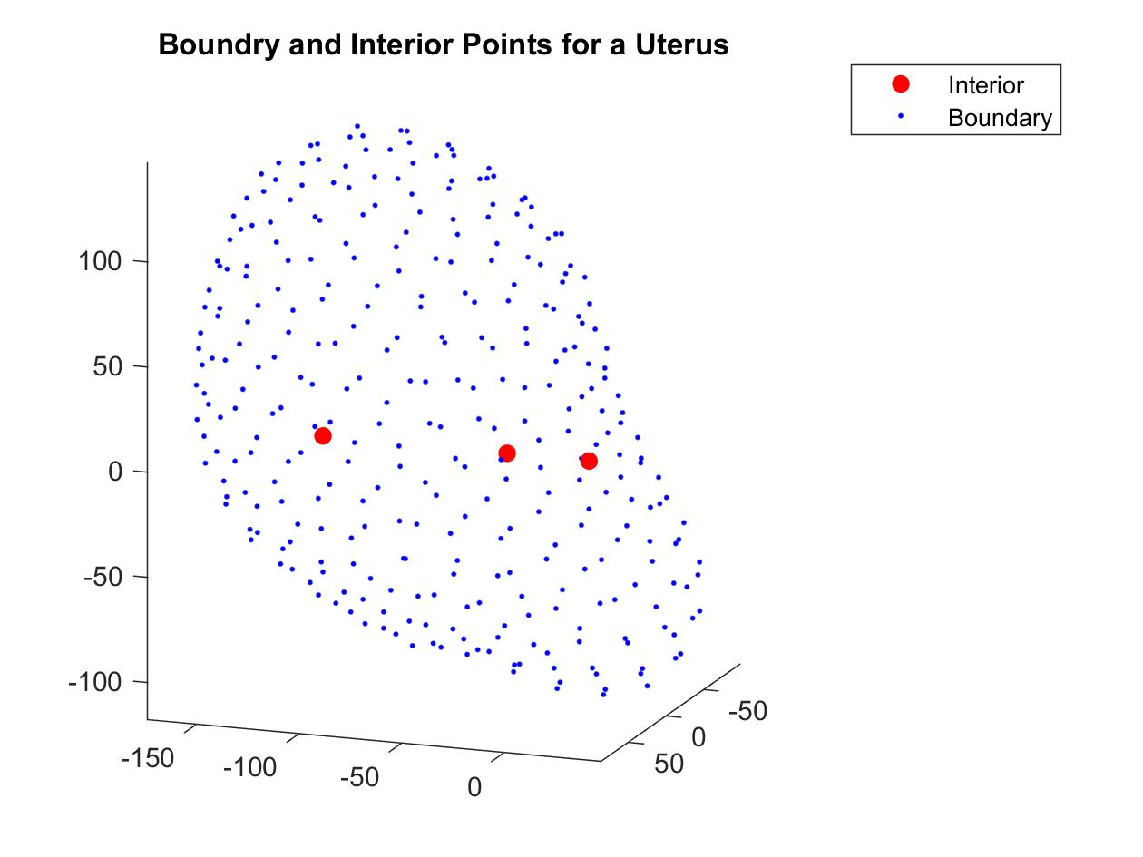
Now, again, a meshgrid is built and it will be the same size as above. However, just following the steps above will leave holes in the uterus isosurface. To correct this, the boundary points are pushed just out to fill in the holes. It was found that in each direction, the boundaries were pushed out by 0.5 would produce the isosurface without holes, which the resulting figure can be viewed below. 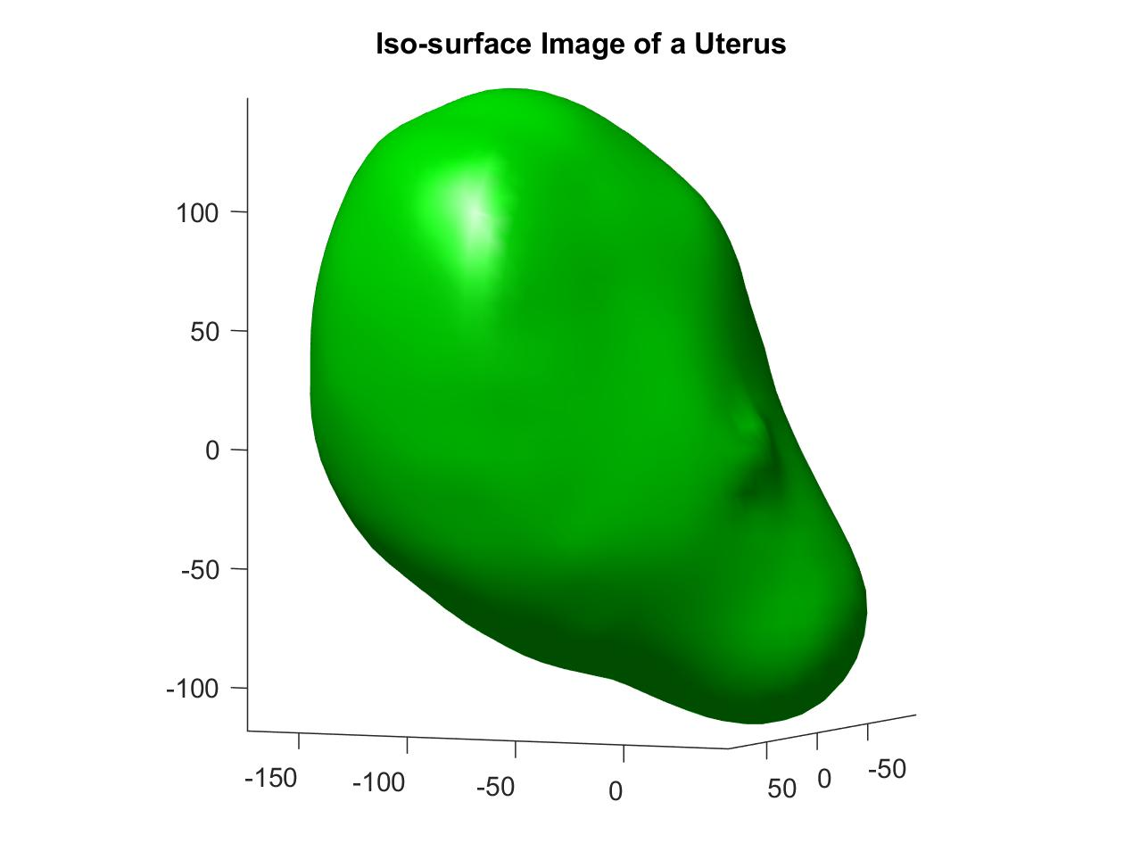
Conclusion:
Now that we have completed the above figures, we can combine the isosurfaces to create one figure. This allows us to view the uterus inside the abdomen. The abdomen is set to have a transparency value of 0.3 to allow us to see through it. The uterus is left to be opaque, and this figure can be viewed below. 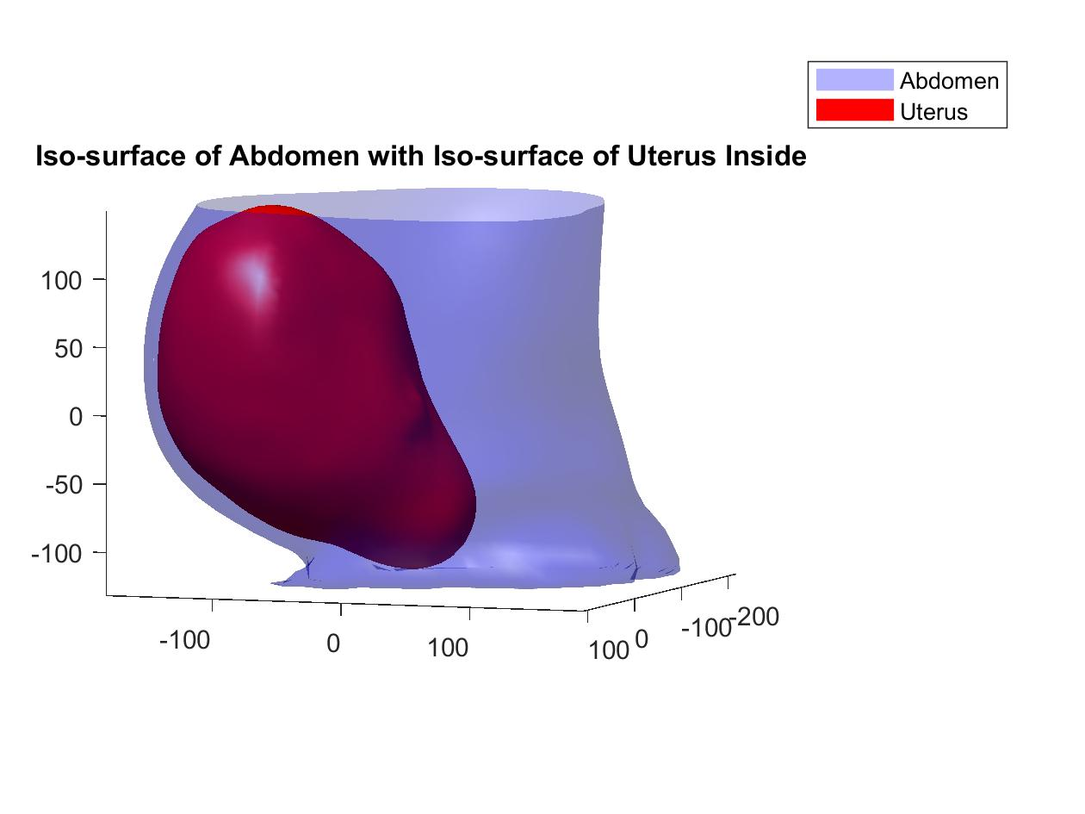
Therefore, reconstruction of the abdomen and uterus have been completed within MATLAB.

