Background:
The cloud data file "Data3D_Bunny2.mat" contains 8171 surface points with the corresponding normal vectors. The task here was to use the data provided to reconstruct a 3D Bunny using normalized MQ. Once the bunny is recreated, the task is to get the resolution as high as possible.
Method:
This assignment is like the prior assignment. However, one significant difference will be that a sphere of points will be generated around the surface points of the bunny. The command "center=(min(bdpt)+max(bdpt))/2" was used to identify the center of the surface points of the bunny. This center is needed to make the bunny at the center of the sphere of points generated. Now, finding the radius of this sphere was a process of elimination. Below are some figures relating to various radius values.
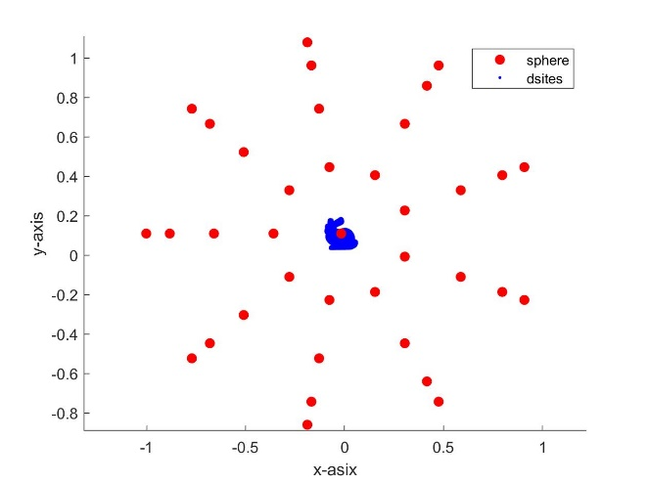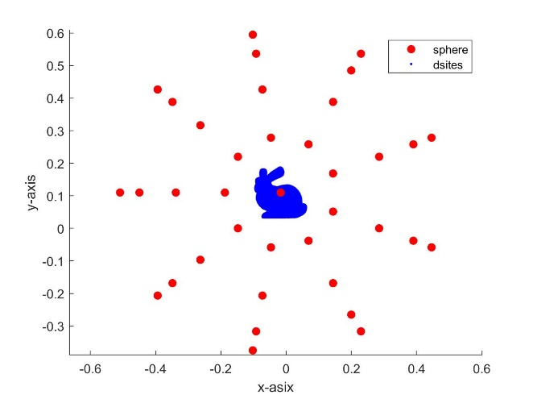
Figure 1: Sphere with Radius of 1 Figure 2: Sphere with Radius of 0.5
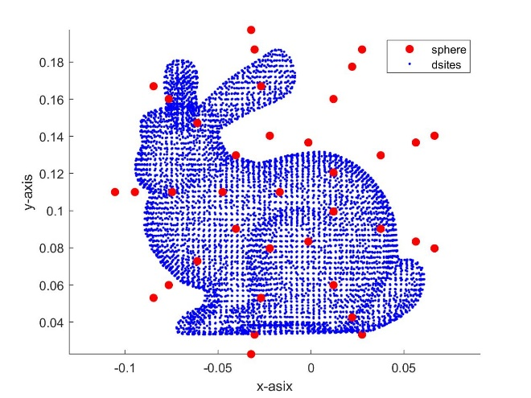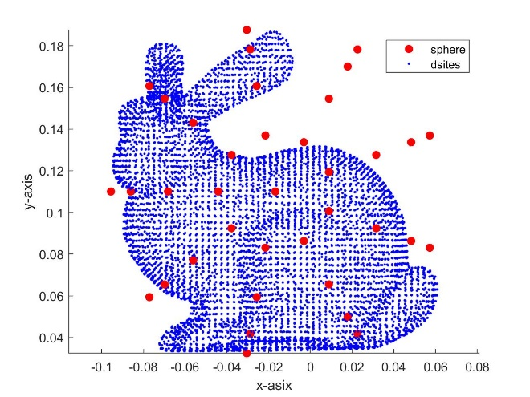
Figure 3: Sphere with Radius of 0.09 Figure 4: Sphere with Radius of 0.08
Here, it can be easy to tell that a small radius will be required to build the 3D model. However, it may not be readily available to tell whether the radius of 0.08 or 0.09 should be used. However, for the time being, the larger value will be used. The reasoning behind this is that by viewing the following figures, a radius of 0.09 fully encircles the surface points of the bunny.
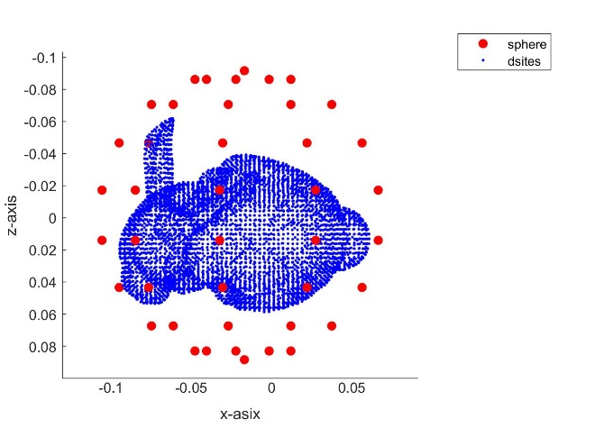
Figure 5: Front View of the Bunny Figure 6: Top-Down View of the Bunny
Through trial and error, it was found that the linear spaces for each axis needed to be extended out by 0.05. The next task was to find the shape parameter's value. The following figures show the shape parameters' values and the resulting figures.
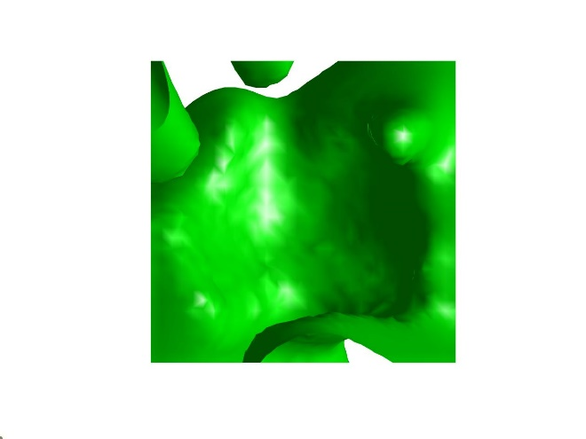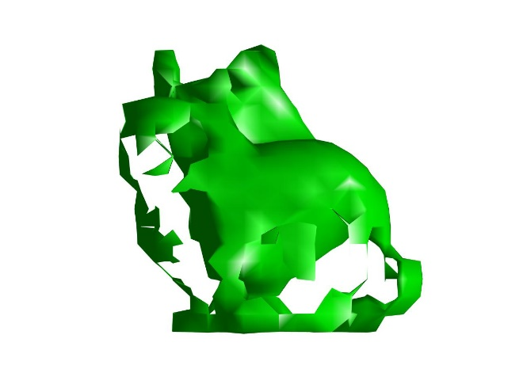
Figure 7: 3D Figure with Shape Parameter of 0.5 Figure 8: 3D Figure with Shape Parameter of 1/150
As shown, a bunny started to appear as the shape parameter's value decreased. Finally, after setting the shape parameter equal to 1/500, a sphere radius of 0.09 centered over the bunny gave us Figure 9. However, it should also be noted that this figure is produced using a neval value of 30. A bunny is starting to take shape in this figure, but the resolution is relatively low, and the ears are not rendered as nicely. Thus, the task is to improve the resolution of the 3D model.
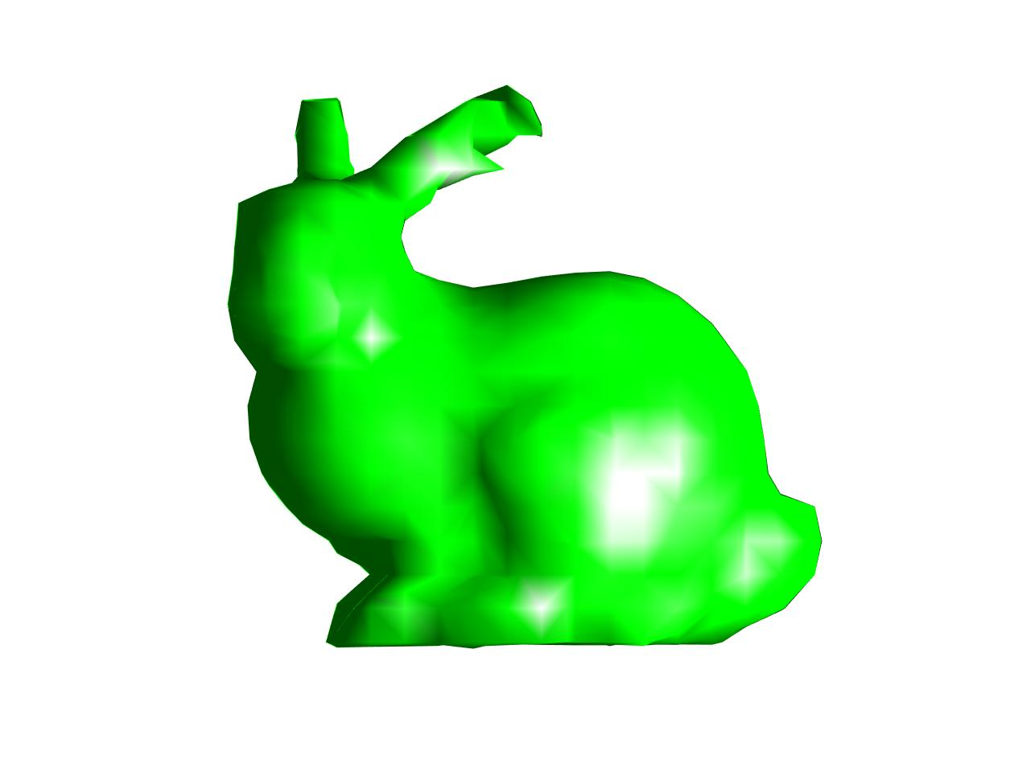
Figure 9: 3D Bunny with Neval at 30
One of the first steps to check on the resolution was to see if 0.09 was the better sphere radius to use. However, building the 3D figure with a sphere radius of 0.08 will produce the following figure.
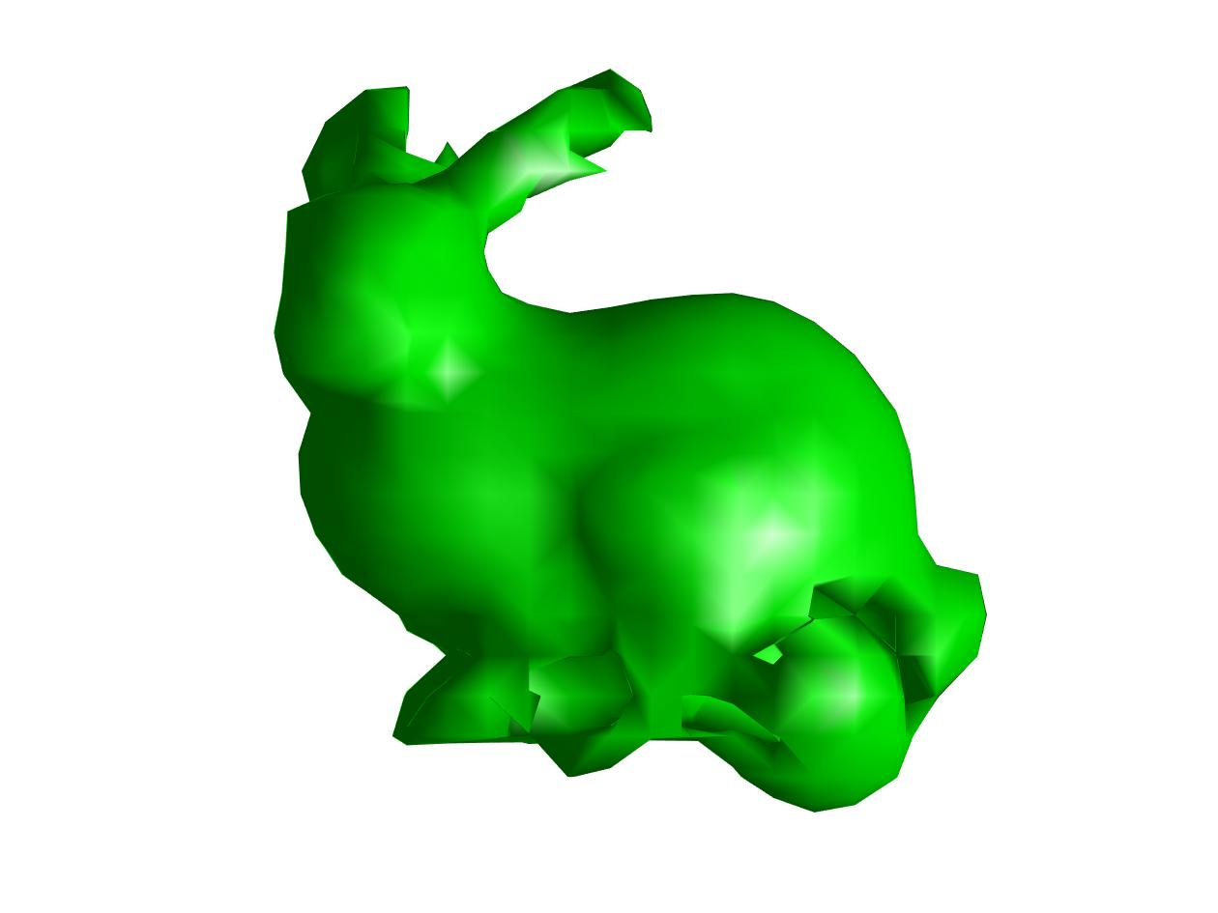
Figure 10: 3D Bunny with Sphere Radius of 0.08 and Neval at 30
Thus, the smaller sphere radius cuts off some surface points, interfering with the 3D model. The next tweak investigated is what happens if the number of sphere faces. The figures above were produced using a value of 9. However, the following figures will demonstrate the results when that value is changed.
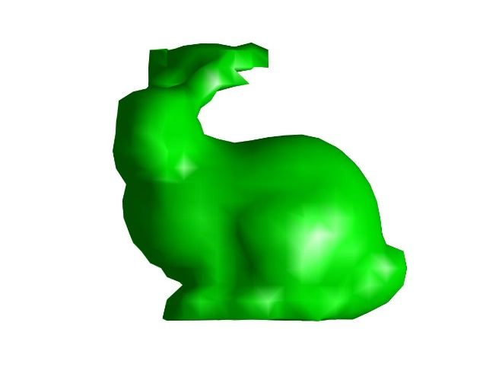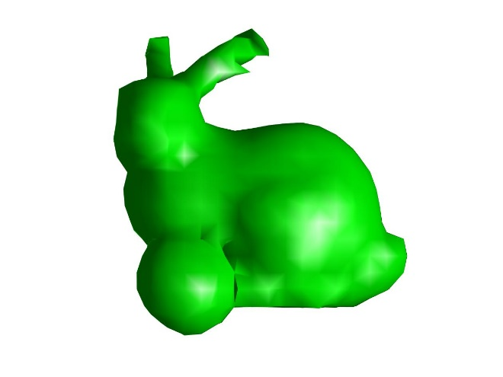
Figure 11: 3 Sphere Faces Selected with Neval at 30 Figure 12: 6 Sphere Faces Selected with Neval at 30
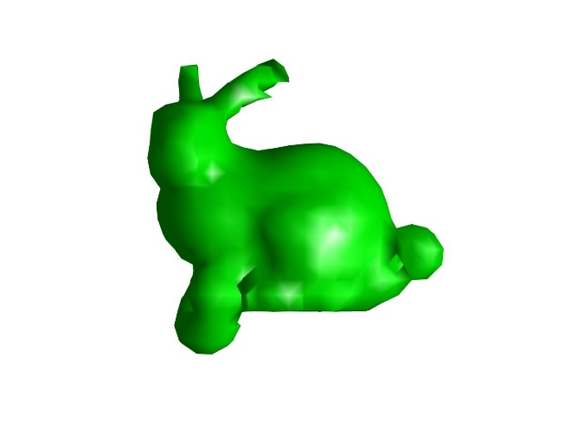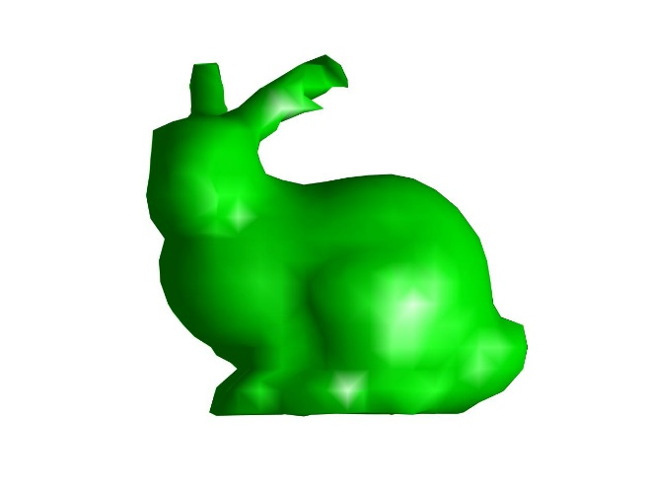
Figure 13: 12 Sphere Faces Selected with Neval at 30 Figure 14: 9 Sphere Faces Selected with Neval at 30
So, a value of 9 gave us the best 3D model.
However, we can still improve upon this model. The last value that we altered was the neval value. This value controlled how many function evaluations the code completed. The results of the tested neval values can be found below.
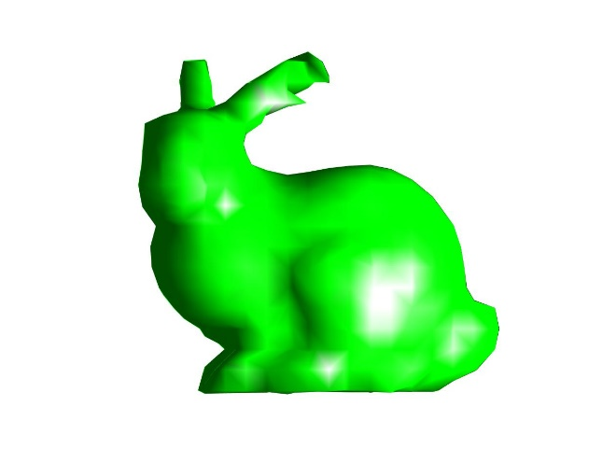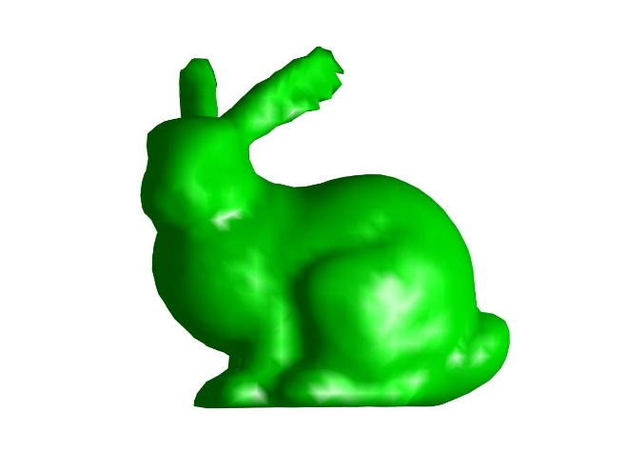
Figure 15: 3D Bunny with Neval at 30 Figure 16: 3D Bunny with Neval at 50
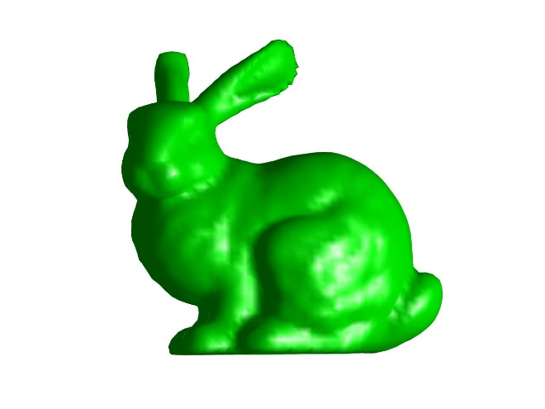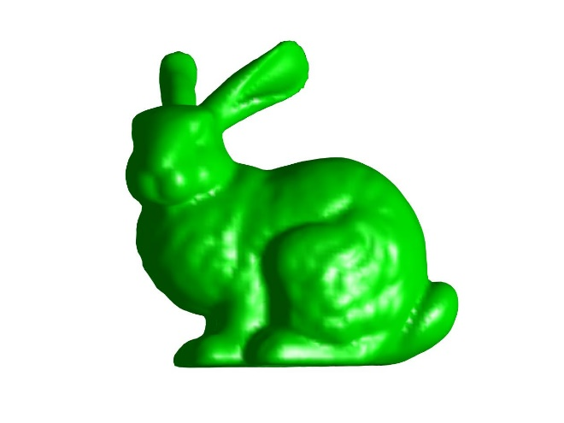
Figure 17: 3D Bunny with Neval at 80 Figure 18: 3D Bunny with Neval at 120
Conclusions:
Through several trial and error steps, the 3D bunny is recreated in the highest resolution possible. This final model took about 5 minutes to complete on my laptop. However, the normal vectors were not factored in throughout all of these runs. Instead, what was considered were the center of surface points, the outer sphere surrounding the surface points, and the surface points. Finally, two more tests were run using the normal with the neval set at 120. Those results can be viewed below.
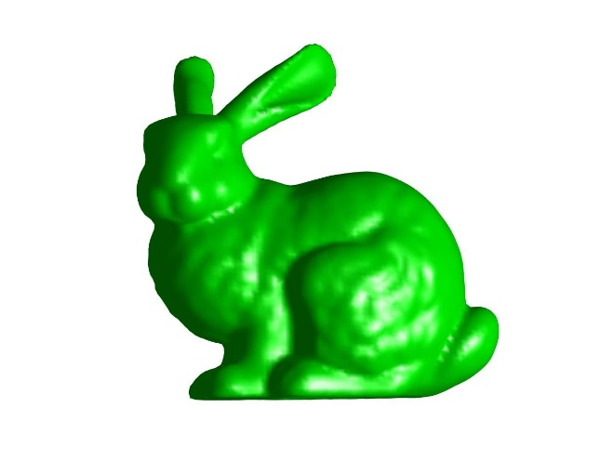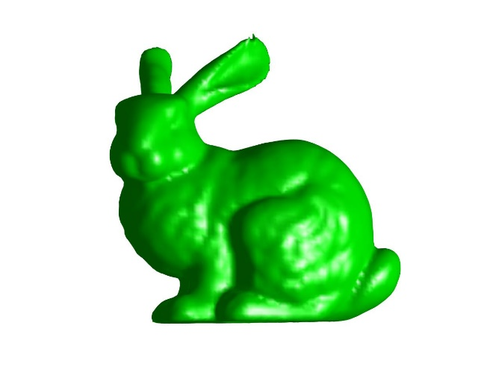
Figure 19: 3D Bunny with Normals pointing outside Figure 20: 3D Bunny with Normals pointing inside
Figures 18 and 19 produce the best results for the 3D bunny. Figure 20 is relatively good; however, it does have a blemish on one of the ears.

