Introduction:
In this assignment, the task was to take a photo of our choice and use singular value decomposition (SVD) to compress the photo. The ranks used to compress the photo were 300, 150, 100, and 50. Then, to make the comparison of the compressed photos more manageable, the MATLAB command "subplot" was used to plot the results at once. The image selected for this assignment was that of a horse.
SVD of Nonsquare Matrices and Ranks:
If A is an $m×n$ matrix, then A can be factored such that,
$$A=UΣV^{T} \\ A=\left[u_{1}…u_{m}\right]\left[\begin{matrix}σ_{11} & ⋯ & σ_{1n} \\ ⋮ & ⋱ & ⋮ \\ σ_{m1} & ⋯ & σ_{mn}\end{matrix}\right]\left[\begin{matrix}v_{1}^{T} \\ ⋮ \\ v_{n}^{T}\end{matrix}\right]$$in which $U, Σ,$ and $V$ have the sizes $m×m, m×n,$ and $n×n,$ respectively. The above formula is a general overview of the factorization, but a more in-depth dive will occur as we examine how it was applied to this assignment.
We can modify the above equation to consider what a rank would do to the factorization. If A is an $m×n$ matrix of rank k, then A can be factored as,
$$A=UΣV^{T} \\ A=\left[u_{1} u_{2}…u_{k}\right| u_{k+1}…u_{m}] \left[\begin{matrix}σ_{1} & 0 & ⋯ & 0 & ⋮ & \\ 0 & σ_{2} & ⋱ & 0 & ⋮ & \\ ⋮ & ⋱ & ⋱ & 0 & ⋮ & 0_{k\left(n-k\right)} \\ 0 & ⋯ & 0 & σ_{k} & ⋮ & \\ ⋯ & ⋯ & ⋯ & ⋯ & ⋯ & ⋯ \\ & & 0_{\left(m-k\right)k} & & ⋮ & 0_{\left(m-k\right)\left(n-k\right)}\end{matrix}\right]\left[\begin{matrix}v_{1}^{T} \\ v_{2}^{T} \\ ⋮ \\ v_{k}^{T} \\ - \\ v_{k+1}^{T} \\ ⋮ \\ v_{n}^{T}\end{matrix}\right] \\ A=σ_{1}u_{1}v_{1}+σ_{2}u_{2}v_{2}+…+σ_{k}u_{k}v_{k}.$$
With rank k, every entry greater than the k-th entry will be discarded.
Generalized Overview of SVD in this Code:
Since this code uses SVD to compress a photo, it is essential to understand how this was applied. The first step was to factor out $Σ$, which will be referred to as S. In this step, the command "eig" was used on $A'×A$. The result will be a square matrix required to use the command "eig." This command returns two matrices, a diagonal matrix (D) that contains the eigenvalues and then another matrix (W) that returns the corresponding right eigenvectors such that $A×W=W×D$. For S, we want to work with the eigenvalues.
Right now, the eigenvalues are stored in a diagonal matrix. Here, the command "diag" extracts the diagonal entries and stores them as a column vector. The next step is to pass this vector through the command "maxk." What this command does is that it finds the greatest values of the input vector and then returns them in descending order. Here, the vector had n entries, so "maxk" was set to sort through all the entries. The result was one column vector that contained the eigenvalues in descending order, which will be called sA, and a second column that contained the indices of sA before being put into descending order. This second vector will be referred to as inA since it will be used later.
The S matrix from SVD is nearly achieved. Only two more steps remain until the desired matrix is reached. The next step is to take the square root of sA before passing it through the "diag" command again. This command will take our column vector and turn it into a square diagonal matrix. Finally, the square sA matrix needs to convert back into the original dimensions. Therefore, A's factorization into S is completed, and now attention can be turned to created U and V.
Starting with V, since it will be needed to create U, the first step is to prime V with the command "zeros (n, n)." This command creates an $n×n$ matrix where every entry is zero. Then, a parallel loop will overwrite the zero entries in the primed V with the eigenvectors from "eig" based on the indexing from inA. The command for this is
$$V\left(:,i\right)=Vec(:,inA\left(i\right))$$
where $i=1:n$. At the end of the loop, the factorization for V is returned, and then attention can be turned to obtaining U. Here, U will also be primed, but the command "zeros (m, m)" will be used. Another parallel loop will be used that will overwrite the entries inside the matrix U. We can compute the entries of U by using the formula $σu_{i}=Av_{i}$, where $σ$ is the eigenvalues that make up the diagonal of S. In our code, this is done within a loop using the command
$$U=S{\left(i,i\right)}^{-1}*A*V\left(:,i\right),$$
where $i=1:m$. Now, the SVD factorization has been completed at the end of this. This factorization was verified using the built-in MATLAB "svd" function.
Application of SVD and Rank in this Code:
The SVD overview was done to generalize what was occurring within this code. As a reminder, the objective was to complete an image compression using SVD. So, the first step to completing this objective is to import a picture into MATLAB. The command used here was "imread," but this imported the data for the picture as uint8, which is not a data type that can be readily manipulated. Here the command "im2double" is used to apply manipulations of the image data. This command takes the date from the image and converts it into double-precision, which we can easily manipulate.
Since the task is to compress an image, extracting the red, blue, and green matrices from the image is the easiest way to perform this. The matrices were named R, G, and B the SVD factorization was completed on each of the matrices separately. Once that factorization was completed, there were nine matrices (sR, vR, uR, sG, vG, uG, sB, vB, uB). Here is where the application of the ranks comes in.
Since rank deletes entries from the SVD factorization, this is where the image compression comes into play. For example, the k values for this code were 300, 150, 100, and 50. Therefore, Only the first 300 entries were kept, then the first 150 entries were kept, the first 100 entries were kept, and the first 50 entries were kept. This rank application reduced the size of the matrices produced from the image that compressed the data.
Results on the Image:
The image in its original form is that of a horse, and it can be viewed below. 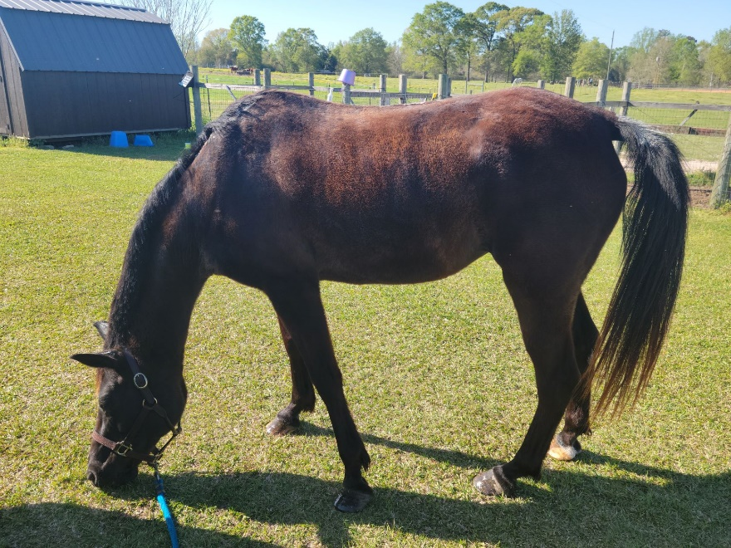
Figure 1: Uncompressed image of a horse
As we can see, there is no loss of data and no distortions appearing in the data with this image. It should be noted that the image in its original form has the dimensions 1254 by 1672, which are the dimensions of the R, G, and B matrices at the start of the code.
After applying the first rank, k1=300, we only retain the first 300 entries from the SVD factorization of our three main color matrices. Currently, the code has factors for U, S, and V, of the three primary color matrices, but the goal is to return to a matrix that contains the color information that can be used to generate the image. To do, the equation $R=uR*uR*{vR}^{T}$ is applied. It should be noted here that U was defined to remain a row vector, S remains an n-by-n matrix, and V is kept as a column vector. This equation would return the compressed R matrix and then repeat this process on the G and B matrices to compress the other color matrices. The results of the 300-rank compression can be viewed below.
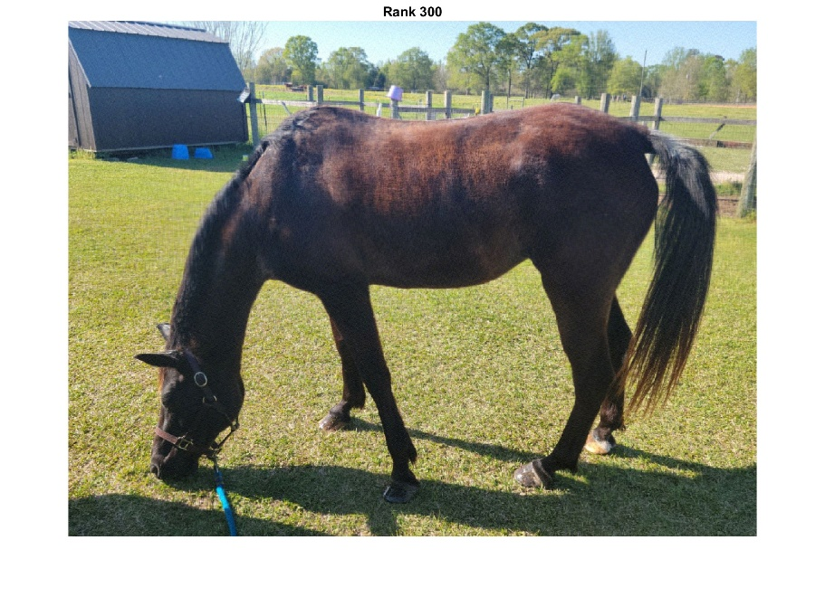
Figure 2: Image Compression at Rank 300
Looking at Figure 2 and comparing it to Figure 1, these look similar. There has been minimal data lost that the human eye can detect. Also, the dimensions of the matrices used to produce this image are 300 by 300.
The process outlined above is repeated for the remaining ranks. Those ranks would be known as k2=150, k3=100, and k4=50. With each rank, the size of the matrices used to produce the image is reduced; k2 only keeps the first 150 entries, k3 keeps the first 100 entries, and finally, k4 keeps the first 50 entries. The results of these rank values can be viewed below.
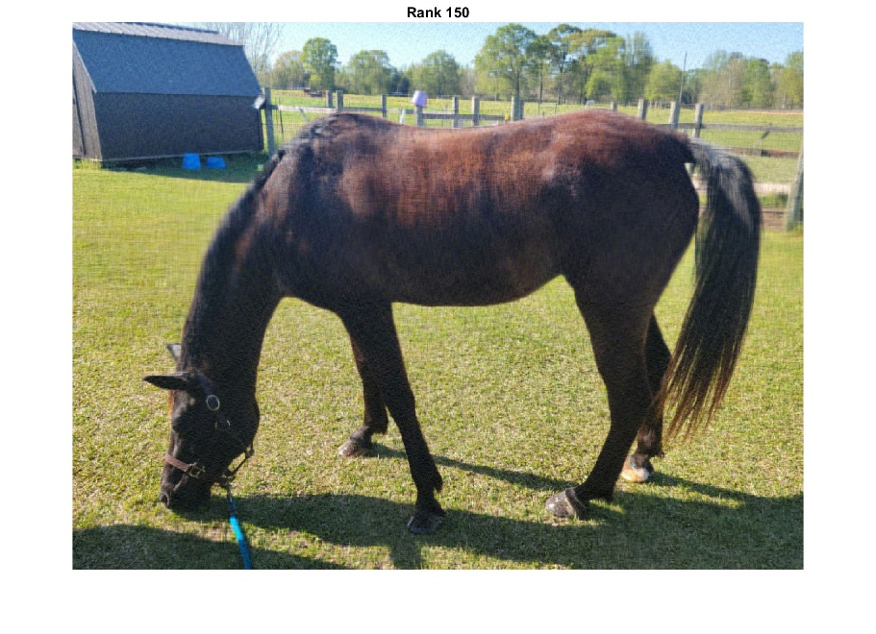
Figure 3: Image Compression at Rank 150
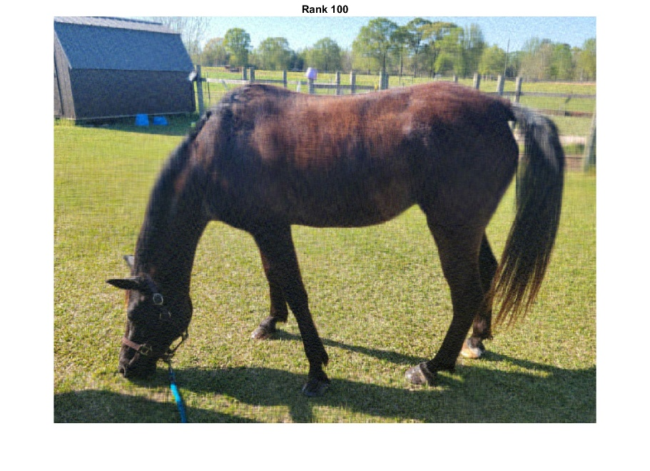
Figure 4: Image Compression at Rank 100
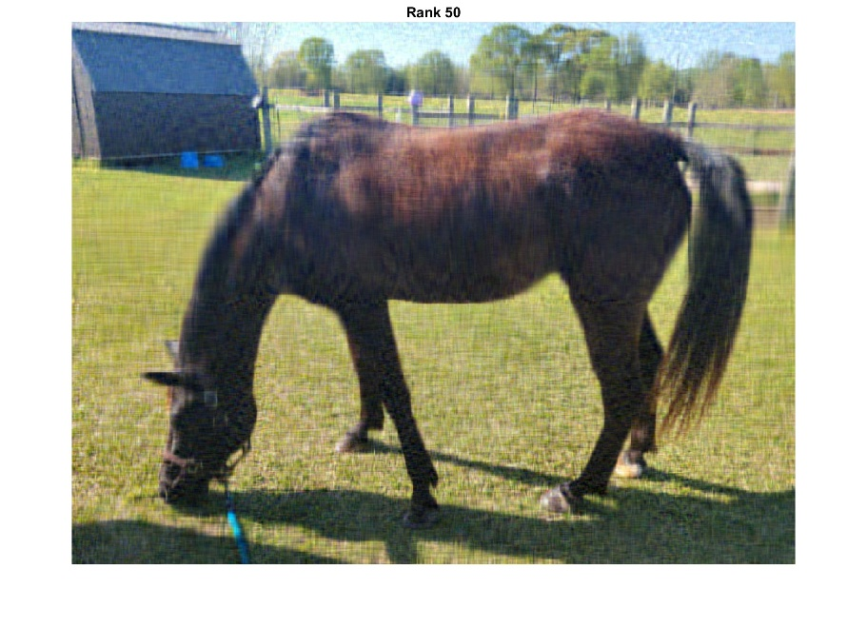
Figure 5: Image Compression at Rank 50
From Figures 3 to 5, it becomes more noticeable that there is a data loss. The image starts to distort to the point that the human eye can detect it. Overall, the image is lost in detail throughout the various ranks. An example of this would be in Figure 1; a purple bucket can be viewed on a fence post in the background. However, as the ranks decrease, it becomes more difficult to tell that this bucket is even in the picture. In order to see the loss of detail more efficiently, please view the figure below.

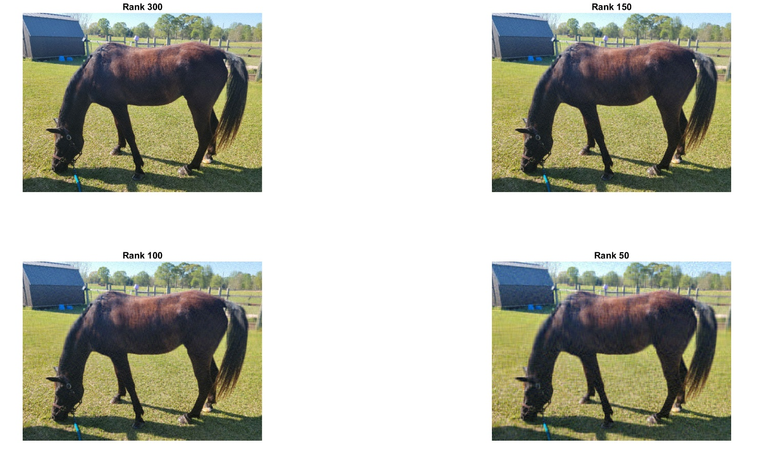
Figure 6: Image Compression Ranks Plotted Using Subplot
Figure 6 utilizes the MATLAB command "subplot" to plot all four compressed images. However, since these images tend to be smaller, it can be harder to see the loss of detail. Thus, that is why Figures 2 through 5 were provided. To allow for easier viewing of the images separately.
Conclusions:
This process seems like too much work to go through to remove some matrix entries, so the question becomes why someone should bother going through the SVD compression instead of just removing the entries from the R, G, and B matrices. If someone had just taken the first 300 entries from R, G, and B and tried to plot that, the result would be a thin white line. There is too much information lost to obtain anything that resembles the original image. SVD factorization with the rank allows the entries to be removed while maintaining the necessary information to generate an image.
Also, it is essential to remain mindful of the data lost. For example, image compression reduces storage space and increases electronic transmission. However, an image resembled the original image at each rank, but there was apparent data lost. There, one must always consider the end goal of the image to determine the amount of acceptable data lost.

