Introduction:
For assignment ten, the goal was to perform a surface reconstruction of a three-dimensional surface. The surface that was used here was that of a dragon. This goal is very similar to when working on the bunny. However, the geometry of the dragon is a bit more complicated, so it provided a new set of challenges that needed to be handled to reconstruct the image correctly. Finally, the last task was to estimate the volume of the dragon.
Reconstruction Process:
During the actual reconstruction of the dragon, a process using normalized multiquadric radial basis functions was used. Now, this was the same process used for the bunny. However, for review, when working with surfaces, they can be approximated using the set $\left\{x_{j}\right| 1≤j≤N\}∈Ω∪∂Ω∈R^{3}$. Here, this set contains $N$ distinct points that correspond to points on the surface. The equations to approximate this surface is given by,
$$s\left(x\right)=\sum_{i=j}^{N}{λ_{j}ϕ(j)}.$$
Where $λ_{j}$ are real-valued coefficients and $ϕ\left(j\right)=ϕ\left(\left|\left|x-x_{j}\right|\right|\right)$ come from the radial basis functions. Now, in this code, the specific radial function used is $ϕ\left(j\right)=\sqrt{1+{\left(rc\right)}^{2}}$ where c is the shape parameter and $r=||x-x_{j}||$ for $1≤j≤N$. For clarity, we are using the Euclidean norm throughout this process. Now, for selecting a value for the shape parameter. Of course, this value must be positive, but this process was completed through trial and error and will be discussed later.
Selecting Interior Versus Exterior Points:
Thinking back to the bunny, it was reconstructed using exterior points. Now, this process was attempted with the dragon. The results of creating an ellipsoid around the dragon can be viewed below.
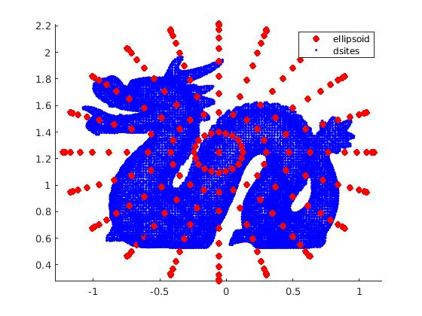
Figure 1: Dragon Surface Points with Ellipsoid Points Plotted
There was a lot of trial and error to achieve this plot. The goal was to create an exterior ellipsoid that encircled the dragon while also minimizing the space included in the ellipsoid. In Figure 1, the default number of points; however, several different point configurations were tested. Unfortunately, the ellipsoid results did not produce a dragon with the quality that was sought after. The results directly related to the plot in Figure 1 can be viewed below.
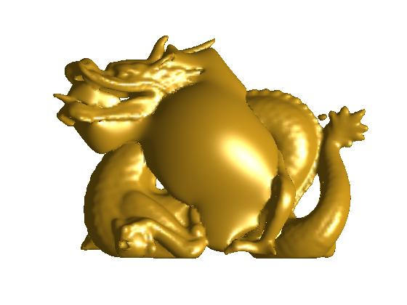
Figure 2: Dragon Reconstructed with Ellipsoid
Viewing the figure above, a lot of the space is being filled. So we can see on the outside that we have a dragon taking shape, but it gets lost in the middle. This process was repeated regardless of the shape parameter now how many points the ellipsoid contained. Thus, for that reason, another approach was taken. This approach used the normal vectors and the surface points to create interior points to help reconstruct the surface.
When using the normal vectors, the goal is to find the interior points by solving the equation $S+V*c$. In this equation, $S$ is the set of surface points, $V$ is the set of normal vectors, and $c$ is the offset distance from the surface points. The results of using all surface points to create the interior points can be viewed below.
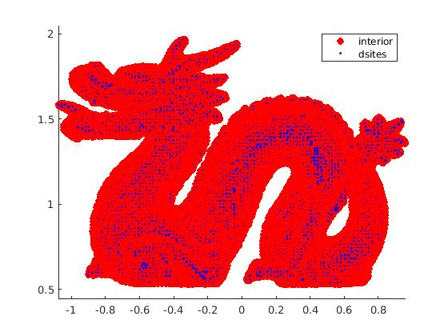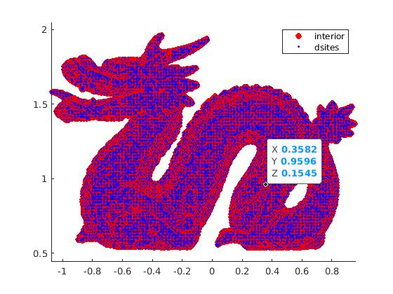
Figure 3: Interior Points with .001 Offset Figure 4: Interior Points with .01 Offset
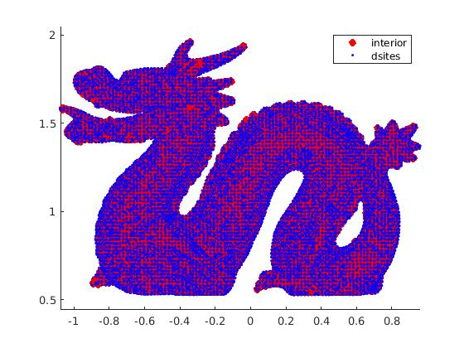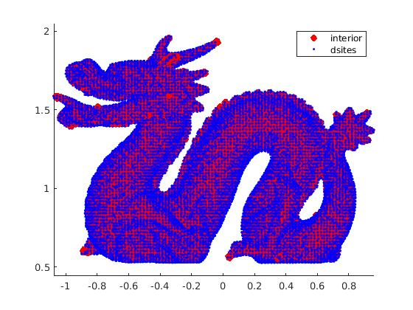
Figure 5: Interior Points with Offset of .015 Figure 6: Interior Points with Offset of .019
On the surface, it seems like it would be better to go with the largest possible offset to ensure all of the points remain inside the surface points. However, this would create the same problem as using the exterior points. Hence, why the offset values were chosen the way they were. Figures 4 and 5 provided points that were well within the surface points, but they did create a few holes in the reconstruction. The offset of .001 was too small and left too many points outside the dragon. Therefore, the offset of .01 was selected since it contained most points inside the dragon while keeping the interior points close to the surface points. In order to see this in the reconstruction, you can view those results below.
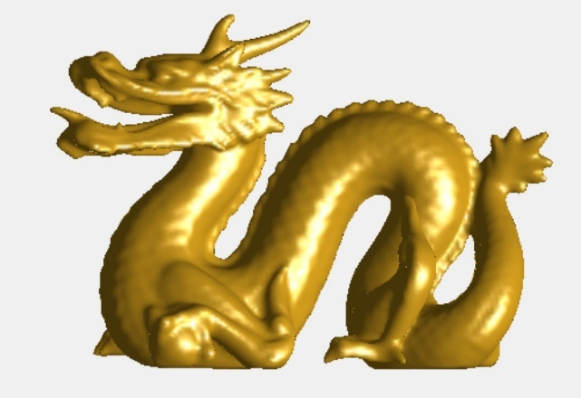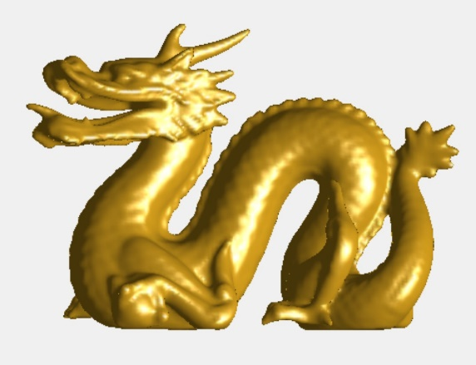
Figure 7: Reconstructed Using .001 Offset Figure 8: Reconstructed Using .01 Offset
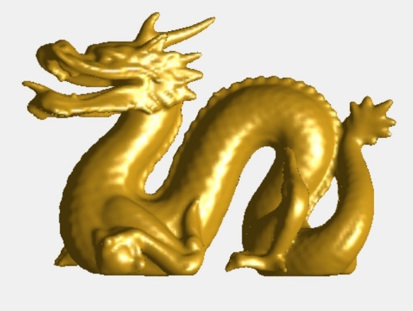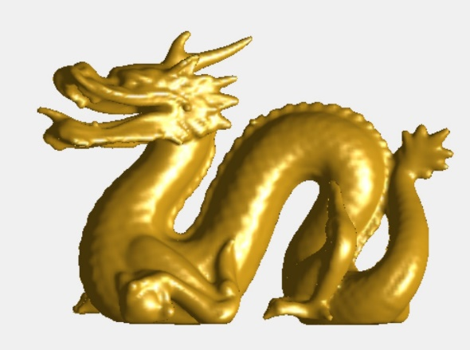
Figure 9: Reconstructed Using .015 Offset Figure 10: Reconstructed Using 0.19 Offset
However, using all surface points to create the surface points is unnecessary because this produces too much extra data. Therefore, the next step is to reduce the number of interior points used but still get an accurate dragon. Since this is still within the testing phase, the resolution will still be reasonably low to speed up the testing process. So, until stated otherwise, the neval value will be set to 60. This decision balances out speed but gives enough resolution to spot potential problem areas. In order to reduce the interior points, the MATLAB command skip will be used. This command lets the code skip values contained within the normal vectors and the surface points to reduce the number of interior points. The skip values used were 200, 400, 800, and 1,000. To quickly explain the skip command, if the skip value is set to 200, it means only using the points $1, 201, 401, …$ so on and so forth. This is the same idea for any of the values mentioned before. Those results can be viewed below.
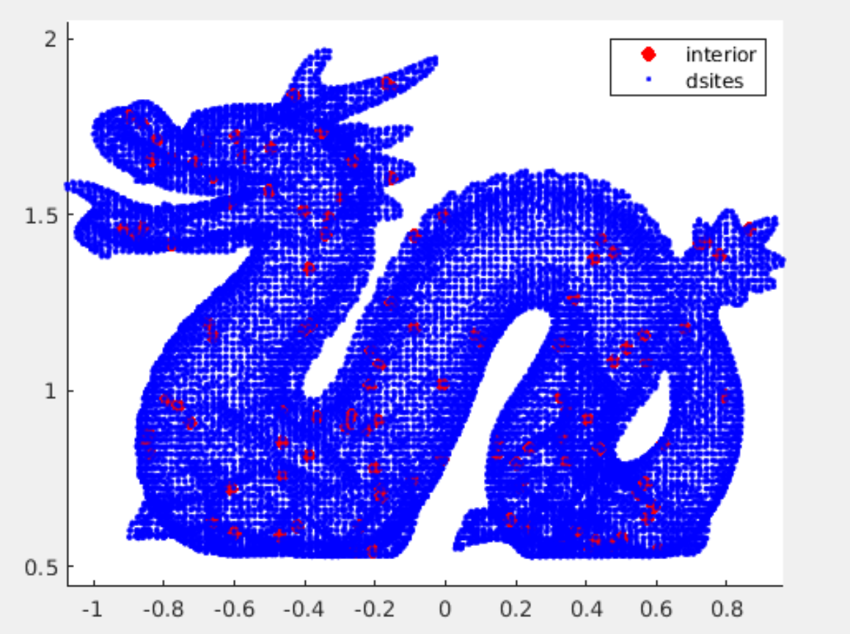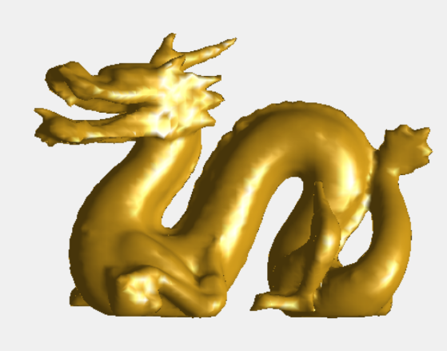
Figure 11: Plot with 200 Skip Figure 12: Related Dragon Reconstruction
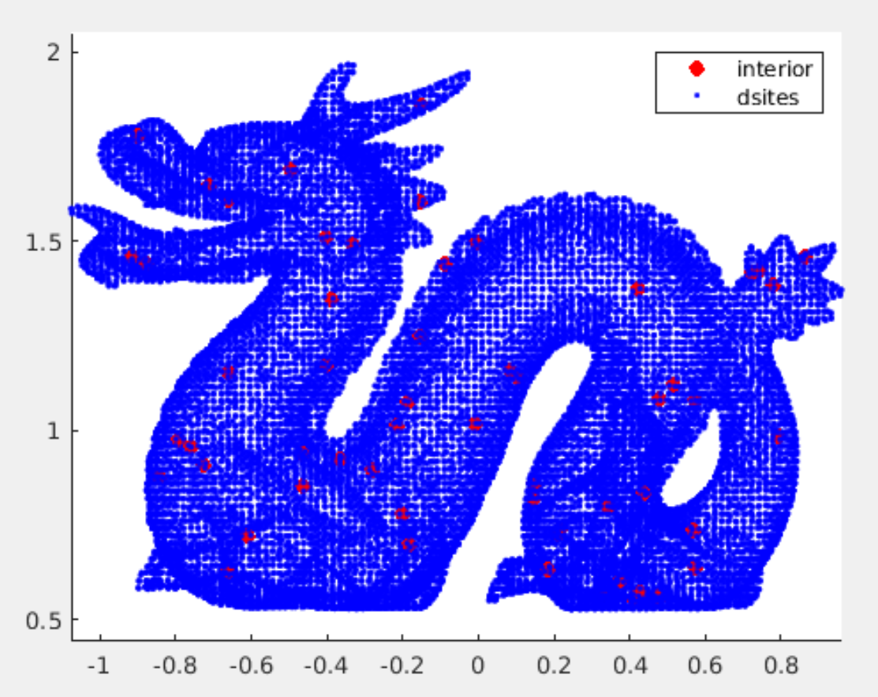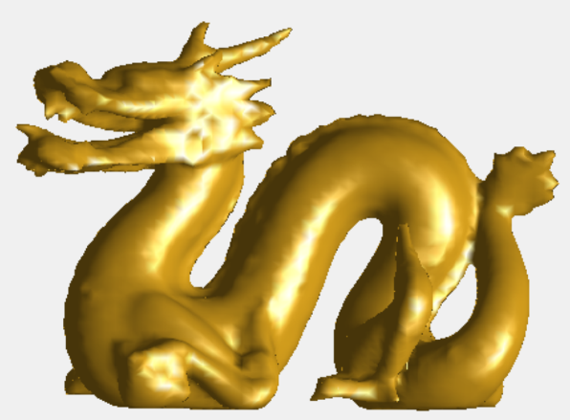
Figure 13: Plot with 400 Skip Figure 14: Related Dragon Reconstruction
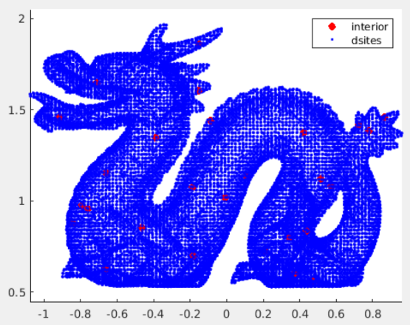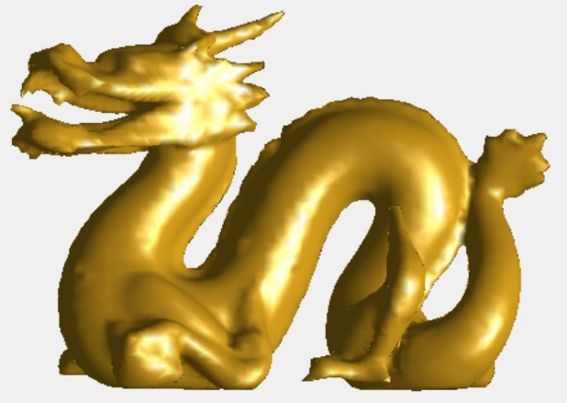
Figure 15: Plot with 800 Skip Figure 16: Related Dragon Reconstruction
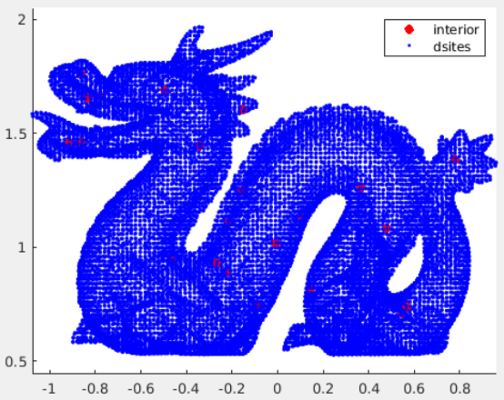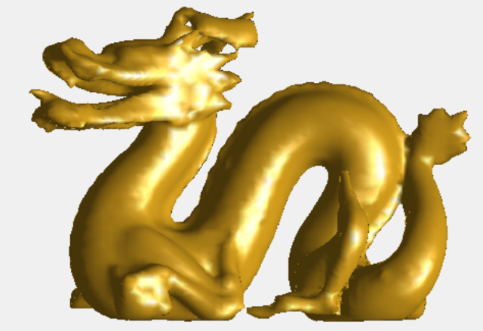
Figure 17: Plot with 1000 Skip Figure 18: Related Dragon Reconstruction
In the figures above, the ideal skip would be 400. This skip balances out limiting the number of interior points while not distorting the image. Also, the details between the 200 skip and the 400 skips appear pretty similar. Thus, this will be the skip value used moving forward. The following discussion will be about how to determine the shape parameter.
Selecting the Shape Parameter:
As stated above, the selection of the shape parameter was made on a trial and error process. However, the goal was to select the one that provided the best results. Therefore, the $c$ values tested were 1/10, 1/75, 1/150, and 1/300. In addition, these values were tested using the 400 skips that were determined to be ideal above.
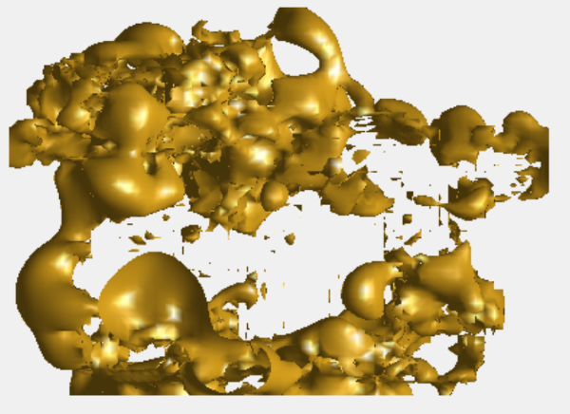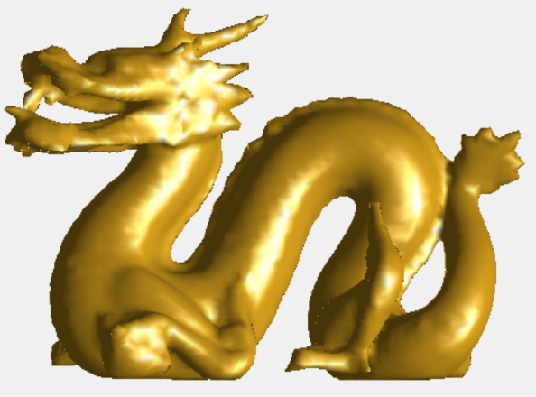
Figure 19: Shape Parameter at 1/10 Figure 20: Shape Parameter at 1/75
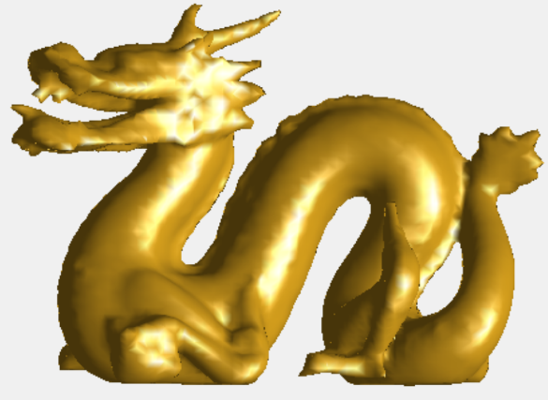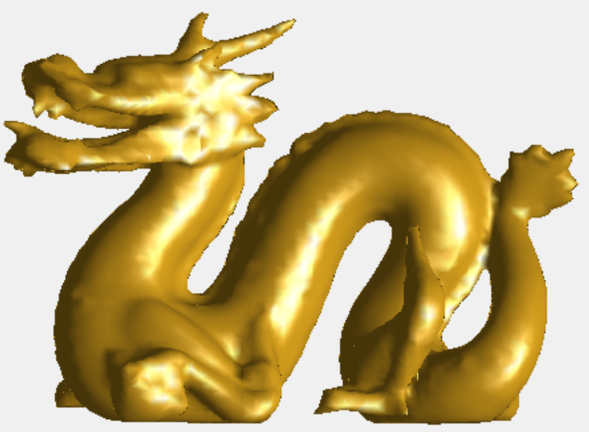
Figure 21: Shape Parameter at 1/150 Figure 22: Shape Parameter at 1/300
Looking at the four figures above, we will want to use the shape parameter equal to 1/300. It can be a bit tricky to tell between Figures 21 and 22. However, when taking a close examination of the jaw, it can be seen that in Figure 22, the teeth are better defined. The teeth in Figure 21 are flat, almost like being cut off. Meanwhile, the teeth in Figure 22 have the shape that one would expect dragon teeth to have.
Reconstructing the Dragon.
Using the information from the above sections, reconstructing the best dragon possible can begin. This dragon uses interior points with an offset of 0.01, and every 400 hundredth point will be kept. Then the shape parameter will be set to 1/300. Also, the neval value will be set to 200 since the goal is to increase the resolution until the dragon's details can be seen.
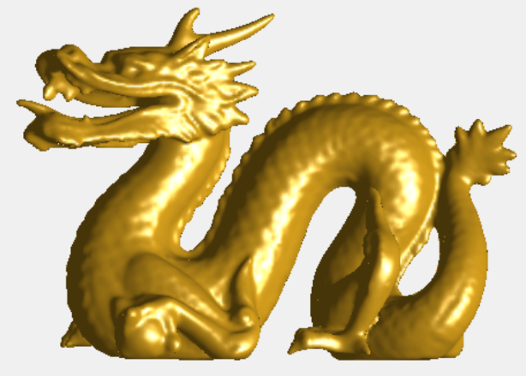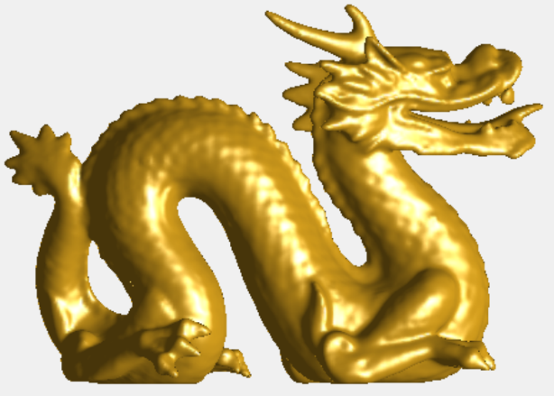
Figure 23: Front of the Dragon Figure 24: Back of the Dragon
Conclusions:
This dragon has been the most complicated surface reconstructed so far in this class. Due to the amount of data required to reconstruct this surface, the use of a cluster computer was required. Even with the cluster computer this code took 454.760201 seconds to complete. Keep in mind this is because that there ended up being 22,803. Also, throughout all of this testing the volume ranged from 0.3980 to 0.4710. These volume values seemed to be dependent on what was selected for the shape parameter value.
Finally, I would like to point out that I was unsuccessful in recreating this surface absolutely perfectly. There ended up being a couple of tiny blemishes that I was unable to correct even after several attempts. I tried reconstruction the surface with the center, without the center, I edited the bounding box several times. I tried including every possible interior point and getting ready as many possible. I even tried using 1/600 and 1/1000 as the shape parameter. However, I was unable to correct the tiny blemishes that I noticed. The blemishes can be viewed in the figures below since they can be hard to see within Figures 23 and 24.
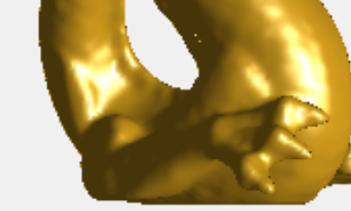
Figure 25: Tiny Holes on the Back of the Dragon Above Back Leg

