BUSINESS ANALYST CASE STUDY B2B Lead Management Process Optimization
Data-Driven Business Process Improvement
Document detail | Value
Version | 1.0
Status | Final – Portfolio Case Study
Project type | Business process analysis and Process Optimization
Dataset | 500 synthetic B2B lead records
Tools | Microsoft Excel, draw.io, Microsoft Word
Prepared by | PRATHIBHA P
Date | November 2026

IMPORTANT CONTEXT : This is a simulated portfolio project, not a real company implementation. Your document already communicates this correctly.

No real customer or company data is represented.

TABLE OF CONTENTS
Contents
TABLE OF CONTENTS 2
Document Guide 4
1. Executive Summary 4
2. Business Problem Statement 4
2.1 Follow-up timeliness 4
2.2 Overdue activities 4
2.3 Missing scheduling information 4
2.4 First-contact tracking 5
3. Project Objectives 5
4. Project Scope 5
4.1 In scope 5
4.2 Out of scope 5
4.3 Project deliverables 6
5. Stakeholder Analysis 6
5.1 Engagement approach 6
6. As-Is Process Analysis 6
6.1 Current-state overview 6
6.2 Observed performance 7
6.3 Process observations 7
7. Root Cause Analysis 8
7.1 Purpose 8
7.2 Potential contributing factors 8
7.3 Validation approach 8
8. Gap Analysis 8
9. Business Requirements 9
10. Functional and Non-Functional Requirements 10
10.1 Functional requirements 10
10.2 Non-functional requirements 10
11. To-Be Process 11
11.1 Proposed future-state workflow 11
11.2 Proposed controls 11
12. KPIs and Expected Business Impact 13
12.1 Baseline and illustrative targets 13
12.2 KPI definitions 13
12.3 Expected business benefits 13
12.4 Measurement limitations 13
13. Acceptance Criteria 14
13.1 Validation approach 15
14. Assumptions, Risks and Dependencies 15
14.1 Assumptions 15
14.2 Risks and mitigations 15
14.3 Dependencies 15
15. Conclusion 16
Appendix A. Supporting Project Files 16
Appendix B. Final Review Checklist 16

Document Guide
This document connects the project’s data findings to process improvements, business requirements and proposed measures of success. Use Word’s References > Table of Contents feature to add an automatic contents page after reviewing the heading styles.
HOW TO READ THIS DOCUMENT Sections 1–8 explain the business context and analysis. Sections 9–11 define requirements and the future workflow. Sections 12–15 cover KPIs, validation, risks and conclusions.

1. Executive Summary
This project examines a simulated B2B lead management workflow to identify opportunities to improve first-contact tracking, lead qualification, follow-up scheduling and sales handoff. The analysis uses 500 synthetic lead records and Microsoft Excel to review data completeness and follow-up performance.
Of 380 completed follow-ups included in the timeliness analysis, 197 were completed on time and 183 were completed after their scheduled due dates. The dataset also identifies 82 overdue activities and 38 records without a recorded follow-up due date.
KEY FINDINGS 48.16% of the 380 completed follow-ups were late; the on-time completion rate was 51.84%. There were 82 overdue activities and 38 records without a recorded follow-up due date.

The proposed future process introduces reminders, required scheduling information, consistent qualification steps, activity logging and escalation for overdue work. Illustrative targets include increasing on-time completion to 80%, reducing the overdue rate to 8%, and reducing missing follow-up due dates to 2%.
These targets are planning assumptions, not achieved results. Actual benefits would need to be confirmed through implementation and post-implementation measurement.

2. Business Problem Statement
B2B lead management involves capturing lead details, assigning ownership, contacting prospects, qualifying opportunities, scheduling follow-ups and handing qualified leads to the next sales stage. If activities are not recorded and monitored consistently, teams may have limited visibility into what needs attention and when.

2.1 Follow-up timeliness
Of 380 completed follow-ups used in the timeliness calculation, 183 (48.16%) were completed after their recorded due dates. The remaining 197 (51.84%) were completed on time.

2.2 Overdue activities
A total of 82 records (16.4% of the 500-lead dataset) were classified as overdue at the time represented by the dataset. This point-in-time status measure is different from the late-completion measure.

2.3 Missing scheduling information
Thirty-eight records (7.6%) had no recorded follow-up due date. Without a due date, it is harder to determine whether a planned activity is on schedule.

2.4 First-contact tracking
Thirty-eight records (7.6%) had no recorded first-contact timestamp. These records cannot be included in a complete first-response-time calculation without additional information.
PROBLEM TO ADDRESS The records show late and overdue follow-up activity alongside missing scheduling and contact information. The project focuses on improving follow-up control, CRM completeness and performance visibility.

The dataset shows what was recorded; it does not establish why delays occurred or prove that a specific tool, policy or management practice caused them.

3. Project Objectives
The project aims to translate the observed data issues into practical process improvements and measurable requirements.
- Improve follow-up timeliness through reminders and clearer ownership of scheduled activities.
- Reduce overdue follow-ups through exception reporting and an agreed escalation process.
- Improve scheduling completeness by requiring a due date and owner when a follow-up is created.
- Improve first-contact measurement by recording contact activities and timestamps consistently.
- Support consistent lead qualification through a documented checklist and clear decision outcomes.
- Improve sales handoff by defining the information that must accompany a qualified lead.
- Establish operational KPIs that can be reviewed regularly.
ILLUSTRATIVE TARGETS On-time completion: 51.84% → 80%. Overdue follow-up rate: 16.4% → 8%. Missing due-date rate: 7.6% → 2%. Targets require business approval and should be reassessed after a pilot.

4. Project Scope

4.1 In scope
- Analysis of 500 synthetic B2B lead records.
- Data quality checks and review of missing timestamps and scheduling fields.
- First-contact, qualification and follow-up performance analysis where source fields allow.
- Creation of As-Is and To-Be process maps.
- Fishbone analysis of potential contributing factors.
- Gap analysis and prioritization of proposed improvements.
- Definition of business requirements, functional requirements and acceptance criteria.
- Definition of baseline KPIs and illustrative targets.

4.2 Out of scope
- Building or deploying a production CRM solution.
- Integrating the workflow with live email, telephony or sales platforms.
- Using real customer or company data.
- Conducting actual stakeholder interviews or organizational process observation.
- Measuring real revenue uplift, conversion improvement or post-implementation benefits.
- Production testing, rollout, training and change management.

4.3 Project deliverables
Deliverable | Description
Excel analysis workbook | Data quality checks, calculations, PivotTables, analysis and KPI comparison.
As-Is process map | Working representation of the assumed current workflow and observed gaps.
To-Be process map | Proposed workflow with reminders, validation and escalation.
Fishbone diagram | Potential causes organized into analysis categories.
Gap analysis | Comparison of current-state observations and proposed future-state controls.
BRD | Business context, requirements, acceptance criteria, KPIs and risks.

5. Stakeholder Analysis
The roles below are representative of a typical B2B sales organization. They illustrate whose needs should be considered; they are not confirmed participants in this simulated case study.
Stakeholder role | Typical responsibility | Likely need
Sales representative | Contact assigned leads and complete follow-ups. | Clear ownership, reminders and simple activity updates.
Sales manager | Monitor team activity and resolve exceptions. | Overdue visibility, workload view and performance reporting.
Business development manager | Oversee lead generation and qualification. | Consistent qualification and response tracking.
CRM administrator | Maintain CRM fields, workflows and access. | Clear field rules, configurable automation and reliable data.
Sales operations analyst | Monitor process performance and reporting. | Consistent KPI definitions and accurate records.
IT / automation team | Configure and support technical workflows. | Testable requirements and integration details.
Business analyst | Elicit, analyze and document business needs. | Validated process information and stakeholder decisions.

5.1 Engagement approach
In a live project, the Business Analyst would validate this stakeholder map, conduct interviews and process walkthroughs, document pain points, agree KPI definitions and obtain approval for requirements and escalation rules.

6. As-Is Process Analysis

6.1 Current-state overview
For analysis purposes, the current-state workflow is represented as lead capture, CRM entry, assignment, first contact, qualification, follow-up scheduling, follow-up completion and qualified-lead handoff. This is a working model inferred from dataset fields and project assumptions, not a verified map of a real organization.
- Lead captured through an assumed sales or marketing channel.
- Lead details recorded in the CRM.
- Lead assigned to a sales representative.
- First-contact attempt recorded, where available.
- Lead qualification performed.
- Follow-up scheduled when further engagement is required.
- Follow-up completed, remains pending or becomes overdue.
- Qualified lead handed to the next sales stage.

6.2 Observed performance
Measure | Observed result | Interpretation
First-contact timestamp missing | 38 / 500 (7.6%) | Response-time tracking is incomplete for these records.
Completed follow-ups late | 183 / 380 (48.16%) | Nearly half of the completed follow-ups in this analysis were late.
Completed follow-ups on time | 197 / 380 (51.84%) | Baseline on-time completion for the defined completed set.
Overdue follow-ups | 82 / 500 (16.4%) | Open overdue work requires monitoring; distinct from late completions.
Follow-up due date missing | 38 / 500 (7.6%) | Scheduling information is missing for some records.

6.3 Process observations
The strongest directly supported opportunity is follow-up control: late completions and overdue activities are present in the dataset. Missing due dates and first-contact timestamps also limit monitoring. Qualification and handoff process details should be validated before making claims about their efficiency.
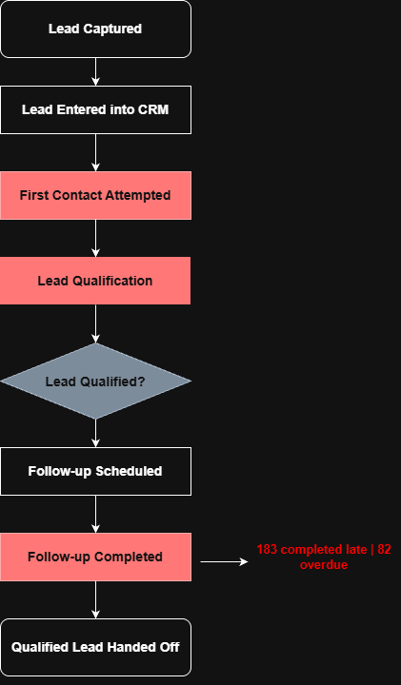
Figure 1: As-Is B2B Lead Management Process (Simulated Workflow).

7. Root Cause Analysis

7.1 Purpose
The Fishbone Diagram organizes possible contributors to delayed follow-ups and incomplete records. It is a hypothesis-generation tool; the available synthetic data cannot confirm the causes.

7.2 Potential contributing factors
Category | Potential causes to validate
People | Competing workload, inconsistent follow-up habits, unfamiliarity with CRM procedures.
Process | No agreed scheduling standard, unclear ownership, undefined escalation thresholds.
Technology | Reminder functionality may be unavailable, disabled or poorly configured; overdue views may be limited.
Data | Missing timestamps, incomplete due dates, inconsistent status updates or duplicate records.
Management | Limited review cadence, unclear service-level expectations, insufficient monitoring of exceptions.

7.3 Validation approach
Validate these hypotheses through interviews with sales representatives and managers, review of CRM configuration, sample record audits, workflow observation and analysis of workload and activity history. Do not present a potential cause as confirmed until evidence supports it.
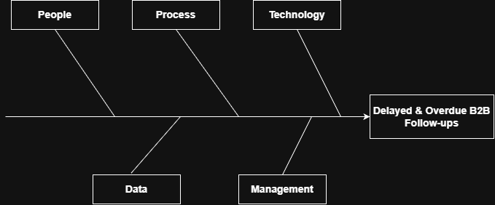
Figure 2: Fishbone Analysis – Potential Causes of Delayed B2B Lead Follow-ups.

8. Gap Analysis
The gap analysis compares the observations available in the dataset with proposed controls for a more measurable future-state process.
Process area | As-Is observation / limitation | Proposed To-Be control | Priority
First contact | 38 records have no first-contact timestamp. | Consistent activity logging and configured first-contact reminders. | High
Qualification | Qualification criteria and workflow have not been validated. | Document qualification checklist and decision outcomes. | Medium
Follow-up scheduling | 38 records have no recorded due date. | Require due date and owner for scheduled follow-ups. | High
Follow-up completion | 183 of 380 completed follow-ups were late. | Reminders before due dates and clear task ownership. | High
Overdue monitoring | 82 records were classified as overdue. | Overdue queue, exception reporting and manager escalation. | High
CRM updates | Some activity fields are incomplete. | Validation rules and auditable activity updates. | High
Sales handoff | Current handoff practice is not verified. | Define minimum handoff information and acceptance step. | Medium

Priorities are preliminary. They reflect the observed data and likely operational relevance, not a completed cost-benefit assessment.

9. Business Requirements
Business requirements describe the capabilities needed to support the proposed process. These are proposed requirements and should be reviewed with stakeholders.
ID | Business requirement | Priority
BR-001 | Maintain complete and accurate lead and activity information. | High
BR-002 | Support timely first-contact activity and measurement. | High
BR-003 | Use consistent lead qualification criteria and decision outcomes. | Medium
BR-004 | Require a due date and responsible owner for scheduled follow-ups. | High
BR-005 | Provide reminders for upcoming follow-up activities. | High
BR-006 | Make overdue follow-up activities visible to responsible users and managers. | High
BR-007 | Maintain an auditable history of lead activities and status changes. | High
BR-008 | Use a consistent process for handing qualified leads to the next sales stage. | Medium
BR-009 | Provide reporting on response, qualification and follow-up performance. | High
BR-010 | Measure performance against approved KPI definitions and baselines. | High

10. Functional and Non-Functional Requirements

10.1 Functional requirements
ID | The solution should… | Priority
FR-001 | Create or update lead records from approved lead-capture inputs. | Medium
FR-002 | Record lead assignment and the responsible owner. | High
FR-003 | Record a timestamp when a first-contact activity is logged. | High
FR-004 | Generate first-contact reminders based on approved business rules. | High
FR-005 | Provide a standardized qualification checklist. | Medium
FR-006 | Require a valid due date and owner when a follow-up is scheduled. | High
FR-007 | Send reminders before a scheduled follow-up due date. | High
FR-008 | Flag an incomplete activity as overdue after its due date passes. | High
FR-009 | Notify designated managers when agreed escalation conditions are met. | High
FR-010 | Allow users to complete or reschedule follow-ups and record the update. | High
FR-011 | Support reassessment of a lead after nurturing activity, where applicable. | Medium
FR-012 | Capture required information when a qualified lead is handed off. | Medium
FR-013 | Provide reports using agreed definitions for response and follow-up KPIs. | High

10.2 Non-functional requirements
ID | Quality area | Proposed requirement
NFR-001 | Security | Access to lead and activity records should follow approved user roles.
NFR-002 | Data integrity | Required fields and timestamps should be validated consistently.
NFR-003 | Reliability | Scheduled reminders and escalation events should run reliably and be monitored.
NFR-004 | Usability | Users should be able to schedule and update follow-ups with minimal friction.
NFR-005 | Auditability | Relevant activity changes should be traceable.
NFR-006 | Performance | Reports and CRM screens should meet thresholds agreed with stakeholders.
NFR-007 | Scalability | The solution should accommodate forecast lead volumes.
NFR-008 | Maintainability | Reminder timings and escalation rules should be configurable.

Numeric service levels, response-time thresholds, retention periods and security standards must be agreed with business and technical stakeholders.

11. To-Be Process

11.1 Proposed future-state workflow
- Capture lead details and create or update the CRM record.
- Assign the lead to a named owner.
- Trigger a first-contact reminder according to an approved rule.
- Record the contact attempt and timestamp.
- Complete the qualification checklist and record the decision.
- If qualified, prepare required information and hand the lead to the next sales stage.
- If unsuitable, record the disqualification reason and close the lead appropriately.
- If further nurturing is required, schedule a follow-up with a due date and owner.
- Send a reminder before the due date.
- If completed on time, update the CRM and reassess the lead where appropriate.
- If not completed by the due date, flag the activity as overdue and notify the responsible owner.
- Escalate unresolved overdue work according to approved rules.
- Record completion or rescheduling and retain an activity history.

11.2 Proposed controls
- Required due date and owner for scheduled follow-ups.
- Configurable reminders before due dates.
- An overdue work queue with clear ownership.
- Escalation rules based on agreed thresholds.
- Consistent qualification and handoff information.
- CRM activity history and KPI reporting.
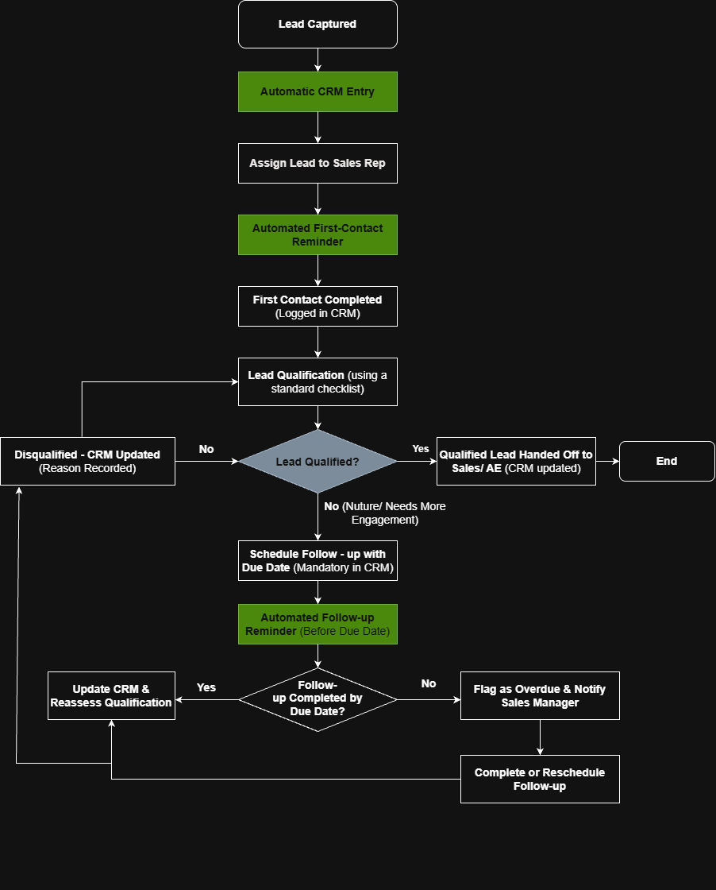
Figure 3: Proposed To-Be B2B Lead Management Process.

12. KPIs and Expected Business Impact

12.1 Baseline and illustrative targets
KPI | Current baseline | Illustrative target | Change
On-time follow-up completion | 51.84% (197 / 380) | 80% | +28.16 percentage points
Late follow-up completion | 48.16% (183 / 380) | 20% | −28.16 percentage points
Overdue follow-up rate | 16.40% (82 / 500) | 8% | −8.40 percentage points
Missing follow-up due-date rate | 7.60% (38 / 500) | 2% | −5.60 percentage points

12.2 KPI definitions
- On-time completion rate = completed follow-ups completed on or before their due date ÷ completed follow-ups with valid due dates.
- Late completion rate = completed follow-ups completed after their due date ÷ completed follow-ups with valid due dates.
- Overdue follow-up rate = open overdue follow-ups ÷ total leads, using the dataset’s classification and denominator.
- Missing due-date rate = records without a recorded follow-up due date ÷ total leads.

12.3 Expected business benefits
If implemented effectively, the proposed controls may improve follow-up visibility, reduce missed activities, strengthen scheduling discipline and provide managers with clearer exception reporting. These are expected benefits, not measured outcomes.

12.4 Measurement limitations
The 183 late completions and 82 overdue activities are different measures and should not be added together. The first measures completed activities that missed their due date; the second measures activities classified as overdue at the dataset’s reporting point. Confirm source definitions and denominator logic before presenting these figures as operational KPIs.
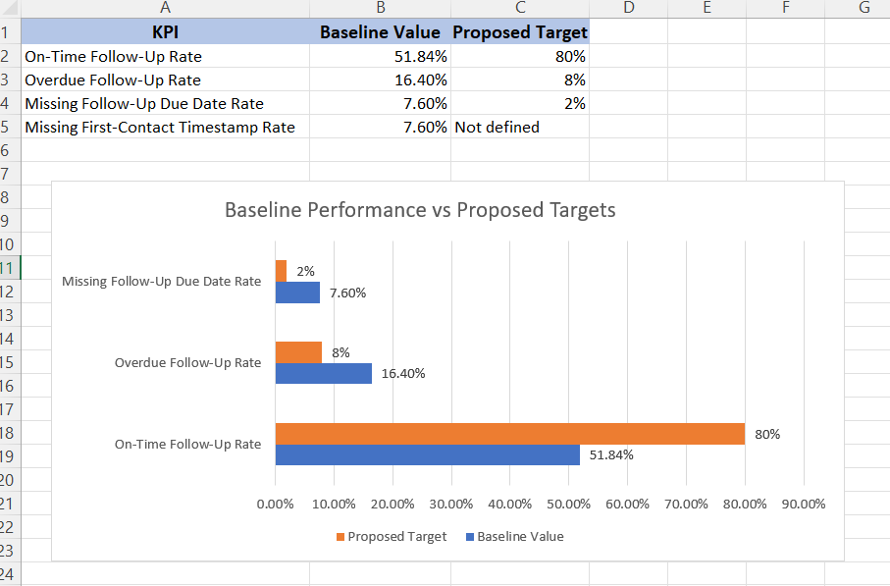
Figure 4: Baseline Performance Compared with Illustrative Targets.

13. Acceptance Criteria
These criteria describe how the proposed capabilities could be tested. They are not evidence that a system has already been built or tested.
ID | Related requirement | Acceptance condition
AC-001 | FR-003 | When a first-contact activity is saved, the correct lead record stores the activity timestamp.
AC-002 | FR-004 | Eligible leads generate reminders according to the approved reminder rule.
AC-003 | FR-005 | A user can complete and save the required qualification fields.
AC-004 | FR-006 | A follow-up cannot be saved without a valid due date and assigned owner.
AC-005 | FR-007 | A reminder is generated at the configured time before the follow-up due date.
AC-006 | FR-008 | An incomplete follow-up is flagged after its due date has passed.
AC-007 | FR-009 | A designated manager is notified when an agreed escalation condition is met.
AC-008 | FR-010 | Users can complete or reschedule a follow-up, and the activity history reflects the change.
AC-009 | FR-012 | A qualified-lead handoff includes all mandatory information defined by the business.
AC-010 | FR-013 | Reports calculate KPIs using approved definitions and the correct reporting period.

13.1 Validation approach
A real delivery team would validate these criteria through functional testing, workflow and exception testing, data validation, user acceptance testing and documented stakeholder sign-off.

14. Assumptions, Risks and Dependencies

14.1 Assumptions
- The organization uses a CRM to manage leads and sales activities.
- Lead records can store ownership, status and activity timestamps.
- Sales representatives are responsible for assigned lead activities.
- The selected CRM can support configurable reminders or integrate with a notification service.
- Business stakeholders will define and approve reminder and escalation thresholds.
- The synthetic dataset is used only to demonstrate analysis methods.

14.2 Risks and mitigations
Risk | Potential effect | Possible mitigation
Inaccurate CRM data | Unreliable reporting and incorrect prioritization. | Validation rules, record audits and clear field definitions.
Too many reminders | Users may ignore notifications. | Use priority-based, configurable reminder rules.
Low user adoption | New controls may not be followed consistently. | Involve users in design, provide training and monitor adoption.
Unclear escalation rules | Unnecessary or delayed manager intervention. | Agree thresholds, ownership and exception handling before rollout.
Inconsistent qualification | Leads may be routed incorrectly. | Define and maintain a common qualification checklist.
Integration complexity | Delivery effort and timelines may increase. | Assess platform capabilities and dependencies early.
Unrealistic targets | Performance expectations may not be achievable. | Pilot the process and reset targets using observed results.

14.3 Dependencies
- Access to reliable CRM data and activity history.
- Agreement on lead ownership, due-date rules and escalation responsibilities.
- Approval of KPI definitions, reporting periods and target values.
- CRM platform support for validation, reminders, notifications and reporting.
- Availability of business users for requirements validation and user acceptance testing.

15. Conclusion
This case study applies a structured Business Analyst approach to a simulated B2B lead management scenario. Analysis of 500 synthetic records identified late follow-up completion, overdue activities and missing scheduling information as areas that merit attention.
The project translates these observations into a proposed future-state workflow, potential root-cause hypotheses, gap analysis, business and functional requirements, acceptance criteria and measurable KPIs. The recommendations focus on clearer ownership, required scheduling information, reminders, overdue monitoring and consistent CRM activity records.
The work demonstrates how data analysis can inform process improvement and requirements definition. Because the dataset is synthetic and no solution has been implemented, proposed causes, requirements and targets should be validated with stakeholders, piloted and measured before claiming business benefits.
FINAL TAKEAWAY The project links data findings → process gaps → proposed controls → requirements → acceptance criteria → KPIs.

Appendix A. Supporting Project Files
Folder | Recommended contents
02_Dataset | B2B_Lead_Management_Synthetic_500.csv; B2B_Lead_Management_Analysis.xlsx
03_Process_Maps | Editable .drawio files and exported .png files for As-Is, To-Be and Fishbone diagrams.
04_Business_Requirements | B2B_Lead_Management_BRD.docx and exported PDF.

Appendix B. Final Review Checklist
- Confirm all counts and percentages against the final Excel workbook.
- Confirm 380 is the correct denominator for completed follow-up timeliness.
- Confirm the definition and denominator used for overdue follow-ups.
- Confirm missing due-date and missing first-contact counts match the workbook.
- Insert final As-Is, To-Be, Fishbone and KPI chart images.
- Update the automatic Table of Contents and page numbers.
- Retain the synthetic-data disclaimer and distinguish assumptions from verified findings.
- Proofread the document and save both editable DOCX and PDF versions.

